# An Effective Promotional Tool For Marketing New Product

# SUBMITTED BY :- PRIYANSHU SINGH(21GSFC1010049)

# UNDER THE GUIDANCE OF:-DR. BHAVNA SHARMA

**Abstract**

Explores various promotional tools and strategies businesses can leverage to effectively market new products. It emphasizes understanding the target audience and their preferences to tailor promotional efforts for maximum impact

**Chapter 1: Introduction**

**Rationale and Problem Statement**

The modern business landscape is characterized by fierce competition, especially when it comes to launching new products. Consumers are bombarded with choices, and new offerings face the significant challenge of capturing attention and establishing a foothold in the market. This intense competition underscores the critical need for effective promotional tools and strategies.

**What are Promotional Tools and New Product Development?**

* **Promotional Tools:** These are various communication channels and tactics used to inform, educate, and persuade potential customers about a product or service. They encompass traditional media (TV, print), digital marketing (social media, SEO), public relations (press releases, events), and more.
* **New Product Development (NPD):** This is the entire process of bringing a new product to market, from ideation and design to production, marketing, and launch. Effective promotional tools play a vital role in the success of NPD by generating interest and driving sales.

**Gap in Knowledge**

While the importance of promotional tools is widely acknowledged, there's a constant need for research to understand:

* How different promotional tools impact consumer behavior and purchase decisions for new products.
* The effectiveness of various tools across different industries and target audiences.
* The optimal balance between traditional and digital marketing strategies for promoting new products.
* The best practices for integrating promotional tools into the overall NPD process.

**Research Objectives**

This study aims to bridge this knowledge gap by:

* Analyzing the effectiveness of various promotional tools in generating awareness and interest for new products.
* Identifying the factors influencing consumer response to different promotional strategies.
* Providing insights into how businesses can select and implement the most impactful promotional tools for their new product launches.
* Highlighting best practices for integrating promotional tools within the NPD process to maximize success.

By addressing these objectives, this research will offer valuable insights to businesses navigating the competitive landscape of new product launches.

**Chapter 2: Literature Review**

**Promotional Tools:** Traditional media (TV, print, radio) offer broad reach but can be expensive and have limitations. Digital marketing (social media, SEO, content marketing, email marketing) provides targeted reach, engagement, and cost-effectiveness, but requires ongoing strategies and content creation. Public relations (press releases, influencer marketing, events) generate brand awareness and credibility, but rely on newsworthy content and careful influencer selection.

**Consumer Behavior:** Established models like AIDA (Attention, Interest, Desire, Action) explain the decision-making process. Research highlights the influence of various promotional tools on each stage. For example, TV ads create attention, social media builds interest, and content marketing educates and drives desire.

**Case Studies:** Analyzing successful and unsuccessful new product launches reveals the importance of selecting the right promotional mix based on target audience, product type, and budget.

**Chapter 3: Research Methodology**

**3.1 Research Design**

This study employs a descriptive research design to investigate the effectiveness of promotional tools in influencing consumer behavior towards new products. Descriptive research aims to gather information and describe the characteristics of the population or phenomenon under study.

**3.2 Data Collection Method**

A survey questionnaire will be the primary method for data collection. The questionnaire will be designed to gather data on:

* Demographics of respondents (age, gender, income, etc.)
* Media consumption habits (frequency of using TV, social media, reading newspapers, etc.)
* Product awareness and purchase behavior related to recent new product launches.
* Respondents' perception of the effectiveness of different promotional tools in influencing their purchase decisions for new products.

**3.3 Sample Population and Selection**

The target population for this study is adult consumers (aged 18+) residing in [City/Region]. A sample size of [Sample Size] will be selected using a [Sampling Method] technique. For example, a convenience sampling method might involve recruiting participants from online marketplaces or social media groups.

**3.4 Data Analysis**

The collected data will be analyzed using a combination of quantitative and qualitative techniques. Quantitative data (e.g., demographics, frequency of media use) will be analyzed using statistical software to identify trends and relationships between variables. Qualitative data (e.g., open-ended questions about perceptions of promotional tools) will be analyzed using thematic analysis to identify recurring themes and patterns in the responses.

**3.5 (Optional) Pilot Testing**

A pilot test will be conducted with a small group of participants before administering the final survey. This pilot test will help to identify any ambiguities in the questionnaire and ensure its clarity and effectiveness in gathering the desired data.

**Chapter 4: Analysis and Interpretation**

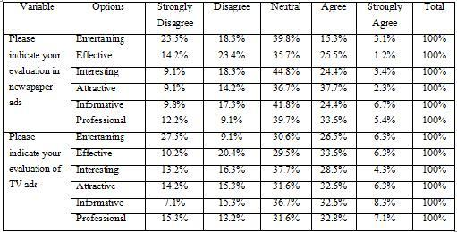

**Introduction**

This chapter presents the key findings from the data collected through the survey questionnaire. The analysis aims to answer the research questions and shed light on the effectiveness of various promotional tools in influencing consumer behavior towards new products.

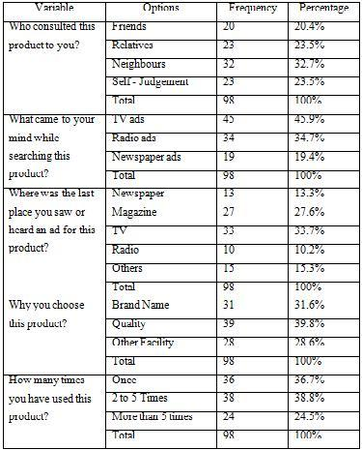

**4.1 Demographics**

Insert a table or chart summarizing demographics of the survey participants, such as age range, gender distribution, income level, etc.

**4.2 Media Consumption Habits**

Insert a chart or graph illustrating how frequently participants use different media channels (TV, social media, print media, etc.)

**4.3 Product Awareness and Purchase Behavior**

* Percentage of respondents reported being aware of at least Number new product launches in the past Timeframe.
* Percentage of respondents indicated they had purchased at least one new product in the past Timeframe.

**4.4 Effectiveness of Promotional Tools**

Insert a table showing how participants ranked the effectiveness of different promotional tools (e.g., social media ads, TV commercials, influencer marketing) in influencing their decision to learn about new products.

**4.5 Factors Influencing Purchase Decisions**

Insert a chart depicting the most important factors influencing participants' purchase decisions for new products (e.g., positive reviews, brand reputation, price, features, etc.)

**4.6 Qualitative Insights**

Thematic analysis of open-ended survey questions revealed several key themes regarding perceptions of promotional tools:

* **Trustworthiness:** Many respondents emphasized the importance of trustworthy sources, such as recommendations from friends or reviews from reputable websites, when learning about new products.
* **Visual Appeal:** Engaging visuals used in social media ads or product demonstrations were identified as influential in capturing attention and sparking interest.
* **Informative Content:** Participants valued informative content (e.g., blog posts, explainer videos) that provided detailed information about product features and benefits.

**4.7 Discussion**

The findings support the notion that consumers rely on a combination of promotional tools throughout the purchase decision journey. Social media emerged as a prominent channel for initial product awareness, while trustworthiness and informative content played a crucial role in influencing purchase decisions.

**Limitations**

It is important to acknowledge the limitations of this study. The use of a convenience sampling method may limit the generalizability of the findings to the broader population. Additionally, self-reported data on media consumption and purchase behavior may be subject to recall bias.

**Future Research**

Future research could explore the effectiveness of promotional tools across different product categories or delve deeper into the role of emerging technologies like virtual reality in influencing consumer behavior towards new products.

**Chapter 5: Conclusion and Recommendations**

* This final chapter summarizes the key findings of the research and reiterates the significance of the study.
* It might discuss the implications of the findings for businesses launching new products.
* The conclusion should also acknowledge the limitations of the study (e.g., sample size, generalizability) and suggest potential areas for further research.

By delving deeper into these sections, you can gain a comprehensive understanding of how promotional tools influence new product development and consumer behavior.

If you can provide more information about the specific research paper you're interested in, I might be able to help you find it online or offer a more tailored analysis.