**Abstract:**

The technique of preparing polyherbal hard lozenges is quick and simple. The prepared formulation is better received organoleptically, especially by pediatric patients, also it is beneficial for adult persons. It is effective therapy including low doses, fast start of action, reduced dosage regime, and economics, as well as patient compliance, convenience, and comfort. This will provide improved and beneficial doses form to improve the immunity. Lozenges currently have significant role in pharmacy and will do so in the future. The current study goal was to create polyherbal lozenges utilizing the heating and congealing procedure. Trails no. 7 of formulated polyherbal lozenges showed that it was successful in all terms of evaluation parameters. These multi-herbal lozenges are primarily used to improve immunity. The remaining study will perform in future in terms of preclinical trials and other evaluation. Polyherbal formulations are gaining popularity due to their potential synergistic effects and fewer side effects compared to single-herb formulations. This study aimed to design, develop, and evaluate polyherbal lozenges as an energy booster. The formulation comprised herbs known for their energy-boosting properties, including Panax ginseng, Withania somnifera, and Centella asiatica. The lozenges were prepared using a blend of these herbs along with excipients. Physicochemical characterization, including weight variation, hardness, and disintegration time, was conducted to ensure the quality of the lozenges. Additionally, sensory evaluation was performed to assess the taste and acceptability of the formulation. The formulated polyherbal lozenges demonstrated promising physicochemical properties and were well-accepted in terms of taste. Further evaluation of the lozenges for their efficacy in boosting energy levels is warranted to establish their utility as a natural energy booster.

**Keywords:** polyherbal, lozenges, energy booster, Panax ginseng, Withania somnifera, Centella asiatica, formulation, physicochemical characterization, sensory evaluation

**INTRODUCTION:**

Lozenges are solid doses form intended to dissolve in mouth for long duration with soothing effect. They contain one or more herbal medicament with a wide range of effect. This is used to treat cough, sore throat, throat infection, fever etc. Even it is use as a source of immune boosting. Patient are recommending lozenges because of swallowing problem of solid doses form and so lozenges are designed such that it releases the medicament slowly in the oral cavity and it bath the throat tissue with the drug solution.

Plant with multiple benefits to boost immunity are used are as follow. Tulsi contains Volatile oil, eugenol, neroli etc. and use as expectorant, carminative, bronchitis, flavouring agent. Pudina consist of limonene, carvone, butyric and caproic and use as flavouring agent, digestive, carminative, stimulant, spasmolytic. Turmeric consists of curcuminoids and essential oil and use as aromatic, anti-inflammatory, uretic, stomachic, stimulant, tonic, blood purifier, carminative, antiperiodic, coloring agent, cold and cough. Fenugreek seed is a good source of calcium, iron, minerals, vitamins like A and D, β-carotene, and dietary fiber and diabetes, constipation, stimulates, balance cholesterol level, cures joint pains, flu and cold, improves heart health, reduce menstrual discomforts. Bael fruits contain xanthotoxin, *β*-sitosterol, imperatorin, alloimperatorin, tannins and it use for in diarrhea, diabetes, dysentery.

**Advantages:**

* Patient with gulping problem given this.
* Geriatric and Pediatric and can consume it.
* Taste can mask by using different flavors and sugar.
* It has high bioavailability.
* There is no change of disintegration.
* It required less time for production.
* It required less cost for production.
* It doesn’t required water for intake.
* Lozenges can withdraw if not required.

**Disadvantages:**

* Drug which are heat stable only they can be used.
* Minimum bitter taste drug can be used.
* Children above four years age can use lozenges safely.
* Hard candy lozenges required high temperature for their preparation.

**Classification of Lozenges:**

**According to texture:**

* Chewy or caramel based medicated lozenges.
* Compressed tablet lozenges.
* Soft lozenges.
* Hard sweets lozenges.

**MATERIAL AND METHODOLOGY**

**Requirements:**

**Materials:** Tulsi leaves, Pudina leaves, Turmeric rhizome, Fenugreek seeds, Bael fruit, Jaggery, Honey, Ghee.

**Apparatus:** Beakers, Glass rods, Measuring cylinders, Hot air oven, Digital weighing balance, Spatulas, Petry plates, Thermometer, Tripod stand, Burner, Molds, Aluminium foil, Filter paper, Pipette etc.

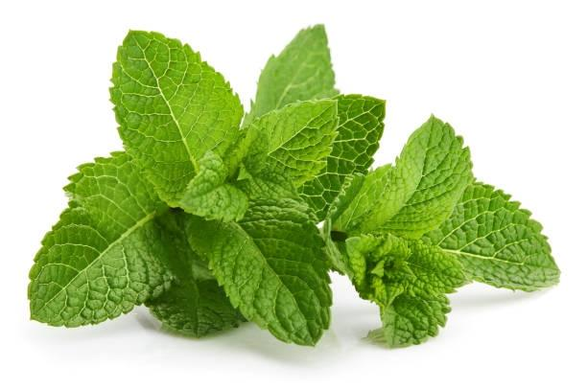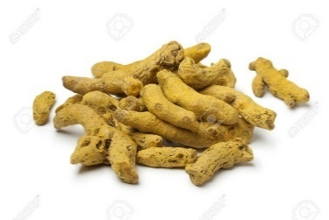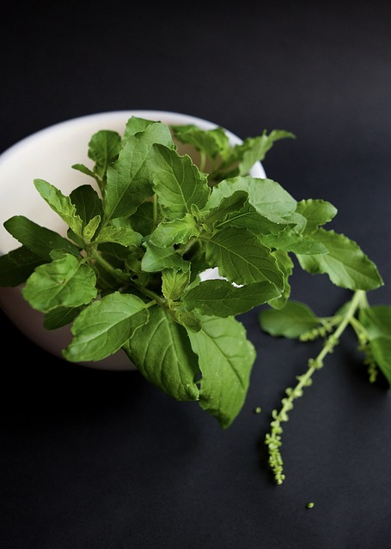

**Fig. 3: Turmeric rhizomes**

**Fig. 2: Pudina Leaves**

**Fig. 1: Tulsi Leaves**

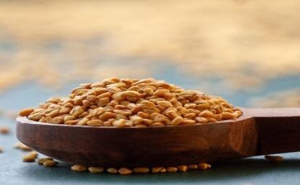

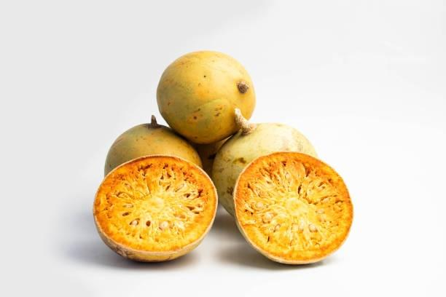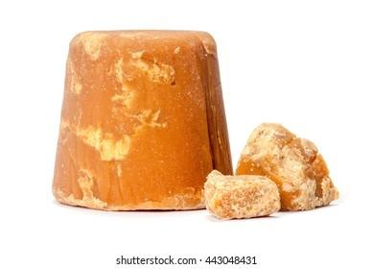

**Fig. 5: Wood Apple Fruit (Bael)**

**Fig. 4: Fenugreek seeds**

**Fig. 6: Jaggery**

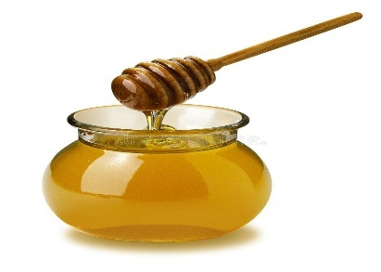**Fig. 4: Fenugreek**

**Fig. 7: Honey**

**Procedure:**

**Collection of Material:**

* The Tulsi leaves has been taken from our own home.
* The Pudina Leaves, Turmeric rhizomes, Fenugreek seeds and jaggery has purchased from local shop.
* Honey of Patanjali brand is purchase from shop.
* Bael fruits are received from farmer.

**Preparation of Decoction:**

**a)** Tulsi and Pudina leaves Decoction:

The Tulsi and Pudina fresh leaves have been taken and wash it by water separately.

Then the leaves of Tulsi and Pudina are placed separate on burner for boiling with water until total extract obtained in water. Now this both extracts are filter out.

**b)** Turmeric Decoction:

The Turmeric rhizomes are taken and make pieces of this rhizomes.

These pieces are place to boil with water until the yellow color extract is obtained. Now filter out the extract.

**c)** Fenugreek Decoction:

The seeds of Fenugreek have been taken wash it. These seeds are placed to boil with water until the extract is obtained. Now filter the extract.

**d)** Wood Apple Decoction:

The ripped fruit of Bael is taken and the pulp of it remove out and separate out **seeds**. This pulp is boiled with water until total extract is obtained. Now filter out the extract

**Preliminary and Phytochemicals Evaluation:**

**Physicochemical studies:**

It involves ash value and extractive value to determine the purity and quality of powder of Tulsi leaves, pudina leaves, turmeric rhizomes, fenugreek seeds, Bael fruit.

**1) Determination of ash values:**[7]

Crude drug incineration results in an ash residue having inorganic material.

a) Total Ash:

Place about 2-4 gm of dried drug crucible. Now place this crucible in muffle furnace and ignite it heat to 4500c. Until it gets white means absence of carbon. Cool it in desiccator and weight. Percentage of ash is calculated.

b) Acid Insoluble Ash:

Boil ash with 25 ml of dilute HCl for 5 minutes. Filter it with ashless filter paper to get Insoluble matter. Place it again to muffler furnace to get ash. Weight it and calculate acid Insoluble ash.

c)Water Insoluble Ash:

Boil ash with 25 ml of water for 5 minutes. Filter it with ash less filter paper to get Insoluble matter. Place it again to muffler furnace to get ash. Weight it and calculate water Insoluble ash.

**2) Extractive Value:**

Take 5 gm of dried coarsely powdered of Tulsi and Pudina leaves, turmeric rhizomes, fenugreek seeds and Bael fruit pulp separately. Macerated it with 100 ml of water and ethanol for 24 hours in close 250 ml conical flask. During first 6 hours shake this all flask frequently and allow it to stand for 18 hours. After 18 hours filter it. Empty Petry disk should weight first. Take 25 ml of filtrate to evaporate in Petry disk under oven at 1050c.

After drying of Petry disk weight it again. Now solvent soluble extractive percentage is calculated with reference to air dried drug.

**3) Phytochemical Screening:**

It is done to determine the secondary plant constituents. The decoction of Tulsi leaves and Pudina leaves, Turmeric rhizomes, Fenugreek seeds and Bael fruit pulp is taken. The test is performed on each decoction separately in test tube as follows.

1. Testing for reducing sugars:

It involved adding 5ml of a 1:1 mixture of Fehling's solutions IA and II (B) to 2ml of the extract and boiling the mixture in a water bath for 5 minutes. The presence of free reducing sugars was indicated by a brick-red precipitate.

1. Testing for Anthraquinone:

Anthraquinone presence should be checked: Shaking 10 ml of the benzene with 0.5g of the extract and was filtered, and the filtrate was then added to 5 ml of a 10 percent ammonia solution. A combination pink, crimson, or violet tint in the ammoniacal (lower) phase after shaking exhibited anthraquinones' existence.

1. Testing for Saponins:

A test tube containing 0.5g of the extract was dissolved in 10 ml of distilled water, sealed with a cork, and shaken violently for 30 seconds. The test tube was then let to stand for 45 minutes to determine the presence of saponins. the persistent foaming appearance that results from warmth. Saponins were present, which indicated.

1. Testing for Flavonoids:

Test for flavonoids by adding a few drops of 10% ferric chloride to a fraction of the dissolved extract. Addition of the remedy. Phenolic nucleus was seen as a green or blue tint.

1. Testing For Steroids or Terpenes:

A test for steroids or terpenes involved dissolving 0.5g of the extract in 2 ml of acetic anhydride, which was then thoroughly chilled in ice. After that, Sulphuric acid was carefully added. The existence of a steroidal nucleus was indicated by a color change from violet to blue to green.

1. Testing For Tanning:

0.5 g of the extract was dissolved in 5 ml of water, then a few drops of the solution were added. 10% ferric chloride is used. An indication of the would be a blue-black, green, or blue-green precipitate. Availability of tannins shows.

1. Testing for alkaloids:

1ml of the filtrate was treated with a few drops of Mayer's reagent, and a second 1ml portion was treated with Dragendorff's reagent. 0.5g of ethanol extract was mixed with 5ml of 1 percent aqueous hydrochloric acid on a steam bath. Turbidity or Both of these reagents would cause precipitation, which would reveal the presence of alkaloids in the extracts.

1. Testing for resins:

10 ml of petroleum ether extract were collected in a test tube,

a solution of copper acetate was added, and the mixture was vigorously agitated before being allowed to separately, the presence of resin is denoted by a green hue.

1. Testing for Protein and Amino Acids:

When proteins and amino acids are heated with a 0.2% solution of ninhydrin (Indane 1, 2, 3 trione hydrate), a violet hue results, indicating the presence of both proteins and amino acids.

**4) Chemical Test for Jaggery and Honey:**

1. **Solubility**: Drug add in cold water and warm water.

Prepare solution of honey and jaggery in water separately.

1. **Reducing Sugar Test:**

In solution add Fehling’s solution A and B. Brick red color precipitate is form.

1. **Molisch’s Test:**

In solution add little Molisch’s reagent. Purple color ring is formed at the junction of two liquid.

1. **Seliwanoff's Test:**

In solution add some seliwanoff reagent heat it. Rose colour is obtained.

**Preparation of lozenges:**

* Take the measured quantity of Tulsi leaves, Turmeric rhizomes, Pudina leaves, Fenugreek seeds and Bael fruit extract in container.
* Place it to heat until get one third quantity.
* Now add the measured quantity of jaggery to it.
* After getting thick consistency add required quantity of honey to it.
* Now pour this to the required shapes molds and place it to cool.

**Energy booster Lozenges are prepared by: -**

**Evaluation test for lozenges**:

**1) Organoleptic characteristics:**

It involves color, odor, taste determination. The effectiveness and safety of produced herbal sweets must be determined by quality evaluation. The formulation was assessed using physicochemical and phytochemical comparisons to the standard criteria. sensory assessment was also carried out and characterized as a field of study that aimed to elicit, quantify, examine, and interpret responses to those food and material features as viewed through the senses of sight, smell, taste, touch.

**2) Physicochemical Evaluation of Herbal Lozenges:**

Molisch Test, Fehling’s Test, Mayers Test, Hanger Reagent Test, Wagner Test, Salkowski Test, Aqueous sodium Hydroxide Test, Sulphuric Acid Test, Ferric Chloride Test are performed on the herbal lozenges.

**3) Weight variation Test:**

A suitable, previously calibrated balance was used to precisely weigh ten lozenges, and the average weight of each was noted. By adding together, the weight of all 10 lozenges and dividing it by 10, the average weight was determined.

**4) Hardness Test:**

A specific level of firmness or hardness is necessary for solid formulations, whether they be tablets or lozenges, to withstand mechanical shocks from manufacturing, packaging, and shipping handling. Using the Monsanto tablet hardness tester is another way to measure hardness; with this test, when lozenges is sandwiched between two anvils, the anvils are forced together with such crushing power that the candy just breaks is captured. Zero reading is taken before the experiment begins. Six sweets were tested for hardness in Kg/cm2, and the average toughness was recorded.

5)  **Testing for Friability:**

Friability is a different indicator of a lozenge’s durability. The Roche friabilator, a plastic circular chamber that rotates at 25 rpm and drops the lozenges at six inches with each rotation, can be used to assess friability. Then the lozenges are reweighed and dusted. It is permissible for tablets or lozenges to lose up to 1% of their weight.

**6) Time of disintegration:**

An appropriate time machine for lozenges disintegration contained six lozenges and sliding discs. The water's temperature was moderate kept at 25 °C. The disintegration machine was turned on, and the amount of time needed to break up all six lozenges was noted, and the mean time was determined.

7)  **PH measurement:**

A 1% W/V solution of lozenges was made by dissolving 1 g of lozenges in 100 ml of distilled water, and the pH of the solution was recorded. The alkalinity or acidity of a product is expressed by using a pH meter, a scale from 1.0 to 14.0.

**CONCLUSION:**

The technique of preparing polyherbal hard lozenges is quick and simple. The prepared formulation is better received organoleptically, especially by pediatric patients, also it is beneficial for adult persons. It is effective therapy including low doses, fast start of action, reduced dosage regime, and economics, as well as patient compliance, convenience, and comfort. This will provide improved and beneficial doses form to improve the immunity. Lozenges currently have significant role in pharmacy and will do so in the future. The current study goal was to create polyherbal lozenges utilizing the heating and congealing procedure. Trails no. 7 of formulated polyherbal lozenges showed that it was successful in all terms of evaluation parameters. These multi-herbal lozenges are primarily used to improve immunity. The remaining study will perform in future in terms of preclinical trials and other evaluation. **REFERENCES :**

1. Vardhanapu Sunny, Yarra Jnaneswari, Formulation of Trachyspermum Ammi Hard Candy Lozenge By Using Heating And Congealing Method And General Evaluation Studies Of Lozenges, Volume 7, Issue 4 July-Aug 2022, pp: 249-263 www.ijprajournal.com ISSN: 2456-4494
2. Sunitha Reddy and Tejasri Ragabhoina, Lozenges Formulation and Evaluation: A Review, Volume 6, Issue 6 Nov-Dec 2021, pp: 678-684

www.ijprajournal.com ISSN: 2249-7781

1. Tripathi Devika and Verma Shashi, Pharmacognostical and Phytochemical Investigation of Tulsi Plants Available in Western Bareilly Region Article in  Global Journal of Pharmacology, January 2015 <https://www.researchgate.net/publication/343050216>
2. Bipin Khanal,Phytochemical and Antibacterial Analysis of Mentha piperita (Peppermint)Thesis, June 2019,

https://www.researchgate.net/publication/347933380

1. R.S. Sawant and A.G. Godghat Qualitative Phytochemical Screening of Rhizomes of Curcuma Longa Linn Article , August 2013, https://www.researchgate.net/publication/279965207
2. Methaq Nazhan Mahmooda, Isra Khald Yahyab, Nutrient and Phytochemical of Fenugreek (Trigonella Foenum graecum) Seeds Research, October 2017

https://www.researchgate.net/publication/337472293

1. Sneh Lata Shakyawar, Preliminary Qualitative Phytochemical, Physico-Chemical And Phyto-Pharmacognostical Standardisation Evaluation Of The Pulp (Without Seed), Pericarp, Leaves And Seed Of Aegle Marmelos L. (Bael), Ijpsr, 2020; Vol. 11(7): 3489-3506. DOI link: http://dx.doi.org/10.13040/IJPSR.0975-8232.11(7).3489-06
2. V. Sharma, A. Joshi, B.K. Dubey, Comperative Pharmacognostical And Phytochemical Evaluation (Leaf) Of Different Species Of Ocimum, Vol. 1 (2), pp.43-49, Nov-Dec 2011 Scholar Science Journals
3. Reena Hooda, Formulation development of a Herbal Candy for Altitude Health Problems JPRPC, Volume 3, Issue 4 December, 2015
4. Anshul Kumar1, Manish Kumar Mishral, Development and Evaluation of Polyherbal Lozenges for Coldand Flu, May 2019

https://www.researchgate.net/publication/332805052

1. Doris Kumadoh1, Kwabena Ofori-Kwakye, Dosage Forms Of Herbal Medicinal Products And Their Stability Considerations-An Overview, Vol 4, Issue 4, 2017

(<http://creativecommons.org/licenses/by/4.0/>)

1. Parth Hirpara, Nitin Thakare, Jaggery: A natural sweetener, September 2020, https://www.researchgate.net/publication/344921769
2. Binu Anand, Irene Thomas, Formulation and Evaluation of Herbal Lozenges Containing Eucalyptus Oil and Coleus Aromaticus Oil, 2018,

http://www.ajptr.com/