**Title:** “**The role of digital transformation in enhancing customer experience and operational efficiency in retail banking**”

**ABSTRACT**

This research looks at how the banking business is being affected by digital transformation and identifies the advantages and difficulties that come with working in such a dynamic field. An historical review of the development of digital banking is given in this article, along with an analysis of the main forces behind the sector's digitization. We also look at the significance of fintech, how it affects conventional banks, and the difficulties the conventional banking sector has integrating digital tactics. The research evaluates the effects of digitization on customer experience and satisfaction in addition to its possible influence on the market for banks. Additionally, it evaluates the benefits and drawbacks of digitization from a regulatory standpoint and highlights the significance of cybersecurity in the context of digital banking. The report examines how blockchain technology can affect banking and offers predictions and trends for the industry's future in the digital era. The purpose of this study is to present a comprehensive analysis of the benefits and drawbacks of digital transformation in the banking industry.

**Keywords:** Banking Sector, Fintech, Blockchain, Digitization, Cybersecurity, Legacy Systems

# INTRODUCTION

The banking industry has been significantly impacted by digital transformation everywhere it has occurred, including in India. The swift digitalization of the nation has resulted in an increase in the need for digital banking services, as clients may now obtain an extensive array of banking amenities from the convenience of their residences. Nonetheless, this shift has also posed major difficulties for banks in terms of upholding data security and privacy while accommodating shifting client demands. In order to better understand the benefits and difficulties that come with digital transformation, this research study will examine how it has affected India's banking industry. This study aims to investigate the diverse range of digital banking services and technology that have surfaced in recent times, together with their effects on the customary banking procedures in India. The study will also examine the legal and regulatory frameworks that banks must follow in order to comply with Indian regulations pertaining to data security and privacy. The study will also look at how India's customer expectations and behavior have evolved as a result of digital transformation, and the difficulties banks have in living up to these expectations. An examination of the function of the customer experience and how to enhance it to satisfy the needs of India's digital age will be part of this.

There are many benefits of digital banking, This transformation in banking system enhance customer experience and efficiency. Digital banking make transaction process much easier, improve flexibility in keeping financial records, make more convenient to monitor the transactions, and it also leads to same time as well as money, and promotes ease of banking activity.

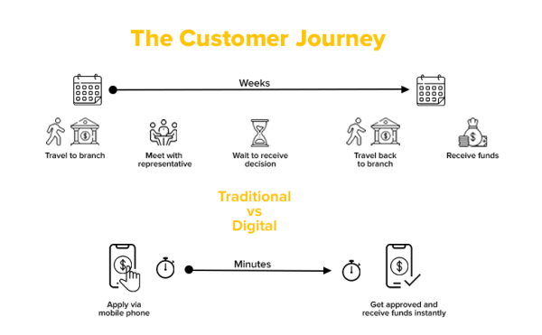

**PROBLEM STATEMENT**

A digital strategy is a plan that describes how a business intends to use digital tools and procedures to meet its goals. Digital strategies are essential for the banking sector to remain competitive and satisfy evolving client demands.   
  
However, because legacy banking systems were created for a different era and are frequently ill-suited to meet the demands of the digital age, implementing digital strategies can be difficult.

A digital strategy is a plan that describes how a business intends to use digital tools and procedures to meet its goals. Digital strategies are essential for the banking sector to remain competitive and satisfy evolving client demands.   
  
However, because legacy banking systems were created for a different era and are frequently ill-suited to meet the demands of the digital age, implementing digital strategies can be difficult.

It can be costly to replace outdated systems with new digital ones, and the ROI might not show up right away. Furthermore, staff members and other stakeholders who are used to the outdated systems could be resistant to change.   
  
Another significant obstacle to implementing a digital strategy with conventional banking systems is data security. Compared to modern digital technologies, legacy systems may not have the same level of security and are frequently more susceptible to cyber threats. Consequently, banks need to exercise caution to make sure that the security and privacy of consumer data are not jeopardized by their digital methods.

The rapid advancement of technology may prove to be too much for the antiquated financial systems to keep up with. Digital technologies are developing quickly, and banks that don't use them quickly enough risk losing ground to their rivals. Staying ahead of the curve can be challenging with legacy systems if they are not flexible enough to adjust to new procedures and technologies.   
  
Banks need to create a complete digital strategy that considers the special requirements and difficulties of their legacy systems in order to overcome these obstacles. This could entail making investments in cutting-edge technology that can be connected with the current systems or collaborating with fintech businesses. It also calls for a change in the organization's culture, with an emphasis on embracing agility and innovation.

It is possible to convert antiquated banking systems into cutting-edge digital platforms that satisfy customers' expectations for speed, convenience, and security in the current digital era.

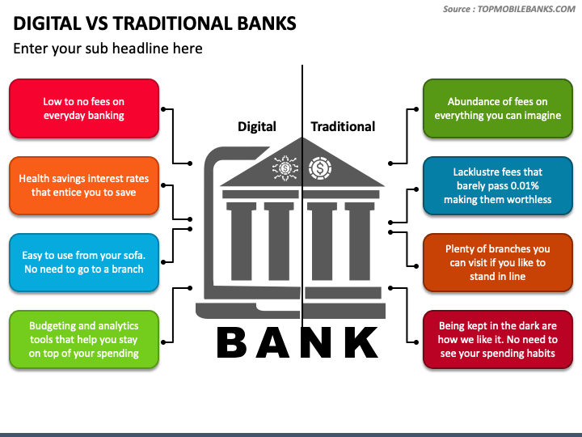

# AIM OF THE STUDY

The study intends to investigate the following goals: to research how involved their customers are with e-banking To analyze consumer satisfaction with e-banking and their experience using it To recognize client service in the digital sphere to track development and involve clients in putting improvements into practice and honing them.

**SCOPE AND LIMITATIONS**

The banking sector's growing embrace of digitalization has completely changed how consumers receive financial services. Although there are many advantages to this technology transformation, such as improved client experiences, cost savings, and higher efficiency, there are also substantial concerns that need to be considered from a regulatory standpoint.   
Cybersecurity is one of the biggest threats connected to digitalization in banking. The use of digital technologies raises the amount of vulnerabilities that criminal actors can use to obtain illegal access to private client information, which can cause banks to suffer large financial losses as well as harm to their reputation.

Regulators must create and implement cybersecurity policies that guarantee banks are using strong security measures to fend off cyberattacks in order to reduce this risk. The possibility of data privacy violations is another concern that comes with digitization. Strong data protection mechanisms that guard against unwanted access, usage, or distribution are necessary as banks gather enormous volumes of consumer data.   
To make sure that banks are gathering, storing, and utilizing consumer data in a way that respects privacy rights, regulators need to set explicit criteria and norms for data privacy.

Furthermore, the transition to digitalization presents obstacles for stable finances. Regulators must make sure the financial system is strong enough to withstand any potential shocks or disruptions since digital technologies enable faster and more complicated financial transactions. In order to facilitate a smooth transition to a digital economy, regulatory frameworks that support financial stability must be established.   
However, there are a number of advantages to digital technology adoption in the banking industry, including enhanced financial inclusion, better client experiences, and increased efficiency. Banks may be able to better manage risks and adhere to regulations thanks to digitalization. It is imperative for regulators to promote the uptake of digital technologies while guaranteeing sufficient risk mitigation through the implementation of well-defined regulatory frameworks.

While digitization has many advantages, maintaining the banking sector's safe, stable operations that safeguard consumers and the larger financial system requires finding a balance between innovation and safety.

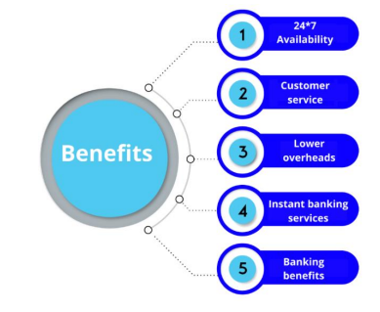

# LITERATURE REVIEW

* Bhattacharya and Ray (2016) highlighted the ways in which digital transformation is affecting the business models of Indian banks. They came to the conclusion that banks need to embrace a client-centric approach to digital transformation, emphasizing the need of customized customer experiences.
* Kapoor and Kapoor examined how digital transformation might improve the operational efficacy of Indian banks in a 2018 study that was published. They found that banks have profited from digital technologies by obtaining faster, more accurate outcomes while spending less.
* The 2019 study by Gupta and Bhatia looked at how the digital revolution has changed the expectations and behavior of Indian consumers. According to their results, customers now expect smooth, personalized banking experiences across a range of channels, including online and mobile banking.
* Jain and Singh (2017) looked into how regulatory frameworks helped the Indian banking sector undergo a digital revolution. They found that if rules are supported and explicit, banks can employ digital technology to improve their business operations and services.
* In their study, Singh and Singhal (2019) highlighted the importance of the customer experience in digital banking for Indian customers. They found that customers valued personalized, faultless experiences highly, which prompted companies to increase their chatbot and virtual assistant spending.
* Saha and Gupta (2017) looked into how digital change can affect India's financial inclusion. They found that while technological advancements can help close the gap in financial inclusion, innovative solutions that address the unique needs of excluded people are still required.
* Mahajan and Singh (2018) investigated the opportunities and challenges associated with digital transformation for Indian banks that are small and medium-sized. They found that while it can be challenging for smaller banks to compete with larger ones, opportunities for growth and development can arise from digital transformation.
* The importance of data analytics in promoting digital transformation in the Indian banking sector was highlighted by Mukherjee and Dutta (2018). They found that banks may use data analytics to better understand the wants and needs of their clients, leading to more efficient and customized services.
* Prasad and Sarangi's 2019 study examined the impact of the digital transformation on India's banking workforce. They found that digital technology can increase productivity and worker happiness, but they also stressed the need for appropriate training and upskilling.
* Singhal and Agarwal's (2019) study examined the impact of digital transformation on risk management within the banking sector of India. They found that banks can identify and mitigate risks more successfully when they use digital technology, but they also stressed the importance of having robust cybersecurity protections.
* Kumar and Kumar stressed the need of digital transformation for improving financial literacy in India in their 2017 study. They found that by utilizing digital technology to increase their degree of financial knowledge and literacy, individuals may make better financial decisions.
* Kumar and Kumar (2019) investigated the potential impact of blockchain technology on the banking sector in India. They found that blockchain can improve the transparency and efficiency of financial operations, but they also stressed the need for clear laws.
* A study by Banerjee et al. looked into how digital revolution has affected India's acceptance of cashless payments in 2018. They found that digital technologies can reduce dependency on cash and improve financial inclusion, but they also stressed the need for appropriate infrastructure and consumer education.
* The authors of a study by Patil (2018) looked into the effects of digital transformation on India's rural banks. They found that digital technologies can make it easier for people in rural areas to obtain financial services, but they also stressed the need for easily accessible and cheaply priced technology solutions.

**RESEARCH METHODOLOGY**

The researcher used data that was both primary and secondary. The researcher collects primary data from the respondents using questionnaire schedules made specifically for this study. In order to collect data, both qualitative and quantitative research approaches have been used in the creation and implementation of the study design. A deliberate attempt has been made to fairly reflect the consumers' age group, occupation, and income, among other criteria, and the level of awareness has been determined using percentage analysis.   
The secondary data was collected from websites, conventional text books, and a range of published journals and publications.

**Sampling design**

For this study, the convenience sampling technique has been used, and a large number of respondents from Jaunpur, Uttar Pradesh, have been included in the sample. Appropriate thought has been given to selecting respondents from a variety of backgrounds, including illiterate people (interviews have been conducted), professionals, businesspeople, teenagers, and others.

**Area of the study**

The area covered for the study is Jaunpur district About 50+ questionnaries were distributed in Purvanchal area using this sampling.

**Limitation of the study**

* The clients who are interested in responding to the questionnaire.
* The study has been limited to Jaunpur city due to time constraints.
* The sample size is limited to 150 due to scheduling restrictions.
* The focus of this study is digital bank clients, which restricts its applicability to other cities and towns.

That being said, the results may be reliable for managing digital banking. Further strengthening this robustness will be achieved by having customers replicate the study via online banking.

# RECOMMENDATIONS

This study looks at online environments and the online consumer experience in a broad sense, covering all aspect of the experience that the framework outlined.   
In the future, a particular dimension may also be looked into to learn more about how customers and bankers interact online. Research concentrating only on the social aspect of the online customer experience in various online contexts, for instance, could yield fascinating insights into consumer behavior.   
If integrated with the previously suggested, more encompassing notion of online environment—even referring to it as online ecosystems—this perspective might provide intriguing insights.

Future studies should also look into how different demographic groupings of consumers under observation have distinct experiences in online environments. In order to increase customer loyalty, banks will therefore need to strike a balance between the needs of their diverse clientele and design and security considerations when new mobile banking technologies become available.   
Future research on all these other areas will contribute to the development of more solid theories for digital bank marketing.

# CONCLUSION :

Answers to the research questions are presented at the outset of the study. The majority of respondents said that online transactions were very safe, convenient, and had high safety precautions. The digital world has greatly satisfied the responders. In conclusion, this study's limitations are assessed and recommendations for the future are also provided.   
The retail banking industry is undergoing a revolution, with digital transformation playing a crucial role in improving customer experience and operational efficiency. This is a succinct conclusion that highlights its significance:

Redefining consumer interactions and changing old banking structures, digital transformation in retail banking has become a transformational force. Through the utilization of cutting-edge technologies like artificial intelligence, data analytics, and mobile platforms, financial institutions have achieved operational efficiency, process automation, and the provision of customized services that cater to the specific requirements of their clientele.   
In addition to increasing consumer accessibility, the integration of digital channels has made seamless, 24-hour banking experiences possible. Customers now have access to never-before-seen conveniences including chatbots, mobile banking apps, and online account management.

Furthermore, banks are now better equipped to comprehend the demands, preferences, and behaviors of their customers thanks to data-driven insights gained from digital interactions. This has made it possible to supply goods and services that are specifically targeted, increasing client happiness and loyalty.   
Simultaneously, digital transformation has improved banks' operational efficiency by streamlining workflows, cutting expenses, and limiting manual intervention. Routine processes like loan processing, fraud detection, and account opening have been automated; this has not only sped up service delivery but also increased accuracy and compliance.

In retail banking, digital transformation has, all things considered, sparked a paradigm shift that is driving operational excellence and encouraging a customer-centric approach. The interplay between digital transformation, customer experience, and operational efficiency will continue to be crucial to banks' performance in the ever-changing banking industry as they innovate and adjust to new technological developments.

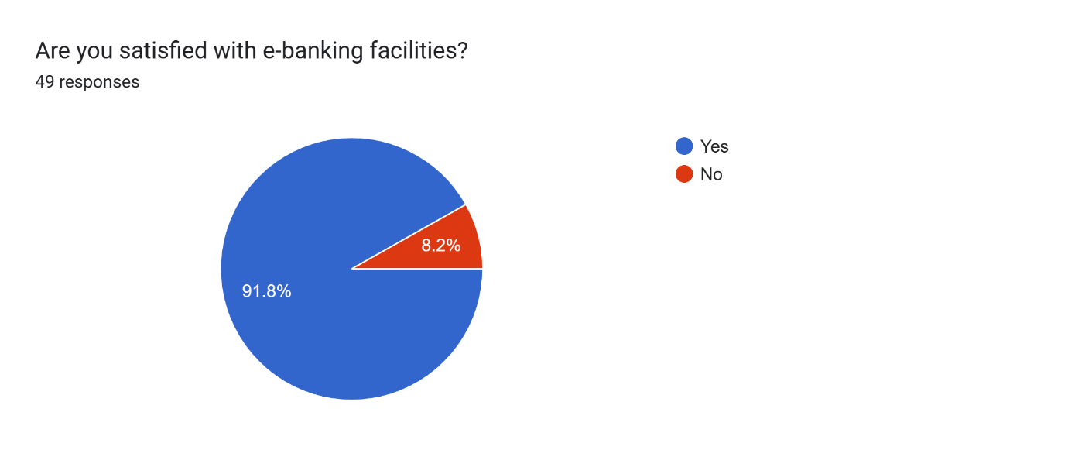

# REFERENCES

[1] Bhattacharya, S., & Ray, S. (2016). Impact of digital transformation on banking business models in India. Journal of Business Strategies, 33(2), 127-146.

[2] Kapoor, A., & Kapoor, S. (2018). Digital transformation of banks in India: An exploratory study. International Journal of Engineering and Technology (UAE), 7(3.25), 243-249.

[3] Gupta, R., & Bhatia, V. (2019). A Study on the Impact of Digital Transformation on Customer Behaviour and Expectations in Banking Sector: With Special Reference to Indian Customers. Journal of Marketing and Logistics, 2(1), 1-11.

[4] Jain, S., & Singh, S. K. (2017). Digital transformation in the banking sector in India: Issues and challenges. International Journal of Scientific Research and Management, 5(10), 6592-6602.

[5] Singh, A., & Singhal, A. (2019). Customer experience in digital banking: A study of Indian customers. Journal of Retailing and Consumer Services, 50, 37-44.

[6] Saha, S., & Gupta, P. (2017). Impact of digital transformation on financial inclusion in India. Journal of Financial Economic Policy, 9(4), 371-386

[7] Mahajan, R., & Singh, P. (2018). Digital transformation: Challenges and opportunities for small and medium-sized banks in India. Journal of Financial Services Marketing, 23(4), 214-222

[8] Mukherjee, D., & Dutta, A. (2018). Driving digital transformation in Indian banking with data analytics. Journal of Financial Services Marketing, 23(1), 37-48.

[9] Prasad, B., & Sarangi, S. K. (2019). Impact of Digital Transformation on Banking Employees: Evidence from India. Vision, 23(3), 308-319

[10] Singhal, A., & Agarwal, P. (2019). Impact of Digital Transformation on Risk Management in Banking Sector of India. International Journal of Computer Science and Information Security, 17(5), 61-67.

[11] Kumar, A., & Kumar, S. (2017). The role of digital technologies in improving financial literacy in India. Journal of Financial Services Marketing, 22(3), 139-149.

[12] Kumar, S., & Kumar, A. (2019). Blockchain technology in Indian banking sector: Opportunities and challenges. International Journal of Scientific Research and Management, 7(7), 187-191.

[13] Banerjee, A., Dutta, A., & Roy, S. (2018). Impact of Digital Transformation on Cashless Payment Adoption in India. International Journal of Advanced Research in Computer Science, 9(2), 41-46.

[14] Patil, S. (2018). Digital transformation in rural banking: A study of opportunities and challenges in India. Journal of Rural Studies, 63, 14-23.

[15] Sonono, Binan and Robert Ortstad. “The Effects of the Digital Transformation Process on Banks’ Relationship with Customers: Case Study of a Large Swedish Bank.” (2017).

[16] J. Dermine, “Digital Banking and Market Disruption: A Sense of Dejà Vu?” in Financial Stability Review, pp. 17–24, Banque de France, 2016.

[17] C. Skinner, Digital Bank: Strategies to Launch or Become a Digital Bank, Marshall Cavendish International (Asia) Pte, Singapore, 2014.

[18] Olanrewaju, Tunde. "The rise of the digital bank." McKinsey & Company, July 1, 2014. <https://www.mckinsey.com/capabilities/mckinsey-digital/our-insights/the-rise-of-the-digitalbank>.

[19] J. Claessens, V. Dem, D. De Cock, B. Preneel, and J. Vandewalle, “On the security of today s online electronic banking systems,” Computers & Security, vol. 21, no. 3, pp. 253–265, 2002.

[20] J. Austin and J. Bloggs, “Big Data Outsourcing and Identity Verification in Fintech Credit Assessment: A Case Study of a Microloans Platform in China,” in Australasian Conference on Information Systems, Sydney, Australia, 2018.

[21] C. Martins, T. Oliveira, and A. Popovič, “Understanding the Internet banking adoption: a unified theory of acceptance and use of technology and perceived risk application,” International Journal of Information Management, vol. 34, no. 1, pp. 1–13, 2014.

[22] Tiago Oliveira, Miguel Faria, Manoj Abraham Thomas, Aleš Popovič, Extending the understanding of mobile banking adoption: When UTAUT meets TTF and ITM, International Journal of Information Management, Volume 34, Issue 5, 2014, Pages 689-703

**Thank You**