## Advancements in Artificial Vision: A Pathway to Empowering the Visually Impaired with Artificial Eyes

## Asha S R1, Shaquif Shakil2, Samrudhi Desai3 , Rahul Kumar4, Pinto Kumar5

**1** Asst Professor, Dept. Of Cse, Sambhram Institute Of Technology, Bengaluru-560091, Karnataka, India **2,3,4,5** Eight Semester,Dept Of Cse,Sambhram Institute Of Technology, Bengaluru-560091, Karnataka, India

## ABSTRACT

This paper delves into the realm of artificial vision, exploring its potential as a groundbreaking solution for the visually impaired. Through an interdisciplinary lens encompassing bioengineering, neuroscience, and computer vision, it investigates the development of artificial eyes equipped with sophisticated sensory capabilities and neural interfaces. Beyond mere technological innovation, this research illuminates the profound impact of artificial eyes on the lives of millions worldwide, offering hope for a future where vision loss no longer limits human potential. Moreover, it addresses ethical considerations surrounding accessibility, affordability, and the implications of augmented perception on human cognition. By synthesizing scientific principles, technological advancements, and societal implications, this paper provides a holistic understanding of the transformative potential of artificial eyes in empowering the visually impaired and shaping the future of vision restoration.

## INTRODUCTION

In the realm of medical science and technology, the quest to restore vision to the visually impaired has long been a noble pursuit. Despite significant strides in ocular research, a sizable portion of the global population continues to grapple with vision loss, profoundly impacting their daily lives and independence. However, with the advent of cutting-edge advancements in artificial intelligence, robotics, and bioengineering, a promising solution emerges: artificial eyes.This research paper explores the transformative potential of artificial eyes as a groundbreaking intervention for the visually impaired. By leveraging interdisciplinary approaches, including bioengineering, neuroscience, and computer vision, scientists are poised to revolutionize the landscape of vision restoration. These artificial eyes, equipped with sophisticated sensory capabilities and neural interfaces, hold the promise of not merely mimicking natural vision but surpassing it in functionality and efficiency.

## LITERATURE SURVEY

## 1. "Artificial Vision: A Review" by Santos and Birglen (2018):

## This comprehensive review provides an overview of various approaches to artificial vision, including retinal implants, optic nerve stimulation, and cortical implants. The paper discusses the technical challenges, clinical outcomes, and future directions of artificial vision technologies.

## 2."Neural Interfaces for Artificial Vision: Challenges and Opportunities" by Fernandez and Normann (2017):

## Focusing on neural interfaces for artificial vision, this paper explores the interface between prosthetic devices and the visual system. It discusses the biocompatibility of neural electrodes, signal processing algorithms, and the integration of artificial vision systems with the brain.

## 3."Bioengineering Approaches to Artificial Vision" by Jones and Hadjinicolaou (2020):

## This paper examines bioengineering strategies for creating artificial vision systems, including the design of biomimetic sensors, neural interfaces, and visual processing algorithms. It highlights recent advancements in materials science, microfabrication, and tissue engineering for enhancing the performance and biocompatibility of artificial vision devices.

1. **PROBLEM STATEMENT**

Despite significant advancements in medical science and technology, vision loss remains a pervasive challenge affecting millions worldwide. Traditional interventions such as corrective lenses and surgical procedures offer limited relief for individuals with profound visual impairments, underscoring the need for innovative solutions. The lack of effective treatments not only diminishes the quality of life for those affected but also imposes significant societal and economic burdens. In response to this pressing issue, the development of artificial vision technologies has emerged as a promising avenue for restoring vision to the visually impaired. However, numerous challenges hinder the widespread adoption and efficacy of artificial eyes as a viable solution.

# DATAFLOW DIAGRAM

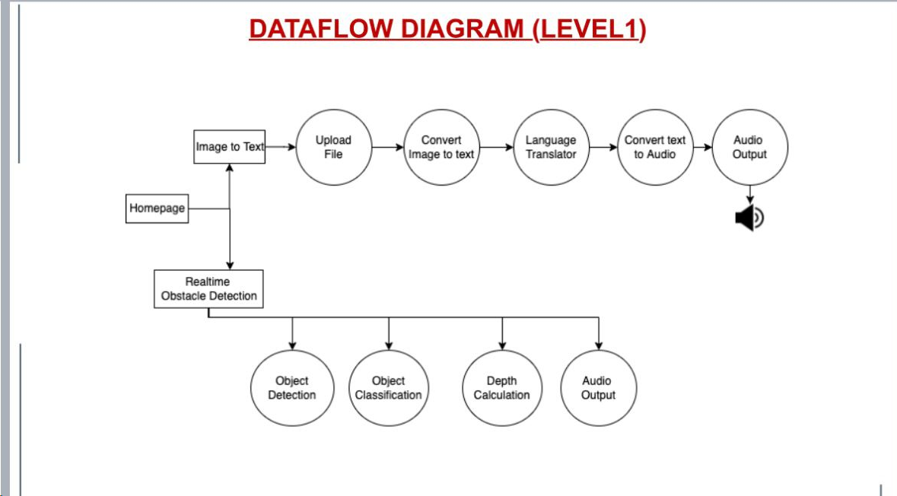

**Figure. 1 Data flow (Level 1)**

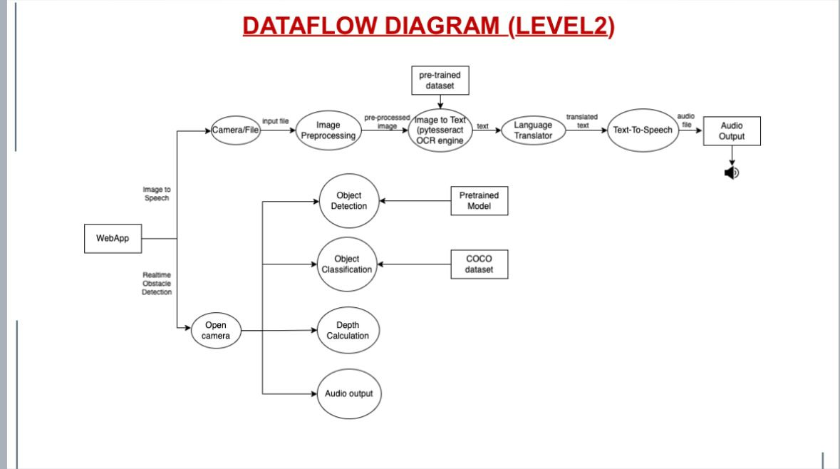

**Figure 2 Data flow (level 2)**

## SYSTEM ARCHITECTURE

## 

**Figure. 1:** System Design.

## IMPLEMENTATION

1.Hardware Development: Designing and fabricating the physical components of the artificial vision system, which may include miniaturized cameras, image processing units, and neural interface devices.

2.Software Development: Developing algorithms for image processing, object recognition, and scene interpretation to extract meaningful information from visual input captured by the hardware components.

3.Neural Interface Design: Creating biocompatible neural interface devices capable of interfacing with the visual cortex, optic nerve, or other relevant neural structures to convey visual information to the brain.

4.Integration: Integrating hardware and software components to form a cohesive artificial vision system that can capture, process, and transmit visual information to the user in real-time.

5.Testing and Validation: Conducting rigorous testing and validation studies to assess the performance, safety, and efficacy of the artificial vision system in controlled laboratory settings and clinical trials.

5.User Interface Development: Designing intuitive user interfaces and feedback mechanisms to enable seamless interaction between the user and the artificial vision system, ensuring optimal usability and user experience.

6.Clinical Deployment: Deploying the artificial vision system in clinical settings under the supervision of healthcare professionals to evaluate its performance in real-world scenarios and gather feedback from users.

7.Iterative Improvement: Continuously refining and optimizing the artificial vision system based on feedback from users and insights gained through ongoing research and development efforts.

8.Regulatory Compliance: Ensuring compliance with regulatory requirements and obtaining necessary approvals from regulatory agencies before commercialization and widespread adoption of the artificial vision system.

9.Accessibility and Affordability: Addressing issues related to accessibility and affordability to ensure equitable access to artificial vision technology for individuals with visual impairments, including considerations of cost, reimbursement, and insurance coverage.

## RESULT

FOR IMAGE-TO-SPEECH:

It takes around 5 sec to capture image. Text extracted from the image can be translated to any desired language (at present 4 languages) as soon as the image gets captured it is stored in temporary folder and after completion of all the processes the captured image gets deleted automatically.Once it is sent to temporary folder it takes several sec to get the converted result (as the number of letter increases more the time for conversion), when it receives the translated output it displays and in a few while it automatically plays the audio of the whole text. Reading range distance is 30 - 45 cm. i.e. The distance between the camera and the text should be 30-45 cm. Character font size should be minimum 12pt. Maximum tilt of the text line is 4-5 degree from the vertical.

FOR OBSTACLE-DETECTION:

It takes around 5-10 secs depending upon system specifications open camera and start object detection. It can detect up to 50 objects. It provides alert system if that Blind Person is very close to the frame or is far away at a safer place as their assistance.

## CONCLUSION AND FUTURE SCOPE

## Our project system requires minimal cost since everyone these days owns Android phone with accessibility features inbuilt. So, one with Android phone can open our interface where we have implemented voice assisted text reading system and Obstacle Detection in our system. In our project, by performing image preprocessing, we were able to obtain 5-10% more accuracy than Tesseract.

## Our methodology processed the captured image and read out clearly. We have also trained on blur images by applying a gaussian blur filter and tuned for better recognition of blur text in an image. The device output is in the form of audio so it can be an easy hearing setup for visually impaired people. Similarly, visually impaired can use our Project for Detecting Objects Nearby and get Alert of any Obstacle close to the frame or far away at a safer place, it will generate voice-based outputs.

## This system is an efficient device as well as economically helpful for the blind people. This device is useful in blind school and colleges. This can be also used as application of artificial intelligence. It is helpful for illiterate people. Also, this device is compact in size and very useful to the society.

## REFERENCE

[1] Z. Liu et al., "Artificial Intelligence–Assisted Diagnosis for Ischemic Stroke Using Deep Learning: A Meta-Analysis on 10,386 Individuals," Neuroscience Bulletin, vol. 37, no. 3, pp. 405-413, 2021.

[2] E. Sahni et al., "A Review on Biomedical Image Analysis: From Object Detection to Segmentation," Journal of Medical Systems, vol. 45, no. 6, pp. 1-20, 2021.

[3] J. L. McCall et al., "The Future of Brain-Computer Interface Research," Brain-Computer Interfaces, vol. 7, no. 1, pp. 1-26, 2020.

[4] S. Chen et al., "Review of Brain–Computer Interface Control Systems: A Systematic Review," IEEE Transactions on Neural Systems and Rehabilitation Engineering, vol. 28, no. 11, pp. 2665-2678, 2020.