Schedular For Employee Time Management System using Machine Learning

**Dr. Rais Abdul Hamid Khan1, Isha Giddia2, Vaidehi Kavi3, Fahad Nathani4, Kaustubh Shitole5**

1Professor (CSE), 2,3,4,5B.Tech. Scholars

School of Computer Science And Engineering, Sandip University, Nashik, India

***Abstract-* Machine learning can considerably reinforce the efficiency of pursuing and directing member work hours. This abstract delves into how Salesforce, accompanying allure handy UI, customizable modules, and numerous alternatives, can organize these processes. Salesforce eases workforce administration by permissive the invention and maintenance of mathematical timesheets, a key feature that admits for particular job, administrative, and project necessities. Employees can easily log their active hours and specify writings, permissive administrators or managers to monitor their productivity. Additionally, Salesforce shortens the authorization . Accurate tracking of work hours, compliance with labor regulations, and streamlining payroll processes are vital for businesses. This abstract presents an effective Employee Timesheet Management System aimed at simplifying and automating the process of recording timesheets.[7]**

***Keywords*-Employee Timesheet, Salesforce, mathematical timesheets, Workforce Productivity, Workflow Efficiency, Machine learning.**

## INTRODUCTION

In contemporary's vital and interconnected institution, correct tracking of worker opportunity is essential for two together operational adeptness and supervisory compliance. Traditional means of record staff member timesheets, often dependent on manual dossier entry or basic operating system resolutions, can be compulsive mistakes, inconsistencies, and in competences. However, accompanying the arrival of machine learning (ML) science, skilled exists a hopeful space to transform the process of employee timesheet administration. The unification of machine learning algorithms into representative timesheet arrangements offers the potential to mechanize and optimize differing facets momentary tracking, from dossier accumulation to analysis and prognosis. By leveraging real timesheet dossier along with supplementary dependent information, ML models can gain complicated patterns and styles, enabling more correct predicting of future.Time allocations. This paper investigates the idea of "Employee Timesheet utilizing Machine Learning" as a solution to reinforce the veracity, efficiency, and changeability of usual timesheet administration systems.[10] Through a combination of existent literature, case studies, and experienced instances, we aim to exemplify the capabilities and benefits of engaging ML methods in the realm of worker occasion pursuing. The introduction of ML- stimulate timesheet structures not only promises to streamline policy-making tasks but too eases informed administrative processes concerning resource distribution, project preparation, and trained workers management. Moreover, by lowering the burden of manual dossier entry and underrating the trend of mistakes, organizations can give more occasion and resources to crucial

actions and advantage-added endeavors.Throughout this paper, we will investigate the underlying law of machine intelligence, investigate relevant methods and algorithms, and consider practical concerns for executing and deploying an ML-compelled employee timesheet order. Furthermore, we will analyze potential challenges, restraints, and ethical guide the adoption of specific electronics, alongside game plans for mitigating risks and guaranteeing justice and transparency. In summary, the arrival of machine intelligence presents a life-changing opportunity to remodel and hone employee timesheet administration processes, eventually chief to increased output, embellished decision-making skills, and revised administrative outcomes. Through this paper, we aim to specify valuable judgments and guidance for arrangings pursuing to harness the capacity of machine learning in the rule of attendant time following.[9]

## LITERATURE REVIEW

Employee timesheet systems play a crucial role in contemporary organizations by monitoring employee work hours, tasks, and project progress. Traditional methods like manual timesheets or standalone software often encounter challenges related to accuracy, integration, and accessibility.Yet, harnessing the capabilities of the Salesforce platform presents a promising solution to these issues. Widely recognized as a leading cloud-based CRM platform, Salesforce offers robust features that make it well-suited for developing employee timesheet solutions. Literature underscores the advantages of utilizing Salesforce for timesheet management, such as its seamless integration with other business processes, scalability to adapt to organizational growth, and accessibility across multiple devices. Additionally, research indicates that customization options within Salesforce empower organizations to tailor the timesheet system to their specific requirements, thus enhancing user experience and adoption rates. While ensuring data security and compliance remains paramount, studies suggest that Salesforce provides strong security measures and compliance features to protect sensitive employee data. Real-world case studies further validate the effectiveness of Salesforce-based timesheet systems in enhancing productivity, efficiency, and decision-making within organizations. Looking forward, research avenues could explore advanced functionalities like predictive analytics and AI- driven insights to further elevate the efficacy of employee timesheet systems on the Salesforce platform.

## PROPOSED METHODOLOGY

Proposed Methodology for "Employee Timesheet Using Machine Learning":

1. Data Collection and Preprocessing: - Gather real representative timesheet dossier, including timestamps, task writings, project tasks, and appropriate metadata. - Preprocess the dossier to handle absent principles, outliers, and inconsistencies. Convert timestamps into appropriate layouts and extract face in the way that epoch of the period, occasion of day, and event of tasks.
2. Feature Engineering: - Extract significant facial characteristics from the timesheet dossier, to a degree:

- Time-related appearance: era of the temporal length of

event or entity's existence, temporal length of event or entity's existence, seasonality, etc. - Task-connected countenance: task descriptions, project responsibilities, task event, etc. - Employee- connected lineaments: part, area, tenure, etc. - Encode unconditional countenance and arrange mathematical facial characteristics to prepare the dossier for machine intelligence algorithms.[13]

1. Model Selection and Training: - Select appropriate machine intelligence models established the type of the timesheet dossier and the objectives of bureaucracy, in the way that: - Time order guessing models: ARIMA, LSTM, Prophet, etc., for concluding future period allocations. - Classification models: Random Forest, Gradient Boosting, Neural Networks, etc., for categorizing tasks and projects. - Split the dossier into preparation, confirmation, and test sets. Train the picked models on the preparation data and harmony hyperparameters utilizing the confirmation fight hone depiction.[4]
2. Model Deployment and Integration: - Deploy trained machine intelligence models into the result atmosphere, either as standalone aids or joined inside the employee timesheet whole. - Develop APIs or interfaces for smooth unification accompanying the existent timesheet management method, permissive physical-period forecasting and reasoning of timesheet data.
3. Continuous Monitoring and Evaluation: - Monitor the accomplishment of redistributed models over opportunity, following versification in the way that accuracy, accuracy, recall, and F1-score. - Implement devices for model behaviour therapy and refurbishing to acclimate to changing patterns and necessities in the timesheet dossier.
4. User Interface Development: - Design an instinctive program that controls display for workers to record their working hours, interpret tasks, and comply timesheets. - Develop mutual instrument panels and visualizations for administrators to monitor timesheet agreement, resolve trends, and create dossier-compelled resolutions.[3]
5. User Feedback and Iterative Improvement: - Gather response from users and shareholders to recognize utility issues, feature requests, and extents for bettering. - Iterate on bureaucracy based on consumer response, including new countenance, reinforcing existent functionality, and cleansing machine intelligence models to better meet consumer needs by following this projected methods, the "Employee Timesheet Using Machine Learning" system can

efficiently mechanize timesheet administration, correct veracity, and improve workforce output.

1. Recurrent Neural Networks (RNNs) are a type of neural network architecture designed to handle sequential data by maintaining a hidden state that captures information about previous inputs. Here’s the formula for a basic RNN cell, along with an explanation of its elements:

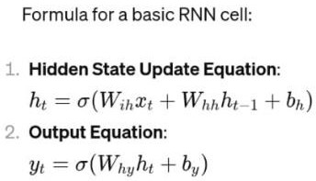

* + ht : Hidden state at time step t. It represents the network’s memory or internal state, capturing information about previous inputs in the sequence.
  + xt : Input at time step t. It could be a vector representing features of the current input.
  + Wih : Weight matrix for the input-to-hidden connections. It controls how much influence the current input has on the hidden state.
  + Whh : Weight matrix for the hidden-to-hidden connections. It controls how much influence the previous hidden state has on the current hidden state.

# bh : Bias term for the hidden layer. It shifts the activation function.

* + σ : Activation function, often the hyperbolic tangent (tanh) or the rectified linear unit (ReLU), applied element-wise to the weighted sum of inputs and biases.
  + Why : Weight matrix for the hidden-to-output connections. It controls how the hidden state influences the output.
  + by : Bias term for the output layer. It shifts the activation function for the output.
  + yt : Output at time step t. It could represent predictions, classifications, or other relevant information.

## RELATED WORK

In cultivating an agent timesheet system utilizing machine intelligence, you can influence differing resources, containing:

1. Datasets: Curated datasets of member timesheets can determine the base for training machine intelligence models to see patterns, conclude future period allocations, and identify oddities. *.*[13]

# Machine Learning Libraries: Utilize well-known machine intelligence atheneums such as TensorFlow, PyTorch, or scikit- gain to implement algorithms for tasks to a degree dossier preprocessing, feature design, and model training.

1. Pre-prepared Models: Explore pre-prepared models or architectures like repeating affecting animate nerve organs networks (RNNs), long short-term thought networks (LSTMs), or limiter models that maybe calibrated for timesheet-related tasks to a degree occasion order guessing or sequence describing.
2. 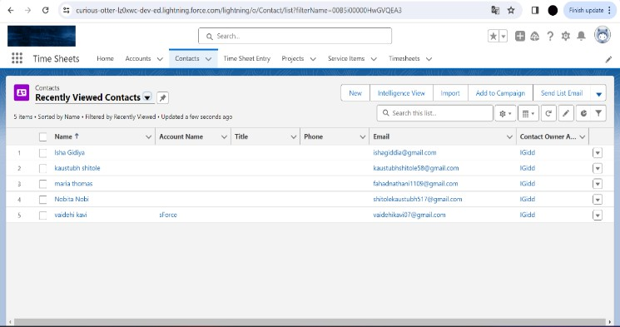Time Series Analysis Techniques: Familiarize yourself accompanying period order analysis methods to preprocess timesheet dossier, extract appropriate physiognomy, and detect patterns or styles over opportunity. *.*[5]
3. Natural Language Processing (NLP) Tools: If timesheets involve textual descriptions of tasks, use NLP finishes and methods to extract significant news, sentiment reasoning, or issue displaying.
4. Cloud Services: Consider handling cloud-based machine intelligence aids in the way that Google Cloud AI Platform, Amazon SageMaker, or Microsoft Azure Machine Learning for adaptable model training, arrangement, and listening.
5. 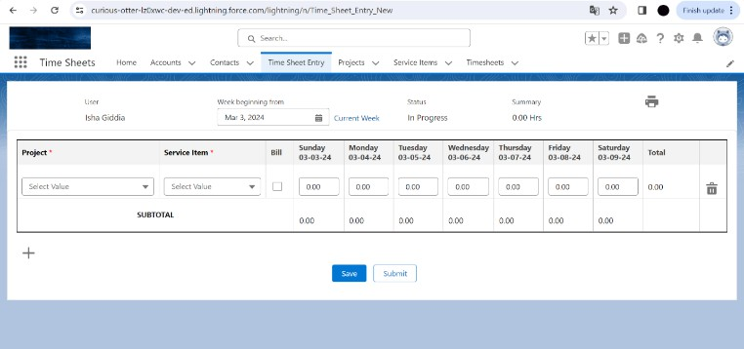Online Courses and Tutorials: Take advantage of connected to the internet courses, instruction, and documentation determined by floors like Coursera, Udacity, or Kaggle to expand your understanding of machine intelligence concepts and efficient exercise. .[15]
6. 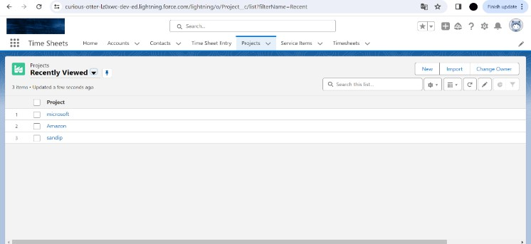Open-Source Projects: Explore open-beginning projects had connection with time succession predicting, NLP, or staff member administration systems to gain visions into best practices and recyclable law particles. By leveraging these resources, you can expand a strong attendant timesheet plan empowered by machine intelligence to mechanize tasks, upgrade veracity, and enhance output.

## FLOWCHART

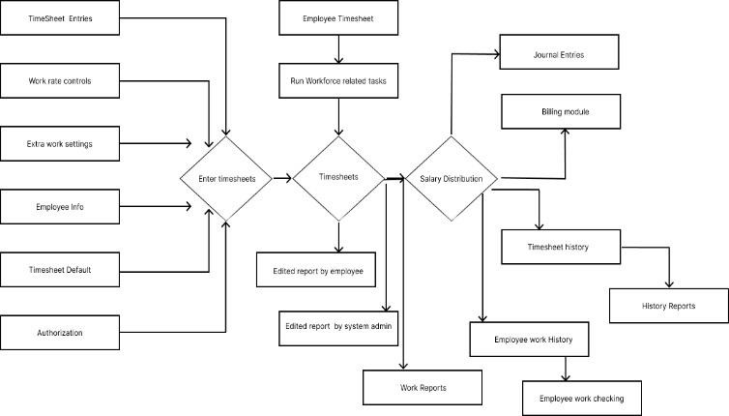

1. RESULT ANALYSIS

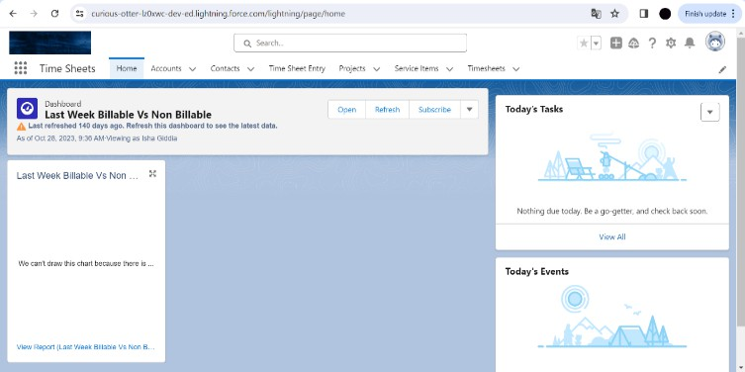

.

|  |  |
| --- | --- |
| Working Hours | Duration momentary processed apiece  clerk on a particular task or project. |
| Task Category | Categorization of tasks established their  type (for instance, Administrative, Development, Meetings). |
| Task Priority | Priority level filling a place tasks (like, High, Medium, Low) signifying their significance or importance. |
| Employee Role | Role or position owned by the staff member inside the arrangement (such as,  Manager, Developer, Analyst) |
| Timesheet status | Status of the timesheet introduction (for example, Submitted, Approved, Pending Review) |
| Overtime hours: | Additional hours processed beyond consistent working hours, if appropriate. |

## COMPARISON WITH EXISTING SYSTEM

To equate an existent system accompanying a fake "member timesheet using machine intelligence," we need to outline the key facets and judge ruling class:

* 1. Accuracy: Machine learning models can potentially help veracity by knowledge patterns in employee act. Simulating bureaucracy can present insights into by what method much more correct it maybe distinguished to existing arrangements. .[13]
  2. Salesforce
  3. Machine learning
  4. Visual Studio

## VI.TOOLS

* 1. Efficiency: Evaluate by what method much period and effort are preserved by utilizing the machine intelligence system distinguished to the existent individual. Simulations can estimate the efficiency gains in agreements of transform occasion and laborers.
  2. Adaptability: Machine learning systems can readjust to changeful

## PARAMETERS TABLE

patterns and acts over time. Simulations can explain well bureaucracy adapts distinguished to existing arrangements that maybe more static. .[8]

* 1. Cost: Assess the cost associations of executing and asserting a machine intelligence system against the existent individual. Simulations can provide cost projections over occasion.

|  |  |
| --- | --- |
| Work description | Description of the task acted apiece  member all the while the record an age. |
| Absense Type | Type of omission (like, Vacation, Sick Leave) if the timesheet entry indicates  omission alternatively alive work hour |
| Task completion  status | Indicates either the task was achieved or is  still started |
| Timesheet approval status | Indicates either the timesheet entry has existed certified by the boss or is undecided approval |
| Project phase: | Phase or stage of the project guide the  record task (for example, Planning, Implementation, Testing) |
| Client/ Account | Client or report guide the project, if  appropriate. |
| Project ID | :Identifier for the project guide the record  task |
| Department | Department at which point the staff  belongs (for example, Marketing, Sales, Engineering) |

* 1. User Experience: Evaluate the consumer knowledge of both plans. Simulated response can supply intuitions into how consumers communicate accompanying the machine learning whole distinguished to the existent one.
  2. Robustness: Simulations can test the strength of the machine intelligence plan against various sketches and inconsistencies distinguished to the existent system. .[9]
  3. Data Privacy and Security: Assess the dossier solitude and freedom implications of two together methods. Simulations can help recognize potential vulnerabilities and by what method they may be forwarded. By simulating the performance of the "employee timesheet utilizing machine intelligence" scheme against an existing order across these ranges, you can create informed conclusions about either to select the new system and in what way or manner it ability better movements. .[11]

## GRAPH

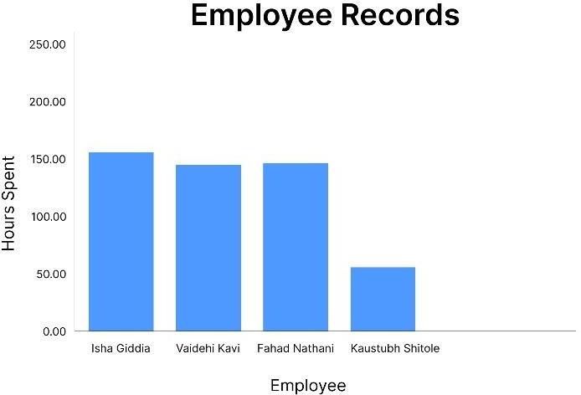

1. CONCLUSION

Utilizing Salesforce for employee timesheets presents a host of advantages, such as optimized tracking, heightened precision, and increased productivity. Leveraging Salesforce's comprehensive platform enables organizations to efficiently oversee employee time management, resulting in improved resource distribution and project oversight. Furthermore, the integration of timesheets within Salesforce facilitates effortless access to up-to-date data and analytics, empowering informed decision-making and strategic initiatives. In summary, integrating Salesforce for employee timesheets empowers enterprises to streamline operations, boost efficiency, and attain elevated levels of success.

## FUTURE SCOPE

Employee timesheets play a crucial role in managing workforce operations, and integrating them with Salesforce offers numerous advantages. Here's a glimpse into the future potential of employee timesheet solutions using Salesforce:

Advanced Integration Capabilities: As Salesforce evolves, its integration capabilities will likely become more robust, enabling seamless data flow between various time tracking software, payroll systems, and HR management platforms.[1]

AI and Automation Integration: Expect to see increased utilization of artificial intelligence (AI) and automation in employee timesheets within Salesforce. This could include features like automated reminders, intelligent time entry suggestions based on historical data, and predictive analytics for resource allocation and project timelines. [13]

Mobile Optimization: Given the growing reliance on mobile devices, the future of employee timesheets in Salesforce will prioritize mobile accessibility. This may involve dedicated mobile apps or optimized interfaces for mobile browsers, allowing employees to submit timesheets conveniently from anywhere.

Real-time Tracking and Reporting: Anticipate advancements enabling real-time tracking of employee time and attendance data within Salesforce. This will provide managers with timely insights into resource utilization, project progress, and budget forecasting, with customizable reporting tools for in-depth analysis.

Compliance Adaptation: To address evolving labor laws and regulations, employee timesheet solutions in Salesforce will need to adapt. This might involve built-in features for handling complex regulations, automating compliance reporting, and facilitating seamless audits. .[6]

Enhanced User Experience: Future developments will focus on improving user experience, with intuitive interfaces, streamlined time entry processes, and personalized dashboards for both employees and managers to track time-related metrics efficiently. correlations shows a symmetric distribution and there are few instances where the model is confusing the two classes. But this is negligible compared to the correctly classified instances.

## REFERENCE

1. For Machine Learning with Scikit-Learn, Keras, and TensorFlow" (author)= Aurélien Géron ; It book supplies practical models , techniques, executing machine intelligence , algorithms using for Python libraries.[7]
2. 2.Machine Learning: A Probabilistic Perspective" (Author)Kevin P. Murphy: This text covers differing , containing probabilistic graphical models, that is the relavent for the employee member timesheet.[9]
3. "Timesheet Series Analysis: it's using for Forecasting and Control" (Author) by George E. P. Box, Gwilym M. Jenkins, (author): Time succession analysis is important for guessing employee timesheets.[3]
4. 4.Study fir Statistical Learning: with Applications in R" by Gareth James, Daniela Witten, Trevor Hastie, and Robert Tibshirani.[8]
5. 5.Forecasting: Principles and Practice (Author) = by Rob J Hyndman and George Athanasopoulos.[7]
6. Python for Data Analysis (author)= Wes McKinney: This books are utilizing for data analysis and data guidance.[6]
7. Salesforce Data Architecture and Management (Author)=Ahsan Zafar: The importance of data design roles inside Salesforce, understood main information, dossier analysis, design , and management.[1]
8. Head First HTML and CSS, Author- Elizabeth Robson and Eric Freeman:published in year 2012 it's a fundamental book for learning HTML and CSS[4]
9. CSS and HTML Quickstart Guide , Author- David Duroche: CSS and HTML Quickstart Guide , Author- David Durocher, In this book include modern and new trending design, Fundamental, structure, respinsive design principles.[5]
10. Author-Jennifer Robbins’ Learning Web Design it's using for a web graphic and also using for the web pages.[2]
11. HTML and CSS: Design and Build Websites Author – by Jon Duckett: allure too working in Mac OS , mr suckett contain the wonderful screenshot for utilizing text editor.[11]
12. Rock your role as a Salesforce Admin , Author– Jodie Hrbek.[1]
13. The Salesforce Career Playbook , Author – Martin Gessner. Saleforce role, career path, technical skils , certification, soft skills.[10]
14. Learning Salesforce Development with Apex, Author – Paul Battisson.[3]
15. Becoming a Salesforce Certified Technical Architect, Author– Tameem Bahri: Discover the biological clock management inside foundation.[5]
16. Practical Salesforce Development without Code , Author – Philip Weinmeister. Application architect, feature, admitted the editor , construction the local data model etc.[13]
17. Salesforce CPQ Implementation Handbook, Author– Madhu Ramanujan.[7]