Smart Parking Management System: Enhancing Parking Experience in the Digital Age Using AI

Mr. Adarsh Singh, Mr. Aakash Srivastava,

BCA Department, BCA Department,

SRMCM, SRMCM,

Lucknow, UP, India. Lucknow,UP,India.

[adarshsingh200405@gmail.com](mailto:Harshcastudies@gmail.com) aakash.ca@srmcem.ac.in

Abstract:

As cities grow denser, managing vehicular parking becomes a complex challenge that exacerbates urban congestion. A cutting-edge smart parking application, designed for Android devices, offers a strategic solution to this urban dilemma. This system not only streamlines parking management but also significantly reduces traffic build-up associated with the search for parking spaces.The app functions as a digital concierge for parking, allowing users to locate, reserve, and manage parking spaces with a few taps on their smartphones. Its interface displays a color-coded map of parking facilities: available slots are highlighted in green and occupied ones in red. This visual guide makes it effortless for drivers to find parking without circling blocks, thus cutting down on traffic congestion.This smart parking app not only simplifies the process of parking in urban centers but also serves as a pivotal tool in transforming cities into smarter, more livable environments. With ongoing enhancements and user-focused features, it is set to redefine urban mobility.

**Introduction:**

Metropolitan cities are drowning in cars, leading to a constant battle for parking spaces. Drivers waste precious time circling blocks, adding to traffic congestion. This paper proposes a solution: a Smart Parking System (SPS) that utilizes a mobile application to revolutionize the parking experience.

Imagine a user opening the SPS app to see real-time availability of nearby parking spots. No more aimless searching! With a tap, they can reserve a specific space and receive convenient navigation guidance straight to it. The app seamlessly handles payment, eliminating the need for cash or meter juggling. In the background, an administrator database keeps track of everything, ensuring smooth operation and informed decision-making.

This system offers a multitude of benefits. Drivers ditch the frustrating search, leading to reduced traffic congestion and a calmer commute. Real-time data ensures optimal use of available parking, maximizing efficiency. The app streamlines the entire process, providing a convenient booking, navigation, and payment experience for users.

This paper lays the groundwork for a smarter parking future. Further exploration can delve into technical details like the specific sensors used to detect parking space availability, the communication protocols between the app and parking infrastructure, and robust security measures to protect user data and transactions. By addressing these aspects, we can create a comprehensive and user-friendly Smart Parking System that benefits drivers, cities, and the environment.

**RELATED WORK:**

Researchers have been actively exploring smart parking systems to tackle the growing challenges in urban areas. One approach involves automated parking, where sensors and mobile apps manage car entry and exit from lots, ensuring a set number of available spaces

1. Another concept focuses on a central smart parking infrastructure. This system gathers real-time parking information and allocates spots to drivers based on their location and requests
2. Image processing is another avenue, where cameras identify available spaces and potentially even guide cars into them
3. Additionally, research has explored automatic parking management using license plate recognition for contactless fee collection and access control, minimizing human interaction
4. Finally, there are studies on intelligent parking space detection that utilize image processing to visually identify available spots
5. These various projects provide a strong foundation for developing a comprehensive smart parking system that merges real-time data, user interaction, and automated management to create a more efficient and convenient parking experience.

# PROPOSED METHODOLOGY

The proposed car parking system revolves around three crucial modules working in tandem to streamline the parking experience. The first module, the User Module, prioritizes user interaction. Here, users can register with their details and create an account. Upon logging in, they'll be greeted by a user-friendly interface that allows them to browse for available parking spaces. With a few clicks, they can select their preferred slot and proceed to the Booking Module.

The Booking Module acts as the central reservation hub. Once a user chooses a parking space in the User Module, this module takes center stage. It displays real-time information on available slots, including their location and associated costs. Users can then seamlessly book their desired space through the app. The Booking Module integrates with the payment gateway, allowing users to make secure online payments directly within the application. This eliminates the need for fumbling with cash or searching for parking meters.

Finally, the Administrator Module serves as the system's backbone, ensuring smooth operation and data integrity. This module empowers administrators to register new users and manage the ever-changing parking landscape. They can update details of all parking slots, including their availability and pricing. Additionally, the Administrator Module houses user information and facilitates modifications to user data if necessary. Importantly, only authorized administrators can access and modify this critical data, ensuring system security.

In essence, these three modules work together to create a user-friendly and efficient parking experience. The User Module empowers drivers to search and book parking spaces conveniently. The Booking Module acts as the central reservation platform, streamlining the booking process. Finally, the Administrator Module ensures the system runs smoothly and maintains data integrity. By combining these functionalities, the car parking system offers a win-win situation for both users and parking lot operators. Users benefit from a stress-free parking experience, while operators gain improved efficiency and potentially increased revenue through optimized parking space utilization.

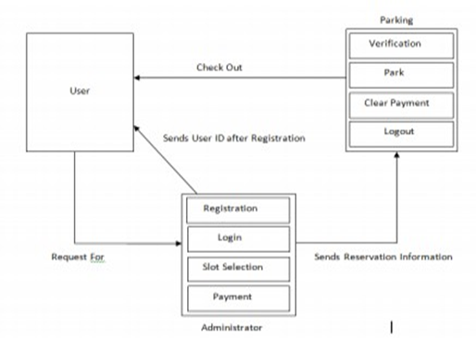

# PROPOSED FLOW

The user-centric slot allocation process goes beyond just reserving a space. It's about transforming the entire parking experience. Imagine the frustration of endlessly circling the block, searching for an elusive open spot. This system eliminates that anxiety entirely. Drivers can leverage a mobile application to search for parking in real-time, prioritizing options closest to their destination. With a few taps, they can not only find a suitable slot but also reserve it instantly. This not only saves them precious time but also eliminates the stress of last-minute parking scrambles.

Convenience is another key benefit. Gone are the days of scrambling for loose change or fumbling with credit cards at parking meters. This app integrates secure online payments, allowing users to seamlessly pay for parking directly within the app itself. Transparency is also paramount. Real-time availability and clear pricing information displayed on the app empower users to make informed decisions about parking options. They can see exactly which spots are open and the associated costs before making a reservation. This eliminates any surprises when it's time to pay. Ultimately, the system streamlines the parking process, allowing users to get to their destinations faster and contributing to a reduction in overall traffic congestion in the city.

The benefits extend beyond user convenience. Parking lot operators can also reap significant advantages. The system provides real-time data on parking occupancy, allowing them to optimize space allocation and potentially increase revenue by ensuring a higher utilization rate for available parking spots. Additionally, the automated nature of the system minimizes the need for manual staff intervention, potentially reducing overall operational costs. Furthermore, the ability to remotely monitor parking activity and track vehicle entries and exits can contribute to a safer parking environment for everyone.

Looking ahead, the potential for further enhancements is exciting. Imagine seamless integration with navigation apps, guiding users directly to their reserved parking space, eliminating the need for additional searching upon arrival. The system could be further enhanced to cater to the growing electric vehicle market by integrating with charging station availability data, allowing drivers to locate not only parking but also charging options. Finally, including features like digital wallets and contactless payment options could further streamline the user experience, making the entire parking process even faster and more convenient.

By incorporating these elements, the car parking system can revolutionize the parking experience for both users and operators. It has the potential to create a more efficient, convenient, and user-friendly parking solution for urban environments, transforming the way we manage parking in the future.

**APPLICATIONS:**

The importance of smart parking is:

1. Accurately sense and predict spot/vehicle occupancy in real-time.
2. Guides residents and visitors to available parking spot.
3. Optimize Parking Space Usage.
4. Simplifies the parking experience and adds value for parking stakeholders, such as merchants and drivers.
5. Helps the free flow of traffic in the city leveraging IoTtechnology.
6. Enables intelligent decisions using data, including real– time status applications and historical analytics reports.
7. Smart Parking plays an important role in creating better urban environment by reducing the emission of CO2 and other pollutants.
8. Smart Parking enables better and real time monitoringand managing of available parking space which results in significant revenue generation.
9. Provides tools to optimize workforce management.

# BLOCK DIAGRAM

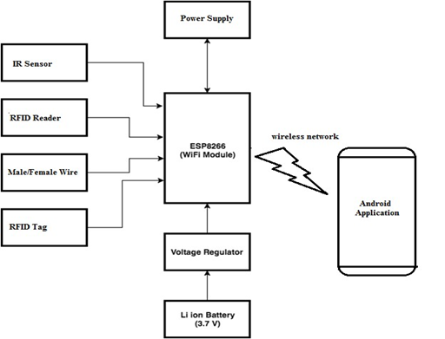

# CONCLUSION

Frustrated with endlessly circling for parking? The Smart Parking Management System (SPMS) is here to save the day! This innovative system empowers users to book parking slots with minimal effort, all through their trusty Android devices. Imagine the convenience - with a few taps on your smartphone, you can check real-time parking availability and secure a spot in advance. No more wasted time driving around in frustration, contributing to traffic congestion.

The beauty of SPMS lies in its user-centric approach. The system leverages the ubiquitous Android platform, the most widely used mobile operating system globally. This ensures broad accessibility, making the SPMS app readily available to a large portion of the population. Android is also known for its user-friendly interface, making the app intuitive and easy to navigate for everyone. Furthermore, mobile computing on a platform like Android offers a powerful tool for efficient data management. The SPMS capitalizes on this strength to maintain accurate and up-to-date parking information, ensuring a seamless user experience.

By combining user convenience with efficient data management, the SPMS offers a promising solution for urban parking woes. Its ease of use and effectiveness pave the way for widespread adoption, ultimately leading to a smoother traffic flow and a less stressful parking experience for all. So, ditch the frustration and embrace the future of parking - download the SPMS app today!

# REFERENCES

1. Faiz Ibrahim Shaikh, Pratik Nirnay Jadhav, Saideep Pradeep Bandarkar, Omkar Pradip Kulkarni, Nikhilkumar B. Shardoor “Smart Parking System Based on Embedded System and Sensor Network”, International Journal of Computer Applications (0975 – 8887) Volume 140 – No.12, April 2016 International Journal of Pure and Applied Mathematics Special Issue 171.
2. Thanh Nam Pham1, Ming-Fong Tsai1, Duc Binh Nguyen1, Chyi- Ren Dow1, And Der-Jiunn Deng2 “A Cloud-Based Smart-Parking System Based on Internet-of-Things Technologies”,IEEE Access, Received July 24, 2015, accepted August 16, 2015, date of publication September 9, 2015, date of current version September 23, 2015.
3. El Mouatezbillah Karbab, Djamel Djenouri, Sahar Boulkaboul, Antoine Bagula, CERIST Research Center, Algiers, Algeria University of the Western Cape, Cape town, South Africa,”Car Park Management with Networked Wireless Sensors and Active RFID”„,978-1-4799-8802-0/15 ©2015 IEEE
4. Mr. Basavaraju S R “Automatic Smart Parking System using Internet of Things (IOT)”, (International Journal of Scientific and Research Publications, Volume 5, Issue 12, December 2015)
5. M. M. Rashid, A. Musa, M. Ataur Rahman, and N. Farahana, A. Farhana, “Automatic Parking Management System and Parking Fee Collection Based on Number Plate Recognition.”, International Journal of Machine Learning and Computing, Vol. 2, No. 2, April 2012,Published 2014.
6. Hilal Al-Kharusi, Ibrahim Al-Bahadly, “Intelligent Parking Management System Based on Image Processing”, World Journal of Engineering and Technology, 2014, 2, 55-67.
7. X. Zhao, K. Zhao, and F. Hai, ``An algorithm of parking planning for smart parking system,'' in Proc. 11th World Congr. Intell. Control Autom. (WCICA), 2014, pp. 4965_4969.
8. L. Mainetti, L. Palano, L. Patrono, M. L. Stefanizzi, and R. Vergallo,``Integration of RFID and WSN technologies in a smart parking system,''in Proc. 22nd Int. Conf. Softw., Telecommun. Comput. Netw. (SoftCOM), 2014, pp. 104_110.
9. Harmeet Singh, Chetan Anand, Vinay Kumar, Ankit Sharma, “Automated Parking System With Bluetooth Access”, International Journal Of Engineering And Computer Science ISSN:2319-7242,Volume 3 Issue 5, May 2014, Page No. 5773- 5775
10. C. Shiyao, W. Ming, L. Chen, and R. Na, ``The research and implementof the intelligent parking reservation management system based on ZigBee technology,'' in Proc. 6th Int. Conf. Meas. Technol. Mechatronics Autom. (ICMTMA), 2014, pp. 741_744.