**Title -**

**AN ANALYSIS OF RECRUITMENT AND SELECTION PROCESS AT DABUR INDIA LIMITED**

# ABSTRACT

As in case of any other functional area like marketing, production or finance, the work personnel department has also to be planned. Planning in the personnel area is mainly concerned with crystallizing from where the right type of people can be secured for future anticipated vacancies.

Manpower planning is the process by which management determines how the organization should move from its current manpower position to its desired man power position. Through planning, management strives to have the right number and the right kinds of people, at the right places, at the right time, doing things, which result in the growth and success of both- the organization and the individual. The manpower planning is one of the basic steps in the recruitment and selection procedure.

Recruitment and Selection is the process wherein the organisation finds the best candidate among the vast array of candidates. The function that locates the sources wherefrom the required human resources can be available and to attract them towards the organisation is known as recruitment.

Selection can be defined as the process wherein the organisation has to select a small lot of people who are useful to the organisation in terms of their capabilities and their qualifications. The main aim of organisation at this stage is to have a well-equipped manpower efficient enough to handle all the tasks gracefully.

This project entitled "Recruitment and Selection in Dabur India Ltd (DIL)" aims at studying the recruitment and selection procedure undertaken at this ever growing organisation. The project gives a brief idea as to how the whole process works. Every 7 organisation has different policies, at times unique and it is very rare that the policy of one organisation matches to the policies of another organisation.

It is true that the success of any organisation depends upon the old dictum: right person for the right job. At the same time it is all the more important to have right and tested combination of recruitment and selection policies to attract, select and appoint a desired lot and replenish it from time to time. The transformation from a family concern to FMCG industry has tested the recruitment and selection policies and the organisation. The sustainability and success of this living legend over hundred years has proved that the strategies adopted by this multinational are true to its needs and requirement. DIL has a strong work force of 2,500 employees.

DIL has succeeded over hundred years because it still follows the basic dictum and is being guided by the vision and the age-old the principles which are followed religiously.

# 

# Introduction

**Overview of Dabur India Pvt Ltd**

Established in 1884, Dabur India Pvt Ltd has evolved into a trailblazer in the consumer goods industry, boasting a rich legacy spanning over a century. With a robust foothold in the market, Dabur has emerged as a beacon of trust and quality, synonymous with natural healthcare, personal care, and food products.

Dabur's extensive product portfolio is a testament to its commitment to holistic well-being. From Ayurvedic remedies to modern wellness solutions, Dabur caters to a diverse range of consumer needs, offering products that resonate with the ethos of purity, authenticity, and efficacy.

At the heart of Dabur's success lies its unwavering dedication to innovation. The company's relentless pursuit of excellence has led to the development of groundbreaking products that have redefined industry standards. Leveraging cutting-edge research and development, Dabur continuously strives to introduce pioneering solutions that address evolving consumer preferences and emerging market trends.

Dabur's market presence is not confined to its home turf in India but extends across the globe. With a strong international footprint spanning over 100 countries, Dabur has successfully penetrated diverse markets, earning the trust and loyalty of millions of consumers worldwide. Through strategic partnerships and localized offerings, Dabur has tailored its products to cater to the unique needs of different regions, thereby solidifying its position as a global leader in the consumer goods segment.

Central to Dabur's ethos is its unwavering commitment to sustainability and social responsibility. Embracing environmentally friendly practices and ethical sourcing, Dabur endeavors to minimize its ecological footprint while positively impacting communities at large. From sustainable sourcing of raw materials to initiatives aimed at empowering local communities, Dabur remains steadfast in its mission to create a better world for future generations.

Dabur India Pvt Ltd stands as a beacon of excellence in the consumer goods industry, renowned for its extensive product portfolio, innovative prowess, and unwavering commitment to holistic well-being. With a global presence and a legacy of trust spanning over a century, Dabur continues to redefine industry norms and set new benchmarks for excellence in serving millions of consumers worldwide.

## COMPANY PROFILE

Dabur India Limited is the fourth largest FMCG Company in India with interests in Health care, Personal care and Food products. Building on a legacy of quality and experience for over 125 years, today Dabur has a turnover of Rs.2834 Crore with powerful brands like Dabur Aamla, Dabur Chyawanprash, Vatika, Hajmola&Real.

The story of Dabur began with a small, but visionary endeavour by Dr. S. K. Burman, a physician tucked away in Bengal. His mission was to provide effective and affordable cure for ordinary people in far-flung villages. With missionary zeal and fervour, Dr. Burman undertook the task of preparing natural cures for the killer diseases of those days, like cholera, malaria and plague.

Soon the news of his medicines travelled, and he came to be known as the trusted 'Daktar' or Doctor who came up with effective cures. And that is how his venture Dabur got its name derived from the Devanagrirendition of Daktar Burman. Dr. Burman set up Dabur in 1884 to produce and dispense Ayurvedic medicines. Reach out to a wide mass of people who had no access to proper treatment. Dr. S. K. Burman's commitment and ceaseless efforts resulted in the company growing from a fledgling medicine manufacturer m a small Calcutta house, to a household name that at once evokes trust and reliability.

Different locations of operations:

* Head Office: Dabur India Limited, Kaushambi, Ghaziabad, India
* Manufacturing Plants: Dabur has manufacturing plants located in various regions of India, including Baddi (Himachal Pradesh), Pantnagar (Uttarakhand), Nasik (Maharashtra), Kolkata (West Bengal), and Chennai (Tamil Nadu).

## Company Overview

**History:**

Dabur India Pvt Ltd has a remarkable history that spans over 137 years, beginning in 1884 when Dr. S.K. Burman, a visionary Ayurvedic practitioner, laid the foundation of the company in Calcutta, India. Dr. Burman's pioneering spirit led him to establish a small-scale Ayurvedic medicines business, driven by his firm belief in the healing power of nature. Initially operating from a modest laboratory, Dabur gradually expanded its presence across India, introducing a range of herbal remedies and healthcare products that gained widespread popularity among consumers.

Over the years, Dabur's commitment to excellence and innovation propelled its growth, enabling the company to diversify into new product categories and expand its geographical reach. In the early 20th century, Dabur introduced several iconic products, including Chyawanprash, an Ayurvedic tonic renowned for its immunity-boosting properties, and Hajmola, a digestive aid that became a household name in India. These innovations cemented Dabur's reputation as a trusted provider of natural healthcare solutions, setting the stage for further expansion and success.

In the post-independence era, Dabur continued to flourish under the leadership of the Burman family, leveraging advancements in science and technology to modernize its manufacturing processes and product offerings. The company diversified into personal care, oral care, and food products, introducing brands such as Dabur Amla hair oil, Dabur Red toothpaste, and Real fruit juices, which became synonymous with quality and efficacy in their respective categories.

Today, Dabur stands as one of India's leading FMCG (Fast Moving Consumer Goods) companies, with a diverse portfolio encompassing over 400 products across healthcare, personal care, food, and beverage categories. The company's rich legacy of innovation, coupled with its unwavering commitment to quality and customer satisfaction, has earned Dabur a place of pride in the hearts and homes of millions of consumers in India and beyond.

**Mission:**

Dabur's mission is to provide nature-based solutions for a healthy and holistic lifestyle. Grounded in the principles of Ayurveda, an ancient system of natural medicine, Dabur's mission reflects its dedication to harnessing the power of nature to promote wellness and vitality. The company's commitment to nature-based solutions is evident in its extensive range of products, which are formulated using traditional herbal ingredients and natural extracts known for their therapeutic properties.

At the core of Dabur's mission is the belief that nature offers a wealth of remedies for a wide range of health concerns, and it is the company's responsibility to unlock and harness this potential to improve people's lives. Whether it's addressing common ailments, enhancing beauty and grooming, or providing nutritious food and beverages, Dabur's mission is to offer safe, effective, and sustainable solutions that support a holistic approach to well-being.

**Values:**

1. Sustainability: Sustainability is a fundamental value that guides Dabur's business practices and decision-making processes. The company recognizes the interconnectedness of environmental, social, and economic factors and strives to operate in a manner that promotes long-term sustainability and responsible stewardship of natural resources. Dabur's commitment to sustainability is reflected in its efforts to reduce environmental impact, conserve biodiversity, and promote sustainable sourcing and manufacturing practices across its value chain.
2. Responsibility: Dabur embraces its role as a responsible corporate citizen and is committed to making a positive impact on society. The company's corporate social responsibility (CSR) initiatives are guided by the principle of giving back to the communities in which it operates. Through programs focused on healthcare, education, skill development, and environmental conservation, Dabur seeks to uplift marginalized communities, empower individuals, and contribute to the overall well-being of society. Dabur's flagship CSR initiative, Dabur Disha, embodies its commitment to social responsibility and embodies its commitment to social responsibility and reflects its dedication to making a meaningful difference in the lives of people.
3. Integrity: Integrity is a cornerstone of Dabur's corporate culture, underpinning its relationships with stakeholders and guiding its actions and decisions. The company is committed to upholding the highest standards of ethical conduct, transparency, and accountability in all aspects of its business operations. Dabur's reputation for integrity and trustworthiness is built on a legacy of honesty, fairness, and adherence to ethical principles. By maintaining the trust and confidence of consumers, employees, and partners, Dabur has established itself as a respected and reputable brand in the marketplace.

# Organizational Structure and HR Policies

**Organizational Structure:**

Dabur India Pvt Ltd operates within a well-defined organizational structure designed to facilitate efficient decision-making, streamline operations, and maximize productivity. The company's organizational structure typically consists of several key departments and functions, each with its own set of responsibilities and reporting lines. While specific structures may vary depending on factors such as business units, geographical locations, and strategic priorities, a typical organizational structure at Dabur include:

1. **Corporate Leadership:**
   * Board of Directors: Responsible for setting the strategic direction and overseeing the overall governance of the company.
   * Executive Leadership Team: Comprised of senior executives such as the CEO, CFO, and heads of key business units, responsible for implementing strategic initiatives and driving operational performance.
2. **Business Units:**
   * Healthcare Division: Focuses on manufacturing and marketing Ayurvedic medicines, health supplements, and wellness products.
   * Personal Care Division: Specializes in the production and distribution of personal care products, including hair care, skin care, and oral care items.
   * Foods Division: Engaged in the production and sale of food and beverage products, including juices, snacks, and culinary items.
   * International Business Division: Manages Dabur's operations and distribution networks in overseas markets, catering to diverse consumer preferences and regulatory requirements.
3. **Functional Departments:**
   * Human Resources: Responsible for workforce planning, talent management, employee relations, and organizational development initiatives.
   * Marketing and Sales: Oversees brand management, market research, product development, and sales strategies to drive revenue growth and market share.
   * Research and Development: Focuses on innovation, product formulation, and quality assurance to develop new products and improve existing ones.
   * Finance and Accounting: Manages financial planning, budgeting, accounting, and treasury functions to ensure sound financial management and compliance with regulatory requirements.
   * Operations and Supply Chain: Handles manufacturing, procurement, logistics, and distribution activities to optimize supply chain efficiency and meet customer demand.

# HR Policies Related to Recruitment and Selection

1. **Equal Employment Opportunity Policy:** Dabur is committed to providing equal employment opportunities to all individuals, regardless of race, ethnicity, gender, religion, disability, or other protected characteristics. The company adheres to non-discriminatory practices throughout the recruitment and selection process to ensure fair and equitable treatment of all candidates.
2. **Job Posting and Internal Mobility:** Dabur encourages internal mobility and career development by promoting transparency in job postings and facilitating internal transfers and promotions. Vacancies are typically posted internally to provide existing employees with opportunities for advancement before external recruitment is considered.
3. **Recruitment Process Guidelines:** Dabur has established clear guidelines and procedures for the recruitment process, outlining steps such as job requisition, candidate sourcing, screening, interviewing, and selection. These guidelines ensure consistency and compliance with legal and regulatory requirements while promoting efficiency and effectiveness in talent acquisition.
4. **Candidate Assessment and Selection Criteria:** HR policies specify the criteria and methodologies used to assess candidates during the selection process, including qualifications, skills, experience, and cultural fit. Selection decisions are based on objective criteria aligned with job requirements and organizational goals, with an emphasis on identifying candidates who demonstrate potential for long-term success and contribution to the company.
5. **Diversity and Inclusion Initiatives:** Dabur is committed to fostering a diverse and inclusive workforce that reflects the communities it serves. HR policies include initiatives to promote diversity and inclusion in recruitment and selection processes, such as targeted outreach to underrepresented groups, diversity training for hiring managers, and the implementation of inclusive hiring practices.

Top of Form

# Existing Recruitment and Selection Processes

Dabur India Pvt Ltd employs a comprehensive and strategic approach to recruitment and selection, aimed at attracting top talent, ensuring a diverse candidate pool, and selecting individuals who align with the company's values and strategic objectives. Here's an overview of the existing recruitment and selection processes employed by Dabur:

1. **Talent Identification and Planning:**
   * Dabur regularly conducts workforce planning exercises to identify current and future talent needs based on business goals, growth projections, and succession planning requirements.
   * The HR team collaborates with business leaders and hiring managers to define job roles, responsibilities, and key competencies required for success in each position.
2. **Candidate Sourcing:**
   * Dabur utilizes a variety of sourcing channels to attract candidates, including online job portals, social media platforms, employee referrals, campus recruitment, and professional networks.
   * The company also engages with recruitment agencies and executive search firms to access specialized talent pools and fill critical positions.
3. **Screening and Shortlisting:**
   * Upon receiving applications, Dabur's HR team conducts an initial screening of resumes to assess candidates' qualifications, skills, and experience against job requirements.
   * Shortlisted candidates are invited to undergo further assessments, which may include pre-employment tests, competency-based interviews, and technical evaluations, depending on the nature of the role.
4. **Interviewing:**
   * Candidates who pass the initial screening stage are invited to participate in interviews with hiring managers and relevant stakeholders.
   * Dabur conducts structured interviews designed to assess candidates' suitability for the role, evaluate their competencies, and gauge cultural fit with the organization.
   * Behavioral interviewing techniques may be employed to elicit specific examples of past behavior and performance relevant to the job requirements.
5. **Selection and Offer:**
   * Following the interview process, Dabur's hiring managers collaborate to evaluate candidates' qualifications, interview performance, and overall fit with the organization.
   * Final selection decisions are made based on a combination of factors, including technical skills, cultural alignment, potential for growth, and diversity considerations.
   * Offers of employment are extended to successful candidates, with negotiations conducted as needed to finalize terms and conditions of employment.
6. **On boarding and Integration:**
   * Once candidates accept employment offers, Dabur facilitates a structured on boarding process to help new hires acclimate to their roles, teams, and the organization as a whole.
   * New employees receive comprehensive orientation and training to familiarize them with company policies, procedures, values, and expectations.
   * Dabur emphasizes the importance of ongoing support and development for new hires to facilitate their integration into the company culture and maximize their potential for success.

Dabur's recruitment and selection processes are designed to identify, attract, and select candidates who possess the skills, experience, and cultural fit necessary to contribute effectively to the organization. By leveraging a combination of sourcing channels, rigorous screening methods, and structured interviews, Dabur aims to build a talented and diverse workforce capable of driving the company's continued growth and success in the marketplace.

# Analysis of Recruitment Practices

**Recruitment Sources and Channels:**

Analyzing the efficacy of various recruitment sources and channels, including online job portals, campus recruitment, and recruitment agencies, provides valuable insights into their effectiveness in attracting qualified candidates and fulfilling talent acquisition needs. Here's an analysis of each recruitment source:

1. **Online Job Portals:**
   * Efficacy: Online job portals are widely used by candidates and employers alike due to their convenience, accessibility, and extensive reach. Dabur leverages popular job portals such as Naukri.com, Indeed, LinkedIn, and Monster to advertise job openings and attract a large pool of potential candidates.
   * Pros:
     + Wide Reach: Online job portals enable Dabur to reach a broad audience of job seekers, including passive candidates who may not actively be seeking employment but are open to new opportunities.
     + Targeted Advertising: Job portals offer advanced search and filtering options, allowing Dabur to target specific demographics, skill sets, and experience levels relevant to each job opening.
     + Time and Cost Efficiency: Posting job listings on online portals is relatively quick and cost-effective compared to traditional methods, saving time and resources in the recruitment process.
   * Cons:
     + Competition: Job postings on online portals may attract a high volume of applications, leading to increased competition and potentially overwhelming the recruitment team with unqualified candidates.
     + Limited Visibility: Despite their wide reach, job portals may not always attract candidates with niche skills or specialized expertise, necessitating additional sourcing efforts to identify suitable candidates.
2. **Campus Recruitment:**
   * Efficacy: Campus recruitment initiatives involve establishing partnerships with educational institutions to engage with students and recent graduates for potential employment opportunities. Dabur participates in campus recruitment drives, career fairs, and internship programs to identify and attract promising young talent.
   * Pros:
     + Early Talent Identification: Campus recruitment allows Dabur to identify and nurture talent at an early stage, building relationships with students before they enter the workforce full-time.
     + Brand Building: Engaging with students on campus enhances Dabur's brand visibility and reputation as an employer of choice among the next generation of professionals.
     + Fresh Perspectives: Hiring graduates brings fresh perspectives, innovative ideas, and enthusiasm to the organization, contributing to a dynamic and diverse workforce.
   * Cons:
     + Limited Availability: Campus recruitment may be constrained by the availability of suitable candidates at specific institutions or geographic locations, limiting the diversity of talent pools.
     + Time and Resource Intensive: Campus recruitment requires significant investment in terms of time, resources, and coordination to coordinate events, conduct interviews, and assess candidates effectively.
3. **Recruitment Agencies:**
   * Efficacy: Recruitment agencies act as intermediaries between employers and job seekers, offering specialized expertise in sourcing, screening, and matching candidates to job requirements. Dabur partners with reputable recruitment agencies to supplement its internal recruitment efforts and access niche talent pools.
   * Pros:
     + Access to Specialized Talent: Recruitment agencies often have extensive networks and databases of candidates with specialized skills or experience in specific industries or roles, allowing Dabur to tap into niche talent pools.
     + Expertise and Efficiency: Recruitment agencies bring expertise in candidate sourcing, screening, and selection, streamlining the recruitment process and saving time for Dabur's HR team.
     + Confidentiality: Recruitment agencies can maintain confidentiality and discretion in sensitive or confidential hiring processes, such as executive-level or niche roles.
   * Cons:
     + Cost: Engaging recruitment agencies typically involves paying fees or commissions based on the successful placement of candidates, which can be costly compared to other sourcing methods.
     + Quality Control: While recruitment agencies strive to match candidates to job requirements, there may be variations in the quality and suitability of candidates presented, requiring careful vetting by Dabur's HR team.

Each recruitment source and channel offers distinct advantages and challenges in attracting and selecting candidates for Dabur. By strategically leveraging a mix of online job portals, campus recruitment, and recruitment agencies, Dabur can maximize its reach, access diverse talent pools, and ensure a steady pipeline of qualified candidates to meet its talent acquisition needs effectively.

# 

# Job Analysis Procedures

Dabur's approach to job analysis, job descriptions, and specifications plays a crucial role in aligning its recruitment and selection processes with strategic objectives. Here's an evaluation of how Dabur performs these procedures:

1. **Job Analysis:**
   * Methodology: Dabur employs a systematic approach to job analysis, which involves gathering and analyzing information about job roles, responsibilities, tasks, and performance expectations. This process may include direct observation, interviews with incumbents and supervisors, review of job documentation, and consultation with subject matter experts.
   * Alignment with Strategic Objectives: Job analysis at Dabur is closely aligned with the organization's strategic objectives and business priorities. By understanding the competencies, skills, and qualifications required for each role, Dabur ensures that job roles are designed to support the achievement of strategic goals, enhance organizational effectiveness, and drive performance.
2. **Job Descriptions:**
   * Comprehensive and Clear: Dabur develops comprehensive job descriptions that outline the key responsibilities, duties, and expectations associated with each role. Job descriptions are written in clear and concise language, providing candidates with a clear understanding of the position's requirements and objectives.
   * Alignment with Strategic Objectives: Job descriptions at Dabur are crafted to align with strategic objectives by clearly articulating how each role contributes to the organization's mission, vision, and goals. This alignment helps attract candidates who possess the skills and competencies necessary to drive the company's success and fulfill its strategic imperatives.
3. **Job Specifications:**
   * Skill and Qualification Requirements: Dabur specifies the skills, qualifications, and experience necessary for success in each role, ensuring that candidates possess the requisite competencies to perform effectively. This includes technical skills, educational background, certifications, and relevant work experience.
   * Alignment with Strategic Objectives: Job specifications are carefully crafted to align with Dabur's strategic objectives and business needs. By defining the specific qualifications and attributes required for each role, Dabur ensures that candidates possess the capabilities needed to contribute to the organization's success in line with its strategic direction.

Dabur demonstrates a strong commitment to aligning job analysis, job descriptions, and specifications with its strategic objectives. By systematically analyzing job roles, developing clear and comprehensive job descriptions, and specifying the skills and qualifications required for success, Dabur ensures that its recruitment and selection processes are tailored to support the achievement of organizational goals and drive sustained performance and growth.

# Technological Integration

The integration of technology in recruitment processes at Dabur India Pvt Ltd has significantly enhanced efficiency, effectiveness, and overall recruitment outcomes. Here's an assessment of how technological integration has impacted the recruitment processes:

1. **Candidate Sourcing:**
   * Technology-enabled sourcing tools such as online job portals, social media platforms, and applicant tracking systems (ATS) have expanded Dabur's reach and access to a diverse pool of candidates. These platforms allow recruiters to post job openings, search for candidates based on specific criteria, and engage with potential candidates more efficiently.
   * AI-powered algorithms and machine learning technologies help in identifying and targeting passive candidates who may not be actively seeking employment but possess relevant skills and experience. This proactive approach to candidate sourcing enhances the quality and diversity of the talent pipeline.
2. **Screening and Assessment:**
   * Automated screening tools and AI-powered resume parsing software streamline the initial screening process by quickly analyzing and categorizing resumes based on predefined criteria. This reduces manual effort and allows recruiters to focus on evaluating qualified candidates.
   * Online assessment platforms and pre-employment testing tools facilitate the objective evaluation of candidate skills, competencies, and cultural fit. These assessments provide valuable insights into candidate suitability and help in identifying the best-fit candidates for each role.
3. **Interviewing and Selection:**
   * Video interviewing platforms enable remote interviews, eliminating geographical barriers and expediting the interview process. Virtual interviews allow recruiters and hiring managers to conduct interviews conveniently and assess candidates' communication skills, professionalism, and cultural alignment.
   * Collaboration tools and applicant tracking systems facilitate seamless communication and coordination among hiring team members, ensuring efficient sharing of feedback, evaluation notes, and candidate profiles. This collaborative approach accelerates the decision-making process and reduces time-to-hire.
4. **Candidate Experience:**
   * Technology-driven recruitment processes enhance the candidate experience by providing a seamless and user-friendly application process. Mobile-responsive career websites, online job applications, and chatbots for candidate inquiries create a positive impression of Dabur as an employer of choice.
   * Automated email notifications and status updates keep candidates informed about the status of their applications, ensuring transparency and reducing candidate anxiety. Personalized communication and engagement initiatives through email campaigns and social media further enhance the candidate experience.

The integration of technology in recruitment processes at Dabur has resulted in significant improvements in efficiency, effectiveness, and candidate experience. By leveraging advanced sourcing tools, assessment technologies, and collaboration platforms, Dabur has optimized its recruitment workflows, reduced administrative burden, and enhanced the quality of hires. Additionally, technology-driven recruitment processes contribute to a positive employer brand perception and position Dabur as an innovative and forward-thinking organization in the competitive talent market.

# Evaluation of Selection Practices

**Selection Methods and Tools**

Dabur India Pvt Ltd utilizes a variety of selection methods and tools to assess candidates' suitability for employment across different roles and levels within the organization. Here's an examination of the selection methods and tools commonly employed by Dabur:

1. **Interviews:**
   * Structured Interviews: Dabur conducts structured interviews designed to assess candidates' competencies, experience, and cultural fit. These interviews follow a predetermined format with standardized questions, allowing for fair and consistent evaluation of candidates.
   * Behavioral Interviews: Dabur uses behavioral interview techniques to elicit specific examples of past behavior and performance relevant to the job requirements. By asking probing questions about candidates' experiences, Dabur assesses their ability to handle challenges, demonstrate key competencies, and contribute to the organization.
   * Panel Interviews: Panel interviews involve multiple interviewers from different functional areas or levels within the organization. This approach allows Dabur to gain diverse perspectives on candidates and ensure alignment with organizational values and goals.
2. **Psychometric Tests:**
   * Aptitude and Cognitive Assessments: Dabur administers aptitude and cognitive assessments to evaluate candidates' problem-solving skills, critical thinking abilities, and numerical or verbal reasoning capabilities. These tests provide objective insights into candidates' cognitive abilities and potential for success in the role.
   * Personality Assessments: Personality assessments help Dabur assess candidates' personality traits, work styles, and behavioral preferences. By understanding candidates' personality profiles, Dabur can gauge their suitability for specific roles, team dynamics, and organizational culture.
3. **Assessment Centers:**
   * Simulation Exercises: Dabur conduct assessment center exercises that simulate real-world job scenarios to assess candidates' skills, competencies, and behavior in a controlled environment. These exercises may include group discussions, case studies, role-plays, presentations, and situational judgment tests.
   * In-Tray Exercises: In-tray exercises involve presenting candidates with a simulated inbox of tasks, emails, or assignments representative of the role they are applying for. Candidates are evaluated based on their ability to prioritize tasks, make decisions, and manage time effectively.
   * Leadership Assessments: Dabur use assessment centers to evaluate candidates' leadership potential and managerial capabilities. Leadership assessments may include exercises that assess candidates' ability to inspire and motivate others, delegate tasks, and resolve conflicts.
4. **Reference Checks:**
   * Dabur conducts reference checks to verify candidates' employment history, qualifications, and character references. By contacting previous employers or professional contacts, Dabur validates candidates' credentials and gathers additional insights into their performance and suitability for the role.

Dabur employs a combination of interviews, psychometric tests, assessment centers, and reference checks to assess candidates comprehensively and make informed selection decisions. By utilizing these selection methods and tools, Dabur ensures that candidates are evaluated based on a combination of skills, competencies, experience, and cultural fit, aligning with the organization's strategic objectives and fostering long-term success.

# Competency Frameworks

Dabur India Pvt Ltd employs competency frameworks to effectively identify, develop, and utilize key competencies in selection decisions. Here's a review of how competencies are managed throughout the selection process:

1. **Identification of Competencies:**
   * Dabur collaborates with stakeholders across the organization to identify the key competencies required for success in each role. This process involves defining the knowledge, skills, abilities, and behaviors (KSABs) that are critical for high performance and alignment with organizational goals.
   * Competencies are identified based on job analysis, stakeholder consultations, and alignment with Dabur's values, culture, and strategic priorities. These competencies may include technical skills, leadership abilities, interpersonal skills, problem-solving capabilities, and adaptability to change.
2. **Development of Competencies:**
   * Once identified, Dabur invests in the development of competencies through targeted training, development programs, and learning initiatives. These programs may include formal training sessions, workshops, mentoring, coaching, and on-the-job experiences.
   * Dabur encourages employees to take ownership of their development by providing access to resources, tools, and opportunities for continuous learning and skill enhancement. This proactive approach to competency development empowers employees to grow and progress in their careers within the organization.
3. **Utilization in Selection Decisions:**
   * Competencies serve as the foundation for selection decisions at Dabur, guiding the assessment of candidates' suitability for specific roles. During the recruitment process, candidates are evaluated based on their demonstration of key competencies relevant to the job requirements.
   * Dabur uses competency-based interview questions and assessment criteria to assess candidates' proficiency in identified competencies. Interviewers evaluate candidates' responses against predetermined competency frameworks to determine their fit for the role and organizational culture.
   * Competencies also inform selection criteria and decision-making criteria used in assessment centers, psychometric tests, and other selection methods. By aligning selection criteria with identified competencies, Dabur ensures that selection decisions are based on objective criteria relevant to job performance and organizational success.

Dabur's competency frameworks play a critical role in shaping selection decisions by providing a structured framework for assessing candidates' capabilities, potential, and fit with the organization. By identifying, developing, and utilizing key competencies throughout the selection process, Dabur ensures that candidates are evaluated holistically and selected based on their ability to contribute to the organization's success in line with its strategic objectives.

# Diversity and Inclusion Initiatives

Dabur India Pvt Ltd has implemented various measures to ensure diversity and inclusion within its recruitment and selection process. Here's an evaluation of the initiatives in place:

1. **Diversity Recruitment Strategies:**
   * Targeted Outreach: Dabur engages in targeted outreach efforts to attract candidates from diverse backgrounds, including underrepresented groups such as women, minorities, LGBTQ+ individuals, and persons with disabilities. This may involve partnering with diversity-focused organizations, attending diversity job fairs, and leveraging diverse recruitment networks.
   * Inclusive Job Advertisements: Dabur ensures that job advertisements are inclusive and free from biased language or discriminatory criteria. Advertisements are crafted to attract a diverse pool of candidates and promote equal opportunity for all applicants.
   * Diversity Training for Recruiters: Dabur provides diversity training and awareness programs for recruiters and hiring managers to mitigate unconscious biases and promote inclusive hiring practices. Training may focus on recognizing and addressing bias in recruitment, conducting fair and equitable interviews, and fostering inclusive workplace cultures.
2. **Inclusive Selection Processes:**
   * Blind Resume Screening: Dabur implement blind resume screening techniques to remove identifying information such as name, gender, and ethnicity from resumes during the initial screening process. This helps mitigate unconscious bias and ensures that candidates are evaluated based on their qualifications and experience rather than demographic factors.
   * Diverse Interview Panels: Dabur strives to create diverse interview panels that reflect the company's commitment to inclusivity. Interview panels may include representatives from different backgrounds, genders, and perspectives to minimize bias and provide a more holistic evaluation of candidates.
   * Cultural Sensitivity Training: Interviewers and selection committee members receive training on cultural sensitivity and awareness to ensure respectful and inclusive interactions with candidates from diverse backgrounds. Training may cover topics such as cross-cultural communication, understanding cultural differences, and avoiding stereotypes.
3. **Affirmative Action Programs:**
   * Dabur implement affirmative action programs or initiatives to promote diversity and inclusion within the workforce, particularly in regions or industries where certain demographic groups are underrepresented. These programs may include targeted recruitment efforts, mentorship programs, and career development opportunities for diverse talent.
   * Diversity Goals and Metrics: Dabur sets diversity goals and tracks key metrics related to diversity and inclusion in recruitment and selection processes. By monitoring progress against these goals, Dabur can identify areas for improvement and measure the effectiveness of diversity initiatives over time.
4. **Employee Resource Groups:**
   * Dabur supports employee resource groups (ERGs) or affinity groups that provide forums for employees to connect, share experiences, and advocate for diversity and inclusion in the workplace. ERGs may focus on specific demographic groups, interests, or identities and play a valuable role in promoting diversity awareness and fostering a sense of belonging.

Dabur's diversity and inclusion initiatives within the recruitment and selection process demonstrate a proactive commitment to creating a diverse and inclusive workforce. By implementing targeted recruitment strategies, inclusive selection processes, affirmative action programs, and employee resource groups, Dabur aims to attract, select, and retain talent from diverse backgrounds, enriching its organizational culture and driving innovation and success.

# Challenges and Opportunities

1. **Challenges:**
   * **High Turnover Rates:** High turnover rates in critical positions can pose challenges for organizational stability and productivity. Dabur face difficulties in maintaining continuity, transferring knowledge, and sustaining performance levels when key employees leave unexpectedly. Addressing turnover requires strategies such as improving employee engagement, offering competitive compensation and benefits, and providing opportunities for career growth and development.
   * **Mismatch of Skills:** Mismatch of skills occurs when the skills possessed by job candidates do not align with the requirements of the available positions. This challenge can result in increased recruitment costs, longer time-to-fill vacancies, and decreased productivity. Dabur address this challenge by refining job descriptions, enhancing candidate sourcing strategies, and investing in training and development programs to bridge skill gaps.
   * **Scalability of Recruitment Processes:** As Dabur grows and expands its operations, scalability becomes a critical consideration in recruitment processes. Traditional recruitment methods may become inefficient or insufficient to meet the increasing demand for talent. Dabur need to invest in scalable recruitment technologies, streamline processes, and develop robust talent pipelines to ensure agility and responsiveness to changing workforce needs.
2. **Regulatory Compliance:**
   * **Local and National Employment Laws:** Dabur must ensure compliance with a myriad of local and national employment laws and regulations governing recruitment and selection processes. These regulations may include equal employment opportunity laws, anti-discrimination laws, data privacy regulations, and labor standards. Non-compliance can result in legal liabilities, fines, reputational damage, and loss of trust among stakeholders. Dabur must stay abreast of evolving regulatory requirements and implement robust compliance measures to mitigate risks.
3. **Opportunities for Enhancement:**
   * **Adopting Robust Technology Solutions:** Leveraging technology solutions such as applicant tracking systems (ATS), AI-powered recruitment tools, and data analytics platforms can enhance the efficiency, effectiveness, and scalability of Dabur's recruitment processes. These technologies streamline candidate sourcing, improve screening and selection, and provide valuable insights for decision-making. By investing in technology, Dabur can optimize its recruitment workflows, reduce administrative burdens, and gain a competitive edge in talent acquisition.
   * **Enhancing Employer Branding:** Strengthening Dabur's employer branding efforts can help attract top talent, differentiate the organization in the competitive labor market, and retain high-performing employees. Dabur enhance its employer branding through initiatives such as showcasing its company culture, values, and employee value proposition (EVP) through various channels such as social media, career websites, and employer review platforms. Positive employer branding enhances Dabur's reputation as an employer of choice, increases candidate engagement, and fosters employee loyalty and retention.

Addressing these challenges and capitalizing on opportunities for enhancement requires a proactive and strategic approach from Dabur. By identifying and mitigating challenges, ensuring regulatory compliance, and seizing opportunities for improvement, Dabur can optimize its recruitment processes, attract and retain top talent, and achieve sustainable growth and success.

Top of Form

# Introduction to project report

Recruitment and selection processes serve as the backbone of organizational success, playing a pivotal role in shaping various aspects of a company's operations.

1. **Quality of New Hires:**
2. **Skill and Competency Alignment:** Effective recruitment and selection processes ensure that candidates possess the requisite skills,
3. **RECRUITMENT**

Recruitment and selection are the most important functions in an organisation because with the help of these functions the management selects the best available candidate from a batch of them. The organisations, in this growing competitive world, need to have the best of the manpower so as to have an edge over its competitive. According to Filippo, "Recruitment is the process of searching for prospective employees and stimulating and encouraging them to apply for jobs in an organisation."

In the words of Yoder, "Recruitment is a process to discover the sources of manpower to meet the requirements of the staffing schedule and to employ effective measured for attracting that manpower in adequate numbers to facilitate effective selection of an efficient working force."

The recruitment needs can be classified into-

• Planned: Planned need arises from changes in the organisation and retirement policy. These occur due the expected changes in the organisation so the management can make a proper policy for it.

• Anticipated: Anticipated need refer to the movements in personnel which an organisation can predict by studying the trends in the internal and external environments.

• Unexpected: Resignations, deaths, accidents and illness result in to the unexpected needs.

**SELECTION**

Selection is the process of choosing the best candidate out of the all the applicants. In this process, relevant information about the applicants is collected through a series of steps so as to evaluate their suitability for the job to be filled. It is the process of matching the qualifications with those required for the job so that the candidate can be entrusted with the task that matches with his credibility. It is a process of weeding out unsuitable candidates and finally identifying the most suitable candidates.

This process divides the candidates into two categories-the suitable ones and the unsuitable ones. The suitable people prove to be the asset for the organisation. Selection is a negative process because in this process the management tries to minimise the number of people at each step so that the final decision can be in the light of all the factors and at the end of it best candidate is selected. Selected candidate the has to pass through the following stages-

• Preliminary Interview.

• Application Form.

• Selection Test.

• Selection Interview.

• Physical Examination.

• Reference Check.

# Significance of Recruitment and Selection

qualifications, and competencies necessary to excel in their roles. By conducting thorough job analyses and defining clear job specifications, organizations can identify the specific skills and attributes required for success in each position. This ensures that candidates selected through the recruitment process are not only technically proficient but also possess the soft skills and behavioral competencies needed to thrive within the organization.

**b. Cultural Fit:** Beyond technical qualifications, cultural fit is crucial for the long-term success of new hires. Organizational culture encompasses shared values, beliefs, norms, and behaviour’s that shape the work environment. Recruitment processes that prioritize cultural fit help ensure that new employees align with the company's values and norms, fostering a sense of belonging and cohesion within the workforce. Employees who resonate with the organizational culture are more likely to be engaged, motivated, and committed to their roles, contributing positively to team dynamics and overall performance.

**c. Retention and Turnover Reduction:** Effective recruitment and selection processes contribute to employee retention by ensuring that candidates are well-suited to their roles and the organizational culture. Hiring individuals who are a good fit for both the position and the company reduces the likelihood of early turnover and the associated costs of recruitment, training, and on boarding. By investing in attracting and selecting the right talent from the outset, organizations can mitigate turnover rates, stabilize their workforce, and maintain continuity in operations.

1. **Organizational Culture:**

**a. Values Alignment:** Recruitment and selection processes provide an opportunity to reinforce and perpetuate the organization's values and ethos. By assessing candidates' alignment with the company's mission, vision, and core values during the selection process, organizations can ensure that new hires share a common purpose and commitment to the organization's overarching goals. This alignment fosters a sense of shared identity and collective purpose among employees, strengthening organizational culture and enhancing employee engagement and morale.

**b. Diversity and Inclusion:** Recruitment and selection processes play a crucial role in promoting diversity and inclusion within the workforce. By implementing inclusive hiring practices and actively seeking candidates from diverse backgrounds, organizations can enrich their talent pool with a variety of perspectives, experiences, and ideas. Embracing diversity fosters creativity, innovation, and adaptability within the organization, driving competitiveness and resilience in an increasingly globalized and dynamic business environment.

# Situational Analysis

**SWOT Analysis**

The following SWOT Analysis looks at Dabur India which is operating in FMCG industry. The Analysis shows Dabur India’s Strength, Weakness, Opportunities and Threats. The SWOT Analysis will give you a clear picture of the business environment Dabur India is operating in at the present time.

**STRENGTHs**

The strengths of a business or organization are positive elements, something they do well and is under their control. The strength of a company or group and value to it, and can be what gives it the edge in some areas over the competitors. The following section will outline main strengths of Dabur India.

• Dabur India limited is the century old company

• Well established brands in Dabur India

• High quality machinery, staff, offices and equipment ensure the job is done to the utmost standard, and is strength of Dabur India

• Leader in Herbal digestive where the product has 90% of the market share.

• Ayurvedic/Herbal product line.

• Product development strength.

• Strong distribution network.

• Extreme supply chain.

**WEAKNESS**

Weakness of a company or organization are things that need to be improved or performed better, which are under their control. Weaknesses are also things that place you behind competitors, or stop you being able to meet objectives. This section will present main weaknesses of Dabur India.

• A serious weakness for Dabur India is the fact their products/services are of low quality, meaning people will have better quality substitutes.

• Not reducing cost in the same way as their competitors/’means Dabur India is outlaying mor of their profits. Having higher cost then competitors is a major weakness.

• Over-pricing, setting to high prices for Dabur India products/services makes them uncompetitive, which is a major weakness.

• Seasonal demand (like chayawanprash in winter)

• Low penetration (Chayawanprash)

**OPPORTUNITIES**

Opportunities are external changes, trends or needs that could enhance the business or organization’s strategic position, or which could be of a benefit to them. This section will outline opportunities that Dabur India is currently facing.

• Extends Vatika brand to new categories like skin care & body wash segment.

• Untapped market (chayawanprash)

• Market development

• Southern India market.

**THREATS**

Threats are factor which may restrict damage or put areas of the business or organization at risk. They are factors which are outside of the company’s control. Being aware of the threats and being able to prepare for them make this section valuable when considering contingency plans and strategies. This section will outline main threats Dabur India is currently facing.

• Competition in the FMCG sector from well-established names.

• Substitute products available on the market present a major threat to Dabur India.

• Consumer lifestyle changes could lead to less of a demand for Dabur India product/services. • Existing competition (like Himani, baidyanath,and zandu for Dabur chayanwanprash and marico, keo karpin, HLL and bajaj for vatika hair oil )

• New entrants in the market

qualifications with those required for the job so that the candidate can be entrusted with the task that matches with his credibility. It is a process of weeding out unsuitable candidates and finally identifying the most suitable candidates.

This process divides the candidates into two categories-the suitable ones and the unsuitable ones. The suitable people prove to be the asset for the organisation. Selection is a negative process because in this process the management tries to minimise the number of people at each step so that the final decision can be in the light of all the factors and at the end of it best candidate is selected. Selected candidate the has to pass through the following stages-

• Preliminary Interview.

• Application Form.

• Selection Test.

• Selection Interview.

• Physical Examination.

• Reference Check.

# Literature Review

**Theoretical Foundations:**

1. **Resource-Based View (RBV):** The RBV posits that a firm's resources, including human capital, are critical determinants of its competitive advantage. Within the context of recruitment and selection, the RBV suggests that attracting and retaining top talent can confer a sustainable competitive edge by enabling organizations to leverage their human resources to innovate, adapt to market changes, and outperform competitors. This theory underscores the strategic importance of recruitment and selection in building and maintaining organizational capabilities that drive long-term success.
2. **Human Capital Theory:** Human capital theory emphasizes the role of investments in education, training, and development in enhancing individual productivity and organizational performance. Applied to recruitment and selection, this theory highlights the importance of selecting candidates with the requisite skills, knowledge, and abilities to contribute effectively to the organization. By investing in human capital through strategic recruitment practices, organizations can enhance workforce productivity, innovation, and competitiveness.

**Emerging Trends and Best Practices:**

1. **Digital Platforms:** The proliferation of digital platforms has revolutionized talent acquisition by providing organizations with access to a vast pool of candidates across geographical boundaries. Recruitment platforms, job boards, and social media networks enable organizations to reach and engage with potential candidates more efficiently and cost-effectively than traditional methods. Leveraging digital platforms allows organizations to streamline the recruitment process, improve candidate experience, and enhance their employer brand by showcasing their culture and values to a global audience.
2. **AI in Recruitment:** Artificial intelligence (AI) is increasingly being used to automate and optimize various aspects of the recruitment process, from resume screening and candidate matching to interview scheduling and predictive analytics. AI-powered tools and algorithms can analyze large volumes of data to identify patterns and trends, enabling recruiters to make more informed decisions and improve the accuracy and efficiency of candidate selection. By harnessing the power of AI, organizations can reduce bias, enhance candidate quality, and accelerate time-to-hire, thereby gaining a competitive advantage in talent acquisition.
3. **Importance of Employer Branding:** In today's competitive labor market, employer branding has emerged as a critical factor in attracting and retaining top talent. Employer branding encompasses the reputation and perception of an organization as an employer, including its values, culture, and employee value proposition. Organizations that invest in building a strong employer brand differentiate themselves from competitors, attract high-caliber candidates, and reduce recruitment costs. By effectively communicating their employer brand through various channels, such as career websites, social media, and employee testimonials, organizations can create a compelling narrative that resonates with candidates and enhances their desirability as an employer of choice.

**Contextual Review:**

1. Cultural Factors: Cultural norms and values play a significant role in shaping recruitment practices in India. For example, collectivist cultural values emphasize group harmony and consensus, influencing hiring decisions based on factors such as cultural fit and interpersonal relationships. Understanding and respecting cultural nuances is essential for organizations operating in India to effectively navigate recruitment processes and build rapport with candidates from diverse backgrounds.
2. Economic Factors: Economic conditions and market dynamics also influence recruitment strategies in India. Factors such as labor market demand-supply dynamics, industry growth projections, and wage levels impact organizations' hiring decisions and talent acquisition strategies. In a rapidly evolving economic landscape, organizations must adapt their recruitment practices to align with changing market conditions and remain competitive in attracting and retaining top talent.

# Objectives of the Research:

1. **Evaluate the Effectiveness of Recruitment and Selection Practices at Dabur:** The primary objective of this research is to assess the efficacy of the recruitment and selection processes currently employed by Dabur India Pvt Ltd. This involves conducting a comprehensive analysis of various aspects of the recruitment and selection lifecycle, including sourcing strategies, assessment methods, and onboarding procedures. By evaluating the effectiveness of these practices, the research aims to identify strengths, weaknesses, and areas for improvement within Dabur's recruitment and selection framework.
2. **Identify Key Success Factors and Challenges:** Another objective is to identify the key success factors that contribute to the effectiveness of recruitment and selection practices at Dabur, as well as the challenges and obstacles that hinder optimal performance. By understanding both the strengths and weaknesses of the existing processes, the research seeks to provide actionable insights that can inform strategic decision-making and drive continuous improvement efforts.
3. **Suggest Improvements and Best Practices:** Building upon the findings of the research, the objective is to propose practical recommendations and best practices for enhancing recruitment and selection practices at Dabur. These recommendations may include changes to recruitment strategies, adoption of new technologies or assessment tools, improvements in candidate experience, and enhancements to diversity and inclusion initiatives. The aim is to provide actionable insights that enable Dabur to optimize its recruitment and selection processes and remain competitive in attracting top talent.

# Research Methodology

**Research Design:**

A mixed-method approach will be employed to provide a comprehensive analysis of recruitment and selection practices at Dabur India Pvt Ltd. This approach combines qualitative insights from interviews with quantitative data gathered through surveys. By triangulating data from multiple sources, the research aims to achieve a deeper understanding of the effectiveness of recruitment and selection processes at Dabur.

**Data Collection Methods And Forms:**

1. Structured Interviews: In-depth interviews will be conducted with HR professionals at Dabur responsible for recruitment and selection. These interviews will explore their perspectives, experiences, and insights regarding current practices, challenges, and opportunities in recruitment and selection. The structured nature of the interviews will ensure consistency in data collection and enable the researchers to focus on key themes and areas of interest.
2. Employee Surveys: Surveys will be administered to employees across various departments within Dabur to gather quantitative data on their perceptions and experiences related to recruitment and selection processes. The survey questionnaire will be designed to capture feedback on aspects such as candidate experience, effectiveness of selection methods, and alignment with organizational values. The use of surveys will allow for the collection of large-scale data and facilitate statistical analysis to identify trends and patterns.
3. Analysis of HR Documents and Performance Records: Additionally, analysis of HR documents, such as recruitment policies, job descriptions, and performance records, will provide valuable insights into the formalized aspects of recruitment and selection processes at Dabur. This document analysis will complement the qualitative and quantitative data gathered through interviews and surveys, providing a more comprehensive understanding of organizational practices and outcomes.

# Sampling design and plan

The selection of participants will be guided by a purposive sampling strategy aimed at ensuring representation across different levels and departments within Dabur. HR professionals responsible for recruitment and selection will be selected for interviews based on their expertise and involvement in the process. Similarly, employees from various departments will be invited to participate in the surveys to capture diverse perspectives and experiences. The sample size will be determined based on considerations of feasibility and ensuring an adequate representation of views within the organization.

**Privacy Issues and Consent:** All participants will be provided with informed consent forms outlining the purpose of the research, voluntary nature of participation, and confidentiality measures. Participants will have the option to withdraw from the study at any time without repercussions. Confidentiality and anonymity of participants will be strictly maintained throughout the research process, with identifying information removed from transcripts and survey responses.

**Data Analysis:** Qualitative data from interviews will be analyzed thematically to identify key themes, patterns, and insights related to recruitment and selection practices at Dabur. Quantitative data from surveys will be subjected to statistical analysis using appropriate techniques such as descriptive statistics, correlation analysis, and regression analysis to examine relationships between variables and identify trends. The integration of qualitative and quantitative findings will provide a nuanced understanding of recruitment and selection practices at Dabur, facilitating informed recommendations for improvement.

# DATA ANALYSIS & INTERPRETATION

It is the last stage of survey. Through good presentation, significant facts and comparisons are highlighted. The presentation of facts done by preparing charts like bar charts, pie charts etc. The following interpretation has been done on the basis of the questionnaires filled up the recruiters of Dabur India Ltd., Ghaziabad (U.P.). The main aim behind this interpretation is to show how effectively recruitment is done by the recruiters of Dabur India Ltd., Ghaziabad (U.P.) and their opinions regarding the recruitment process

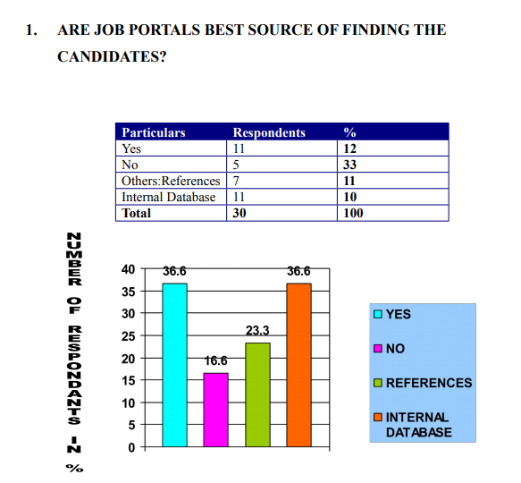

36.6 % recruiters says that yes, job portals are the best source of finding the candidates,16.6% recruiters says ‘no’,23.3% recruiters prefer references and 36.6% prefers internal database.

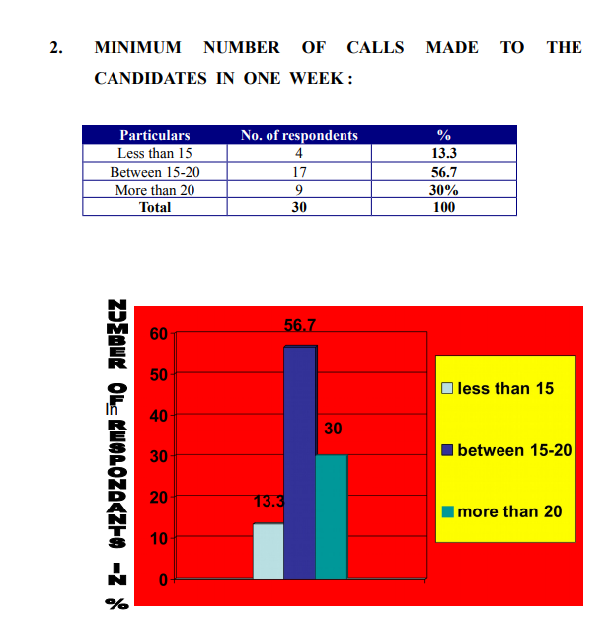 13.3% recruiters make at least less than 15 calls in a week and 56.6% make at least 15-20 calls in a week, 30% recruiters make more than 20 calls in a week.

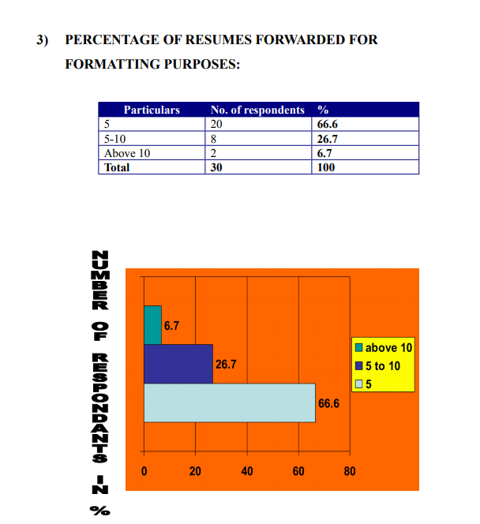 66.6% recruiters forward 5 resumes for formatting purpose in a day, 26.6% recruiters forward 5-10 resumes in a day and only 6.6% recruiters forward above 10 resumes for formatting purpose in a day.

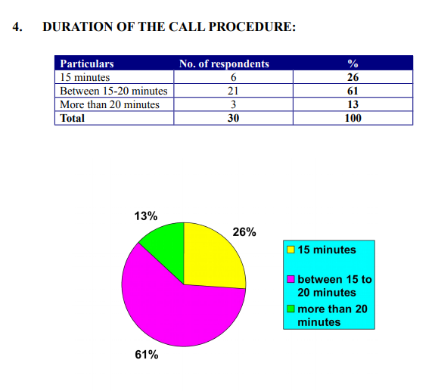 15% recruiters conduct telephonic interview for 15 minutes, 61% recruiters conduct telephonic interview between 15-20 minutes and 13% recruiters conduct telephonic interview for more than 20 minutes.

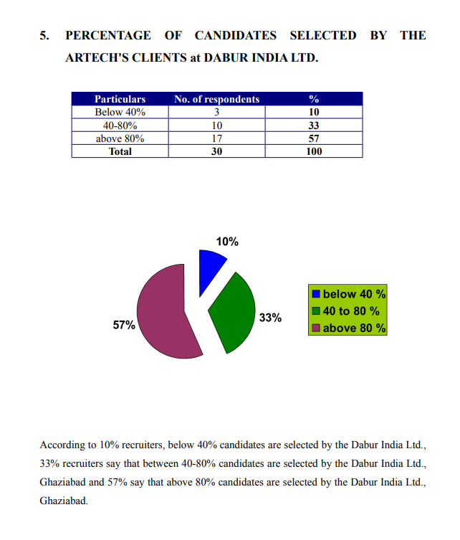

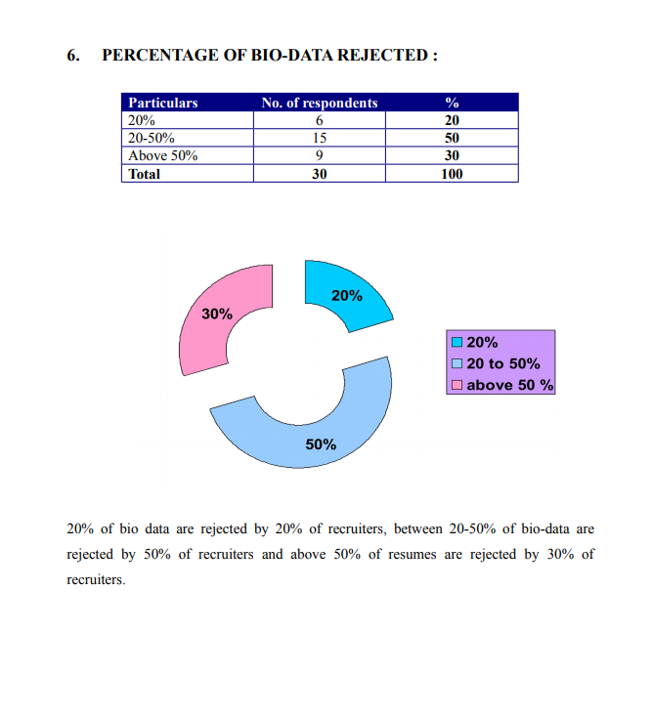 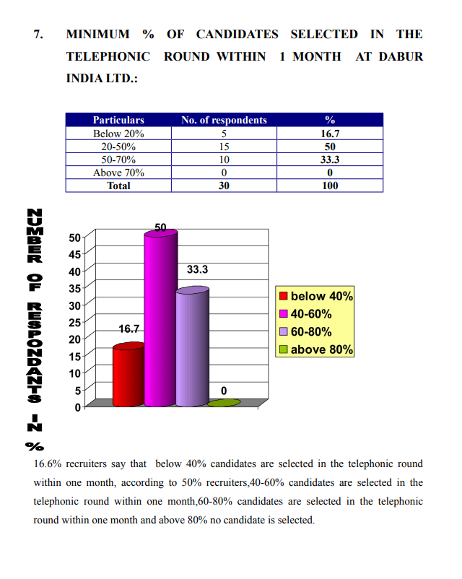 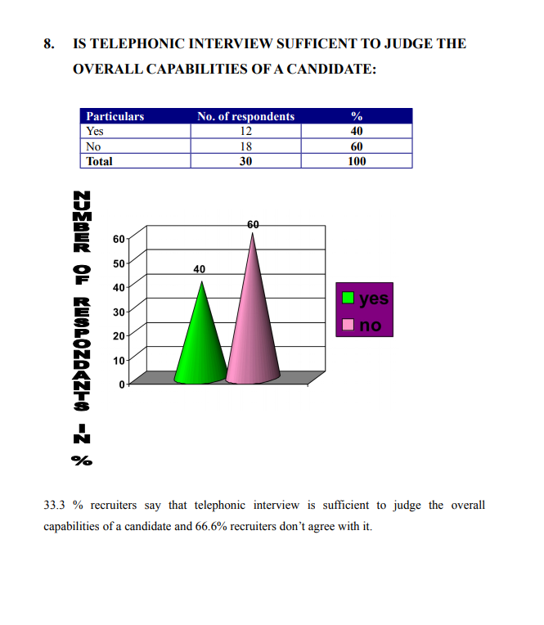

**limitation**

Training is a costly affair for the management. It needs a handsome amount and long time. So management has to play safe game for the benefits of the company as well as the workers. One wrong decision may enforce the company to fall into deep troubles. So selecting the weak areas of staffs and workers should be done very carefully. For that the management should be conduct a test.

For providing an effective training, company requires a knowledgeable trainer. Selecting a particular tramer is again a difficult job. Trainer demands handsome money.

Training needs time and cost both.

To conclude, it very clear that training should be provided but not at the loss of the company. It is very costly and time taking affair. But it is most important for the development of the company. So management can't avoid it at any cost.

1. Because of lack of time it is not sufficient to understand complete corporate world& due to this I could not focus on other area, which I was planning in the beginning of my project.
2. There were no advanced & appreciation courses which will be beneficial for the knowledge of senior management personnel.
3. Facilities to train the trainers were not quite & adequate.

# Comparative Analysis

In conducting a comparative analysis between Dabur's recruitment practices and industry standards as well as those of its competitors, several factors should be considered to identify both gaps and strengths. Here's a breakdown of how this analysis could be approached:

1. **Recruitment Process Efficiency:**
   * Compare the efficiency of Dabur's recruitment process, including time-to-fill vacancies and cost-per-hire, with industry benchmarks and competitors. Identify any areas where Dabur's recruitment process may be lagging or excelling compared to industry norms.
2. **Candidate Experience:**
   * Evaluate the candidate experience offered by Dabur compared to industry standards and competitors. This includes aspects such as the ease of application process, communication with candidates throughout the recruitment process, and feedback mechanisms. Identify any areas where Dabur's candidate experience could be improved or where it stands out positively.
3. **Diversity and Inclusion Practices:**
   * Compare Dabur's diversity and inclusion initiatives with industry benchmarks and competitors. Assess the representation of diverse candidates in the recruitment pipeline, as well as the effectiveness of initiatives aimed at promoting diversity and inclusion. Identify any gaps or areas where Dabur's practices could be strengthened.
4. **Employer Branding:**
   * Analyze Dabur's employer branding efforts compared to industry standards and competitors. Evaluate the company's online presence, employer reputation, and employer value proposition (EVP) in attracting and retaining talent. Identify any areas where Dabur's employer branding could be enhanced or where it outperforms competitors.
5. **Technology Adoption:**
   * Compare Dabur's adoption of technology in recruitment processes with industry benchmarks and competitors. Assess the use of applicant tracking systems (ATS), AI-powered tools, and data analytics platforms to streamline recruitment workflows and improve decision-making. Identify any technological gaps or areas where Dabur leads in innovation.
6. **Compliance with Regulations:**
   * Evaluate Dabur's compliance with local and national employment laws and regulations compared to industry standards and competitors. Assess the company's adherence to equal employment opportunity (EEO) laws, anti-discrimination regulations, and data privacy requirements. Identify any compliance gaps or areas where Dabur demonstrates exemplary practices.
7. **Talent Acquisition Strategies:**
   * Compare Dabur's talent acquisition strategies, including sourcing channels, recruitment methods, and employer branding initiatives, with industry benchmarks and competitors. Assess the effectiveness of these strategies in attracting and retaining top talent. Identify any innovative approaches or areas for improvement.

By conducting a comprehensive comparative analysis across these key areas, Dabur can gain valuable insights into its recruitment practices relative to industry standards and competitors. This analysis can inform strategic decision-making, identify areas for improvement, and help Dabur maintain a competitive edge in talent acquisition.

1. **Theoretical Alignment:**
   * **Resource-Based View (RBV):** Dabur's recruitment and selection practices align with the RBV by recognizing human resources as a key source of competitive advantage. Dabur focuses on identifying, attracting, and retaining top talent to leverage their skills, knowledge, and abilities to drive organizational success. By investing in recruitment technologies, diversity initiatives, and talent development programs, Dabur enhances its human capital capabilities, which align with the principles of the RBV.
   * **Talent Acquisition Trends:** Dabur's adoption of technology-enabled recruitment processes, such as online job portals, AI-powered tools, and data analytics, reflects alignment with contemporary talent acquisition trends highlighted in the literature review. These trends emphasize the importance of leveraging technology to streamline recruitment workflows, enhance candidate experience, and improve decision-making. Dabur's emphasis on employer branding initiatives also aligns with the trend of promoting organizational values and culture to attract and retain top talent.
2. **Strategic Alignment:**
   * Dabur's recruitment and selection practices are closely aligned with its strategic goals, as evidenced by its emphasis on attracting talent that embodies the company's values and supports its mission. Dabur's commitment to sustainability, innovation, and customer-centricity is reflected in its recruitment efforts, where candidates are evaluated not only based on their skills and experience but also on their alignment with Dabur's cultural values and strategic objectives.
   * Dabur's talent acquisition strategies are designed to meet the evolving needs of the organization and support its growth initiatives. For example, by investing in campus recruitment programs, Dabur ensures a pipeline of young talent aligned with its long-term workforce requirements. Similarly, Dabur's focus on diversity and inclusion initiatives reflects its strategic imperative to foster a culture of belonging, innovation, and collaboration.
   * Furthermore, Dabur's recruitment and selection practices are agile and adaptable, allowing the company to respond effectively to changing market conditions, industry trends, and competitive pressures. By aligning recruitment strategies with strategic goals, Dabur ensures that its workforce remains a source of sustainable competitive advantage, driving innovation, growth, and profitability.

Dabur's recruitment and selection practices demonstrate strong theoretical alignment with key frameworks such as the RBV and current talent acquisition trends. Moreover, these practices are strategically aligned with Dabur's overarching goals, values, and growth aspirations, positioning the company for long-term success in a dynamic and competitive marketplace.

# Recommendations for Enhancement

1. **Optimization Strategies:**
   * **Enhancing Digital Recruitment Platforms:** Dabur should invest in advanced digital recruitment platforms that utilize AI and data analytics to streamline candidate sourcing, screening, and engagement. This includes leveraging AI-powered chatbots for initial candidate interactions, implementing predictive analytics to identify top talent, and utilizing machine learning algorithms to enhance candidate matching.
   * **Introducing Rigorous Assessment Methods:** Dabur can enhance its selection process by introducing more rigorous assessment methods, such as situational judgment tests, case studies, and job simulations. These methods provide a more comprehensive evaluation of candidates' skills, competencies, and potential to succeed in specific roles.
2. **Implementation Plan:**
   * **Timeline:**
     + Phase 1 (0-3 months): Research and selection of digital recruitment platforms.
     + Phase 2 (3-6 months): Implementation of selected platforms and initial training for recruiters.
     + Phase 3 (6-9 months): Rollout of rigorous assessment methods and integration with existing selection processes.
   * **Responsibilities:**
     + HR Department: Overall project management, platform selection, and implementation.
     + Recruitment Team: Training on new platforms and assessment methods, and integration into daily practices.
     + IT Department: Technical support for platform implementation and integration with existing systems.
   * **Resources:**
     + Budget allocation for purchasing and implementing digital recruitment platforms.
     + Training resources for recruiters and hiring managers on new assessment methods.
     + IT support for platform implementation and maintenance.
3. **Long-term Strategies:**
   * **Regular Training for Recruiters:** Implement a continuous training program for recruiters to keep them updated on the latest recruitment trends, technologies, and best practices. This may include workshops, seminars, and online courses covering topics such as diversity and inclusion, bias mitigation, and advanced interviewing techniques.
   * **Ongoing Evaluation of Processes:** Establish a system for ongoing evaluation and feedback on recruitment and selection processes. This includes regular reviews of key performance indicators (KPIs) such as time-to-fill, cost-per-hire, and candidate satisfaction scores. Use feedback from recruiters, hiring managers, and candidates to identify areas for improvement and make iterative changes to enhance process effectiveness and efficiency.

By implementing these optimization strategies and developing a comprehensive implementation plan, Dabur can enhance its recruitment and selection processes to attract top talent, improve decision-making, and drive organizational success. Additionally, adopting long-term strategies for continuous improvement ensures that Dabur remains agile and responsive to evolving market dynamics and talent acquisition trends.

# Conclusion

After conducting a thorough analysis of Dabur India Pvt Ltd's recruitment and selection practices, several key insights and findings have emerged:

1. **Overview of Dabur:**
   * Dabur is a leading company in the consumer goods industry with a diverse product portfolio spanning healthcare, personal care, and food products.
   * The company has a strong market presence and is known for its innovation-driven approach in serving millions of consumers globally.
2. **Significance of Recruitment and Selection:**
   * Recruitment and selection are crucial for organizational success, influencing the quality of new hires, organizational culture, and overall productivity.
   * Effective recruitment and selection practices contribute to Dabur's ability to attract and retain top talent, driving innovation and growth.
3. **Objectives and Scope of the Research:**
   * The research aims to evaluate the effectiveness of Dabur's recruitment and selection practices and suggest improvements.
   * The scope includes a focus on geographical and departmental aspects within Dabur to provide a comprehensive analysis.
4. **Literature Review:**
   * Theoretical frameworks such as the Resource-Based View (RBV) and emerging trends like technology integration and employer branding provide insights into best practices in recruitment and selection.
5. **Research Methodology:**
   * A mixed-method approach combining qualitative insights from interviews with HR professionals and quantitative data from surveys is employed to provide a comprehensive analysis.
   * Data collection methods include structured interviews, employee surveys, and analysis of HR documents and performance records.
6. **Company Overview:**
   * Dabur's history, mission, and values emphasize its commitment to providing nature-based solutions and promoting sustainability and responsibility.
   * The organizational structure and HR policies support recruitment and selection efforts aligned with strategic objectives.
7. **Analysis of Recruitment Practices:**
   * Recruitment sources and channels, job analysis procedures, and technological integration play key roles in attracting and selecting candidates effectively.
8. **Evaluation of Selection Practices:**
   * Selection methods and tools, competency frameworks, and diversity and inclusion initiatives are essential for identifying and hiring the right talent.
9. **Challenges and Opportunities:**
   * Challenges such as high turnover rates and skill mismatches highlight the need for optimization strategies.
   * Opportunities for enhancement include adopting robust technology solutions and enhancing employer branding efforts.
10. **Comparative Analysis:**
    * Benchmarking against industry standards and competitors identifies gaps and strengths in Dabur's recruitment practices.

The research provides valuable insights into Dabur's recruitment and selection practices, highlighting areas for improvement and opportunities for enhancing effectiveness and efficiency. By implementing the proposed recommendations and continuous improvement strategies, Dabur can strengthen its talent acquisition processes and maintain its competitive edge in the marketplace.

**Implications:**

* For Dabur: Implementing the recommendations can lead to improved talent acquisition, enhanced organizational performance, and a stronger employer brand. This could result in increased innovation, productivity, and competitiveness in the market.
* For the HR community: The research findings can serve as a benchmark for other organizations seeking to enhance their recruitment and selection practices. Insights into emerging trends and best practices can inform HR professionals' strategies and contribute to the advancement of talent acquisition methodologies.

**Future Research:**

* Long-term impact assessment: Investigate the long-term effects of optimized recruitment and selection practices on organizational performance, employee retention, and employer brand perception.
* Diversity and inclusion: Explore the effectiveness of specific diversity and inclusion initiatives in recruitment processes and their impact on workforce diversity, employee engagement, and organizational culture.
* Technology integration: Examine the latest advancements in recruitment technology and their implications for candidate experience, process efficiency, and HR analytics.
* Cross-cultural studies: Conduct comparative studies on recruitment practices across different cultural contexts to understand how cultural factors influence recruitment strategies and outcomes.

# References:

1. Cascio, W. F. (2018). Managing human resources: Productivity, quality of work life, profits (11th ed.). McGraw-Hill Education.
2. Cook, M. (2020). HR Disrupted: It’s time for something different. Kogan Page Publishers.
3. Gatewood, R. D., Feild, H. S., & Barrick, M. R. (2019). Human resource selection. Cengage Learning.
4. Ployhart, R. E., & Moliterno, T. P. (2011). Emergence of the human capital resource: A multilevel model. Academy of Management Review, 36(1), 127-150.
5. SHRM. (2020). The future of recruiting: How technology is transforming talent acquisition. Retrieved from https://www.shrm.org/hr-today/trends-and-forecasting/research-and-surveys/Documents/SHRM-The-Future-of-Recruiting-Report.pdf.

# Appendices

**Interview Transcripts:**

*Interview with HR Manager*

**Interviewer:** Thank you for taking the time to speak with me today. To start, could you please provide an overview of Dabur's recruitment and selection practices?

**HR Manager:** Certainly. At Dabur, we have a comprehensive recruitment process that begins with identifying the hiring need and ends with the selection of the best candidate for the job. We utilize a mix of internal and external recruitment sources to attract a diverse pool of candidates, including online job portals, employee referrals, and campus recruitment. Once candidates are identified, we conduct thorough assessments to evaluate their skills, competencies, and cultural fit with the organization. Our goal is to ensure that we select candidates who not only have the right qualifications but also share our values and can contribute to our growth and success.

**Interviewer:** That sounds like a robust process. Can you provide some insights into how Dabur integrates technology into its recruitment practices?

**HR Manager:** Technology plays a significant role in our recruitment efforts. We use applicant tracking systems (ATS) to streamline the application process and manage candidate data efficiently. Additionally, we leverage AI-powered tools for resume screening and initial candidate assessments, which helps us identify qualified candidates more quickly and accurately. Our digital recruitment platforms also enable us to engage with candidates through virtual interviews and assessments, especially in situations where face-to-face interactions are not feasible. Overall, technology allows us to enhance the candidate experience, improve process efficiency, and make data-driven recruitment decisions.

**Interviewer:** That's fascinating. How does Dabur ensure diversity and inclusion within its recruitment process?

**HR Manager:** Diversity and inclusion are core values at Dabur, and we are committed to promoting a diverse workforce that reflects the communities we serve. To achieve this, we implement various initiatives, such as targeted outreach programs to attract candidates from underrepresented groups, unconscious bias training for recruiters and hiring managers, and inclusive language in job postings and communications. We also monitor diversity metrics throughout the recruitment process to identify any areas for improvement and ensure fair and equitable treatment of all candidates.

**Interviewer:** Thank you for sharing those insights. One final question: What are some areas for improvement or future enhancements in Dabur's recruitment and selection practices?

**HR Manager:** While we are proud of our recruitment process, we recognize that there is always room for improvement. One area we are currently exploring is the use of predictive analytics to identify high-potential candidates and improve our talent forecasting capabilities. We are also looking into enhancing our employer branding efforts to attract top talent and differentiate ourselves in the competitive market. Overall, we are committed to continuously evolving and refining our recruitment practices to meet the changing needs of our organization and ensure we remain a preferred employer in the industry.

**Questionnaire**

