**The Oil and Gas Static Equipment Maintenance procedures & Special Torquing and Blasting Devices**

**By Amr Abbass**

**Masters of Engineering University of Idaho**

**ABSTRACT (Font-Times New Roman, Bold, Font Size -12)**

The Maintenace of static equipment represents a challenge in all of the refinery, petrochemical and oil gathering facilities accordingly this paper was initiated to detail the maintenance procedures for the different static equipment and identify the work steps for heat exchangers, ejectors, tanks, heaters, boilers and flares

**Keywords:** Heaters, static, Towers, Maintenance, procedures

1. **INTRODUCTION (Font-Times New Roman, Bold, Font Size -12)**

The research will identify most of major static equipment and identify the procedures of the maintenance.

1. **METHODOLOGY**
2. **The Refinery Static Equipment**
3. **Flares**

|  |  |  |  |
| --- | --- | --- | --- |
|  |  **| | |
|  |
| 1. Erect Scaffold for Blinding | |  |
| 1. Install battery limit blinds | |  |
| 1. Install flare blinds | |  |
| 1. Disconnect Tip | |  |
| 1. Remove Tip from Flare | |  |
| 1. Clean Tip and Top Flange | |  |
| 1. Inspect Tip Flare and Flare | |  |
| 1. Reinstall Tip | |  |
| 1. Fix Tip and Tight | |  |
| 1. Remove Blinds | |  |
| 1. Remove Scaffold & Area Clean | |  |

1. **Heat Exchangers**

|  |
| --- |
| **Job Step** |
| 1. Erect Scaffolding |
| 1. Remove Insulation as required |
| 1. Isolate Connect Drain |
| 1. Install Blinds |
| 1. Disconnect Piping |
| 1. Remove Channel bonnet (both inlet and outlet side) |
| 1. Remove internal tube bundle expansion joint and install lock bolt |
| 1. Remove tube bundle |
| 1. Transport Tube bundle and Exchanger Parts to Shop / yard |
| 1. Clean shell and all components |
| 1. Offer inspection / Repair(if any) |
| 1. Hydro blast Tube Bundle |
| 1. Offer inspection / Repair(if any) |
| 1. Inspect all Gasket Surfaces |
| 1. Transport Bundle / Heads to Site |
| 1. Install Tube bundle and test ring |
| 1. Hydrotest Shell Side, Repeat Test as Required |
| 1. Offer inspection / Repair(if any) |
| 1. Remove test ring and fix inlet side bonnet |
| 1. Install outlet side expansion joint(tighten expansion joint bolts) |
| 1. Hydrotest Tube Side, Repeat Test as Required |
| 1. Offer inspection / Repair(if any) |
| 1. Install outlet side bonnet and tighten all flanges |
| 1. Hydro test shell side(final) |
| 1. Remove Blinds |
| 1. Refit Pipes |
| 1. Repair and Refit Insulation |
| 1. Remove Scaffolding |

1. **Tank**

|  |
| --- |
| **Job Step** |
| 1. Erect Scaffolding |
| 1. Isolate and Drain |
| 1. Install Blinds |
| 1. Open Manway |
| 1. Remove LG & LT's as required |
| 1. Install Lights Internally as required |
| 1. Clean Vessel Internally |
| 1. Inspect Internals |
| 1. Repair as per Inspection |
| 1. Clean and flush all connected nozzles |
| 1. Remove Internal Lighting |
| 1. Install LG & LT's |
| 1. Close Manway |
| 1. Remove blinds |
| 1. Remove External Scaffolding |
| 1. Clean Area |

1. **Filters**

|  |
| --- |
| **Job Step** |
| 1. Erect Scaffolding |
| 1. Isolate Filter Elements " Install Blinds " |
| 1. Remove Filter Heads |
| 1. Remove and Clean Filter Elements |
| 1. Clean Filter Shell Internally |
| 1. Clean filter element / offer inspection |
| 1. Install Filter Elements |
| 1. Reinstall Filter Heads |
| 1. Remove Blinds |
| 1. Remove Scaffold |
| 1. Clean Area Around Filter |

1. **Boilers**

|  |
| --- |
| **Job Step** |
| 1. Erect External Scaffold |
| 1. Install Blinds |
| 1. Open Steam Drum Manways |
| 1. Install Ventilation Equipment |
| 1. Remove Valves and PSV's to Shop |
| 1. Remove Sight Glass Float Chamber to Shop |
| 1. Install Internal Lights |
| 1. Remove Internals |
| 1. Clean Steam Drum Internally for Inspection |
| 1. Clean Steam Drum Parts for Inspection |
| 1. Inspect and Repair as Required |
| 1. Install Internals and Steam Drum Parts |
| 1. Remove Internal Lights |
| 1. Remove Ventilation Equipment |
| 1. Close Steam Drum Manways |
| 1. Install PSV's and Valves |
| 1. Install Sight Glass and Float Chamber |
| 1. Remove Blinds |
| 1. Repair Insulation |
| 1. Remove External Scaffold |
| 1. Clean Area |
| 1. **FIN FANs**   **Job Step** |
| 1. Isolate and Connect Drain |
| 1. Erect scaffold |
| 1. Install Blinds |
| 1. Remove Plugs: Selected 10 % of Total No |
| 1. Remove Plugs : Balance 90 % |
| 1. Clean Tubes & Fins by Hydro blasting |
| 1. Offer Inspection-Corrosion / Repair as required |
| 1. Remove Bank and transport to Shop-Yard for retubing Repair as required and transport to site and erect after Repair |
| 1. Install Plugs : Selected 10 % of Total No |
| 1. Install Plugs : Balance 90 % |
| 1. Hydrotest Tubes, Repeat Test as Required |
| 1. Offer Inspection / Repair as required |
| 1. Remove Blinds & Clean Area |
| 1. Remove the scaffold & Clean Area |

11

1. **Coolers**

|  |
| --- |
| **Job Step** |
|  |
| 1. Erect Scaffolding |  |
| 1. Remove insulation as required |  |
| 1. Install Blinds |  |
| 1. Remove channel head cover |  |
| 1. Remove Channel head |  |
| 1. Remove 'U' tube bundle |  |
| 1. Transport bundle to workshop |  |
| 1. Clean parts |  |
| 1. Hydroblast tube bundle |  |
| 1. Inspect all gasket surfaces |  |
| 1. Install tube bundle in shell |  |
| 1. Install channel head |  |
| 1. Hydrotest shell side |  |
| 1. Install channel head cover |  |
| 1. Final tube side hydrotest |  |
| 1. Remove blinds |  |
| 1. Repair and refit insulation |  |
| 1. Remove scaffolding & clean area |  |

1. **Heaters**

|  |
| --- |
| **Job Step** |
| 1. Install Scaffold for Blinding / Isolation |
| 1. Isolate / Drain |
| 1. Install Blinds as required |
| 1. Drop / Clean all heater burners and steam out connected lines |
| 1. Offer Inspection / Repair as required |
| 1. Remove Control Valves and transport to Shop |
| 1. Open Man doors(Both Radiation and convection sides) |
| 1. Neutralize the tubes by soda ash |
| 1. Erect internal scaffold and provide internal lighting |
| 1. Clean Tubes, Weld Joints, U - Bends and Tube Sheet |
| 1. Offer Inspection / Repair as required |
| 1. Repair Refractory |
| 1. Service Dampers (erect scaffold as required and remove after repair) |
| 1. Hydrostatic Test Coils, Repeat Test as Required |
| 1. Offer Inspection / Repair as required |
| 1. Transport Control Valves to Site and Install |
| 1. Remove internal scaffold |
| 1. Clean internally get Operation clearance |
| 1. Reinstall all burners Get Operation Clearance |
| 1. Remove Internal Lights |
| 1. Install Man Way Covers |
| 1. Remove Blinds |
| 1. Remove Scaffold Externally |
| 1. House keep the area |

|  |
| --- |
| 1. **Pressure Vessel**   **Job Step** |
| 1. Erect External Scaffolding as required |
| 1. Isolate / Drain |
| 1. Install Blinds |
| 1. Open Hand Holes |
| 1. Remove Sight Glass - Float Chamber & clean as required |
| 1. Clean Vessel Internally |
| 1. Inspect Internals / Repair as required |
| 1. Install Sight Glass and Float Chamber |
| 1. Close Hand Holes |
| 1. Remove Blinds |
| 1. Remove External Scaffolding |
| 1. Clean Area |
|  |

|  |
| --- |
| 1. **Towers**   **Job Step** |
| 1. Erect External Scaffolding & at Skirt Area |
| 1. Isolate and Drain Vessel |
| 1. Install Blinds & N2 Purge |
| 1. Open Manway |
| 1. Remove PSV |
| 1. Remove & clean sight glass and float chamber(LG &LT) |
| 1. Install Ventilation Equipment |
| 1. Install Light Internally |
| 1. Open Tray Hatchways |
| 1. Remove complete tray segments |
| 1. Erect Internal Scaffolding |
| 1. Clean Trays, Down Commers |
| 1. Remove Demisters and clean as required |
| 1. Inspect Internals & Repair as Per Inspection |
| 1. Reinstall Tray segments |
| 1. Replace Damage Tray Valves |
| 1. Reinstall Tray Hatchways |
| 1. Connect Water Hoses & Flush all connected nozzles |
| 1. Reinstall demisters |
| 1. Remove internal scaffolding |
| 1. Remove Internal Lighting |
| 1. Remove Ventilation Equipment |
| 1. Install PSV |
| 1. Install sight glass and float chamber |
| 1. Close Manway |
| 1. Remove Blinds |
| 1. Remove External Scaffolding |
| 1. Clean Area including all platforms |

1. **Bolting and Hydro blasting Equipment**
2. **Hydraulic Torque wrench**

From 130 ft/lbs to 60,000 ft/lbs the hydraulic torque wrench . lubrication and preventative maintenance, is required for safe operation Different varitey of machine are found in <https://www.torcup.com/> and brief is as follows .

1. **Pneumatic Torque Wrench**

The Pneumatic Torque wrench is identical to Hydraulic wrench but with less torque wrench but it is easier in the application and economical.

1. **Tensioning & Bolting**

Those are hydraulic, pneumatic and manual torque wrenches; hydraulic bolt tensioning; and all tools associated are utilized to achieve accurate bolting within identified torques.

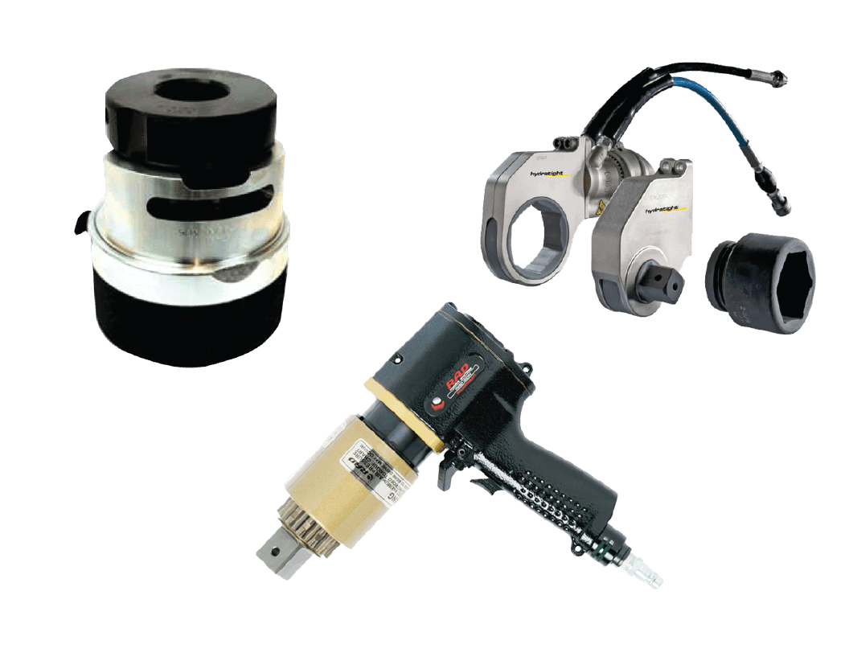

1. **Hydroblasting Machines**

High Pressure Diesel Water Jet Pump System can [produce High-Pressure](https://www.nlbcorp.com/shop/pumps-units/diesel-units/#dedicateduhpunits), from 4,000 psi to 40,000 psi with different flow rates to meet all application of normal surface blasting till fully clogged heat exchanger tubes . different variety of Machine are found in https://www.nlbcorp.com/

1. **CONCLUSION**

The Oil Refinery contains a variety of Equipment from Tanks , Heat Exchangers, Pressure Vessels, Filters, Boilers and Heaters…etc.

Each Equipment has its own maintenance procedures that vary between scaffolding erection, heavy lifts, and special torquing and blasting procedures. The Study identifies each equipment its procedure and the paper could be a good reference for shutdown planners & cost estimators to identify the required works durations and resources and costs based on the dimensions of the Equipment.

.

1. **REFERENCES**
2. Plant Equipment & Maintenance Engineering Handbook By [Duncan Richardson](https://www.google.ca/search?sca_esv=f0d7a24c669b6213&sca_upv=1&hl=en&q=inauthor:%22Duncan+Richardson%22&tbm=bks) · 2013
3. Torcup web site <https://www.torcup.com/>
4. NLB web site <https://www.nlbcorp.com/>
5. [Major Process Equipment Maintenance and Repair](https://books.google.com/books?id=IpBaybUJ5T8C&printsec=frontcover&dq=Static+equipment+maintenance++books&hl=en&newbks=1&newbks_redir=1&sa=X&ved=2ahUKEwikqeu-3vGFAxUiFjQIHbFqAFQQ6AF6BAgIEAI) [[Heinz P. Bloch](https://books.google.com/books?id=IpBaybUJ5T8C&printsec=frontcover&dq=Static+equipment+maintenance++books&hl=en&newbks=1&newbks_redir=1&sa=X&ved=2ahUKEwikqeu-3vGFAxUiFjQIHbFqAFQQ6AF6BAgIEAI)](https://www.google.com/search?sa=X&sca_esv=f0d7a24c669b6213&tbm=bks&sxsrf=ADLYWIL9LltsTobSoTVa_QI-sKaxX-f_eg:1714748107976&tbm=bks&q=inauthor:%22Heinz+P.+Bloch%22&ved=2ahUKEwikqeu-3vGFAxUiFjQIHbFqAFQQ9Ah6BAgIEAU)[, ‎](https://books.google.com/books?id=IpBaybUJ5T8C&printsec=frontcover&dq=Static+equipment+maintenance++books&hl=en&newbks=1&newbks_redir=1&sa=X&ved=2ahUKEwikqeu-3vGFAxUiFjQIHbFqAFQQ6AF6BAgIEAI)[[Fred K. Geitner](https://books.google.com/books?id=IpBaybUJ5T8C&printsec=frontcover&dq=Static+equipment+maintenance++books&hl=en&newbks=1&newbks_redir=1&sa=X&ved=2ahUKEwikqeu-3vGFAxUiFjQIHbFqAFQQ6AF6BAgIEAI)](https://www.google.com/search?sa=X&sca_esv=f0d7a24c669b6213&tbm=bks&sxsrf=ADLYWIL9LltsTobSoTVa_QI-sKaxX-f_eg:1714748107976&tbm=bks&q=inauthor:%22Fred+K.+Geitner%22&ved=2ahUKEwikqeu-3vGFAxUiFjQIHbFqAFQQ9Ah6BAgIEAY)[· 1997](https://books.google.com/books?id=IpBaybUJ5T8C&printsec=frontcover&dq=Static+equipment+maintenance++books&hl=en&newbks=1&newbks_redir=1&sa=X&ved=2ahUKEwikqeu-3vGFAxUiFjQIHbFqAFQQ6AF6BAgIEAI)
6. [Maintenance Engineering Handbook By](https://books.google.com/books?id=IpBaybUJ5T8C&printsec=frontcover&dq=Static+equipment+maintenance++books&hl=en&newbks=1&newbks_redir=1&sa=X&ved=2ahUKEwikqeu-3vGFAxUiFjQIHbFqAFQQ6AF6BAgIEAI)[[Keith Mobley](https://books.google.com/books?id=IpBaybUJ5T8C&printsec=frontcover&dq=Static+equipment+maintenance++books&hl=en&newbks=1&newbks_redir=1&sa=X&ved=2ahUKEwikqeu-3vGFAxUiFjQIHbFqAFQQ6AF6BAgIEAI)](https://www.google.ca/search?sca_esv=f0d7a24c669b6213&sca_upv=1&hl=en&q=inauthor:%22Keith+Mobley%22&tbm=bks)[· 2008](https://books.google.com/books?id=IpBaybUJ5T8C&printsec=frontcover&dq=Static+equipment+maintenance++books&hl=en&newbks=1&newbks_redir=1&sa=X&ved=2ahUKEwikqeu-3vGFAxUiFjQIHbFqAFQQ6AF6BAgIEAI)
7. [Industrial Machinery Repair: Best Maintenance Practices](https://books.google.com/books?id=5pZvJzvBYZwC&printsec=frontcover&dq=Static+equipment+maintenance++books&hl=en&newbks=1&newbks_redir=1&sa=X&ved=2ahUKEwikqeu-3vGFAxUiFjQIHbFqAFQQ6AF6BAgEEAI) [[Ricky Smith](https://books.google.com/books?id=5pZvJzvBYZwC&printsec=frontcover&dq=Static+equipment+maintenance++books&hl=en&newbks=1&newbks_redir=1&sa=X&ved=2ahUKEwikqeu-3vGFAxUiFjQIHbFqAFQQ6AF6BAgEEAI)](https://www.google.com/search?sa=X&sca_esv=f0d7a24c669b6213&tbm=bks&sxsrf=ADLYWIL9LltsTobSoTVa_QI-sKaxX-f_eg:1714748107976&tbm=bks&q=inauthor:%22Ricky+Smith%22&ved=2ahUKEwikqeu-3vGFAxUiFjQIHbFqAFQQ9Ah6BAgEEAU)[, ‎](https://books.google.com/books?id=5pZvJzvBYZwC&printsec=frontcover&dq=Static+equipment+maintenance++books&hl=en&newbks=1&newbks_redir=1&sa=X&ved=2ahUKEwikqeu-3vGFAxUiFjQIHbFqAFQQ6AF6BAgEEAI)[[R. Keith Mobley](https://books.google.com/books?id=5pZvJzvBYZwC&printsec=frontcover&dq=Static+equipment+maintenance++books&hl=en&newbks=1&newbks_redir=1&sa=X&ved=2ahUKEwikqeu-3vGFAxUiFjQIHbFqAFQQ6AF6BAgEEAI)](https://www.google.com/search?sa=X&sca_esv=f0d7a24c669b6213&tbm=bks&sxsrf=ADLYWIL9LltsTobSoTVa_QI-sKaxX-f_eg:1714748107976&tbm=bks&q=inauthor:%22R.+Keith+Mobley%22&ved=2ahUKEwikqeu-3vGFAxUiFjQIHbFqAFQQ9Ah6BAgEEAY)
8. [Engineering Maintenance A Modern Approach By](https://books.google.com/books?id=IpBaybUJ5T8C&printsec=frontcover&dq=Static+equipment+maintenance++books&hl=en&newbks=1&newbks_redir=1&sa=X&ved=2ahUKEwikqeu-3vGFAxUiFjQIHbFqAFQQ6AF6BAgIEAI)[[B.S. Dhillon](https://books.google.com/books?id=IpBaybUJ5T8C&printsec=frontcover&dq=Static+equipment+maintenance++books&hl=en&newbks=1&newbks_redir=1&sa=X&ved=2ahUKEwikqeu-3vGFAxUiFjQIHbFqAFQQ6AF6BAgIEAI)](https://www.google.ca/search?sca_esv=f0d7a24c669b6213&sca_upv=1&hl=en&q=inauthor:%22B.S.+Dhillon%22&tbm=bks)[· 2002](https://books.google.com/books?id=IpBaybUJ5T8C&printsec=frontcover&dq=Static+equipment+maintenance++books&hl=en&newbks=1&newbks_redir=1&sa=X&ved=2ahUKEwikqeu-3vGFAxUiFjQIHbFqAFQQ6AF6BAgIEAI)