**ACPWM CONTROL SYSTEM FOR INDUCTION MOTOR USING AVR MICROCONTROLLER**

**Prof Mayur Pote , Kalpak Dekate, Divyapranal Atram, Vaishnavi Save, Sadichchha Meshram**

*Department of Electrical Engineering*

*Shri Sai College of Engineering and Technology, Bhadrawati(MS), India*

**ABSTRACT**:

In today's industrial world, induction motors are one of the most often used machines and IoT plays an essential role in our day to day life. This paper thesis deals with the hardware part for monitoring the continuous parameters and speed control part of Induction Motor. And by controlling the speed part of the induction motor with the help of PWM techniques. By monitoring the parameters of the induction motor which is the reliability of the induction motor obtained. If there is any fault takes place in the induction motor should be automatically disconnected from the supply by using IoT applications. They also run at a nearly constant speed and have a high torque-to-speed ratio. In this project we are aiming to monitor and control the induction motor using IOT technology. Arduino reads the measurements, monitors the motor & also interfaces with the Wi-Fi module thereby allowing us to access the various parameter values of the motor remotely.

**KEYWORDS: Induction Motor, Arduino Uno, ESP8266 IOT Module**

**OBJECTIVES**:

The main objective is to increase the reliability of the motor. This work ensures the continuous monitoring of motor and acquires real time condition of induction motor parameters remotely using IOT. By Early fault detection, process interruption of the motor can be reduced; also reduced damages of the motor in an industrial process to a larger extent which makes motor should be more reliable. To protect Motor from overloading, over-current, and high temperature.

**INTRODUCTION:**

ACPWM control for induction motor is a system, that enables the single-phase AC motor to run at different speeds. This project aims at controlling the AC power by using the concept of firing angle control of thyristors. This project uses a new speed control technique for the single-phase AC induction motor. It presents a low-cost design with high-efficiency drive capable of supplying a single-phase AC induction motor with a PWM modulated sinusoidal voltage. The circuit operation is controlled by an AVR family microcontroller. The circuit is capable of supplying a single-phase AC induction motor (or general a.c. inductive/resistive load) with varying AC voltage. The same as in triac control, the voltage applied to the load can be varied from zero to maximum value. On the other side, it uses a pulse width modulation technique (PWM circuit), and when compared with the phase angle control used for triacs, produces much lower high order harmonics. It directly modulates the mains a.c. voltage. Compared with costly converter, it requires a lower number of active and passive power components. By the means of range, the speed of induction motor is been increased with the help of button. AC voltage is provided to the load. Once it reaches to the maximum voltage which is 230 volts, it starts decreasing. It helps to control the speed of induction motor.

Presently Induction Motor is the most common type of motor in all over fields. About 50% of global electric power consumption is due to the induction motor. In industry 90% of uses the induction motor because of necessary characteristics such as it is inherently 'self-start' motor, it does not require permanent magnet, No brushes, No commutator rings, No position sensor. Induction motor also has a simple and robust operation, maintains a good power factor, less maintenance, highly efficient, small in size, reliable, and cheaper than another type of motor. The essential advantage part of an Induction motor is that its speed can be control easily as it has good speed regulation, sustainable overload capacity, and high starting torque.

Due to all of these advantages, Induction Motor is frequently used in an all-over application like industry, electric train, electric Vehicles, crane, elevator, domestic, agriculture motors, etc . The project uses zero crossing point of the waveform which is detected by a comparator whose output is then fed to the microcontroller. The microcontroller provides required delayed triggering control to TRIAC through optoisolator interface and further the power is applied to the load through a TRIAC. This project uses an ATmega328P microcontroller which is interfaced with ESP8266 Nodemcu IOT module.

The IOT WiFi module receives data from Blynk app and further controls the speed and direction of motor. The varying power shall result in variation in the speed of the single-phase induction motor. Single phase induction motors are small motors having a wide field of usefulness where a poly phase supply is not available.

They are generally used in fans, blowers, washing machines, refrigerators, etc. The speed of the induction motor can be varied in a narrow range by varying the voltage applied to the stator winding. This method of speed control is suitable for such applications, where the load varies approximately as the square of speed, such as centrifugal pump drives, fan load. A project has been created in Blynk mobile based application for controlling speed and direction of single-phase induction motor. The Wi-Fi IOT module has a feature of giving real time and accurate data of system.

**BLOCK DIAGRAM**

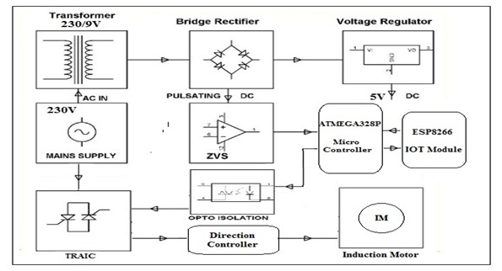

Figure 1: Block Diagram

**HARDWARE IMPLEMENTATION**

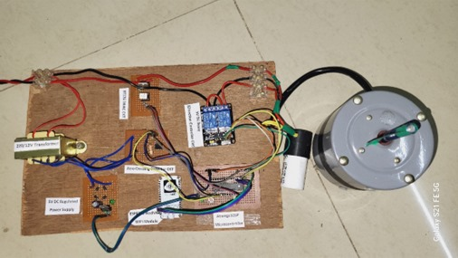

Figure 2: Real Image of the Project

Hardware presented in the experimental setup is hard framed to protect it from any mechanical damage and provide robustness. The base of setup was made up of hard wood to provide mechanical strength. This system can be implemented in any industries and paper where motor’s various operations are essential requirement. This system will save time, reduce the amount of work of the administrator has to do. This prototype model of microcontroller-based protection system is very simple in design, reliable, highly versatile, and cost effective and gives quick response.

## **SOFTWARE REQUIREMENTS**

### Arduino IDE

The ATMega328p microcontroller IC with Arduino bootloader makes a lot of work easier in this project as Arduino code is written in C++ with an addition of special methods and functions, which we’ll mention later on. C++ is a human-readable programming language. When you create a ‘sketch’ (the name given to Arduino code files), it is processed and compiled to machine language.

The Arduino Integrated Development Environment (IDE) is the main text editing program used for Arduino programming. It is where you’ll be typing up your code before uploading it to the board you want to program. Arduino code is referred to as sketches.



Figure 3: Arduino IDE

### Blynk IoT: Android/Web App

A scope of Arduino modules accessible including Arduino Uno, Arduino Mega, Arduino Leonardo, Arduino Micro and some more with no earlier specialized information can consider going all in with the learning procedure. It is easily available for operating systems like MAC, Windows, Linux and runs on the Java Platform that comes with inbuilt functions and each of them contains a microcontroller on the board that is really modified and acknowledges the data as code. Blynk is an IoT (Internet of Things) stage utilizing which you can without much of a stretch and distantly control equipment. Furthermore, you can likewise see sensor information, store the information, picture the information and so on everywhere.

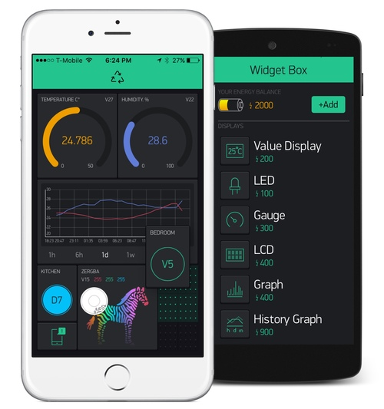

Figure 4: Blynk IOT app

## **Arduino Libraries**

### ESP8266

The Wi-Fi library for ESP8266 has been developed based on ESP8266 SDK, using the naming conventions and overall functionality philosophy of the Arduino Wi-Fi library. Over time, the wealth of Wi-Fi features ported from ESP8266 SDK to esp8266 / Arduino outgrew Arduino Wi-Fi library and it became apparent that we would need to provide separate documentation on what is new and extra.

In the first line of the sketch, #include <ESP8266WiFi.h> we are including the ESP8266WiFi library. This library provides ESP8266 specific Wi-Fi routines that we are calling to connect to the network.

### Blynk

Blynk Library is an extension that runs on top of your hardware application. It handles all the connection routines and data exchange between your hardware, Blynk Cloud, and your app project. Blynk is the most popular Internet of Things platform for connecting any hardware to the cloud, designing apps to control them, and managing your deployed products at scale.

**ADVANTAGES:**

* High efficiency
* Easy to control the speed
* Switching losses are reduced

**CONCLUSION**: In this project we have demonstrated a new method to control the speed of single–phase induction motor in both directions by the use of a semiconductor device TRIAC and reversed its direction by the use of relay switch .We can change or vary the speed of induction motor by varying gate firing angle, that means we can vary the voltage as well as speed of induction motor using TRIAC along with direction of motor.

**FUTURE SCOPE**: In a country like India which has a shortage of revenues and high monetary losses, we see a huge scope of our project being implemented on a large scale. This will not only reduce losses due to lack of automation and artificial intelligence but will also be a preliminary step towards automated protection of the electrical equipment’s. The project implementation using Arduino microcontroller improves the performance of system and it is more reliable than any other existing system.

**REFERENCES:**

## [1]. Nitin Gore, Prof. A. V. Naik, “IOT Based Induction Motor Speed Control and Parameter Monitoring ISSN 2321-9653,2013

[2]. Keerthana p, vinoth g, senthil kumar r, rajesh s “Implementation of motor testing for single phase induction motor using IOT” (IJCESR) ISSN (PRINT): 2393-8374, (ONLINE): 2394-0697, volume-5, issue-2, 2018.

[3]. Aditya rayan Sharma, Jaikaran Singh “Protection of induction motor and monitioring”Journal of Advances in Electrical Devices Volume 2 Issue 1,MAT Journals 2017.

[4]. The research done by P.M.AKOTKAR, V.S.KARAL, Dr.A.U.JAWADEKAR on “Condition Monitoring Of Three Phase Induction Motor Based on

IOT” IJEEE Volume 3 Issue 4, August 2020.

[5]. Anurag Tiwari, Bharati Vidyapeeth “Prototype Health Monitoring of Induction Motor Using IOT” JEDR 2019 Volume 7, Issue 2

[6]. Ayushi Gajbiye, Prajakta Zodpe, Zamin Abbas, Hatim Patanwala, Christopher Paul, Prof. Pramod Gadge “Iot Based Condition Monitoring Of An Induction Motor “International Conference on Innovation & Research in Engineering, Science & Technology (ICIREST-19)

[7]. M. Ashmitha, D.J. Dhanusha, M.S.Vijitlin & G. Biju George “ Real Time Monitoring IoT Based Methodology for Fault Detection in Induction Motor”Irish Interdisciplinary Journal of Science & Research (IIJSR) Vol.5, Iss.2, April-June 2021

[8]. Kalpesh J Parekh , Ravi M Joshi “Analysis of the Induction Motor used in Temperature Controller Machine by Condition Based Monitoring System”IJSTE - International Journal of Science Technology & Engineering Volume 3 Issue 10 April 2017 ISSN (online).

[9] Ashwini B. Kaule,” IoT Based Monitoring and Speed Control of an Induction Motor”, et. al. International Journal of Engineering Research and Applications ISSN : 2248-9622, Vol. 10, Issue 11, ( Series -III) November 2020, pp.06-10

[10] F. Wang, S. Rosado, D. Boroyevich, “Open Modular Power System Controller Applications”, IEEE Power Electronics Specialist Conference, June 2003, Vol. 4, pp. 1792-1797Sumit Narwade, Prasad Kulkarni and C.Y.Patil ―Fault Detection of Induction Motor UsingCurrent and Vibration Monitoring‖. International Journal of Advanced Computer Volume-3 Number-4 Issue-13 December-2013.