**PLC BASED CAR WASHING SYSTEM**

**Prof Dinesh Majumdar, Mayank Telang, Kartik Khokle, Akshay Parghane, Pratham Gajbhiye**

*Department of Electrical Engineering*

*Shri Sai College of Engineering and Technology,Bhadrawati(MS), India*

**Abstract**:

Automation is a need of era. Today in this present era, automation serves us to preserve time, expense as well as manpower. It is significant to have smooth and effective system for sustain the vehicles cleanliness. Our report concentrates on car washer system using PLC. Our car washer system has three capital processes namely wash, cleansing and drying, Hence the external of the car will be washed by detecting the car on conveyor belt and further controlled by PLC.

**Keywords:**

**PLC, Wiper Motor, Conveyer Belt, Brushes, Relays, Switches, Shower, Cleaner, Dry Fan, SMPS.**

**Objectives**:

In this system, ladder diagram is written for using PLC. The aim of this project is to demonstrate the effectiveness of PLC and HMI technologies in automating the car washing process and to show how these technologies can be used to improve the efficiency and reliability of the process.

**Introduction:**

Car wash systems allow for fully automated car wash in a short amount of time. Here we demonstrate a smart PLC based car wash system that allows for completely automated car washing process. The system consists of a 4 stage car wash system. The system consists of a small conveyor type belt that holds on to a car. The system has a IR sensor to check if a car has been parked in the system. On detection the system now starts the belt movement using a motorized system and vehicle moves to the first stage. This stage has a preliminary sprayer that sprays water on the car and passes it to the next stage. The next one is a spinning brush system that spins dual brushes to further clean and wipe the vehicle. The next stage is s dual sprayer that sprays water from top as well as bottom to wash the car from both sides. The belt now takes the car to the last step there we have DC fans to dry up the vehicle after the wash. The system allows for an automated car washing process using PLC to detect vehicle and control its movement at each step. The water poured on vehicle is collected under the mesh of the system and is passed through a filter to reuse for the next wash, thus saving a lot of water unnecessarily wasted in car washes. With the increasing speed of life, the demand to perform tasks at a higher speed is being laid out . In the modern world, technology has linked each town, city and country with the other through means of transportation. This has ultimately led to a massive increase in the number of vehicles. To clean these vehicles there is a need of a proper washing system. The most common problem often encountered while cleaning these vehicles is time consumption. Time is a commodity that needs to be managed effectively and efficiently in order maximize productivity. So this project is developed to reduce the time to clean vehicles, In this automatic car washing project we use a conveyor belt on which customer stop the car. When we press a switch conveyor belt start moving. Sensors are placed on conveyor belt at different places for car detection. When the first sensor senses the car, it stops the conveyor belt and starts a valve simultaneously through water on car similarly at different levels when a car is detected it will use brushes, soap, and dryer to clean the car. With the rapid development of science and technology in today's society and the improvement of human living standards, the number of private cars and buses is increasing day by day. At the same time, car washing services also emerge. Due to the large number of cars, there may be some uncertainties such as waste of water, time-consuming, inefficient and so on in manual car washing, so the automatic car washing industry is becoming more and more popular. The development of automatic car washing control system can meet the needs of more people and improve the competitive advantage of our country in the automatic car washing industry. In many car wash control systems, the mainstream control methods are PLC and single-chip computer. PLC has the advantages of flexibility, versatility, strong anti-interference ability and convenient maintenance. At the same time, the current automatic car wash control system mainly includes door-frame Reciprocating Car wash and brushless car wash. This project serves us to usage a conveyor belt on which patron

stops the car. After that, inductive proximity sensor is used for detected the car, then the conveyor belt begin running. Sensor plays essential role on conveyor belt for car detection. As early as car is sensed functioning of conveyor assembly invokes. After mention delay for all activities to accomplish conveyor get suspend

**Flowchart:**

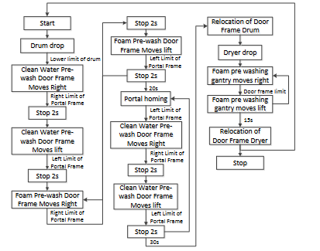

**Block Diagram:**

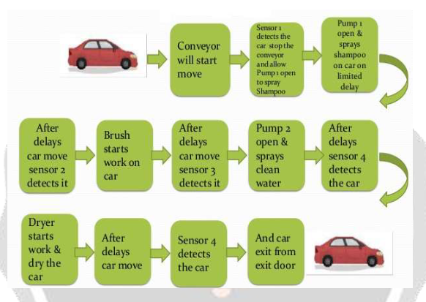

Working:

A 230V AC Supply is given as input to the SMPS for obtaining 24V DC, since PLC can operate at 24V DC. Terminal Block is used for multi inputs and outputs. PLC is connected to PC through RS-232 communication cable for downloading or uploading the program. Conveyor is used for shifting the car through various stages of washing. We use 100 rpm DC motors for driving the conveyor belt via pulley and for driving brushes . Generally brushes are now either cloth , or a brush, which does not hold dirt or water. High pressure nozzles are pointed at various position for spraying soap solution and water to clean difficult to reach parts of the vehicle. At the end, hot steam air is generally used for drying the car. A visual programming language known as the Ladder Logic was used to program the PLC. An Infrared sensor is used which emits radiation in order to sense presence of car at the entry level. Once the Infrared radiation is cut by the car an input signal is given to PLC. As an input signal is received, PLC starts executing the Ladder Program. First the conveyor moves by fixing a timer for few sec. After that, it stops at the stage of washing. In general process, Car is cleaned by spraying soap solutions; rinsing, brushing, drying, waxing, etc. depends on the requirement of customer. We have chosen spraying water, Brushing and finally drying for cleaning the car. Each activity is carried out for a certain time period. Water is sprayed for few sec and nozzle is closed. Then four brushes rotate for few sec and stops. Now the conveyor starts moving to next stage. After few sec, it stops for drying. Two fans are used for drying the car up to few sec. Then the conveyor carrying car moves to the exit level. Again an IR sensor senses the car and sends an input signal to Programmable logic controller.

**Advantages:**

1) The whole system is automatic so no manpower required

2) If we use special car washing pressure pumps no compressor will required

3) Can be use in domestic service stations, as there is no compressor & number of loud noise

4) Very less maintenance

5) Comparatively cost of system is less

6) No. more space required. No. environmental pollution.

**Applications:**

1.In car manufacturing companies. After final assembly of car.

2. In service stations.

3. Car replacing and maintaining stations.

4. Car body building industry

**Conclusion:**

This design is based on PLC automatic car wash control system, which has high efficiency, strong stability, low cost, greatly improves the car wash efficiency and automation, and can realize the switch between manual and automatic modes. The PLC controller is stable, reliable, easy to maintain and compatible. It can work in various environments. The automatic car washing control system not only cleans all aspects of the vehicle, but also adapts to many types of vehicles, and has practical application value

**FUTURE SCOPE:**

Using this concept in more compact and efficient way, multiple case studies for industrial applications as well as domestic can be carried out. In order to save water we can implement water

recycling or purifying system to wash cars. With required systematic hardware arrangement system can be used to wash trains, Buses, trucks, etc. too.

**REFERENCES:**

[1] X.D.Wang, Design of Integrated Automation Control System, Electrical Age. 6(2011) 118-120.

[2] S.P.Ji, Siemens PLC and Industrial Network Technology, Xi'an: Machinery Industry Press, 2008.

[3] G.X.Zhu, Control system of train automatic cleaning machine based on PLC and configuration

software, Electrical technology, 2010(6), pp.30-31.

[4] T.Y.Zhang, S.Ma, Z.Liu, Design of Automatic Car Washing Control System Based on PLC,

Mechanical Engineering and Automation, 2018(4), pp.177-179

[5] Janik, A. Kupiec ," Trends in Modern Car Washing Polish J. of Environ. Stud. Vol. 16, No.6 (2007).

[6] International Journal of engineering science and computing Automatic car washing system using PLC volume 6, Issue 5, may 2016

[7] International Journal Of Innovative Research In Electrical, Electronics, Instrumentation And Control Engineering Vol. 4 Issue 4, April 2016. Do not use the word "essentially to mean "approximately" or "effectively"

[8] International Journal of innovative research and technology Automatic car washing system using PLC.

[9]. Amir Hossein Daei Sorkhabi, Bika Khazini, “Manufacturing of Full Automatic Carwash Using With Intelligent Control Algorithms” IEEE Vol:7 No:3,2013.

## [10]. Introduction to PLC controllers Author: Nebojsa Matic Publisher: Mikroelektronika Publishing year: 2007