**“MedSyncBlock”-** **Leveraging Blockchain Technology for Secure and Collaborative Disease Diagnosis in Healthcare.**

**Alagu sundaram R1, Ragul M2, Arun kumar GV3**

1Student, ComputerScienceEngineering, Sri Venkateswaraa college of Technology, Chennai, Tamilnadu, India

Student, ComputerScienceEngineering, Sri Venkateswaraa college of Technology, Chennai, Tamilnadu, India

Student, ComputerScienceEngineering, Sri Venkateswaraa college of Technology, Chennai, Tamilnadu, India

**ABSTRACT**

This study explores the integration of blockchain technology in healthcare systems, focusing on enhancing data security, interoperability, and patient privacy. Through the development of a secure medical record system using blockchain and a chatbot assistant for personalized patient care, we aim to revolutionize healthcare delivery. Our methodology involves designing and analyzing the system's performance, including user interactions and data management. Results demonstrate improved data accessibility, security, and patient engagement. This research highlights blockchain's potential to transform healthcare by ensuring data integrity, enhancing communication, and enabling collaborative research.

**Keywords:** Blockchain, healthcare, medical records, chatbot, data security.

1. **INTRODUCTION**

Our project endeavors to transform healthcare data management by harnessing the power of blockchain technology and integrating intelligent chatbot assistance. With a primary focus on bolstering security, interoperability, and patient engagement, our initiative aims to tackle the pressing challenges confronting the healthcare sector. By leveraging blockchain's decentralized and immutable framework alongside sophisticated chatbot capabilities, we aim to establish a resilient system that ensures data integrity, fosters seamless collaboration among stakeholders, and empowers patients to actively manage their health information. Through this comprehensive approach, we envision a future where healthcare data is securely managed, seamlessly accessible, and intelligently utilized to drive improved patient outcomes and healthcare delivery efficiency.

1. **METHODOLOGY**

In the section, we outline our systematic approach to integrating chatbot assistance for enhanced user interaction and support. This involves data collection, analysis, and the implementation of chatbot integration and blockchain technology.

**2.1 Data Collection and Analysis**

Through rigorous data gathering and meticulous analysis, we ensure the acquisition of relevant insights essential for effective chatbot implementation and blockchain integration.

**2.2 Chatbot Integration Strategy**

Employing cutting-edge AI algorithms and natural language processing techniques, we devise a robust chatbot integration strategy aimed at enhancing user interaction and streamlining access to medical records.

* 1. **Blockchain Integration Strategy**

Leveraging blockchain's immutable ledger technology, we establish a secure and transparent framework for seamlessly integrating medical records, ensuring data integrity and privacy while fostering trust among stakeholders.

1. **MODELING AND ANALYSIS**

In Modeling and Analysis, we integrate patient and hospital information with the admin section, enabling access to both sets of data. Additionally, the chatbot is designed to provide responses to inquiries from both patients and hospitals**.**

**Figure 1: Integrated Flow Diagram**

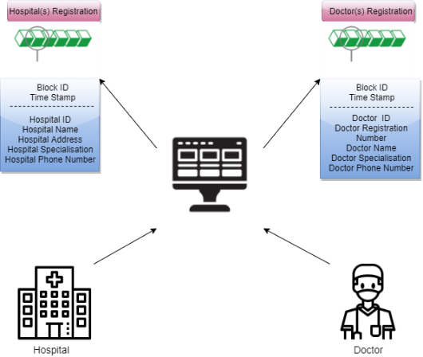

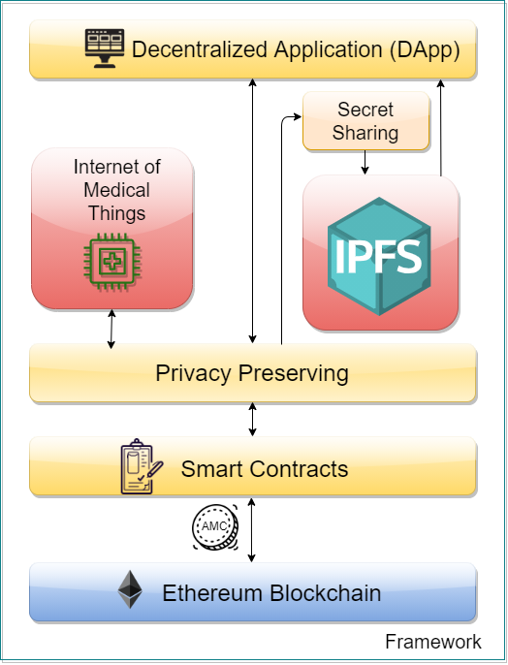

**Figure 2:** System Architecture

1. **RESULTS AND DISCUSSION**

In this Section results and discussion of the study is written. we delve into the outcomes of our system integration, exploring its impact on data sharing, communication enhancement, and overall healthcare service delivery

Our efforts underscore the importance of leveraging technology to empower patients, accelerate medical research, and ensure the delivery of high-quality care. As we move forward, we remain committed to advancing our solutions and driving further innovation in health care delivery .

**Figure 1.** Sample Interface

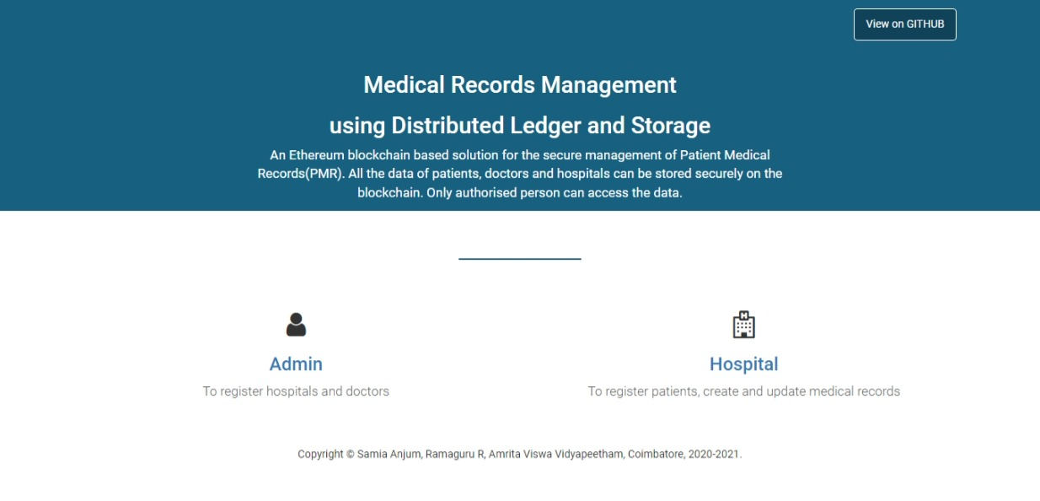

Future enhancements include advanced machine learning integration, expanded blockchain functionalities, and strategic partnerships for enhanced data interoperability..

1. **CONCLUSION**

In conclusion, our study underscores the significance of integrating patient and hospital information within the administrative framework, augmented by chatbot assistance. This approach enhances accessibility and efficiency in healthcare management, paving the way for streamlined patient care and improved communication channels.

1. **REFERENCES**
2. https://srinivaspublication.com/wp-content/uploads/2021/07/10.-Review-of-Blockchain_Fullpaper.pdf
3. https://ieeexplore.ieee.org/abstract/document/10015729/
4. Ancile: Privacy-preserving framework for access control and interoperability of electronic health records using blockchain technology - ScienceDirect
5. OmniPHR: A distributed architecture model to integrate personal health records - ScienceDirect
6. J. Huang, Y. W. Qi, M. R. Asghar, A. Meads and Y. Tu, "MedBloc: A Blockchain-Based Secure EHR System for Sharing and Accessing Medical Data," 2019 18th IEEE International Conference On Trust, Security And Privacy In Computing And Communications/13th IEEE International Conference On Big Data Science And Engineering (TrustCom/BigDataSE), Rotorua, New Zealand, 2019, pp. 594-601, doi: 10.1109/TrustCom/BigDataSE.2019.00085
7. Ethereum Whitepaper | ethereum.org
8. E. Daraghmi, Y. Daraghmi and S. Yuan, "MedChain: A Design of Blockchain-Based System for Medical Records Access and
9. Permissions Management," in IEEE Access, vol. 7, pp. 164595-164613, 2019, doi: 10.1109/ACCESS.2019.2952942.
10. (PDF) BLOCKCHAIN: IT'S STRUCTURE, PRINCIPLES, APPLICATIONS AND FORESEEN ISSUES (researchgate.net)
11. M. M. Madine et al., "Blockchain for Giving Patients Control Over Their Medical Records," in IEEE Access, vol. 8, pp. 193102-193115, 2020, doi: 10.1109/ACCESS.2020.3032553.