SEISMIC PERFORMANCE ASSESSMENT OF IRREGULAR REINFORCED
CONCRETE STRUCTURES: A COMPREHENSIVE STUDY ON THE IMPACT OF
CONFIGURATIONALLY IRREGULARITIES

BHASKAR¹, Mr. SANDDEP PANNU²

¹ M.Tech Scholar,Matu Ram Institute Of Engineering & Management, Rohtak, India
Bhaskarmalik63@gmail.com

2 Assistant Professor, Matu Ram Institute Of Engineering & Management, Rohtak, India
sandeeppannu4628@gmail.com

ABSTRACT

The seismic performance of reinforced concrete (RC) structures is greatly affected by irregularities in their construction, which presents issues for structural engineers and designers. This research thoroughly examines the seismic behaviour of reinforced concrete buildings, taking into account different types of imperfections in their layout.
The research employs sophisticated computational tools and analytical approaches to assess the dynamic behaviour of reinforced concrete (RC) buildings with various irregularities, such as plan abnormalities, vertical setbacks, mass irregularities, and reentrant corners. The finite element analysis (FEA) is performed using cutting-edge software to model seismic loading conditions and evaluate structural reactions.
The study investigates how configuration inconsistencies affect crucial seismic performance characteristics, including base shear, inter-story drift, floor acceleration, and mode shapes. Parametric studies are performed to investigate how changes in irregularity types, magnitudes, and positions affect the structural response.
Moreover, the research examines the efficacy of several seismic design provisions and retrofitting procedures in improving the seismic resilience of irregular reinforced concrete buildings. The research seeks to provide useful insights into the most effective design and retrofitting methods for reducing the seismic susceptibility caused by configuration abnormalities, using a comparative analysis.
The results of this research enhance our knowledge of how irregular reinforced concrete buildings behave during seismic events and provide practical recommendations for enhancing their seismic performance. The study ultimately seeks to enable the creation of stronger structural designs that can resist seismic pressures, thereby assuring the protection of people and assets in locations prone to earthquakes.

Key Words: (MSE) Seismic performance assessment, Irregular reinforced concrete structures, Configuration irregularities, Structural response, Finite element analysis (FEA)

INTRODUCTION

Irregularities in the construction of reinforced concrete (RC) buildings have a significant impact on their seismic performance, posing challenges for structural engineers and designers. This study comprehensively investigates the seismic performance of reinforced concrete structures, considering various forms of defects in their arrangement.
The study utilises advanced computational tools and analytical methods to evaluate the dynamic behaviour of reinforced concrete (RC) structures with different irregularities, including plan abnormalities, vertical setbacks, mass irregularities, and reentrant corners. Seismic loading conditions and structural responses are evaluated with the use of advanced software in the process of finite element analysis (FEA).
The research examines the impact of configuration discrepancies on key seismic performance parameters, such as base shear, inter-story drift, floor acceleration, and mode shapes. Parametric studies are conducted to examine the impact of variations in irregularity types, magnitudes, and locations on the structural response.
In addition, the study investigates the effectiveness of various seismic design regulations and retrofitting methods in enhancing the seismic resilience of irregular reinforced concrete structures. The study aims to provide valuable insights into the optimal design and retrofitting techniques for mitigating seismic vulnerability resulting from configuration irregularities, via a comparative analysis.
This study improves our understanding of the behaviour of irregular reinforced concrete structures during earthquakes and offers practical suggestions for improving their ability to withstand seismic occurrences. The research aims to facilitate the development of more robust structural designs capable of withstanding seismic stresses, therefore ensuring the safety of individuals and safeguarding assets in earthquake-prone areas.

Earthquake

An earthquake may be defined as the shaking of the Earth's surface caused by the abrupt release of energy due to the movement of the Earth. The movement of the Earth is a result of the movement of tectonic plates. The Earth's lithosphere is surrounded by several large tectonic plates that constantly move in relation to one other. This phenomenon is caused by the unexpected coming together of these elements, leading to the release of energy that travels towards the Earth's surface as waves.

Earthquake Zones Of-India:

Division of India on the basis of earthquake zones is mentioned below:
Zone 2: it attracts very less earthquake forces consisting less earthquake intensity causing zone factor to be very low.
Zone 3: having medium earthquake intensities of earthquakes since it attracts medium earthquake forces, the zone factor is above zone 2 lying in medium range.

Zone 4: attracts moderate earthquake forces having moderate intensities of earthquake and the zone factor is moderate.
Zone 5: The structure is subject to significant shaking with high magnitude due to the elevated zone factor.

Irregularities:

A structure is irregular when limits specified by the standards are exceeded for structural parameters.
Table 1 shows the limits of re entrant corner (RI) and torsional (THI), mass (MVI), stiffness (SVI), and vertical geometric (VIG) irregularities as per (IS: 1893:2016(part-1))
Table 1 limits for irregularities prescribed as per (IS: 1893:2016(part-1))
Classification Of Irregularity | Type Of Irregularity | Limit
A. Horizontal irregularity | a) Re Entrant corner(RI) | RIX <=15%
 | b) Torsional(THI) | ΔMAX <= 1.5ΔAVG
B. Vertical irregularity | a) Mass(MVI) | MVIX<1.5MVIY
 | b) Stiffness(SVI) | SVIX<SVI1+X
 | c) Vertical geometry(VIG) | VIG<1.25VIGY

X= Number of the Storey, Y = Number of the Adjacent Storey, ΔMAX = Maximum Deformation and-ΔAVG = Average Deformation
The state of the structure being perfectly regular. is an ideal condition but in real life structures are usually irregular. Original forces which act on structures are always more than design forces. Overall earthquake performance of the irregular structure is significantly reduced As a result of earthquake activity, additional strain, movement, and distortion are generated.A model structure should pass all the design checks in order to get a safe design.
Structures with irregularities are bound to be constructed by engineers due to the increasing need of appealing for structures. Sometimes, irregularities are provided due to different functionality of the building i.e. for buildings with an unfamiliar resolutions. However, it is undeniable that vulnerability of such types of irregular structures is increased in earthquake or any dynamic event. The response of the building is considerably affected by torsion in addition to stiffness and stiffness of-structure. Decrement in structural stiffness makes structure more susceptible to the large displacement as structures reduced geometrically to provide provision for setbacks which might turn destructive in nature. Mass of structure plays important role in affecting building response, large torsional moment will be developed if mass of building is concentrated at particular portion which is not recommended in designing. For overcoming these irregular configuration building defects, effective assessment methodology is to be followed which is adept in investigating these weak zones in the structures.

Types of Irregularities

The basis classification of Structural irregularities is of two types:

- Plan irregularities
- Vertical irregularities

Table .2.Plan irregularities as per IS 1893(part-1):2016

Plan irregularities as per IS 1893(part-1):2016
Type Of- Irregularity  SNo. | Description
1. Torsion Irregularity | It is considered when floor diaphragms are rigid in plan when compared with lateral force resisting vertical structural members. Condition of torsional irregularity arises when eccentricity is used to compute the max. storey drift of one side is 1.2 times avg. storey drift of two sides
2. Re – entrant corners | Re-entrant corner on lateral force resisting system and plan, with fifteen percent projection beyond re-entrant in a direction
3. Diaphragm Discontinuity | Abrupt discontinuous diaphragm or varied stiffness with open or cutout of greater than fifty percent for one storey to another
4. Out of plane offsets | Out of plane offsets leading to discontinuity in lateral force resisting  path
5. Non parallel Systems | Non parallel or symmetrical along major axis of vertical lateral force resisting members

Table.3.Vertical irregularities as per IS 1893(part 1):2016

Vertical Irregularities (IS 1893 (Part 1): 2016)

SNo. | Irregularity Type | Description
1. Stiffness Irregularity |  | Soft storey: lateral stiffness less than eighty percent for three stories above or seventy percent of single storey  Extreme Soft storey: lateral stiffness less than seventy percent for three stories above or sixty percent of single storey  For example: STILTS in buildings
2. Mass Irregularity |  | Earthquake weight of a floor more than two hundred times of adjacent floor this doesn’t include roofs
3. Vertical Geometrical Irregularity |  | Horizontal dimension is one fifty times of adjacent storey for lateral resisting force
4. In Plane Discontinuity |  | Greater length of in plane offset of members than vertical lateral force resisting elements

OBJECTIVES
The objectives of this research are:-

- Classify and categorise different forms of configuration anomalies in reinforced concrete constructions.
- Examine the impact of plan flaws on the seismic behaviour of reinforced concrete structures.
- Examine the impact of vertical setbacks on the dynamic response of irregular reinforced concrete structures subjected to seismic forces.
- Evaluate the influence of large-scale imperfections on the structural behaviour during seismic occurrences.
- Analyse the importance of reentrant corners in worsening the susceptibility of reinforced concrete structures to seismic damage.
- Measure essential seismic performance factors, such as the amount of force exerted on the foundation (base shear) and the displacement between adjacent floors (inter-story drift), in irregular reinforced concrete (RC) buildings.
- Analyse and differentiate the seismic behaviour of irregular reinforced concrete structures in comparison to regular ones.

- Perform parametric analyses to investigate the impact of different kinds and magnitudes of irregularities on the structural response.
- Examine the effectiveness of seismic design regulations in reducing the impact of structural anomalies.
- Suggest retrofitting methods to improve the seismic resilience of irregular reinforced concrete buildings and decrease susceptibility to seismic risks.

LITERATURE REVIEW

Mohammed Affan, Md. Imtiyaz Qureshi, Syed Farooq Anwar (Nov 2018): This study aims to conduct a comparative assessment This paper discusses the utilisation of dynamic and static techniques to assess the earthquake resistance of tall structures in different earthquake regions and soil conditions. using E Tabs software. This paper presents a technical assessment of a multi-storey building in various earthquake zones across India, considering different soil types ranging from medium or soft soil to hard or rocky soils. The assessment includes both static and dynamic assessments. The assessment was conducted using the E Tabs software. The building's earthquake and wind loading conforms to the standards set by the IS codes. Upon conducting an assessment of the building design parameters, including storey drift and storey torsion, a comparison was made across various zones. The conclusion drawn is that static assessment yields greater values for all parameters, including displacement, torsion, and drift, when compared to dynamic assessment.
RaviKumar, P Raghava, Dr.T.Suresh Babu (April 2017): “Performing earthquake assessment on high-rise structures across varying earthquake zones. This paper presents an assessment of Response Theory for the G+20 Building using Finite Element Method (FEM) software known as E Tabs. employed to examine the subject matter. Response A spectral assessment was conducted on a 90-meter tall structure across multiple earthquake zones, with varying wind speeds and zone factors for each zone. Based on the structural assessment, it has been determined that the performance of the building in Zone 2 is favourable in comparison to other zones. The stability indices value in Zone 3 is 170% greater than that of Zone 5.
Siva Naveen E, Nimmy Mariam Abraham et al (2018): “Earthquake assessment of non-linear structures. This paper presents a study on the structural behaviour of a multi-storey frame with a single irregularity and multiple irregularities The anomalies being taken into account are: The technical terms for the aforementioned irregularities are Mass Discontinuity, Vertical Discontinuity, Tension Discontinuity, and Stiffness Discontinuity, respectively.It has been noted that frames exhibiting singular or multiple irregularities undergo alterations in their response. The amalgamation of rigidity and vertical non-uniformity has demonstrated the highest displacement reaction, while the amalgamation of inwardly curving corners and vertical non-uniformity has demonstrated the highest displacement.
Rakshith G.M, Panender Naik G, et al (2019): “The present study investigates the impact of lateral forces on tall structures in various zones using E Tabs software. The structures in question is a G+20 RCC structure. The structural wind loads are evaluated in accordance with IS 1875 Part 3, while the earthquake loads are assessed in accordance with IS 1893 2016. The structural modelling software employed is E Tabs. Upon completion of the building assessment, the subsequent findings have been deduced.

MV Naveen, KJ Brahma Chari (2016): “A technical investigation was conducted on the dynamic and static evaluation of a multi-storey building. The following document outlines the performance of a reinforced concrete multi-level houses structure (consisting of ground floor and ten additional stories) located in earthquakes zone 2 during an earthquake. The earthquake zone 2 employs a significance factor of 0.10, 0.16, 0.21, 0.36 and a reaction decrease factor of 3. The assessment is performed utilising two techniques, namely Similar static and The dynamic techniques, employing E Tabs software. A zone-wise assessment has been conducted to examine the parameters of the design. The conclusion drawn is that static assessment produces shifting amounts that are greater than those obtained through dynamic assessment. - The increase in storeys results in a corresponding improve in base shear. - The dynamic evaluation is necessary in addition to static evaluation for tall structures.
A. Fathima, Shashi Kumar N V Assessment of the The earthquake Performance of Vertical Uneven Buildings in Varied The earthquake Zones. In this paper a RCC building with 15 storey is analyzed for irregularity of re-entrant corner using equivalent static assessment and push over method of assessment for all the earthquake zone, soil condition and wind speeds. Assessment is carried out using ETABS. Assessment is done for irregularity and a comparison between equivalent static method and pushover assessment is carried out and result obtained can be concluded as:
- Zone-5 gives maximum response for all the cases under consideration.
- Push over assessment gives less response when compared with equivalent method responses.

P A Krishnan, N Thasleen Performing earthquake assessment on reinforced concrete building frames with plan irregularities. In this paper a RCC building with 15 storey is analyzed for irregularity of re-entrant corner using push over method of assessment for earthquake zone-V. Assessment is carried out using ETABS. Assessment is done for irregularity and strengthening technique and result obtained can be concluded as:

- With an increase in dimension of projection, an increase in storey displacement is observed.
- At re-entrant corners, high level of stress concentration are observed.

METHODOLOGY

Building Considered for the Analytical Study For present work seismic analysis is carried out for reinforced concrete moment resisting building frame having (PLINTH+G+15) storey situated for ground slope. Analysis & design arecarried out by using ETABS.
In civil structurestatic analysis is performfor R.C.C frame regular and irregular building up to G+15 storey by using Dynamic Analysis method. The problems introduced due to discontinuity in stiffness, mass and geometry of Structure. Therefore, the structural engineer needs to have a thorough understanding of the seismic response of irregular structures. Several related studies have focused on evaluating the response of ‘Regular Structures” However, there is lack of understanding of the seismic response of structure with irregularities.
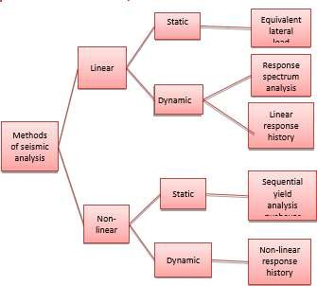

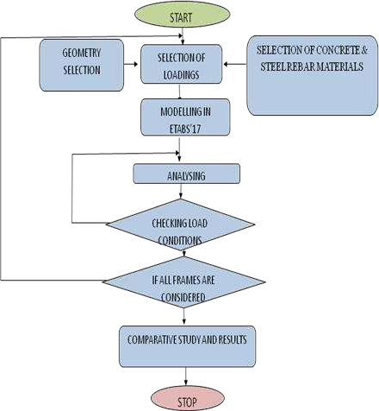

Table No.1: MODELLING & PROBLEM FORMULATION

S.NO | Description | Value
1. | Area | 16 X 20 m
2. | Number of bays in X- direction | 4
3. | Number of bays in Y direction | 5
4. | Overall height | 45m
5. | Seismic zone | V
6. | WALLS | RED BRICK
7. | SUPPORT TYPE | FIXED SUPPORT

PARAMETERS FOR REGULAR AND IRREGULAR STRUCTURE:

S.NO | DESCRIPTION | SIZES
1. | Type of Structure | Framed
2. | Type of Building | Residential
3. | Number of storey | 16(G + 15)
4. | Height of storey | 3 m
5. | Cross section of beams | 300x500mm
6. | Cross section of columns | 500x500mm
7. | Slab Thickness | 150mm
8. | Grade of concrete | M25
9. | Grade of steel | Fe 500
10. | Dead Load | 1 factor

Table no.3 Loadings….

S.NO | LOAD PARAMETERS | DESCRIPTION
1. | DEAD LOAD | - WALLLOAD-  5KN/M2  - SLABLOAD  4.8KN/M2
2. | LIVE LOAD | 2 KN/M2
3. | SEISMIC LOAD | AS PER IS 1893- 2012
4. | SEISMIC ZONE | V
5. | SITE LOCATION | VERY SEVERE
6. | IMPORTANCE FACTOR | 1.2
7. | SOIL PROPERTY | HARD SOIL

IRREGULAR BUILDING
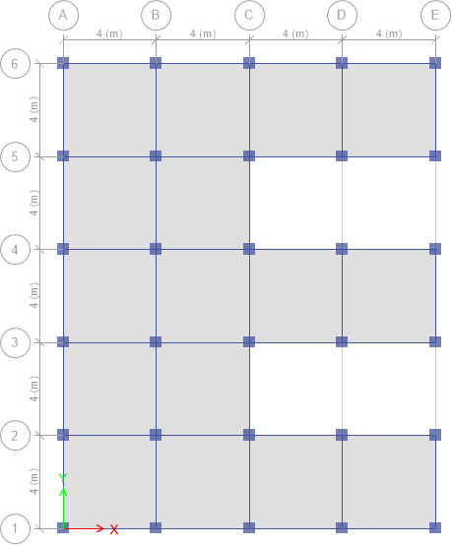
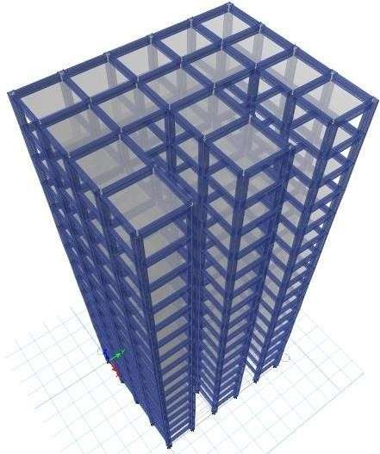

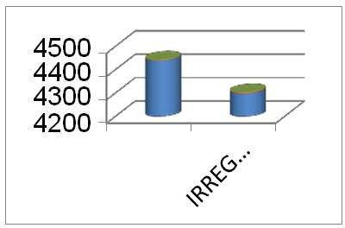

Table No. 10 STOREY DISPLACEMENT

Conclusions

Based on the work presented following conclusions can be drawn:

Amount of setback increases, the shear force also increases. The irregular building frames possess very low shear force compared to setback regular frames.
The critical bending moment of irregular frames is lesser than the regular frame for all the storey heights. This is due to decrease in stiffness of building frames due to setbacks.
According to results of Dynamic Response method, the stiffness irregular building experienced larger inter storey drifts as compared to regular frame and geometric irregular frames.
It is seen that the storey displacement of 15th storey is maximum among all the frames and the stiffness irregular structure frame has maximum joint displacements for all the floor levels. However, regular and both the verticalgeometric frames have almost variant joint displacement
The seismic performance of regular frame is found to be better than corresponding irregular frames in nearly all the cases.
Therefore it should be constructed to minimize the seismic effects. Among setback frames, the geometric irregular frame 1 building having setback at 3rd floor configuration is found superior than others

REFERENCES

[1].“Comparative Study of the Static and Dynamic Analysis of MultiStorey Irregular Building” Bahador Bagheri, Ehsan Salimi Firoozabad, and Mohammadreza Yahyaei [2]. Static and Dynamic Behaviour of Reinforced Concrete Framed Building: A Comparative Study [3]. Prakash Sangamnerkar*, Dr. S. K. Dubey
[2]. Professor, Deptt. Of Civil Engineering, Maulana Azad National Institute of Technology, Bhopal (M.P.) 462051 Response Analysis of Multistory RC Buildings under Equivalent Static and Dynamic Loads According to Egyptian Code Sayed Mahmoud1, Waleed Abdallah2

[3]. N. Lakshmanan, K. Muthumani, G. V. RamaRao,N.Gopal krishnan and G. R. Reddy (2007), "Verification of Pushover Analysis Method With Static Load Testing", International Workshop on Earthquake Hazards and Mitigation, Guwahati, India, 78 December2007.

[4] . Pardeshi S, N. G. Gore, “Study of seismic analysis and design of multi storey symmetrical and asymmetrical building”, International Research Journal of Engineering and Technology, Volume03, Issue01, pp.732737, January 2016.
[5]. Kumar P, A. Naresh , M. Nagajyothi, M. Rajasekhar, “Earthquake Analysis of Multi Storied Residential Building”, International Journal of Engineering Research and Applications, Volume 4, Issue 11, pp.5964, November 2014.
[6]. Neha P. Modakwar, Sangita S. Meshram, Dinesh W. Gawatre (2014),“Seismic Analysisof Structures with Irregularities" IOSRJournalof Mechanical and Civil Engineering (IOSRJMCE) eISSN:22781684, pISSN:2320334XPP6366

[7]. Dr.S.K.Dubey&P.D.Sangamnerkar (2011), "Seismic Behaviour of Asymmetric RC Buildings", International

[8]. Journal of Advanced Engineering Technology EISSN 09763945, IJAET/Vol.II/ Issue IV/October December, 2011/296301
[9].Chourasiya Rahul, Rashmi Akalle, “Seismic Evaluation Of MultiStoried R.C. Structure Using Different Floor Diaphragms”, International Journal Of Research In Engineering, And Technologies,Volume02, Issue, 09, pp. 641648 December 2015.M. Young, The Technical Writer’sHandbook. MillValley,CA:University Science, 1989.
[10].Dubey S. K, Sangamnerkar P. D, “Seismic Behaviour Of Asymmetric RC Buildings”, International Journal Of Advanced Engineering, Volume02,SpecialIssue04,pp.641648,(2011).

