**WATER PROOFING OF THE STRUCTURE BY USING SODIUM POLYACRYLATE**

**Sanmit P. Nalawade*1, Abhijit B. Shendge*2, Kamal M. Sharma*3**

*1P.G. Student, Department of Civil Engineering, Dattakala Group of Institutions Faculty of Engineering, Bhigwan, Maharashtra, India.

*2,3Assistant Professor, Department of Civil Engineering, Dattakala Group of Institutions Faculty of Engineering, Bhigwan, Maharashtra, India.

**ABSTRACT**

In our day to day routine, cotton, paper and wipes are usually used to retain water. These materials retain a couple of times their weight of water and have rather unfortunate properties concerning water maintenance. In any case, a few sorts of polymers and copolymers really do work as high water sponges, having generally excellent water maintenance properties and high proclivity towards water. These polymers are named as Super Permeable Polymers As referenced above superabsorbent polymer can ingest water up to a few thousand seasons of its own weight and hold this water under tension. The assimilated water can be delivered gradually at the point when the SAP is placed in dry air to keep up with the dampness of the climate. Superabsorbent polymers (SAPs) are materials that can assimilate and hold enormous volumes of water and fluid arrangements. This makes them ideal for use in water engrossing applications like child nappies and grown-ups incontinence cushions to spongy clinical dressings and controlled discharge medium.

**Keywords:** Waterproofing, Sodium Polyacrylate, Very Spongy, Superabsorbent Polymers.

**INTRODUCTION**

In now days, because of urbanization and modernization there is quick development in development of building, houses, individual homes, towers, loft, business and public structures. For these recently built structures it is needful to give the waterproofing treatment to a come in part the contact with the water. Any other way water will infiltrate into it and makes the harm the individuals, additionally decreases the existence of the design that is why it is vital movement in the development process. Waterproofing is the arrangement of an impenetrable layer or a hindrance over surfaces of establishments, rooftops, walls, Section and other cement primary individuals. The capability of the impermeable layer hindrance is to forestall water entrances onto those individuals. The structure surfaces, Section, Depressed Section are made water-safe and in some cases waterproof to build the strength and the existence of the design. Additionally to forestall the issue happens from the water leakage.

The utilization of fluid waterproofing layer, cementations materials, polyurethane fluid layer, Fluid waterproofing synthetic substances, TPN sheets, Waterproof preliminary paints and bituminous material are normal in the waterproofing of structures. Waterproofing treatment is important for the individuals who are straightforwardly presented to the daylight, Water, what's more, ground water and day to day consumable water, for example, storm cellar, walls, washrooms, kitchen, galleries, decks, porch or rooftops, green rooftops, water tanks, and pools, and so forth.

**OBJECTIVES OF WORK**

* To diminish the water penetrability into part.
* Figure out new waterproofing procedure and material
* To lessen the expense of the waterproofing treatment.

**LITERATURE REVIEW:-**

Prior to venturing to the genuine review work, the accessible distributed materials connected with waterproofing framework, regular sorts of the waterproofing, technique for waterproofing framework were concentrated cautiously. Additionally distributed project reports of this framework, leaflets, booklets and books accessible on web were examined and assessed. Likewise concentrate on the way of behaving of the Sodium Polyacrylate with concrete and cement. It were considered and audited to follow articles during this task work.

**1] Wenhua Zhuang, Longguo Li, Chao Liu, et.al.**

***-Effects of Sodium Polyacrylate on water retention and infiltration capacity of a sandy soil.***

In this article writer examined about the conduct of the sodium Polyacrylate in the dirt soil. Its consequence. Likewise examined about the impact on the porousness of the dirt.

From this article we can concentrate on the way of behaving and the water maintenance property of the sofium Polyacrylate.

**2] M. Achyutha Kumar Reddy, et.al.**

***-Experimental study on strength and durability parameters of concrete by partial replacement of cement with sodium Polyacrylate*.**

In this examination paper creator do some exploratory concentrate on the sodium Polyacrylate and examined the consequence of this trial with respect to strength and the solidness. Likewise they play out the different synthetic assault tests on it for 28 days. The sodium Polyacrylate was bomb in the pressure strength yet finish the compound assault assessment.

**3] Mohammad Daoud, Moayyad Al-Nasra, et.al.**

***-The Use of Super Absorbent Polymer as a Sealing Agent in Plain Concrete.***

The very permeable polymer (SAP) has the capacity to retain moderately enormous measure of water what's more, convert it into gel simultaneously the volume increments relatively. These properties are found to be exceptionally helpful and successful in plain concrete. Likewise the utilization of very retentive polymer in concrete is demonstrated to affect the properties of cement in its the two phases; new concrete and solidified concrete. This study centers on the water snugness properties of plain concrete with time. The review incorporates present moment and long term impact of the very permeable polymer on the water fixing properties. There are likewise quite a large number benefits of the utilization of the very spongy polymer in plain cement including giving inside water source..

**4] Ting Xu, Wenxiang Zhu and Jian Sun, et,al.**

***-Structural Modifications of Sodium Polyacrylate to Enhance Its Water Absorption Rate.***

Superabsorbent polymers (SAPs) can retain a lot of water and track down expansive applications in different enterprises. There are many reports on the blend and primary alteration methods to further develop the water retention property of SAPs. In any case, we see not many examinations on the correlation what's more, reconciliation of these strategies. In this review, three primarily adjusted SAPs were combined what's more, areassessed for the impacts of surface cross connecting, frothing, and the reconciliation of the two adjustments to further develop the retention rate and limit of a customary SAP.

**5**] **Ting Xu, Wenxiang Zhu and Jian Sun, et,al.**

***− Structural Modifications of Sodium Polyacrylate to Enhance Its Water Absorption Rate.***

Superabsorbent polymers (SAPs) can absorb a large amount of water and find broad applications in various industries. There are many reports on the synthesis and structural modification techniques to improve the water absorption property of SAPs. However, we see few studies on the comparison and integration of these techniques. In this study, three structurally modified SAPs were synthesized and are evaluated for the effects of surface cross-linking, foaming, and the integration of the two modifications to improve the absorption rate and capacity of a conventional SAP.

**6] Yash. A. Sangle, Swati. B. Kshirsagar, et,al.**

***− Study of Waterproofing Systems Methodology in Construction Management.***

Water seepage is one of the major sources of common building flaws. Seepage leads to mugginess, erosion of metals, fungus growth and also affects the structural characteristics of concrete as well as damage attractiveness of the structure. It also has hostile effect on human fitness by creating hostile condition. If water seepage can be prevented, almost 90% structure faults can be removed. Thus, choosing the top system for waterproofing plays a dynamic role in the protection of the structure. That’s why the study of waterproofing system is very important. This research paper helps to study the waterproofing systems with help of construction sites case study.

**7] Zhineng Tong, et,al.**

***− Research on Waterproof Technology of Construction Engineering.***

Waterproof construction is a comprehensive, practical, strong engineering; it relates to a waterproof material, waterproof engineering design, construction technology, building materials management and other parties, use function of building engineering plays a vital role. No seepage leakage, to ensure smooth drainage. The building has a good waterproof and the use of the function is the basic requirement of building waterproof technology. This paper according to the requirements was the elaboration and discussion.

**8] Gourav S. jankar, Vishwajeet R. Kale, et, al.**

***− Waterproofing Method for Slab – A Comparative Effective Analysis For Ashta Region.***

The study on waterproofing method of roof top slab, it is an essential component of aesthetic appearance and prevent structural damage. Water proofing requirement may vary with location and exposures condition to identify the waterproofing type material applications and quality controlling field survey are carried out so in this project going to conduct cementations waterproofing, liquid water proofing membrane, bituminous coating waterproofing, brick bat coba waterproofing.

**9] Md Azree Othuman Mydin1, Mohd Nasrun Mohd Naw, et,al.**

***− Assessment of Waterproofing Failures In Concrete Buildings And Structures.***

This paper focuses on waterproofing failures in concrete buildings and structures. The objectives of this paper are three folds; to determine the main factors that contribute to waterproofing failures in concrete buildings and structures to discover different types of present waterproofing system applied for concrete buildings and structures to propose remedial waterproofing solutions of concrete buildings and structures. There are 4 case studies were carried out at Cyberjaya, Malacca, Kuala Lumpur and Sere ban. Each of them consist of different type of building namely SOHO (small office), Commercial building, Hotel Building and shopping mall. The results obtained shows that the main factors that contribute to waterproofing failures in concrete buildings and structure are cracks, deteriorated waterproofing system, honeycombs in concrete and construction joint failure. At the moment there are few types of present waterproofing system applied for concrete buildings and structures such as cementations system, sheet membrane system and liquid system. Remedial waterproofing solutions of concrete building structures includes cleaning, removing old sealant or joint, injecting appropriate epoxy or chemical grout and applying a new layer of waterproofing system.

**INTRODUCTION TO SPA**

Until the 1980’s, water absorbing materials were cellulosic or fiber-based products. Choices were tissue paper, cotton, sponge, and fluff pulp. The water absorbent capacity of these types of materials is only up to 11 times their weight, but most of it is lost under moderate pressure.

In the early 1960s, the United States Department of Agriculture (USDA) was conducting work on materials to improve water conservation in soils. They developed a resin based on the grafting of acrylonitrile polymer onto the backbone of starch molecules (i.e. starch-grafting). The hydrolyzed product of the hydrolysis of this starch-acrylonitrile co-polymer gave water absorption greater than 400 times its weight. Also, the gel did not release liquid water the way that fiber-based absorbents do.

The polymer came to be known as “Super Slurper”. The USDA gave the technical know-how to several USA companies for further development of the basic technology. A wide range of grafting combinations were attempted including work with acrylic acid, acryl amide and poly vinyl alcohol (PVA). Polyacrylate/polyacrylamide copolymers were originally designed for use in conditions with high electrolyte/mineral content and a need for long term stability including numerous wet/dry cycles.

Sodium Polyacrylate is a water soluble polymer. The chemical structure of the polymer is shown below. The basic polymer is poly (acrylic acid), which has a carboxylic acid group on each repeat unit. In sodium Polyacrylate, the carboxylic acid groups are neutralized with a sodium counter-ion.

Sodium Polyacrylate is a super absorbent polymer is a polymer that can absorb many times it weight of liquid. Typically superabsorbent polymers absorb water. Sodium Polyacrylate is soluble in water. Cross linked sodium Polyacrylate, such as found in diapers will swell in water. This is driven by the dissociation of the sodium carboxyl ate salt in the water and the hydrogen bonding interactions between the water and the polymer.

Based on the laboratory study, the effects of sodium Polyacrylate (SP) was investigated at 5 rates of 0, 0.08, 0.2, 0.5, and 1%, on water retention, saturated hydraulic conductivity (Ks), infiltration characteristic and water distribution profiles of a sandy soil. The results showed that water retention and available water capacity effectively increased with increasing SP rate. The Ks and the rate of wetting front advance and infiltration under certain pond infiltration was significantly reduced by increasing SP rate, which effectively reduced water in a sandy soil leaking to a deeper layer under the plough layer. The effect of SP on water distribution was obviously to the up layer and very little to the following deeper layers. Considering both the effects on water retention and infiltration capacity, it is suggested that SP be used to the sandy soil at concentrations ranging from 0.2 to 0.5%.

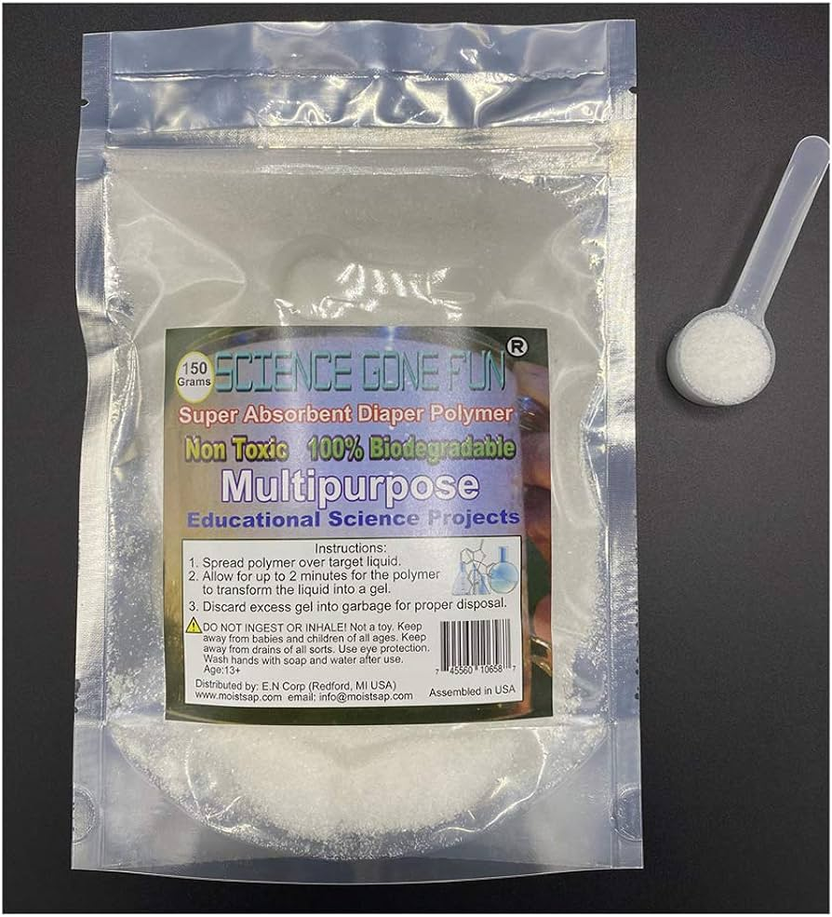 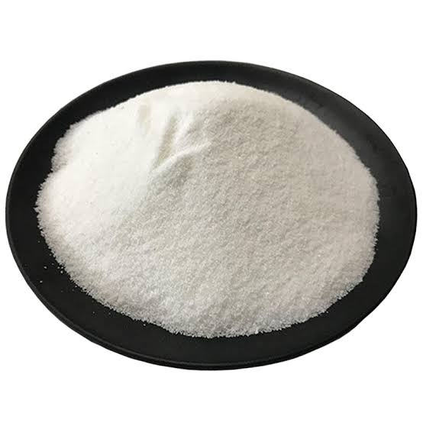

Figure No 01. Sodium Polyacrylate Powder

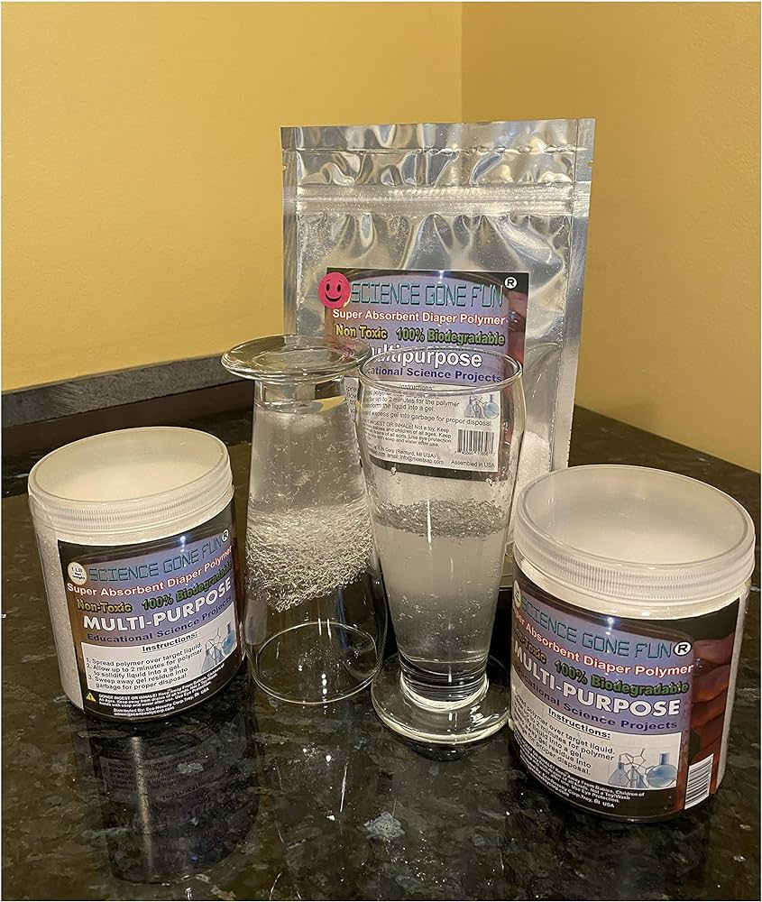 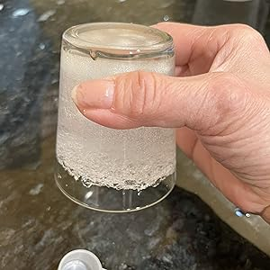

Figure No 02. Behavior of Sodium Polyacrylate Powder mix with water.

**PROCESS OF SPA CRYSTALLINE WATERPROOFING**

Crystalline waterproofing is an innovation that includes the improvement of precious stones to help accomplish watertight substantial designs. The fundamental thought behind translucent waterproofing is to forestall the development of water through the substantial by stopping of impeding the regular pores, vessels also, miniature breaks viewed as in all substantial. This stands rather than additional ordinary method for waterproofing, which typically includes applying a covering or film to the substantial surface, however is at some point additionally endeavored through densification of the substantial.

When added or applied to concrete, translucent synthetic compounds make a response that causes long, thin gems to frame and fill the pores, vessels and hairline breaks of the substantial. As long as dampness stays present, precious stones proceed to develop all through the substantial. When the substantial has restored and dried, the translucent synthetic substances sit lethargic until one more portion of water, (for example, through another break) causes the synthetic response to start once more and develop precious stones to shut down the water.

1. Surface to be ready by brush or packed air. All surfaces to be applied absolute requirement are liberated from dust, free material oil or some other material. Surface should be perfect and have an open slender surface.
2. Making the surface harsh by point processor or tucking on a superficial level.
3. Substantial piece with breaks, development joints, honeycombing, and so on should be treated with glasslike water stop grout. Prior to treating the surface, it ought to be wet by clean water.
4. Development joints ought to be treated by water stop grout. Blend water stop grout to clay consistency (4 section water stop grout to 1 section clean water) in a furrow of 15 mm*20 mm.
5. Tie Bar ought to be treated with water stop grout. Blend water stop grout to clay consistency (4 part water stop grout to 1 section clean water) in a score of 10 mm*15 mm.
6. Apply 2 layers of Glasslike in a slurry consistency with a characteristic fiber substantial brush utilizing a forceful round movement to cover the concrete. The delay between 2 coats ought to be 5-6 hours.
7. Pass on it to dry for 3-4 days. Presently the Translucent work is finished.



Figure No 03. Waterproofing of Bathroom duct with Sodium Polyacrylate Powder.

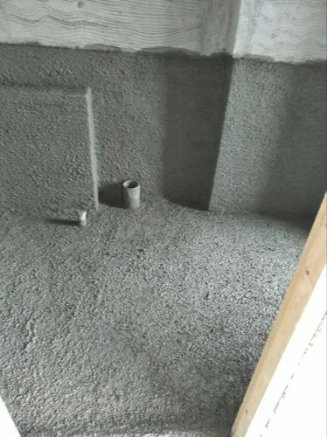

Figure No 04. Waterproofing of Bathroom duct with Sodium Polyacrylate Powder.

**APPLICATION**

* Artificial snow
* Water scavenger pouches to absorb water from hydrocarbon fuel and oil
* Artificial soils for hydroponics
* Drilling fluid additive usable in wellbores
* Sealing underground formations, joints in water-supply pipes, building constructions.
* Fiber optic cables.
* Polymer concrete compositions.
* Static demolition agent for destroying rock structures.
* Thickening sewage ,
* Absorbing moisture from powder of coking coal.
* Biomass support and carrier ,
* Antifouling coating for watercraft.
* Thermal energy storage.
* A dew-preventing coating.
* Preventing electrolyte leakage and electrode drowning.

**COST ESTIMATION**

For the experimental waterproofing by this method 2 numbers of the toilet duct elect having area of 24 sq.ft. of each (72” X 48”) . A one bag of cement bag covers almost 48 sq.ft. Area in single coat. For that area the SBR latex waterproofing chemical requires is 5 liters and 6 kg of Sodium Polyacrylate required. For per sq.ft. the approximate cost of the treatment calculated as follows;

1. **Cement:-**

$\frac{50 Kg.}{48 Sq.ft.÷ 2}$ ≅ 2.08 Kg./Sq.ft

1. **Chemical:-**

$\frac{10 liters}{48 Sq.ft. }$ ≅ 0.20 liters/Sq.ft

1. **Sodium Polyacrylate:-**

$\frac{6Kg}{48 sq.ft}$ ≅ 0.125 kg/Sq.ft

Table 1- Approximate cost calculation per sq.ft.

|  |  |  |  |  |
| --- | --- | --- | --- | --- |
| **Sr. No.** | **Material** | **Rate** | **Quantity required** | **Amount/Sq.ft** |
|  | | | | |
| **1** | Cement | 335/- / 50Kg | 2.08 Kg./Sq.ft | 14/- |
| **2** | SBR | 1600/- / 10Liters | 0.20 liters/Sq.ft | 32/- |
| **3** | Sodium Polyacrylate | 340/- / Kg | 0.125 kg/sq.ft | 43/- |
| **Total** | | | | 89/- |
|  | | | | |

For single coat of this material required approximate 89/- per sq.ft. and for double it is 180/- /sq.ft.. Adding the extra labor charges approximately 25/- to 30/- Per Sq.ft. By adding both material cost & labor charges it will be approximately 205/- to 215/- per sq.ft.

**RESULTS OF SPA CRYSTALLINE WATERPROOFING**

After the experimental investigation of the Sodium Polyacrylate in waterproofing techniques it is seen that the Sodium Polyacrylate help to achieve watertight concrete structures, cement layer by development of crystals in the homogeneous mix of concrete.

The cost of the Sodium Polyacrylate is also less so the waterproofing method cost is also low compare to the other traditional methods. Also the less time required to complete the process.

* The application of sodium Polyacrylate can increase the water-holding capacity of cement layer under different water potentials, including the maximum capillary water content and the wilting water level, and under the same water potential the larger the application amount of sodium Polyacrylate is, the larger the water holding capacity of concrete, and as for the treatment of 0.08% the increasing amount of application amount is significantly lower than the three other treatments.
* Sodium Polyacrylate effectively enhances the maximum water storage and water absorbing capacity of concrete, and water supply capacity increases in power function with the application amount increasing, and as for the treatment of 0.08% the increasing amount of application amount is significantly lower than the three other treatments;
* Sodium Polyacrylate significantly decreases the saturated hydraulic conductivity of concrete, and the larger the application amount is, the larger the decreasing degree of saturated hydraulic conductivity.

Table 2- Comparative study of traditional methods with SPA method

|  |  |  |  |
| --- | --- | --- | --- |
| **Sr. No.** | **Parameters** | **Traditional**  **Method** | **SPA Method** |
|  | | | |
| **1** | Cost of treatment | Cost is more | Cost is less |
| **2** | Time required | Time required for the treatment is more | Time required for the treatment is less |
| **3** | Dead Load of Structure | Dead load of structure is increase | Dead load of structure is remain same |
| **4** | Water Absorption capacity | Water Absorption capacity of this methods is less | Water Absorption capacity of this methods is more |
| **5** | Water Peculation possibility | Water Peculation possibility of this methods is more | Water Peculation possibility of this methods is less |
| **6** | Applying Method | Hard method to apply | Easy to apply |
| **7** | Material Required | Material Required is more | Material Required is less |
| **8** | Material Cost | Material Cost of this methods is more | Material Cost of this methods is less |
| **9** | Labor required | Skilled & more labor required | Semi skilled &less labor required |
|  | | | |

**CONCLUSION**

This work is devoted to the study of synthesis, properties and practical Applications of class of acrylic-based sodium Polyacrylate superabsorbent polymers. The techniques of solution, emulsion/gel polymerization were used for synthesis. Each absorbent was mainly characterized by its equilibrium capacity of water absorption and by the rate of absorption.

The swelling characteristics of the polymers were evaluated in terms of change in polymerization variables which include, type and amount of cross linker, monomer composition, and process of polymerization, temperature, initiator concentration, monomer concentration, Rate of agitation and particle size of the product. The swelling dependency on salinity, ionic strength and PH was also examined. The rapid growing nanotechnology has led to more explorations of SAPs and SAPCs for applications in biomedical, biotechnology and advanced technologies. Examples of research work of SAPs and SAPCs published in refereed, reviewed articles are referred.

This is study that the SPA is suitable for the repetitive use and highly water absorbing property therefore this material is useful and suitable for the waterproofing of the building members.

The following conclusions are made after the end of the experimental work

* SPA mixes shown Lower cost, Less time requirement comparative to the traditional method.
* The weight of SPA concrete decreasing gradually, least was observed for SPA9, 6748 grams for self curing and 6400 for water curing .
* The volume of SPA concrete mixes increased gradually, the maximum was observed for SPA9 of 15.78%.
* The weights are decreasing gradually after all attacks, the least was observed for SPA6, 7270,7370 and 7200 for NaCl, MgSO4 and H2SO4 attacks respectively.

**REFERENCES**

[1] Shazim A M, Rao A, Sardar K, Tommy Y L. Utilization of pakistani bentonite as a partial replacement of cement in concrete. Construction and building materials. 2012; 30, 237-242.

[2] Moayyad A N. Optimizing the use of Sodium polyacrylate in plain concrete. International journal of engineering research and applications. 2013 June; 3(3), 1058-1062.

[3] Peppas N A, Flory P J. Lecture 7: Hydrogel Biomaterials: Structure and Physical chemistry. BEH.462/3.962J Molecular Principles of Bio-Materials, Spring 2003.

[4] Thomus T, Rajendra P, Venkataramana, K Subhash C Y. Partial replacement of coarse aggregates by expanding polystyrene beds in concrete. International journal of research in engineering and technology. 2014 February; 03(2), 238-241.

[5] Moayyad A N. Concrete made for energy conservation mixed with sodium polyacrylate. International journal of engineering research and applications. 2013 September; 3(5), 601-604.

[6] Tanvir M, Shohana I, Muzaz A N. Efficiency of sodium polyacrylate to improve the durability of concrete under adverse curing condition. Hindawi publishing corporation Advances in material sciences and engineering. 2015; 1-8.

[7] Beushausen H, Gillmer M, Alexander M. The influence of superabsorbent polymers on strength and durability properties of blended cement mortars. Cement and concrete composites. 2014; 52, 73-80.

[8] IS: 8112. Ordinary Portland cement, 43 grade - Specification. Bureau of Indian Standards, New Delhi, 2013.

[9] IS: 383. Specification for coarse and fine aggregates from natural sources for concrete. Bureau of Indian

Standards, New Delhi, 1970.

[10] IS:10262. Concrete mix proportioning - Guidelines. Bureau of Indian Standards, New Delhi, 2009.

[11] IS:516. Methods of tests for strength of concrete. Bureau of Indian Standards, New Delhi, 1959.