**DESIGN AND IMPLEMENTATION OF SMART**

**GLASS FOR VISUALLY IMPARIED**

**K. Kumaran1, B. Keerthika2, M. Harshavardini3**

1Student, Electronics and Communication Engineering, Sri Venkateswaraa College of Technology, Chennai, Tamilnadu, India

2 Student, Electronics and Communication Engineering, Sri Venkateswaraa College of Technology, Chennai, Tamilnadu, India

3 Student, Electronics and Communication Engineering, Sri Venkateswaraa College of Technology, Chennai, Tamilnadu, India

**ABSTRACT**

Even with the aid of canes or sticks, blind people have a difficult time walking on their own. They must always be accompanied to regions where they must go, whether by trained dogs or people; nonetheless, there may be times when there is no supervisor present and they are stranded due to mobility limits. This difficulty is addressed by this smart glass. Its approach is based on object identification and depth estimation. This approach examines the environment for potential threats along a walk path, including the distance to the object and the type of object, and notifies the user of the danger, allowing the user to move around freely without continual monitoring. After the model detects the object, an algorithm tracks the distance to the selected user and provides the user with the necessary information required to process his environment. The glass's camera collects data from the user's surroundings and delivers it to the model, which scans it and gives input on probable directions. This smart glass is a tremendous help to blind individuals who are always frustrated by the fact that, due to their condition, they must be constantly overseen by others, relieving their anxieties a little by providing new solutions to their problems.

**Keywords:** Assistive Technology, Object Detection, Environmental awareness, Independent Mobility, Accessbible

1. **INTRODUCTION**

T Addressing global concerns surrounding blindness, WHO reports approximately 2.2 billion individuals worldwide with varying degrees of visual impairment, while Nigeria sees 1.13 million under-40s affected. Outdoor navigation poses significant challenges for the visually impaired, including risks of falls and collisions with obstacles. Despite technological advancements, navigating outdoor spaces remains daunting. This underscores the urgent need for safer navigation systems to empower independent mobility.

**2.METHODOLOGY**

Reviewing existing research on navigation aids for visually impaired individuals and gathering insights from them regarding outdoor navigation challenges, evaluating current assistive technologies to determine their suitability in addressing these challenges, designing and developing a prototype navigation system based on the identified needs, conducting usability testing, and iterating upon the prototype based on user feedback to enhance its effectiveness and usability.

**2.1 Obstacle Detection and Navigation:**

Integrate an ultrasonic sensor to detect obstacles, providing real-time visual alerts on the laptop screen and enabling guided navigation through button switches, ensuring safer mobility and increased confidence for visually impaired individuals in various environments.

* 1. **3D Object Visualization:**

Implement image processing algorithms to generate a 3D model of detected objects, which is then displayed on the laptop screen, providing users with a comprehensive visual representation of their surroundings and aiding in navigation and obstacle avoidance.

**2.3 Image Recognition and Description:**

Utilize the camera module to capture and process images, enabling the identification of objects and text, with the results displayed as visual feedback on the laptop screen, enhancing situational awareness and facilitating better understanding of surroundings.

1. **MODELING AND ANALYSIS**

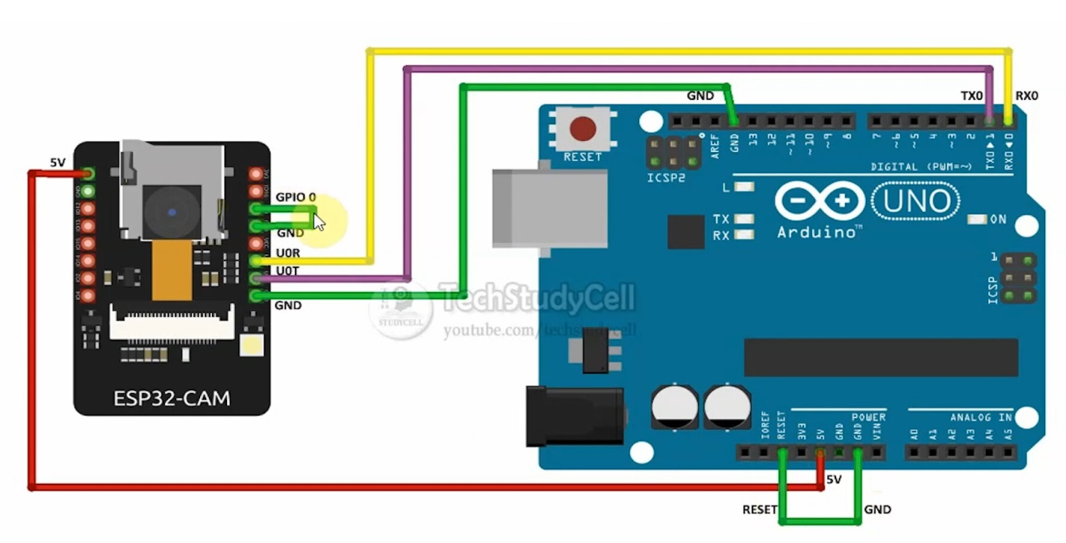

**Figure 1:** Aurdino and ESP32

1. **RESULTS AND DISCUSSION**

The developed prototype navigation system successfully integrated object detection and distance estimation technologies to provide real-time feedback to visually impaired users during outdoor navigation. Usability testing with a group of visually impaired individuals indicated that the system effectively alerted users to potential obstacles and hazards, such as stairs, obstacles on footpaths, and gaps between transportation platforms. Users reported feeling more confident and secure while navigating outdoor environments with the assistance of the prototype.

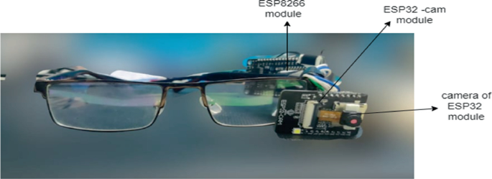

**Figure 2:** 10 Smart Glass Vision for Impared

1. **CONCLUSION**

smart glass technology presents a transformative solution for aiding the visually impaired in outdoor navigation. By utilizing object identification and depth estimation, these glasses offer real-time feedback on environmental hazards, enhancing users' confidence and safety. Addressing challenges such as obstacles and gaps, smart glasses reduce reliance on constant supervision, fostering independence. As research progresses, these innovations hold promise in revolutionizing the lives of visually impaired individuals, empowering them to navigate the world with greater freedom and autonomy.

1. **REFERENCES**
2. M. V. S. Gudlavalleti et al., "Prevalence of Blindness and Visual Impairment in Nigeria: The National Blindness and Visual Impairment Survey," May 2009 2009.
3. WeCapable, "Daily Life Problems, Struggle and Challenges Faced by Blind People."
4. J. C. Read, "Stereo vision and strabismus," Eye, vol. 29, no. 2, pp. 214-224, 2015.
5. Mygreatlearning, Object Detection [image], accessed 11 may 2022,https://encrypted- tbn0.gstatic.com/images?q=tbn:ANd9GcTDdMrU0NGskffDnoXh5RF1N wTqMnfHESd2IQ&usqp=CAU
6. H. A. Said, L. Alkhatib, A. Aloraidh, and S. Alhaidar, "Smart Glasses for Blind people," 2018.
7. [11] 2017 8th IEEE Annual Information Technology, Electronics and Mobile Communication Conference (IEMCON), 2017: IEEE, pp. 210-213. A. Krishnan, G. Deepakraj, N. Nishanth, and K. Anandkumar, "Autonomous walking stick for the blind using echolocation and image processing," in 2016 2nd International Conference on Contemporary Computing and Informatics (IC3I), 2016: IEEE, pp. 13-16.
8. [11] 2017 8th IEEE Annual Information Technology, Electronics and Mobile Communication Conference (IEMCON), 2017: IEEE, pp. 210-213. A. Krishnan, G. Deepakraj, N. Nishanth, and K. Anandkumar, "Autonomous walking stick for the blind using echolocation and image processing," in 2016 2nd International Conference on Contemporary Computing and Informatics (IC3I), 2016: IEEE, pp. 13-16.
9. GeekforGeek, "OpenCV - Overview," August 2021.