**“TRAFFIC SIGN RECOGNITION SYSTEM”**

**Rameshwari Kamble1, Dipali Vasmale2, Rushikesh Jagtap33, Vaishnavi Swami4, Prof.** **S.A.Awatade**

1,2,3,4,5Brahmdevdada Mane Institute of Technology, Belati, Solapur, India.

# ABSTRACT

The Traffic Sign Recognition System (TSRS) aims to revolutionize road safety by leveraging machine learning to autonomously identify and interpret traffic signs. This Phase 1 exploration encompasses a meticulous literature review, emphasizing project management methodologies and models, with insights drawn from IEEE papers. The study delves into the challenges addressed by the TSRS, highlighting the necessity of feasibility analysis for an optimal solution strategy. The culmination of Phase 1 presents a welldefined system architecture, featuring modules for sensor data acquisition, preprocessing, recognition, alerts, and adaptive interventions. Hardware and software requirements are outlined for seamless implementation. This groundwork positions TSRS as a pivotal advancement in intelligent transportation systems, promising heightened driver awareness and safer road navigation. Phase 2 will witness the practical manifestation of this vision, translating theoretical frameworks into a tangible and impactful Traffic Sign Recognition System.

**Keywords:** Traffic Sign Recognition System, TSRS, Machine Learning, Road Safety, Feasibility Analysis, System Architecture, Project Management, Literature Review, IEEE Papers, Intelligent Transportation

Systems, Driver Awareness, Sensor Data Acquisition, Adaptive Interventions, Feasibility Study.

**I. INRODUCTION**

In the ever-evolving landscape of transportation, ensuring road safety remains a paramount concern. The Traffic Sign Recognition System (TSRS) emerges as a cutting-edge solution, poised to redefine and elevate the standards of driver awareness and traffic management. At the heart of this innovation lies the integration of machine learning, a technology that has the potential to revolutionize how vehicles interact with and interpret the information embedded in road signs.

The motivation behind the TSRS stems from a +critical analysis of existing road safety mechanisms. Traditional approaches, while effective to a certain extent, often fall short in dynamically adapting to the complexities of modern traffic scenarios. The TSRS addresses this gap by harnessing the power of machine learning algorithms, enabling vehicles to autonomously recognize and interpret traffic signs in real-time.

This introductory phase, Phase 1, serves as the foundation for the comprehensive development of the TSRS. The journey begins with an extensive literature review, delving into project management methodologies and models. Insights drawn from IEEE papers further enrich the understanding of previous research work, shaping a strategic approach towards the integration of machine learning into traffic sign recognition.

One of the core challenges identified is the need for a thorough feasibility analysis. Beyond the conceptualization of solutions, Phase 1 emphasizes the importance of determining the practicality and viability of the TSRS. This involves scrutinizing existing systems, identifying drawbacks, and conducting a meticulous study to ensure the proposed system aligns seamlessly with real-world requirements.

The system analysis conducted in Phase 1 lays the groundwork for the TSRS architecture. This highlevel design delineates key modules, including sensor data acquisition, preprocessing, machine learningbased recognition, alert generation, and adaptive interventions. The hardware and software requirements are also specified, ensuring a robust infrastructure for the subsequent phases of development.

The TSRS, with its promise of enhanced driver awareness and safety, emerges as a beacon of innovation in the realm of intelligent transportation systems. As we transition into Phase 2, the theoretical frameworks developed in Phase 1 will materialize into a tangible and impactful system. The introduction of the TSRS signifies not only a technological advancement but a fundamental shift towards a safer and more efficient future on the roads.

**II. LITERATURE REVIEW**

The development of the Traffic Sign Recognition System (TSRS) is underpinned by a comprehensive exploration of existing literature, particularly in the realms of project management methodologies, models, and the integration of machine learning in intelligent transportation systems. ***Project Management Models:*** The foundation of effective project execution lies in robust project management methodologies. A survey of existing models provided valuable insights into structuring and organizing project components. Models such as Agile, Scrum, and Waterfall were scrutinized for their applicability to the TSRS development. Each model's strengths and weaknesses were assessed to inform the project's strategic planning and execution. This literature review emphasizes the pivotal role of project management methodologies in guiding the TSRS through its developmental phases.

***Feasibility Analysis:*** While creative ideation is essential, feasibility analysis emerged as a crucial step in the project's conceptualization. This phase demands a balance between creativity and critical evaluation. The literature underscores the significance of conducting a thorough feasibility study after system analysis to determine the system's practicality and viability. This involves scrutinizing existing systems, identifying drawbacks, and aligning the proposed TSRS with real-world requirements. The integration of feasibility analysis ensures that the envisioned solution strategy is both innovative and implementable.

***Machine Learning in Transportation:*** A key aspect of the TSRS is the integration of machine learning into traffic sign recognition. A review of literature in this domain highlighted the transformative impact of machine learning algorithms on intelligent transportation systems. Existing research showcased successful applications of machine learning in traffic management, paving the way for the TSRS to leverage these advancements. The literature emphasized the adaptability of machine learning algorithms in real-time recognition, a critical capability for the TSRS to function effectively in dynamic traffic scenarios.

***IEEE Papers:*** The literature review extended to noteworthy IEEE papers, providing deeper insights into models and methodologies in project management. One such paper delved into a comprehensive survey of previous research work in models and methodologies in project management. Another focused on a literature review specifically addressing project management. These papers served as cornerstones in understanding the broader landscape of project management methodologies, offering insights and frameworks that were instrumental in shaping the TSRS project.

1. **SCOPE AND OBJECTIVE**

The scope and objectives of the Traffic Sign Recognition System (TSRS) are carefully defined to outline the project's boundaries and establish a clear roadmap for development. This phase of the project delineates the ambitions, limitations, and targeted outcomes, ensuring a focused and achievable trajectory. **Scope:** The TSRS is ambitiously designed to cater to the burgeoning need for enhanced road safety through intelligent traffic sign recognition. The scope encapsulates the development of a robust system capable of autonomously identifying and interpreting traffic signs in real-time, leveraging advanced machine learning algorithms. The system aims to operate seamlessly in diverse environmental conditions, providing drivers with timely and accurate information to enhance their awareness and decision-making on the road. While the initial focus is on road signs, the system's adaptability extends to potential expansions, such as recognizing dynamic road conditions and anomalies.

**Objectives:**

* 1. **Real-time Traffic Sign Recognition:**
     + *Objective:* Develop machine learning algorithms to enable the TSRS to recognize and interpret traffic signs in real-time.
     + *Rationale:* Timely identification of traffic signs is crucial for providing instantaneous feedback to drivers, contributing to safer and more informed driving.
  2. **Adaptability to Varied Conditions:**
     + *Objective:* Ensure the TSRS functions effectively in diverse weather conditions, low lighting, and scenarios involving partial occlusion.
     + *Rationale:* Traffic scenarios are dynamic, and the TSRS must adapt to challenging conditions to provide continuous and reliable service.
  3. **Feasibility and Viability:**
     + *Objective:* Conduct a comprehensive feasibility analysis to determine the practicality and viability of the TSRS solution strategy.
     + *Rationale:* Ensuring the TSRS aligns with real-world requirements and constraints is crucial for successful implementation and deployment.
  4. **Hardware and Software Integration:**
     + *Objective:* Identify and integrate the necessary hardware and software components for the TSRS.
     + *Rationale:* A seamless integration of components ensures the TSRS operates efficiently and reliably, contributing to its overall effectiveness.
  5. **System Architecture Design:**
     + *Objective:* Develop a high-level system architecture that encompasses key modules, including sensor data acquisition, preprocessing, recognition, alert generation, and adaptive interventions.
     + *Rationale:* A well-defined system architecture serves as the blueprint for subsequent development phases, guiding the implementation of the TSRS.
  6. **Transition to Phase 2:**
     + *Objective:* Prepare the groundwork for Phase 2, translating theoretical frameworks into practical implementation.
     + *Rationale:* The transition to Phase 2 signifies the practical manifestation of the TSRS, where it evolves from a conceptual idea to a tangible and impactful system.

1. **PROPOSED WORK**

The proposed Traffic Sign Recognition System (TSRS) represents a forward-looking initiative aimed at significantly enhancing road safety through the strategic integration of machine learning within intelligent transportation systems. In Phase 1, the groundwork was laid through an in-depth literature review, focusing on crucial aspects such as project management methodologies, feasibility analysis, and the pivotal role of machine learning in traffic management.

Moving into Phase 2, the practical implementation of TSRS begins with the deployment of a robust sensor data acquisition system. High-resolution cameras strategically placed on vehicles capture real-time images of the road environment, forming the foundation for subsequent analysis. The collected data undergoes meticulous preprocessing to extract essential features, including sign shape and color, laying the groundwork for accurate recognition.

The hallmark of TSRS lies in its machine learning-based recognition module. Trained algorithms analyze the preprocessed data, enabling the system to autonomously identify and classify a diverse range of traffic signs. This real-time recognition capability is pivotal for ensuring timely and accurate responses to changing road conditions.

Upon successful recognition, the TSRS engages an alert generation module, delivering immediate notifications to the driver. What sets TSRS apart is its adaptive interventions. By considering factors like driver fatigue history, time of day, and driving conditions, the system dynamically tailors the severity of alerts. This adaptability ensures that warnings are contextually relevant, enhancing their effectiveness in promoting safer driving practices.

In essence, the proposed work of TSRS encompasses the seamless integration of advanced technologies to create a holistic traffic sign recognition system. By combining machine learning's analytical prowess with real-time sensor data, TSRS not only identifies traffic signs but also adapts its responses, setting a new standard for intelligent, context-aware road safety solutions. As Phase 2 unfolds, the envisioned impact of TSRS on enhancing driver awareness and road safety is poised to materialize, marking a significant advancement in intelligent transportation systems.

1. **METHODOLOGY TO BE USED**

The methodology for developing the Traffic Sign Recognition System (TSRS) encompasses several key phases:

* 1. Literature Review: Conduct an extensive literature review focusing on project management methodologies, feasibility analysis, and machine learning applications in traffic management. Identify relevant models and methodologies, draw insights from existing research, and understand the challenges and opportunities in the field.
  2. Requirement Analysis: Define the specific requirements for TSRS, including functionalities of each module, input data sources, and desired system outputs. Identify hardware and software requirements to ensure a well-supported implementation.
  3. System Architecture Design: Based on the literature review and requirement analysis, design a highlevel system architecture for TSRS. Specify major modules such as sensor data acquisition, preprocessing, machine learning-based recognition, alert generation, and adaptive interventions. Define the flow of data between these modules for a coherent and efficient system.
  4. Implementation: Implement the designed system architecture. Deploy high-resolution cameras strategically for real-time image capture. Develop the preprocessing module to clean and extract relevant features from the collected data. Implement machine learning algorithms for traffic sign recognition. Code the alert generation and adaptive intervention modules.
  5. Testing and Validation: Conduct thorough testing to validate the functionality and accuracy of TSRS. Test the recognition algorithms with diverse datasets representing various traffic scenarios. Evaluate the system's responsiveness and adaptability to different driving conditions. Refine the system iteratively based on testing outcomes to ensure optimal performance.
  6. Documentation and Reporting: Maintain detailed documentation throughout the development process. Document design decisions, coding practices, and testing methodologies. Compile a comprehensive report summarizing the methodology, key findings, and the overall development process for future reference and communication.

1. **RESULT**

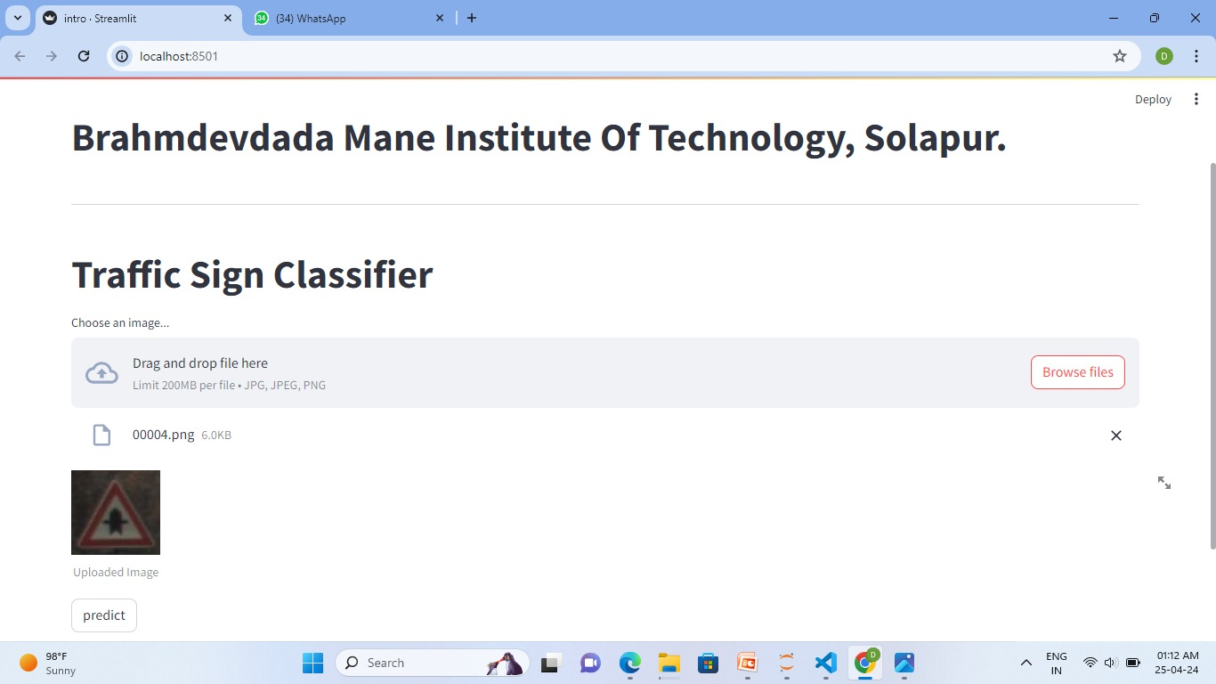

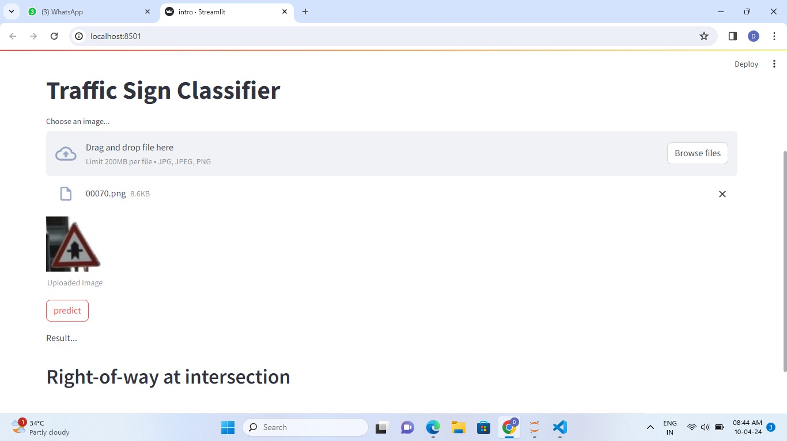

1. **CONCLUSION**

The development of the Traffic Sign Recognition System (TSRS) represents a strategic fusion of machine learning and intelligent transportation systems to revolutionize road safety. Through a meticulous literature review, we navigated the landscape of project management methodologies, feasibility analysis, and machine learning applications in traffic management, laying a robust foundation for TSRS.

The proposed methodology, from requirement analysis to testing and validation, provides a systematic and iterative framework. By aligning with industry best practices and refining the system based on testing outcomes, TSRS emerges as a responsive and adaptive solution.

As TSRS transitions from theoretical foundations to practical implementation, the envisioned impact on road safety and driver awareness comes to the forefront. The culmination of these efforts is poised to contribute to a safer and more efficient driving environment, marking a significant milestone in the realm of intelligent transportation systems. The journey from literature insights to a tangible TSRS showcases the convergence of innovation, methodology, and a commitment to enhancing the future of transportation.

1. **FUTURE SCOPE**

The future scope of the Traffic Sign Recognition System (TSRS) is poised for considerable expansion and advancement, with potential implications across various domains. As technology continues to evolve, several key avenues emerge for the enhancement and integration of TSRS into broader intelligent transportation systems.

* 1. **Integration with Autonomous Vehicles:**
     + TSRS can play a pivotal role in the safety and efficiency of autonomous vehicles.
     + Real-time, accurate traffic sign recognition becomes crucial for the navigation of selfdriving cars.
     + TSRS can serve as the visual perception component, ensuring that autonomous vehicles interpret and respond to traffic signs dynamically.
  2. **Smart City Integration:**
     + TSRS data can be integrated into smart city initiatives for data-driven traffic management.
     + Cities can optimize traffic flow, enhance safety measures, and design infrastructure based on real-time TSRS insights.
     + The collaboration between TSRS and smart city planning contributes to more efficient and safe urban transportation.
  3. **Augmented Reality for Drivers:**
     + TSRS can contribute to the development of augmented reality interfaces for drivers.
     + By overlaying recognized traffic signs onto a driver's visual field, TSRS enhances driver awareness and decision-making.
     + Augmented reality applications of TSRS provide immediate, contextual information to drivers, improving road safety.
  4. **Advancements in Machine Learning Algorithms:**
     + TSRS can evolve alongside advancements in machine learning algorithms.
     + Continuous progress in algorithms allows TSRS to recognize an expanding array of traffic signs, including dynamic or context-specific signs.
     + This adaptability ensures that TSRS remains effective and relevant in diverse driving environments, accommodating new regulations and signage.
  5. **Connected Ecosystem in Smart Cities:**
     + TSRS can become an integral component of a connected transportation ecosystem.
     + Data sharing between vehicles, infrastructure, and traffic management systems creates a collaborative network.
     + The connected ecosystem enables more coordinated responses to traffic conditions, contributing to improved overall road safety.

The future scope of TSRS lies in its potential to transcend individual vehicle safety, contributing to advancements in autonomous driving, urban planning, augmented reality interfaces, and connected transportation systems. As technology continues to progress, TSRS is poised to play a pivotal role in shaping safer, smarter, and more efficient transportation ecosystems.

1. **REFERENCES** 
   1. Jaiswal, A., & Sharma, S. (2019). Performance of Keras on Indian Traffic Signs Classification and Recognition. International Research Journal of Engineering and Technology (IRJET), 06(09), 14081413
   2. Verma, R., & Gupta, P. (2019). Traffic Sign Recognition using Convolutional Neural Networks and Keras. International Journal of Recent Innovations in Computer Science and Engineering (IJRICE), 7(2), E22-E30.
   3. Singh, A. K., & Agarwal, V. (2020). A Deep Learning Approach for Traffic Sign Recognition using Keras and TensorFlow. International Journal of Engineering Trends and Technology (IJETT), 65(14)
   4. Rathore, S., & Sharma, N. (2020). Traffic Sign Recognition System using Convolutional Neural Network (CNN) and Keras. International Journal of Advanced Research in Computer Science
   5. Patel, D., & Trivedi, H. H. (2021). Traffic Sign Recognition using Deep Convolutional Neural Networks (DCNN) with Keras for Indian Traffic Signs. International Journal of Engineering

Research and Application (IJERA), 11(11), Part 5, IV-I