VISIBLE LIGHT COMMUNICATION

Prathibha V D   
Dept of electronics and Communication Enginerring  
SJC Institute Of TechnologyChickaballapura, karnataka, India  
[prathibha1177@gmail.com](mailto:prathibha1177@gmail.com)

Dr. C Rangaswamy  
Associate professor *Dept of Electronics and Communication Engineering*  
SJC Institute Of TechnologyChickaballapura, karnataka, India  
[crsecesait@gmail.com](mailto:mohanbabu015@gmail.com)

**Abstract**—visible light communication (VLC) offers cheap, unrestricted bandwidth and widespread infrastructure support, it is emerging as a viable option for next-generation wireless technology. It is intended for this technology to be utilized in many indoor and outdoor applications. Light emitting diodes (LEDs) are used in visible light communication (VLC) to transmit data and provide lighting simultaneously. This cutting edge technology uses LED light to transfer data at rapid speeds, including music and video and internet traffic. Visible Light Communication (VLC) is a technology that is being driven in part by the use of LEDs. This study proposes a visible light communications system that uses wavelength division multiplexing to send numerous data streams from several data sources concurrently. It also shows how to communicate an image using LED lights and an audio song. Not only that, but the LED circuitry effectively recovered several source signals that were broadcast simultaneously in various frequency bands. This illustrates our design's feasibility assessments for signal broadcasting.

# **I Introduction**

A large number of researchers are currently working on the creation of lighting systems that use light-emitting diodes (LEDs).   
Compared to the fluorescent lamp system, the LED lighting system can achieve reduced power consumption and a longer lifespan. Visible Light Communication (VLC) is a rapidly developing technology that uses ubiquitous, low-cost LEDs and photodiodes to transmit data [1]. There is a pressing need to improve communication methods in the fast-paced world of today.   
Visible Light Communication (VLC) wireless networks are a recently popular concept that have the potential to provide a comfortable wire-free future. One novel and as-yet-uncommercialized technology is the use of light as a means of communication [2] LEDs used for illumination are also employed for wireless data transmission in visible light communication (VLC). It has many benefits, including faster data speeds, unrestricted huge bandwidth, and improved data security that creates smart spaces [5].   
Numerous approaches have been put out in the literature to address a variety of issues, including brightness management, enhanced data transmission speeds, performance analysis, and VLC system architecture.   
However, because the visible spectrum is less susceptible to attenuation, VLC has made high data-rate (10Mbps), moderate distance (100m), and underwater communication possible [8]. As a result, VLC shows up as a good substitute when RF is unable to deliver. Because of physical or bandwidth limits. In this study, we looked into employing LED light bulbs to convey both an image and an audio file.   
This is how the remainder of the paper is structured. We discuss wavelength division multiplexing in Section II. Section III: VLC System Hardware. In Part IV, Performance Analysis is covered. Section V presents the application. The limitation is shown in Section VI. The paper is concluded in Section VII.

**II.WAVELENGTHDIVISION MULTIPLEXING**

Since wavelength division multiplexing was first used in fiber optics, a general introduction to optical fibers is given before moving on to the application of wavelength division multiplexing in visible light communications.

**A. WDM: A Fiber-Optics Perspective**

Wavelength-division multiplexing (WDM) is a method used in fiber-optic communications that multiplexes multiple optical carrier signals on a single optical fiber by employing distinct laser light wavelengths (colors) to convey different signals. This permits bidirectional communications on a single fiber strand in addition to a multiplication of capacity.

Although it is sometimes referred to as wavelength division multiplexing, this is a type of frequency division multiplexing (FDM). While frequency-division multiplexing generally refers to a radio carrier, which is more frequently characterized by frequency, wavelength-division multiplexing is frequently used to describe an optical carrier.

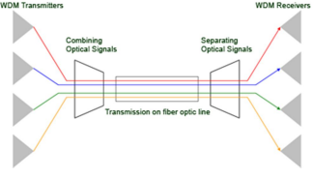

**III. HARDWARE IMPLEMENTATION**

We now introduce the suggested VLC system, which transmits multiple data streams simultaneously using WDM. Different colored LED sources are employed to broadcast each data stream at different wavelengths. We send an audio stream from one laptop to another in the prototype implementation.

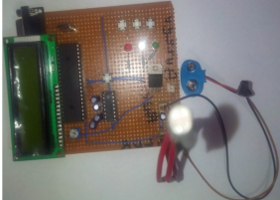

First of all, if the hardware is not powered on, it is unable to detect light, which prevents communication. The hardware indicates that there is no light when it is linked to the battery. The audio song is transmitted and played on the receiving laptop when we turn on the red LED. The audio will stop if the LED is not on. Once more, if we turn on the yellow LED, the audio will start up again where it left off. The reduced transmission distance of 50 cm can also be explained by the fact that single, inexpensive tiny LEDs were utilized instead of the more costly high power ones. In addition to serving as lights, red, yellow, and green LEDs were employed as visible light data transmitters. Audio data was sent to the serial port via a computer program. The laptop was connected to an RS232-to-TTL level converter IC (MAX232) via a USB-to-serial converter cable. Using these LEDs, we will use picture transmission in place of audio transmission to move an image from one laptop to another.

**IV. PERFORMANCE ANALYSIS**

In this research, we used visible light communication to send an audio file and an image from one laptop to another.

**A. Transmitting an audio song:**

In the first experiment, we used visible LED lights to transfer an audio track from one laptop to another. light communication) and sang that tune as well. In the absence of light, data transmission ceases, resulting in the audio not playing, as illustrated in figure:

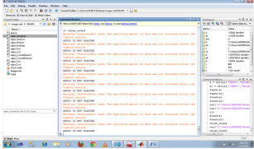

The audio music will be sent and played when the red LED is lit up. It implies that data will exist wherever there is light.   
The audio is transferred as the output result and plays as seen in figure:

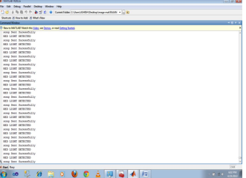

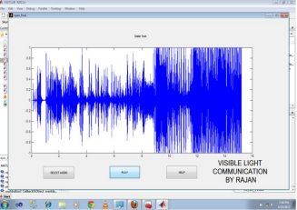

**B. Transmitting of an image:**

We were sending the JPG file in the second experiment. Any of the common file formats, such as.jpg, jpeg, .bmp, etc., can be used for the image because it has no effect on transmission. The 92*112 pixel.jpg file that we are using is this one.



The image is not transferred from one laptop to another when there is no light. The result is shown below:

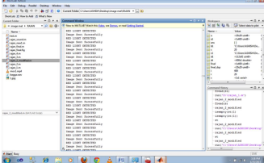

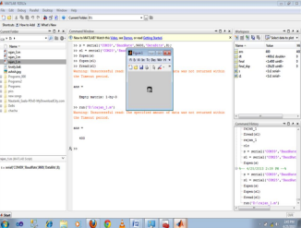

**V. APPLICATIONS**

Light is perhaps the safest energy source available, hence the possibilities for this technology are virtually endless:

A. Intelligent Lighting   
Smart lighting is a prerequisite for smart buildings. The infrastructure for illumination, control, and communications is provided by smart lighting with VLC, which also significantly lowers wiring and energy usage inside a building.

B. Wireless Internet Access   
You can establish an extremely fast, intrinsically secure data link with another device simply by directing visible light towards it. Unlike Bluetooth or Wi-Fi, this eliminates the need to pair or connect and offers a far higher data throughput.

C. Dangerous Conditions   
It can be difficult to communicate in places where there is a chance of explosions, such as mines, petrochemical facilities, oil rigs, etc. VLC offers secure connection as well as safe illumination by nature.

D. Automobile & Transit   
LED lights are already common in many cars. There are numerous application options here because LED technology is being adopted by street lamps, traffic signals, and traffic signage [4].

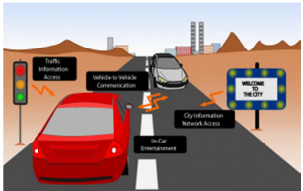

E. Security & Defense   
For many applications, the key to sending data swiftly and securely is essential. There were significant security benefits to the inability of visible light to be detected on the other side of a wall.

F. Healthcare & Hospitals   
The use of VLC in healthcare and hospitals has benefits. In some hospital areas, such as the areas near MRI scanners and operating rooms, mobile phones and Wi-Fi are not permitted.

G. Relief from Wi-Fi Spectrum   
Although Wi-Fi has gotten quicker over time, it still cannot meet the demand for wireless data. Because the RF parts and antenna system are no longer needed, VLC can deliver data speeds that are significantly higher than those of Wi-Fi today, and it can do so at a reduced cost.

H. It is not desirable to have aviation radio in an aircraft's passenger cabin.   
LEDs can be used to deliver media services to passengers in place of wires; they are already used for illumination. This lowers the weight and building costs of the aircraft.

I. Communications Through Underwater   
Underwater, visible light can facilitate high-speed data transmission over short distances, but radio frequency (RF) cannot function. This could make it possible for underwater vehicles and divers to communicate [8].

J. Services Based on Location   
any visible light information source may be individually identified, making it possible to swiftly and precisely locate any VLC equipment.

**VI. LIMITATIONS**

The current largest drawback is the constrained coverage area.   
Practically speaking, communication distances cannot be reached even with high power LEDs. [14] Displays comprehensive visible light communication prototypes, but the range is still insufficient. Another drawback is that new infrastructure will have to be created in order to implement apps. It is anticipated that high power LED sources will replace the current lighting in the street light application described above. Passing such resolutions would require a substantial investment of time and money, despite the fact that they will prove advantageous in many ways. Entering full-duplex mode is the third restriction. Transmitting a modulating signal and simultaneously receiving and detecting another modulating signal would be an extremely difficult assignment for a single module. Some of the initial concepts include employing various wavelengths of LEDs,

Utilizing adaptive digital filters, shielding, and optical isolation for the transmitter and receiver modules. Even while these techniques make sense, they still need a lot of testing and investigation, and not much progress has been made in this area. Only by combining visible light communication with electricity lines or by using visible light for front-end communication and infrared for back-end communication has full-duplex communication been made possible.

**VII. CONCLUSION AND FUTURE SCOPE**

A workable technique for employing visible light for safe and affordable data transfer has been demonstrated, allowing for the effective reproduction of both an image and an audio song. It has been explained how to accomplish both the faithful reproduction of the image and the transmission of an audio song. Even so, this technology is still quite young. Its broad uses will only improve with additional research and development.   
The core of the VLC technology is the simultaneous data transmission and illumination of LED light bulbs. It works best as a backup plan for data transfer in situations when radio transmission networks are either unfeasible or undesirable. In the future, LED light bulbs will allow us to broadcast voice, images, and potentially high-definition videos.

**REFERENCES:**

[1]The IEEE Proceedings, vol. 85, no. 2, pp. 265–298 (J. Kahn and J. Barry), "Wireless infrared communications,"

[2] "Visible Spectrum Optical Communication and Distance Sensing for Underwater Applications," Felix Schill1, Uwe R. Zimmer1, Jochen Trumpf, proceedings of ACRA 2004.

[3] M. Nakagawa, "Visible light communications," in Quantum Electronics and Laser Science Conference and Photonic Applications Systems Technologies, 2007; Conference on Lasers and Electro- Optics.

[4] Enabling Vehicular Visible Light Communication (V2LC) Networks, K. Bilstrup, E. Uhlemann, E. Strom, and U. Bilstrup, EURASIP 2009, 2008 issues of Journal on Wireless Communication and Networking.

[5] "High-speed visible light communications using multiple resonant equalization," Photonics Technology Letters, IEEE, vol. 20, no. 14, pp. 1243–1245, 2008, by H. Le Minh, D. O'Brien, G. Faulkner, L. Zeng, K. Lee, D. Jung, and

Y

[6] "An integrated, underwater optical/acoustic communications system," N. Farr, A. Bowen, J. Ware, C. Pontbriand, and M. Tivey, OCEANS 2010 IEEE Sydney, pp. 1–6, IEEE, 2010.

[7] "Internet utilizing Visible Light Communication," Akassh A. Mishra and Neelesh S. Salian, IACSIT International Journal of Engineering and Technology, Vol. 3, No. 5, October 2011.

[8] "Indoor channel characteristics for visible light communications," K. Lee, H. Park, and J. Barry, Communications Letters, IEEE, vol. 15, no. 2, pp. 217–219, 2011