“Impact of Training and Development
on employee performance”

Shreya Jaiswal- 22GSOB2010281

Under Guidance Of
DR. NAMITA GUPTA
GALGOTIAS UNIVAESITY

ABSTRACT:
My study outlines a comprehensive investigation into the impact of training and development programs on organizational success and the quality of work life for employees. By combining both qualitative and quantitative research methods, you aim to provide a nuanced understanding of how different training approaches influence various aspects of employee performance and well-being.
The differentiation between training and development is crucial, as it allows for a deeper exploration of how each contributes to organizational growth and employee satisfaction. Your objective to examine the relationship between training initiatives and the quality of work life is particularly insightful, as it highlights the holistic impact of these programs beyond just skill acquisition.
The mixed-methods approach you've chosen is well-suited to capture both individual experiences and broader trends within the organization. By conducting interviews, focus group discussions, and surveys, you can gather diverse perspectives and quantitative data to support your findings.
Stratified random sampling ensures representation from different departments and levels, enhancing the generalizability of your results. Additionally, your reliance on both primary and secondary data sources strengthens the robustness of your study.
In conclusion, your study underscores the importance of investing in training and development programs as essential components of organizational success. By prioritizing employee development and fostering a supportive work environment, organizations can enhance employee satisfaction, productivity, and ultimately, their own performance.

INTRODUCTION:
In today's rapidly evolving market landscape, organizations face both opportunities and challenges. To remain competitive, they must adapt their workplace policies, regulations, and training methods to attract and retain top talent while accommodating the need for work-life balance.
Training plays a pivotal role in equipping the workforce with the necessary skills and knowledge to meet organizational goals and sustain competitiveness. Effective training programs not only enhance employee capabilities but also contribute to organizational profitability, employment rates, and market demand. They foster a high quality of work life by improving job satisfaction, involvement, safety, and work-life balance.
In the Indian technological industry, companies like Wipro, Tata Consultancy Services, and Infosys have implemented robust training and development initiatives to stay ahead in the global market. These initiatives range from in-house training programs to e-learning platforms, aiming to upskill employees and build a workforce ready for the challenges of tomorrow.
The major tech hubs in India, including Bangalore, Hyderabad, Chennai, and Thiruvananthapuram, offer conducive environments for tech innovation, supported by state-of-the-art infrastructure and government policies. These hubs attract both domestic and international tech companies, contributing significantly to India's economic growth.
The IT industry in India has witnessed rapid growth, with projections indicating continued expansion in the coming years. Revenue from software services, IT consulting, outsourcing, and domestic IT & Business Services markets has been steadily increasing, fueled by factors such as digital transformation, automation, and increasing internet penetration.
However, alongside the opportunities, there are challenges such as the cost of training, scheduling sessions around work hours, and maintaining employee interest. Overcoming these challenges requires strategic planning and investment in diverse learning and development approaches, including formal training, informal learning, coaching, mentoring, and skill building programs.

LITERATURE REVIEW:
The need for organizations to invest in training programs to enhance employee competencies and decision-making abilities is emphasized by Tai (2006), as it ensures competitiveness in the fast-paced and uncertain business environment.
Vallet et al. (2000) highlights the role of training in building and maintaining capabilities at both individual and organizational levels, facilitating organizational change processes.
Training initiatives not only contribute to talent retention by increasing employee skills and job satisfaction but also foster a supportive work environment and boost employee motivation, as noted by Jones and Wright (1992), Shaw et al. (1998), and Pfeffer (1994).
Investments in training translate into competitive advantages for organizations (Youndt et al., 1996) and lead to improved employee performance and organizational productivity, according to Bartel (1994), Knoke and Kalleberg (1994), Huselid (1995), and Delery and Doty (1996).
Training programs play a pivotal role in enhancing organizational resilience and success in dynamic business landscapes by improving employee performance and bridging the gap between current and desired standards.
Various forms of training, such as coaching, mentoring, peer collaboration, and participation from subordinates, foster teamwork and active engagement, enhancing job performance and overall organizational success.
According to Jie and Roger (2005), firms should prioritize the planning and implementation of training programs to enhance employee abilities and competencies required in the workplace.
Training not only develops employee capabilities but also enhances critical thinking, creativity, and customer interaction skills, leading to more informed decision-making and efficient work methods, as highlighted by David (2006), Hollenbeck, Derue, and Guzzo (2004), Svenja (2007), Kathiravan, Devadason, and Zakkeer (2006).
Two definitions of training objectives, provided by Kalaiselvan and Naachimuthu (2011) and Karthik R (2012), emphasize the importance of clear expectations for trainees and stakeholders.
Finally, training is defined by Michael Armstrong, Edwin B. Flippo, and Aswath Appa as the systematic development of knowledge, skills, and attitudes necessary for individuals to perform specific tasks or jobs adequately, emphasizing its role in individual, organizational, functional, and social objectives.
RESEARCH METHODOLOGY:
The research objectives on the topic of "Impact of Development and Training on Employee Performance" are as follows:
To examine the extent to which training and development programs influence various dimensions of employee performance, including productivity, job satisfaction, job retention, and overall organizational effectiveness.
To identify the specific skills, competencies, and behaviors that are enhanced through training and development initiatives, and their subsequent impact on employee performance.
To investigate the organizational factors that moderate the relationship between training interventions and employee performance outcomes, including factors such as organizational culture, leadership support, and employee engagement.
To explore the effectiveness of different training modalities and approaches, such as classroom-based training, e-learning platforms, on-the-job training, and coaching, in improving employee performance.
To assess the long-term effects of training and development initiatives on employee performance, including the sustainability of performance improvements over time and their contribution to organizational success.
To examine the role of individual factors, such as employee motivation, learning orientation, and personal development goals, in mediating the impact of training and development on employee performance.
To provide practical recommendations for organizations to design and implement effective training and development programs that maximize their impact on employee performance, taking into account best practices, organizational context, and the needs of diverse employee populations.
To contribute to the existing body of knowledge on the relationship between training and development and employee performance through empirical research and theoretical synthesis, thereby advancing scholarly understanding in this field.
OBJECTIVE:
The research objectives on the topic of "Impact of Development and Training on Employee Performance" are as follows:
To examine the extent to which training and development programs influence various dimensions of employee performance, including productivity, job satisfaction, job retention, and overall organizational effectiveness.
To identify the specific skills, competencies, and behaviors that are enhanced through training and development initiatives, and their subsequent impact on employee performance.
To investigate the organizational factors that moderate the relationship between training interventions and employee performance outcomes, including factors such as organizational culture, leadership support, and employee engagement.
To explore the effectiveness of different training modalities and approaches, such as classroom-based training, e-learning platforms, on-the-job training, and coaching, in improving employee performance.
To assess the long-term effects of training and development initiatives on employee performance, including the sustainability of performance improvements over time and their contribution to organizational success.
To examine the role of individual factors, such as employee motivation, learning orientation, and personal development goals, in mediating the impact of training and development on employee performance.
To provide practical recommendations for organizations to design and implement effective training and development programs that maximize their impact on employee performance, taking into account best practices, organizational context, and the needs of diverse employee populations.
To contribute to the existing body of knowledge on the relationship between training and development and employee performance through empirical research and theoretical synthesis, thereby advancing scholarly understanding in this field.
DATA ANALYSIS

3.1 Questionnaire:
The questionnaire is being prepared to find out or we can say that for my research I have collected data with the help of questionnaire to represent the facts and figures of IT industry with the help of survey.
Following were being prepared to collect the date from the people who are the employee of the Indian Technology Industry. The data reflects the learning and development process which is being adapted by the IT industry so that it can help in the growth of the employee and the firm too.
In order to comprehensively explore the dynamics of social media usage and its impact on individuals' perceptions and behaviours, this research incorporates a structured questionnaire as a key data collection instrument. The questionnaire is designed to solicit responses from participants regarding various aspects of their social media habits, attitudes, and experiences.

Following are questions which is asked by the employee of the its industry:

Questions: -
1) Have you participated in any training programs provided by the company in the past year?

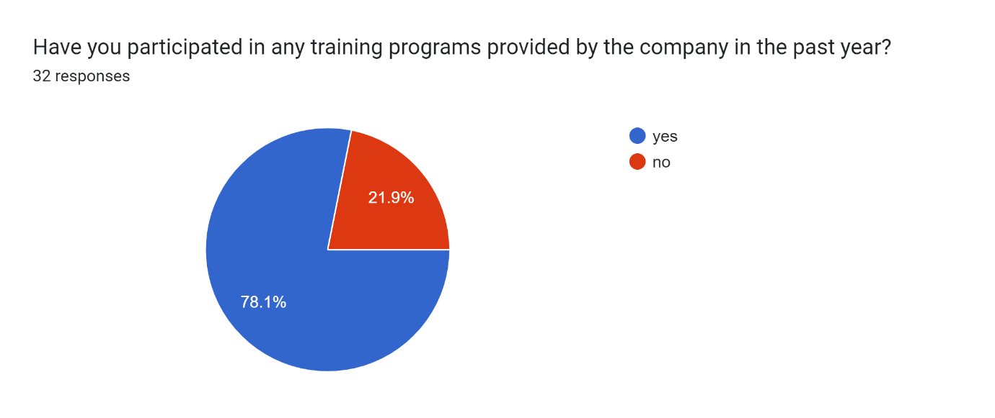
2) how satisfied were you with the training programs you attended?
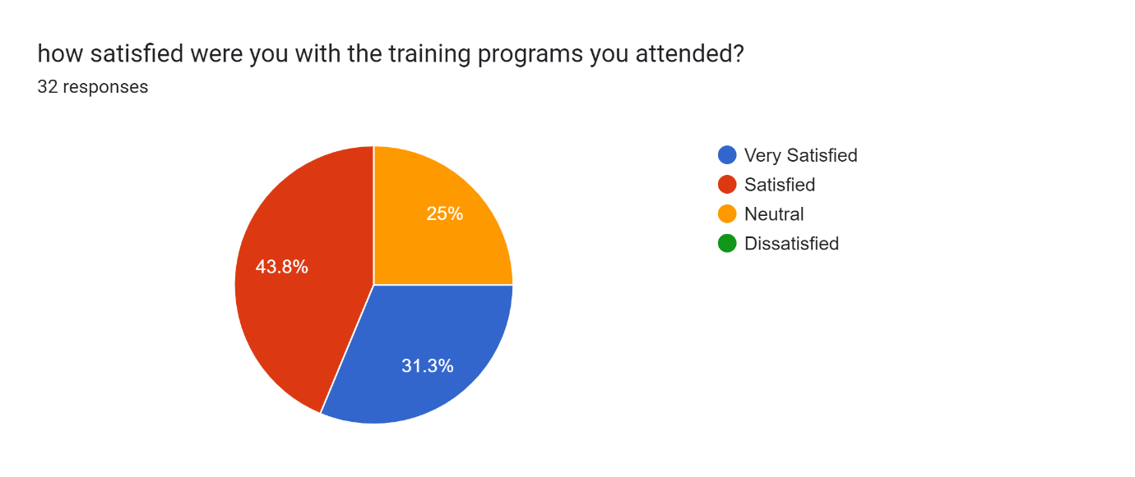
3) Have you observed any changes in your productivity or efficiency as a result of the training programs?

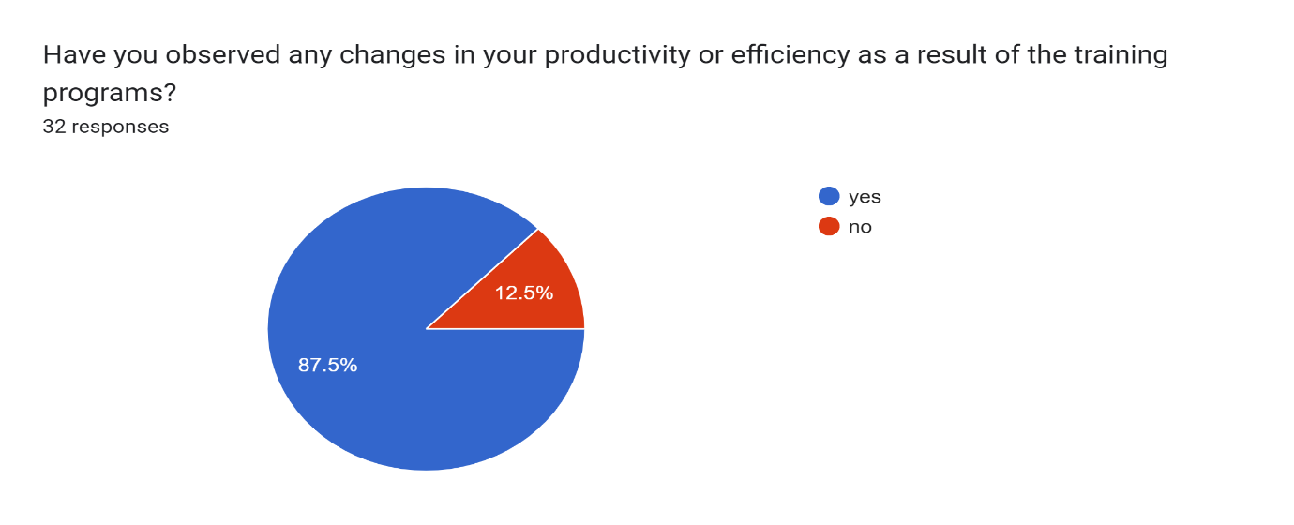

Conclusion:
The primary objective of any training session is to enhance the performance of employees, leading businesses to continuously design and implement training and development programs. However, it is crucial for organizations to establish clear goals and objectives for their training initiatives, considering the specific needs of both individuals and the firm This study emphasizes the significant role of training in improving employee performance. Training not only builds competencies among new and existing employees but also prepares them for future positions within the organization. Moreover, it helps address deficiencies in job-related areas and is viewed as a valuable investment by firms, yielding high returns and competitive advantages Employees are recognized as a rare, non-imitable, and valuable resource for businesses, with their performance greatly influencing the success or failure of an organization. Consequently, organizations are increasingly willing to invest in training programs to develop their workforce. Effective training is pivotal in enhancing both employee and firm competency, bridging the gap between desired and training programs serve as a catalyst for improving workers' performance and capabilities, ultimately boosting organizational productivity. Therefore, it is imperative for training to be tailored to meet the specific needs and objectives of each firm. Effective training interventions are carefully designed to facilitate the acquisition of necessary skills and knowledge, leading to enhanced employee performance.

