**MACHINE LEARNING-ENHANCED SURVEILLANCE FOR PROACTIVE HIGHWAY ACCIDENT DETECTION**

Dr. N. Abdurrahman **1** , K.Akash Raj **2** , S.Logesh **2** , N.Sruthie **2**

* Assistant-Professor, Department of Electronics and Communication Engineering, Sri Venkateswaraa College of Technology,Vadakal , Sriperambudur - 602 105

**2**

Department of Electronics and Communication Engineering, Sri Venkateswaraa College of Technology, Vadakal ,Sriperumbudur – 602105 Abdurrahman.n@svct.edu.in(corresponding author)

**Abstract *--The aim of the project is to improve road safety by deploying a state-of-the-art accident detection system that uses CCTV cameras and machine learning algorithms. The system prioritizes preventive measures, using advanced algorithms and computer vision techniques to quickly identify incidents in real-time. Quick reaction times are made possible by seamless connection with the current CCTV system. When an accident is detected, automatic notifications are set off and sent to emergency personnel, which maximizes the effectiveness of the response and may even save lives. This effort intends to make significant progress in lowering the effect of accidents on highways by addressing critical difficulties in accident detection systems, such as decreasing response times and improving overall highway safety.***

***This required examining the cameras' responses to dynamic elements like shifting weather patterns and low light conditions, which yielded insightful information for more system improvement.To improve our accident detection system's resilience, we painstakingly reorganized the information to account for certain circumstances like hazy areas and nocturnal situations.***

**Keywords*--Machine Learning Surveillance , Highway Safety Accident Detection,Computer Vision, Real-time Monitoring, Emergency Response.***

**INTRODUCTION**

The study of computer vision makes it possible for machines to mimic the human visual system. Throughout the process, images are acquired, screened, analyzed, identified, and information is extracted. Computers are better able to recognize and respond to visual input because of this comprehensive processing. The number of motor vehicles is increasing more quickly than both population growth and the economy.

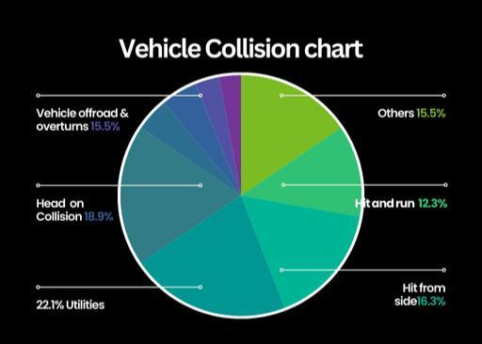

**Fig -1: vehicle collision chart**

Road accidents are causing an alarming number of accidents and deaths, particularly involving two-wheelers. Lack of access to emergency medical care is the primary cause of most accident-related fatalities , especially on motorways.

The system initiates a sequence of automated steps when it detects an accident.It starts calling pre-selected emergency services, such as hospitals, fire departments, and police stations, and sends the accident location data to a central hub.This speeds up emergency response times and removes the need for human interaction.This study demonstrates how machine learning and computer vision may dramatically change traffic safety. By ensuring prompt medical attention and cutting down on response times, our system’s real-time accident detection and automated emergency response have the potential to save lives.

**LITERATURE SURVEY**

**Balfaqih et al. 's (2022)** machine learning-based Internet of Things system for early accident detection was impeded by a deficiency of comprehensive data [1]. Our study aims to overcome this limitation by using a more comprehensive technology stack, which includes Python and OpenCV, to improve accident detection on roadways. Our goal is to increase highway safety by improving the efficiency and accuracy of real-time accident detection by integrating new tools and approaches on top of its base.

**Ghahremannad et al. (2022)** used deep learning and computer vision techniques to detect accidents in real time; nevertheless, their system was devoid of an all-inclusive emergency alerting and communication system. On the other hand, our project overcomes this constraint by putting in place a reliable communication system that permits prompt reaction to mishaps [2]. We hope to guarantee prompt notice and deployment of emergency services by including effective communication mechanisms into our system. This would ultimately shorten reaction times and possibly save lives on highways.

**Rayapureddy and Jaya Lakshmi (2022)** introduced an ensemble learning model for accurate object detection; nevertheless, a lack of understanding of object-tracking techniques limited the model's usefulness. Our approach builds on their work by incorporating cutting-edge object-tracking algorithms to improve the accuracy of accident investigation [3]. Our goal is to enhance highway safety by improving the overall performance and reliability of our accident detection system by fusing effective tracking techniques with accurate object detection.

**Ghahremaninezhad (2022)** their system did not include emergency response processing [4]. Our approach incorporates emergency response processing for further categorization to improve accident detection in order to overcome this constraint. Our goal is to improve highway safety outcomes by facilitating faster emergency response efforts and providing more thorough accident investigation through the integration of emergency response processes into our system.

**Shaik et al. (2018),** while object tracking received less attention, which affected the precision of accident reconstruction. In contrast, to guarantee precise accident investigation, our approach incorporates advanced object-tracking algorithms within the IoT architecture [5]. Our goal is to improve the precision and dependability of accident reconstruction by merging IoT capabilities with cutting-edge object-tracking methods. This will yield important information for enhancing traffic safety protocols.

**Kumar et al. (2021)** provided a superficial overview of advanced video analysis techniques. Our proposal uses state-of-the-art techniques for a more dependable emergency call system in order to close this gap [6]. Our goal is to increase the efficiency and accuracy of accident detection by utilizing cutting-edge video analysis techniques. This will allow for a quicker emergency response and lessen the impact of accidents on roadways.

**MOTIVATION AND PROBLEM DEFINITION**

Delays in emergency response, sometimes caused by relying on individuals to report occurrences and inadequate situational awareness, result in numerous deaths on roadways each year. This project aims to solve this issue by developing a smart system that can automatically detect traffic events on roadways, quickly alert emergency services, and ultimately save lives by speeding up response times. It does this by utilizing cameras and artificial intelligence.

**PROBLEM DEFINITION**

Highway accidents pose a significant risk to public safety and can be caused by a variety of factors, such as reckless driving, speeding, inclement weather, and mechanical issues with cars. The current root of the problem is the limitations of traditional detection methods:

There are a number of causes/issues of Accident:-

1. **Delayed and Inaccurate Reporting:** People often report accidents late or inaccurately, leading to lost time crucial for proper medical attention and rescue efforts.
2. **Limited Visibility and Awareness:** Traditional systems might not have a complete view of the highway, potentially missing accidents or delaying their exact location identification.

These limitations cause delays that have severe consequences:

**Worst Injuries:** Delayed medical attention can worsen injuries and increase the risk of fatalities. **Hindered Rescue:** Timely action is critical for rescuing trapped individuals and minimizing further harm.



**Traffic Jams:** Accident scenes often lead to traffic disruptions, creating additional delays for emergency services.



In order to address these problems, this project develops a proactive approach that makes use of computer vision and machine learning to proactively detect accidents, reduce response times, and eventually improve highway safety.

**DESIGN AND METHODOLOGY**

This suggested approach starts with pre-processing to improve image quality, then moves on to obtaining real-time video or pre-recorded film. Next, when each frame is analyzed, a pre-trained deep learning model identifies and tracks the motion of cars. The system makes use of this data to identify and categorize possible mishaps. The system can improve reaction times and possibly save lives by transmitting the location of an accident and immediately initiating emergency calls. The efficacy of the system will be continually assessed and improved for increased precision.

**DETECTION**

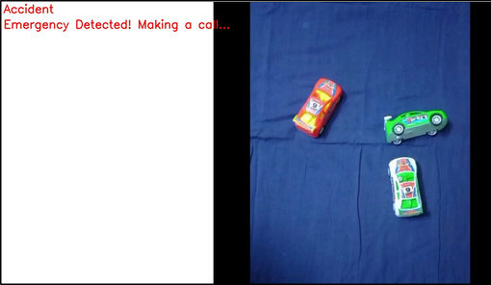

**Fig -2: Accident detection frame**

This proposed detection technique uses a multi-phase procedure to accurately identify accidents. Firstly, cars are effectively detected by a pre-trained CNN model, and Deep SORT tracks their progress over multiple frames. Next comes feature extraction, when the deep learning model is used to analyze both visual features (debris, halted vehicles) and vehicle movements (sudden stops, swerving). Combining these characteristics allows anomaly detection systems to spot changes from typical traffic patterns. To guarantee that the system concentrates on long-lasting anomalies and minimizes false positives caused by transient events, a threshold and confirmation step are included at the end. The goal of this multi-stage approach is to obtain extremely accurate highway accident detection by combining feature analysis and confirmation processes.

**MACHINE LEARNING ALGORITHM**

**Convolutional Neural Networks**

The conception of CNNs, the feature extraction techniques used for computer vision tasks were manual and were thus time-consuming.The capacity of Convolutional Neural Networks (CNNs) to accurately detect accidents is crucial to our project. CNNs are very good at identifying patterns and features in images, in contrast to more conventional image processing techniques. Consider CNN as a filter with multiple layers. Every layer examines a different part of the picture, gradually extracting more complex characteristics. While higher layers learn to identify complicated objects like vehicles or garbage, the initial layers may only be able to distinguish forms and edges.

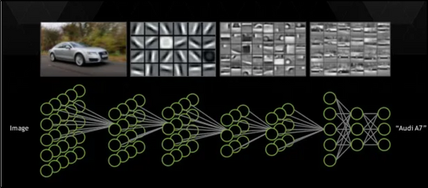

**Fig -3: CNN pixel format**

CNN is able to differentiate between accident sites and regular traffic flow thanks to its hierarchical processing. The pre-trained CNN model in our project would be adjusted to recognize particular accident-related elements in the video frames.It was probably trained on a sizable dataset of highway scenes.

Through this fine-tuning, the CNN is enabled to function as a potent feature extractor, offering insightful information for the ensuing anomaly detection phases that ultimately result in more precise accident recognition.

**WORKING PROCESS**

**A.Image upload:**

Our project utilizes a CNN in Jupyter Notebook (managed by Anaconda Navigator) to analyze an image dataset (potentially resized for efficiency) containing highway scenes with and without accidents. The CNN will learn to distinguish between normal and accident scenarios based on the image features.

**B.Sending geological location :**

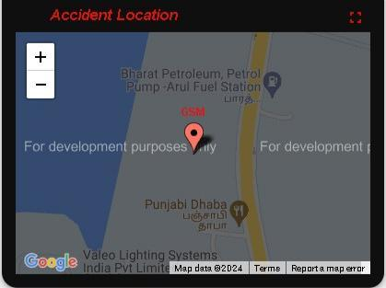

In order to improve the effectiveness of emergency response, the system uses a preprogrammed geographic location provider to localize accident locations.

**Fig -4: G-location of Accident**

**C. Notification :**

As this concept uses GSM modules for notifications, emergency reaction should be the main priority. To speed up response times, the system can be configured to automatically contact neighboring emergency services when an accident is detected.

**HARDWARE AND DATASET**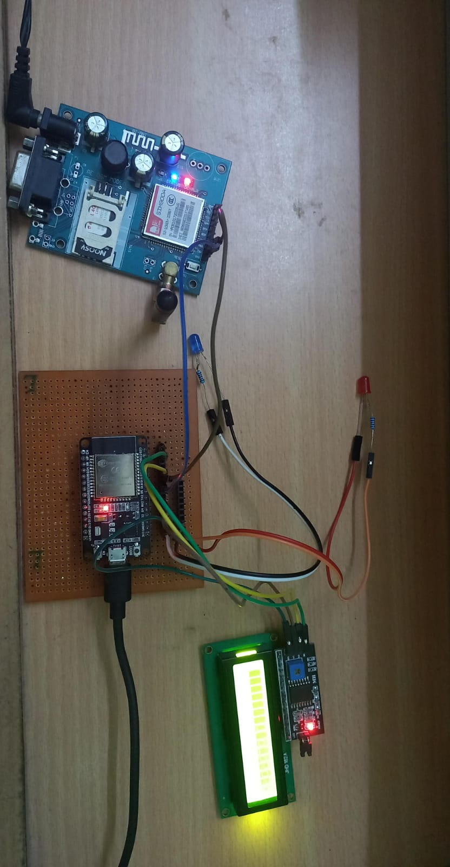

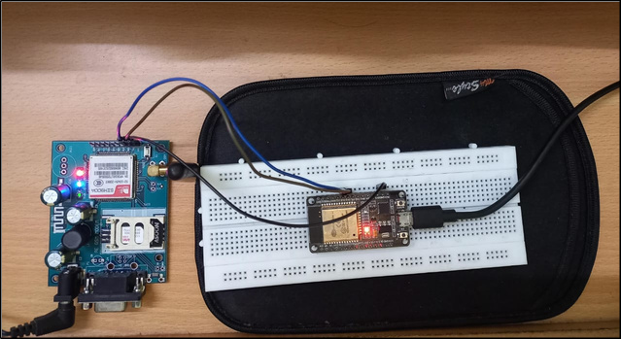

**Fig -6: Hardware components**

The ESP32 application uses the GSM module to automatically call pre-programmed emergency service numbers when an accident is detected. This reduces the need for manual notification, which speeds up response times.

Our software development platform for this project is the Arduino IDE, which makes it simple to change the communication protocols and accident detection algorithms. The brains of the system are an ESP32 microcontroller, which processes video input (perhaps from an external camera module) and runs the machine learning model. Most importantly, the ESP32 allows for communication with a GSM module, bridging the gap between software and

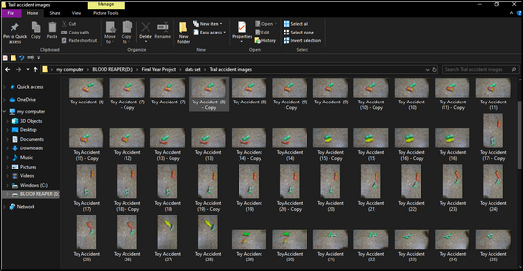

| **Fig -5: Dataset** | hardware. |  |
| --- | --- | --- |
|  |  |

**WORKFLOW**

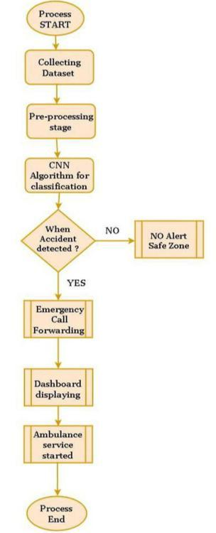

**Fig -7: Workflow of Module**

**RESULT AND OBSERVATION**

**A. Accident Detection Frame pic**

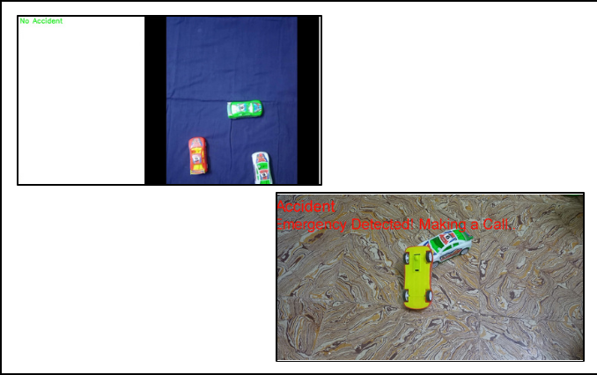

**Fig -8: image of accident and no accident img**

**B. Accident List in Jupyter notebook Application**

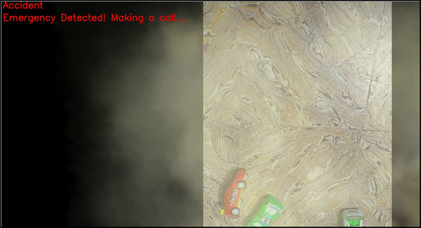

**Fig -9: Accident frame in fog condition**

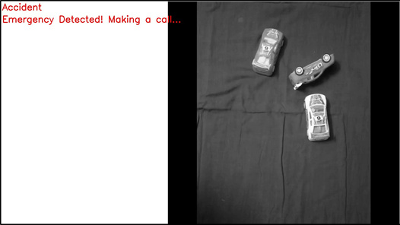

1. **Smoke/Fog:** A part of our system reportedly uses image processing methods to take into consideration the fact that smoke or fog reduces visibility. This could include ways to improve visual contrast and adjust for low vision, or it could entail algorithms for the detection of smoke and fog.
2. **Night time:** Because there is less light throughout the night, situations can be difficult. In order to identify accidents, the system we use can utilize algorithms designed specifically to analyze video material shot at night or night vision processing.

**Fig -10: Accident frame in night condition**

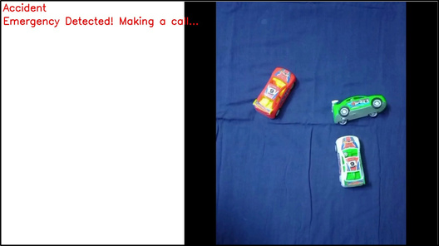

**3) Normal Daylight:** Accidents can happen even in the best of circumstances. A significant dataset comprising both accident situations and typical daytime scenes should be used to train the system.

**Fig -11: Accident frame in daylight condition**

**C. Training and Accuracy Graph in ML**

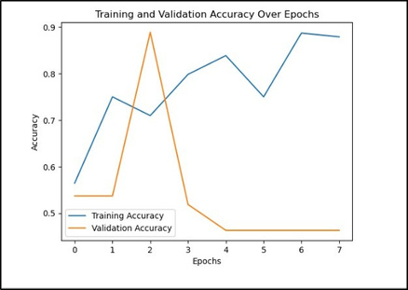

**Fig -12: Accuracy graph**

**D.Accident Video in Thingsboard Application**

**Integration with ThingsBoard:**

ThingsBoard is an open-source Internet of Things platform that facilitates data visualization, device administration, and remote monitoring.

**Including ThingsBoard in project allows us to:**

**Visualization:**

The ThingsBoard application's dashboard allows for the visualization of accident sites as well as possibly other pertinent data. This offers a consolidated perspective for tracking and handling mishaps

**Data management:**

The ThingsBoard platform can store and analyze data that the system safely transmits, such as coordinates of camera locations and possibly further accident information.

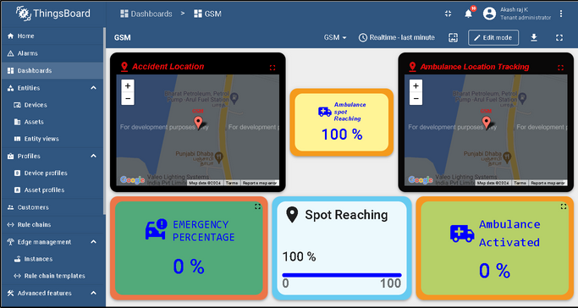

**Fig -13: Thingsboard dashboard**

**CONCLUSIONS**

In this research, we developed an effective monitoring cameras accident detection system and automated surveillance using convolutional neural networks (CNN). The model showed excellent accuracy when batch normalization, dropout for training optimization, and data augmentation strategies were used. Real-time accident monitoring across a variety of video formats, including grainy and black-and-white photos, demonstrated the versatility of our technology. An important advancement in intelligent video surveillance can be made by skillfully integrating these technologies, which have the potential to enhance emergency response and public safety. To further improve the model, the ongoing research will focus on fine-tuning, looking at complex structures, and expanding the dataset for more diverse accident scenarios. As we navigate future advancements in machine learning-based security, this work paves the way for innovative applications in the field.

**FUTURE SCOPE**

Our project could explore expanding the dataset used for training our accident detection system beyond toy accidents to include a wider range of real-world scenarios. This would improve the system's accuracy and reliability in detecting actual accidents on highways. Additionally, integrating our system with traffic flow monitoring technologies could provide insights for optimizing road infrastructure and managing traffic more efficiently. Developing algorithms to predict the severity of accidents and integrating our system with emerging vehicle-to-infrastructure communication technologies could further enhance its effectiveness.

Collaboration with autonomous vehicle developers and emergency services to integrate our system into their platforms and dispatch systems respectively could streamline response efforts and improve overall safety. Continuous monitoring and improvement of our system's performance, along with potential expansion to other transportation modes, could further extend its impact in enhancing highway safety.

**REFERENCES**

1. Balfaqih, M., Alharbi, S.A., Alzain, M., Alqurashi, F. and Almilad, S., 2021. An accident detection and classification system using internet of things and machine learning towards smart city. Sustainability, 14(1), p.210.

[2].Pillai, M.S., Chaudhary, G., Khari, M. and Crespo, R.G., 2021. Real-time image enhancement for automatic automobile accident detection through CCTV using deep learning.

1. Choi, J.G., Kong, C.W., Kim, G. and Lim S., 2021. Car crash detection using ensemble deep learning and multimodal data from dashboard cameras Expert Systems with Applications, 183, p.115400.
2. Huang, X., He, P., Rangarajan, A. and Ranka, S., 2020. Intelligent intersection: Two-stream convolutional networks for real-time near-accident detection in traffic video. ACM Transactions on Spatial Algorithms and Systems

(TSAS), 6(2), pp.1-28.

[5].Ozbayoglu, M., Kucukayan, GunDogdu, E., 2016, December. Real-time autonomous highway accident detection model based on big data processing and computational intelligence. 2016 IEEE international conference on big data (Big Data) (pp.1807-1813). IEEE.

[6].Kumar, B., Basit, A., Kiruba,M.B., Giridharan, R. and Keerthana, S.M., 2021, July. Road Accident Detection Using Machine Learning. In 2021 International Conference On System, Computation, Automation and Networking (ICSCAN) (pp. 1-5). IEEE.

1. QF Tian, ZZ Chen and LG Zhang (2010). Incident detection in urban freeway traffic based on adaptive algorithms. Journal of Transportation Engineering and Information, 8(4), 99-103.
2. L Calderoni, D Maio and S Rovis (2014). Deploying a network of smart cameras for traffic monitoring on a 'city kernel. Expert Systems with Applications, 41(2), 502-507.

**BIOGRAPHIES**



**Akash Raj.K**

Electronics and Communication Engineering**,**

Sri Venkateswaraa College of Technology,

Sriperumbudur **,** Tamil Nadu.

kakashraj220@gmail.com



**Sruthie N**

Electronics and Communication Engineering**,** Sri Venkateswaraa College of Technology, Sriperumbudur **,** Tamil Nadu. sruthiedevi03@gmail.com



**Logesh S**

Electronics and Communication Engineering**,**

Sri Venkateswaraa College of Technology,

Sriperumbudur **,**Tamil Nadu.

logeshs1416@gmail.com