Master’s Thesis On

A STUDY ON ANALYSIS OF CONSUMER BUYING BEHAVIOUR IN ONLINE SHOPING WEBSITES WITH REFERENCE TO FLIPKART

FOR THE PARTIAL FULFILLMENT OF THE REQUIREMENT
FOR THE AWARD OF
MASTER OF BUSINESS ADMINISTRATION

UNDER THE GUIDANCE OF
Prof. Dr. Mujibur Rahman

Submitted By
Anjali Nandan

22GSOB2010258

MBA 2022-2024



SCHOOL OF BUSINESS
GALGOTIAS UNIVERSITY

May, 2024 2

1

CERTIFICATE
This is to certify that the Master’s Thesis “A STUDY ON ANALYSIS OF CONSUMER BUYING

BEHAVIOUR IN ONLINE SHOPING WEBSITES WITH REFERENCE TO FLIPKART” has been prepared

by Miss. Anjali Nandan under my supervision and guidance. The project report is submitted towards the partial fulfilment of 2 year, Full time Master of Business Administration.

Name & Signature of Faculty

Date 3

2

DECLARATION

I, Anjali Nandan (22GSOB2010258), student of School of Business, Galgotias University, Greater Noida, hereby declare that the Master’s Thesis on “A STUDY ON ANALYSIS OF CONSUMER BUYING BEHAVIOUR IN ONLINE SHOPING WEBSITES WITH REFERENCE TO
FLIPKART” is an original and authenticated work done by me.

I further declare that it has not been submitted elsewhere by any other person in any of the institutes for the award of any degree or diploma.

Name and Signature of the Student

Date

3

ACKNOWLEDGEMENT

I would like to acknowledge and express our sincere gratitude to all those who have contributed to the completion of this project report. Firstly, I would like to thank our faculty Dr. Mujibur Rahman for their guidance, support, and valuable feedback throughout the entire project. His expertise and knowledge have been instrumental in shaping the direction and content of this report.

Furthermore, I would like to thank our colleagues and friends who provided valuable insights, suggestions, and assistance during various stages of this master thesis. Their input and constructive criticism have greatly contributed to the overall quality of this report. Additionally, I am grateful to the participants who took part in interviews, surveys, or any other data collection activities. Their willingness to share their experiences and opinions has enriched the findings of this report.

Lastly, I would like to express our gratitude to our families for their unwavering support and understanding throughout the duration of this master thesis. Their encouragement and belief in our abilities have been a constant source of motivation. I acknowledge that this master thesis would not have been possible without the support and contributions of all those mentioned above. I am truly grateful for their involvement and assistance.

Thank you

4

TABLE OF CONTENTS

Chapter Title

1. Introduction

- Introduction to industry

- Introduction to Online websites

- Literature review

2. Objectives and scope

- Objectives of the study

- Scope of the study

  - Research methodology

- Research design

- . Sample design

- Data Collection methods and tools

  - Data Preparation and analysis

- Finding and conclusion

- Limitations

- Suggestions

- Annexure

- Bibliography

  - Questionnaire

5

Abstract

Consumer Behavior towards online shopping during this epidemic period of COVID- 19 is changing presto. nearly every aspect of our life has been modify due to this epidemic. There are numerous factors shooting up in these delicate times which are governing the buying opinions and preferences of the people. This exploration takes a descriptive analysis towards carrying its findings and results. The results of this report are supported by dependable secondary data and primary data. The study focuses on copping rudiments and giving first concern to safe and secure delivery of products. This exploration will help Ecommerce enterprises to understand the changing demands and gets of its guests during this delicate time and give the stylish of services leading to client delight Keeping in mind in the period of globalization digital marketing is a great revolution. Over the last decade outside business associations are running with technological change. Online shopping or marketing is the use of technology (i.e., computer) for better marketing performance. And retailers are contriving strategies to meet the demand of online shoppers; they're busy in studying consumer gets in the field of online shopping, to see the consumer stations towards online shopping. thus, we have also decided to study consumer's stations towards online shopping and precisely studying the factors companion consumers to shop online.

6

INTRODUCTION

7

INTRODUCTION

Internet is changing the way consumers shop and buy goods and services, and has rapidly evolved into a global phenomenon. Many companies have started using the Internet with the aim of cutting marketing costs, thereby reducing the price of their products and services in order to stay ahead in highly competitive markets. Companies also use the Internet to convey communicates and disseminate information, to sell the product, to take feedback and also to conduct satisfaction surveys with customers. Customers use the Internet not only to buy the product online, but also to compare prices, product features and after sale service facilities the will receive if they purchase the product from a particular store. Many experts are optimistic about the prospect of online business.

In addition to the tremendous potential of the E-commerce market, the Internet provides a unique opportunity for companies to more efficiently reach existing and potential customers. Although most of the revenue of online transactions comes from business-to-business commerce, the practitioners of business-to-consumer commerce should not lose confidence .It has been more than

- decade since business-to-consumer E-commerce first evolved. Scholars and practitioners of electronic commerce constantly strive to gain an improved insight into consumer behavior in cyberspace. Along with the development of E-retailing, researchers continue to explain E-consumers behavior from different perspectives. Many of their studies have posited new emergent factors or assumptions which are based on the traditional models of consumer behavior, and then examine their validity in the Internet context.

8

ONLINE SHOPPING IN INDIA

The birth and growth of Internet has been the biggest event of the century. E-commerce in India has come a long way from a timid beginning in the 1999-2000 to a period where one can sell and find all sorts of stuff from a high end product to a meager peanut online. Most corporations are using Internet to represent their product range and services so that it is accessible to the global market and to reach out to a larger range of their audience.

Computers and the Internet have completely changed the way one handles day-to-day transactions; online shopping is one of them. The Internet has brought about sweeping changes in the purchasing habits of the people. In the comfort of one's home, office or cyber cafe or anywhere across the globe, one can log on and buy just about anything from apparel, books, music, and jewellery to digital cameras, mobile phones, MP3 players, video games, movie tickets, rail and air tickets. Ease, simplicity, convenience and security are the key factors turning the users to buy online.

It is a fact that a great online shopping revolution is expected in India in the coming years. There is a huge purchasing power of a youth population aged 18-40 in the urban area

- FEW FACTORS THAT BOOST ONLINE SHOPPING IN INDIA

  - Rapid growth of cybercafés across India

  - Access to Information

  - The increase in number of computer users

  - Reach to net services through broadband

  - Middle-class population with spending power is growing. There are about 200 million of middle-class population good spending powers. These people have very little time to spend for shopping. Many of them have started to depend on internet to satisfy their shopping desires.

9

- FEW FACTS ABOUT ONLINE SHOPPING

The figures from IAMAI show that the internet users in India will grow to 300 million by 2016. Around 25% of regular shoppers in India are in the 18-25 age groups, and 46% are in the 26-35 year range.
  - Indian online matrimonial sector is worth around $230 million.

  - Worldwide E-commerce is only growing at the rate of 28%, since India being a younger market, the growth of e-commerce is expected at 51% in the coming years.

  - In line with global trends finally India has also started shopping online these days. As per the study by IAMAI online shopping in India has rose from $11million in 1999-2000 to $522 million in 2007 and it is expected to rise above $750 million by end March 2016.

- CHANGING ATTITUDE TOWARDS ONLINE SHOPPING

“Awareness, Future Demand Focus for Emerging Markets & Current Issues” Malls springing up everywhere and yet people are E-shopping! And not in small numbers either. Consumers are more rational nowadays and have ability to get the choices from the market. Awareness among the consumers is spread through internet. The number of internet users is increasing day by day which attracts people who have an option to buy online. It was never thought that Indians would go in for e-shopping in such a big way. Ticketing, travel bookings and even books and movies seem fine to buy online. Knowing that in India sizes vary from brand to brand and quality is inconsistent, even of some electronic items, how is it that there are people buying these items online? In India there are some segments of people who have not yet tried purchasing over internet.

Here is the few reason why internet shopping is preferable:

1. Convenien

Online stores are usually available 24 hours a day, and many consumers have Internet access both at work and at home. Other establishments such as internet cafes and schools provide access as well. A visit to a conventional retail store requires travel and must take place during business hours.

10

2. Information and reviews

Online stores must describe products for sale with text, photos, and multimedia files. Some stores even allow customers to comment or rate their items. There are also dedicated review sites that host user reviews for different products. Reviews and now blogs gives customers

3. Concept

the option of shopping cheaper organize purchases from all over the world without having to depend on local retailers.

In any case, home delivery is a concept that Indians are familiar with and love. The mall craze has started only now. Earlier it was a choice between sweating it out in small crowded markets, or asking a friendly neighborhood kirana (grocer) to deliver groceries home and this system is still thriving.

4. Increase in the Internet users

Increasing penetration of Internet connectivity and PCs has led to an increase in the Internet users across India. The demographic segments that have witnessed maximum growth comprise college going students and young persons. These segments are the users of advanced applications and technologies online and are most likely to be heavy E-Commerce users.
5. Increase in the number of buyers and sellers

The success of a marketplace depends on the presence of a large number of buyers and a large number of sellers. In addition to online buyers, many offline stores have begun to sell their products in the online marketplace. The greater the number of sellers and buyers, the faster the market grows.

11

HISTORY

OF

ONLINE SHOPPING

12

HISTORY OF ONLINE SHOPPING

Online shopping is a form of electronic commerce whereby consumers directly buy goods or services from a seller over the Internet without an intermediary service. An online shop, e-shop, e-store, Internet shop, web-shop, web-store, online store, or virtual store evokes the physical analogy of buying products or services at a bricks-and-mortar retailer or shopping centre. The process is called business-to-consumer (B2C) online shopping. When a business buys from another business it is called business-to-business (B2B) online shopping.

1979

Videotex was being researched since much earlier for supplying the end users with textual information. Much work was done in UK on videotext, it was a two way message service and developed basically for information sending where “many companies” were interested in, but on the backdrop of all that Michael Aldrich in 1979 gave the “concept of teleshopping” (today online shopping) which revolutionized the way businesses happen. Same happened in the US around that year with services like The Source and CompuServe.

1982

Minitel succeeded Videotext as online service making online purchases, check share market, search telephone directory and could even chat. This is one of the most successful services before

- using telephone lines; it was launched in France successfully but in UK as well but to less success.

1987

With Swreg (offshoot of CompuServe) the community of software developers and shareware authors got an online market where they could sell their product using “Merchant account”. Thus online shopping started for then software industry people.

1990

Tim Berners-Lee wrote the World Wide Web and gave the first browser to view the web which changed most of things; a whole new revolution started, which till date is ON.

13

1992

Revolutionary book by J.H. Snider and Terra Ziporyn namely; Future Shop: How New Technologies Will Change the Way We Shop and What We Buy. St. Martin’s Press.

1994

Netscape released Navigator browser, later introduced Secure Sockets Layer (SSL) encryption for secure transaction. Pizza Hut started online ordering on their webpage, cars, bikes and adult content as well started selling on the internet.

1995

Amazon.com started selling each and everything online, and along with that Jeff Bezos starts first commercial-free 24 hour, internet-only radio stations. Then Radio HK and NetRadio start broadcasting. Companies like Dell and Cisco started using internet in all their transactions. Online auction started by eBay.

1998

United States started selling Electronic postal stamps online wherein they could be purchased and downloaded for print.

1999

Acquisition of Business.com by e-Companies in US $7.5 million. Napster the peer-to-peer file sharing software launches. Home decorative items started selling on ATG Stores.

2000

The dot-com bust as we know it today wasn’t something that happened in a day, over speculation for a period of time (approx. 1995-2000) where just the prefix “e-” or “.com” in names could make stock prices rise at great rates. This saw a great many companies rise and fall.

Many entrepreneurs came up with brilliant plans and most got pretty “generous” venture capitalists, most of these firms started working on the principle “expand the market and later profits will cover all present debts and losses.” This speculation was constantly taking the market upwards with NASDAQ at a peak of 5132.52 points on March 10, 2000. After this the market goes down and with them the over speculating ones were just wiped off the market.

14

2002

PayPal the company which offered an alternative (through internet) to cash or check payment was acquired by eBay for $1.5 billion. CSN Stores and NetShops were founded with the concept of domain specific commodity and sprung with many online stores, going for one item on each website.

2003

Online shopping matures showing to the world their confidence Amazon.com posted first yearly profit and thus again making presence on the stock market.

2007

Acquisition of Business.com by R.H. Donnelley for $345 million, making way for bigger players in technology domain.

2012

Tremendous growth in US in Ecommerce with sales figures touching $204 billion, a decent 17% rise from the previous year.

2014

Online Retailer – Amazon.com has an estimated turnover on a daily basis is over US $2.5 trillion with growth rate of 14% annually. EBay having sales of US $1.89 billion, these numbers alone speak.

2017

average online purchases are expected to increase by 78 percent in 2016 from 66 percent in 2015, due to attractive deals and aggressive marketing of ever-expanding range of merchandise from clothes to jewellery, from electronics to books," said a study by Assocham and international accounting firm Price water house .

15

THEORIES

16


3.1 INTRODUCTION TO THE STUDY

The Internet has entered the mainstream consciousness over the past decade. This has happened primarily because the web has got a graphical interface and Internet has moved from governmental control to private hands. The activities which are happening on the Internet are email and instant messaging, general web surfing or browsing, reading news, hobby searches, entertainment searches, shopping and buying online, medical information searches, travel information searches, tracking credit cards, and playing games.

Communication i.e. email, chat or instant message is the basic activity for which Internet is used. It is the single most important reason for people to go online. E-mail provides the opportunity to communicate more often with a much broader circle of people than one can reach by telephone or by mail in a convenient way. In India too email constitutes the major activity on the Internet. It was found that more elderly people are increasingly using email as compared to the younger generations.

In India the top five online activities are e-mail, surfing, chatting, search and job search. Some of the sites, which are commonly used for these particular activities, are:

Yahoo -Most preferred communication portal, tops for email and chat

Indiatimes –Best event and sports news provider.

Naukri-Best recruitment portal

Google-Best information domain

Shaadi-Best for matrimonial services

eBay-Best online shopping portal

17
Rapid growth of cybercafés across India

Access to Information

The increase in number of computer users

Reach to net services through broadband

Middle-class population with spending power is growing. There are about 200 million of middle-class population good spending powers. These people have very little time to spend for shopping. Many of them have started to depend on internet to satisfy their shopping desires.

The figures from IAMAI show that the internet users in India will grow to 200 million by 2010. Around 25% of regular shoppers in India are in the 18-25 age groups, and 46% are in the 26-35-year range.

- Indian online matrimonial sector is worth around $230 million.

- Worldwide e-commerce is only growing at the rate of 28%, since India being a younger market, the growth of e-commerce is expected at 51% in the coming years.

- In line with global trends finally India has also started shopping online these days. As per the study by IAMAI online shopping in India has rose from $11million in 1999-2000 to $522 million in 2008 and it is expected to rise above $700 million by end March 2010.

- Indians are also Shopaholics like other Asians. There is a strong booming young adult population in India with good levels of disposable income.

In India

Over $50 Billion and growing rapidly - Most popular online shopping products include: books (45%), electronic gadgets (42%), railway tickets (38%), accessories apparel (35%), apparel (35%),

18

gifts (34%), computer and peripherals (32%), airline tickets (28%), music downloads (21%), movie downloads (21%), hotel rooms (22%), magazines (18%), tools (16%), home appliances (16%), toys (16%), jewelry (17%),movie ticket (15%), etc.

Payments

Online shoppers commonly use a credit card to make payments, however some systems enable users to create accounts and pay by alternative means, such as:

- Billing to mobile phones and landlines

- Cash on delivery (C.O.D., offered by very few online stores)

- Cheque/ Check

- Debit card

- Direct debit in some countries

- Electronic money of various types

- Gift cards

- Postal money order

- Wire transfer/delivery on payment

19
Some sites will not accept international credit cards, some require both the purchaser's billing address and shipping address to be in the same country in which site does its business, and still other sites allow customers from anywhere to send gifts anywhere. The financial part of a transaction might be processed in real time (for example, letting the consumer know their credit card was declined before they log off), or might be done later as part of the fulfillment process.

AIDA PRINCIPLE IN ONLINE MARKETING :

- ATTENTION 2.INTREST 3.DESIRE
4.ACTION

a

20
PORTER 5 FORCE ANALYSIS IN ONLINE SHOPPING

Porters Five Forces is a framework for describing factors that affect the pr ofitability and attractiveness of industries. Named after Michael E. Porter, this model ide ntifies and analyzes 5 competitive forces that shape every industry, and helps determine an ind ustry's weaknesses and strengths.

1.Supplier Power

2.Buyer Power

3.Competitive Rivalry

4.Threat of Substitute

5.Threat of New Entry

Supplier Power

Here we assess how easy i t is for suppliers to drive up prices. This is d riven by the number of suppliers of each key input, the uniqueness of their product o r service, their strength and control over u s, the cost of switching from one supplier to another, and so on. The fewer the supplier choices we have, and the more we need supp liers' help, the more powerful the supplie rs are.

Buyer Power

This is driven by the number of buyers, the importance of each individu al buyer to one’s business, the cost to them of switching from one’s products and s ervices to those of someone else, and so on . If you deal with few, powerful buyers, then they are often able to dictate terms to you .

Competitive Rivalry

What is important here is the number and capability of your competitors. If you have many competitors, and they offer equally attractive products and services, then you'll most likely have little power in the situation, because suppliers and buyers will go elsewhere if they don't get a good deal from you. On the other hand, if no-one else can do what you do, then you can often have tremendous strength.

Threat of Substitutes

This is affected by the ability of your customers to find a different way of doing what you do – for example, if you supply a unique softwa re product that automates an important process, people may substitute by doing the process manually or by outsourcing it. If substitution is easy and substitution is viable, then this weakens your power

21
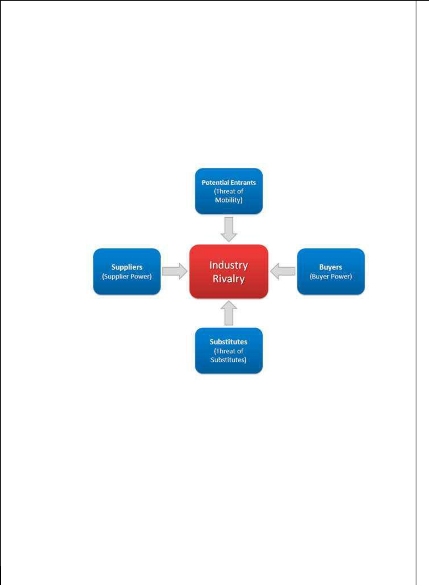
Threat of New Entry

Power is also affected by the ability of people to enter your market. If it costs little in time or money to enter your market and compete effectively, if there are few economies of scale in place, or if you have little protection for your key technologies, then new competitors can quickly enter your market and weaken your position. If you have strong and durable barriers to entry, then you can preserve a favorable position and take fair advantage of it.

Porter’s five forces for Online Retailer

22
Supplier power:

Here, suppliers are the manufacturers of finished products. For any product, there are many suppliers online, so they can’t show power on online retail companies. For example, if you take computers category, there are many suppliers like Dell, Apple, Lenovo, and Toshiba everyone wants to sell their products through online retails like Flipkart,Amazon,Snapdeal etc. Selling online saves a lot of money for the manufacturers, and as many people nowadays prefer purchasing product through online stores, Companies cannot afford to lose this channel. So, in this industry the supplier power is low.

Buyer power:

Buyers in this industry are customers who purchase products online. Since this industry is flooded with so many players, buyers are having lots of options to choose. With many competitors like Amazon.com, eBay, Snapdeal etc. Customers get a wide range of choices. Customer would prefer the one who would provide goods at reasonable price, deliver it fast and provide them with other benefits like Cash on Delivery, EMI facilities, other offers etc. Here Buyers have more power.

Competitive Rivalry:

Competition is very high in this industry with so many players like Jabong, Snapdeal, Amazon, Homeshop18 etc. Many competitors means more choices for the customer to choose from. This also increases the cost incurred by the company to stay in the customer’s mind i.e. on Promotions and Advertisements etc. Giving the customer better deals, making customer’s experience delightful and continuous innovation can help a company to stay at top even with tons of competitors around.

23

Threat of New Entrants:

Threat of new entrants is very high in this online retail industry because of following reasons:

Indian government has allowed 51% FDI in multi-brand online retail and 100% FDI in single brand online retail. So, this means foreign companies can come and start their own online retail companies.

There are very less barriers to entry like less capital required to start a business, less amount of infrastructure required to start business. All you need is to tie up with suppliers of products and you need to develop a website to display products so that customers can order products, and a tie up with online payment gateway provider like bill desk.

Industry is also going to grow at a rapid rate. It is going to touch 76 billion $ by 2021. Industry is going to experience an exponential growth rate. So, obviously no one wants to miss this big opportunity.

With the new entrants like Jabong, Snapdeal etc. rapidly racing towards the top Position.

Threat of substitutes:

Substitute for this industry as of now is physical stores. Their threat is very low for this industry because customers are going for online purchases instead of going to physical stores as it will save time, effort, and money. With the advent and penetration of internet and smart phones, future in retail belongs to online retail.

When we compare relative quality, relative price of product a person buys online with physical store, both are almost same and in some cases, online retail store offers more discounts and this attracts the customer to purchase products online.

24

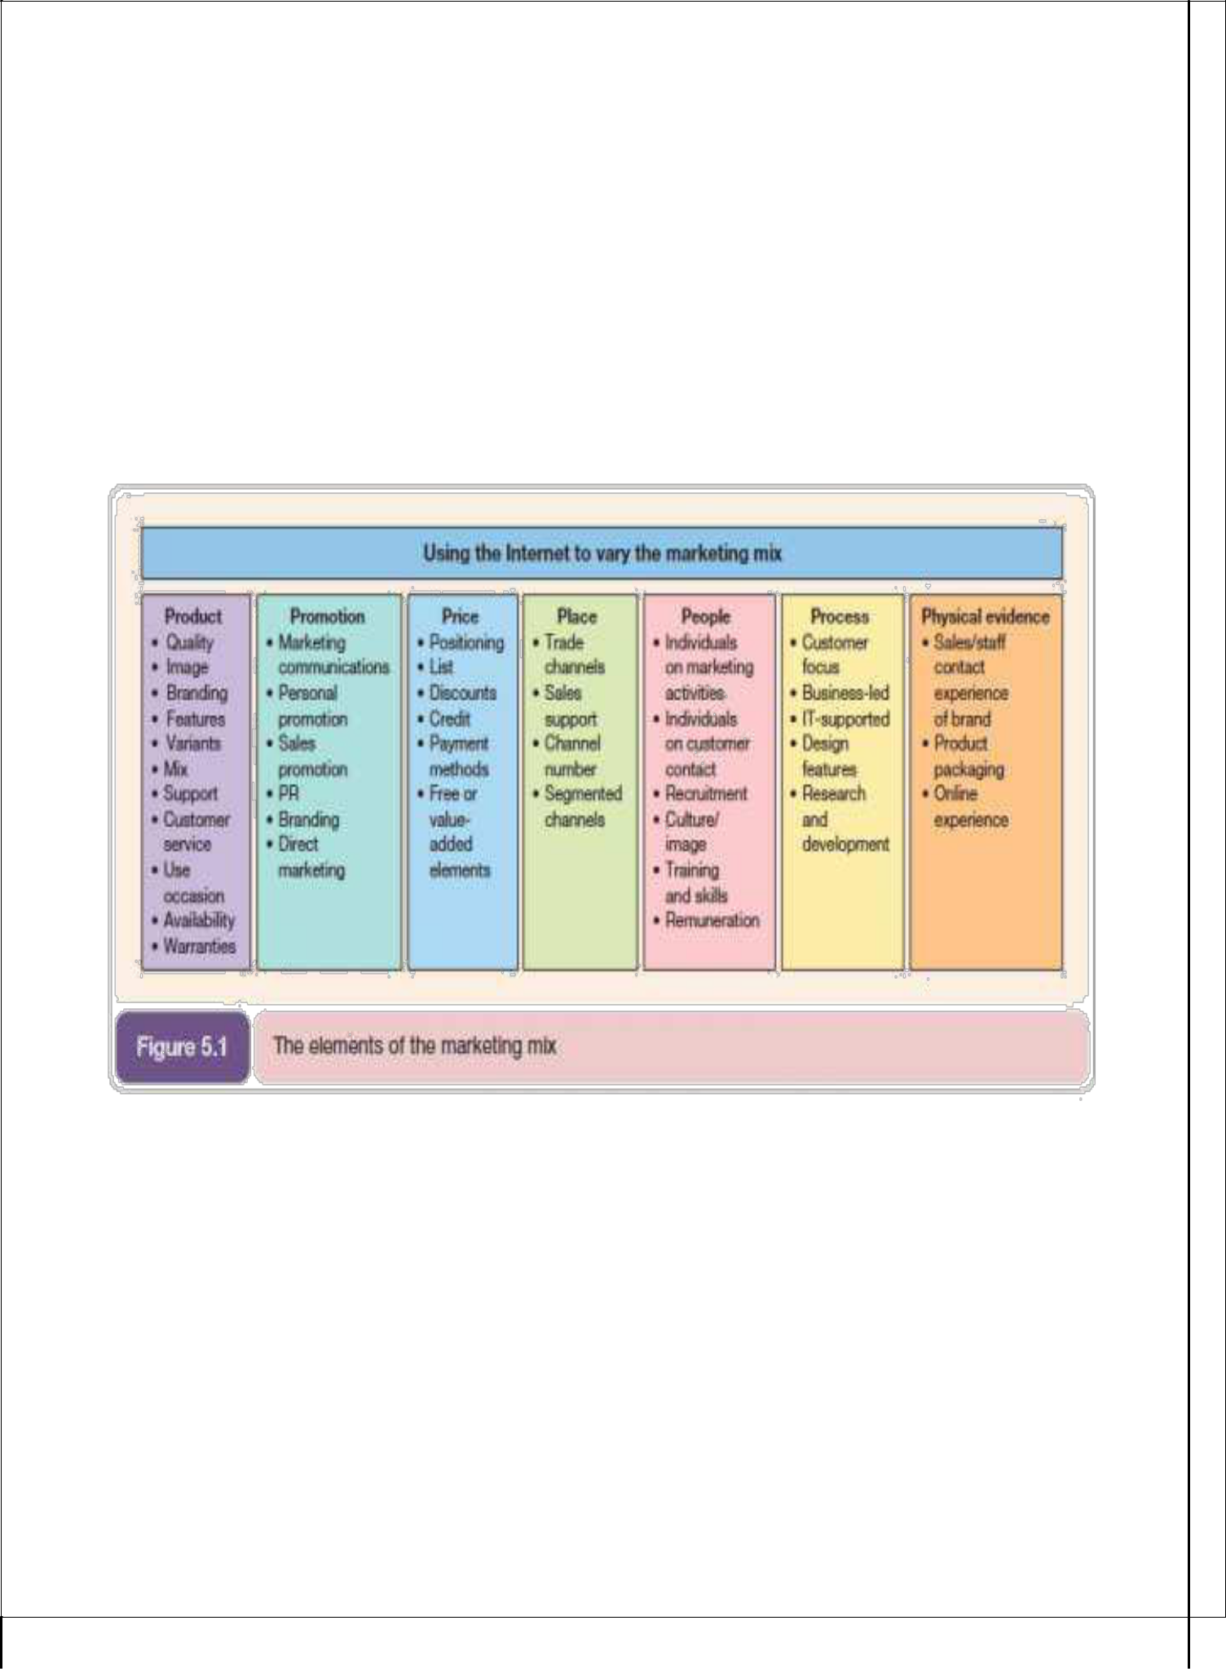

MARKETING MIX OF ONLINE SHOPPING

The elements of marketing mix are also being applied for online marketing. Marketing mix is essential for analysing the business. Marketer analyses the parameters then select appropriate strategy in order to face the market complexion effectively. The 7Ps of marketing is being applied in the online marketing industry. The effect of marketing mix is being explained below diagram :

.

25

MODELS OF ONLINE SHOPING

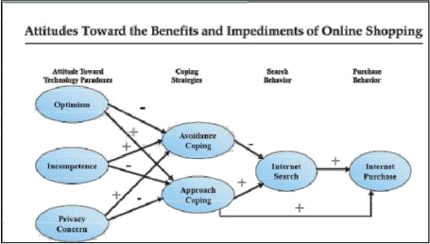

26

This chart shows how consumer attitude toward online shopping can lead either to approach coping (wanting to shop online) or to avoidance coping (deciding not to search or shop online). Someone who is optimistic toward the benefits of online shopping will develop approach coping. A person who is pessimistic toward online shopping will think of the

drawbacks to it and decide to purchase in physical stores instead, which is avoidance coping.

27

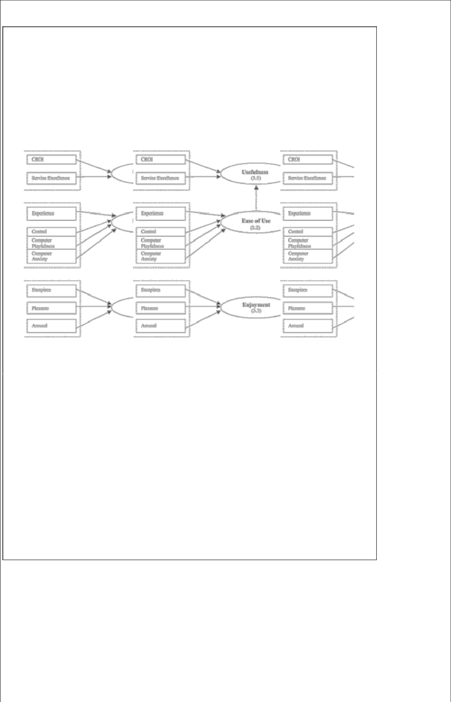

ONLINE SHOPPING SITES

28

Shopping Sites

PC Data Online issued top 20 web retailers on January 2001. The chart below is based on PC Data Online data.



    - Amazon.in Score (4.75) - World leader in e-commerce market recently started operation in India, Now Indians can buy Books, CDS and Electronic at cheaper price from Amzon.in. For limited time they offering free shipping.

- Amazon Coupons

- Amazon Deals & Offers

  - Flipkart.com – Score (4.78) – Founded in 2004 with only Rs. 400000 now in 2014 tuned over 60,000 Crore company. You can not only buy books online through Flipkart, but also mobile phones & mobile accessories, laptops, computer accessories, cameras, movies, music, televisions, refrigerators, air-conditioners, washing-machines, Clothings, Footwears, Accessories, MP3 players and products from a host of other categories. After takeover of letsbuy.com now flipkart is largest player of e-commerce of India.

- Flipkart Coupons

- Flipkart Deals & Offers



29



  - Snapdeal.com -Score (4.90) Snapdeal offers everything from local daily deals on restaurants, spas, travel to online products deals. They offer you best price with free shipping.

- Snapdeal Coupons

- Snapdeal Deals & Offers

(4) Paytm.com– Score (5.01) – Started with Mobile Recharge and Bill Payment website now Paytm selling everything from Home Decor, Clothing, Laptops to Mobile at killer price. In very short time period Paytm has grown very fastly and able to place under our Top 10 Indian Shopping Website list.

- Paytm Coupons

- Paytm Deals & Offers

  - ebay.in -Score (5.02) After almost 6month of dominating at number 1 ebay has come down at number two on india freestuff.in list. EBay.in is the Indian version of the popular online shopping portal eBay.com – world’s online marketplace. Ebay has a diverse and passionate community of individuals and small businesses. Ebay offers used and fresh items with a wide network of international shipping. http://www.ebay.in

- Ebay Coupons

- Ebay Deals & Offers



30



  - Jabong.com:- score (5.11) Jabong Fashion & Lifestyle Store offers you great discount on all listed product. They offers wide range of products from Apparel to Home needs.

- Jabong Coupons

- Jabong Deals & Offers

  - Myntra.com :- score (5.16) Myntra.com is leading online retailer of lifestyle and fashion products. Myntra offers T-shirts, Shoes, watches and more at discounted price.

    - Myntra Coupons

    - Myntra Deals & Offers

  - Shopclues.com:- score (5.55) - Shopclues is famous for their heavily discounted Jaw Dropping deals. Shopclues is one of the best online stores that offers a wide variety of cameras, Computer accessories, Mobile, Gift, Jewellery, Cosmetics, toys, clothes, books and bag. Their Jaw Dropping deal has become most liked deal of 2012.

- Shopclues Coupons

- Shopclues Deals & Offers





31



  - Pepperfry.com :- score (5.81)-Pepperfry is one of leading Indian website in selling lifestyle products ranging from men and womens clothing, home decor, jewellery, perfumes and cosmetics, furnitures, bags and accessories.

- Pepperfry Coupons

- Pepperfry Deals & Offers

  - Homeshop18.com -Score (5.87) here you find large range appliances, kitchen, cameras, mobiles, laptops, site, Indian, gifts, apparel, buy, online, gifts. And more, HomeShop18 is a venture of theNetwork18 Group, India’s fastest growing media and entertainment Group. Network18 operates India’s leading business news television channels – CNBC TV18 and CNBC Awaaz. HomeShop18 has also launched India’s first 24 hour Home Shopping TV channel. The


company has its headquarters in Noida, UP. The website has received the ‘Best shopping site” award from PC World Magazine in 2008

- Homeshop18 Coupons

- Homeshop18 Deals & Offers

  - Groupon :-Groupon India launched in 2011 offers Products and Service deals at good discount.

- Groupon Coupons

- Groupon Deals & Offers



32



  - Zovi.com :- Zovi is one stop destination for all shopping needs from Clothing to Accessories at very reasonable price.

- Zovi Coupons

- Zovi Deals & Offers

  - Infibeam.com – India’s Online Shopping Platform offers Buy Mobile Phones, Books, Apparel, Jewellery, Cameras, Watches, Send Gifts to India, New/ Used Cars & Bikes in India a report says 40 lakh visits per month by Indians on this site.

- Infibeam Coupons

- Infibeam Deals & Offers

    - Firstcry.com :- Firstcry.com India’s largest store for Kids selling 70000+ items from 400+ top International and Indian brands.

- Firstcry Coupons

- Firstcry Deals & Offers





33



  - Shopping.indiatimes.com :- Shopping.Indiatimes.com has a wide array of products that range from electronic items to products related to health & beauty, home appliances, fashion, music, movies and games.

- Indiatimes Coupons

- Indiatimes Deals & Offers

(16) Tradus.com – Tradus.in is owned by ibibo from books to clothes they sell you everything and after buying Buytheprice.com they have become bigger. Tradus offers the Online Shopping in India to buy Books, Mobiles, Cameras, Watches, Apparel, Home Appliances, Ipods & Many More at Lowest Price & Free shipping although their refunding process takes more than expected time and they don’t ship all over India but still at no 3 on our list.

- Tradus Coupons

- Tradus Deals & Offers

  - Futurebazaar.com -FutureBazaar.com is owned and operated by Future Bazaar India Ltd futurebazaar offers you wide range with good price The people of behind this company are same from bigbazaar, pantaloon and ezone.

- Futurebazaar Coupons

- Futurebazaar Deals & Offers



34



  - Koovs.com:- Koovs offers best offers in dining, luxury, technology, entertainment, utilities, health care, fashion, travel & adventure and plenty more.

- Koovs Coupons

- Koovs Deals & Offers



  - Bestylish.com :- Bestylish is one stop destination for all your footwear shopping, they have good range with good price.

- Bestylish Coupons

- Bestylish Deals & Offers

  - Zoomin.com :- Now not only Photo gifts but also you can buy Camera, Mobile, ‚ Accessories and more from zoomin with discounted rate.



35

SNAPDEAL.COM

Snapdeal is an e-commerce company based in India. It is a daily deals' website that features discount offers across lifestyle segments such as dining, health & beauty, entertainment and travel. It also offers discounts on products like electronics, perfumes, watches, bags, sunglasses, apparels and mobile phones.

Headquartered in Delhi, Snapdeal.com was launched in February 2010. The company was founded by KunalBahl, a Wharton graduate and RohitBansal, alumnus of IIT Delhi who are friends since school. They had agreed that after finishing their studies and gaining required work experience, they would start a project of their own.

Snapdeal.com serves as an advertising platform for merchants and a discount platform for customers. For the merchants who partner with Snapdeal, it is a cost-effective channel for acquiring new customers. It also works as a risk-free alternate marketing channel. From the merchant’s standpoint, they are passing on the customer acquisition cost in the form of a discount offer.



36

PRODUCT CATEGORIES PROVIDED BY SNAPDEAL.COM

Mobiles & Accessories

Men’s & Women’s Apparel

Watches, Bags & Accessories

Electronics & Cameras

Computers & Peripherals

Perfumes, Beauty & Health

Jewelry

Books & Movies

Footwear

Home, Kitchen & Appliances

Infants, Kids & Toys

Sports & Hobbies

Travel Packages

Adventure & Entertainment

Terms of Sale, Website Terms of Use, Privacy Policy

This 'User Agreement', which is intended to be a legally binding contract between you and us, contains the following:

- Terms of Sale: this governs your purchase and use of the coupons/vouchers.

- Website Terms of Use: this governs the access and use of the Website.

- Privacy Policy: this governs the use of your personal information we collect.

You agree that you are of legal age to enter into binding contracts, have read, understood and are bound by the User Agreement. If you do not want to be bound by this User Agreement, you should not use this Website or conduct any sale/purchase transaction.

References to "you", "User" shall mean the end user accessing the Website, its contents and using the Functionalities offered through the Website, "Service Providers" mean independent third party service providers or merchants, and "we", "us", "Jasper InfoTech" and "our" shall mean Jasper InfoTech Pvt. Ltd

37

A. TERMS OF SALE

  - The Voucher you purchase is redeemable for goods or services by the seller of such goods and services, or the Service Provider. The Service Provider, not Jasper, is the seller of the goods and services and is solely responsible for redeeming any Voucher you purchase.

  - The Voucher shall have the necessary redemption instructions on it. The Vouchers may have an offer period, or expiry date, mentioned on it. You shall use it accordingly.

  - Unless otherwise stated, you will not be entitled to receive credit or cash-back for whatever value of the Voucher you don't use.

  - Unless otherwise stated, you cannot combine the Voucher offer with other special offers or promotions that may be on.

  - Unless there is something wrong with the purchase or an error attributable to us, we do not offer refunds. Vouchers once sold are non-refundable, whether you use it or not.

  - Neither Jasper nor the Service Provider shall have any liability in the event you lose your Voucher at the Service Provider venue.

  - Jasper is merely the aggregator of deals and issuer of usable Vouchers. The Vouchers and the deals are the property of the respective third party Service Provider.

  - As such, Service Provider shall be fully responsible for any and all injuries, illnesses, damages, claims, liabilities and costs suffered by or in respect of a customer, caused in whole or in part by the Service Provider.

- Snapdeal.Com Return Policy

There could be certain circumstances beyond our control where you could receive a damaged / defective product or a product that is not the same as per your original order. We will replace the product to your satisfaction at no extra cost. In such circumstances we would request you to get in touch with our Customer Service Team through one of the below channels and they will guide you on the next steps for the same

- 24 hour call centre.

• Or by filling up the 'contact us' form using the following

link http://www.snapdeal.com/info/contactus

38

- Or by sending an email at help@snapdeal.com

Before accepting shipment, kindly ensure that the product's packaging is not damaged or tampered. If you observe that the package is damaged or tampered, we would request you to refuse to accept delivery and inform us as soon as possible. The return process of the product can be restricted depending on the nature and category of the product.

Conditions for return:

- Please notify us of receipt of a Damaged / Defective product within 48 hours of delivery. If you are unable to do so within 48 hours, there shall be no liability of Snapdeal.com to replace the order
- Products/Items should be UNUSED.

- Snapdeal.com will arrange pickup of the damaged/defective product through its own logistics partner. In the event of Snapdeal.com not being able to get the pickup arranged, you will need to send the product using one of the reputed couriers in their area.

- Courier freight charges reimbursement will be as SD cash, if any and up to a maximum as defined by our logistics team.

- Products should be returned in their original packaging along with the original price tags, labels and invoices.

- It is advised that the return packets should be strongly and adequately packaged so that there is no further damage of goods in transit.

- The returned goods are subject to verification and checks from Snapdeal.com team to judge the legitimacy of the complaint

Refunds:

We will process the refund after receipt of the product by Snapdeal.com. Refund will be processed based on the mode of payment of the order

  - Orders paid online will be refunded within 7-21 working days

  - For COD payments, we will send a refund cheque.

- Bulk Order Cancellation Policy

  - Snapdeal reserves the right to cancel any orders that classify as 'Bulk Order' as per internal criteria

39

- Any SD cash or Promo Code used for placing the 'Bulk Order' will not be refunded as per our cancellation policy

- Some of the reasons that an order is classified as 'Bulk Order' are listed below

- Where it is felt that the products ordered are not for self-consumption but for further sale

- Multiple orders placed for same product at the same address

- Bulk quantity of the same product ordered

- Invalid address given in order details

- Any malpractice is used to place the order

- AMAZON.COM

Amazon.com is an American multinational electronic commerce company with headquarters in Seattle, Washington, United States. It is the world's largest online retailer. The company also produces consumer electronics - notably the Amazon Kindle e-book reader - and is a major provider of cloud computing services.

Amazon has separate retail websites for the following countries: United States, Canada, United Kingdom, Germany, France, Italy, Spain, Japan and China, with international shipping to certain other countries for some of its products. It is also expected to launch its websites in Poland, Netherlands and Sweden.

Jeff Bezos incorporated the company (as Cadabra) in July 1994, and the site went online as amazon.com in 1995. Amazon.com started as an online bookstore, but soon diversified, selling DVDs, CDs, MP3 downloads, software, video games, electronics, apparel, furniture, food, toys, and jewelry.

The company was founded in 1994, spurred by what Bezos called his "regret minimization framework", which he described as his effort to fend off regret for not staking a claim in the Internet gold rush.

The company began as an online bookstore. While the largest brick-and-mortar bookstores and mail-order catalogs might offer 200,000 titles, an online bookstore could sell far more. Bezos wanted a name for his company that began with "A" so that it would appear early in alphabetic

40

order. He began looking through the dictionary and settled on "Amazon" because it was a place that was "exotic and different" and it was the river he considered the biggest in the world, as he hoped his company would be. Since 2000, Amazon's logotype is an arrow leading from A to Z, representing customer satisfaction. A goal was to have every product in the alphabet.



PRODUCT CATEGORIES PROVIDED BY AMAZON.COM

Books

Movies, Music & Games

Electronic & Computers

Home, Garden & Tools

Pet Products

Grocery, Health & Beauty

Kitchen & Dining

Furniture & Decor

Toy, Kids & Baby

Clothing, Shoes & Jewelry

Sports & Outdoors, Automotive & Industrial

TERMS OF USE

This is an agreement between the consumer and amazon digital services, inc. before using the amazon games and software downloads service (the "games and software service"), please read these terms of use, all rules and policies related to the games and software service (including, but not limited to, any specific rules or usage provisions specified on any applicable product, application or service detail page or in any link from a detail page), the amazon.com privacy notice at http://www.amazon.com/privacy and the amazon.com conditions of use at http://www.amazon.com/conditionsofuse (collectively, this "agreement"). If you use the games and software service, you will be bound by the terms of this agreement.

41

Copyright Complaints

Amazon respects the intellectual property of others. If you believe that your work has been copied in a way that constitutes copyright infringement, please follow our Notice and Procedure for Making Claims of Copyright Infringement.

Risk of loss

All items purchased from Amazon are made pursuant to a shipment contract. This means that the risk of loss and title for such items pass to you upon our delivery to the carrier.

Returns, Refunds and Title

Amazon does not take title to returned items until the item arrives at our fulfillment center. At our discretion, a refund may be issued without requiring a return. In this situation, Amazon does not take title to the refunded item. For more information about our returns and refunds.

DISCLAIMER OF WARRANTIES AND LIMITATION OF LIABILITY

This site and all information, content, materials, products (including software) and services included on or otherwise made available to you through this site are provided by Amazon on an "as is" and "as available" basis, unless otherwise specified in writing. Amazon makes no representations or warranties of any kind, express or implied, as to the operation of this site or the information, content, materials, products (including software) or services included on or otherwise made available to you through this site, unless otherwise specified in writing. You expressly agree that your use of this site is at your sole risk.

To the full extent permissible by applicable law, Amazon disclaims all warranties, express or implied, including, but not limited to, implied warranties of merchantability and fitness for a particular purpose. Amazon does not warrant that this site; information, content, materials, products (including software) or services included on or otherwise made available to you through this site; their servers; or electronic communications sent from Amazon are free of viruses or other harmful components. Amazon will not be liable for any damages of any kind arising from the use of this site or from any information, content, materials, products (including software) or services included on or otherwise made available to you through this site, including, but not limited to

42

direct, indirect, incidental, punitive, and consequential damages, unless otherwise specified in writing.

Certain state laws do not allow limitations on implied warranties or the exclusion or limitation of certain damages. if these laws apply to you, some or all of the above disclaimers, exclusions, or limitations may not apply to you, and you might have additional rights.

TERMS AND CONDITIONS

Each item in your order is sold by Amazon Export Sales, Inc. ("Amazon Export") or the merchant that the item is specified as sold by ("Merchant"). Those items for shipment to countries outside of the U.S. may be subject to taxes, customs duties and fees levied by the destination country ("Import Fees"). The recipient of the shipment is the importer of record in the destination country and is responsible for all Import Fees.

With respect to each item for which Import Fees have been calculated, you authorize Amazon Export or Merchant (as applicable) to designate a carrier ("Designated Carrier") to act as your agent with the relevant customs and tax authorities in the destination country, to clear your merchandise, process and remit your actual Import Fees for such item.

"Import Fees Deposit" represents an estimate of the Import Fees that will be levied on the items in your order for shipment to countries outside of the US. By placing your order, you agree to allow Amazon Export and/or Merchant (as applicable) to collect the Import Fees Deposit for the applicable items in your order. This deposit will be used, on your behalf, to reimburse the Designated Carriers for the import fees that they have paid on your behalf to the appropriate authorities of the destination country.

You further agree that the Designated Carriers may disclose to Amazon Export or Merchant (as applicable) the amount of actual Import Fees levied on the item you have purchased from Amazon Export and/or Merchant ("Actual Import Fees"). In the event that the Import Fees Deposit exceeds the Actual Import Fees, Amazon Export or Merchant (as applicable) will refund the difference to you.

In the case of gifts or other purchases made on behalf of another recipient, you also agree to grant the foregoing authorizations on behalf of the recipient designated in your order.

43

To obtain details regarding the Actual Import Fees, or to obtain documentation or receipts in connection with customs clearance, you may contact the Carrier specified in your shipment confirmation e-mail.

These terms and conditions are in addition to the standard Conditions of Use of the Amazon website. Pursuant to those terms, title and risk of loss for the items transfer to the recipient upon delivery to the common carrier in the United States.

Please note that Merchants participating in the International Direct program may have policies that differ from Amazon Export's terms and conditions. For items you have purchased from a Merchant, please see the applicable Merchant's policies for any other terms and conditions that may apply to your purchase of such items.

44

- EBAY.COM

EBay is an American multinational internet consumer-to-consumer corporation that manages eBay.com, an online auction and shopping website in which people and businesses buy and sell a broad variety of goods and services worldwide. Founded in 1995, eBay is one of the notable success stories of the dot-com bubble; it is now a multi-billion dollar business with operations localized in over thirty countries. EBay expanded from its original "set-time" auction format to include "Buy It Now" standard shopping; shopping by UPC, ISBN, or other kind of SKU; online classified advertisements; online event ticket trading; online money transfers and other services.

The online auction website was founded as Auction Web in San Jose, California, on September 5, 1995, by French-born Iranian-American computer programmer Pierre Omidyar as part of a larger personal site that included, among other things, Omidyar's own tongue-in-cheek tribute to the Ebola virus. One of the first items sold on eBay was a broken laser pointer for $14.83. Astonished, Omidyar contacted the winning bidder to ask if he understood that the laser pointer was broken. In his responding email, the buyer explained: "I'm a collector of broken laser pointers."The frequently repeated story that eBay was founded to help Omidyar's fiancée trade Pez candy dispensers was fabricated by a public relations manager in 1997 to interest the media, which were not interested in the company's previous explanation about wanting to create a "perfect market". This was revealed in Adam Cohen's 2002 book, The Perfect Store, and confirmed by eBay.
PRODUCT CATEGORIES PROVIDED BY EBAY.COM

Fashion

Motors

Electronics

Collectibles & Art

Home, Outdoors & Décor

Entertainment

Deals & Gifts

Sporting Goods

45

TERMS AND CONDITIONS

- These Terms and Conditions are between you, the registered user of www.ebay.in ("eBay. in") who wish to buy the goods as appearing in the listing on this webpage of eBay. in Global Easy Buy Micro Site ("Listed Goods") and i2c World Inc., a company incorporated under the laws of United States of America having its principal place of business at 59 West 37 th Street, New York New York 10018, USA (hereinafter referred to as "International Reseller") and governs Your purchases of Listed Goods from International Reseller on eBay. in Global Easy Buy Micro Site and related payments for the same using Paisa Pay Facility on eBay. in.

- You must read, agree with and accept all of the terms and conditions contained in these Global Buying Terms, as these terms constitute your legal and contractual obligations towards International Reseller for using eBay. in Global Easy Buy Micro Site for buying Listed Goods. These Global Buying Terms are in addition to any other terms and conditions mentioned in the item description page of the Listed Goods.

- These Global Buying Terms shall be effective and binding upon your 'acceptance'. 'Acceptance' shall mean Your affirmative action in clicking on the 'Buy It Now' or on 'Bid' or on the 'continue' button as provided on this webpage or such other actions that implies Your acceptance including without limitation making a buying offer and/or making or attempting to make any payments thereto. If You do not agree or are not willing to be bound by the terms and conditions of these Global Buying Terms please do not click on the "Buy It Now" or on 'Bid' or on the "continue" button and do not seek to obtain access to or otherwise undertake any activity on this webpage in relation to Listed Goods.

- Disclaimer of warranties: International Reseller Disclaims Any And All Warranties or Representation Express or Implied, Including, But Not Limited To, The Implied Warranties of Merchantability, Title, Non-Infringement and Fitness for a Particular Purpose. In No Event Shall International Reseller Be Liable For Any Consequential, Indirect, Special Or Punitive Damages, Interest Or Lost Profits, Even If Advised Of The Possibility Thereof.

46

- Limitation of Liability: International Reseller Shall Not Be Liable To You For Any Indirect, Incidental, Consequential, Punitive Or Special Damages, Arising Out Of Or Related To These Global Buying Terms Or In Manner Relating To Buying, Reselling, Packing, Storing, Customs Clearance, Shipment Etc. Of The Listed Goods Including, Without Limitation, Damages For Loss Of Business Profits, Business Interruption, Loss Of Business Information Whether In An Action In Contract Or Tort, Product Liability, Statute, Equity, And The Like, Even If International Reseller Has Been Advised Of The Possibility Of Such Damages. International Reseller Shall Be Cumulatively Liable To You To Only Refund You A Maximum Of The Amount Actually Paid By You To International Reseller For Buying The Listed Goods.

- Invitation to offer, offer and acceptance: The Listed Goods displayed on this webpage and other details thereto are the invitation to offer made by International Reseller to You. Upon acceptance of these Global Buying Terms, on paying advance purchase consideration to International Reseller through eBay. in Paisa Pay Facility You shall be deemed to have accepted such invitation to offer and thereby Your action (paying advance purchase consideration to International Reseller through eBay. in Paisa Pay Facility) shall deem to be an offer to International Reseller to buy the Listed Goods from eBay.com Seller and resell

- the same to You in accordance with these Global Buying Terms, the Foreign Exchange Management Act, 1999 ("FEMA") and the regulations made there under and other terms and conditions mentioned on this webpage or in relation to Listed Goods. International Reseller may at its sole discretion accept or reject your offer without assigning any reasons whatsoever. If International Reseller accepts your offer, the International Reseller will purchase the Listed Goods from eBay.com Seller on eBay.com and shall resell the same to you in accordance with FEMA and the regulations made there under. If International Reseller rejects your offer, the International Reseller will refund the advance purchase consideration to you through eBay. inPaisa Pay Facility or such other means as may be deemed appropriate by International Reseller and such refund shall be made in reasonable time but no later than fifteen (15) days of the date of Your accepting the invitation to offer and making a consequent offer. You shall not be entitled and International Reseller shall not be liable to pay you any interest on the advance purchase consideration in any circumstances whatsoever.

47

- Delivery, Title & Risk of Loss: Subject to the clearance of the Indian customs authorities, International Reseller will ensure Listed Goods are delivered to the location specified by You at eBay. In / eBay.in Global Easy Buy Micro Site within reasonable time and in accordance with the rules of eBay.in. Without prejudice to the rights of International Reseller as a unpaid seller to the extent of any entry taxes, octroi or municipal taxes levied in any part of India before delivering the goods to You, the title to goods passes to You when International Reseller has repacked the goods at its warehouse outside India and tendered the goods to the shipping agent for delivery to You or your agent. However, the goods will remain in the custody of International Reseller till the same are delivered to You at the address designated by You on eBay. in and/or in eBay.in Global EasyBuy Micro Site.

- Mode of receipt of advance purchase consideration: International Reseller will accept your payments through its designated payment collection agent in India who is registered with Paisa Pay Facility of eBay.in. International Reseller will only purchase your items upon your payment being approved by Paisa Pay.

- Price of goods and extra costs: The price of the goods as displayed on this webpage is all inclusive price but shall exclude any entry taxes, octroi or municipal taxes levied in any part of India before delivering the goods to You, which shall be paid by You to the International Reseller and/or its agents / service provider / contractor / sub-contractor in India before the goods are delivered to You. If you refuse or fail to make the full payment of the extra costs then the International Reseller or its agents or service providers or contractors or sub-contractors in India shall be entitled to sell, liquidate or otherwise deal with the goods in any manner whatsoever to recover this extra costs.

- Export and Import: You agree and acknowledge that Your acceptance of invitation to offer and International Reseller's consequent acceptance of your buy offer/order will result into an import into India. The International Reseller shall be the exporter for the purpose of import of goods into India and you shall be the importer for the same purpose. You hereby authorize International Reseller to appoint a customs clearance and forwarding agent to pay customs

48

duties and other duties, taxes and levies for import of goods into India in accordance with FEMA and the regulations made there under and the Foreign Trade Policy and delivery of goods to You and such other activities as may be necessary to clear the goods from customs department. You shall provide all required and appropriate papers, documents, permits, approvals; licenses, sanctions etc. and such other assistance as may be required by

- International Reseller or its agent, service providers or contractors/sub-contractors in India for clearing the goods from customs and/or required by any statutory authority in India. International Reseller does not warrant or guarantee that the goods shall always be cleared by customs authority in India and the taxes, duties and levies charged by customs or other statutory authorities or the valuation thereto shall be accurate and correct and would not be disputed / challenged / revised by them.

- By accepting these Global Buying Terms and/or making any buying activity on this webpage of eBay.in Global Easy Buy Micro Site or making any payments through PaisaPay Facility You hereby agree to observe full compliance with all the applicable laws, rules, regulations, guidelines etc. whether applicable in India or outside India as amended from time to time, including without limitation Reserve Bank of India Act, 1934 and rules made there under, Prevention of Money Laundering Act, 2002 and the rules made there under, Foreign Exchange Management Act, 1999 and the rules and regulations made there under; Customs Act, 1962 and the rules made there under, Foreign Trade Policy, Income Tax Act, 1961, item or goods specific laws, rules, regulations and guidelines in India and also with Your agreement with eBay.in Site with respect to any use of eBay.in Global Easy Buy Micro Site and/or any buying and payment activity on eBay.in Global Easy Buy Micro Site and Paisa Pay Facility and/or any import into India and/or with limitations or restrictions, if any, to end use of any goods being bought or imported as such.

- Indemnification: You shall indemnify, defend and hold harmless International Reseller, its subsidiaries and affiliates, their respective, owners, directors, officers, employees, sub-licensees, users, customers, agents, attorneys, affiliates, successors, and assigns

49

("Indemnified Parties") from any and all claims, losses, liabilities, damages, suits, actions, government procedures, taxes, penalties or interest, associated auditing and legal expenses and other costs incurred by the Indemnified Parties (including reasonable attorneys' fees and costs of suit) arising from any breach of these Global Buying Terms whether the said breach is willful or otherwise.

50

4. FLIPKART.COM



Flipkart is an Indian e-commerce company headquartered in Bangalore, Karnataka. It was started by two IIT graduates, Sachin Bansal and Binny Bansal, in the year 2007. They were working in Amazon.com previously. Earlier, Flipkart mainly dealt with books but now, it has expanded to electronic goods and a variety of other products.

Flipkart was founded in 2007 by Sachin Bansal and Binny Bansal, both alumni of the Indian Institute of Technology Delhi. They worked for Amazon.com before quitting and founding their own company. Initially they used word of mouth marketing to popularize their company. A few months later, the company sold its first book on flipkart.com—John Woods' Leaving Microsoft to Change the World. Today, as per Alexa traffic rankings, Flipkart is among the top 30 Indian Web sites and has been credited with being India's largest online bookseller with over 11 million titles on offer. Flipkart broke even in March 2010 and claims to have had at least 100% growth every quarter since its founding. The store started with selling books and in 2010 branched out to selling CDs, DVDs, mobile phones and accessories, cameras, computers, computer accessories and peripherals, and in 2011 Pens & stationery, other electronic items such as home appliances, kitchen appliances, personal care gadgets, health care products etc. Further in 2012, Flipkart added A.C, Air coolers, School supplies, Office supplies, Art Supplies & life style products to its product portfolio. Today, Flipkart employs over 4500 people.

PRODUCT CATEGORIES PROVIDED BY FLIPKART.COM

51

Books

Mobiles & Accessories

Computers

Gaming

Movies & TV Shows

Music, CDs, DVDs & Vinyl

TV, Video & MP3 Players

Personal & Health Care

Home & Kitchen

Pens & Stationary

Fragrances

Terms & Conditions

Operating Agreement -:

This Agreement contains the complete terms and conditions that apply to an individual's or entity's participation in the Flipkart.com(A unit of WS Retail Services Pvt Ltd) Associates Program (the "Program""Program"). As used in this Agreement, "we", "us", or "our" means WS Retail Services Pvt Ltd or any of our affiliate companies, as the case may be, and "you" means the applicant. “Flipkart Site” means, collectively, the flipkart.com web site."Your site" means any site that you will link to the Flipkart Site (and which you will identify in your Program application).
1. Enrollment in the Program

To begin the enrollment process, you will submit a complete Program application via the Flipkart Site. We will evaluate your application in good faith and will notify you of its acceptance or rejection. We may reject your application if we determine (in our sole discretion) that your site is unsuitable for the Program. Unsuitable sites include, but are not limited to, those that:

- list affiliate links on price comparison sites

- advertise affiliate links through pop-up windows / pop-unders

- advertise affiliate links as Flipkart ‘coupon codes’ or special offers

52

  - advertise affiliate links as a cash back offer

  - use affiliate links in HTML emailers, newsletters or any other form of bulk emails

  - use affiliate links on illegal audio/video download sites

  - promote sexually explicit materials

  - promote violence

  - promote discrimination based on race, sex, religion, nationality, disability, sexual orientation, or age

  - promote illegal activities

  - Include any trademark of Flipkart.com, Inc. or its affiliates in any username, group name, or other identifier on any social networking website.

  - include any colour combination or layout similar or identical to Flipkart.com, with or without intention to deceive

  - Otherwise violate intellectual property rights.

- Links on Your Site

Once you have been notified that your site has been accepted into the Program, we grant you a revocable, non-exclusive, worldwide, royalty-free license for the duration of the term of this Agreement, solely for purposes of facilitating referrals from your site to the Flipkart Site, to provide on your site one or more of the following types of links to the Flipkart Site:

- Product Links: You may select one or more Products to list on your site using a variety of formats that we make available to you, such as text link format, graphical link format, customizable "widget" format, or "product preview" link format. A "Product" is any product listed on the Flipkart Site that is fulfilled by us or on our behalf, a Digital Product (defined below), or any product sold by a third party seller on the Flipkart Site. For each selected Product, you will display on your site a short description, review, or other reference. You will be responsible for the content, style, and placement of these references.

- Search Box Link: You may provide an Flipkart Site search box on your site that will permit your site visitors to view Products that are the results of their search query within the Search Box link or view results that link directly to a page on the Flipkart Site that

53

contains the results of their search query. We will provide you with technical specifications describing how to include a Flipkart Site search box on y our site.

  - General Link to Flipkart Site Home Page: You may provide a general link on your site to the home page of the Flipkart Site.

  - Search Results Link: You may provide a link on your site that will link to a particular search result on the Flipkart Site, the parameters of which will be determined by you based on search generating alternatives we make available to you. You acknowledge and agree that you will: (a) not, in connection with this Agreement, display or reference on your site, any trademark or logo of any third party seller on the Flipkart Site; (b) ensure that any

“Privacy Information” link or Flipkart trademark (either in logo or text form) that we include in a Special Link is not obscured or altered in any way or made invisible,

illegible or indecipherable to visitors of your site; (c) use any data, images, text, or other information obtained by you from us or the Flipkart Site in connection with this Agreement ("Content") only in a lawful manner and only in accordance with the terms of this Agreement; (d) not use any Content relating to any Excluded Merchant or any product sold by any Excluded Merchant; (e) not modify or alter any Content that consists of a graphic image, other than to resize it.

- Order Processing

We will process Product orders placed by customers who follow Special Links from your site to the Flipkart Site. We reserve the right to reject orders that do not comply with any requirements that we periodically may establish. We will be responsible for all aspects of order processing and fulfillment. Among other things, we will prepare order forms, process payments, cancellations, and returns, and handle customer service. We will track sales made to customers who purchase Products by using Special Links from your site to the Flipkart Site and will make available to you reports summarizing this sales activity. The form, content, and frequency of the reports may vary from time to time in our discretion.

54

4. Referral Fees

We will pay you (in accordance with Sections 5 and 6 below) referral fees on certain Product sales to third parties. For a Product sale to be eligible to earn a referral fee, the customer must click-through a Special Link on your site to the Flipkart Site and during a single session, add

the Product to his or her shopping cart. The session begins when the customer clicks through a Special Link on your site to the Flipkart Site and ends upon the first to occur of the following events: (a) 7 days elapse from the customer's initial click-through, (b) the customer places an order for a Product or (c) the customer follows a third party link to the Flipkart Site that is formatted with an Associate’s tag. We will only pay referral fees on eligible Products after order, payment, and shipping.

5. Referral Fee Schedule

During each calendar month, for Qualifying Products sold during sessions initiated through Special Links on your site, you will earn (subject to the other terms of this Agreement) referral fees in accordance with the "Fee Structure" described below.
• Fee Structure

Subject to the other terms of this Agreement, you will earn a percentage of Qualifying Revenues (revenues derived by us from customers as a result of sales of Qualifying Product units sold during sessions initiated through Special Links on your site, excluding costs for shipping, handling, gift-wrapping, taxes separately stated and charged to the customer, service charges, rebates, credit card processing fees, returns and bad debt) set forth in the table below that corresponds to the number of such Qualifying Product units sold during sessions initiated through Special Links on your site.

6. Referral Fee Payment

We will pay you referral fees on a monthly basis for Qualifying Products shipped in the applicable month. Approximately 60 days following the end of each calendar month, we will either (a) send you a check for the referral fees earned, (b) send you a gift card good for purchase of Products through the Flipkart.com site, subject to our standard terms or conditions. If you select payment via Flipkart.com site gift card, we will accrue and withhold referral fees

55

until the total amount due is at least Rs 250.00. If you select payment via check, we will accrue and withhold referral fees until the total amount due is at least Rs 2500.00.

7. Policies and Pricing

Customers who buy products through this Program will be deemed to be our customers. Accordingly, all of our rules, policies, and operating procedures concerning customer orders, customer service, and product sales will apply to those customers. We may change our policies and operating procedures at any time. For example, we will determine the prices to be charged for products sold under this Program in accordance with our own pricing policies. Product prices and availability may vary from time to time. Because price changes may affect Products that you have listed on your site, your site may only show prices when we serve the link in which those prices are displayed. We will use commercially reasonable efforts to present accurate information, but we cannot guarantee the availability or price of any particular product.

8. Identifying Yourself as an Associate

You may not issue any press release with respect to this Agreement or your participation in the Program; such action may result in your termination from the Program. You may not in any manner misrepresent or embellish the relationship between us and you, or express or imply any relationship or affiliation between us and you or any other person or entity except as expressly permitted by this Agreement (including by expressing or implying that we support, sponsor, endorse, or contribute money to any charity or other cause).
9. Limited License

We grant you a nonexclusive, revocable right to use the graphic image and text described in Section 8 and such other text or images for which we grant express permission, solely for the purpose of identifying your site as a Program participant and to assist in generating Product sales. You may not use such image or text in an offline promotion or other offline manner (e.g., in any printed material, mailing or other document). You may not modify the graphic image or text, or any other of our images, in any way. We reserve all of our rights in the graphic image and text, any other images, our trade names and trademarks, and all other intellectual

56

property rights. You agree to follow our Trademark Guidelines, as those guidelines may change from time to time. We may revoke your license at any time by giving you written notice.

- Responsibility for Your Site

You will be solely responsible for the development, operation, and maintenance of your site and for all materials that appear on your site. For example, you will be solely responsible for:

  - the technical operation of your site and all related equipment

  - ensuring the display of Special Links on your site does not violate any agreement between you and any third party (including without limitation any restrictions or requirements placed on you by a third party that hosts your site)

  - creating and posting Product descriptions on your site and linking those descriptions to the Flipkart Site catalog

  - the accuracy and appropriateness of materials posted on your site (including, among other things, all Product-related materials and any information you include within or associate with Special Links)

  - ensuring that materials posted on your site do not violate or infringe upon the rights of any third party (including, for example, copyrights, trademarks, privacy, or other personal or proprietary rights)

  - ensuring that materials posted on your site are not libelous or otherwise illegal

- Compliance with Laws

As a condition to your participation in the Program, you agree that while you are a Program participant you will comply with all laws, ordinances, rules, regulations, orders, licenses, permits, judgments, decisions or other requirements of any governmental authority that has jurisdiction over you, whether those laws, etc. are now in effect or later come into effect during the time you are a Program participant.

- Term of the Agreement

The term of this Agreement will begin upon our acceptance of your Program application and will end when terminated by either party. Either you or we may terminate this Agreement at

57

any time, with or without cause, by giving the other party written notice of termination. Upon the termination of this Agreement for any reason, you will immediately cease use of, and remove from your site, all links to the Flipkart Site, and all of our trademarks, trade dress, and logos, and all other materials provided by or on behalf of us to you pursuant hereto or in connection with the Program. You are eligible to earn referral fees only on sales of Qualifying Products that occur during the term, and referral fees earned through the date of termination will remain payable only if the related orders are not canceled or returned. We may withhold your final payment for a reasonable time to ensure that the correct amount is paid.
13. Modification

We may modify any of the terms and conditions contained in this Agreement, at any time and in our sole discretion, by posting a change notice or a new agreement on the Flipkart Site. Modifications may include, for example, changes in the scope of available referral fees, referral fee schedules, payment procedures, and Program rules. If any modification is unacceptable to you, your only recourse is to terminate this agreement. Your continued participation in the program following our posting of a change notice or new agreement on the flipkart site will constitute binding acceptance of the change.

14. Relationship of Parties

You and we are independent contractors, and nothing in this Agreement will create any partnership, joint venture, agency, franchise, sales representative, or employment relationship between the parties. You will have no authority to make or accept any offers or representations on our behalf. You will not make any statement, whether on your site or otherwise, that reasonably would contradict anything in this Section.

15. Limitation of Liability

We will not be liable for indirect, special, or consequential damages (or any loss of revenue, profits, or data) arising in connection with this Agreement or the Program, even if we have been advised of the possibility of such damages. Further, our aggregate liability arising with respect to this Agreement and the Program will not exceed the total referral fees paid or payable to you under this Agreement.

58

- Disclaimers

We make no express or implied warranties or representations with respect to the Program or any products sold through the Program (including, without limitation, warranties of fitness, merchantability, non-infringement, or any implied warranties arising out of a course of performance, dealing, or trade usage). In addition, we make no representation that the operation of the Flipkart Site will be uninterrupted or error-free, and we will not be liable for the consequences of any interruptions or errors.

- Independent Investigation

You acknowledge that you have read this agreement and agree to all its terms and conditions. You understand that we may at any time (directly or indirectly) solicit customer referrals on terms that may differ from those contained in this agreement or operate web sites that are similar to or compete with your web site. You have independently evaluated the desirability of participating in the program and are not relying on any representation, guarantee, or statement other than as set forth in this agreement.

- Disputes

Any dispute relating in any way to the Program or this Agreement in which the aggregate total claim for relief sought on behalf of one or more parties exceeds Rs 1, 00,000 will be adjudicated in any state or federal court in Bangalore, Karnataka, and you hereby consent to exclusive jurisdiction and venue in those courts. You further acknowledge and agree that our rights in the Content are of a special, unique, extraordinary character, giving them peculiar

value, the loss of which cannot be readily estimated and may not be adequately compensated for in monetary damages.

59

INTRODUCTION TO THE

PROBLEM

60

PROBLEM STATEMENT

During my research study I found that the customer facing the numerous problem in online shopping in India. Some problems are listing here:

- Quality and right product: It is one of the main problem in shopping online. after getting the delivery of the product the customer may come to know that customer has purchased the wrong product. the size which the customer is not as per customer requirement or might have chosen the wrong size. if customer replace the product will have to pay the extra shipping charges.
- Return policy: This is the another factor which is important while shopping online.

Sometimes the customers don’t look and feel of the product, there are chances to return while not satisfying with the delivered product. Hence, the company do not accept the return policy of the product.

- Hidden charges: while doing online shopping check the final price, as the shipping charges may not be added in the product and display price may differ.

- Security: There are some “scam online stores” also, on those websites online shopping may not be safe, they may offer the products at low cost but might collect card payment details and personal details.

- Delivery problem: Some websites inform the delivery time immediately after the purchase of the product, but not all. Sometimes the company do not delivered the product at the time. Last but not least, I would like to mention that E-commerce playing a key role in human life in current scenario because the people don’t have the time to go and shop the product in physical stores, so they preferred purchase the product through online stores. That’s why I chosen this study, and focuses on factors which online buyers keep in mind while shopping online.

61

LITERATURE REVIEW

62

LITERATURE REVIEW

According to Sharma and Mittal (2009) in their study "Prospects of e-commerce in India",mentions that India is showing tremendous growth in the Ecommerce. Undoubtedly, with the population of millions of people, online shopping shows unlimited potential in India... Today E-commerce is a common word in Indian society and it has become an integral part of our daily life. There are websites providing a number of goods and services. Then there are those, which provide a specific product along with its allied services. Multi-product ecommerce- These Indian E-commerce portals provide goods and services in a variety of categories. To name a few: Apparel and accessories for men and women, Health and beauty products, Books and magazines, Computers and peripherals, Vehicles, Software, Consumer electronics, Household appliances, Jewelry, Audio/video, entertainment, goods, Gift articles,

Real estate and services. Ramírez Nicolas (2010) state that "The Internet has changed many facets of our daily lives: the way we relate and communicate with one another, how we interact with a bank, read newspapers or watch television. Even the way we buy and sell. These changes have occurred due to the constant flow of companies offering new business models and innovative formulae. Discount coupons have always been a powerful marketing tool. Whether inserted in printed media or posted through letter boxes, they attracted new customers and were also offered at the time of purchase to promote consumer loyalty by encouraging repeat purchases at ISSN 2348 – 8891 Altius Shodh Journal of Management & Commerce outlets. In order to play the "high number game", there were many businesses which offered special discounts to a group of customers together. This led Andrew Mason in 2008 to launch "The Point", an online community to obtain best group deals. In the November of same year, famous "Groupon" was incorporated. Currently, Groupon is present in over 45 countries around the world since March 2010, and has received multi-million dollar bids from industry giants like

Yahoo! and Google .All these advantages have triggered a rush among consumers to buy discount coupons and the rate of user growth is rising incessantly. Donald Rogan (2007) explains the relationship between consumer behavior and marketing strategy. He states that strategy is about increasing the probability and frequency of buyer behavior. Requirements for succeeding in doing

63

this are to know the customer and understand the consumer's needs and wants. The expectation-confirmation model (Oliver 1980), on the other hand, focuses on the post-purchase behavior. It is a widely used model in the consumer behavior literature, particularly in explaining consumer satisfaction and repeat purchase. Satisfaction is the central notion of this model and it is formed by the gap between expectation and perceived performance (Oliver 1980). The expectation-confirmation theory suggests that if the perceived performance meets one's expectation, confirmation is formed and consumers are satisfied. Bhattacherjee (2001) stated that satisfied users are more likely to continue the IS use. Thus, we point that adoption and continuance are connected to each other through several mediating and moderating factors such as trust and satisfaction.

Venkatesh (2000) reported that perceived convenience offered by Internet Vendors has a positive impact on consumers' attitude towards online shopping, as they perceive Internet as a medium that enhances the outcome of their shopping experience in an easy way. Online shopping holds a great potential for youth marketers. According to Vrechopoulos et al. (2001) youth are the main buyers who used to buy products through online. Dholakia and Uusitalo (2002) study examined the relationship between age and Internet shopping; found that younger consumers reported more linen to the online shopping. They also found that younger consumers searched for more products online and they were more likely to agree that online shopping was more convenient.

Benedict et al (2001) in his study on perceptions towards online shopping reveals that perceptions toward online shopping and intention to shop online are not only affected byease of use, usefulness, and enjoyment, but also by external factors like consumer traits, situational factors, product characteristics, previous online shopping experiences, and trust in online shopping.
Customer online purchase intention

According to the theory of reasoned action, consumer behavior could be predicted from its corresponding intentions (Ajzen and Fishbein, 1980). Intentional measures are more effective than behavioral measures in drawing new customers as customers tend to skip real preferences because of their constraints (Day, 1969). Customer online purchase intention is defined as the construct that gives the strength of a customer's intention to purchase online (Salisbury et al., 2001). Pavlou (2003) observed online purchase intention to be a more appropriate measure of intention to use a

64

web site when assessing online consumer behavior. Since online transaction involves information sharing and purchase action, purchase intention will depend on many factors (Pavlou, 2003). In order to trigger online purchase intention among consumers, web retailers often need to focus on these factors to enhance the chance of purchase by customers.

While developing a reference model for summarizing the antecedents of customer purchase intention from 45 research studies on online shopping, Chang et al. (2005) categorized the antecedents into three categories namely, perceived characteristics of the web as a sales channel, web site and product characteristics and consumer characteristics, thus identifying more than 80 variables as antecedents. Knowing that it is not possible to explore them all, the study confines itself in studying the effect of shopping orientations, prior online purchase experience, online trust and demographics on online purchase intention as these have not been studied together in the Indian context.

Online trust and customer online purchase intention

Online trust is a necessity when it comes to online shopping (McCole and Palmer, 2001). Due to the risky nature of online shopping, trust and risk play significant roles in effecting online transactions (Pavlou, 2003). Trust contributes positively towards the success of online transactions (Jarvenpaa and Tractinsky, 1999). Online trust needs to be there when personal financial information and personal data is shared while making a purchase online (Egger, 2006). Online trust is based on the perception of the risks or benefits of the online transaction (Teo and Liu, 2007). In the Indian context, the influence of the online trust as of mediating effect has been studied on customer online purchase intention (Ganguly et al., 2009). Numerous studies have concluded that the higher consumer online trust will result in higher customer online purchase intention (Verhagen et al., 2006; McKnight et al., 2002; Lim et al., 2006;Ling et al., 2010). Thus, we propose:

H1. Higher customer online trust will lead to higher customer online purchase intention.

65

Prior online purchase experience and customer online purchase intention

Future behavior is determined by prior experiences. Online purchases are still considered to be risky compared to offline retail purchases (Laroche et al., 2005). In an online shopping environment, prior online purchase experience leads to the reduction of uncertainties and eventually leads to an increase in the customer purchase intention (Shim and Drake, 1990). Online shoppers who have bought products online are more open and inclined to shop online than others (Lee and Tan, 2003). Shim et al. (2001a, b)found that past satisfactory online purchase will lead to future online purchase while past negative experience will decrease online purchase intention. In the Indian context, thus we propose:

H2. Higher prior online purchase experience will lead to higher customer online purchase intention.

Shopping orientations and customer online purchase orientation

Shopping orientations are defined as a general disposition toward the acts of shopping (Brown et al., 2001). Swaminathan et al.(1999) asserted that shopping orientation is one of the prime indicators of making online purchases. The concept of shopping orientation refers to a specific segment of lifestyle that is operationalized by various activities, interests and opinion statements relevant to shopping (Li et al., 1999). Being regarded as a multi‐dimensional construct, shopping orientation comprises of many constructs referring to different attitudes and opinions. Vijayasarathy and Jones (2000) segmented the shoppers into seven distinct varieties

namely: in‐home shoppers, economic shoppers, mall shoppers, personalized shoppers, ethical

shoppers and convenience shoppers. They found in‐home shoppers more inclined to online

purchase and having higher purchase intention than the rest of the classes. Seven shopping orientation types identified by Gehrt et al. (2007) are recreation, novelty, impulse purchase, quality, brand, price and convenience. Of all the seven shopping orientations, impulse purchase orientation, quality orientation and brand orientation were perceived as more important from the web retailer perspective and often investigated together (Ling et al., 2010). These three orientations were chosen for this study

.

66

a. Impulse purchase orientation

Impulse purchase behavior happens when a customer feels the urge to purchase something at the very instant without any more evaluation (Rook, 1987). According to Piron (1991), Impulse purchase behavior is an action done without any prior plan as a result of a stimulus.

With the rampant growth of online shopping, the studies made by Donthu and Garcia (1999) have found that impulse purchase orientation is a default characteristic of an online shopper. Thus, we propose:

H3. Higher impulse purchase orientation will lead to higher customer online purchase intention. b. Brand orientation

In internet transactions, customers use trusted corporate and brand names in place of product information while purchasing online (Ward and Lee, 2000). Jayawardhena et al. (2007) have established from their study that there is a significant effect of brand orientation on customer online purchase intention. Thus, we propose:

H4. Higher brand orientation will lead to higher customer online purchase intention. c. Quality orientation

Bellenger and Korgaonkar (1980) found that one of the things that recreational shoppers tend to take into consideration is quality when choosing stores for shopping. In an online shopping context, Gehrt et al. (2007) found that customers who shop for recreation online are significantly associated with quality. Thus, we propose:

H5. Higher quality orientation will lead to higher customer online purchase intention. Demographic factors

Though demographic variables are not extensively studied, males were found to shop online more than females (Li et al., 1999). Access to credit card and computer experience has a significant effect on purchase intention (Slyke, 2002).

Sin and Tse (2002) have studied various demographic variables like education level, gender, age and level of internet usage on online purchase intention. They found that the profile of online shoppers tends to be male, well educated, between 21 and 30 and have a high internet usage. Hence in our research study, we propose to study the effect of gender, age, education, level of internet usage, credit card and computer usage experience on customer online purchase experience.

67

OBJECTIVE AND SCOPE

68

OBJECTIVE OF THE STUDY

This project research helps to find out what are the main factors affect the online consumer when considering and making a purchase over Internet.

The objectives of the study are:
- To study the online shopping behavior of customers.

- To study the factors influencing online shoppers and consumers.

- To study the customers level of satisfaction with regard to online shopping.

- To examine whether customers prefer online shopping to physical stores.

69

SCOPE OF THE STUDY

70

Scope of the study

At any given time there are millions of people online and each of them is a potential customer for a company providing online sales. Due to the rapid development of the technologies surrounding the Internet, a company that is interested in selling products from its website will constantly has to search for an edge in the fierce competition. Since there are so many potential consumers, it is of the out most importance to be able to understand what the consumer wants and needs. The importance of analyzing and identifying factors that influence the consumer when he or she decides to purchase on the Internet is vital. Since the Internet is a new medium for there have been new demands set by the consumer. That is why it is crucial for the online retailers to know what influences the online consumer. Since online retailing is a new retailing medium and online consumer behavior is diverse from traditional consumer behavior, one must identify what influences the online consumer. Analyzing the process that the online consumer goes through when deciding and making a purchase over the Internet, shows some factors that consumers consider these factors need to be identified and taken into account by online retailers in order to satisfy consumer demands and compete in the online market. Thus this study will be beneficial to the online marketer in making the strategy to fulfill the need of customer through knowing the attitude and satisfaction level.

71

RESEARCH

METHODOLOGY

72

RESEARCH DESIGN:

The purpose of the methodology is to design the research procedure. This includes the overall design, the sampling procedure, the data collection method and analysis procedure.

Marking research is the systematic gathering recoding and analyzing of data about problem retaining to the marketing of goods and services.

The essential purpose of marketing research is to provide information, which will facilitate the identification of an opportunity of problem situation and to assist manager in arriving at the best possible decisions when such situations are encountered.

Basically there are two types of researches, which according to their applicability, strength, weaknesses, and requirements used before selecting proper type of research, their suitability must be seen with respect to a specific problem two general types of researches are exploratory and conclusive.

1. Exploratory Research Design:

It is also known as qualitative research, it seeks to discover new relationships it aims a defining the main problem & inducing the identification of the relevant variables and the possible alternative solutions it can further be divided in to three parts.

2. Conclusive Research: ---

It is also known as quantitative research; it is designed to help executives of action that is to make decision.

When a marketing executive makes a decision are course of action is being selected from among a number of available. The alternatives may be as few as two or virtually infinite. They may be well defined or only vaguely glimpsed.

The type of research here is “Descriptive Research Design”. This kind of design is used for more precise investigation or of developing the working hypotheses from an operational point of view.

73

It has inbuilt flexibility, which is needed because the research problem, broadly defined initially, is transformed into one with more precise meaning in exploratory studies, which in fact may necessitate changes in research procedure for gathering relevant data.

STUDY:-

“CONSUMER PREFERENCE TOWARDS ONLINE SHOPPING BEHAVIOUR AND SATISFACTION”

SAMPLING UNITS:-

The sampling units are taken from Greater Noida area.

SAMPLE SIZE:-

The sample size taken was 100.

SAMPLING METHOD:-

The sampling method used for the project was “Random Sampling”. This type of sampling is also known as probability sampling where each and every item in the population has an equal chance of inclusion in the sample and each one of the possible samples.This procedure give each item an equal probability of being selected.

Data Analysis

Data analysis was done mainly from the data collected through the customers. The data Collected from secondary sources is also used to analyse on one particular parameter. Qualitative analysis was done on the data collected from the primary as well as secondary Sources.

STATISTICAL TOOL USED:

The main statistical tools used for the collection and analyses of data in this project are:
- Pie Charts

- Tables

- MS excel

74

COLLECTION OF DATA

SOURCE OF INFORMATION:-

Basically the source of the information for this project was taken from those who were residing in Greater Noida only.

METHODS USED FOR DATA COLLECTION:
- PRIMARY DATA :-

Primary research entails the use of immediate data in determining the survival of the market. The popular ways to collect primary data consist of surveys, interviews and focus groups, which shows that direct relationship between potential customers and the companies.

- Questionnaires

  - SECONDARY DATA -:

Secondary research is a means to reprocess and reuse collected information as an indication for betterments of the service or product.

  - Newspapers

  - Magazines

  - Internet sites

Both primary and secondary data are useful for businesses but both may differ from each other in various aspects.

75

DATA ANALYSIS

AND

INTERPRETATION

76

1. What is your gender?

Male

Female

62

38

CHART


gender

38%

male

female

62%

In this pie chart we can easily seen that 62%are male respondent and remaining 38% are female respondent.

77

Q2) What is your current age ?

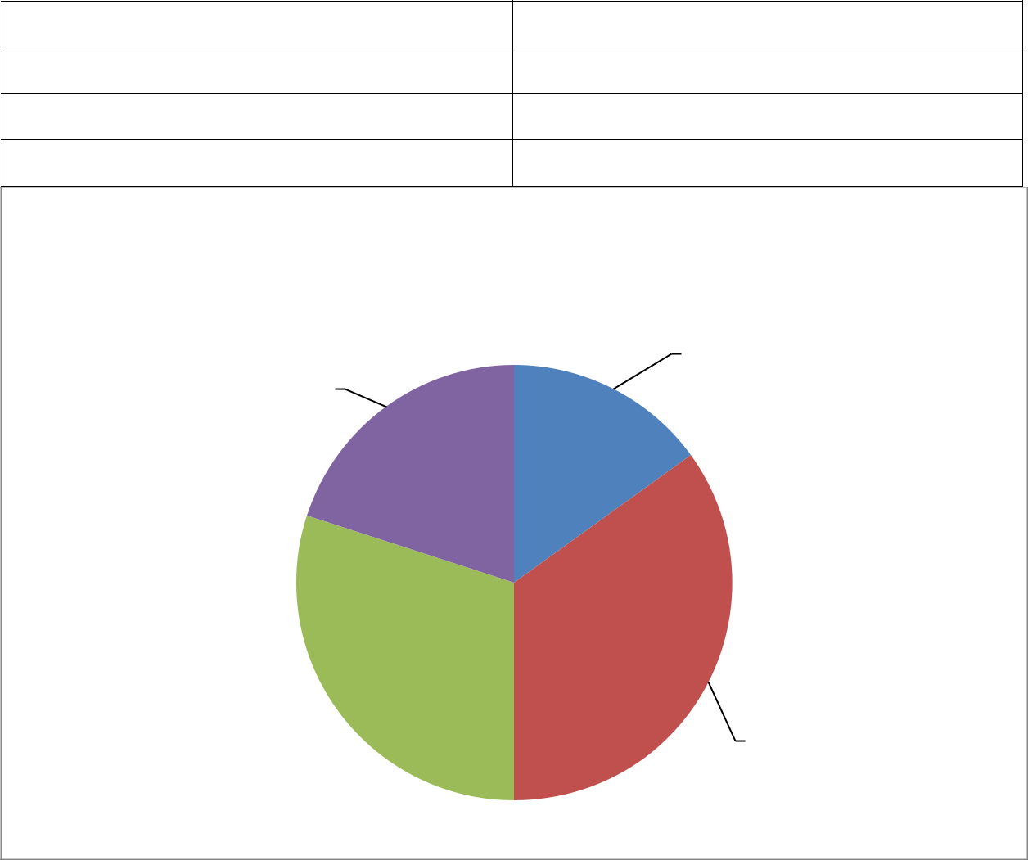

Under 18

18-24

25-34

35 above

15

35

30

20

Age

 | under 18 |  | 18-24 |  | 25-34 |  | 35 above

15%

20%

30% 35%

A figure shows that the age group of the respondent and the result is 35%are comes under or belong to the 18to 24 and 30% of the people are belong to the 25to 34 age group and 20%are belong to the 35 above age group and 15%are belong to below 18age group.

78

Q3) what is your highest educational qualification ?

High school | 14
Associate degree | 16
Bachelor degree | 25
Master degree | 35
Above master | 10
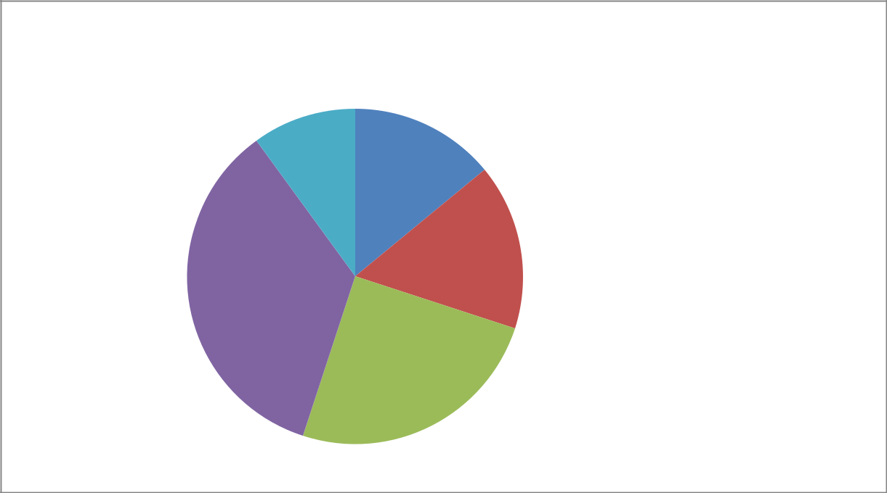

qulification

10% ^{14%}

 |  |  | high school
 | 16% |  | associate degree
35% |  |  | bachelor degree
 |  |  | master degree
 |  |  | above master

25%

In this figure we can easily seen that most of the people are master and bachelor degree holder . 37% of the people are master degree and 26% are bachelor degree and 17 %are holding a associate degree and rest 11% are above master and 9% are in high school.

79

Q4). what is your current occupation?

Student | 25
Salaried | 20
Entrepreneur | 18
Consultant | 12
others | 25

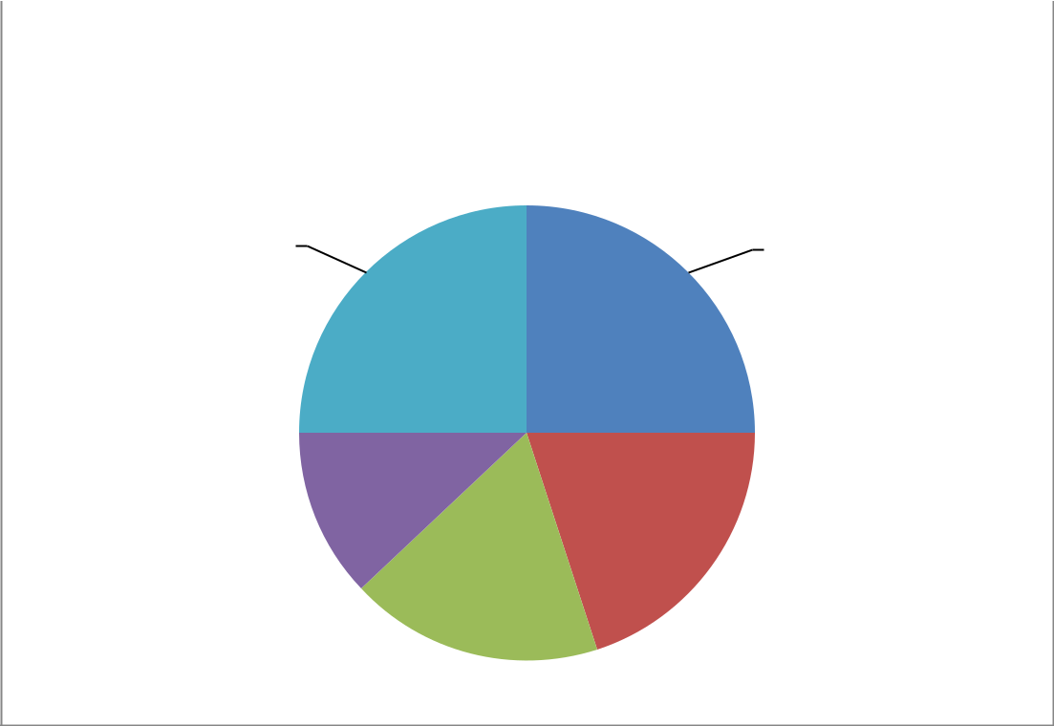

 |  |  |  | occupation
 | student |  | salaried |  |  | entrepreneur |  | consultant |  | others
25% |  |  |  | 25%

12%

20%

18%

When we see the result of the occupation of the respondent are 25% people are student and 20%are comes under the salaried and 18% of the people are entrepreneur and 12%are consultant and rest 25% are comes under the other occupation.

80

Q5). What is the monthly income of the respondents?

PARTICULAR | NUMBER
10,000-20,000 | 11
20,000-30,000 | 45
30,000-40,000 | 29
40,000 ABOVE | 15
TOTAL | 100
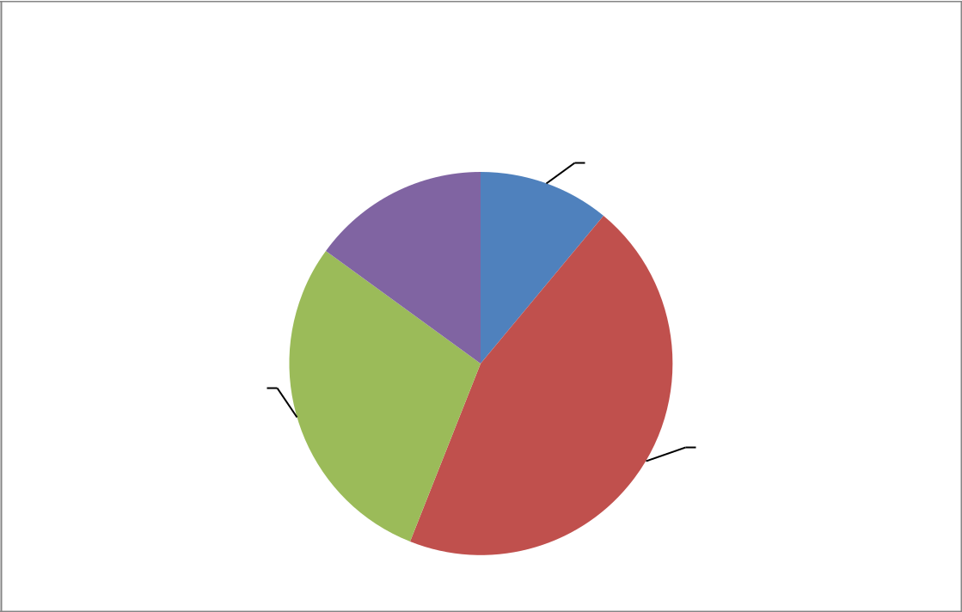

MONTHLY INCOME

10000-20000 20000-30000 30000-40000 40000 ABOVE

11%
15%

29%

45%

This above graph shows the percentage that the monthly income of the different respondents, and it show that respondents between 20,000-30,000 have bought more online products because most of them are graduates and they use electronic products like music cds, mobiles, laptops , trendy clothes, etc .

81

Q6) 0n average how often have you visit online shopping website in last six month ?

Everyday | 19
Two times a week | 20
Weekly | 21
Once every two week | 25
Once a month | 15
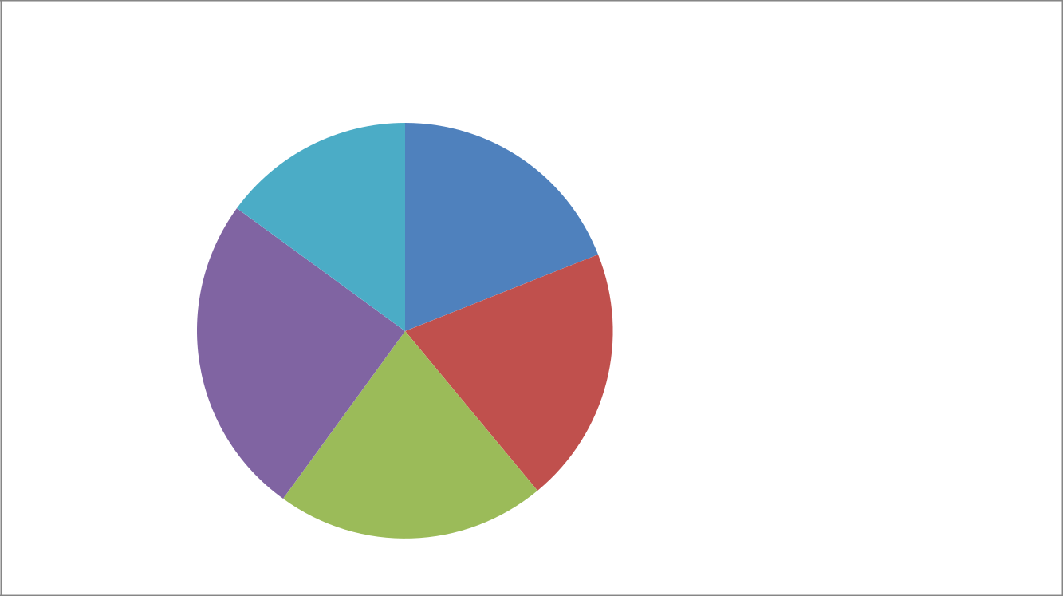

visit online

15%
19%

 |  |  | everyday
 |  |  | 2 times a week
 |  |  | week
25% | 20% |  | once every two week
 | 20% |  | once a month

21%

In this figure it is clearly shown that 19%of the people are visit everyday and the 20%of the are people are visit twice in a week and 21 % are once in week and 25% once every two week and rest 15 % are visit once in a month .

82

Q7) how much time do you spend on internet everyday ?

Below 1 hours

1hours

2to 3 hours

3 to 6 hours

15

29

35

21

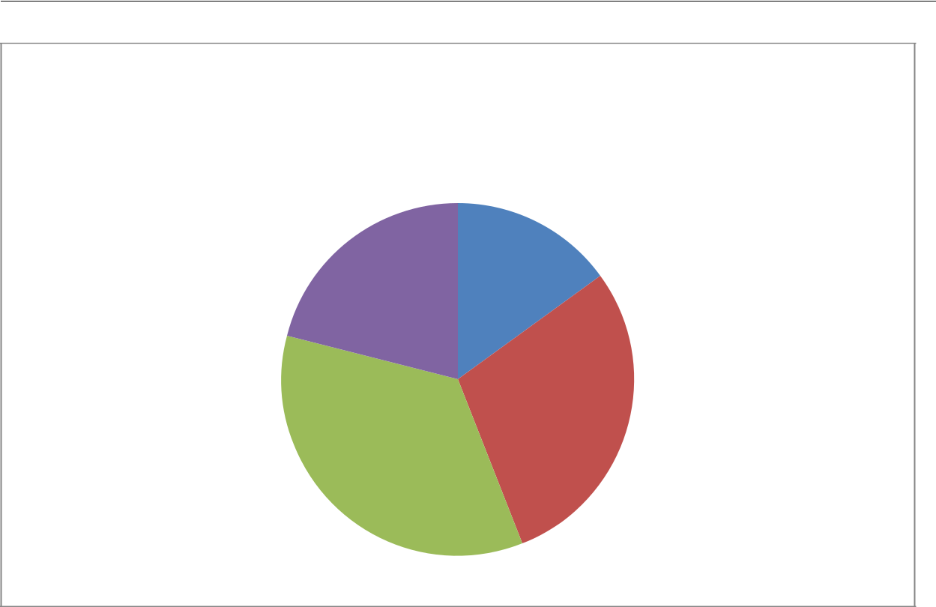

time spend

 | below 1 hours |  | 1 hours |  | 2 to 3 hours |  | 3to 6 hours

15%

21%

29%

35%

This graph shows that the time spend on the internet and the result are 29%of the people are using 1hours a day and 15% of the people using below 1 hours and majority of the pople 35 % are using 2 to 3 hours and rest of the people 215 are using 3to 6 hours

83

Q8) . Which of the following site have you ever visited for shopping online?

Flipkart

Snapdeal

Amazon

Paytm

Others

23

17

25

27

8

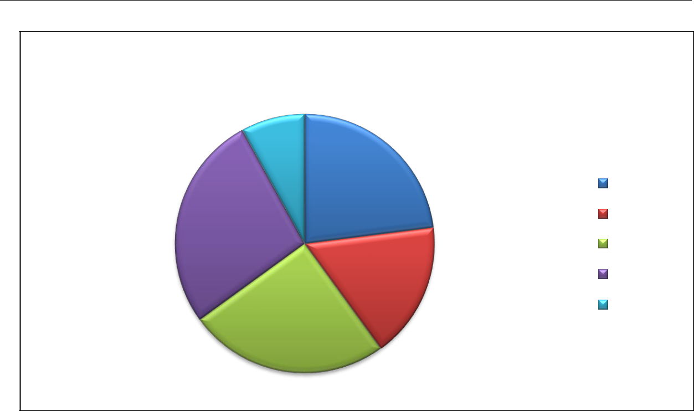

ONLINE E-STORES
8%
23%
 | flipkart
27% | snapdeal
 | amazon
 | paytm
17% | others

25%

This graph shows that 23%% people visit flipkart for online shopping, 25% go at amazon.com for electronic products, 17 % people go to snapdeal for affordable deals, 27% people visit paytm & remaining 8% go to other sites.

84

Q9) why are you choosing shop online ?

PARTICULARS | NUMBER
Very convinience and time sharing | 42
Low price | 22
Product variety | 28
others | 8


factors

8%

 | 42% |  | convenience and time
28% |  |  | low price

product variety

others

22%

People responses towards this question are 42% are shop for convenience and time saving and 22% are for low price and 28 % are go for online for wide range of product variety and rest are for the other purpose.

85

10. The service quality of seller is important ?

Strongly agree | 37
Agree | 24
Neutral | 13
Disagree | 17
Strongly disagree | 9
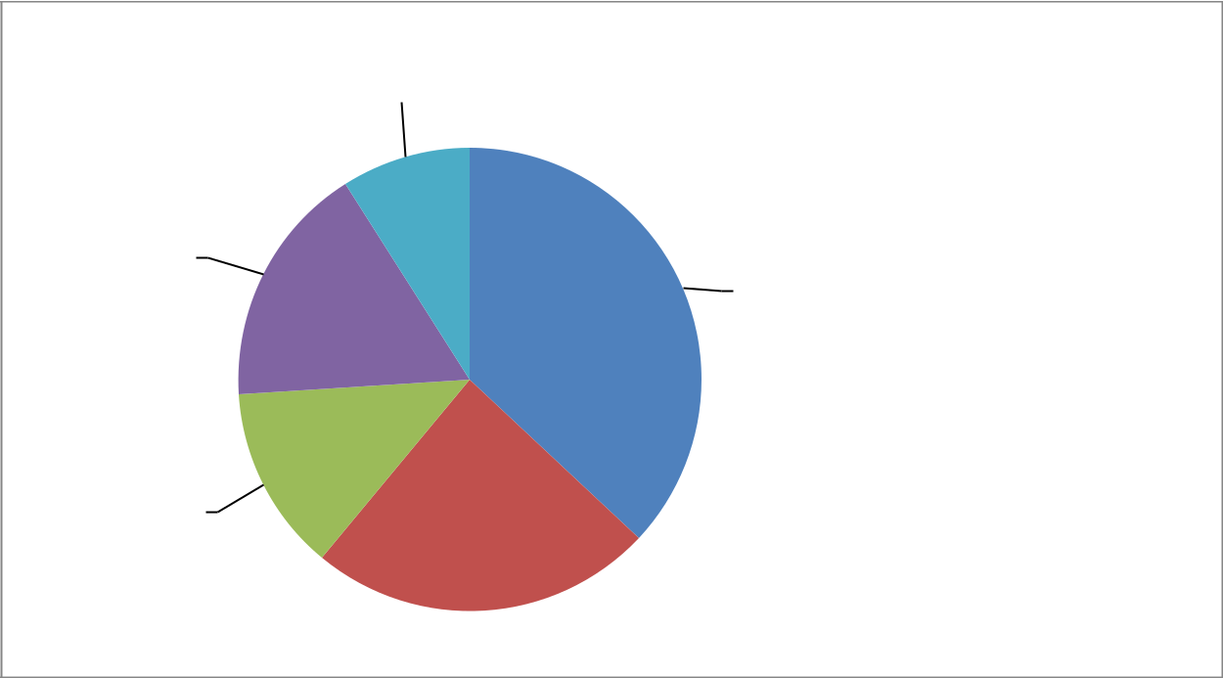

service quality
9%

17%
 | 37% |  | strongly agree
 |  |  | agree
 |  |  | neutral
 |  |  | disagree
13% |  |  | strongly disagree

24%

When I am ask this question from the respondent so the responses of the customer are 37%are strongly agree with service quality of seller and 24%are agree and 13% of the people are neutral and 17 % people are disagree and 95 strongly disagree.

86

Q11) so far I am generally satisfied with the service quality among these online shops ?

Strongly agree | 30
Agree | 22
Neutral | 16
Disagree | 19
Strongly disagree | 13

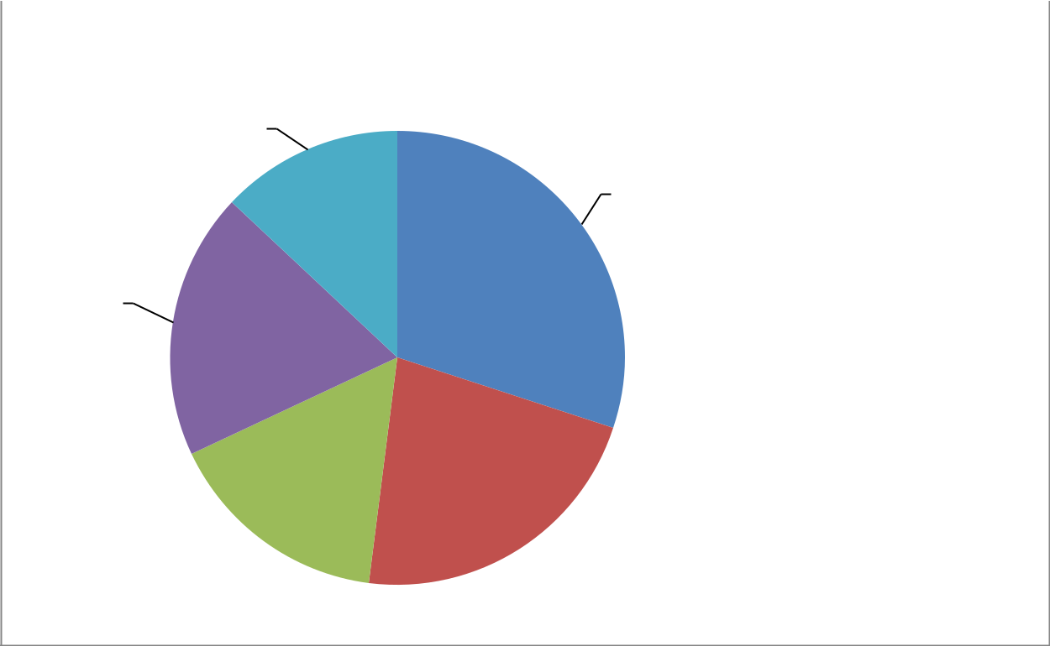

Column1

13%

30%

strongly agree
19% |  | agree
 |  | neutral
 |  | disagree
 |  | strongly disagree

16%_{22%}

In this figure we see that 30%of the people are strongly agree with this statement and 22% are agree and the 16% of the people are neutral and and 195are disagree with this statement and 13 % are strongly disagree

87

Q12) The speed of delivery is important to you?

strongly agree | 37
agree | 29
Neutral | 10
Disagree | 15
Strongly disagree | 9
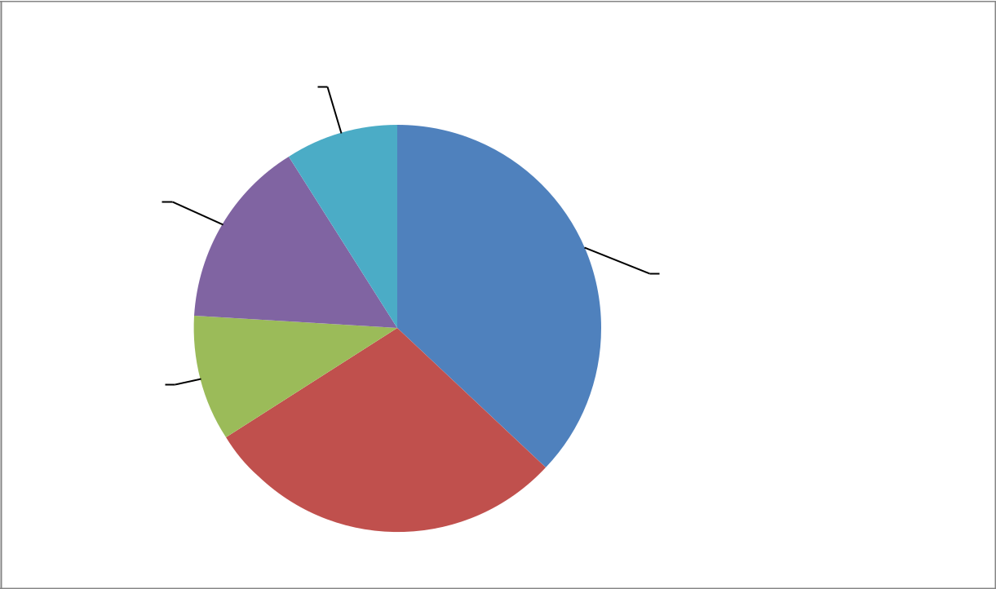

factor
9%

15%

 | 37% |  | strongly agree
 | 37% |  | agree
 |  |  | neutral
10% |  |  | disagree
 |  |  | strongly disagree

29%

People said that speed are important for online shopping and the result of the respondent are 37% of people are strongly agree and 29%are agree and the 10% of the people are neutral and 15% of the people are those who are disagree and rest of the 95 people are strongly disagree.

88

- The price is important when you shopping online ?

strongly agree | 39
Agree | 23
Neutral | 9
Disagree | 19
Strongly disagree | 10
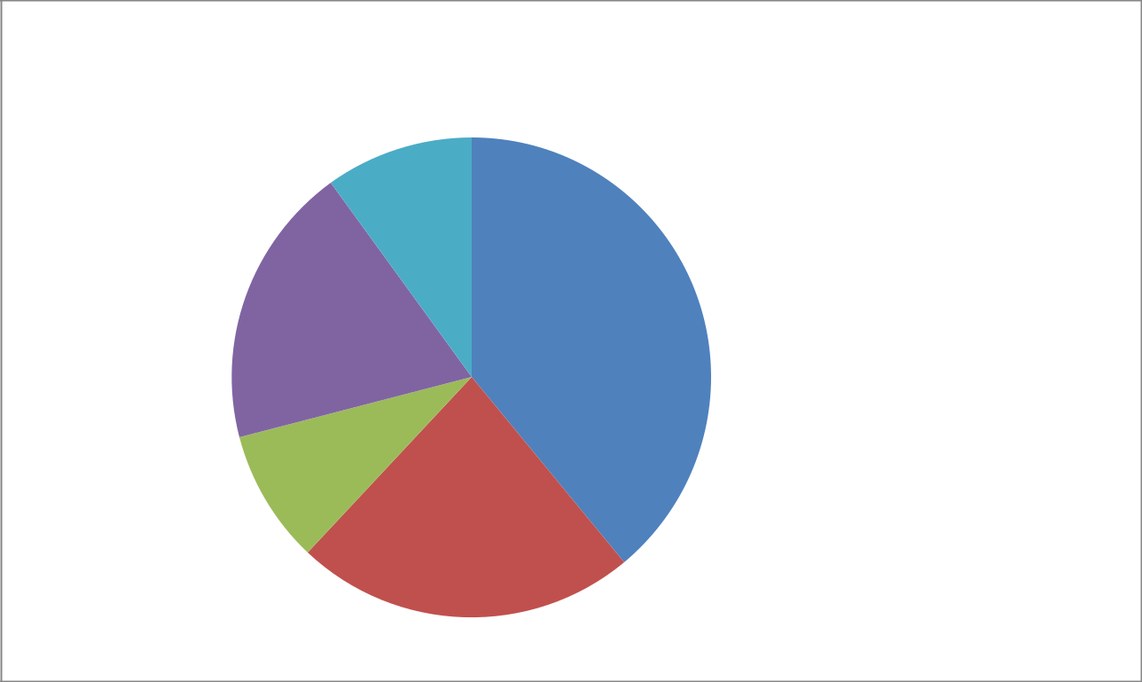

factor

10%

19% | 39% |  | strongly agree

agree

neutral

disagree

strongly agree

9%

23%

In this figure we see that 39% strongly agree of the people are influence from the price factor and 23%of the people are agree and 9%are neutral and 19%are disagree and rest of the people are 10%are strongly disagree.

89

.Q14) the difference between your expectation and real product would influence Your satisfaction ?

strongly agree | 24
agree | 33
Neutral | 13
Disagree | 17
Strongly disagree | 13
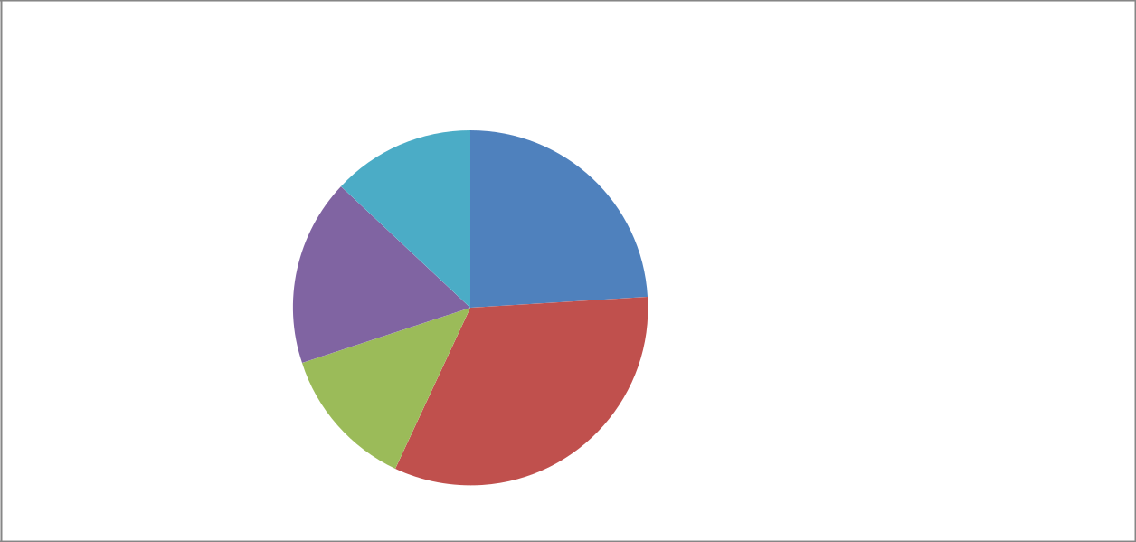

 | factor
 | 13%
 | 24%
 |  |  | strongly agree
17% |  |  | agree
17% |  |  | neutral
 |  |  | disagree
 |  |  | strongly agree

13% _{33%}

In this figure we se that 24% of the people strongly agree and says that this factors are influence their decision and 33% of people are agree and 13% are neutral on this factor and 17% are disagree and rest13% are strongly disagree.

90

Q15) you will not repurchase the product again in this shop if there is a great

Difference between your expectation and real.

strongly agree | 21
agree | 28
Neutral | 17
Disagree | 23
Strongly disagree | 11
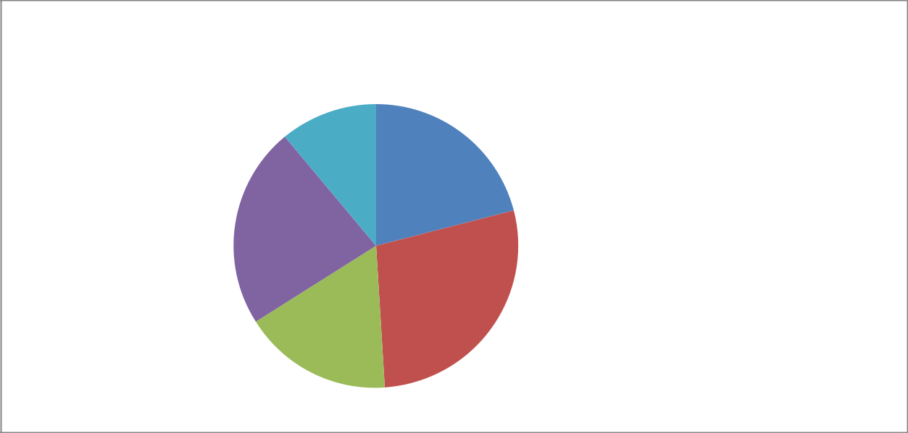

factor

11%

21%

strongly agree

23% |  | agree

neutral

disagree

strongly agree

28%
17%

It is general phenomenon of a customer that they cannot purchase when there is difference between expectation and real so the result is 21%of respondent are strongly agree and 28%are agree and 17%of people are neutral and 23%are disagree and rest 11% are strongly disagree.

91

Q16) how much amount you spend generally in a single online

Transaction/purchase?

Less than 1000 | 31
1000-5000 | 26
5000 – 10000 | 29
More than 10000 | 14
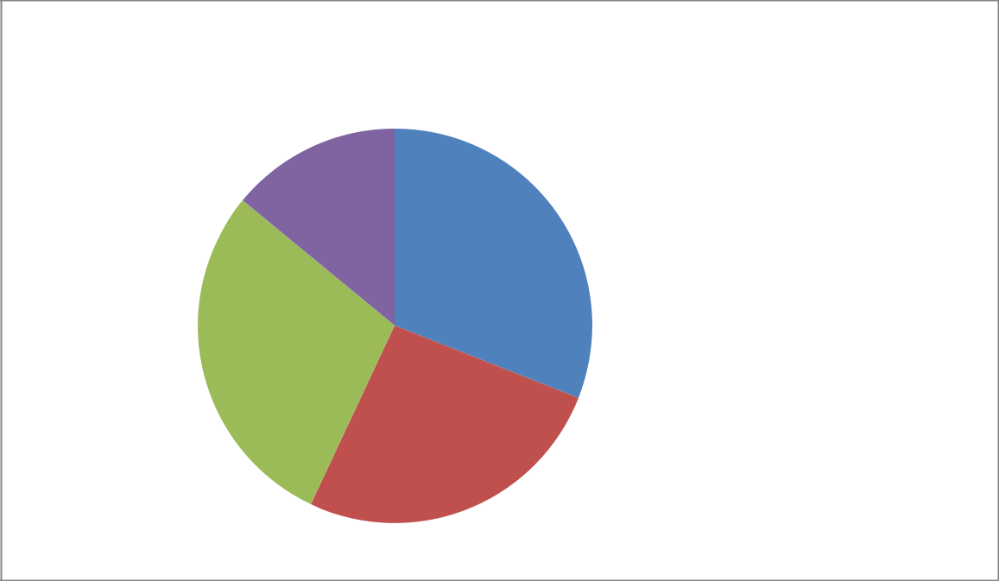

spending power

14%

31%

less than 1000

1000-5000

5000-10000

more than10000
29%

26%

In this figure we can easily find that 31 % of the people or a customer are spend less than 1000 and the 26%of the people are spend 1000to5000 and 29% of the customer are belong to the third group and rest are from more than 10000

92

Q17) Will you buy the product again from a shop if you are satisfied with it?

strongly agree | 34
agree | 23
Neutral | 13
Disagree | 19
Strongly disagree | 11
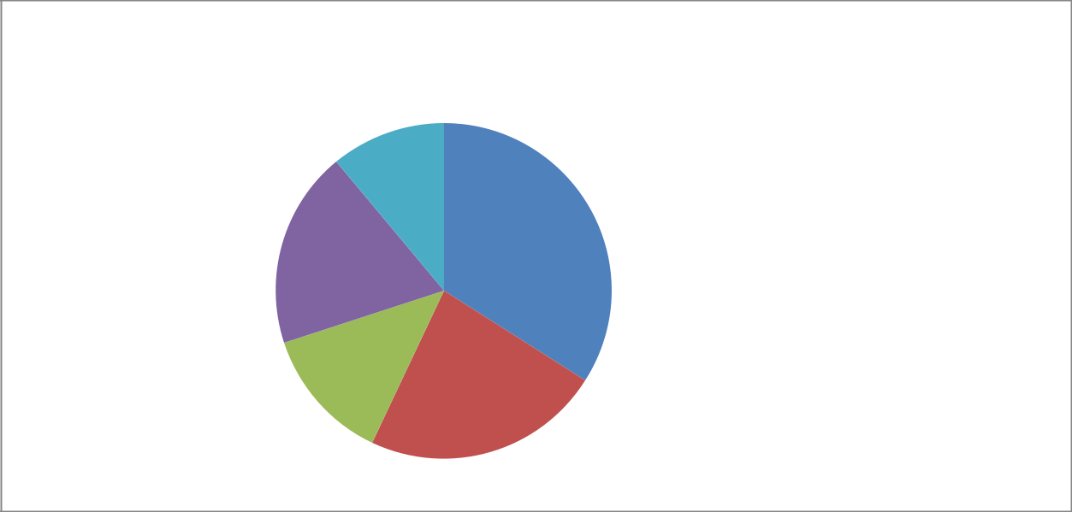

factor

11%

34% |  | strongly agree
19% |  | agree
 |  | neutral
 |  | disagree
 |  | strongly agree

13%

23%

I n this pie chart the people are buy the product when they are satisfied so the 34% of the people are strongly agree with this and 23 % of the people are agree and 13% are neutral and 19% of people disagree with this statement and rest 11% are strongly disagree.

93

Q18 ) select the payment mode normally adopted by you in internet shopping?

Credit card | 17
Net banking | 22
Debit card | 16
Cash on delivery | 34
others | 11
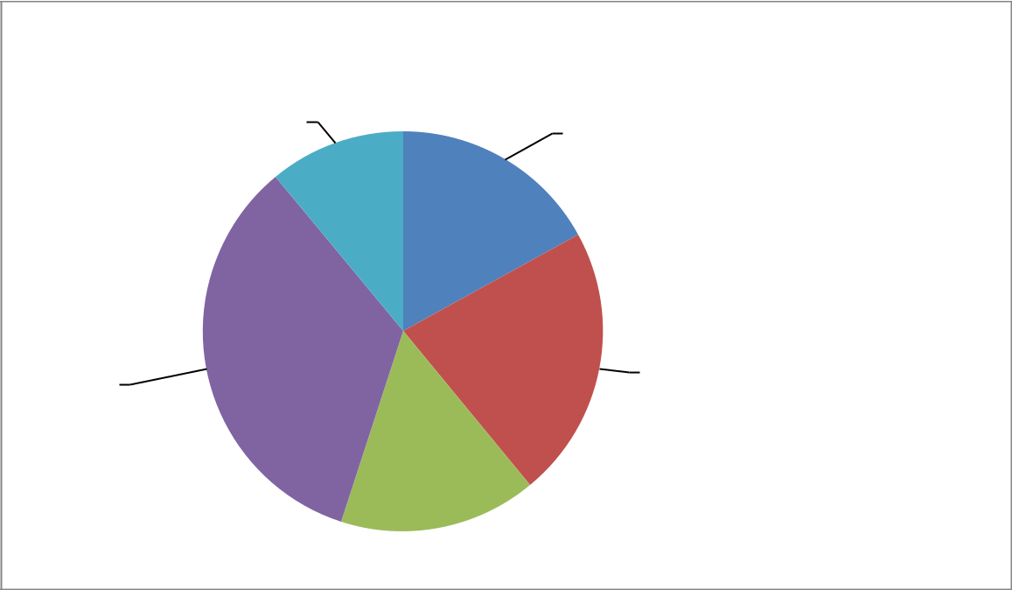

payment method

11% _{17%}

 |  |  | credit card
 |  |  | net banking
 | 22% |  | debit card
34% | 22% |  | cash on delivery

others

16%

In the payment mechanism people have different type of payment method . in which 34%of the people prefer cash on delivery and 22% of paid through net banking and 17%payment made by credit card and 16%payment paid by debit card and rest 11% by others

94

Q19) will you recommend others to use online shopping?

Yes

No

73

27

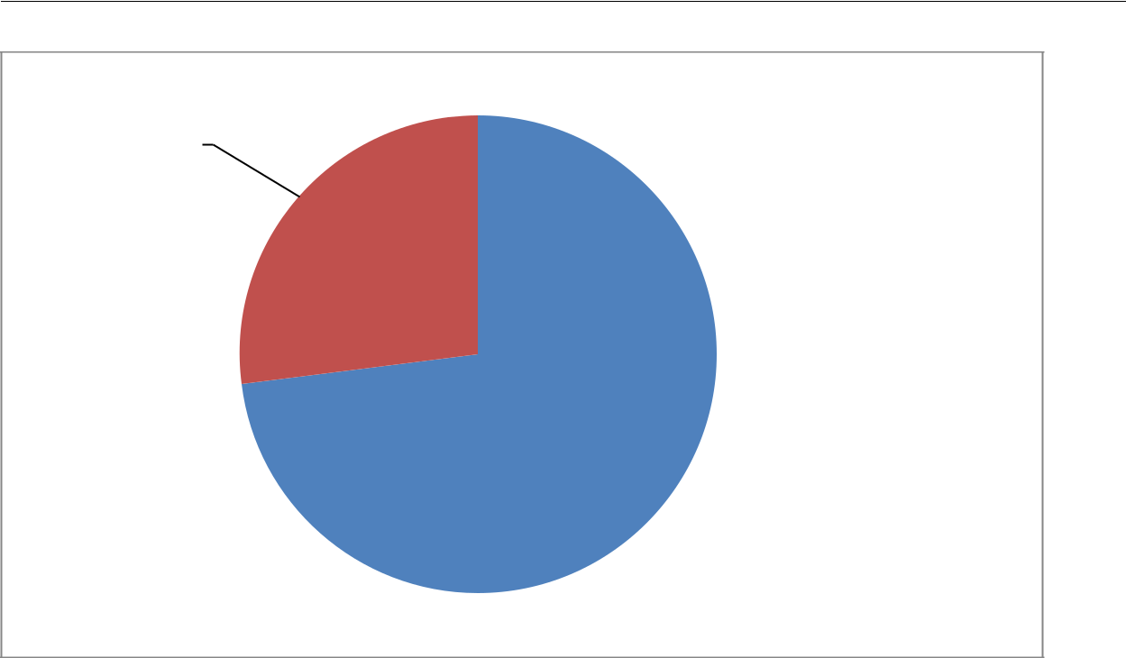

27%

yes

no

73%

In the above chart we seen that 73 %of the people who are using online shopping will recommend to others and only 27% of people not recommended to others.

95

FINDINGS

96

- Now the current scenario there has been increasing number of buyers and sellers towards online shopping day by day. because the people preferring to purchase the product through online shopping due to saving of time another aspect is product is delivering at home with nominal delivery charge that’s why people prefer online shopping instead of physical store.

- Online stores are usually available 24 hours in a day, and many consumers have Internet access both at work and at home even at villages. They may shop the products through online shopping at any time with any devices may be mobile phones, tablets, PC’s, Laptop etc.

- Another aspect is product is available at reasonable price as compare to physical store price in market and people’s mentality is “if product is available at Reasonable price so why should purchase from physical store”.

- Most of the people in professional segments are prefer to buy the products due to having lack of time and avoided to visits at physical stores.

- Most of the people motivate to buying the product because of their facilities and no need to travel to shop or physical store and the product is deliver at home with paying nominal charges.

- 34% of the people are buy product when they are satisfied because satisfaction from the shopping ,sites affect the buying decision .

- 37% of the people are strongly supported that service quality of the seller are important when go for online shopping decision.

- Another finding is that 33% of the people are agree that satisfaction level are influence by the difference between the expectation and actual product they received.

97

CONCLUSIONS

98

Increased Internet penetration, a hassle free shopping environment providing to the online shoppers with one click and the product is delivered at home so, that’s why more Indians prefer shopping online. But at the same time the companies need to reduce the risks related to consumer incompetence by tactics such as making purchase websites easier to navigate, and introducing Internet kiosk, computers and other aids in stores. The goal is not to convert all shoppers to online purchasing, but to show them it’s an option. In addition to above, efforts need to be taken to educate the online buyers on the steps that need to be undertaken while making an online purchase. Moreover, the feedback of an online buyer should be captured to identify flaws in service delivery. This can be done through online communities and blogs that serve as advertising and marketing tools and a source of feedback for enterprises. I found that it is a challenge for E-marketers to convert low frequency online buyers into regular buyers through successful website design and by addressing concerns about reliable performance. Thus, the online retailing raises more issues than the benefits it currently offers. The quality of products offered online and procedures for service delivery are yet to be standardized. Till the same is done, the buyer is at a higher risk of frauds.

99

LIMITATIONS

100

LIMITATIONS

There are some problems which I faced during my research study and listed few problems are:

- The first problem which I faced is unable to getting the co-operation of the customers. Many of the respondents did not agree to the need and utility of the project and hence not agreed to provide the information.

- The behavior of the customer is unpredictable which may result in the lacking of accuracy in the data.

- As the sample size of the survey was so small and comprise of only 100 customers, the results may have some prone to errors.

- Study accuracy is based upon the respondent’s response.

101

SUGGESTION

&

RECOMMENDATIONS

102

After researching this topic, I would recommend some suggestions and listed are as follows as:

- First of all I recommend that the online sellers have to make transparent payment transactions because sometimes the online shoppers unaware about hidden cost. So, there must be transparency regarding price between online sellers and shoppers.

- Online sellers also helps to make people more aware about the low risk towards shopping of the net because online shoppers facing the fraudulent.

- one more thing is that there should be transaction of money is very slow they have to make it fast so that customer don’t have to face much problem to pay for the product, if customer is going to face some problem he is not going to visit our site and buy product

- online sellers have to give more offers to their customers so that they may visit again and again to their site.

- There are some implications should be followed by the online sellers are as follows as:

  - Discount prices

  - Cash back offers

  - Fast transactions

  - Focus on customer satisfaction

103

BIBLIOGRAPHY

104

  - Kotler Philip, (2003) marketing management, eleventh edition, Pearson education, Delhi.

- Kothari c.r, research methodology, vishwa prakashan.

- http://www.emeraldinsight.com/doi/full/10.1108/17554191311303367

- http://shodhganga.inflibnet.ac.in/handle/10603/2695

- http://www.amazon.in/b/ref=gw_m_b_corporate/275-9063862-9125330?_encoding=UTF8&node=1592138031

- http://www.flipkart.com/about-us

- http://www.snapdeal.com/info/aboutus

- http://www.ebay.in/?aff_source=Google_cpc

- https://www.google.co.in/#q=project+report+on+consumer+perception+towards+online+

shopping+in+india
- www.abhinavjournal.com

- Alba, J., Lynch, J., Weitz, B., Janiszewski, C., Lutz, R., Saywer, A. and Wood, S.,

“Interactive Home Shopping: Consumer, Retailer, and Manufacturers Incentives to

Participate in Electronic Marketplaces”, Journal of Marketing, Vol. 61, No. 3: 38-53, 1997.
- Butler, P. and Peppard, J., “Consumer purchasing on the Internet: Process and Prospects”,

European Management Journal, Vol. 16, No. 5: 600-610, 1998.

- Http://www.studymode.com/essays/attitude-of-indian-consumers-towards-online 647049.html

- Http://www.ijsrp.org/research-paper-0613.php?Rp=P181300

105

QUESTIONNAIRE

106

Q1) what is your gender?

a) Male b) female

Q2) what is your age?

- Under 18

- b) 18-24

- c) 25 -34

- d) 35 above

Q3) what is your highest educational qualification? a) High school b) associate degree Q4) what is your current occupation?
- Student b) salaried c) entrepreneur d) consultants e) others Q5) what is your monthly income ?

a) 10000-25000 b) 25000-50000 c) more than 50000

Q6) on average how often have you visit online shopping website in the last six month ?

a) Everyday b) 2times a week

c) weekly d) once every two week e) once a month

Q7) how much time do you spend on internet everyday ?

2. Below 1 hours b) 1 hours

c) 2 to 3 hours d) 3 to 6 hours

Q8) which site you like the most ?

a) Flipkart b) snapdeal (C) amazon

(d) jabong (e) paytm

Q9) why are you choosing shop online ?

(a) Very convenience and time sharing (b)Low price \

( c) product variety d) others

Q10) The service quality of seller is important ?

a) Strongly agree (b) agree

(d) disagree (e) strongly disagree

(c) neutral

107

Q11) | so far I am generally satisfied with the service quality among these online shops?
 | a)Strongly agree | (b) agree | (c) neutral
 | (d) disagree | (e) strongly disagree
Q12) | The speed of delivery is important to you ?
 | a)Strongly agree | (b) agree | (c) neutral
 | (d) disagree | (e) strongly disagree
Q13) | The price is important when you shopping online ?
 | a)Strongly agree | (b) agree | (c) neutral
 | (d) disagree | (e) strongly disagree
Q14) The difference between your expectation and the real product would influence |  |  |  | your
satisfaction?
 | a)Strongly agree | (b) agree | (c) neutral
 | (d) disagree | (e) strongly disagree

Q15) you will not repurchase the products again in this shop if there is a great difference between your expectation and the real ?

a)Strongly agree

(d) disagree

(b) agree

(e) strongly disagree

(c) neutral

Q16) you will buy the product again from a same shop if you are satisfied with it ?

a)Strongly agree (b) agree (c) neutral

(d) disagree (e) strongly disagree

Q17) How much amount you spend generally in a single online transaction /

(a) Less than 1000

(b) 1000-5000

purchase ?

(c) 5000- 10000

(d) more than 10000

108

Q18) select the payment mode normally adopted by you in internet shopping ?

- Credit card

  - net banking

  - debit card

- cash on delivery

  - other

- Yes

  - No

Name -

Contact No. –

Place -

109

THANK YOU

110

