**REVIEW PAPER ON: MACHINE LEARNING AND IOT ENABLED FUSION OF FACE RECOGNITION BASED DOOR LOCK SYSTEM AND HAND GESTURE -CONTROLLED SMART HOME**

**Sujith .K.S, Asha .K, Shiney Thankachan**

**PG Student, College Of Engineering, Kidangoor, Kottayam, Kerala**

[**sks5203@gmail.com**](mailto:sks5203@gmail.com)

**Assistant Professor, College Of Engineering, Kidangoor, Kottayam, Kerala**

[**Ashapanicker06@gmail.com**](mailto:Ashapanicker06@gmail.com)

**HOD, E&C, College Of Engineering, Kidangoor, Kottayam, Kerala**

**shineythankachan@gmail.com**

**Abstract:** *In this era of rapid technological progression, this paper presents an integrated solution that merges the potency of Machine Learning (ML) and the Internet of Things (IoT) to establish a revolutionary Hand Gesture-Controlled Smart Home and Face Recognition-Based Door Lock system. This innovative fusion redefines the paradigm of home automation and security, offering a seamless and secure living experience. The Hand Gesture-Controlled Smart Home component employs sophisticated ML algorithms in combination with IoT devices.This system empowers users to effortlessly manage and customize various facets of their living spaces. In addition, the Face Recognition-Based Door Lock system utilizes ML-driven facial recognition algorithms as well as IoT connectivity.Access is granted exclusively to authorized users, ensuring robust security while providing a convenient and hands-free entry process.Moreover, users can remotely monitor and control home appliances.This paper embodies significant progress in smart home technology. It envisions a future where homes are not only secure and convenient but also intelligent enough to adapt to individual preferences while enhancing daily life's quality.The purpose of this article is to encourage further research and innovation that will propel us toward smarter, more responsive living environments.*

**Keywords**:**Machine learning,Appliances, Internet of Things,Face Recognition, Algorithm, Facets.**

**INTRODUCTION.**

In contemporary times, the potential for hand gestures in consumer electronics and mobile devices has markedly expanded. The primary goal of a home automation system is to establish an apparatus capable of controlling household appliances through either gesture-based or web-based means.

Individuals with disabilities or advanced age who are unable to move about require a seamless method of accessing their surroundings, one that is both systematic and efficient. This concept involves the integration of robotics and technology. Conventional home automation systems are ill-suited for the elderly or disabled, as they are designed for individuals who can perform basic activities without difficulty. Web-based and gesture-controlled automation offer ease and convenience to those who face physical limitations in performing everyday tasks with efficiency.

The notion of identifying bodily movements, particularly hand gestures, is comprised of three fundamental layers: Detection, Tracking and Recognition. We rely on specialized interfaces to capture such motions and subsequently employ computer vision technology &deep learning algorithms to comprehend the underlying pattern. Cameras, microcontrollers, as well as sensors are strategically positioned throughout the smart home environment for capturing and interpreting hand gestures. This system provides users with an effortless means of managing and customizing various aspects of their living spaces including lighting control, temperature regulation, entertainment systems among others. By obviating physical interfaces and voice commands it enhances accessibility while ensuring a touchless interaction experience.

Facial recognition is a sophisticated technique for verifying or validating an individual's identity through their facial features. This state-of-the-art technology enables the identification of people in photographs, videos, and even real-time scenarios.

In the realm of face recognition, the initial stage is that of face detection, wherein a camera identifies and pinpoints an image of a visage, be it in isolation or among a group. The photograph may depict the subject gazing straightforwardly or from an angle. The subsequent phase is one of facial analysis. During this juncture, an image capturing the person's countenance undergoes scrutiny. Most facial recognition technology relies on 2D as opposed to 3D images because it can more easily match them with public photographs or those contained within a database. Software reads the geometry of the face by taking into account critical factors such as inter-eye distance, eye socket depth, forehead-to-chin span, cheekbone shape and lip contouring alongside ear and chin outlines. This approach aims to pinpoint those specific features which are instrumental in distinguishing individual faces from one another.

The following step involves transforming analog data (the human face) into digital information based on distinct facial traits belonging to said person; through analyzing our visages we essentially create mathematical formulas for each unique expression thereof - numerical codes referred to as "faceprints". Just like fingerprints are unique identifiers for individuals so too do all people possess their own distinctive set of facial features resulting in their very own definitive "faceprint". Finally these newly minted codes are compared against databases containing other known faces - for instance,the FBI has access up to over six-hundred-and-fifty million photos drawn from various state databases while Facebook uses any photo tagged with someone’s name becoming part-and-parcel with its database also usable for facial recognition purposes - if there exists any kindred matches then determinations will be made accordingly.

Any photograph that is labeled with an individual's name on Facebook becomes integrated into the platform's database, which can subsequently be utilized for facial recognition purposes. In the event that a faceprint corresponds to an image within a given facial recognition database, a decision will be rendered accordingly.

In a door lock system that utilizes face recognition, specialized cameras and microcontrollers stationed at entry points consistently observe and verify the identities of individuals approaching the door. Only authorized users are granted access, ensuring strong security measures while also offering a seamless and contactless entry experience.

The amalgamation of these two systems guarantees a smooth and uninterrupted transition within the realm of smart homes. As residents approach their abode, the Face Recognition-Based Door Lock system expeditiously recognizes and verifies them. Once authentication is successful, the door unlocks automatically, cordially ushering users inside. Subsequently, the Hand Gesture-Controlled Smart Home system takes charge by enabling instinctive regulation of diverse functions within the home using natural hand movements.

The term IoT, which stands for Internet of Things, pertains to the interconnected network of devices and technology that enables communication between the cloud and devices, as well as among the devices themselves. One significant advantage of home automation made possible by IoT is its capacity to manage and oversee an extensive array of gadgets and systems from a sole centralized location like a smartphone or tablet. This encompasses a broad range of functions such as regulating lighting and temperature settings, monitoring security cameras, and activating alarm systems.

This paper examines prior literature on home automation and delves into the technical complexities of integrating ML and IoT technologies. This encompasses a range of topics, including ML model training, hardware selection, gesture and facial recognition algorithms, communication protocols, and IoT device integration.

**OBJECTIVE.**

To develop a smart home automation along with door lock security system is the main objective.The specific objectives are the implementation of door lock system based on facial recognition ,controlling home appliances through hand gestures and accessing home appliances from remote areas.

**NEED.**

One of this system’s main goal is to make easier for person with disabilities and elderly.In this pandemic times,it also promotes safety.It enables the use of contact less equipments in public spaces,assuring the safety of those who use it. Compared to traditional lock-and-key systems, which can be picked or forced open, facial recognition adds an extra layer of security. It significantly reduces the risk of break-ins and unauthorized entries. The Internet of Things for home automation is building the future of our houses, bringing our quality of life to the next level. IoT makes our homes "smart'', letting ho

meowners manage lighting, air conditioning,

security systems, and home appliances with just one touch,with remote access.

**LITERATURE REVIEW**

In **[1]** ,Blob analysis was done for fruit detection and video clips in Matlab, Python ,and SCILAB .Response time taken for object detection is calculated for python MatLab and SCILAB and it was found that Python detects video and image faster than Scilab and Matlab

The system's **[2]** primary source of input will consist of images captured by a laptop camera. These image data sets will be processed using a Python-based software application. To train the system, pre-captured facial images and feature data must be integrated into the training database within the same software application. The automated solenoid lock is controlled by a microcontroller board that lacks on-board USB support hardware, thus requiring the utilization of a Virtual Serial Communication Port over USB connection to enable communication between both devices. Through this virtual COM port, command signals from the software application can be sent to control the microcontroller board. The relay driver board uses General-purpose I/O (GPIO) pins to drive solenoid locks, ultimately granting or denying access to individuals seeking authentication in restricted areas. The system precisely identifies the authorized individual's face, thereby granting access through the door. It is important to note that this paper does not encompass any implementation of Internet of Things (IoT) technology

Here **[3]** , The Python programming language is utilized to process images captured by a web camera and control the door locking mechanism via a solenoid valve. Furthermore, this system incorporates an additional security measure through fingerprint recognition in addition to face detection. . This paper employs the HOG algorithm (Histogram of Oriented Gradients) for face detection and CNN for face recognition, as HOG has been shown to posses superior accuracy compared to Haar cascade classifiers which tend to generate more false positive This paper employs the HOG algorithm (Histogram of Oriented Gradients) for face detection and CNN for face recognition, as HOG has been shown to posses superior accuracy compared to Haar cascade classifiers which tend to generate more false positive

The range for the detection and recognition of a person's face by a webcamera is limited to a certain distance. The software takes around 0.7 seconds to detect the fingerprint, while detecting and recognizing an individual's face requires more time, roughly about 2.5 seconds. To enhance this process of facial recognition, it may be worthwhile exploring the use of STM32 microcontroller which boasts similar clock speed as raspberry pi zero at approximately 400Mh

In [4] ,The system will operate in two distinct segments. The initial segment involves the acquisition andestablishment of a database by storing images, while the latter entails comparing these images with those stored within the database.

Initially, the process involves saving images as data sets. Subsequently, the system undergoes training using LBPH algorithm before storing in the database. Initially, color images areconverted to grayscale and then transformed into pixels for detection purposes. The image is segmented into various pieces while recording the values of each pixel. Pixels that are low are represented as 0 while those that are high become 1; these values are arranged in a 3×3 matrix format for comparison with stored database images on screen. The following steps outline this procedure: firstly, interfacing with the camera to capture live images; secondly, creating a database for authorized personnel; thirdly, capturing and saving current images before comparing them with stored ones in the database; finally, interfacing with GSM module to send alerts via SMS or calls when unlocking locked doors to authorized persons.The facial recognition algorithm utilized in this project is the Local Binary Pattern Histogram (LBPH), a straightforward yet highly effective texture operator that assigns labels to each pixel of an image by thresholding its surrounding neighborhood and treating the resulting output as a binary number, which is then converted into a decimal value that becomes the new center pixel. The system has been implemented with a combination of several components, including a webcam, Raspberry Pi, relay, solenoid door lock, and GSM module. Moreover, we have employed LBPH for face recognition purposes. By using Raspberry Pi to set up our facial recognition system instead of relying on PCs or other larger devices, we were able to create a smaller and lighter setup that consumes less power while still operating efficiently. Additionally, our system sends security alerts only to authorized individuals as needed while providing backup power capabilities via an external battery pack designed specifically for charging the Raspberry Pi so there are no interruptions in service due to power outages or fluctuations. In conclusion, our IoT-enabled facial recognition security system has proven successful at detecting faces and sending notifications when unknown entities are detected within range via IoT technology.

One of the limitation of the system is that the user must appear exactly as the training image captured by them. For example, if the intended user does not wears a spectacle when taking sample image then he cannot wear them during authorization. Sometimes, it is also sensitive when the user smiles wider than usual due to the size of mouth changing differently than the training image.

Face recognition is carried out by using PCA algorithm(Eigen faces) in [5] .Facial recognition is accomplished by projecting the face onto the space created by the eigenfaces and comparing it to the eigenvectors of the eigenfaces, as well as with that of the image being analysed. If there is a small Euclidean distance the vectors and identification of individual is occurred The Eigen Face Algorithm holds significant value as it is capable of identifying multiple faces within a single frame. Its computational approach and straightforward algorithm make it applicable to various real-time scenarios. However, precise facial alignment is crucial for optimal performance. Specifically, the algorithm requires a frontal view of the face to function accurately.

The purpose of this paper [6] is to discuss the Linear Discriminant Algorithm (LDA) in relation to face recognition. The LDA algorithm is utilized during the learning phase to identify a linear combination of features that can distinguish known classes from one another. However, during the run phase, the LDA is no longer necessary, as the learned linear combinations can be used to classify unknown data into known class buckets. In the context of face recognition, LDA will similarly find a linear combination of features that can differentiate each face from other faces. During the run phase, an unknown face can be classified as belonging to a known face by utilizing the linear combination of features learned during the training phase. This approach allows for efficient and accurate identification of individuals in various applications, such as security systems or biometric authentication processes.In a recent experiment, two distinct sets of image data were utilized and analyzed. The statistical measures of both the mean and variance within each class were carefully calculated and recorded for further analysis. This process was conducted with great precision to ensure accurate results.

The system's [7] workflow can be succinctly summarized as follows: Gestures serve as input and are processed using a MATLAB-based computer program for image analysis. The gesture processing is accomplished through the utilization of a contour point detection technique, while Image Acquisition, Pre-Processing, Expectation Maximization Algorithm, Image Segmentation, and Gabor Feature Extraction constitute the various stages involved in this process. Upon completion of these stages, data from images is then transmitted to an Arduino-based microcontroller for further processing.This proposed study captures hand movements from a database and analyzes the gestures using the simulation tool, MATLAB. The motions generate various threshold values which are then used by an Arduino microcontroller to control home appliances. While this gesture identification algorithm is highly efficient for light backdrops, it should be noted that threshold values for gesture detection will differ in dark backgrounds or noisy settings. The contour point detection algorithm serves as the basis for the gesture processing technique and effectively recognizes each movement without interference from noise. This technology is more precise than relying on a hand glove to recognize gestures.

In paper [8] , palm of the hand is segmented from the background first. Compare pixels in each frame of real-time video and remove those with equal color values. Apply this to all pixels in each frame and compare frames over time. If a pixel doesn't match between two frames, it is retained in the first frame. Otsu's thresholding method involves iterating through all possible threshold values and measuring pixel spread for foreground and background pixels on either side of the threshold value. As a reault, gray scale image containing hand is obtained. The subsequent step involves utilizing the Haar-cascade classifier, an OpenCV library, for hand gesture tracking. The cascaded classifier serves as a program feature that enables the machine to precisely classify objects in each image frame. Additionally, it is imperative to consider the Region of Interest (ROI) for detecting hand recognition availability. The detected region must align with the ROI; thus, as the classifier tracks and identifies the desired object - which is typically represented by a bounding rectangle around the hand contour - there should be an overlap between this area and that of interest. Employing conditional methods to determine overlapping regions allows identification of whether or not selected regions (e.g., rectangles surrounding hand contours) overlap with other active areas (in this case, hands). By integrating these theoretical aspects into simulations and hardware implementations, we can ultimately achieve our goalThe Region of Interest (ROI) is employed for this project to capture hand gestures, as its implementation enables the detection of overlapping regions. Additionally, the system recognizes only two outputs per hand gesture recognition.Then the simuulation is done.This model is capable of establishing a comprehensive system for detecting, recognizing, and interpreting hand gesture recognition through computer vision utilizing Python and OpenCV. The proposed hand gesture recognition necessitates the use of a webcam to capture the user's gesture against a clear background. Under normal lighting conditions, the system can recognize and track the user's hand movement with ease. The segmentation process facilitates the detection of user movement while also counting contours accurately.

However, certain limitations exist within this program; specifically, variations in lighting environments still have an influence on the segmentation process, particularly during background removal. Additionally, both the user's hand and webcam must remain fixed in position so that images captured by said camera are able to precisely identify gestures made by users.

The implementation of this project [9] involves the use of Raspberry Pi, along with Python and OpenCV library. Firstly, essential packages such as cv2, numpy, PiCamera and time are defined and imported for algorithmic purposes. Subsequently, GPIO pins of the Raspberry Pi are defined to establish connectivity with the robot driver. The current frame of video is then initialized while global variables are also defined at this stage. Following that, frames are captured before being converted into grayscale in order to rectify regions of interest (ROI). Gaussian blur is applied to mitigate high frequency components in images while segmentation removes any undesirable background elements. Counters are then drawn twice for optimal clarity.Each of the five directional gestures is practiced fifteen times to generate a sufficient number of template vectors for four different experimental cases, resulting in a total of 75 stored templates. During the test phase, each gesture is executed by the mobile robot 30 times at runtime. The motion of the mobile robot with respect to its corresponding finger command is monitored and recognition accuracy is computed. Table 1 presents the recognition rate (RR) for a sample of tested gestures in the database that have been conducted using three, five, ten or fifteen template vectors per gesture for each of the four different cases. Using only three template feature vectors per target gesture results in poor RR, while increasing it to five significantly improves RR. With ten template vectors there is very good RR achieved and adding more templates up to fifteen leads only to slight improvement in recognition rates.

By issuing a series of finger commands, it becomes possible to direct the robot along any desired trajectory towards its target destination while also controlling obstacles on its path by adjusting fingers that are captured by camera view. This approach has resulted in achieving an impressive recognition rate reaching around 98%

The initial step in [10] involves capturing the first RGB image using a web camera. Subsequently, preprocessing of the captured image is conducted. This entails converting the image into grayscale and performing background subtraction to isolate the hand image from the background. Following this, thresholding is applied to obtain only the hand gestures in white color. The subsequent step involves extracting the counters. Finally, feature extraction and recognition are carried out.

During the implementation of the recognition system using background subtraction, numerous issues and accuracy problems were encountered. Background subtraction is unable to handle sudden changes in lighting, leading to inconsistencies. However, the gesture recognition system proves to be robust and highly accurate when used against plain backgrounds. This level of accuracy is maintained even when the background color varies, as long as it remains simple and consistent. On the other hand, if the background is unclear, it can cause inconsistencies between the object in the background and the captured image, resulting in incorrect output. Therefore, it is strongly recommended to use this system with a clear background in order to achieve the best possible results and ensure excellent accuracy.

This paper [11] explain about Haar like features, Haar cascade classifiers.. EtcThis paper presents a face detection system that utilizes the Haar cascade classifier. The system employs a three-phase approach for tracking objects. In the first stage, the HCC face detector scans the entire frame and combines the near positive results to generate a single detection outcome. The HCC makes use of a 4-split cart as a basic classifier and sets the position to achieve a required true positive ratio of 0.999 for each point. The HCC decision is made in conjunction with the conciliate AdaBoost algorithm.To train the face HCC, a positive learning package consisting of 2500 face images of kathak and kuchipudi dances is used. The negative collection is created by randomly gathering 3,500 images that do not contain any faces. True positives are identified as errors smaller than 0.1, while false positives are also taken into account.The proposed approach effectively identifies specific facial features and validates a person’s identity. Haar-based face detection is a widely used and robust algorithm for real-time applications. It exhibits high precision in detecting frontal faces. The accuracy of identification relies on the image quality and quantity in the database. The larger the database, the longer the recognition process may take.

This paper [12] provides a review of Otsu's thresholding method and K-Means thresholding. Otsu's method involves examining all possible threshold values between the background and foreground, calculating the variance within each cluster, and selecting the threshold value that minimizes the weighted sum of these variances. On the other hand, the K-Means technique is based on grouping similar pixels and assigning the median value. By repeating this process multiple times, better identification of objects can be achieved. This algorithm is capable of producing high-quality output images. The discrimination of objects relies on the correlation among the pixels present in the image. The Otsu algorithm and k-means method is reviewed with its working and limitations. Because of simple nature of Otsu algorithm it is being used widely. On the basis of analysis done it can be said that the Otsu method needs the image to be pre-processed so that the high accuracy can be obtained. K-means method is also not suitable for many image types like if the image does not form the spherical clusters then it can work improperly and outcome may be affected

This paper [13] discusses discuses about two algorithms. First is Haar Cascade and second is LBPH .The Haar Cascade uses the cascade function and the cascade window. It tries to calculate features for each window and classify them as positive and negative. If the window could be part of an object, then positive else negative. If the window could be part of an object, then positive else negative. The cascade function is trained from many positive and negative images. It is then used to detect objects in other images. First, the algorithm needs a lot of positive images (images of faces) and negative images (images without faces) to train the classifier. Then it is necessary to extract features from it. Hair features are used for this. They are like a convolution kernel. Each feature is a single value obtained by subtracting the sum of pixels under the white rectangle from the sum of pixels under the black rectangle. LBPH is a method that divides the facial image into multiple blocks. Histograms are calculated for each block and in the matrix we compare the pixels with the central pixel. At the end a binary number is output which is converted to decimal format. It is summarized under a vector that helps recognize the face in the database. In this article, the author can claim that the hair cascade classifier detects facial efficiency and is a simple method. The LBPH can represent the local features of the face. By using LBPH, the facial image can be represented with a single simple data vector

The system [14] establishes a connection with the Internet if it detects a preconfigured SSID; otherwise, it performs automated controls without requiring any input from the owner. The sensors collect data which is then processed by the microcontroller before being transmitted to a web server. Users can access sensor readings at any time and from anywhere, as each second of sensor data is logged for future analysis. Furthermore, in addition to its automanual mode of operation, this system boasts several other functions that are

**PROPOSED SYSTEM**

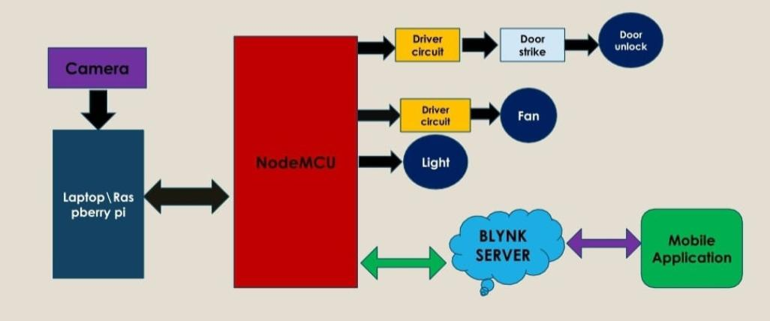Python is used here The image recognition speed of python is grater than MatLab and other programming tools[1]. OpenCV[8] is an open-source library. It is supported by different programming languages such as R, Python, etc. It runs probably on most platforms such as Windows, Linux, and macOS.Here, OpenCv is used. Open CV is free of cost and an open-source library. With less system RAM, OpenCV works better.Using either a laptop or a Raspberry Pi, real-time images are captured by a camera for facial recognition Open CV is free of cost and an open-source library. With less system RAM, OpenCV works better.Using either a laptop or a Raspberry Pi, real-time images are captured by a camera for facial recognition. If the face belongs to a recognized person, the Raspberry Pi sends a control command to a NodeMCU to open the door; for unauthorized individuals, an alarm is triggered. Hand gesture recognition involves processing captured hand images on the Raspberry Pi to determine gestures, which then prompt the NodeMCU to activate relays controlling home appliances accordingly. Monitoring and operating these devices remotely is facilitated through the Blynk [14]application on a smartphone

Fig.Block diagram if proposed system

**METHODOLOGY**

**The proposed system is devided into three parts**

**A-Face recognition based door locking**

**B-Hand gesture controlled smart home**

**C-Remote monitoring and control using IoT.**

**A-Face Recognition Based Door Locking**

It consists of two phases- Face detection, face recognition and door Control

Face Detection

Proposed method of face detection is as follows:

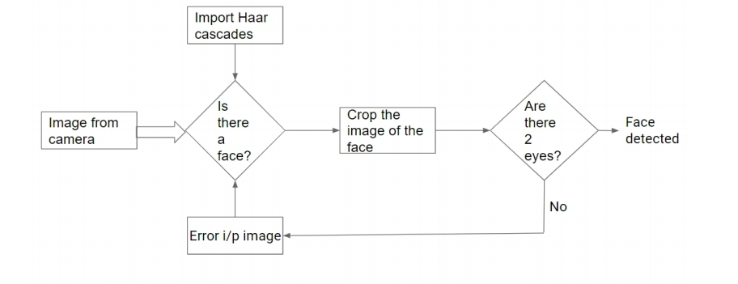Fig.Face detection flow chart

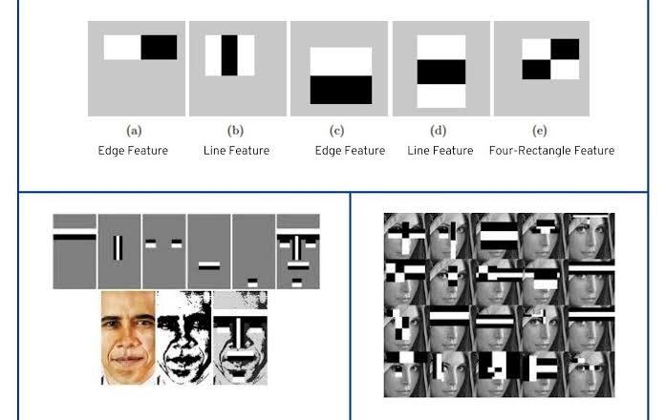For face detection, HAAR cascade features are applied to imagesa as per **[11] & [13]** HAAR features on the image make it easy to find out the edges of the lines in the image or pick areas where there is a sudden change in the intensities of the pixels.Initially, the algorithm needs many images of faces (positive image)and images without faces(negative images) to train the classifier. From that, we need to extract features from it. For this, Haar features shown in the imageEach feature is a single value obtained by subtracting the sum of pixels under the white rectangle from the aggregate under the black rectangle. Now all possible sizes and locations of each kernel are used to calculate plenty of features. We need to find the sum of the pixels under the white and black rectangles for each feature calculation.The first feature selected seems to focus on the property that the region of the eyes is often darker than the region of the nose and cheeks. The second feature chosen relies on the property that the eyes are darker than the bridge of the nose.

Fig .Haar cascade .

But the same windows applying on cheeks or any other place is irrelevant

Software Implementation.

Creating a new Haar cascade requires a face detection system using Haar cascade training. OpenCV has a powerful set of Haar cascades that will be useful for this project. The face cascade alone can be used to identify arbitrary objects, while the inclusion of the eye cascade enables reliable face detection. Classier objects are created by using OpenCV's cv2.CascadeClassier() class and loading the corresponding XML file. To capture images, a camera object is created using cv2.VideoCapture(). CascadeClassier.DetectMultiScale() matches objects of different sizes and returns their positions. Faces are cropped for further verification using location data. The eye cascade is used to identify both eyes in a cropped face. If everything is satisfactory, a marker will be placed around the face indicating that the face has been detected at that location.

Face Recognition

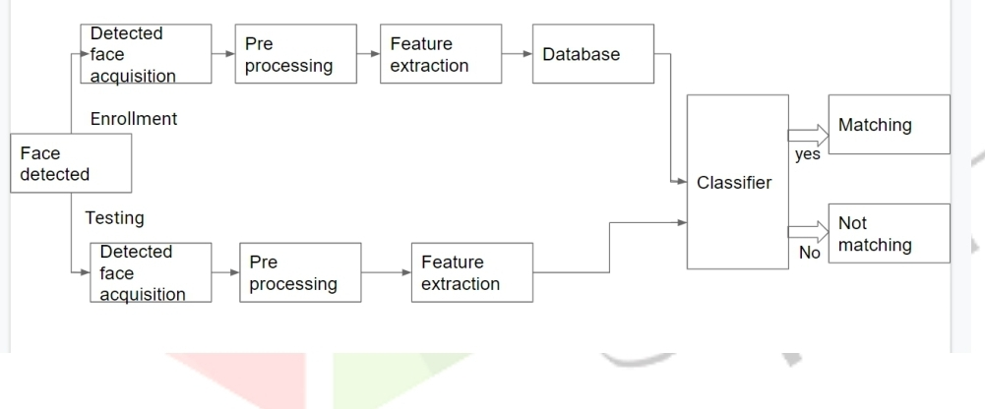The proposed method for face recognition is as follows

The detected face image and reduced the image dimension by applying the LBPH method as pr paper  **[4]** . LBPH algorithm can recognize both front and side faces and upgrade the value of poor enlightened picture and also expands the recognition rate in real time.There for it is chosen.

LBPH Algoritm

Here first the local binary patterns of the image is computed and after that the histogram is created. extracting the texture of the feature of the picture by dividing the image into local images and extracting the binary pattern for each local region. The original LBP operator, which works on eight neighbors of a pixel. Image is divided into small regions called cells. Each pixel in the cell is compared with each of its eight neighbors. The center pixel value will be used as the threshold value. The eightneighbors-pixel will be set to one if its value is equal to or greater than the center pixel; otherwise, the value is set to zero. Accordingly, the LBP code for the center pixel is generated by concatenating the eight neighbor pixel values (ones or zeroes) into a binary code, which is converted to a 256- dimensional decimal for convenience as a texture descriptor of the center pixel

.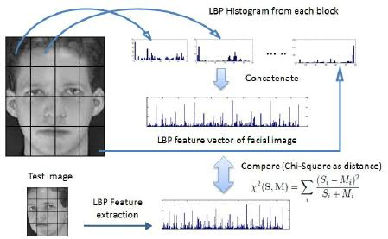For dimension reduction, we use the histogram to reduce the image features from a 256-dimensional decimal to a 59- dimensional histogram, which contains information about the local patterns. A separate bin for each uniform way and one particular bin for all non-uniform patterns used by histogram. In the 8-bit binary number, we have 58 uniform patterns; therefore, we use 58 bins for them and one bin for all non-uniform patterns. The global description of the face image is obtained by concatenating all regional histograms

Face Recognition And Door Control

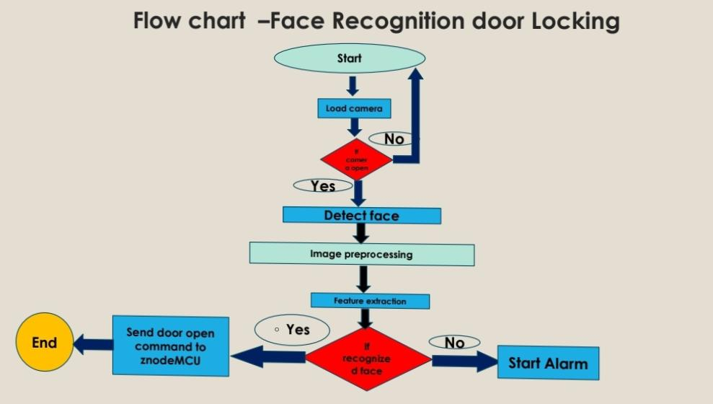The extracted features are fed to the classifier which recognizes or classifies by using an algorithm. The Classifier compares the test image with the images saved in the database and can be done with a supervised Classifier. After recognizing a face, commands are send from Raspbery Pi to node MCU for operating the relay connected to the motor for controlling the door

**B-Hand Gesture controlled Smart Home**

Here, two phases.. Hand gesture recognition and Controlling home appliances

Hand gesture recognition

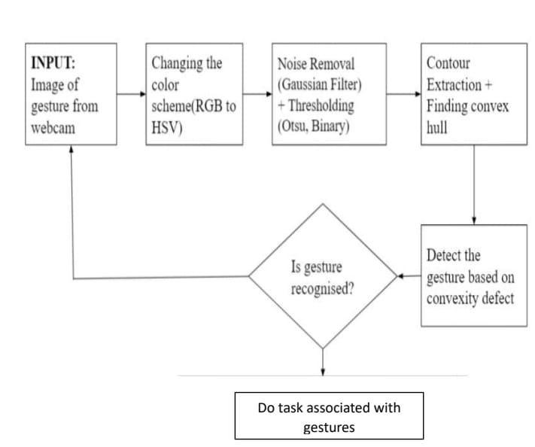

**Fig. Method of hand gesture recognition**

Noise Removal and Image Smoothening

The input image is taken from the webcam, is in RGB color space, is cropped to a size of 200 * 200 pixels. It is then converted to HSV color space Random variation in the brightness produced while taking input images from a webcam can be considered as noise. Noise is an undesirable component in the image and needs to be removed. To perform this, a Gaussian filter is used. A Gaussian kernel of size (5,5) is used, which convolves with each point in an input array. These are then added to produce the output array

Thresholding

Thresholding is a type of segmentation that creates a binary image from a grayscale image for easier analysis. A binary image is an image that consists of exactly two types of pixels: white and black. In thresholding, each pixel in the image that has an intensity (e.g. I) is compared to a threshold intensity value (e.g. T). If I\text is greater than T, it is replaced with a white pixel. In our system, we use binary thresholding and Otsu thresholding according to paper **(12).and (10).**

Contour Extraction

Contour detection is an efficient tool for object detection in image processing. Curves that link Continuous points which are of the same color or same intensity are called contours. In this paper, contour detection is used to recognize the hand, which will help recognize the gesture with the help of contour analysis. Before finding contours, a threshold has been applied to the binary image to achieve higher accuracy because In OpenCV, finding contour is like finding a white object on black background. After this next step is to draw The contours, which can be used to remove any shape provided the boundary points are known. The image below Shows the front-end window that portrays the contour of the user’s gesture input.

Convex Hull

****Mathematically, the convex hull of a set X of points in an affine space is defined as the smallest convex Set that contains X. To calculate the convex hull of the given contour, the palm is considered. The convex hull Will be the convex polygon, where the tip of the fingers will be the vertices of the polygon. This will simplify **The** complex gesture structure.

**Fig. Threshold version of input gesture**

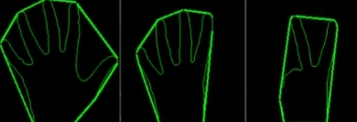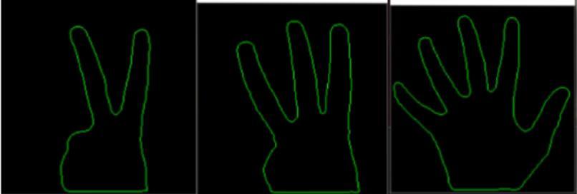**Fig. Counter extraction**

**Fig. Convex hull**

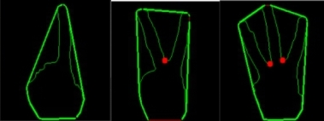

**Fig. Convexity defect**

Convexity defect

The divergence of contour from the convex hull of gesture is defined as a convexity defect. Points farthest from the convex points are considered defects. So, if the fingertips are considered as convex points, then through between the fingers will be defects in this case. A defect is counted if the angle between the two fingers is within 90 degrees, so anything greater than 90 degrees is not considered. By counting these defects, gestures will be recognized.

Controlling Home Appliances

After recognizing gesture, corresponding action assigned to each gesture is done by sending commands from Raspbeeey pi/PC to Node MCU.

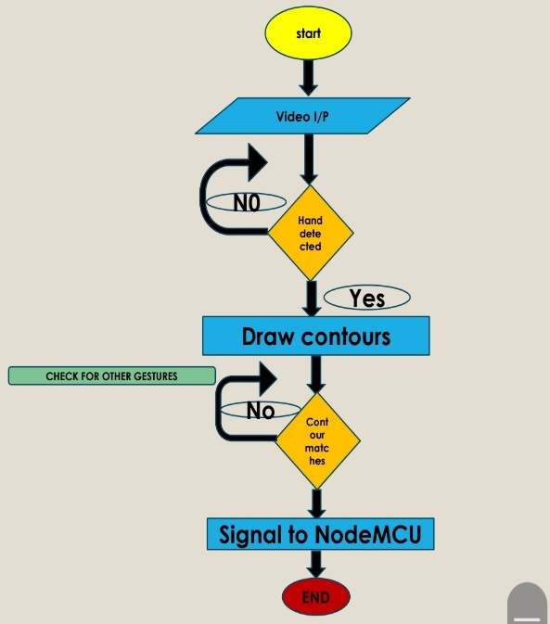

**Fig. Hand gesture control flow**

**C-Remote monitoring and control using IoT**

Here, Blynk is used for remote monitoring and control of home appliences. as by paper [14]. can control hardware remotely, it can display sensor data, it can store data, visualize it and do many other cool things.

Blynk is used here.Blynk allows users to connect various devices to the cloud and develop applications that can be used to monitor and control these devices. It can be used to develop prototypes, test them and even launch them commercially. If you want to develop Iot Devices.

**REFERENCES**

**[1]** ] SaiTeja Chopparapu, Dr. Beatrice Seventline J,” OBJECT DETECTION USING MATLAB, SCILAB AND PYTHON” International Journal of Electrical Engineering and Technology (IJEET) Volume 11, Issue 6, August 2020, pp. 101-108, Article ID: IJEET_11_06_010 Available online at http://iaeme.com/Home/issue/IJEET?V olume=11&Issue=6 ISSN Print: 0976- 6545 and ISSN Online: 0976-6553 DOI: 10.34218/IJEET.11.6.2020.010

**[2]** Saim Khot, Shivraj Kadam,Chinmay Patil, Ankita Raut,Prof. Swapnil Kharat,” .SMART DOOR UNLOCK SYSTEM USING FACE RECOGNITION”, e-ISSN: 2582-5208 International Research Journal of Modernization in Engineering Technology and Science ( Peer-Reviewed, Open Access, Fully Refereed International Journal )Volume:04/Issue:04/April-2022 Impact Factor- 6.752 [www.irjmets.com](http://www.irjmets.com)

**[3]** Jimmy Linggarjati “Raspberry Pi Zero Door Locking System with Face Recognition using CNN (Convolutional Neural Network) and Fingerprint Sensor”, Proceedings of the 3rd South American International Industrial Engineering and Operations Management Conference, Asuncion, Paraguay, July 19-21, 2022,jimmyl@binus.edu

**[4]**  Raghu Prasath, Aditya Kumar2 Akanksha Yadav3, Bhuvishri Acharya, Md Tauseef,” Face Recognition Door Lock System”, International Research Journal of Engineering and Technology, Volume: 07 Issue: 05 | May 2020

**[5]** Jagadeesh Subramanian,” Face Recognition Using Raspberry Pi” International Journal of Advanced Research in Computer and Communication Engineering, Vol. 8, Issue 10, October 2019

**[6]** Manju Bala, Priti Singh, Mahendra Singh Meena,” FACE RECOGNITION USING LINEAR DISCRIMINANT ANALYSIS” International Journal of Electrical and Electronics Research ISSN 2348-6988 (online)Vol. 4, Issue 2, pp: (96-103), Month: April - June 2016, Available at: [www.researchpublish.com](http://www.researchpublish.com).

**[7]** V. Savitha, J. Nandhini, S. Kokilavani3,G. Kalaiarasi4, A. S. Narmadha,” Hand Gesture Recognition for Home Automation”, International Journal of Research in Engineering, Science and Management Volume-2, Issue-2, February-2019,www.ijresm.com | ISSN (Online): 2581-5792

**[8]** Ahmad Puad Ismail, Farah Athirah Abd Aziz, Nazirah Mohamat Kasim and Kamarulazhar Daud1,” Hand gesture recognition on python and opencv” ICEEPE 2020,IOP Conf. Series: Materials Science and Engineering 1045 (2021) 012043,IOP Publishing, doi:10.1088/1757-899X/1045/1/012043

**[9]** Sarah A. Rahman, Ali A. Abed,” Python-based Raspberry Pi for Hand Gesture Recognition” International Journal of Computer Applications (0975 – 8887),Volume 173 – No.4, September 2017

**[10]** Suryanarayana Sharma,Dr.Rangarajan,”Hand gesture recognition using OpenCV and Puthon”,International Journal Of Trends in Scentific Research And Development(IJTSRD),Volume-2,January 2021.

**[11]** Bhavana R. Maale , Dr. Suvarna Nandyal,” Face Detection Using Haar Cascade Classifiers” International Journal of Science and Research (IJSR)ISSN: 2319-7064SJIF (2019): 7.583

**[12]** Arpan Kumar, Anamika Tiwari,” A Comparative Study of Otsu Thresholding and K-means Algorithm of Image Segmentation” International Journal of Engineering and Technical Research (IJETR) ISSN: 2321-0869 (O) 2454-4698 (P) Volume-9, Issue

**[13]** Priyanka Chilap ,Nikitha Chaskar,” Haar Cascade Algorithm And Local Binary Pattern Histogram LBPH Algorithm In Face Recognition”, International Journal of Research Publication and Reviews, Vol 3, no 4, pp 2395-2398, April 2022

**[14]** M.Jaya lakshmi,C.Sadia Sameen2, D.Maneesha,, G.Dharani,, K.Farhat Mubeena,” Smart Home using Blynk App Based On IOT”,International Journel Of Creative Research And Thoughts,(IJCRT),Volume-10,5 May 2022

.