## TITLE OF MASTER THESIS

THE INVESTMENT PATTERN AND BANKING NEEDS OF THE HOUSING SOCIETIES

**Abstract:**

The Investment Industry is highly growing amidst the pandemic issues. With the development of infrastructure today, we have a wide range of investment alternatives. There are two main categories of investments: active and passive. Active investing calls for expertise, patience, and time as the investor must adjust the assets in their portfolio in accordance with market developments. The passive, sometimes known as the industry's "buy and hold" strategy, doesn't require you to be active. This is for those who are unable to fully indulge. High investments are considered active, whereas lower investments are considered passive. While passive risk decreases over time as securities are held, active risk rises with an increase in the buying and selling of assets and securities. As a result, the study only considers these two variables and evaluates how Indian citizens' investment behavior has changed. Their actions are monitored based on majority criteria and the advancements in technology.

**Keywords:**

***Investment, Banking, Savings, Stock market, securities, Indian investors***

**Objective:**

* To study the investment patterns of the citizens of India.
* To study the various investment options provided by the system to the citizens.
* To analyse the investment decisions and changes with changes in the economic development of the country.
* To identify awareness of the study topic.
* To understand attitude of investors on profitability factors of investment.
* To provide adequate information of the study to convince the citizens to invest smartly and explain to them the advantage of the process.
* To comprehend Indian residents' purchasing habits in the stock market.
* To understand the lack of awareness about Investment market in the citizens of India.
* To study the volatility of the Indian Investment market. 10) To reach to customers to invest in Indian Market.
* To understand the options, ways to invest, costing system, procedures and benefits of the Investment Market.

**Introduction:**

History of investment in India lies far back in the 1850’s. The history didn’t start from India, but rather started as a war in the foreign countries. The war was USA against the Britishers. This war led to shortage of cotton supply for clothing to the British. Now the British had to explore ways to find alternative for this supply. Seeing options of roadways, railways and waterways, they thought that the waterways is the cheapest and convenient options for the import of cotton. Now they sighted their eyes to the Indian market for supply of cotton as India served as the biggest market of cotton. Calcutta being the major market for export of cotton, the British couldn’t find a way to reach Calcutta since they had to cross the whole of Africa and travel through the peninsula of India to reach there. Now the British found another route famously called as the Swiss Canal route which led them directly to Bombay. Now Bombay become the hub of export for cotton to the British. Hence new business emerged in Bombay for the purpose of exports. Now to run the business, the companies seek large capital investments . Now this investment need gave rise to Securities in India. This is how the concept of Securities emerged in India. Now understanding how the concept emerged, we’ll move back to the time of 1855 where 2 Indians who were Parsi and Gujrati sitting under the Banyan Tree thought of using security as means of business. But in 1874 they found a permanent place called as the “Dalal Street” in Bombay. This was the place all the ones in support of securities came forward to grow this business. Now in 1875 they officially became the organization called “The Native Share And Stock Broker Association”. This organisation was then converted to BSE in 1925. This BSE was categorised as AOP- Association of Person. This maybe was an unregistered company. But after Independence, it was converted and recognised as the first stock exchange of India in 1957. Now this is the proper registered company. Now talking about rules and regulations as every organisation requires regulations to function. Going back to 1925, BSE made a Law for itself known as the BSE Regulations Act ,1925. But this was a law for just the functioning of BSE. Now they needed a law and regulations for the companies listing, or the investors investing or brokers etc. that under which law will trading be possible. For that purpose, Capital Issue Control Act 1945 came into the scenario.

This law resolved the issue for the investors, listing companies, brokers etc. But in 1988 the Government replaced the Capital Issue Control with SEBI – Stock Exchange Board of India. Now SEBI became the regulating authority under the Capital Issue Control Act,1945. Now SEBI act 1992 enacted that came into force. But the complete power was transferred in 1995. Now SEBI became the soul regulator of the stock market. Now in existence of only SEBI and BSE, there was very minimal understanding and information that the common man could access and the investors were totally dependent on the brokers for their trade because no one can trade without a broker be it for any purpose. Hence NSE- National Stock Exchange was established in 1992 with the purpose to provide with trade using the electronic manner and to make all the information available to all the investors at all times. Today we can access any data about any companies, trends, performance, stock rates etc. within seconds and this is possible because of the revolutionary reforms of the NSE. The concept of electronic securities shares was developed and the need to dematerialise all these securities form paper format to e-format. This led to Depository Authorities Act,1996 in which the depository was responsible for the dematerialisation of the shares. Later on a lot of other exchanges, rules and acts were passed to form today’s Morden day investment sector.So this was the evolution of the investment market of India.

India is aiming to increase opportunities in the investment market. Though the market has become so volatile due to the pandemic of COVID-19, Indian is trying to be firm in gaining 15% on the benchmark indices when the mid and small cap industries have outperformed. Studying the investment during the COVID era has changed the phase and pattern of investment. India is aiming at the largest sectors that may boom in this situation namely being the Pharmaceutical industry, Information and Technology sector, Chemical sector, Steel sector, Real estate, Life Insurance sector etc. Market is estimating that these industries will prove to reap in benefits to the investors. The lockdown in major states have created fears of market crash because the 2020 nationwide lockdown has left the market bleeding with the indices shattering to around 40% in just 2 weeks. But in 2021, the crash is not likely to happen. India has also open doors even wider for the Foreign Direct Investments. Market is always uncertain, but the corrections are helping in stabilising the prices and recovery in the market is also reflecting as good hope. But in contradiction of the current situation, the rapidly growing US economy has put India in danger as there will be stronger put forward of the dollar rates. US had accelerated 6.4% in first quarter already. The second and third wave of covid will have devastating effects to the Indian market if compared to USA. The trade and manufacturing has already been hampered and is lowering the GDP of India as India had expected 12.5% growth but would be fulfilling only 12% by FY2022. Looking at the speed of the USA economy in terms of health and wealth, they’ll soon be the dominating country. This growth of US might lift the growth globally.

**TYPES OF SECURITIES**

1. Stocks
2. Bonds
3. Mutual Funds
4. ETF’s
5. Derivatives
6. Hedge funds

**INVESTMENT P**

**ATTERN OBSERVED BY CONSUMERS IN THE SECURITIES MARKET**

After the Brief overview of the Securities market, we shall now observe how Indian citizens have taken advantage of the investment market. If we take the statistics of Investment in India versus investment in USA, we realise that only 5% of Indian population invest in markets whereas in the USA, 50% of the citizens invest. This is simple logic of understanding that how vast is the awareness created in the USA market and lack of awareness in the Indian Market. As we understood earlier that the better the investment pattern the better is the economy. The more the demand, the more the supply and the more the growth the county shall observe.

1. Stock Market As per the Analysts, we can see in the above image that India becomes the 7th largest stock market as India at $2.7 trillion is eyeing on better recovery in domestic demands amidst the COVID-19 crunch and the governments are making way to revive the fallen economy. Also India is aiming at 11.5% growth in FY 22.

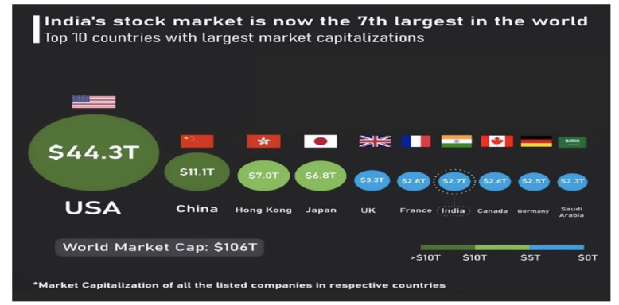

1. The States The picture shown above shows the statics of investment contributions by the states of the country in the last 4 years. With this we understand that Uttar Pradesh is the highest contributor which signifies that investors are in majority in Uttar Pradesh and the rest of the states are follow by in the same manner. As per studies, in Dec 2020 The Lucknow Municipal Corporation listed on the BSE and raised ₹200 crore for the state. Lucknow became the 9th city in the country to raise capital at this amount via municipal corporation. These bonds issued at 8.5% for 10 years and the actual cost was at 7.25% . The Uttar Pradesh government spread awareness to the MSME’s to invest in stock market to raise good amount of capital and grow their businesses. The listing of the municipal bond marked a new development era wherein this ₹200 crore remark made a new way towards self-reliance . Until FY2020 a total of ₹3,600 crore was raised by the use of such bonds.

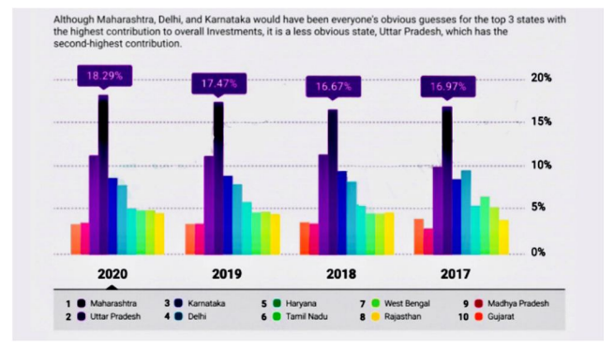

1. Allocation of Capital

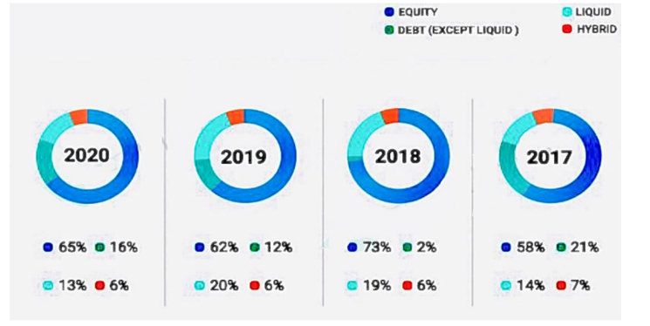

From the above image we can infer that over the years from 2017-2020 there has been changes as to how investors allocate their funds based on their portfolios. Even till date, the equity investment holds the majority part of the allocation which is followed by the liquid, debt and the hybrid funds. This allocation is for mutual fund investments where the entire country is analysed and interpreted. Mutual funds have this advantage of investing as per diversification into multiple securities. Investing in different companies helpes in mitigating risk factor even if the market goes down. Mutual funds are aimed as long term investment usually in the Indian market where investors aim to have family oriented goals to achieve with the gain amounts. The mutual fund industry stood at ₹31,42,764 crores as per March 2021 and the industry crossed its ₹30 trillion mark. The total number of accounts (folios) stood at reaping 9.79 crores while the folios in equity, hybrid schemes stood at 8.18 crore. We shall now understand that what holds back the Indians to invest in the market?

1. Lack of Money/Capital It’s a belief in India that investing in market requires huge capital requirements but the fact is that you can also invest with small amounts.
2. Investment Illiteracy Little or no knowledge about the market doesn’t attract investor.
3. Old methods Indians are of the belief of using safer means to invest like in fixed deposits or precious metals etc. where in they assure returns and no loss of capital invested. The risk taking attitude lacks in citizens which is why FD’s are an option even if stock market gives in more of returns
4. Past Incidents If one has experienced losses in the past because of investing in wrong stocks, this creates fears instead of them realising their mistake and rectifying it.
5. To clarify the above myths of the market, investing isn’t complicated and is easier than before due to the advance technology. Consumers can easily trade with the entire amount they wish to invest or they can also use systematic investment plan wherein they can invest small amounts at equal intervals. The market has also made it easy to add or remove money as per wished at any time from any part of the world. Taking positive advantage of the volatility of market and understanding concepts of investment than myths can easily gain you money. Creating smart portfolios can also help investor gain wealth. Investing early is also considered as a boon in the long run which changes the chance of financial success of an individual. As per experts, in pandemic, one must also maintain cash emergency reserves.

**INVESTMENT IN BANKING INDUSTRY**

Is the Banking Industry a good choice and value for money? Let us now understand the second sector of the study which is the banking industry. Investing in the banking sector is another form of investment than investing in securities. Banking is a good choice for all the value investors. In this bank pays dividends to the divided holder which is the demonstration of great history to provide profits to investors. These value investors are drawn towards the bank stock. Value investment is a type of theory which is used by Allowing investors to select stocks that are traded below their book value. The market has undervalued these selected stocks. They purchase a lot of equities all at once, selling them off when the market performs poorly or the economy weakens. This occurs when competitors attempt to sell their high-priced stocks, which incentivizes investors to purchase the stocks at a discount. Value investors also prioritize long-term objectives above short-term ones. We will now comprehend the viewpoint of both long-term and short-term banking sector investing. One of the investing legends, Benjamin Graham, is quoted as saying that "short-term investing is like voting machines."

**SERVICES PROVIDED BY THE COMMERCIAL BANK TO THE INVESTORS**

India is well-known for its superstitions and tales, some of which are also quite plausible.One such is that there is significantly less worry of money loss because banks keep our money safe.The majority of Indians still invest in banking services such as mutual funds, post office deposits, savings bank accounts, life insurance deposits, provident funds, and fixed deposits when they wish to make money.Banks have an advantage over the stock market in that they are safer overall, but the main drawback is that banks rarely offer as high of returns as equities do.   
For instance, if banks offered a 7.5% interest rate on fixed deposits, but the same amount was deposited in the investment market, they would offer as much as :-

1 Savings accounts: They resemble short-term investment schemes.They serve as investors' main tool.Interest is paid on your contributions to a savings bank account, usually once a month.To invest in the bank that offers the best return, one must compare banks, their policies, and their rates. In India, banks typically offer interest rates between 2.5 and 7.2% .

2) Fixed Deposits: These provide investors higher interest rates than standard savings accounts. They are financial instruments with too little risk. In India, fixed deposit yields start at 6.50% and can reach a maximum of 6.75%. It has good higher rates for older persons and is a wonderful long-term alternative.

3Life Insurance: Banks offer a range of life insurance coverage options to suit different investor types. The nation's government introduces these programs, with banks acting as an intermediary. Given the high cost of healthcare, the programs are quite reasonable and inexpensive.

4) Provident Fund: These long-term programs have a 15-year maturity period and require minimum payments of ₹100 and maximum payments of ₹60,000, with interest rates ranging from 7-8%. Due to its government management and guaranteed returns, this scheme is quite popular. Tax benefits under the EEE category are also favorable. Retraction of the invested sum is only possible after a 15-year maturity period.

a) Statistics

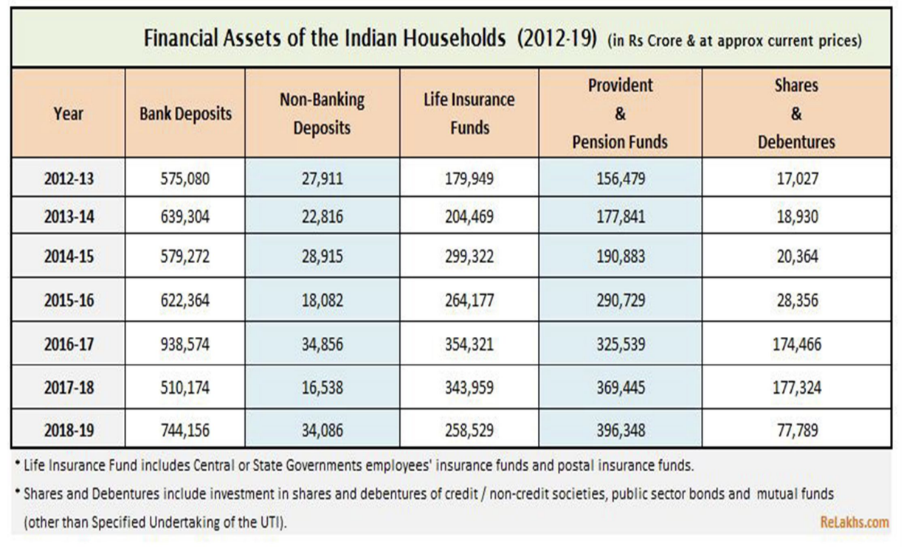

b) Interpretation:

We may observe how Indian households invest in bank-provided plans and services by looking at the secondary data table above.Data spanning seven years reveals a sharp rise in bank deposits, which have been followed by a twofold increase in non-banking deposits between FY 17–18 and FY 18–19.Given the current circumstances, life insurance has also doubled throughout the previous seven years.Positive increase has been observed with appropriate knowledge of the significance of life insurance and life covers.Additionally, investments in shares and debentures have increased more than 4.5 times, and provident funds have doubled.Investors have grown and made more favorable investments in the market's services throughout time.

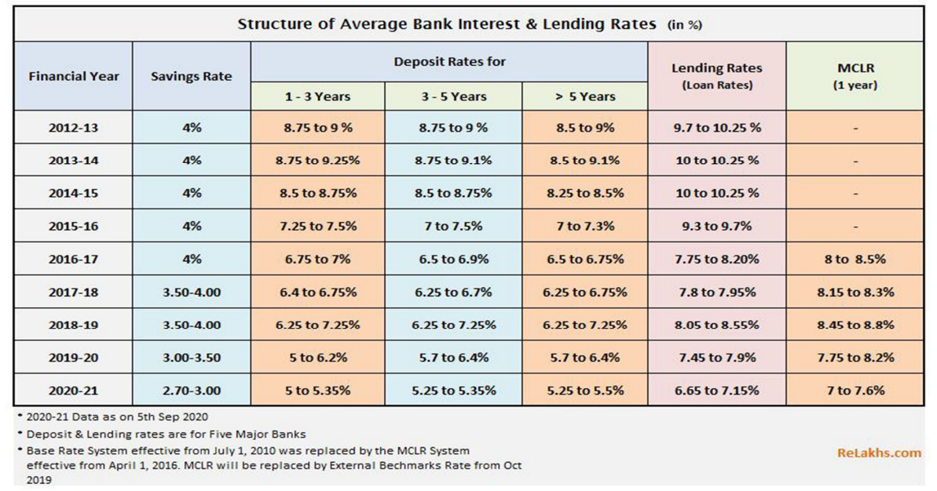

In order to help investors assess and make methodical investments to increase their returns on investment, secondary data was used to create the following table, which displays all of the interest rates that banks have offered for the services they have supplied over the years. From the last seven years of data, the rates have gotten lower with time. With large declines in deposit rates and just slight declines in leading, MCR, and savings rates.

**Situational Analysis**

To conduct a situational analysis on the investment pattern and banking needs of housing societies, several factors need consideration:

1. **Current Economic Environment**: Examine the current state of the economy, taking into account the inflation rate, interest rates, and general stability of the market. These elements have a big impact on banking preferences and investing decisions.
2. **Regulatory Framework**: Recognize the regulatory environment that affects housing societies' financial operations. Regulations may impact the banking requirements and investing choices that societies have access to.
3. **Demographic Profile**: Examine the age, income, and preference distributions in the housing societies' demographic composition. The demand for particular financial products and other banking requirements, such as investment decisions, can be influenced by demographics.
4. **Investment Pattern**: Analyze housing societies' present investment portfolio. This involves evaluating how different asset classes—like stocks, bonds, real estate, and alternative investments—are allocated.
5. **Risk Tolerance**: Find out how risk-averse housing societies are about making investments. While some societies may place more value on wealth preservation, others might pursue better returns at the possible expense of increased risk.
6. **Financial Goals**: Determine the housing societies' financial goals, including capital appreciation, revenue production, and wealth preservation. Comprehending these objectives is essential for coordinating banking services and investing plans.
7. **Banking Needs** Analyze transactional services, credit facilities, and liquidity management in relation to the banking needs of housing societies. Determine if the banking arrangements in place now sufficiently satisfy these needs or whether they could be improved.
8. **Technology Adoption**: Think about how much technology is used in housing societies and how that affects the banks that people prefer. Requirements for societies adopting digital banking may differ from those of those favoring traditional financial services.
9. **Competitive Landscape**: Examine the products and services that different banks and financial organizations provide to housing societies. Selecting appropriate banking partners and negotiating advantageous terms can be aided by having a thorough understanding of competitive advantages and weaknesses.
10. **Future Outlook**Be aware of potential future trends and changes that could affect housing societies' banking requirements and investment patterns. This covers elements including modifications to laws, improvements in technology, and adjustments to the dynamics of the market.

**Review of literature**

Beck, Thorsten, Asli Demirguc-Kunt, and Maria Soledad Martinez Peria. 2007. Reaching Out: Access to and Use of Banking Services Across Countries. Journal of Financial Economics 85(1): 234–266.

Black, J., D. de Meza, and D. Jeffreys. 1996. House Prices, the Supply of Collateral and the Enterprise Economy. The Economic Journal 106:60–75.

Blackman, T., and J. Harvey. 2001. Housing Renewal and Mental Health: A Case Study. Journal of Mental Health 10(5): 571–583. Bon, R. 1992.

The Prospects for Global Construction in the Future: Secular Trends of Development and Recession. Habitat International 16(3): 119–128.

Bon, R., and R. Pietroforte. 1990. Using input-output tables, a historical comparison of the construction sectors in the US, Japan, Italy, and Finland. Construction Management and Economics 8:233–247.

Bon, R., T. Birgonul, and I. Ozdogan. 1999. An Input Output Analysis of the Turkish Construction Sector, 1973–1990: A Note.

Construction Management and Economics 17:543–551. Breysse, P., N. Farr, W. Galke, B. Lanphear, R. Morley, and L. Bergofsky. 2004.

An historical comparison of the US, Japan, Italy, and Finland's construction industries using input-output tablesz. Environmental Health Perspectives 112(15): 1583–1588.

Buckley, R., and J. Kalarickal. 2005. Housing Policy in Developing Countries: Conjectures and Refutations. The World Bank Research Observer 20(2): 233–257. Buckley, R., L.

Chiquier, and M. Lea. 2009. Housing Finance and the Economy. In L. Chiquier and M. Lea, eds. Housing Finance Policy in Emerging Markets. Washington, DC: World Bank.

Erbas, S., and F. Nothaft. 2005. Mortgage Markets in Middle East and North African Countries: Market Development, Poverty Reduction, and Growth, Journal of Housing Economics 14:212–241.

Fogel, R. 1994. Economic Growth, Population Theory and Physiology: The Bearing of Long Term Processes on the Making of Public Policy. American Economic Review June:369– 395.

Green, R., and M. White. 1997. Measuring the Benefits of Home Owning: Effects on Children. Journal of Urban Economics 41:441–461.

Hardt, J., and J-D Lichtenberger. 2001. The Economic and Financial Importance of Mortgage Bonds in Europe. Housing Finance International June:19–29.

Haurin, D., Parcel, T., and Haurin R. 2001. The Impact of Homeownership on Child Outcomes. Low-Income Homeownership Working Paper Series LIHO-01.14.

Joint Center for Housing Studies of Harvard University. Holzmann, R., T. Packard, and J. Cuesta. 2001.

Extending Coverage in Multi-pillar Systems: Constraints and Hypotheses, Preliminary Evidence and Future Research Agenda. In R. Holzmann and J. Stiglitz, eds. New Ideas about Old Age Security: Toward Sustainable Pension Systems in the 21st Century.

Washington, DC: World Bank. ILO. 2008. Labour Statistics. International Labour Organization. Jamison, D. T., H. W. Mosley, A. R. Measham, and J. L. Bobadilla, eds. 1993.

Disease Control Priorities in Developing Countries. Washington, DC: World Bank. Jappelli, T., and M. Pagano. 1994. Saving, Growth and Liquidity Constraints.

The Quarterly Journal of Economics 109 :83–109. Kofowolora, O., and S. Gheewala. 2008.

An Input–Output Analysis of Thailand’s Construction Sector. Construction Management and Economics 26:1227–1240. Klyuev, V., and P. Mills. 2007. Is Housing Wealth and “ATM”? The Relationship between Household Wealth, Home Equity Withdrawal and Saving Rates.

IMF Staff Papers 54(3): 539–5621. Laskar, A., and C. Murty. 2004. Challenges Before Construction Industry in India. Department of Civil Engineering, Indian Institute of Technology, Kanpur ([www.iityk.ac.in](http://www.iityk.ac.in)).

Lean, S. C. 2001. Empirical Tests to Discern Linkages between Construction and Other Economic Sectors in Singapore. Construction Management and Economics 13:253– 262.

Le Blanc. 2009. Residential Rental Housing Finance. In L. Chiquier and M. Lea, eds. Housing Finance Policy in Emerging Markets. Washington, DC: World Bank.

When reviewing literature on the investment patterns and banking needs of housing societies, it's crucial to explore various facets, including financial management practices, regulatory frameworks, and socio-economic factors influencing these entities. Here's a structured approach for your review:

1. Financial Management Practices:
   1. Investigate literature on the typical investment patterns observed in housing societies. This may include studies analyzing the allocation of funds into different asset classes such as fixed deposits, mutual funds, or real estate ventures.
   2. Explore research that examines the decision-making processes within housing societies regarding investment strategies. Understand factors like risk tolerance, liquidity needs, and investment horizon.
2. Regulatory Framework:
   1. Examine the regulatory landscape governing the financial activities of housing societies. This includes laws, regulations, and guidelines set forth by governmental bodies or regulatory authorities.
   2. Review studies assessing the compliance levels of housing societies with relevant financial regulations. Analyze any gaps or challenges in adherence to these regulatory requirements.
3. Banking Needs:
   1. Look into literature addressing the banking needs of housing societies, including savings accounts, loans, and other financial services.
   2. Identify research discussing the preferences and priorities of housing societies when choosing banking partners. Consider factors like interest rates, service quality, and convenience of banking facilities.
4. Socio-Economic Factors:
   1. Explore literature examining the socio-economic characteristics of housing societies and their implications for financial decision-making. Factors such as income levels, demographics, and geographic location may influence investment patterns and banking needs.
   2. Investigate studies that analyze how external economic conditions, such as interest rate fluctuations or market volatility, impact the financial behavior of housing societies.
5. Case Studies and Best Practices:
   1. Look for case studies or empirical research highlighting successful investment strategies and banking arrangements adopted by housing societies. Identify key lessons learned and best practices that can be generalized to similar contexts.
   2. Consider studies that offer practical recommendations for improving the financial management and banking services of housing societies, based on real-world experiences and insights.
6. Emerging Trends and Future Directions:
   1. Explore recent literature discussing emerging trends in the investment patterns and banking needs of housing societies. This may include the adoption of digital banking solutions, innovative investment products, or regulatory changes affecting financial operations.
   2. Look for forward-looking research that anticipates future challenges and opportunities for housing societies in managing their finances and accessing banking services.

**Exploratory Research**

It involves gathering preliminary information to understand the landscape before conducting more in-depth studies. Here's how you might approach it:

1. **Literature Review** Start by reading through the literature, reports, and research that are currently available regarding housing societies' banking needs and investing behavior. This aids in establishing a foundational comprehension of the subject and pointing out any holes or places that need more research.
2. **Surveys and Questionnaires** Create and deliver questionnaires or surveys to housing society representatives. Learn about their preferences, banking affiliations, current investment portfolios, and financial management concerns. Ask them about their preferred technology, investment objectives, and risk tolerance.
3. **Data Analysis**: Examine whatever information that is accessible regarding the banking operations and investment strategies of housing societies. Membership demographics, transaction records, and financial statements are a few examples of this. Find patterns, correlations, and anomalies to learn about standard procedures and areas that could want improvement.
4. **Case Studies**: Examine particular instances of housing societies that have effectively integrated cutting-edge financial solutions or streamlined their investment portfolios. Examine the elements that made them successful and speculate about how other housing societies can implement comparable tactics.
5. **Market Research**: Explore the offerings of banks and financial institutions catering to housing societies. Evaluate the range of banking services available, including transactional accounts, loans, investment products, and digital platforms. Compare the features, fees, and customer support offered by different providers.
6. **Regulatory Analysis**: Analyze the legal structure controlling the financial activities of housing societies. Recognize the potential and restrictions brought about by laws pertaining to banking connections, reporting requirements, and investing options.
7. **Technology Assessment**: Examine housing societies' inclinations and technological prowess with relation to banking services. Examine how they handle their finances using digital payment methods, smartphone applications, online banking, and other IT tools.
8. **Stakeholder Engagement**: Interact with pertinent parties, such as governmental organizations, business associations, and educational establishments that offer courses on home finance. To improve the banking and investment environment for housing societies, get their opinion on new developments, industry best practices, and suggested policies.

**FINDINGS OF THE STUDY**

1. As of 100%, majority were the male with 56% and the minority were female with 44%. This shows that the male are more interested in investing than women.
2. As of 100%, majority of the respondents were between the age of 20-30 with 42% and the minority were above 50 with 5%. This shows that younger people are more interested in investing with respect to their perception regarding investing.
3. As of 100%, majority of the respondents are businessmen with 49% and corporate 1category with 36%, Entrepreneurs with 15%. This shows that businessmen frequently invest than any other category of respondents.
4. As of 100% majority of the respondents have a monthly income above 1,00,000 with 56%, respondents have a monthly income of 20,000-50,000 with 15%, respondents have a monthly income of 50,000-1,00,000 with 29%. This shows that respondents with a monthly income above 1,00,000 frequently invest.
5. As of 100% majority of the respondents have an annual income above 20,00,000 with 40%, respondents with an annual income of 0-10,00,000 with 22%, respondents with an annual income of 10,00,000-20,00,000 with 38%.This shows that the respondents with an annual income above 20,00,000 invest frequently.
6. The respondents invest up to 10 years with 32% and minority respondents invest for 0-5 years, 26% of the respondents invest for 5+ years and 22% of the respondents invest as open term. This o shows that the respondents frequently invest up to 10 years.
7. The respondents want to invest 10,00,000-30,00,000 with 44%, minority of the respondents want to invest above 50,00,000 with 13%, 25% respondents want to invest less than 10,00,000 and 18% of the respondents want to invest 30,00,000-50,00,000. This shows that the respondents frequently invest 10,00,000-30,00,000.
8. The respondents strongly agree with the statement with 69%, 21% of respondents tend to agree with the statement, 07% of the respondents are in between; neither agree nor disagree, 03% of the respondents tend to disagree, This shows that respondents would enjoy exploring investment opportunities with their money.
9. The respondents sometimes go for the possible return with 28%, 23% of them always got for it, 14% of them usually go for it, 21% of them rarely go for the possible return and lastly 14% of them never want to go it.
10. The respondents are fairly cautious with their attitude with 28%, 14% of them are very adventurous with their attitude, 07% of them are fairly adventurous with their attitude, 25% of them are average with attitude and 26% of them are very cautious with their attitude while making financial decisions.
11. The respondents take small amount of risk with 49%, 07% of them take very large amount of risk, 05% of them take large amount risk, 14% of them take medium amount of risk and 25% of them take very small amount of risk.
12. The respondents are in between with 35%, 25% of them strongly agree with slow growth, 17% of them tend to agree with slow growth, 15% of them tend to disagree with slow growth and 08% of them strongly disagree with slow growth.
13. The respondents are in between that they feel anxious with 37%, 14% of them strongly agree that they feel anxious, 22% of them tend to agree that they feel anxious, 19% of them tend to disagree that they feel anxious and lastly 08% of them strongly disagree that they feel anxious while investing.
14. The respondents would invest more funds to take advantage of the lower price, expecting future growth with 44%, 43% of them would transfer their money to more secure investment product to reduce risk of further losses, 13% of them would monitor the investment and wait to see if it improves.
15. The respondents tend to disagree to take risk with 39%, 18% of them strongly agree to take risk, 15% of them tend to agree to take risk, 14% of them are in between to take risk and 14% of them strongly disagree to take risk even if they had to bear losses.
16. The respondents would invest half of their money with 35%, 14% of them would invest all of their money, 12% of them would invest more than half of their money, 28% of them would invest less than half of their amount and 11% of them would invest very little amount of their money.
17. The respondents think their friends would say they are daring sometimes with 38%, 28% of them think their friends would say they are daring, 25% of them think they would say that they are a thoughtful risk taker, 08% of them think they would say they are careful, 01% of them thinks that they would say they are very cautious.
18. The respondents felt a little concerned while investing with fear of losing all money with 38%, 17% of them felt panicked and very uncomfortable while investing, 19% of them felt quite uneasy while investing, 21% of them felt like accepting of the possible high and lows, 05% of them felt excited by the potential for gain.
19. The respondents choose to invest on a mixture of the two products with 51%, 29% of them choose to invest on a product with a low average annual return but almost no risk of loss of the initial investment, 20% of them choose to invest on a product with higher average annual return but some risk of losing part of the initial investment.
20. Majority of the tend to agree to have small certain gains to large uncertain ones with 29%, 13% of them strongly agree to have small certain gains, 26% of them are in between to have small certain gains to large uncertain ones, 22% of them tend to disagree to have small certain gains, 10% of them strongly disagree to have small certain gains to large uncertain ones.
21. The respondents think about both the possible gains and losses with 43%, 10% of them are excited about the possible gains, 17% of them are optimistic about possible gains, 25% of them are conscious of the possible losses and 05% of them are worried about the possible losses.
22. The respondents strongly agree to get low returns safe investments with 47%, 28% of them tend to agree to get low return safe investments, 14% of them are in between to get low returns safe investments, 08% of them tend to disagree to get low returns safe investments, 03% of them strongly disagree to get low returns safe investments.

**II. Explanation on Research Topic**

1. **Understanding Member Preferences**: Housing societies can learn more about their members' interests and preferences for banking services and investment possibilities by conducting research. This knowledge enables societies to efficiently adjust their financial strategy to satisfy the various needs of their members.
2. **Optimizing Investment Returns**: Housing societies can evaluate the performance of their present investment portfolios and pinpoint areas for optimization with the use of research. Societies can decide how best to manage risk and optimize returns by analyzing various asset classes, risk profiles, and investment techniques.
3. **Enhancing Financial Management**: Research offers insightful information and analysis to help with financial management decision-making. Research findings can be used by societies to create strong investment policies, efficient governance frameworks, and responsible banking practices that support efficiency, accountability, and transparency.
4. **Mitigating Risks**: Housing societies might evaluate any risks related to their banking and investing activities by conducting research. Societies can use risk management techniques to defend their financial assets and members' interests by recognizing legislative limits, market vulnerabilities, and operational hazards.
5. **Improving Banking Relationships**: Housing societies can investigate other banking choices and assess the suitability of their current banking arrangements with the use of research. Societies can improve the overall banking experience for their members by negotiating better terms with banks and financial institutions by evaluating issues including service quality, pricing, and technology capabilities.
6. **Promoting Financial Inclusion**: Barriers to inclusion and financial access in housing societies might be found through research. Societies can create programs to increase financial literacy, broaden banking outreach, and encourage more involvement in the formal financial system by identifying underserved members or segments that do not have access to banking services.
7. **Adapting to Market Trends**: Housing societies can keep up with changing market trends, technology developments, and regulatory changes affecting the banking and investing sector by doing research. In order to stay resilient and competitive in a changing environment, societies can proactively adjust their strategy by keeping an eye on industry developments and benchmarking against best practices.
8. **Fostering Stakeholder Engagement**: Research can help to engage stakeholders, including members, committee members, regulators, banking partners, and other relevant parties. Societies can foster a sense of ownership, accountability, and transparency among stakeholders by soliciting feedback, disseminating research findings, and promoting cooperative discourse.

**Research Objective**

The research object of the investment pattern and banking needs of housing societies encompasses several key aspects:

1. **Investment Portfolio Composition**: This includes analyzing the types of investments held by housing societies, such as equities, bonds, mutual funds, real estate, and alternative assets. Understanding the allocation and diversification within the investment portfolio provides insights into risk management strategies and potential returns.
2. **Risk Management Practices**: Investigating how housing societies assess, mitigate, and monitor investment risks is crucial. This involves examining risk tolerance levels, the use of hedging instruments, and strategies to preserve capital while seeking returns commensurate with the society's objectives.
3. **Banking Relationships**: Exploring the banking relationships of housing societies involves studying their interactions with banks and financial institutions. This includes assessing the types of accounts held, transactional activities, credit facilities utilized, and the quality of banking services received.
4. **Financial Goals and Objectives**: Understanding the financial goals and objectives of housing societies provides context for their investment and banking decisions. Research should delve into whether societies prioritize capital preservation, income generation, capital appreciation, or a combination thereof.
5. **Technological Adoption**: Investigating the technological adoption levels within housing societies is important, particularly regarding banking services. This includes assessing the use of online banking platforms, mobile apps, electronic payment systems, and other digital tools to manage finances efficiently.
6. **Regulatory Compliance**: Researching the regulatory framework governing housing societies' investment and banking activities is essential. This involves examining compliance requirements, reporting obligations, and any constraints or opportunities presented by regulatory authorities.
7. **Member Demographics and Preferences**: Understanding the demographic profile of housing society members and their financial preferences is critical. Research should explore factors such as age, income levels, risk appetite, and investment literacy to tailor financial services effectively.
8. **Market Trends and Developments**: Researching market trends and developments helps housing societies stay informed about changes that may impact their investment and banking strategies. This includes monitoring interest rate movements, inflation expectations, geopolitical risks, and emerging investment opportunities.

**Methodology:**

Sampling is a part of the whole research method. Once market researchers decide to conduct a field survey, they must decide whether to use a census survey or a sample survey. In place of complete censuses, sample surveys are often used due to their numerous advantages. In order to perform a sample survey, it is necessary to first identify the target population. After that, choosing a suitable method of sampling is possible. What kind of sample design is used is decided by how easily obtainable the required sample frame is. Because of the need for substantial human engagement in the data gathering process, a sample survey was selected as the sampling technique. Their involvement is also unnecessary since every housing cooperative has the same fundamental framework and procedures. In addition, open-ended replies cannot be gathered through census. A lack of benefit would also cause frightened people to lose interest. This is why a survey based on a representative sample is superior than a census. A random sample does not favour any one segment of the population over any other segment since each individual is picked at random. Since all housing cooperatives are bound by the same set of bylaws, it stands to reason that their investment policies, revenue streams, and banking needs are all fairly standard across the board. Therefore, there is no need for a massive sample size. In addition, the time required to complete the project will skyrocket if the sample size is very huge. A community of 50 dwellings is an adequate target for social improvement.

**RESEARCH DESIGN**

Type of Research The type of research used for data collection is Descriptive and Analytical Research. In this Research the researcher made the questionnaire and took respondents interview through market survey. In the study, both primary and secondary data has been taken use. The primary data was collected by questionnaire method and secondary data used was collected from magazines, newspapers, books, website. As per present day study , the researcher has used Convenience Sampling Method.

**Types of Research Design**

* **Descriptive Research Design**: traits, actions, and viewpoints of a group of people. Surveying members of housing societies to learn about their banking practices, investment choices, and level of satisfaction with current financial services could be part of this design.
* **Cross-Sectional Design**: In a cross-sectional design, information is gathered from a subset of participants at one particular moment. This method could be applied to housing societies' investment portfolios and banking partnerships, giving an overview of their present financial operations.
* **Longitudinal Design**Data collection from the same participants over an extended period of time is the goal of a longitudinal design. Researchers may be able to spot trends and variables impacting financial decision-making by utilizing this method to monitor changes in banking requirements and investment patterns over time inside housing societies.
* **Mixed-Methods Design**: Techniques for gathering and analyzing data, both quantitative and qualitative, are used in a mixed-methods approach. In order to collect quantitative data on housing society members' banking and investment preferences, this strategy would involve surveying them. Focus groups or interviews would then be used to further investigate the underlying motives and decision-making processes.
* **Case Study Design**: A case study design involves in-depth analysis of one or more housing societies to understand their investment patterns and banking needs in detail. This approach could involve collecting data from financial records, interviews with key stakeholders, and observation of governance processes to provide a comprehensive understanding of financial management practices within specific societies.
* **Experimental Design**: While less common in studies of investment patterns and banking needs of housing societies, experimental designs involve manipulating variables to observe their effects on outcomes. In this context, an experimental design could involve testing the impact of different investment strategies or banking interventions on the financial performance and member satisfaction of housing societies.
* **Action Research Design**: Action research involves collaboration between researchers and practitioners to address real-world problems and improve practices. In the context of housing societies, action research could involve working closely with society committees and financial advisors to develop and implement strategies for optimizing investment portfolios and banking relationships.

**Data Collection and Forms**

After deciding that primary data collection is necessary, picking the right method is the next step. In this case, you may either (1) use a purely observational method or (2) conduct a survey. The word "observation" is used to describe a method of study in which data is collected by simply watching events unfold. The observational approach would be unsuitable for this research since the necessary data cannot be acquired without conducting in-depth interviews with the persons involved. Surveys: Primary data from respondents is commonly gathered via field surveys in marketing research. Surveys may be conducted via a variety of channels, including in-person meetings, phone calls, written replies, and diaries. Most polls in India are taken either in person or over the mail. It's crucial to choose the optimal strategy for gathering information. There are advantages and disadvantages to doing each sort of survey. A telephone survey is a good choice when just a little quantity of information has to be gathered fast. Responders should have quick and easy access to this information. In this situation, neither time nor information constraints are an issue. As a result, a survey by telephone is inappropriate. The use of personal diaries or letters is likewise not acceptable for this study. In-person meetings might be useful here. It is common routine to collect data from respondents using structured questionnaires. It is crucial for the researcher to conduct pilot studies of the questionnaire to identify any issues before finalising it. The final, thoroughly tested survey may be found in the appendices.

* **Surveys**: Surveys are a good way to get quantitative data from members of housing societies about their demographics, banking practices, satisfaction levels, and investment choices. Structured questionnaires designed to gather pertinent data can be used for online, email, or in-person surveys.
* using structured questionnaires tailored to capture relevant information.
* **Interviews**: Interviews allow for in-depth exploration of participants' perspectives, motivations, and experiences related to investment and banking. Conducting semi-structured interviews with housing society committee members, financial advisors, and banking representatives can yield valuable insights into decision-making processes, challenges, and opportunities.
* **Focus Groups**: Focus groups bring together a small group of housing society members or stakeholders to discuss investment and banking topics in a facilitated setting. This method enables researchers to observe interactions, probe participants' responses, and uncover shared perceptions, preferences, and concerns.
* **Document Analysis**: Analyzing financial statements, investment reports, banking agreements, and regulatory documents provides valuable secondary data on the investment pattern and banking needs of housing societies. Document analysis helps validate findings from other data collection methods and offers insights into historical trends and performance metrics.
* **Observation**: Observational methods involve directly observing housing society meetings, financial transactions, and interactions with banking representatives. This approach can provide contextual understanding and identify nuances that may not be captured through self-reporting methods alone.
* **Financial Records Review**: Reviewing financial records, including investment portfolios, banking transactions, and budget reports, offers quantitative data on the allocation of funds, returns on investments, and expenditure patterns within housing societies. Analyzing financial records helps assess the effectiveness of current financial management practices and identify areas for improvement.
* **Case Studies**: Conducting detailed case studies of individual housing societies allows researchers to explore specific investment strategies, banking relationships, and governance structures in depth. Case studies provide rich, context-specific data that can offer valuable lessons and insights applicable to broader research objectives.
* **Online Platforms and Forums**: Monitoring online platforms, forums, and social media groups dedicated to housing society management can provide anecdotal evidence, member feedback, and discussions related to investment and banking topics. Participating in online discussions or analyzing content can complement other data collection methods and capture diverse perspectives.
* **Expert Consultations**: Seeking input from financial experts, economists, regulatory authorities, and industry professionals can provide specialized knowledge and insights into investment trends, banking regulations, and best practices relevant to housing societies. Expert consultations help contextualize findings and inform recommendations for policy and practice.
* **Participant Observation**: Immersing researchers within housing societies as active participants allows for firsthand experience and insights into investment patterns, banking needs, and decision-making dynamics. Participant observation fosters rapport, trust, and deeper understanding of the sociocultural context shaping financial behaviors within societies.

**Data Analysis and Interpretation**

To make relevant findings and provide practical insights, data on the investment pattern and banking requirements of housing societies must be analyzed and interpreted. This is how the process of analyzing and interpreting data could go:

1. **Quantitative Analysis**:
   * **Descriptive Statistics**: Calculate summary statistics such as mean, median, standard deviation, and range to describe key variables such as investment allocations, banking preferences, and demographic characteristics of housing society members.
   * **Correlation Analysis**: Explore relationships between variables using correlation coefficients to assess how factors such as risk tolerance, income levels, and investment returns may be related to banking preferences and investment patterns.
   * **Regression Analysis**: Conduct regression analysis to identify predictors of specific outcomes, such as the factors influencing investment diversification or satisfaction with banking services within housing societies.
2. **Qualitative Analysis**:
   * **Thematic Coding**: Use thematic coding to identify recurring themes, patterns, and insights from qualitative data sources such as interviews, focus groups, and open-ended survey responses. Group similar responses into thematic categories related to investment behavior, banking needs, challenges, and opportunities.
   * **Content Analysis**: Analyze textual data from documents, meeting minutes, and online forums to extract relevant information and insights related to investment strategies, banking relationships, regulatory compliance, and member feedback.
   * **Narrative Analysis**: Explore the narratives and stories shared by housing society members and stakeholders to uncover underlying beliefs, values, and motivations shaping investment decisions and banking preferences.
3. **Integration of Quantitative and Qualitative Findings**:
   * **Triangulation**: Compare findings from quantitative and qualitative analyses to validate and complement each other. Look for convergence or divergence of themes and patterns across different data sources to gain a more comprehensive understanding of the investment pattern and banking needs of housing societies.
   * **Mixed-Methods Synthesis**: Integrate quantitative and qualitative data using a mixed-methods approach to provide a holistic interpretation of the research findings. Use triangulation, complementarity, and expansion strategies to leverage the strengths of both quantitative and qualitative data in generating insights.
4. **Interpretation and Synthesis**:
   * **Identify Key Findings**: Summarize the most significant findings and insights emerging from the data analysis, highlighting trends, patterns, and relationships relevant to the investment pattern and banking needs of housing societies.
   * **Contextualize Findings**: Interpret the findings within the broader context of housing society management, financial market dynamics, regulatory frameworks, and socio-economic factors influencing investment behavior and banking preferences.
   * **Implications and Recommendations**: Draw implications from the findings for housing society committees, financial advisors, policymakers, and other stakeholders. Offer recommendations for optimizing investment strategies, improving banking services, and addressing challenges identified through the research.
5. **Presentation and Dissemination**:
   * **Visualizations**: Present findings using charts, graphs, tables, and other visual aids to enhance clarity and accessibility. Visualizations help communicate complex data patterns and trends effectively to diverse audiences.
   * **Reports and Presentations**: Prepare research reports, presentations, and executive summaries summarizing the findings, analysis, and interpretation of the investment pattern and banking needs of housing societies. Tailor communication materials to the needs and preferences of different stakeholders, ensuring relevance and impact.

**Limitations**

The following constraints could have an impact on the analysis of housing societies' banking requirements and investment patterns:

1. **Sample Bias**: Research conducted on a subset of housing societies may not be representative of the broader population. Sample bias can arise from factors such as self-selection bias, where only certain societies participate in the study, or non-response bias, where certain groups are underrepresented in survey responses.
2. **Data Quality**: The accuracy and reliability of data collected on investment patterns and banking needs depend on the quality of data sources and collection methods. Inaccurate reporting, incomplete records, or measurement errors can compromise the validity of findings and interpretations.
3. **Limited Access to Information**: Housing societies may not disclose sensitive financial information or may lack transparency in reporting their investment portfolios and banking relationships. Limited access to information can hinder researchers' ability to conduct comprehensive analyses and draw meaningful conclusions.
4. **Heterogeneity of Societies**: Housing societies vary widely in terms of size, demographics, financial resources, and governance structures. Generalizing findings across diverse societies may overlook unique characteristics and challenges faced by different types of societies, limiting the applicability of research findings.
5. **Regulatory Constraints**: Regulatory restrictions on data collection, privacy regulations, and confidentiality requirements may limit researchers' ability to access certain types of financial data or conduct detailed analyses on specific aspects of investment and banking practices within housing societies.
6. **External Factors**: External economic conditions, market fluctuations, and unforeseen events such as natural disasters or political instability can influence investment patterns and banking needs, introducing variability and uncertainty into research findings.
7. **Response Bias**: Respondents may provide biased or socially desirable responses when reporting their investment preferences, banking habits, or satisfaction levels. Response bias can distort research findings and lead to inaccurate conclusions if not adequately addressed through careful survey design and data validation techniques.
8. **Technological Limitations**: Housing societies with limited access to technology or outdated infrastructure may face challenges in adopting digital banking solutions or participating in online surveys, potentially excluding certain segments of the population from research studies.
9. **Time Constraints**: Longitudinal studies tracking changes in investment patterns and banking needs over time require substantial time and resources to conduct. Time constraints may limit the scope and depth of research studies or lead to incomplete assessments of evolving trends and dynamics within housing societies.
10. **Interpretation Challenges**: Interpreting data on investment patterns and banking needs requires careful consideration of contextual factors, stakeholder perspectives, and potential biases. Misinterpretation or oversimplification of findings can lead to flawed conclusions and ineffective policy recommendations.

**Recommendations:**

* The financial institutions should be more active in spreading awareness about the development schemes and securities to the local customers on regular basis with adequate updates .
* The investors should understand the importance of investment in today’s scenario where their decisions shouldn’t be reliable on brokers but they should be self reliant in understanding the markets.
* Since the investors are expecting better services, the financial institutions and stock market should provide with better facilities and Infrastructure.
* Advertising is the key to success in today’s scenario. With the global pandemic hit, advertising over social media and using the social media to reach the hardest of the areas is necessary.
* The government must provide with virtual drives through social media to explain what the government is providing and how citizens can benefit.
* Indians must understand the need of the hour and start making changes from traditional thought to new and reliable thinking with broader visions.
* Risk factor of the market must not hamper the investment and hence the banking sector can control risk factor via risk management to attract investors.
* The securities market must come up with flexible and customizable securities pattern with proper regulations and add more intermediary services.
* Using diversification of portfolios can increase huge scope in various sectors due to more capital indulgence and healthy development of stock market and securities.
* Transparency and feedback from customers should be applied with immediate affect to sustain on the same page as the investors.
* India should come up with Indian styled securities for better connect of the customers than following foreign styles.

**Conclusion:**

The main aim of the study was to understand Indian investment patterns in the securities and banking industry. Through this investigation, the researcher came to the conclusion that the investment patterns of investors are mostly determined by the economic stability and GDP factors of the country, which include policy, taxation, employment rate, inflation, and other financial elements. This study shows that how different financial instruments have their own pattern of risks and return factor. The study shows the readers the importance of investing with benefits to self and country economy and sufficient statics have proved that growth in the economy has resulted in better showing strengths to perform better in the near future. The market is a super volatile place. No one can exactly guess the situation of the market in the future. One thing is definitely definite that we cannot predict future but we can create it. The study explains that how one can take advantage of this volatility and move towards better developmental situations. The study shows uniqueness of each financial service provided to increase the vastness in choices for the investors. The market has shown rapid growth over the years due to the securities market and banks have shown growth as per RBI norms of amalgamations of small banks into large banks and create fewer banks with better capital and effective sustainability. Today we talk about saving money. This study proves the statement wrong as saving will never increase your money value, investing with right choices will do.

**Reference:**

1. [www.icici.com](http://www.icici.com)
2. [www.infoplease.com](http://www.infoplease.com)
3. Brochures & booklets of ICICI Bank
4. ‘Marketing Management’ by Philip Kotler Published by Pearson Education (Singapore) Pte. Ltd.
5. ‘Research Methodology: Methods & Techniques’ by C.R.Kothari
6. ‘The Marketing of Services’ by Donald Covell Published by Heinamall, London
7. ‘Marketing Research’ by G.C.Bery Published by Tata McGraw-Hill Publishing Company Limited, New Delhi
8. Aaronson, D. 2000. A Note on the Benefits of Homeownership. Journal of Urban Economics 47:356–369.
9. Agus, R. 2002. The Role of the State and Market in the Malaysian Housing Sector. Journal of Housing and the Built Environment 17:49–67.
10. Wright, C., M. El Alamy, H. DuPont, A. Holguin, B. Hsi, S. Thacker, A. Zaki, and M. Habib. 1991. The Role of House Environment in Infant Diarrhea in Rural Egypt. American Journal of Epidemiology 134(8): 887–894.
11. Zhang, Xing Quan. 2008. Housing and Urban Upgrading in Yantai, [People’s Republic of] China. Nairobi: United Nations Human Settlement Programme (UN-HABITAT).
12. Zhuang, J., H. Gunatilake, Y. Niimi, M. E. Khan, Y. Jiang, R. Hasan, N. Khor, A. Lagman-Martin, P. Bracey, and B. Huang. 2009. Financial Sector Development, Economic Growth, and Poverty Reduction: A Literature Review. ADB Economics Working Paper No 173. Manila: Asian Development Bank.
13. Li, X. 2001. Mortgage Market Development, Savings, and Growth. IMF Working Paper WP/01/36.
14. Majale, M., G. Tipple, and M. French. 2011. Affordable Land and Housing in Asia: Volume 2. United Nations Human Settlement Program (UN-HABITAT). Nairobi: Union Publishing Services.

**Appendices:**

The data from the project has been taken from the following sources:

1. <https://www.equitymaster.com/research-it/sector-info/finance/Investment-Finance-Sector-Analysis-Report.asp>
2. <https://www.capitalmarket.com/Company-Information/Information/About-Company/State-Bank-of-India/1375>
3. [https://www.5paisa.com/articles/why-do-most-indians-not-invest-in-the-stock-marketshttps://www.relakhs.com/indian-household-savings-investments-pattern-2019-20/](https://www.5paisa.com/articles/why-do-most-indians-not-invest-in-the-stock-marketshttps:/www.relakhs.com/indian-household-savings-investments-pattern-2019-20/)
4. <https://www.etmoney.com/blog/india-investment-report-2020-a-look-at-how-india-invests/>
5. <https://www.forbes.com/advisor/in/investing/guide-to-investing-in-the-stock-market-during-coronavirus/?amp>
6. <https://www.google.co.in/amp/s/m.businesstoday.in/lite/story/union-bank-of-india-merger-with-andhra-bank-corporation-bank-what-happens-to-account-numbers-ifsc-codes-loans/1/401516.html>
7. <https://www.google.co.in/amp/s/wap.business-standard.com/article-amp/markets/india-s-stock-market-overtakes-germany-to-become-7th-largest-in-the-world-118122200249_1.html>
8. <https://cleartax.in/s/investment>

**QUESTIONNAIRE**

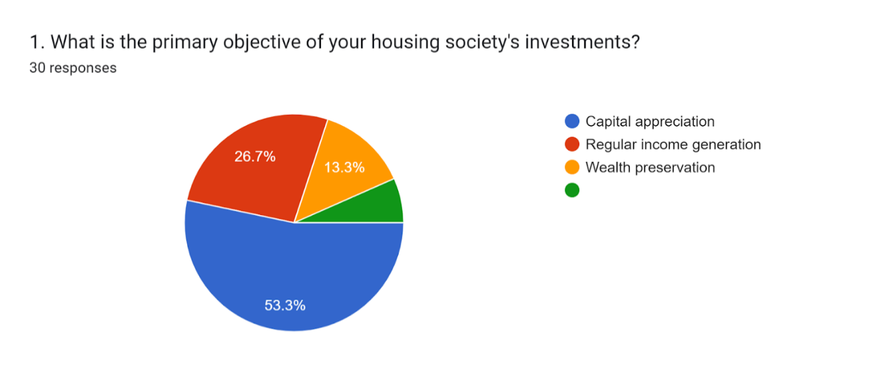

Forms response chart. Question title: 
2. Which investment instruments does your housing society currently utilize?
. Number of responses: 23 responses.

Forms response chart. Question title: 3. What are the primary banking services utilized by your housing society?
. Number of responses: 23 responses.

Forms response chart. Question title: 4. Does your housing society have any plans to diversify its investment portfolio in the near future?
. Number of responses: 22 responses.

Forms response chart. Question title: 5. If yes, which areas is your housing society considering for diversification?
. Number of responses: 23 responses.

Forms response chart. Question title: 6. Would your housing society be interested in financial advisory services to optimize its investment portfolio?
. Number of responses: 23 responses.

Forms response chart. Question title: 
7. Which banking services does your housing society prioritize?. Number of responses: 22 responses.

Forms response chart. Question title: 8.How satisfied is your housing society with the current banking services it receives? 
. Number of responses: 24 responses.

Forms response chart. Question title: 9. Does your housing society actively seek financial advice or consultation regarding its investments?
. Number of responses: 24 responses.

Forms response chart. Question title: 10. In what areas do you think your housing society needs more support from banking institutions?
. Number of responses: 24 responses.