**Master Thesis**

**On**

**“A STUDY ON RURAL BANKING FINANCE”**

**Submitted in Partial Fulfillment of The Requirement**

**For the Award of Degree of**

**MASTER’S OF BUSINESS ADMINISTRATION**

**Under the Guidance of**

**Prof.Dr. Neha Verma**

**Submitted By - Prashant Tripathi**

**Admission No-22GSOB201733**

**MBA-4th**

**ENROLLMENT NO - 22042010677**



**School of Busineess**

**Galgotias University**

Greater Noida ,Uttarpradesh (201310)

**INTRODUCTION**

**1.1 Importance**

Financial market liberalization, advancements in risk management, and reductions in transaction and supervisory expenses have notably benefited agricultural finance institutions. This study aims to build upon these advancements by drawing from recent innovations in developing countries to foster further innovations in rural finance. Focusing on four main areas—warehouse receipts and collateral securitization mechanisms, risk management products, supply chain finance, and technology—the paper explores how innovative approaches can address traditional barriers to providing financial services to agriculture. It discusses how these innovations can mitigate lending risks, reduce costs, or both, thereby enhancing access to agricultural finance. Through diverse case studies and thematic discussions, the study highlights key lessons, particularly regarding the role of government in lowering costs and risks in rural finance. Rural finance encompasses various financial services, including lending, savings, insurance, and remittance services, offered by different entities such as friends, relatives, microfinance programs, or banks in rural areas for both agricultural and non-agricultural purposes. It recognizes the diverse needs of different groups within the rural sector, from savings facilities for certain groups to larger credit requirements for those engaged in cash crop production, spanning production, input, processing, and marketing. Rural finance serves as a crucial tool for the poor, enabling them to safeguard and stabilize their families and livelihoods, not just their businesses. Understanding rural finance sheds light on the survival strategies and priorities of impoverished rural communities. It is particularly vital for the poor, who often allocate a significant portion of their income, sometimes up to 90%, towards food expenses. Any fluctuations in earnings or unexpected health expenses can have immediate and severe repercussions on family well-being unless they can access savings or loans. Hence, financial transactions are deeply integrated into the livelihood systems of the poor.

**REVIEW OF LITERATURE**

These objectives are accomplished through innovations across various institutions, products, services, and processes, aimed at addressing the information, incentive, and contract enforcement challenges hindering financial transactions in rural areas. These innovations thrive in a conducive environment fostered by robust policies and supportive institutions. Given the extensive and diverse nature of rural finance literature, it is impractical to thoroughly explore it within a short timeframe. However, our conceptual framework, literature review, and consultations with experts guided us to focus on 12 key themes. These themes helped us identify significant issues in rural finance and gaps requiring further investigation. The 12 themes are grouped below according to our framework.

**2.1 The Old Rural Finance Paradigm**

The 1960s and 1970s saw a surge in rural credit initiatives worldwide, particularly in Asia and Latin America. These initiatives were based on the recognition of the unique costs and risks associated with rural finance, which discouraged formal financial institutions from extending their services to rural areas. Consequently, a rationale emerged, advocating for government and donor intervention in rural financial markets. Five primary types of interventions were proposed: imposing lending requirements and quotas on banks and other financial institutions, establishing refinance schemes, offering loans at preferential interest rates, providing credit guarantees, and directing lending activities through development finance institutions (DFIs). These rural finance programs aimed to stimulate agricultural development by encouraging increased lending to rural clients and sectors. Measures such as subsidized interest rates and debt forgiveness programs were implemented to alleviate the financial burden on priority-sector borrowers, particularly during times of natural disasters or market downturns. Credit was viewed as a crucial tool for accelerating agricultural progress, boosting exports, supporting small-scale farmers, alleviating poverty, and ensuring affordable food supplies to urban areas. Many governments received backing from multilateral and bilateral donors for these interventions, with funding often directed towards targeted supply projects. This approach yielded positive outcomes for some developing countries. Countries, particularly in Asia, adopted strategies to enhance agricultural productivity in the short run, but these approaches proved costly and unsustainable in the long term, failing to benefit the majority of rural households. Despite some positive outcomes, these initiatives fell short of their goals to increase rural incomes, facilitate asset accumulation, and alleviate rural poverty. Emphasizing lending exclusively for agricultural purposes overlooked the potential advantages of supporting growth-oriented investments more suitable for the rural poor or small-scale off-farm enterprises. Bailouts of state-owned agricultural credit institutions, while costly, hindered the development of private, profit-driven rural financial institutions.

* 1. **OBJECTIVES**
* Investigating the amount of loans disbursed.
* Examining progress in offerings, amenities, technological advancements, and the establishment of microfinance initiatives
* . • The objective of Rural Finance is to deliver banking facilities to India's rural populace. Analyzing the most favored types of bank accounts in rural regions
* . • Scrutinizing Savings and Credit Cooperative Organizations (SACCOs).
  1. **SCOPE**
* This research focuses on rural banking finance.
* A total of 56 samples have been targeted for the study, specifically gathered for rural banking finance.
* The study incorporates both primary and secondary data sources**.**
* **Methods of Research:**

This study employed a quantitative research approach using Google Forms to administer a structured survey. Convenience and snowball sampling techniques were utilized to recruit participants from rural areas. The survey questionnaire was designed to collect data on rural banking finance and financial inclusion. Ethical considerations included obtaining informed consent and ensuring data confidentiality. Overall, Google Forms facilitated efficient data collection from a diverse rural population, contributing to the study's objectives.

**ANALYSIS AND INTERPRETATIONS**

Occupation

**Source: Primary Data**

Graph No 3.1

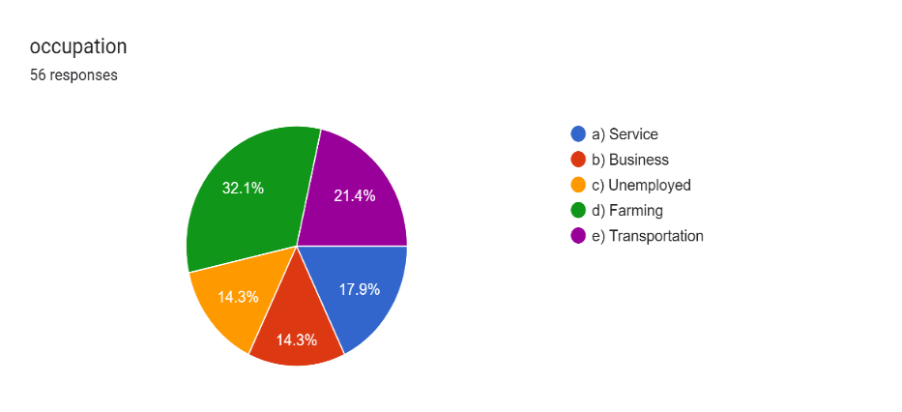

**Source: Primary Data**

Forms response chart. Question title:  

 Specify the age group to take finance. Number of responses: 56 responses.

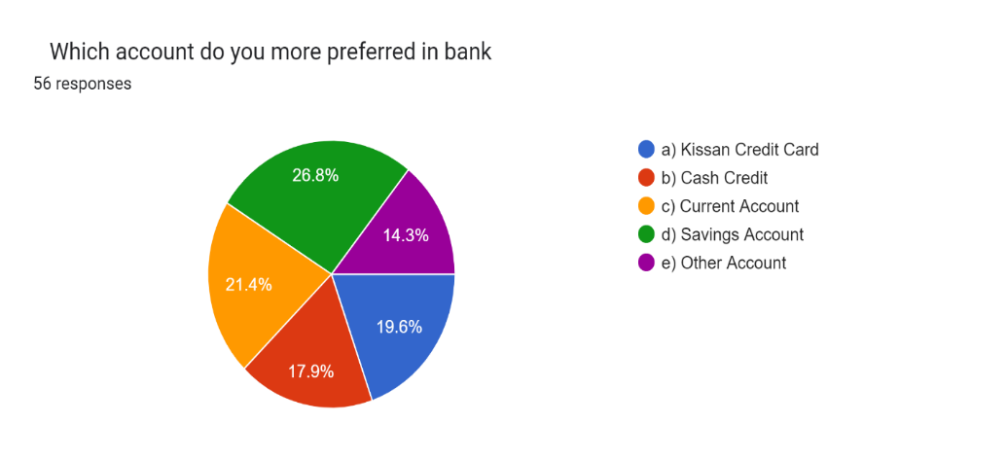

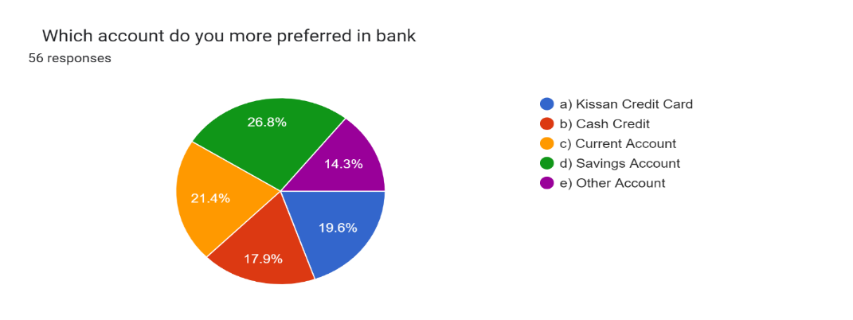

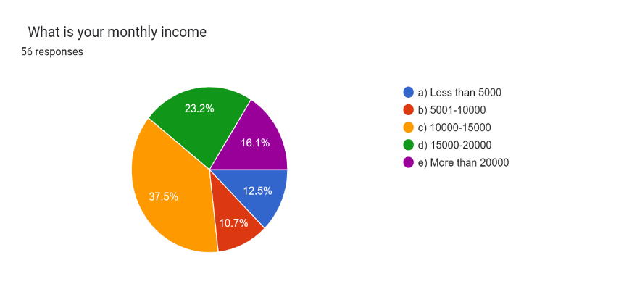

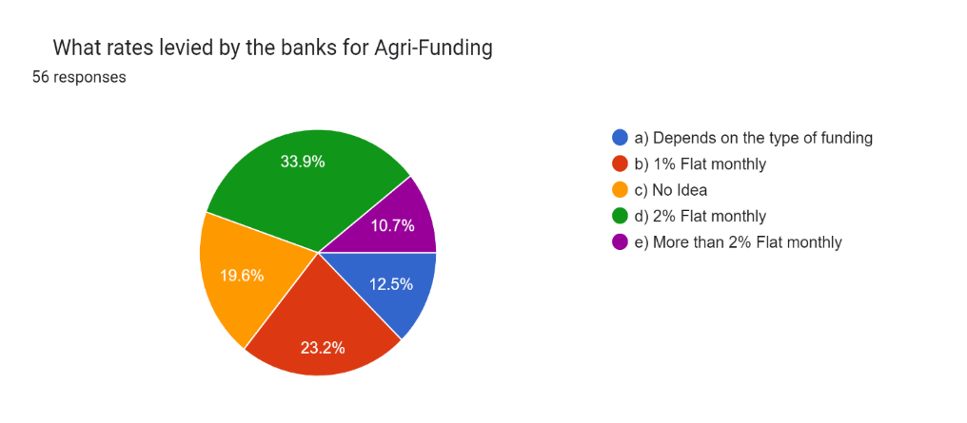

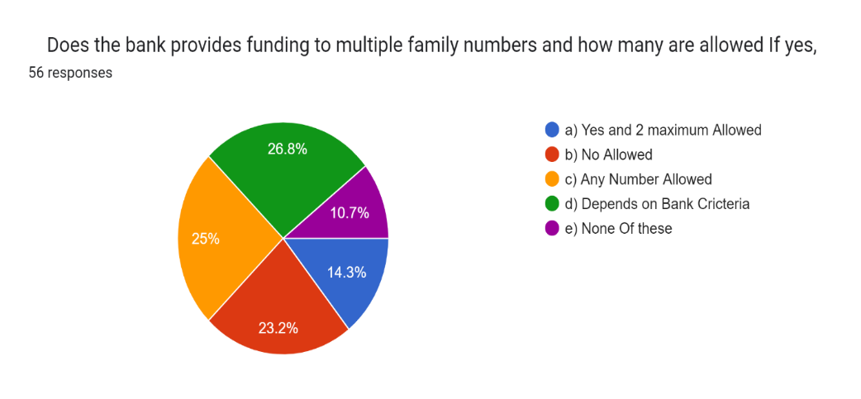Forms response chart. Question title:  

   On an average how many days does it take to grant loan. Number of responses: 56 responses.

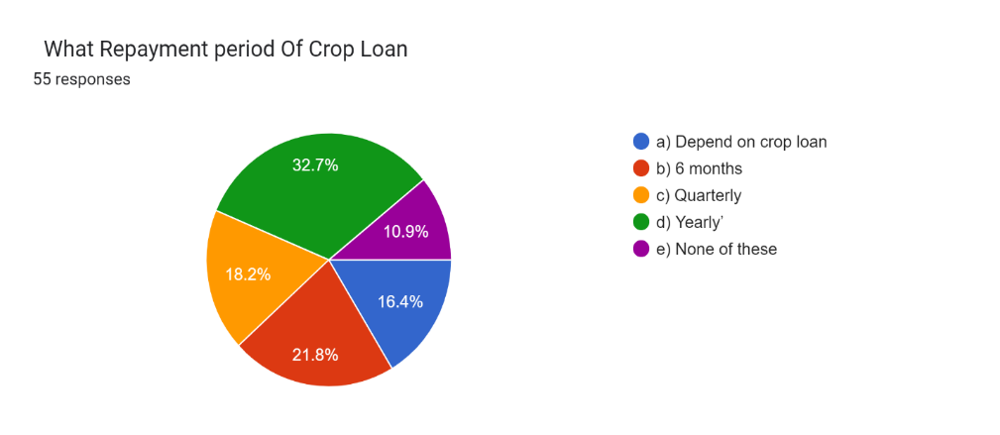

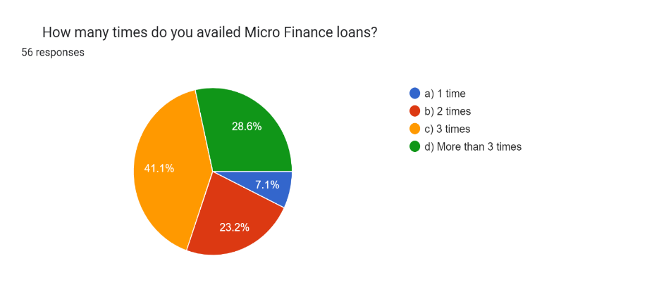

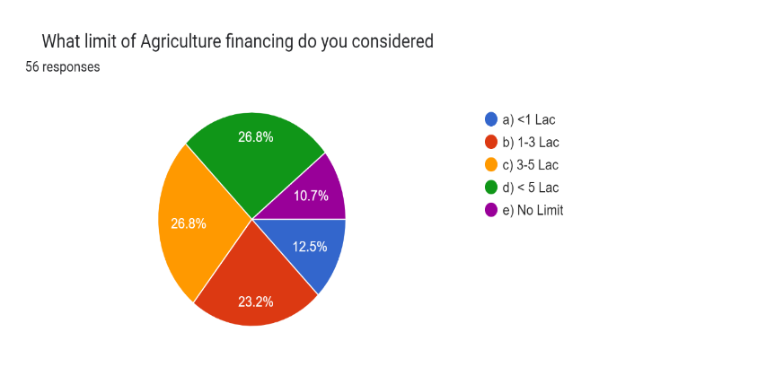

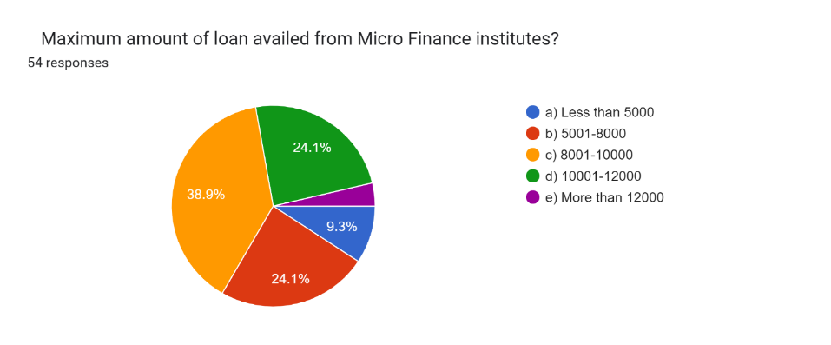

**FINDINGS AND SUGGESTIONS**

**4.1 FINDINGS:**

1. Limited access to formal banking services in rural areas.
2. Reliance on informal financial mechanisms such as savings groups and moneylenders.
3. Lack of physical banking infrastructure like branches and ATMs in rural regions.
4. Challenges in agricultural finance due to seasonal nature and lack of collateral.
5. Significant role of Microfinance Institutions (MFIs) in rural financial inclusion.
6. Potential impact of digital financial services on improving rural access.
7. Influence of government policies and interventions on rural banking finance.
8. Importance of financial literacy and education for rural communities.

**4.2 SUGGESTION**

Interest rates must be different for different categories. It should be concessional rate for small and marginal farmers.

1. Clearly define research objectives.
2. Determine geographic focus.
3. Engage with stakeholders.
4. Use mixed research methods.
5. Ensure representative sample selection.

**Conclusion**

In conclusion, this study on rural banking finance has provided valuable insights into the current status, challenges, and opportunities in promoting financial inclusion in rural areas. Through a mixed-methods approach incorporating both primary data collected via Google Forms surveys and secondary data from existing literature, several key findings have emerged.

Firstly, the study revealed that while there has been progress in expanding access to banking services in rural areas, significant challenges persist, including limited physical infrastructure, low financial literacy levels, and inadequate outreach by financial institutions. These challenges contribute to the exclusion of many rural residents from formal financial services, hindering their economic empowerment and development.

**BIBLIOGRAPHY**

**B.1 BOOKS**

**i) Micro Finance Thomas Fisher and M.S. Sriram**

**ii) Rural banking and Agriculture finance Durgadas Roy**

**iii) Micro Finance and India’s Rural Economy Sudhansu Kumar Das**

**iv) Agriculture Financing In India S.N. Ghosal**

**B.2 JOURNALS**

**i) Indian Journal Of Finance**

**ii) Vikalpa IIM, Ahmadabad**

**iii) Management Review, IIM, Bangalore**

**iv) State bank of India Journals**

**B.3 WEB SITES**

**1)** [**www.**](http://www.)**adb.org**

**ii)** [**www.mofpi.nic.in**](http://www.mofpi.nic.in)

**iii) www.rural finance.com.au**

**iv) www.ruralbank.com.au**