**Analysis for Effect of Slight Pitch Difference on the Fatigue Life of Bolt**

**Mr.Shivsharan Vikas Haridas.1 Dr. Keste A.A.2, Prof.Kathale S.S.3**

1PG Student, Department of Mechanical Engineering, DGOI,FOE, Swami Chincholi,Bhigwan, Maharashtra

2Principal, DGOI,FOE, Swami Chincholi,Bhigwan, Maharashtra

3HOD, Department of Mechanical Engineering, DCOER, Bhigwan, Maharashtra

**ABSTRACT**

This study examines fatigue failure in bolt-nut connections when a small pitch variation is introduced between the bolt and nut. To enhance fatigue resistance, three types of slight pitch variations are applied to the specimens, and the results are analyzed using FEM (Finite Element Method) analysis. Comparing with the standard bolt and nut connection with zero pitch difference (α = 0 μm), it's found that introducing a slight pitch difference of α = 5 μm or α = 15 μm prevents bolt fractures at the No. 1 thread. Additionally, it's observed that the fatigue life of the bolt can be prolonged by incorporating these slight pitch differences. This study highlights the impact of slight pitch differences in bolt-nut connections on fatigue failure.

**Keywords:** fatigue failure, bolt-nut connections, pitch difference, specimens, FEM analysis

1. **INTRODUCTION**

Bolt and nut connections are a ubiquitous feature in mechanical systems. Typically, these connections offer several advantages: they facilitate easy assembly and disassembly, allow for precise adjustment, and can securely fasten thick components. Due to these benefits, they find extensive use in various machines and structures, including machine tools, transportation equipment, and bridges. However, despite their utility, bolt-nut connections are susceptible to fatigue failure, particularly under repeated loading conditions, which can lead to premature failure. Several factors, such as the root radius, thread pitch, material composition, and thread angle, can significantly influence the performance and lifespan of bolts. Bolts and nuts come in various types, including fine and coarse threads.

One crucial question is determining the optimal thread pitch to maximize fatigue life and load-carrying capacity for standard steel bolts with standard nut dimensions. This choice is essential as other parameters, such as fillet radius and thread depth, are directly related to the pitch. Fatigue failure in bolts is a significant concern and can result in severe accidents, as illustrated by the failure of a large bolt (known as a tie rod) in Japan in 1975. In this case, the failure was attributed to fatigue-induced crack initiation at the thread root, leading to propagation and eventual failure. Uneven load distribution among the threads exacerbates this issue, with the first loaded thread bearing more stress than the subsequent ones, resulting in high stress concentrations at the thread roots.

* 1. **Problem Statement**

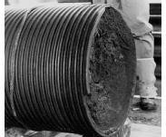

Figure : Failure of Bolt

Currently fatigue failure in bolt is observed due to effect of pitch difference in nut and bolt connection. Find the solution to increase the fatigue life of bolt to avoid the crack in first engagement of thread by using suitable pitch difference.

* 1. **Objectives**

This study systematically explores how varying the pitch of bolts affects fatigue life improvement. The primary aim of this seminar is to devise a bolt-nut connection that enhances fatigue strength without inflating costs. The specific objectives include:

1. Utilizing Finite Element Analysis to examine how pitch differences impact the stress distribution across bolt threads.
2. Identifying pitch variations conducive to extending fatigue life.
   1. **Effect of Contact between Bolt and Nut on Stress Value**

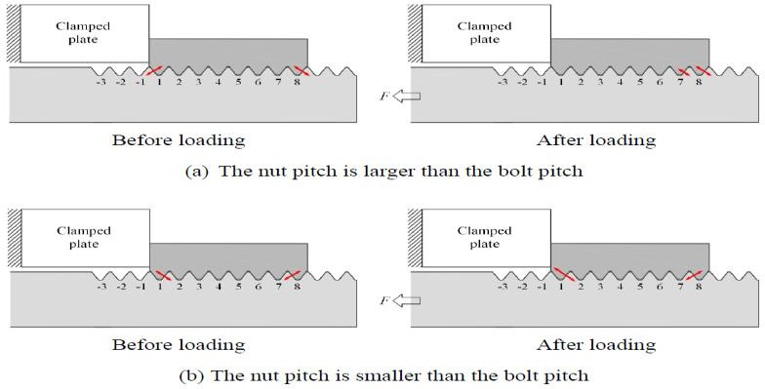

Figure : Contact between bolt and nut before and after the loading

If the nut's thread pitch exceeds that of the bolt, there's initial contact on the left side of thread No.1 prior to loading, but this contact shifts to no contact after loading, as depicted in the figure. This absence of contact implies that crack failure doesn't occur on thread No.1 compared to a standard Nut and Bolt Connection. Conversely, if the nut's pitch is smaller than the bolt's, there's consistent contact on the right side of thread No.1 both before and after loading. To reduce the maximum stress concentration at thread No.1 of the bolt, increasing the nut pitch is the only solution.

1. **Literature Review**

A review of literature pertaining to the analysis of bolts to determine their fatigue life, in the context of the present study, is provided and referenced. Nao-Aki et al. discuss the impact of slight variations in pitch difference between bolts and nuts on fatigue failure. They conducted fatigue testing using three different pitch differences at varied stress amplitudes and observed that considering certain pitch differences can increase the fatigue life of bolts. They elaborate on the criteria for fatigue failure concerning pitch difference variations and underscore the significance of this factor in influencing fatigue limits.

Nao-Aki et.al introduces that pitch difference having slight variation between a bolt and nut is affecting on fatigue failure. Fatigue testing is done using three pitch differences by varied stress amplitudes. It is found that the life of fatigue for the bolt can be increase while some pitch difference is taken in the account. Here the criteria for fatigue failure are discussed in terms of variation of pitch difference. They also showed that how importance of pitch difference affecting fatigue limits. They show that the fatigue life can be increase while some pitch difference is considered.

Dragoni found that slight pitch on the fatigue value of strength of ISO steel bolts which are used for analysis. It can have studied boundary element analysis and cross- comparison with theory and photo elasticity, the load capacity of the bolt is ultimately related to a comprehensive stress concentration dependencies. In the work of plotting the function of nominal diameter verses the thread pitch of bolt for the steel bolts. It concludes endurance phenomenon for load lightly increases if the value of pitch is decreased for small diameter bolts of low value of grade steel. Conversely, the value of endurance load increases with the pitch large bolts of high value of grade steel.

Chen et.al has focused on fatigue failure, for bolt and nut connections, while pitch difference is introduced between the connection of bolt and nut. For improvement the fatigue life, there are three types of pitch difference are produced on the specimens which are compared with experimental results and discussed in terms of FEM analysis.The analysis results shows that it can improve the fatigue life of bolt.

Wahabb et.al introduces the slight pitch difference between the bolt and nut engagement in order to study its effect on the fatigue performance. They considered that the pitch of nut was some microns greater than the pitch of the bolt. Fatigue experiment was done for three types of specimens with different measurement of pitch differences. The plot of S-N curves for the fatigue life shows that it was extended by 1.5 times which compare with the standard connection.

On the work done by them to increase the fatigue life of nut and bolt is considered by having pitch differences.

Sano et.al focused on the work done by them to increase the fatigue life of nut and bolt, they can varies the some pitch differences. They also discussed the loosening experiment and relation between the prevailing torque and clamping force.

Chae-Ho Lee shows, reduction mechanism of the stress concentration in bolt-nut connectors was investigated by performing shape optimization using finite element method implementing PQRSM- Progressive Quadratic Response Surface Modeling and the GSM- growth-strain method. The reduction mechanism for stress concentration is achieved by these methods. It was found that stress concentration can be reduced by uniformly over the entire threads as far as possible.

Majzoobi found the stress, various factor of stress concentration in the bolt and fatigue strength / endurance limit by analytically and correlate with the experimentally. They compared results standard of ISO having coarse threaded bolts and with the comparatively fine dimension threaded bolts. Which shows have coarse thread are preferred. Here the reason for preferring coarse thread is that the value of pitch difference is more compare to fine threads. The condition of loading is same for both type of coarse and also fine threads. For the comparison which is made on the basis of parameter of core diameter. The conclusion that for the same stress, which the fatigue life for both ISO as well as unified bolts, for 100 unified bolts, comes low as the nominal bolt diameter increases within the range tested.

Shin-ichi Nishida et.al introduces new method for improve the fatigue strength value of bolts is developed. The new method CD for fracture stands for "Critical Design for Fracture". Improved profile of thread greatly minimizes the peak stresses. The new profile doubles the fatigue strength of bolts as compared to conventional profiles. For both the pre-stressed and non-pre-stressed conditions has improved strength.

D. G. Sopwith et. al stated that for improving the load distribution, discussed differential tapered threads, pitch, and the use of a soft material for nut. Distribution of load along the length of a nut isn’t uniform owing to the strains set up in the bolt and nut under load. In the ordinary bolt and nut case the maximum intensity of loading happens at the bearing face of the nut, and may be from two or more extents the mean, depending on the thread form, the proportions of the members, and the degree of lubrication; the maximum intensity is nearly independent of the length of nut (expect yielding happens). These strains are analysed and the load distribution across the thread helix reduced lowered.

E.A. Patterson et. al introduces Modifying Sopwith’s theory for the load distribution along the threads of a nut and bolt by incorporating modelling of the thread runout in the nut, and by the use of finite element analysis to determine the deflection factor for the thread. Then, it is observe that the stress reduction is noticeable, that the height of bolt threads is reduced near the bolt head and the nut is closer to the bolt head. The outcome of this theory compare with from three-dimensional photoelastic analyses of the loads in the threads of two bolts fitted with conventional nuts.

A. Chhaban et. al investigate the stress field in threaded closures of thick wall in high pressure vessels with the help of the finite element method. A set of elastic analyses of vessels with 5, 8, 11, 15, 20 and 25 standard Buttress threads was used for predicting distribution of load along length of the thread. The index factors for root stress in the region of the first three threads are introduced. The result of this work is to the development in new division of the ASME Pressure Vessel Code for thick walled high pressure vessels.

Jien-Jong Chen et. al. stated distribution of load on every thread in axisymmetric model and three-dimensional model are provided. In the observation of three-dimensional finite element analysis of bolt joint with sliding contact has studied, the friction effect on load distribution of each thread is analyzed. It shows the analytical method by Yamamoto’s method produces a minimum value of load ratio than the numerical method (FE analysis) at the first thread. Hence, increasing the frictional coefficient and decreasing the lead angle may increase the load distribution slightly, for 1-inch in 16 UNF bolt joints, the 12 % error of load ratio at the first thread in axisymmetric finite element model with respect to three-dimensional analysis.

Noda, N. A., said in study, the bolted joints with tapered threads are analyzed with the finite element method, and stress reduction effect of CD bolts is observed with different geometrical conditions. The reduction of the stress concentration is observed by tapering threads. Then, found that the reduction of stress is in view when the height of threads is lower significantly near head of bolt and the nut is closer to bolt head. It is found that the maximum stress reduced by 20% with compared to the cases of standard connection of bolts and nuts

1. **Experimental Setup**

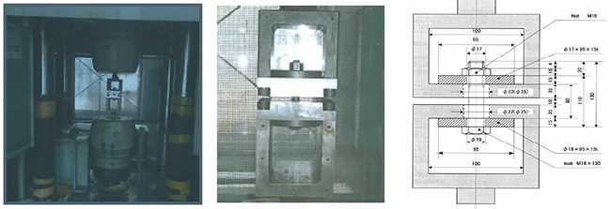

Figure 3: Fatigue experimental device

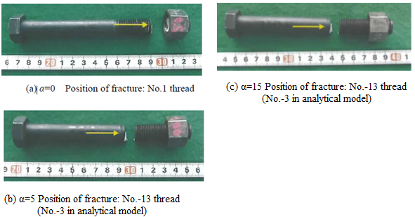

Figure 4: Fractured specimens

1. **Finite Element Analysis**

The stress at the bolt threads resulting from variations in pitch was investigated by conducting elastic and plastic finite element analyses using ANSYS Workbench. The analyses were carried out for pitch differences of α = 0 micron, α = 5 micron, and α = 15 micron, with a model including standard M20 bolt and nut bodies in contact.

* + 1. **Material Properties**

For this work the material is chosen as mild steel.

The Material Properties for mild steel are as follows: Density – 7.8 x 10-6 Kg/mm3

Young’s Modulus – 210 GPa Poisson’s Ratio – 0.3

Yield Strength – 640 MPa Ultimate Strength – 800 MPa

* + 1. **Geometry of Bolt and Nut Thread**

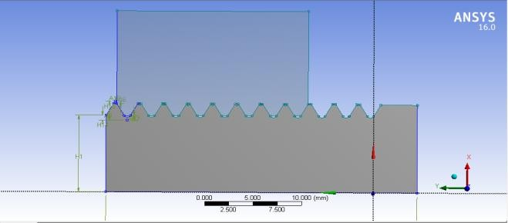

Figure : Create the 2D element and add material

Initially, create a geometric outline of the typical M20 × 2.5 mm bolt based on the measurements provided in figure within the design modeler of ANSYS Workbench, depicted in figure. As an axisymmetric model is utilized for the two-dimensional analysis, transform the sketches into 2D surfaces, representing both the nut and bolt. This conversion is carried out to facilitate meshing the model using 2D elements.

* + 1. **Meshing**

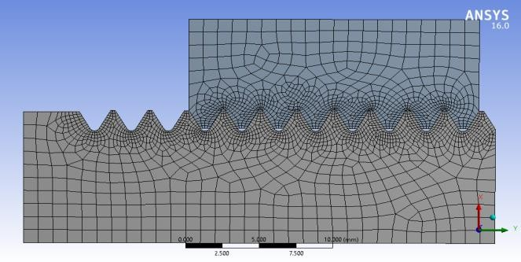

Figure : Meshing

To achieve precise outcomes at a specific point, a mesh is generated starting from the base of the bolt thread, with dimensions of 0.01 mm × 0.01 mm. Four-noded linear quad elements are then applied on the surface, utilizing an axisymmetric solid element, as illustrated in the figure.

* + 1. **Standard Boundary Condition**

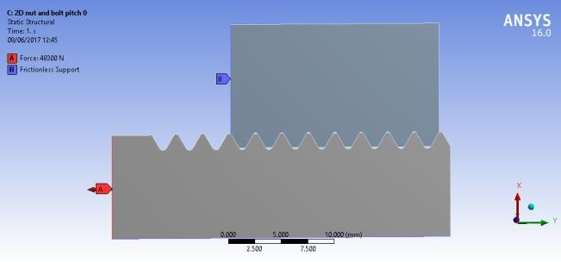

Figure : Boundary Conditions

During the tightening procedure, the gradual pitch variance leads to an axial force exerted between the threads of the bolt and the nut. In this simulation, frictionless support is applied to the inner part of the nut and the bottom part of the bolt, while the initial tension force applied to the bolt ranges from 30 to 18.3 kilonewtons, as illustrated.

1. **Result and Discussion**
   1. **Maximum Principal Stress**

An Ansys Workbench analysis was conducted on an axisymmetric nut and bolt model, adhering to specified boundary conditions, to determine the maximum principal stress at α values of 0 µm, 5 µm, and 15 µm. The resulting contour plots are depicted in figures.

|  |  |
| --- | --- |
| Description: C:\Users\Umesh\Desktop\seminor result images\16.PNG  Figure 8: For Model when α=0µm | Description: E:\ME\PROJECT\Project Stage 2\Results for 5 micron pitch difference\Max.PNG  Figure 9: For Model when α=5µm |

* 1. **Minimum Principal Stress**

|  |  |  |
| --- | --- | --- |
| Description: C:\Users\Umesh\Desktop\seminor result images\17.PNG  Figure 10: For model when α=0µm | Description: E:\ME\PROJECT\Project Stage 2\Results for 5 micron pitch difference\Min.PNG  Figure 11: For model when α=5µm | Min15  Figure 12: For model when α=15µm |

Additionally, a symmetrical model of a nut and bolt was examined using the specified boundary conditions in Ansys Workbench to determine the minimum principal stress at α values of 0 µm, 5 µm, and 15 µm. The contour plots depicting these analyses are illustrated in the figure.

|  |  |  |
| --- | --- | --- |
| Figure 13: Location of maximum and minimum load stress at each thread for model when α=0µm | E:\ME\PROJECT\Project Stage 2\Results\5 micron\5.PNG  Figure 14: Location of maximum and minimum load stress at each thread for model when α=5µm | E:\ME\PROJECT\Project Stage 2\Results\15 micron\1.PNG  Figure 15: Location of maximum and minimum load stress at each thread for model when α=15µm |

* 1. **Investigate the Result by Stress Concentration**

The stress concentration is most pronounced at No. 1 due to the final crack occurring there. This concentration can be lessened at threads No.-3 to No.-1 where there is no contact. Threads like No. 7 or No. 8 may experience crack propagation, but it doesn't necessarily lead to complete fracture since other threads bear the load. However, in this work, we focus on the stress concentration at No. 1 because preventing fracture there helps control the overall fracture.

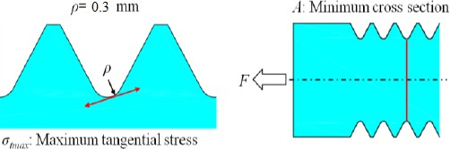

Figure : Tangential and normal stress for value of Kt.

|  |  |  |
| --- | --- | --- |
| Figure 17: Stress Concentration Factor ά=0µm | Figure 18: Stress Concentration Factor ά=5µm | Figure 19: Stress Concentration Factor ά=15µm |

The Kt of each bolt root is indicated in Above Figure and shows the comparison of the stress concentration factors Kt for α=0 μm, α=5 μm and α=15 μm under the same load of F=30 KN. It is found that when α=5μm is introduced; the stress concentration at root No. 1 reduces significantly. However, the stress concentration at roots No. 7 and No. 8 increases largely when α=15 μm. Figure 16, 17, 18 and 19 shows the stress concentration factors of each bolt root under different loads for α=0 μm, α=5 μm and α=15 μm. For the standard bolt-nut connection, with increasing the load, the stress concentration factor Kt at each root does not change. In the case of α=5 μm and α=15 μm, however, with increasing the load the stress concentration Kt at No. 8 decreases sharply.

* 1. **Mean Stress and Stress Amplitude for Root of Bolt Thread**

The maximum stress of each thread under the maximum load, denoted as σmax, occurs when the load is at its peak, F=30+18.3 kN, while the maximum stress under the minimum load, denoted as σmin, happens when the load is at its lowest, F=30-18.3 kN. In the bolt-nut connection scenario with α=0, it's observed in Figure that thread No. 1 bears the highest stress amplitude. However, when α=5 μm both the stress amplitude and mean stress for thread No. 1 decrease notably. This reduction indicates an improvement in load distribution among the bolt threads compared to the α=0 μm condition, as the disparity among threads lessens. Moving to α=15 μm threads No. 7 and No. 8 exhibit significant stress concentrations instead of thread No. 1. As depicted in Figure 10, when the pitch difference is considerable, threads No. 7 and No. 8 pose greater risk than thread No. 1, although fracture occurrences on threads No. 7 and No. 8 do not necessarily lead to the bolt's final fracture. This outcome suggests that other threads may bear and distribute the load, mitigating the risk associated with individual thread failures.

|  |  |  |
| --- | --- | --- |
| Figure 20: Stress Amplitude Vs Mean Stress for α=0µm | E:\ME\PROJECT\Project Stage 2\Results for 5 micron pitch difference\6.PNG  Figure 21: Stress Amplitude Vs Mean Stress for α=5µm | E:\ME\PROJECT\Project Stage 2\Results for 15 micron\3.PNG  Figure 22: Stress Amplitude Vs Mean Stress for α=15µm |

1. **CONCLUSION**

This study utilized Finite Element Method (FEM) analysis to examine bolt-nut connections with slight variations in pitch. Three specimens were analyzed, revealing stress distributions across the bolt's root threads. Findings indicate the following: In a standard connection (α=0 μm), fatigue fracture occurs at the first thread. However, with a pitch difference of α=5 μm, stress at the first thread is lower compared to α=0 μm. Moreover, at α=15 μm, maximum stress shifts to the eighth thread. Notably, at this pitch difference, stress concentrates at the seventh and eighth threads, though this doesn't necessarily lead to bolt failure. These results suggest that adjusting the pitch difference can reduce stress amplitude and average stress at the first root thread of the bolt.

1. **REFERENCES**
2. Nao-Aki Noda, Xin Chen, Yoshikazu Sano, Magd Abdel Wahab, Hikaru Maruyama, Ryota Fujisawa, Yasushi Takase, “Effect of pitch difference between the bolt–nut connections upon the anti-loosening performance and fatigue life”, Materials and Design, Volume 96, Pages 476-489, April 2016. https://doi.org/10.1016/j.matdes.2016.01.128
3. E Dragoni, “Effect of thread pitch on the fatigue strength of steel bolts” Proceedings of the Institution of Mechanical Engineers, Part C: Journal of Mechanical Engineering Science, Volume: 211 issue: 8, pp. 591- 600, August 1997. https://doi.org/10.1243/0954406981521970
4. Xin Chen, Nao-Aki Noda, Magd Abdel Wahab, Yu- Ichiro Akaishi, Yoshikazu Sano, Yasushi Takase, Gusztáv Fekete, “Fatigue Failure Analysis for Bolt- Nut Connections having Slight Pitch Differences using Experimental and Finite Element Methods”, Acta Polytechnica Hungarica, Vol. 12, No. 8, 2015. http://hdl.handle.net/1854/LU-7007869
5. Nao-Aki Noda, Yoshikazu Sano Xin Chen, Magd Abdel Wahab, Hikaru Maruyama, “Effect of pitch difference between the bolt and nut connections upon the anti-loosening performance and fatigue life” Materials & Design, Volume 96, April 2016, Pages 476-489. https://doi.org/10.1016/j.matdes.2016.01.128
6. Xin Chen, Nao-Aki Noda, Yu-Ichiro Akaishi, Yoshikazu Sano, “Effect of Pitch Difference on Anti- loosening Performance and fatigue strength for high Strength Bolts and Nuts”, 13th International Conference on Fracture, Beijing, China, June 16–21, 2013.
7. G.H. Majzoobi, G.H. Farrahi, N. Habibi, “Experimental evaluation of the effect of thread pitch on fatigue life of bolts”, International Journal of Fatigue, Volume 27, Issue 2, Pages 189-196, February 2005. https://doi.org/10.1016/j.ijfatigue.2004.06.011
8. Chae-Ho Lee, Beom-Jun Kim, and Seog Young Han, Mechanism for Reducing Stress Concentrations in Bolt and Nut Connectors”, International Journal Of Precision Engineering And Manufacturing, volume 15, No. 7, no. 7, pp. 1337-1343, 2014. https://doi.org/10.1007/s12541-014-0474-y