# Chapter 1 : INTRODUCTION

## Background of Study

* 1. COVID-19 is one of most serious crises in modern history, and it came as a shock to medical professionals, governments, businesses, and individuals all across the world. Many countries and politicians were adopting bold and strict measures to stop the virus from spreading further and causing the healthcare system to collapse. Many businesses and industries are experiencing major problems as a result of people being forced to stay at home and practice social distance. The spread of digital technologies and the internet, on the other hand, allows humans to connect and communicate and businesses to interact with their consumers despite being physically separated. With the advancement of technology, brands and merchants may continue to sell their products to customers and conduct at least some of their company operations. Businesses who approach this challenging time of building a strong digital presence with a long-term strategy will have a much better chance of thriving in the post-COVID-19 era.
  2. The reason why I selected online book store web services is because everyone must exercise social distancing, which requires spending the most of the day at home. The objective of this project is to develop an e-book store where people may buy books from the comfort of their own homes. A virtual book store on the internet where customers can browse the catalogue and select books of interest is known as an online book store. A shopping cart can be used to collect the selected books. The items in the shopping cart will be displayed as an order at the moment of checkout. More information will be required at that time to complete the transaction. The customer will generally be required to fill out or select a billing address, a shipping address, a shipment option, and payment information such as a debit or credit card number. As soon as the order is placed, the customer receives an email notification.

## 9 1.2 Problem Statement

Companies all over the world are being impacted by the Covid-19 pandemic. Some of the world's largest corporations experienced unfavorable consequences, such as empty stores due to a lack of customers. The COVID-19 epidemic, on the other hand, has encouraged the growth of the online shopping convenience movement. Starting with an easy-to-use website, businesses may make it simple for customers to conduct research, compare alternatives and specifications, and do anything else relevant online.

This project aims to develop an online shopping for customers with the goal so that it is very easy to shop loved things from an extensive number of online shopping sites available on the web. The customer simply requires a PC or a laptop and one important payment sending option to shop online. To get to this online shopping system, all the customers will need to have an email and password to login and proceed to their shopping. Upon successful login, the customer can purchase a wide range of books. The customer will pick their favorite books from the online book store sites. They do not need to go physical shops, instead just need a computer and a payment making options like net banking, credit card or debit card. If an order has not yet been shipped out to the customer, the customer may cancel it. The system cancels the order with the publishers or returns the books to them in the occurrence of a cancellation. A book can also be returned within a week. The payments will be credited to the customer's debit or credit card, depending on their preference.

## Objective

* + 1. **Main Objective**

An online bookstore software project that serves as a central database for all of the books in stock, as well as their title, author, and price. The goal of this project is to create a website that serves as a central book store. This website was built with php on the front end and SQL on the back end. Various book-related details are stored in the SQL database. A user visiting the website will find a wide selection of books organized by category. The user can choose a book and see its price. The user can even utilize the website to look for certain books. After the user chooses a book, he/she must fill out a form before the book is booked for the user.

Customers may shop for books online using a web browser thanks to the Online Book Store Project. A customer can create an account, log in, sort books by category, add books to a shopping basket, and pay their bill using their credit card information. When compared to a regular user, the Administrator will have more options. He can edit the author, publisher, book categories, book details, and member information, as well as confirm an order.

The following are the three main components of the software:

1. Implementation of a new user registration and login process.
2. Allow the user to select any book.
3. Allow the user to purchase books.

## Specific Objectives

* + - * To design an online book store management system.
      * To analyze the problems in the existing system.
      * To analyze the possible requirements for the new system.

## Purpose and Scope of Study

* + 1. **Purpose**

The purpose of an online shopping system would be to achieve the following goals:

* + - * Create a web user interface for adding, viewing, and deleting records in different areas.
      * Create a user interface for inputting computer details.
      * Provide a user interface for changing computer and accessory details.
      * Provide a user interface that allows users to browse the store and select things to purchase.

## Scope

The main scope deliverables of the project would be to:

* + - * Analyze and develop detailed specifications and requirements
      * Prepare high-level and detailed system design specifications
      * Prepare a test plan as well as test cases.
      * Develop the system and write the code.
      * Unit, integration, and system testing should all be performed.

• Demonstrate a bug-free application after making any necessary changes

# Chapter 2 : Literature Review

## 2.1 Literature Review

When we use Google to search for educational websites and applications, we will find a lot of options. However, there is some ambiguity in selecting suitable content at the proper time. Some websites have been developed that contain stories, novels, essays, and other types of content. Electronic Commerce (e-commerce) applications allow multiple parties involved in a commerce transaction to connect in order to shop for new, secondhand, rare, and out-of- print books. Review of literature for an online bookstore. The prototype serves as a roadmap for establishing a solid Online Book Ordering System based on user feedback, notably from the perspective of academics, which will be handled by the university's book store. The arranging, however, is still done manually.

According to a software development firm, an e-catalogue delivers vital information about product specifications to potential customers. It makes it easier for potential customers to find the items they want in the format they want. It is the ideal and ideal product catalogue because it does not require printing, has no number or color restrictions, and does not require distribution. The system is described as self-updatable in a few simple clicks, with the content in the e-catalogue always being accurate and, best of all, requiring no reprinting. Furthermore, the e-catalogue promotes the products on its own, with greater interactivity, consumer personalization, and even a shopping cart for inquiries.

MPHOnline, BookDepository, and Amazon are few of the most popular online shopping sites that employ an e-catalogue to display their products. The website lists the many types of books that are available. The book cover can be found on the left side of the main frame, as well as the book 13 description, which includes information such as the title, author, price, and number of volumes left to be sold, as well as customer ratings



## Strength

Within 3 to 5 business days, the customers can anticipate their orders to arrive. The website also sells stationery, office products, toys, and games in addition to books. You can search for a book by title, author, ISBN, or publisher using the prominent search bar at the top of the website.

## Weakness

Shipment to West Malaysia is free for non-members and RM80 for members on orders above RM120. The company charges RM7 per shipment for orders that are less than the specified amount. Free shipping is provided for orders over RM120 for non-members and RM80 for members in East Malaysia. Orders over a certain amount apply for free shipping and no additional handling fees. The company charges RM12 each shipment for orders under the stipulated amount, plus an extra RM3 handling cost per book (both members and non-members



Many Malaysians are unaware of Book Depository, an online book retailer that is a hidden gem. This online book store is situated in the United Kingdom, but it ships worldwide, including to Malaysia. Even better, the site provides free international shipping.

## Strength

The Book Depository is a true find. This online book store is situated in the United Kingdom, but it ships worldwide for free. They have over 19 million titles available for sale at cheap costs.

Keywords, best sellers, 'quick movers,' 'book of the week,' and other search options are available on the website. It's a great place to browse for those hard-to-find books while still saving money on shipping.

## Weakness

The main disadvantage of purchasing books from this website is that delivery can be slow. Regardless of whether the book is shipped from their UK or Australia center, it can take anywhere from 7 to 14 days (often up to 3 weeks) for an order to arrive in Malay



Amazon.com is the world's most well-known online bookshop, and it is the website that launched the online buying revolution. On Amazon.com, the customers may find almost any book in almost any edition. The best part is that they deliver to Malaysia.

## Strength

The website is clean and straightforward, with a large search bar at the top that makes discovering books a breeze. There are several subcategories, and books are classified by department, format, author, promotions, prizes, languages, and other factors. Amazon.com also has a much larger selection of books in several languages than any of the other online bookstores listed here. There are also audiobooks and magazines available.

Amazon.com also sells e-books in the Kindle format, which the user can read on their Kindle device. Most other Malaysian online booksellers do not sell e-books in this format. Unfortunately, Amazon does not sell Kindles or e-books to Malaysians directly.

The user rating and book description part of Amazon.com is one of the best features, since it allows the user to make an informed decision before purchasing a book. The site also proposes 16 books depending on the user's browsing habits, which can be very helpful and intuitive at times. Another important feature is a list of alternatives for whether the user wants a brand new, preloved (with lower costs mentioned), or Kindle version of the book.

## Weakness

Amazon's shipping rates are unfortunately rather high, with ordinary shipments costing $4.99 (RM20) per shipment and $4.99 (RM20) per item for book purchases. The cost of shipping might easily exceed $29.99 (RM 125) each shipment. Priority courier delivery, as well as large and bulky shipments, can be rather costly. There are some items, however, that are eligible for free shipping with Amazon if the customers spend $25 (RM100) or more.

# Chapter 3 : Proposed Work

Creating an online bookstore involves several key steps. Below is a proposed outline for the work involved in establishing and running an online book store:

## Market Research:

* + Identify your target audience and their reading preferences.
  + Analyze the competition and identify unique selling points for your bookstore.
  + Research trends in the book industry and e-commerce.

## Business Plan:

* + Define your business model, including revenue streams, pricing strategy, and sales channels.
  + Outline a marketing and promotion plan to attract customers.
  + Develop a budget for startup and ongoing operational costs.

## Legal Considerations:

* + Register your business and choose a suitable business structure.
  + Ensure compliance with local and international e-commerce regulations.
  + Consider trademarking your bookstore's name and logo.

## Website Development:

* + Choose a reliable e-commerce platform for your bookstore.
  + Design an intuitive and visually appealing website.
  + Implement secure payment gateways and SSL certificates for data protection.

## Book Inventory:

* + Establish relationships with publishers, distributors, and wholesalers.
  + Curate a diverse and appealing inventory of books across genres.
  + Consider offering both physical books and digital formats (e-books and audiobooks).

## Logistics and Fulfillment:

* + Set up a reliable system for inventory management.
  + Establish partnerships with shipping and logistics providers.
  + Implement a smooth order fulfillment process.

## Customer Experience:

* + Prioritize user experience on your website for easy navigation.
  + Provide detailed book descriptions, reviews, and recommendations.
  + Implement customer support channels for inquiries and assistance.

## Marketing and Promotion:

* + Develop a comprehensive marketing strategy, including social media, email, and content marketing.
  + Utilize search engine optimization (SEO) techniques to improve online visibility.
  + Consider running promotions, discounts, and loyalty programs.

## Data Security:

* + Implement robust cybersecurity measures to protect customer data.
  + Ensure compliance with data protection regulations.
  + Regularly update security protocols to address potential threats.

## Monitoring and Optimization:

* + Use analytics tools to monitor website traffic, sales, and customer behavior.
  + Gather feedback from customers and adapt your strategy accordingly.
  + Continuously optimize your website for better performance and user satisfaction.

## Expansion and Innovation:

* + Explore opportunities for expansion, such as partnerships or international shipping.
  + Stay informed about industry trends and adopt innovative features or technologies.

## Customer Engagement:

* + Engage with your audience through social media, newsletters, and blog content.
  + Foster a sense of community through book clubs, author events, or discussion forums.

Remember to adapt these steps to your specific vision and goals for the online bookstore. Regularly reassess and refine your strategies based on customer feedback and market trends.

# Chapter 4 : Methodology and Implementation

**Research Methodology**

The first step in starting this project is gathering all of the necessary requirements in order to develop a website that is easy to maintain and meets user needs. The emphasis is primarily on study into various online bookstores that are already operational. Accordingly, questionnaires and interviews with target end users have been shown to be the most effective methods for gathering exact data from them. The design paradigm starts with a prototype of the graphical user interface (GUI) layer and then outlines the website's back end (database and system architecture) system, which is only visible to the portal's administrators. The prototype's construction was adjusted in response to end-user feedback in order to build an online book catalogue that meets the project's requirements at the completion. Iteration occurs as the prototype is refined to meet the user's needs while also allowing the developer to gain a better understanding of what needs to be done. The website is then deployed on a web hosting to make it available via the internet after the GUI design prototype is finalized.

Within a software project, the Software Development Life Cycle (SDLC) is a process that is followed for a software project. It is a detailed strategy that describes how to build, maintain, replace, and change or improve particular software. The life cycle is a mechanism for enhancing software quality and the development process itself. During the software development process, numerous software development life cycle models have been established and designed. To assure success in the software development process, each process model follows a set of stages specific to its type. Agile Methodology is the model I'm using for this project.

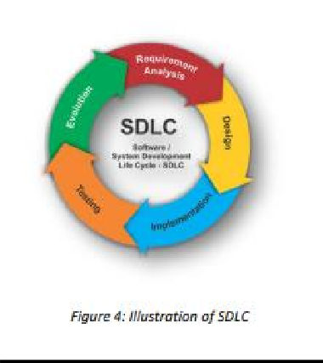

## Agile Methodology

To deliver a smooth execution of the project, a methodology has been chosen to assist in managing the project phase by phase, beginning with the initiation and ending with the closure. A methodology is necessary for selecting the best methods, practices, approaches, and procedures from among the many available. As a result, Agile Methodology was chosen for the development of the Online Book Store System platform. Agile technique is the ideal strategy to complete this

project because it divides it into phases and requires constant adjustments and input until the final product is completed.

Agile methodology is an iterative project management strategy that allows a project to adapt to changing working conditions and develop in a short amount of time. In this method, which is referred to as "sprint," a project term is divided into shorter and repeatable stages. Sprint lengths were decided during the project's early planning stages and will be reflected in the final product.

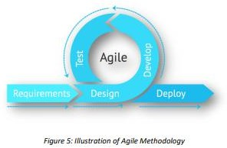

## Process

**Research, Analysis and Gathering Requirement**

This phase includes conducting literature reviews and analyses of existing systems in order to determine the requirements and features for an online book system website. Prepare documentation after evaluating the research study. Surveys and feedback are used to gather requirements. Requirements are subject to change over time. The prerequisites for the Online Book System platform are listed below:

1. A product catalogue on the home page After a successful login, the user will be directed to this page. It will provide all of the book categories and provide a search keyword option for finding the desired title. It also has some unique elements, such as recommended titles and weekly special books.
2. Search 20 Search textbox provides the user with the option of searching by keyword. The book title should be used as the keyword.
3. Advanced Search The user can utilize advanced search to find a book based on the title, author, category, and price range. The total number of books that match the specific search criteria will be presented. The user can choose a book and add it to their shopping cart from here.
4. Book Description If a user wants more information about a book, he/she can click on the title and be taken to a Book Description page. It includes annotations on the book's content as well as a link to Amazon.com where you can read the book review.
5. Voting by users A user can rate a book based on his or her interests. They can give it a five-star rating if it's excellent, four if it's very good, three if it's good, two if it's regular, and one if it's deficient. The final rating of a book is determined by the sum of all user ratings.
6. Shopping Cart The user can manage a shopping cart that contains all of the books that they had chosen. The user can change, delete, and update the contents of their shopping cart. A final shopping cart summary is shown, which includes all of the products selected by the user as well as the overall cost.
7. Managing User Account To access all of the website's functions, each user should create an account. The user can log in and out using the login and logout pages, respectively. The database will save all of the user sessions.
8. Administration Special functions for the Administrator will be granted, such as adding or deleting a book category, adding or deleting a member, managing member orders, adding or deleting a debit/credit card type, and so on.

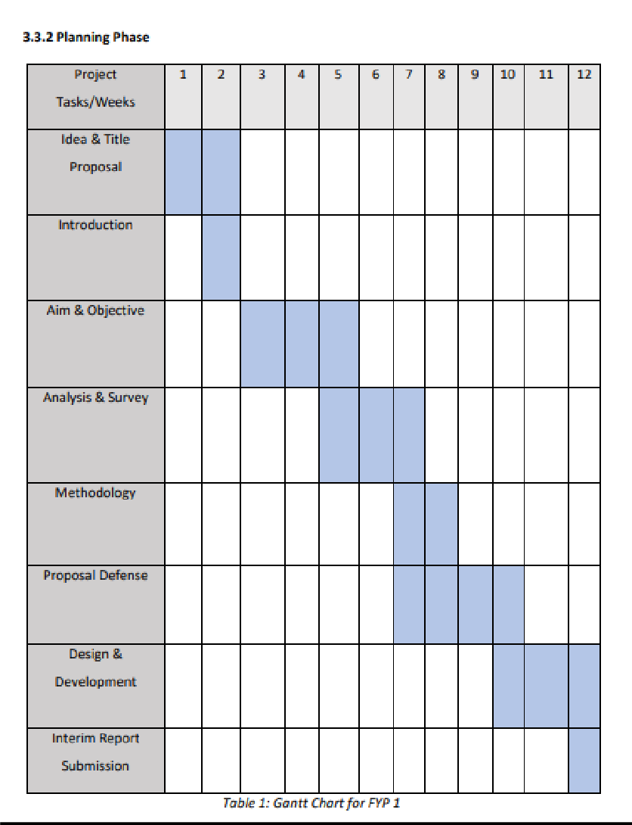

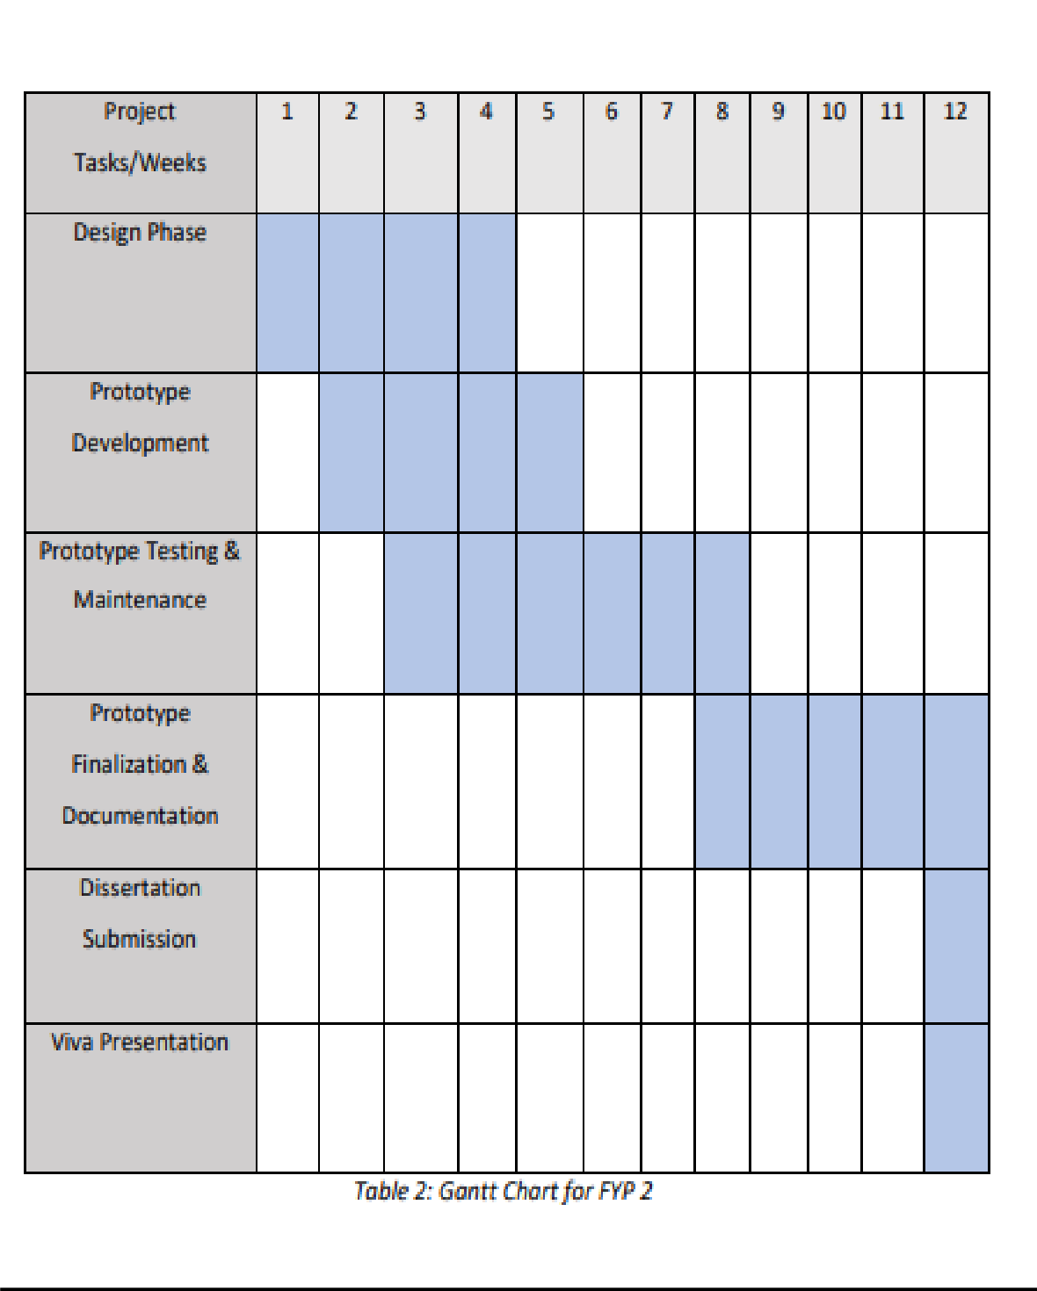

## Project Design Phase

In order to design a web site, the relational database must be designed first. The data model and the process model are the two aspects of conceptual design. The data model specifies which data should be stored in the database, whereas the process model defines how the data should be handled. To put it another way, the data model is used to construct the relational tables of a relational database. The process model is used to design the queries that will access those tables and perform operations on them.

A decomposition diagram illustrates a system's top-down functional decomposition and highlights its structure. The goal of the Functional Decomposition is to break down a system step by step, starting with the system's main function and progressing through the intermediate levels to the level of basic functions. More extensive process diagrams, such as Data Flow Diagrams (DFD) start with this diagram. Data Flow Diagrams illustrate the flow of data from external entities into the system, as well as from one process to the next. A DFD can be drawn using four symbols:

* 1. Rectangles that represent external entities such as data sources and destinations.
  2. Ellipses, which represent processes that receive data as input, validate, process, and output it.
  3. Data flows are represented by arrows, which can be electronic data or physical items.
  4. Data stores, especially electronic stores such as databases, are represented by openended rectangles or a Disk symbol.

## 0-Level DFD:

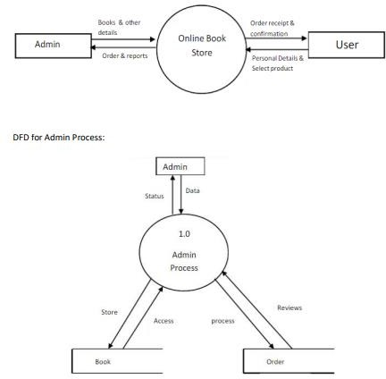

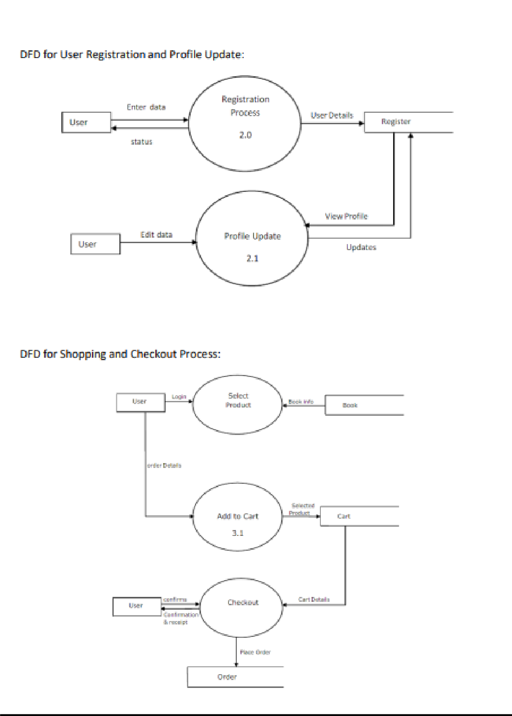

Development, Testing and Review Phase Development Phase includes writing codes using programming languages. The website will be programmed using HTML and CSS. In the meantime, MySQL will be used as the database. This process will be repeated until the client is satisfied with the final product.

Maintaining Phase test the website's functionality. This process will take place in parallel with the development phase. This is to check that the programmed codes are working properly and that there are no errors in the coding.

Review Phase includes obtaining feedback from users and testers. This process will

be followed once the finalized website has been created. This process is necessary in order to develop the platform in the future. For the evaluation process, this website will shared with a group of users or testers.

# Chapter 5 : Project Work

Creating an online bookstore project involves several components such as user authentication, book management, shopping cart functionality, and order processing. Below is a simplified outline of the steps you can take to create a basic online bookstore project. Keep in mind that this is a broad overview, and you may need to adapt it based on your specific requirements and the technologies you choose to use.

## Project Setup

Tools and Technologies

* + Choose a programming language (e.g., Python, Java, PHP).
  + Choose a web development framework (e.g., Django, Flask, Spring Boot, Laravel).
  + Choose a front-end framework (e.g., React, Angular, Vue.js).
  + Set up a database (e.g., MySQL, PostgreSQL).

## Database Design

Design the database schema to store information about books, users, orders, and any other relevant data.

## User Authentication

Implement user authentication to allow users to create accounts, log in, and log out.

## Book Management

Admin Panel

* + Create an admin panel for managing books (add, edit, delete).
  + Include features for adding book details such as title, author, genre, price, etc.
  + Implement image upload for book covers.

User Interface

* + Display a list of books on the front end.
  + Allow users to search and filter books based on different criteria.

## Shopping Cart

* + Allow users to add books to their shopping cart.
  + Implement functionality to update and remove items from the cart.
  + Display the total price in the shopping cart.

## Checkout Process

* + Create a checkout process where users enter their shipping details.
  + Calculate the total cost, including taxes and shipping fees.
  + Integrate with a payment gateway for processing payments.

## Order Processing

* + Store order details in the database.
  + Send confirmation emails to users after successful orders.

## Security

* + Implement security measures, including data validation and protection against common web vulnerabilities.

## User Reviews and Ratings

* + Allow users to leave reviews and ratings for books.

## Responsive Design

Ensure that your bookstore is accessible and usable on various devices by implementing responsive design.

## Testing

Test your application thoroughly to identify and fix bugs.

## Deployment

Deploy your application to a web server or cloud platform.

## Maintenance

Regularly update and maintain your application to address any issues and add new features. Additional Features (Optional)

* + Wishlist functionality
  + User profiles and order history
  + Recommendations based on user preferences
  + Social media integration

Remember to document your code, and consider using version control (e.g., Git) to track changes. Additionally, depending on the scale and complexity of your project, you may want to explore additional features and optimizations.

# Chapter 6 : Conduct of Experimentation

Conducting experimentation in the context of an online book store project involves testing various aspects of the system to ensure it meets performance, usability, and security requirements. Here's a general guide on how you can conduct experimentation for your online book store:

## Performance Testing:

**Objective:**

* + Evaluate the system's responsiveness and efficiency under different loads.

## Steps:

1. **Define Performance Metrics:**
   * Response time: Measure the time it takes for different actions (e.g., page loading, search queries).
   * Throughput: Assess the number of transactions the system can handle in a given time.

## Load Testing:

* + Use tools like Apache JMeter or Gatling to simulate various levels of user traffic.
  + Measure the system's performance under normal, peak, and stress conditions.

## Identify Bottlenecks:

* + Analyze performance metrics to identify any bottlenecks.
  + Optimize database queries, server resources, or network configurations as needed.

## Usability Testing:

**Objective:**

* + Evaluate the user-friendliness and overall user experience.

## Steps:

1. **Define Usability Metrics:**
   * Completion rate: Measure the percentage of tasks completed successfully.
   * Time on task: Assess the time users take to complete common actions.
   * Error rate: Track the number of user errors.

## User Testing:

* + Recruit participants to perform specific tasks on your online bookstore.
  + Collect feedback through surveys, interviews, or usability testing tools.

## Iterative Design:

* + Use feedback to make improvements to the user interface.
  + Test and refine the design iteratively.

## 3. Security Testing:

**Objective:**

- Identify and address potential security vulnerabilities.

## Steps:

1. **Penetration Testing:**
   * Hire ethical hackers or use automated tools to simulate attacks.
   * Identify and address vulnerabilities in the system.

## Data Encryption:

* + Ensure sensitive data, such as user credentials and payment information, is encrypted during transmission and storage.

## Access Controls:

* + Test and verify that users can only access the features and data they are authorized to.

## A/B Testing:

**Objective:**

* + Compare different versions of a feature to determine the most effective one.

## Steps:

1. **Define Variations:**
   * Select a specific feature or design element to test.
   * Create multiple variations of that feature.

## Randomized Testing:

* + Randomly assign users to different variations.
  + Track user behavior and collect data on user engagement.

## Analysis and Implementation:

* + Analyze the data to determine which variation performs better.
  + Implement the preferred variation in the production environment.

## Acceptance Testing:

**Objective:**

* + Ensure the system meets all specified requirements.

## Steps:

1. **Create Test Cases:**
   * Develop test cases based on project requirements.
   * Include both positive and negative test scenarios.

## Execute Test Cases:

* + Systematically go through each test case to verify that the system behaves as expected.

## Bug Tracking:

* + Document and prioritize any issues or bugs found during testing.
  + Address and resolve identified issues.

## Continuous Monitoring:

**Objective:**

* + Establish ongoing monitoring processes to detect and address issues in real-time.

## Steps:

1. **Implement Monitoring Tools:**
   * Set up tools to monitor system performance, user behavior, and security.
   * Establish alerts for critical events.

## Regular Review:

* + Regularly review monitoring data.
  + Address any emerging issues promptly.

Remember to document all testing procedures and outcomes. Regularly revisit your testing strategy as the project evolves to account for new features and changes.

# Chapter 7 : Plan of Research

Research is a critical phase in the development of an online bookstore. It involves gathering information on various aspects such as market analysis, user preferences, technology trends, and competitors. Below is a plan of research that you can follow:

## Market Analysis:

**Objective:**

Understand the current state of the online book market, identify potential customers, and evaluate the demand for your services.

## Steps:

1. **Identify Target Audience:**
   * Define the demographics and preferences of your potential customers.

## Competitor Analysis:

* + Identify existing online bookstores.
  + Analyze their strengths, weaknesses, opportunities, and threats (SWOT analysis).

## Market Trends:

* + Explore current trends in the book industry and e-commerce.
  + Identify emerging technologies or business models.

## Regulatory Compliance:

* + Understand legal and regulatory requirements for online bookstores.

## User Research:

**Objective:**

Gain insights into the needs and preferences of your target users.

## Steps:

1. **User Surveys and Interviews:**
   * Create surveys or conduct interviews to understand user preferences.
   * Gather information on preferred features, design elements, and shoppingbehaviors.

## Persona Development:

* + Create user personas based on the collected data.
  + Use personas to guide design and development decisions.

## User Journey Mapping:

* + Map out the typical user journey from browsing to purchasing.
  + Identify pain points and areas for improvement.

## 3. Technology Stack:

**Objective:**

Identify the most suitable technologies for your online bookstore.

## Steps:

1. **Backend Technologies:**
   * Research backend frameworks (e.g., Django, Flask, Spring Boot) and databases(e.g., MySQL, PostgreSQL).

## Frontend Technologies:

* + Explore frontend frameworks (e.g., React, Angular, Vue.js).
  + Consider responsive design principles.

## Hosting and Deployment:

* + Research hosting options (e.g., AWS, Heroku, DigitalOcean).
  + Decide on a deployment strategy.

## Security and Privacy:

**Objective:**

Ensure the security of user data and transactions.

## Steps:

1. **Payment Gateways:**
   * Research and choose secure payment gateways.
   * Understand their integration requirements.

## SSL Certificates:

* + Ensure the use of SSL certificates for secure data transmission.

## Data Protection:

* + Research data protection regulations and implement necessary measures.

## Feature Set:

**Objective:**

Define the features and functionalities your online bookstore will offer.

## Steps:

1. **Core Features:**
   * Identify essential features such as user registration, book browsing, shoppingcart, and checkout.

## Additional Features:

* + Research and decide on additional features like user reviews, recommendations, and social media integration.

## Development Methodology:

**Objective:**

Choose a development methodology that aligns with your project goals and team structure.

## Steps:

1. **Agile vs. Waterfall:**
   * Research Agile and Waterfall methodologies.
   * Choose the one that suits your project.

## Project Management Tools:

* + Explore project management tools for collaboration and task tracking.

## Cost Estimation:

**Objective:**

Estimate the budget required for the development and maintenance of the onlinebookstore.

## Steps:

1. **Development Costs:**
   * Estimate costs related to development, including technology, tools, and team resources.

## Operational Costs:

* + Consider ongoing operational costs such as hosting, maintenance, and support.

## Risk Assessment:

**Objective:**

Identify potential risks that may impact the success of your project.

## Steps:

1. **Risk Identification:**
   * List potential risks related to technology, market, competition, and projectmanagement.

## Risk Mitigation:

* + Develop strategies to mitigate identified risks.

## Ethical Considerations:

**Objective:**

Consider ethical aspects of your online bookstore, including user privacy andresponsible data handling.

## Steps:

1. **Privacy Policies:**

- Develop clear and comprehensive privacy policies.

* + Communicate how user data will be handled.

## Accessibility:

* + Ensure your online bookstore is accessible to users with disabilities.

## Documentation:

**Objective:**

Create comprehensive documentation for the entire project.

## Steps:

1. **Technical Documentation:**
   * Document the technical aspects of your project, including APIs, databaseschema, and codebase.

## User Documentation:

* + Create user guides for using the online bookstore.

## Timeline and Milestones:

**Objective:**

Create a realistic timeline for the development and launch of your online bookstore.

## Steps:

1. **Define Milestones:**
   * Break down the project into milestones (e.g., design completion, development, testing).

## Timeline Allocation:

* + Allocate timeframes for each milestone.

## Feedback and Iteration:

**Objective:**

Plan for gathering feedback and iterating on the project.

## Steps:

1. **Beta Testing:**
   * Plan a beta testing phase to gather user feedback.

## Iterative Development:

* + Be prepared to make improvements based on user feedback.

By following this research plan, you can ensure that your online bookstore project is well-informed, aligns with user expectations, and is built on a solid foundation of technology and methodology.

# Chapter 8 : Conclusion and Future Work

## Conclusion

Online shopping has gained importance not only from the standpoint of the entrepreneur, but also from the standpoint of the customer, since the Internet has become a vital resource in modern business. Electronic shopping opens up new business prospects for the entrepreneur, and it allows customers to compare prices. According to a report, most online shoppers are impulsive and decide whether or not to stay on a site within the first few seconds. "Website design is similar to the interior design of a store." If the shop appears to be run-down or similar to hundreds of other shops, the customer is likely to move on to the next site." As a result, I created the project to give the user as much ease of navigation, data retrieval, and essential feedback as possible. The user is given with an ecommerce web site that can be utilized to purchase books online in this project.

I utilized PHP to make this a web application. PHP (XAMPP) has a number of advantages, including improved performance, scalability, security, and simplicity. To create a web application with PHP, I'll need a programming language like JAVA, HTML, or anything similar. The language used to develop this application was JAVA. PHP connects with the database using the MySQL server because it offers in-memory caching, which reduces the need to visit the database server frequently, and it is simple to deploy and manage. MySQL was chosen as the back-end database because it is one of the most widely used open-source databases, with rapid data access, ease of installation, and simplicity.

A user-friendly shopping cart functionality must match a solid shopping cart design. Viewing the contents of the customer's cart and being able to remove or add items to the cart should be easy. 49 This project's shopping cart application includes a variety of features aimed at making the customer's experience more pleasant. This project will help me understand how to make an interactive web page and the tools that go into making it. The project's architecture, which contains a Data Model and a Process Model, shows how the database is constructed with various tables, as well as how data is accessed and processed from the tables. The project's development has provided me a thorough understanding of how PHP is utilized to develop a website, how it connects to a database to obtain data, and how the data and web pages are modified to provide a shopping cart application to the user.

## Recommendation for Future Work

Software development is a never-ending process that maintains the software's life based on the changing needs of the user throughout time. The project will undoubtedly be designed with easy modification and enhancement in mind, which may be required from time to time. This project, on the other hand, can be modified in a variety of ways. Because of limited a time frame, I am unable to incorporate many things here. But I will attempt to cover all of the existing system that the Online Book Store should consist.

During the development phase, various improvements were found that would be considered in future versions of the Web-Based Online Book Store System:

* Introduce the Barcode System Adding an effective Bar Cord Reader helps to improve data capture reliability at the operational level. The accuracy of data entry for sales and purchasing activities can be improved by employing system-generated barcodes for items' SKUs.
* To manage the business in the future, integrate application and back-office operations connected to the technology of the existing website and internal system as Enterprise Resource Planning (ERP). 50
* Provide an SMS service when orders are processed and for special jobs. By implementing this recommendation, users will be able to acquire relevant information from the system without having to enter the system or their email account.
* As the Intranet deals with a considerable amount of sensitive information, improve security by putting in a standardized Firewall and Gateways methods to tighten security even more.
* Obtain an SSL Certificate to ensure that all transactions are conducted over a secure channel using https.
* Make plans to secure an Intellectual Property (IPR) for the company's website.

## 6.3 Lessons Learnt

As a student participating in a degree program, this was a fantastic opportunity for me to put what I had learned in class into practice. Because the domain area was so extensive, it allowed me to get experience in a variety of business strategies and broadened my understanding of how to map connected business operations into a computerized system. It also gives me an excellent opportunity to put everything I've learned into practice. The creation of the Web-Based Online Book Store System helps in gaining valuable knowledge in system development throughout the SDLC.

Various software engineering approaches, such as requirement collecting techniques, OOD techniques, and designing systems using UML, are practiced during the analysis and design phases, which will be useful in my future job. This phase also assists me in improving my knowledge of PHP, AJAX, JQuery, and other programming languages. The evaluation phase provided a great opportunity for me to practice evaluating systems, particularly on the user side. A better understanding of how to communicate with a real customer was gained. In addition, the working environment included web-related language

# REFERENCES

* L. T. T. Tran (2021, January). Managing the effectiveness of e-commerce platforms in a pandemic.
* https://[www.sciencedirect.com/science/article/pii/S0969698920312959](http://www.sciencedirect.com/science/article/pii/S0969698920312959)
* Essay Sauce (2019, August). Analyze the website requirements both functional and nonfunctional of the XYZ bookstore. [https://www.essaysauce.com/information-technology-](https://www.essaysauce.com/information-technology-essays/analyze-the-websiterequirements-both-functional-and-non-functional-of-the-xyz-bookstore/) [essays/analyze-the-websiterequirements-both-functional-and-non-functional-of-the-xyz-](https://www.essaysauce.com/information-technology-essays/analyze-the-websiterequirements-both-functional-and-non-functional-of-the-xyz-bookstore/) [bookstore/](https://www.essaysauce.com/information-technology-essays/analyze-the-websiterequirements-both-functional-and-non-functional-of-the-xyz-bookstore/)
* Shirley R. (2009, April). The System Development Life Cycle (SDLC). https://csrc.nist.gov/csrc/media/publications/shared/documents/itl-bulletin/itlbul2009- 04.pdf
* Gaurav K. (2012, August). Impact of Agile Methodology on Software Development Process. <https://www.researchgate.net/profile/Gaurav> - Kumar175/publication/255707851_Impact_of_Agile_Methodology_on_Software_Develop men t_Process/links/00b49520489442e12d000000/Impact-of-Agile-Methodology- onSoftware-Development-Process.pdf
* Verma A. (2017, November). A Comparative Study of Black Box Testing and White Box Testing. https://[www.researchgate.net/profile/SarikaChaudhary/publication/325816726_A_Compa](http://www.researchgate.net/profile/SarikaChaudhary/publication/325816726_A_Compa) rative_Study_of_Black_Box_Testing_and_ White_Box_Testing/links/5d289f29458515c11c2a99b6/A-Comparative-Study-of-BlackBox- Testing-and-White-Box-Testing.pdf 52
* Leonidio, U. da C., Montezano, R. M. da S., Carvalho, F. A. de (2017, November). Evaluation of Perceived Quality of The Website of An Online Bookstore: An Empirical Application of The Barnes and Vidgen Model. <https://www.scielo.br/j/jistm/a/cHf5LJhTf7sQnByJn5zgSPp/?format=pdf&lang=en>
* Huang, L. C. (2017, November). Customer Relationship Management (CRM) in Businessto- Business (B2B) e-commerce. [https://www.emerald.com/insight/content/doi/10.1108/IntR-](https://www.emerald.com/insight/content/doi/10.1108/IntR-05-2016-0142/full/html) [05-2016-0142/full/html](https://www.emerald.com/insight/content/doi/10.1108/IntR-05-2016-0142/full/html)
* ➢ Hsu, C.L., Wu, C.C. and Chen, M.C. (2013, April). How social shopping retain customers? Capturing the essence of website quality and relationship quality https://[www.researchgate.net/publication/299442291_How_social_shopping_retain_c](http://www.researchgate.net/publication/299442291_How_social_shopping_retain_c)

ustomers_Capturing_the_essence_of_website_quality_and_relationship_quality

**THANK YOU!!**