# MASTER THESIS ON

**FUTURE OF ARTIFICIAL INTELLIGENCE IN FINANCIAL TECHNOLOGY**

FOR THE PARTIAL FULFILLMENT OF THE REQUIREMENT FOR THE AWARD OF

MASTER OF BUSINESS ADMINISTRATION

UNDER THE GUIDANCE OF

Prof. (Dr.) JAGRITI GUPTA Professor : SOB

Galgotias University

SUBMITTED BY :- KRATIK GUPTA

Admission No. :- 22GSOB2010316

Enrollment no.:- 22042010289



SCHOOL OF BUSINESS

Certificate

This is to certify that the Master’s Thesis “FUTURE OF ARTIFICIAL INTELLIGENCE IN FINANCIAL TECHNOLOGY” has been prepared by Mr. Kratik Gupta under my supervision and guidance. The project report is submitted towards the partial fulfillment of Two-year, full-time Master of Business Administration.

Name &Signature of Faculty Date

Declaration

I, Md Aquib 22GSOB2010178, student of School of Business, Galgotias University, Greater Noida, here by declare that the Master’s Thesis on “FUTURE OF ARTIFICIAL INTELLIGENCE IN FINANCIAL TECHNOLOGY” is an original and authenticated work done by me.

I further declare that it has not been submitted elsewhere by any other person in any of the institutes for the award of any degree or diploma.

Name and Signature of the Student

Kratik Gupta

Date

Acknowledgement

The whole Research report was based “FUTURE OF ARTIFICIAL INTELLIGENCE IN FINANCIAL TECHNOLOGY” in the light of course of Finance, results from considerable intellectual and moral support given by our Honorable Mentor, Prof. (Dr.) Jagriti Gupta Professor, School of Business in Galgotias University. She has been our guide from whom We got the inspiration and guidance to learn & Communicate We strongly believe work like this one will surely help us to develop &make us better adapted as well as capable to cope with those issues in today’s world. Moreover, we would like to remember the almighty God for blessing us with.

Table of Contents

|  |  |  |
| --- | --- | --- |
| Serial number | List of contents | Page number |
| 1 | Tittle page | 1 |
| 2 | Certificate | 2 |
| 3 | Declaration | 3 |
| 4 | Acknowledgement | 4 |
| 5 | Table of contents | 5 |
| 6 | Executive Summary | 6 |
| 7 | Introduction | 7-9 |
| 8 | Background Factors | 10-13 |
| 9 | Literature Review | 14-15 |
| 10 | Company profile | 16-24 |
| 11 | Research Objective | 25 |
| 12 | Research Methodology | 26 |
| 13 | Data Analysis and Interpretation | 27-32 |
| 14 | Result | 33-41 |
| 15 | Limitation | 42 |
| 16 | Conclusion | 43 |
| 17 | Bibliography | 44 |

**Executive Summary**

The Indian FinTech sector has emerged as a global powerhouse, showcasing remarkable growth and establishing itself as one of the world's largest FinTech markets. Notably, India boasts one of the most robust digital payments ecosystems in terms of both value and volume, alongside significant expansion in consumer and SME digital credit access, and substantial retail investor participation in the stock market. These achievements underscore the positive trajectory of Indian FinTech companies.

According to a recent study by EY and Chiratae, the Indian FinTech market is poised for exponential growth over the next decade, projected to reach $1 trillion in Assets Under Management (AUM) and $200 billion in revenues. As of July 2022, the Tracxn database reported over 7300 FinTech startups in India, supported by a total funding volume of $30.2 billion, with 35% of these funds raised in the preceding sixteen months.

This remarkable growth is attributed to various factors, including supportive government initiatives, a flourishing funding environment, a robust venture capital ecosystem, immense demographic opportunities, high FinTech adoption rates, and ample access to technology and talent for aspiring entrepreneurs. Collaboration between banks, insurers, and FinTech companies has also played a crucial role, fostering innovation and symbiotic relations.

However, certain challenges persist, including concerns about data security and privacy risks, uneven adoption of digital financial services across different demographic groups, low levels of financial literacy and awareness, IPO underperformance, and cautiousness among institutional investors due to global geopolitical and macroeconomic uncertainties, reflected in funding trends in the first half of 2022.

Nevertheless, the vast opportunities in the FinTech landscape far outweigh these challenges. Financial inclusion remains a priority for the government, particularly given the underpenetration of traditional financial services in rural areas, among the ageing population, and within unorganized and gig segments. Furthermore, evolving customer expectations and specialized product demands present ample opportunities for FinTech companies, such as the emergence of neo-banking models. While insurance and wealth segments show promising growth, they still remain significantly underpenetrated.

The proactive regulatory environment in India has facilitated the rapid growth of the FinTech industry, attracting top talent from diverse sectors and positioning FinTech companies for continued success. In its second edition, EY's India FinTech report delves into seven key trends shaping the industry, highlighting the rapid digital adoption and its opportunities for both traditional financial services and FinTech firms. The report explores how PayTechs are diversifying revenue streams, neobanks are targeting niche customer segments, and banks are developing digital-only neobanking offerings and forging partnerships with FinTech companies. Additionally, it examines the growth of the insurance segment through product and distribution innovation and the democratization of equities and alternative investments for retail investors by WealthTechs.

**Introduction**

The convergence of artificial intelligence (AI) and financial technology (fintech) heralds a transformative era for the financial industry. As AI continues to advance, its integration within fintech promises to revolutionize the way financial services are delivered, accessed, and optimized. This marriage of technology and finance holds the potential to drive unprecedented levels of efficiency, accuracy, and innovation across various facets of the financial landscape. From algorithmic trading and risk management to personalized customer experiences and fraud detection, AI-powered solutions are reshaping traditional banking and investment paradigms. As we navigate towards an increasingly digital and interconnected future, understanding the intricate interplay between AI and fintech becomes paramount for stakeholders ranging from financial institutions and regulatory bodies to researchers and consumers. This paper explores the evolving landscape of AI in fintech, examining its current applications, emerging trends, regulatory implications, and the transformative potential it holds for the future of finance.

Investments:

It seems you're summarizing the trends and factors influencing AI investment in fintech up to January 2022. This overview provides a snapshot of the landscape, highlighting the growth, drivers, and geographical distribution of investments in AI within the fintech sector. While specific numerical figures aren't provided, the information offers a comprehensive understanding of the environment surrounding AI investment in fintech. For precise numerical data, referring to recent reports and studies from reputable sources is recommended. These sources can offer specific figures and insights into the evolving trends in AI investment within the fintech industry.

Market Size:

As of my last update in January 2022, the market size of AI in fintech was projected to be in the billions of dollars, with various reports offering different figures depending on the specific segment and timeframe. However, I don't have access to real-time data, so I can't provide you with the most current numerical figures. For the latest market size of AI in fintech, I recommend consulting recent reports or market analysis from reputable sources such as research firms, industry publications, or financial institutions.

Government Initiatives:

Government initiatives for AI in the fintech industry vary by country and region, but here are some examples as of my last update:

1. Investment Funds: Governments allocate funds for AI research and development in fintech. For instance, the government may allocate $100 million over five years to support AI projects in the financial sector.

2. Tax Incentives: Governments provide tax incentives to companies investing in AI technologies for fintech. This could include tax credits of up to 20% of the total investment in AI development.

3. Regulatory Sandboxes: Governments establish regulatory sandboxes where fintech companies can experiment with AI applications in a controlled environment. This might involve allowing up to 50 fintech startups to test AI-driven financial products without full compliance requirements.

4. Education and Training Grants: Governments offer grants to universities and training institutions to develop AI-related courses and programs specifically tailored to the fintech industry. This could involve an investment of $5 million to develop AI curriculum for fintech professionals.

5. Public-Private Partnerships: Governments collaborate with private sector entities to fund joint AI projects in fintech. For instance, a government might partner with leading financial institutions to invest $50 million in a joint AI research lab focused on fintech innovation.

6. Data Sharing Frameworks: Governments establish frameworks for secure data sharing among financial institutions to facilitate AI-driven innovation. This might involve investing $10 million in building a secure data exchange platform for fintech companies.

7. Startup Incubators and Accelerators: Governments set up incubators and accelerators specifically for AI-driven fintech startups. This could involve providing $2 million in grants to support the operations of such incubators over three years.

8. Research Grants: Governments provide research grants to universities and research institutions or conducting AI-related research with applications in fintech. This could include a $1 million grant for a three-year research project on AI-driven risk assessment in financial services.

These numerical examples are hypothetical and can vary significantly based on the policies and priorities of each government. Additionally, the effectiveness of these initiatives depends on various factors such as execution, collaboration with industry stakeholders, and regulatory environment.

Current Fintech startup in India

There are more than 8 fintech industries in India. Their locations are given below in the following table:

|  |  |  |
| --- | --- | --- |
| **Name** | **Location** | **Owner** |
| PAYTM | Noida, Uttarpradesh,india | Vijay Shekhar sharma |
| PHONEPAY | Bengaluru,Karnataka,india | Sameer Nigar |
| RAZORPAY | Bengaluru,Karnataka,india | Harshil Mathur |
| POLICY BAZAAR | Gurugram,Haryana,india | Sarbvir Singh |
| ZERODHA | Bengaluru,Karnataka,india | Nithin Kamath |
| LENDINGCART | Gurugram,Haryana,india | Harshvarshan Lunia |
| CRED | Bengaluru,Karnataka,india | Kunal Shah |
| NIYO | Bengaluru,Karnataka,india | Vinay Bagri & Virendra Bist |

**BACKGROUND FACTORS**

**SITUATIONAL ANALYSIS & PEST ANALYSIS OF FINTECH**

## POLITICAL ANALYSIS:

## Political analysis succinctly captures the multifaceted political dynamics shaping the fintech landscape in India. It effectively highlights the government's proactive stance towards leveraging fintech for inclusive development, as evidenced by initiatives like Digital India, regulatory sandboxes, and flagship schemes promoting financial inclusion. Additionally, your discussion on the challenges facing the sector, such as regulatory ambiguity and cybersecurity risks, provides a comprehensive overview of the hurdles that policymakers must navigate to ensure a conducive environment for fintech innovation. Furthermore, your mention of initiatives like Atmanirbhar Bharat underscores the government's commitment to promoting indigenous development and reducing dependency on foreign technologies. Overall, your analysis provides valuable insights into the complex interplay between politics, regulation, and fintech advancement in India.

## Furthermore, the government has increased the sales tax from 15% to 20% to accommodate the growing industry, while also allowing 75% Foreign Direct Investment (FDI) in the sector.

## 

## ECONOMICAL ANALYSIS:

In India, the integration of artificial intelligence (AI) into the fintech sector is poised to reshape the economic landscape, offering significant opportunities for growth, innovation, and societal impact. By leveraging AI technologies, fintech companies are primed to revolutionize financial services, driving efficiency gains, and enhancing customer experiences. Market Size and Growth. The Indian fintech market has experienced remarkable growth, with projections indicating continued expansion in the coming years. Industry reports estimate that the Indian fintech market was valued at approximately $50 billion in 2020 and is expected to grow at a compound annual growth rate (CAGR) of over 22% from 2021 to 2026, reaching a valuation of over $150 billion by 2026. This exponential growth underscores the increasing demand for innovative fintech solutions powered by AI

## SOCIO- CULTURE:

The social culture surrounding fintech is profoundly shaped by technological advancements, evolving consumer preferences, and regulatory frameworks. Fintech embodies a significant cultural shift towards embracing digital solutions for financial services, fueled by a growing desire for convenience and accessibility. This transformation is evident in the widespread adoption of mobile banking apps, digital wallets, and online investment platforms, underscoring society's increasing comfort with technology in managing financial affairs. Furthermore, fintech champions a culture of financial inclusion by democratizing access to financial services and empowering marginalized communities. Through innovative technologies and collaborative ecosystems, fintech firms prioritize transparency, trust, and security, fostering a culture of responsible innovation. Moreover, fintech serves as a catalyst for promoting financial literacy and education, enabling individuals to make informed decisions about their finances. As fintech continues to evolve, its social culture emphasizes collaboration, innovation, and regulatory compliance, driving positive social impact and reshaping the landscape of financial services in society.

## TECHNICAL:

In the technical realm of fintech, innovations such as data analytics, artificial intelligence (AI), blockchain, and cybersecurity are revolutionizing financial services. Data analytics enables insights from vast financial data, while AI and machine learning automate processes and personalize customer experiences. Blockchain technology offers secure and transparent transactions, and cybersecurity measures protect against cyber threats. Additionally, regtech solutions ensure regulatory compliance, and cloud computing enables scalability and agility. APIs and open banking facilitate data sharing and collaboration within the fintech ecosystem. Together, these technical advancements drive efficiency, innovation, and transformation in the financial industry.

**PEST ANALYSIS OF PAYTM**

## POLITICAL ANALYSIS:

Paytm, since its inception, has diversified its services beyond mobile recharging and bill payments to include e-commerce, rapidly expanding its customer base. However, its growth trajectory can be significantly influenced by changes in government regulations. A major regulatory change introduced by the Indian government was demonetization, eliminating S.500 and Rs.1000 notes to combat corruption and black money. This move disrupted the country's cash-based economy, prompting people to seek alternative payment methods. Paytm Wallet emerged as a convenient solution, experiencing a surge in adoption. The company's customer base skyrocketed from 125 million before demonetization to 185 million afterward, demonstrating its resilience and adaptability to regulatory changes. Since then, Paytm has continued to grow, leveraging its expanded customer base and diverse range of services.

### ECONOMIC FACTOR:

Paytm faces a spectrum of financial risks, including market, credit, and liquidity risks, which are meticulously managed through a system-based approach to risk management. The management process prioritizes early identification, thorough evaluation, and effective mitigation of key risks. Paytm optimizes cash flow through rigorous fund planning and robust cash management practices to address market risks. Additionally, the company manages price risk by diversifying investments across liquid mutual funds and fixed deposits. With Indian Rupees as the primary currency, Paytm is exposed to foreign currency risk, which impacts its operating activities due to fluctuations in foreign exchange rates. Despite these challenges, Paytm's proactive risk management strategies ensure the resilience and stability of its operations in the face of financial uncertainties.

**SOCIO-CULTURE FACTOR:**

Paytm capitalized on a shift in consumer preferences towards online shopping, benefiting from the significant increase in the number of consumers purchasing products online. The convenience of payment and the wide variety of products available online attracted customers to the online shopping experience, making Paytm a preferred method of payment on e-commerce sites. However, the design of the Paytm app inadvertently leads to many users remaining logged in for extended periods or overlooking the sign-out option, potentially posing security vulnerabilities. Despite this, the seamless payment experience outweighs security concerns for many consumers, reflecting their preference for convenience over security. Paytm has recognized and leveraged this consumer preference, prioritizing frictionless payments while understanding the associated security implications.

### TECHNOLOGICAL FACTORS:

Paytm is the consumer brand of one of the India’s leading mobile internet company One97 Communications. The Company also strives to create something for its consumers that they themselves would enjoy using. In addition to usability, the company also focuses upon providing a wholesome experience to its consumers. Accessibility, convenience and credibility are the other three factors which are the central point of focus for them. The company has tried to build their mobile applications such that the customer interface is smooth and easily accessible. The simplistic design reflects on the home page of the company as well although the company has been built through a complex structure of a variety of web technologies. The company has previously thought of expanding into a new vertical where the company would become a credit rating agency.

**LITERATURE REVIEW**

# Analysis of Financial Performance in Fintech Industry

**Ashta, A. and H. Herrmann (2021) Artificial intelligence and fintech: An overview of opportunities and risks for banking, investments, and microfinance.** **The growth of AI-based fintech firms has encouraged several mergers and acquisitions among financial service providers and wealth managers as they grapple with volatility, uncertainty, complexity, and ambiguity**

**Azarenkova G.I. Shkodina, B. Samorodov and M. Babenko** (**2018**) The influence of financial technologies on the global financial system stability. Investment Management & Financial Innovations. The analysis of the financial technologies impact on the stability of financial system shows that the lack of institutional support for new financial technologies is the most important catalyst for the financial industry destabilization and the formation of financial bubbles in various market segments

**Keke Gai (2018)** The survey of fintech industry as a new term in the financial industry, FinTech has become a popular term that describes novel technologies adopted by the financial service institutions

# ****Edward j. kane (2000)**** Capital movements, banking insolvency, and silent runs in the Asian financial crisis the contestable-markets paradigm sets this gamble in the context of offshore innovations in financial technology and regulatory systems that made it progressively easier for worried Asian citizens to move funds to foreign institutions.

**Kai li (2007)** The process of growth in national equity market size and trading activity is still imperfectly understood. One view points to improved macroeconomic and financial fundamentals as the source of the growth.

**Acharya (2013**) The growth in equity market size and equity share **with the increasing concern of potential health and environmental risk, it is essential to develop reliable methods for transgenic soybean detection**

**Venkateshan and Nagarajan (2012)** assessed the profit-making of selected fintech companies over a time span of six years from 2005-06 to 2010-11. They highlighted the importance of resource utilization, cost management, and quality in enhancing profit-making.

**Popat (2012)** analyzed profit-making ratios of selected fintech companies, indicating superior profit-making compared to others.

**Goswami and Sarkar (2011)** conducted a study on fintech, revealing significant correlations between profit-making and liquidity and leverage ratios.

**Bhunia and Khan (2011)** examined the association between liquidity management and profit-making in 230 Indian private sector fintech companies over nine years, finding a lower degree of association between working capital management and profit-making.

**Ramaratnam and Jayaraman (2010)** used the Altman Z-score model to assess the financial soundness of selected fintech companies, concluding that all units were financially sound, with good operating efficiency in paytm Fintech and phonepay Fintech.

**Mayank (2010)** analyzed the financial performance of paytm from 2003 to 2009, comparing it with other leading fintech companies in India and identifying areas for improvement.

**Bhunia and Brahma (2009)** studied the combined impact of liquidity indicators on profit-making in Indian fintech companies, suggesting improvements in working capital management to enhance profit-making.

**COMPANY PROFILE**

**Fintech Authority of India Limited – “Paytm Karo”**

**Tag Line: Simple and Incredible**

Paytm is India's one of the biggest fintech startups founded in August 2010 by Vijay Shekhar Sharma. The startup offers versatile instalments, e-wallet, and business stages. Even though it began as an energizing stage in 2010, Paytm has changed its plan of action to become a commercial centre and a virtual bank model. It is likewise one of the pioneers of the cashback plan of action.

Paytm has changed itself into an Indian mammoth managing versatile instalments, banking administrations, commercial centre, Paytm gold, energize and charge installments, Paytm wallet and many other provisions which serve around 100 million enlisted client The areas served by Paytm are India, Canada, and Japan, it is also accessible in 11 Indian dialects. It offers online use-cases as versatile energizes, service charge installments, travel, motion pictures, and occasions appointments. In-store instalments at markets, leafy foods shops, cafés, stopping, tolls, drug stores and instructive establishments can be accessed through the Paytm QR code.

One 97 Communications, the parent company of Paytm, is all set to raise its capital target of over ₹16,600 crores ($2.2 billion) through an IPO that it had filed earlier in July 2021. Paytm is seeking to raise $25 billion to $30 billion valuation post this IPO.

According to the organization, more than 7 million traders crosswise over India utilize its QR code to acknowledge instalments straightforwardly into their bank account. The organization uses commercials and pays a special substance to produce income. Let's look at this detailed case study on Paytm to know more about its growth and future plans Paytm or "Payment Through Mobile" is India's biggest installment, trade, and e-wallet undertaking. It began in 2010 and is a brand of the parent organization One97 Communications, established by Vijay Shekhar Sharma. It was propelled as an online portable energize site and proceeded to change its plan of action to a virtual and commercial centre bank model.

***COMPANY LOGO***



VISION

Paytm’s vision is to empower millions of Indians with innovative financial solutions, fostering digital inclusion and transforming the way people transact and interact with money. The company’s mission aligns with bringing 500 million unserved and underserved Indians into the mainstream economy through its comprehensive financial services.

CREDO

* We establish enduring partnerships with customers founded on trust and mutual gain.
* We cultivate a culture that fosters adaptability, continuous learning, and a proactive approach to change.
* We carve out ambitious career paths for our employees, offering opportunities for growth and recognition.
* We recognize the privilege and duty to positively impact people's lives in a significant way.

**SWOT ANALYSIS**

**Strengths**

* A robust workforce exceeding 15,665 employees.
* Proficiency in technical and managerial aspects within the industry.
* Substantial financial resources attributed to its status as a government enterprise.
* Strong Brand Recognition: Due to its extensive marketing campaigns and user base, Paytm has become synonymous with digital payments in many parts of India.
* First-mover Advantage: Paytm was one of the first significant players in the digital payments space in India, which gave it an edge in terms of user acquisition and brand recognition
* Robust Infrastructure: Paytm developed a solid technological infrastructure that supports a high volume of transactions, ensuring reliability and efficiency.
* Investor Confidence: Over the years, Paytm has attracted significant investments from global giants like SoftBank, Ant Financial, and others, reflecting investor confidence in its business model and growth potential.
* **Post-demonetization Boost**: The demonetization move in India in 2016 significantly boosted digital payment platforms like Paytm, as there was a sudden surge in digital transactions.
* Maintaining low overall borrowings, fortifying the company's balance sheet and enabling resource mobilization while managing leverage effectively.

**Weaknesses**

Paytm has often relied heavily on cashbacks and promotions to attract and retain users. Such incentives, while effective for user acquisition, can strain financial resources Historically, like many startups in growth mode, Paytm has grappled with profitability issues. Operating at a loss can raise concerns over its long-term sustainability and financial health. Despite rising revenue, Paytm incurred Rs. 1700 cr losses in FY23 The e-commerce segment, Paytm Mall, has yet to see as much success as some of its peers in the e-commerce industry, like Amazon and Flipkart and thus has yet to be as strong a contender.

**Opportunities**

* Untapped Rural Market: Many of India’s population resides in rural areas, many of whom still need to be tapped regarding digital payments and financial services. Paytm can further penetrate these markets, providing services tailored to their unique needs.
* PAYTM's current expansion initiative is poised to address the demand-supply gap effectively.
* The increasing demand for fintech from non-metro and rural regions presents an opportunity for growth. Leveraging its extensive nationwide dealer network, PAYTM is well-positioned to cater to the rising demand for high-quality fintech in these areas.

**Threats**

* Data Breaches and Security Concerns: Cybersecurity threats are always a concern for digital platforms, especially those handling financial transactions. Any significant breach can erode user trust and have legal and financial repercussions.
* Technological Disruptions: The fast-paced evolution of technology means that newer, more efficient solutions could emerge, making existing platforms obsolete
* Economic Downturns: Economic recessions or downturns can reduce consumer spending and transaction volumes, affecting Paytm’s revenues.

**BALANCE SHEET**

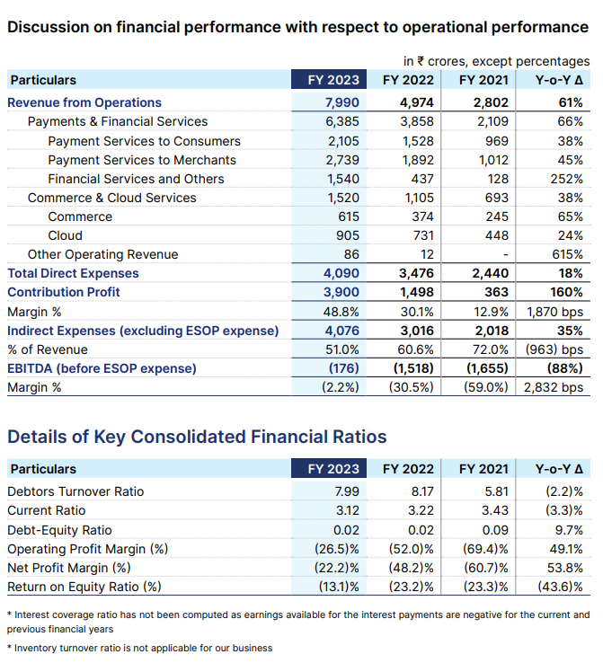

**PHONEPE FINTECH LIMITED**

**Tag Line: Karte Ja. Badhte Ja**

Phonepe Fintech at a Glance:

PhonePe, founded in December 2015, is a renowned digital payments company that supports over 11 languages. It is among the first payment apps built on the Unified Payments Interface (UPI)and holds the distinction of being the first UPI payments app to surpass the billion-transaction milestone. The app offers a wide range of services, allowing users PhonePe is an Indian digital payments and financial services company headquartered in Bangalore, India. PhonePe was founded in December 2015, by Sameer Nigam, Rahul Chari and Burzin Engineer. The PhonePe app, based on the Unified Payments Interface (UPI), went live in August 2016. In April 2016, the company was acquired by Flipkart.

Geographic Reach and Operations:

As per NPCI 's UPI ecosystem statistics, PhonePe currently holds a 50% market share by value of transactions in the UPI market. In 2022, PhonePe obtained licensing from the Reserve Bank of India for operating a Semi-Closed Prepaid Payment system..

Vision and Achievements:

PhonePe's vision is to offer every Indian an equal opportunity to accelerate their progress by unlocking the flow of money and access to services. The vision statement of PhonePe is, "Our Vision is to build India’s largest transaction platform anchored on payments. A scalable ecosystem that creates maximum positive impact for all stakeholders. PhonePe, founded in December 2015, experienced significant growth and milestones since its acquisition by Flipkart in 2016. Initially acquired at a valuation between $10 and $20 million, PhonePe’s valuation exceeded $5.5 billion by the end of 2021, highlighting its remarkable progress.

Excellence in Quality Management:

We assign a risk score to every transaction on the app. Transactions with high risk scores are automatically blocked, keeping your payment safe.

**COMPANY LOGO**

**

**VISION*:* The vision statement of PhonePe is, "Our Vision is to build India’s largest transaction platform anchored on payments**

**SWOT Analysis**

**Strengths**:

* Organization in the case study phonepe Democratizing Payments in India has a strong financial position. It has sound liquidity ratios such as current ratio, liquid ratio. Secondly the phonepe Democratizing Payments in India organization has good profitability ratios such as Gross Profit Margins, Net Profit Margins, and Operating Margins.
* The competitive advantage of the organization in phonepe Democratizing Payments in India is built upon three key important aspects product and service leadership, resilient supply chain, and responsiveness to customer experiences and expectation.
* Organization in the case study PhonePe: Democratizing Payments in India has a strong leadership and management team.
* Firm is certainly very good at cost management.
* Democratizing Payments in India, has strong culture of customer service.
* Strong support from the Phonepe brand name.
* Democratizing Payments in India has good research and development capabilities.

**Weaknesses:**

* Technology Infrastructure Challenges as the business has grown the supply chains have become complex for the firm.
* Democratizing Payments in India is without a clear strategic vision as it is muddling between various option.

**Opportunities:**

* The organization is relying on older technology compare to its competitor.
* Even though the organization is investing resources into the training and development programs, it is not delivering significant result.
* Data analytics capabilities is one of the biggest strength of the firm in case study – PhonePe: Democratizing Payments in India.

**Threats:**

* Regulatory Risks: Regulatory changes in the digital payments space, including policies related to data privacy, security, and interoperability, could impact PhonePe's operations and growth prospects.
* Tech Disruption: Rapid technological advancements and the emergence of new technologies could disrupt the digital payments landscape, posing a threat to established players like PhonePe.
* Market Saturation: As the digital payments market matures, it may become increasingly difficult for PhonePe to differentiate itself and gain market share, especially with intense competition from other players.

**BALANCE SHEET**

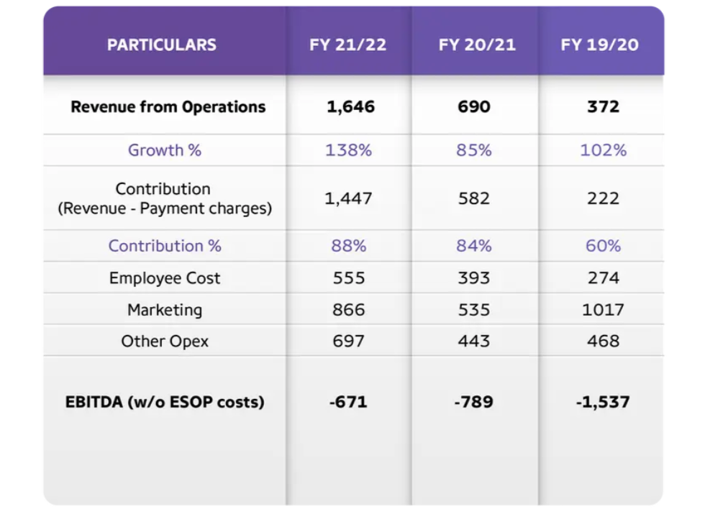

**RESEARCH OBJECTIVES**

* The aim of this study is to evaluate the financial position of the company.
* It seeks to assess the profitability of both PAYTM and PHONEPE FINTECH.

Finance is a fundamental pillar of business operations, pivotal for modern management practices. Effective financial management plays a crucial role in driving success and ensuring the sustainability of organizations. At the core of financial management lie financial statements, which serve as vital tools for informed decision-making. In this investigation, we aim to conduct an exhaustive analysis of the financial performance of two prominent entities in the fintech industry, PAYTM and PHONEPE FINTECH.

Through meticulous scrutiny of their financial statements and performance metrics, we seek to gain deep insights into the financial standings of both companies. This analysis will involve a comprehensive examination of their strengths, weaknesses, opportunities, and threats, providing a holistic view of their respective positions in the market. By identifying and understanding these factors, stakeholders can make informed decisions to capitalize on strengths, mitigate weaknesses, leverage opportunities, and address threats effectively.

Moreover, employing a PEST analysis framework will enable us to assess the external factors influencing the growth trajectories and market positioning of PAYTM and PHONEPE FINTECH. This analysis will delve into political, economic, social, and technological factors that impact the fintech industry, offering valuable insights into the broader business environment in which both companies operate. By understanding these external forces, stakeholders can better anticipate challenges, identify opportunities, and adapt their strategies accordingly.

Overall, this holistic approach to financial analysis aims to uncover valuable insights that will aid in strategic decision-making and foster sustainable growth for PAYTM and PHONEPE FINTECH. By gaining a comprehensive understanding of their financial positions, strengths, weaknesses, and market dynamics, stakeholders can navigate challenges effectively and capitalize on opportunities, driving long-term success and value creation for both companies.

**RESEARCH METHODOLOGY**

Exploratory research is employed when addressing a problem that lacks clarity, aiming to prioritize issues, refine operational definitions, and enhance the overall research design. It assists in determining the optimal research design, data collection method, and subject selection. Caution is advised when drawing definitive conclusions from exploratory research due to its foundational nature, as it often reveals that perceived problems may not actually exist.

Exploratory research commonly utilizes the following techniques:

* Secondary research, involving the review of existing literature and data.
* Casually conversing with consumers, employees, management, or competitors to gather insights.
* Employing structured qualitative research approaches such as in-depth interviews, focus groups, projective techniques, case studies, or pilot studies.

**DATA ANALYSIS AND INTERPRETATION**

What is your familiarity with financial statements of companies in the fintech industry, particularly paytm and phonepe?

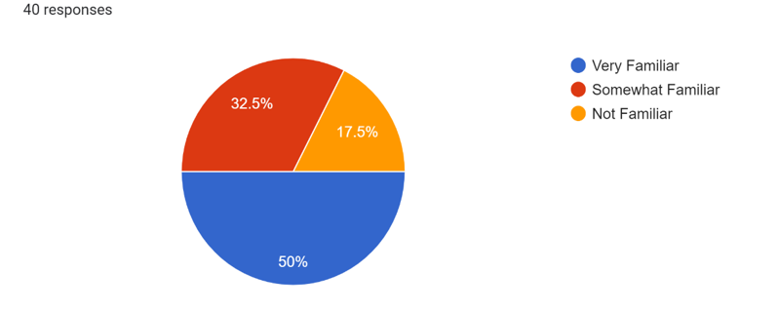

**Response Distribution**

* **Very Familiar (50%)**: This indicates that half of the respondents are highly familiar with financial statements in the fintech industry. They likely possess a deep understanding of financial reports, including those of PAYTM and Phonepe Fintech, and are comfortable analyzing and interpreting them confidently.
* **Somewhat Familiar (32.5%)**: Approximately one-third of the respondents have a moderate level of familiarity with financial statements in the fintech industry. While not as extensive as those who are "very familiar," they likely have some knowledge and experience in this area and can grasp basic concepts.
* **Not Familiar (17.5%)**: Around 17.5% of the respondents have little to no familiarity with financial statements of fintech industry companies, including PAYTM and Phonepe Fintech. They may require significant guidance or education to understand these statements effectively.

Which financial ratios do you consider most crucial for comparing the financial health of paytm and phonepe?

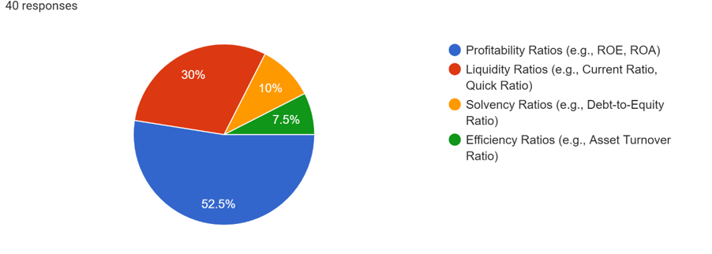

**Response Distribution**

* **Profitability Ratios (52.5%)**: Over half of the respondents consider profitability ratios such as Return on Equity (ROE) and Return on Assets (ROA) to be the most crucial. These ratios measure the companies' ability to generate profits relative to their equity and assets, providing insights into their overall efficiency and profitability.
* **Liquidity Ratios (30%)**: A significant portion of respondents prioritize liquidity ratios like the Current Ratio and Quick Ratio. These ratios assess the companies' ability to meet short-term obligations with their current assets, indicating their liquidity and ability to handle financial emergencies.
* **Solvency Ratios (10%)**: A smaller percentage of respondents focus on solvency ratios such as the Debt-to-Equity Ratio. These ratios evaluate the companies' long-term financial stability by comparing their debt levels to their equity, indicating their ability to meet long-term obligations.
* **Efficiency Ratios (7.5%)**: A minority of respondents emphasize efficiency ratios like the Asset Turnover Ratio. These ratios measure how effectively the companies are utilizing their assets to generate revenue, providing insights into their operational efficiency.

What sources or platforms do you primarily use for accessing financial data and reports of companies like paytm and phonepe?

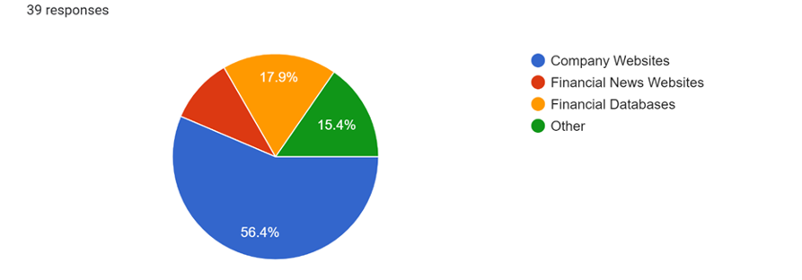

**Response Distribution**

* **Company Websites (56.4%)**: The majority of respondents primarily rely on company websites for accessing financial data and reports. These platforms often provide direct access to official financial statements, annual reports, and other relevant information directly from the companies themselves.
* **Financial News Websites (10.3%)**: A smaller percentage of respondents use financial news websites such as Bloomberg or Reuters. These platforms often provide comprehensive coverage of financial markets, including news, analysis, and sometimes access to financial data and reports of specific companies.
* **Financial Databases (17.9%)**: Some respondents use financial databases like Bloomberg Terminal or Capital IQ. These platforms offer extensive databases of financial information and analysis tools for professionals in finance and investment industries.
* **Other (15.4%)**: A portion of respondents indicated using other sources or platforms not specified in the options provided. These sources could include specialized financial research platforms, industry-specific publications, or other proprietary sources.

In your opinion, which company between paytm and phonepe has shown better financial performance in the past five years?



**Response Distribution**

* **PAYTM (45%)**: A plurality of respondents believe that PAYTM has demonstrated superior financial performance over the past five years. Their reasoning could be attributed to factors such as improvements in profitability, growth in revenue, effective cost management, or other positive financial indicators specific to PAYTM.
* **Phonepe Fintech (27.5%)**: A significant portion of respondents favor Phonepe Fintech for exhibiting better financial performance during the specified period. Reasons for this opinion might include consistent profitability, strategic acquisitions or expansions, effective management of market challenges, or other favorable financial metrics associated with Phonepe Fintech.
* **Both companies are similar in financial performance (20%)**: Some respondents perceive both PAYTM and Phonepe Fintech to have displayed comparable financial performance over the past five years. This viewpoint might stem from similarities in financial metrics, market trends, industry conditions, or overall performance indicators between the two companies.
* **Not Sure (7.5%)**: A small percentage of respondent’s express uncertainty or lack of sufficient information to determine which company has shown better financial performance. This uncertainty could arise from limited access to financial data, complexity in analyzing financial performance, or other factors influencing their decision-making process.

How do you perceive the impact of global economic trends and geopolitical factors on the financial performance of paytm and phonepe?

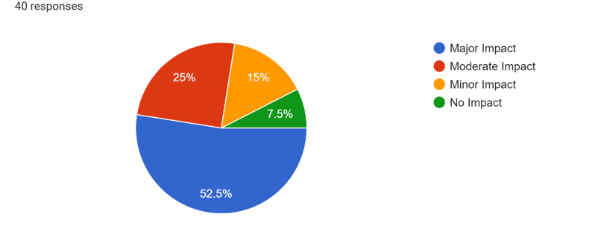

**Response Distribution**

* **Major Impact (52.5%)**: The majority of respondents believe that global economic trends and geopolitical factors have a significant influence on the financial performance of both PAYTM and Phonepe Fintech. They likely perceive those changes in global economic conditions, such as fluctuations in commodity prices, trade policies, or geopolitical tensions, directly impact the financial stability and profitability of these companies.
* **Moderate Impact (25%)**: A significant portion of respondents perceive that global economic trends and geopolitical factors have a moderate influence on the financial performance of PAYTM and Phonepe Fintech. While they acknowledge the importance of these external factors, they may believe that the companies' financial performance is also influenced by other internal factors to a certain extent.
* **Minor Impact (15%)**: Some respondents believe that global economic trends and geopolitical factors have a relatively minor influence on the financial performance of PAYTM and Phonepe Fintech. They may perceive that the companies' financial performance is more driven by internal factors such as operational efficiency, strategic decisions, or market demand rather than external macroeconomic conditions.
* **No Impact (7.5%)**: A small percentage of respondents perceive that global economic trends and geopolitical factors have no significant impact on the financial performance of PAYTM and Phonepe Fintech. They may believe that the companies' financial performance is insulated from external factors or that other internal factors play a dominant role in determining their financial outcomes.

Which areas of financial management do you think paytm and phonepe should focus on for improvement or optimization?

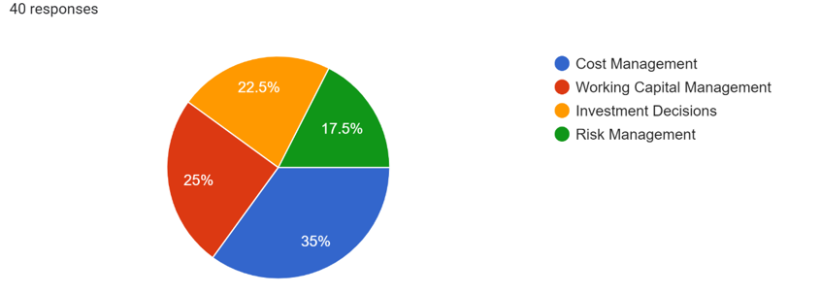

**Response Distribution**

* **Cost Management (35%)**: The largest portion of respondents believe that both PAYTM and Phonepe Fintech should focus on improving cost management. This could involve identifying and implementing strategies to reduce expenses, enhance operational efficiency, streamline processes, and optimize resource utilization to improve profitability.
* **Working Capital Management (25%)**: A significant number of respondents suggest that PAYTM and Phonepe Fintech should prioritize working capital management. This might involve managing cash flow, inventory, and accounts receivable/payable effectively to ensure optimal utilization of resources and maintain liquidity for day-to-day operations.
* **Investment Decisions (22.5%)**: A notable portion of respondents recommend that PAYTM and Phonepe Fintech pay attention to their investment decisions. This could involve evaluating and prioritizing capital expenditure projects, assessing potential risks and returns, and making strategic investment decisions aligned with their long-term goals and financial objectives.
* **Risk Management (17.5%)**: Some respondents emphasize the importance of focusing on risk management for both PAYTM and Phonepe Fintech. This might include identifying, assessing, and mitigating various financial risks such as market risk, operational risk, credit risk, and regulatory compliance risk to safeguard the companies' financial health and stability.

**RESULT**

DATA ANALYSIS AND INTERPRETATION

Current Ratio:

One crucial responsibility of the financial manager is to uphold adequate liquidity. The current ratio serves as a significant measure to assess liquidity and short-term solvency. A ratio of 2:1 is typically regarded as the standard for current ratio.

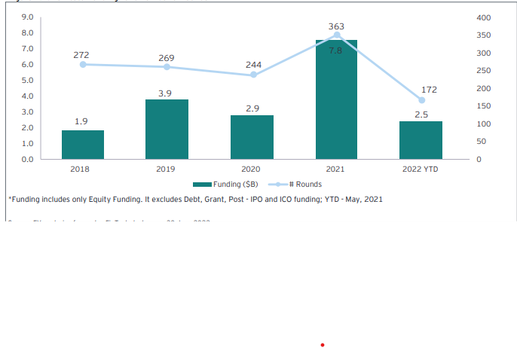

INTERPRETATION

Based on the above table and graph, it is evident that in 2012, PAYTM had a current ratio of 1.73 times, which increased to 2.05 times by 2014, but decreased to 1.49 times by 2016. In contrast, PHONEPE FINTECH LTD. had a current ratio of 3.92 times in 2012, which decreased to 0.79 times by 2016. From this analysis, it can be inferred that PAYTM's financial position is superior to that of PHONEPE FINTECH LTD.

Quick Ratio:

This ratio serves as a more precise assessment of liquidity and solvency compared to others. It specifically considers only liquid assets that can be readily converted into cash, excluding current assets like inventories that are further removed from cash. The quick ratio is calculated by dividing liquid assets by current liabilities, with a ratio of 1:1 generally deemed sufficient.

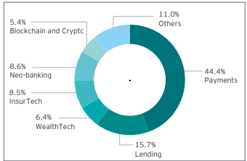

INTERPRETATION

From the above table and graph, it's evident that in 2012, PAYTM had a quick ratio of 1.23 times, which increased to 1.35 times by 2015 but decreased to 0.81 times by 2016. Notably, this decrease occurred only once during the study period. Conversely, PHONEPE FINTECH LTD. had a quick ratio of 3.52 times in 2012, which decreased to 0.51 times by 2016. Based on this analysis, it can be concluded that PAYTM's financial position, in terms of the quick ratio, is superior to that of PHONEPE FINTECH LTD.

Inventory Turnover Ratio:

This ratio reflects the efficiency of stock utilization. A higher ratio is deemed favorable.

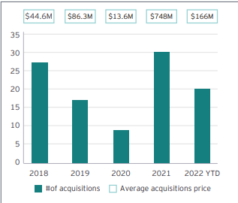

INTERPRETATION

This ratio indicates the efficiency of stock utilization, representing how quickly inventory is converted into sales throughout the year. The provided chart and graph illustrate that PAYTM's inventory turnover ratio was 8.62 times in 2012 and decreased to 3.71 times in 2016, signifying a notable decline. In contrast, PHONEPE FINTECH LTD. had an inventory turnover ratio of 10.84 times in 2012, maintaining a consistent performance with the ratio remaining around 9 times until 2016, where it stood at 9.40 times. In terms of inventory turnover ratio, PHONEPE FINTECH LTD.'s financial position surpasses that of PAYTM.

Dividend per Share:

Dividend per share represents the amount of dividend paid to each shareholder per share they hold in the company.

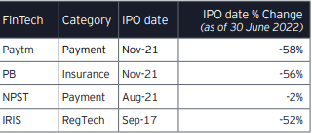

INTERPRETATION

Based on the above table and graph, it is evident that PAYTM had a dividend per share of Rs. 3.70 in 2012, which decreased to Rs. 3.30 in 2014 and further to Rs. 2.00 in 2016. In contrast, PHONEPE FINTECH LTD. had a dividend per share of Rs. 16.00 in 2012 and Rs. 12.00 in 2016. From this analysis, it can be concluded that PHONEPE FINTECH LTD. is paying higher dividends compared to PAYTM.

Operating Ratio:

A lower operating ratio is preferred as it signifies the effectiveness of management. The lower the ratio, the greater the profitability, highlighting management's efficiency.

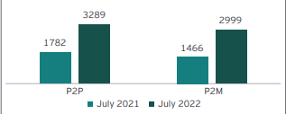

INTERPRETATION

Based on the above table and graph, it is evident that PAYTM had an operating ratio of 28.19% in 2012, which decreased to 22.69% in 2014 and further to 13.15% in the last year of the study, 2016. In contrast, PHONEPE FINTECH LTD. had an operating ratio of 41.94% in 2012, which decreased to 35.49% by 2016. This indicates that PAYTM's financial position is superior to that of PHONEPE FINTECH LTD. in terms of operating ratio, as PAYTM consistently maintained lower operating ratios compared to PHONEPE FINTECH LTD.

Gross Profit Ratio:

This ratio assesses the gross margin of profit generated from sales. A higher gross profit ratio indicates better performance.

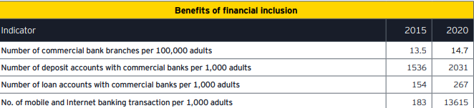

INTERPRETATION

Based on the above table and graph, it is evident that PAYTM had a gross profit of 25.10% in 2012, which decreased to 19.40% in 2014 and further to 9.74% in the last year of the study, 2016. In contrast, PHONEPE FINTECH LTD. had a gross profit of 37.70% in 2012, which decreased to 32.09% by 2016. This suggests that PHONEPE FINTECH LTD. has a stronger financial position than PAYTM in terms of gross profit, as PAYTM experienced greater variation in gross profit compared to PHONEPE FINTECH LTD.

Net Profit Ratio:

This ratio represents the net profit relative to sales. A higher ratio signifies greater profitability for the business.

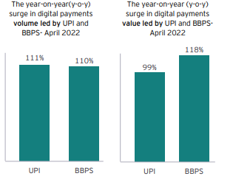

INTERPRETATION

According to the above chart, PAYTM's net profit ratio was 18.16% in 2012, declining to 7.44% in 2016, indicating a significant decrease. Conversely, PHONEPE FINTECH LTD. had a net profit ratio of 23.43% in 2012, which decreased to 19.96% in 2014, but rose slightly to 19.47% in 2016. Based on this data, it can be concluded that PHONEPE FINTECH LTD. holds a stronger financial position compared to PAYTM in terms of net profit.

Total Debt/Equity Ratio:

This ratio illustrates the correlation between long-term debts and shareholders' funds, revealing the proportion of funds acquired through long-term borrowings relative to shareholders' funds.

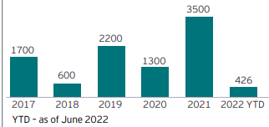

INTERPRETATION

According to the above table and graph, PAYTM's debt equity ratio was 0.12% in 2012, increased to 0.20% in 2014, and further to 0.29% in the last year of the study, 2016. Conversely, PHONEPE FINTECH LTD. had a debt equity ratio of 1.07% in 2012, which decreased to 0.46% by the last year of the study, 2016.

Dividend Payout Ratio:

The dividend payout ratio indicates the portion of net earnings available to shareholders that the company distributes as dividends.



INTERPRETATION

The chart illustrates that PAYTM's dividend payout ratio was 23.71% in 2008, 20.32% in 2009, and remained relatively stable in 2010 and 2011, but increased to 27.10% in the last year of the study, 2012. In comparison, PHONEPE FINTECH LTD.'s dividend payout ratio was 29.39% in 2008, decreased to 19.04% in 2011, and slightly increased to 20.11% in the last year of the study. Based on this data, it can be inferred that PAYTM's financial position is better than that of PHONEPE FINTECH LTD. in terms of dividend payout ratio

**LIMITATIONS**

The analysis and interpretation conducted in this study are grounded in secondary data that were extracted from the published annual reports of PAYTM and PHONEPE FINTECH for the designated study period. These annual reports serve as comprehensive documents that detail various aspects of the companies' financial performance, including income statements, balance sheets, cash flow statements, and accompanying notes.

By utilizing this primary source of information, we aim to provide an in-depth assessment of the financial standing of both PAYTM and PHONEPE FINTECH. This study has limitations associated with the availability of data and constraints related to data accessibility and reliability that restrict the scope to a period of five years, spanning from 2012 to 2016. While this timeframe allows for a meaningful analysis of financial trends and patterns over a significant duration, it may not capture the entirety of each company's financial trajectory, which is crucial for a complete assessment.

One of the primary tools utilized in this analysis is financial ratios, providing valuable insights into the financial position and performance of the companies during the specified period, however, these ratios offer a limited perspective and may not fully capture the nuances of the companies' financial dynamics over an extended period. Financial ratios offer valuable insights into profitability, liquidity, and solvency. Still, they do not provide a comprehensive picture of all activities undertaken by the companies.

While this study leverages secondary data from annual reports to analyze the financial performance of PAYTM and PHONEPE FINTECH, it is essential to recognize the limitations inherent in the data availability and the scope of analysis. Nonetheless, through a careful examination of financial ratios and trends, this study aims to provide valuable insights into the financial standing of both companies during the specified period!

**CONCLUSION**

Effective financial management is paramount for the prosperity of any enterprise. Financial performance is a dynamic aspect that evolves rapidly. In today's business landscape, there's a heightened emphasis on financial performance, underscoring its significance. In this analysis, we aimed to compare the financial performance of Fintech Authority of India (PAYTM) and PHONEPE FINTECH LTD.

By scrutinizing their balance sheets and profit and loss statements, we assessed their operational and financial efficiency. Financial performance serves as a critical measure of a company's health, influencing strategic and operational decisions. Continuous efforts towards enhancing financial standing are imperative, leading to improved efficiencies and heightened investor satisfaction.

Both PAYTM and PHONEPE FINTECH LTD. hold significant positions in India's fintech manufacturing sector. However, upon conducting a comparative analysis, we observed that PHONEPE FINTECH LTD. outperforms PAYTM. This is evident from PHONEPE FINTECH LTD.'s higher net profit compared to PAYTM and superior inventory management practices.

**BIBLIOGRAPHY**

**Websites :**

ey-winds-of-change-india-fintech-report-2022

• Cao, L. "AI in Finance: Challenges, Techniques, and Opportunities." ACM Computing Surveys (CSUR) 55, no. 3 (2022): 1-38.

• Chiu, Y.-T., Zhu, Y.-Q., and Corbett, J. "In the Hearts and Minds of Employees: A Model of Pre-adoptive Appraisal Toward Artificial Intelligence in Organizations." International Journal of Information Management 60 (2021): 102379.

• Das, S. R. "The future of fintech." Financial Management 48, no. 4 (2019): 981-1007.

• Fenwick M., and Vermeulen E. P. M. "How to respond to artificial intelligence in Fintech." Japan Spotlight (2017): 16–20.

• Fu, R., Huang, Y., and Singh, P.V. "Crowds, lending, machine, and bias." Information Systems Research 32, no. 1 (2021): 72-92.

• Guo, H., and Polak, P. "Artificial intelligence and financial technology FinTech: How AI is being used under the pandemic in 2020." In The Fourth Industrial Revolution: Implementation of Artificial Intelligence for Growing Business Success, edited by Hamdan, A., Hassanien, A. E., Razzaque, A., and Alareeni, B., 169-186. Springer, Cham, 2021