**SERIES VOLTAGE REGULATOR FOR A DISTRIBUTION TRANSFORMER TO COMPENSATE VOLTAGE USING SVPWM**

Shrinath Yadav1, Prakash Narayan Tiwari2

1M. Tech Scholar, Department of Electrical & Electronics Engineering, Rabindranath Tagore University, Bhopal (India)

2Assistant Professor, Department of Electrical & Electronics Engineering, Rabindranath Tagore University, Bhopal (India)

**ABSTRACT**

In this paper a series voltage regulator is proposed which supports the output voltage during sag and swell conditions at the input. The input of the converter is single phase AC and the output is also single-phase AC with different voltage magnitude. The input voltage is modified with abnormalities like sag and swells conditions. The output voltage is stabilized by closed loop controller which maintains the voltage at certain level. A comparative analysis is carried out with sinusoidal PWM and space vector PWM technique for the generation of output voltage. Magnitude and THD comparisons are taken between these two techniques using FFT analysis tool available in MATLAB Simulink software.

**Keywords:** Single-Phase AC, Sag and Swell Conditions, SVPWM, THD, MATLAB.

**1 INTRODUCTION**

The event of a sensible grid system, a highly reliable electricity supply has become a very important issue. A fundamental component in providing reliable electricity to the end-user is that the step-down distribution transformer, this distribution transformer operates at line frequency (LF) (50/60 Hz) to step down from medium voltage (MV) to low voltage (LV). whether or not the traditional distribution transformer is comparatively inexpensive, highly efficient, and reliable, it's not absolute to protect loads from undesirable events like voltage sags and swells. Voltage sags and swells became one amongst the foremost critical power quality issues faced by many industrial consumers in power distribution systems. because the complexity of the electronics equipment utilized in industrial applications grows, customer loads have become more liable to voltage disturbances like sags and swells. Voltage sags/swells cost many scores of dollars per annum within the us. The voltage sags and swells lead to significant economic losses in a very wide selection of industries, including financial services, health care, and process manufacturing. Consequently, it's suggested to incorporate voltage compensation functionality within the conventional MV/LV step-down distribution transformer. Voltage sags and swells may be described by two essential characteristics: magnitude and duration. The survey of power quality presents that voltage sags with 40–50% of the face value and with the duration from 2 to 30 cycles occurred in about 92% of all power grid events. the facility acceptability curves are introduced within the bus voltage and duration time plane. the data Technology Industry Council (ITIC) curve presents a suitable voltage range between the upper locus (labeled over-voltage condition) and therefore the lower locus (labeled under-voltage condition), which is that the “acceptable power quality” region. Hence, it's recommended to think about a deep voltage compensator for a wider range of voltage compensation over an extended steady-state period. so as to make amends for voltage sags and swells within the power distribution system, several approaches include on-load tap changers, dynamic sag correctors (DVSCS), ride-through voltage compensators, and dynamic voltage restorers (DVR), and hybrid distribution transformers are developed.

A customer may experience a wide variety of power quality issues, which may be categorised in part by the degree to which the voltage waveform has been distorted. Voltage imbalance, waveform distortion (dc offset, harmonics, inter harmonics, notching, and noise), voltage fluctuations, and power frequency variations all exist, as do transients, short duration variations (sags, swells, and interruption), and long duration variations (sustained interruptions, under voltages, over voltages).

## 1.1 Power Quality Issue

Power quality issues might include fluctuations in voltage, fluctuations in frequency, distortion of harmonics, impulse transients, and power outages. Drops in voltage may happen at any moment, with amplitudes ranging from 10% to 90%, and lasting anywhere from half a cycle to one minute. However, a voltage surge is defined as a rise in rms voltage or current at the power frequency for times ranging from half a cycle to one minute. Magnitudes between 1.1 and 1.8 are common. The residual voltage is another metric for describing the size of a swell, and in this instance, it is always larger than 1.0. [13] because they occur less often, voltage surges are not as significant in power grids as voltage dips. Sensitive equipment (such that found in semiconductor or chemical facilities) may malfunction or shut down due to voltage fluctuations, and the resulting significant current imbalance may cause fuses or breakers to blow. These implications, which might range from slight quality differences to production stops and equipment damage, can add up to significant costs for the client.[4].

# 2. METHODOLOGY

Existing LFT is connected to an auto-connected PEs module on the secondary side to smooth out voltage dips and spikes; this is the suggested solution. As a result of this auto connection, a compensator with a shunt input and series output may be constructed, with no capacitive energy storage required. Thus, the suggested system is distinct from the typical series compensator, such as a DVR, in both its structure and its operation.

To produce the compensating voltage Vc, the suggested system takes use of the Vin at the input. Rather of relying on a battery to control the voltage, this is a tap changer transformer, which uses the source voltage to modify the turns ratio of the transformer, thereby regulating the load voltage. As a result of how the PEs module is built, we may use its partial power processing capacity to decrease the suggested system's rating. In addition, the system's overall efficiency may be improved when in bypass mode. The output voltage delivered to the load may be controlled by the PEs module, which does so by generating a compensating voltage that is vector-added to the grid voltage.

# 2.1 Typical Single Phase Voltage Swell

In comparison to voltage dips, voltage swells are described by the IEC 61000-4-30 standard as a transient rise in RMS voltage of 10% or more over the equipment specified voltage range for a duration of 1/2 cycle to 1 minute. Voltage surges are not as prevalent as voltage dips, and they are often caused by problems with the system. A single line to ground fault may cause a swell, as seen in the following example, which temporarily raises the voltage level of the unfaulted phases. Ungrounded or floating ground delta systems are more prone to this. In addition to this, swells may occur when a substantial load is suddenly removed from service

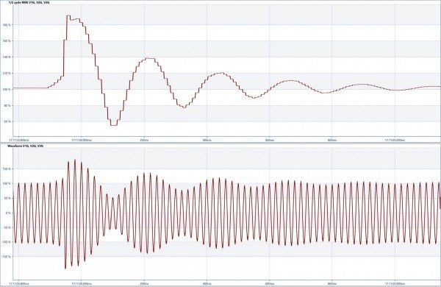

Fig. 1. Typical single phase voltage swell

Table 1. Voltage swells magnitude and duration

|  |  |  |
| --- | --- | --- |
| **Voltage Swell** | **Magnitude** | **Duration** |
| Instantaneous | 1.1 to 1.8 pu | 0.5 to 30 Cycles |
| Momentary | 1.1 to 1.4 pu | 30 cycles to 3 sec |
| Temporary | 1.1 to 1.2 pu | 3 sec to 1 min |

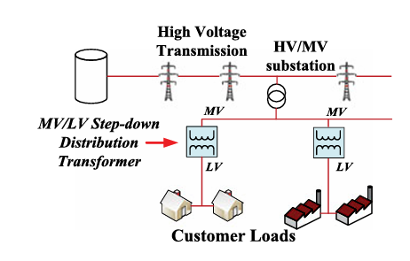

Fig. 2. step-down distribution transformer in the distribution grid network

## 2.1 Space Vector Pulse Width Modulation Technique:

Controlling the power switches in the right order to minimise switching loss and maximise efficiency is the goal of Space Vector Modulation (SVM). the output voltage and input current are modulated via a space vector pulse width modulator. The method's benefit lies in the fact that the switching vector used to regulate the input current and the output voltage may be selected arbitrarily. When the scales are tipped in one direction, this strategy may be advantageous. vectors in space are used to represent the three phase variables. In order to ensure that each PWM cycle has the correct gate drive waveform, this module creates that waveform automatically. Because of this, the inverter may merge many switching states into a single one (number of switching states depends on levels). For each of these states, the SVPWM calculates a different switching time. This method is compatible with all types of multilevel inverters and may be simply adapted for use with greater voltages (cascaded, capacitor clamped, diode clamped). The required voltage vector Vref may be calculated from the duty cycle time of each of the three input vectors that compose a triangle. [3] The SVPWM vector chart is shown in the figure.

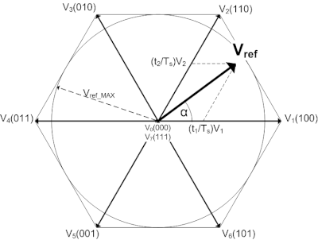

Fig. 3. Space Vector modulation

Waveforms are a specific example of the triangulation approach with a modified reference waveform, as illustrated in figure, which is generated by adding an essentially triangular, third harmonic distortion waveform to the required sinusoidal component. “Due to the inherent additive third harmonic triangle waveform, the characteristics of the space vector PWM waveforms are very similar to those obtained through the addition of third harmonic sinusoidal distortion to a triangulation modulator although, as will be shown later, the space vector generation technique presented in this has many advantages over the traditional triangulation method in particular it is more amenable to microprocessor implementation.[4].

## 2.2 Conventional Sine PWM

The voltage source inverter makes advantage of the SPWM control method. In this method, triangle signals are compared to sine waves; if the sine wave has a larger amplitude, a pulse is generated for the positive half cycle, and if the sine wave has a smaller amplitude, a pulse is generated for the negative half cycle. The number of pulses per half-cycle is determined by the carrier signal, whose frequency is twenty times that of the sinewave. Carrier signals operate at a significantly higher frequency than radio waves.

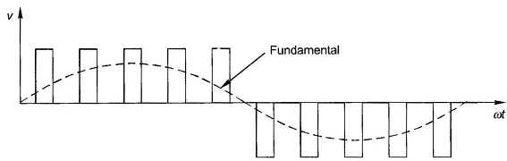

Fig. (a). Sinusoidal Pulse Width Modulation waveform

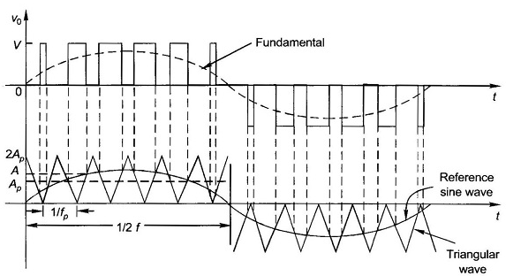

Fig. (b). Output voltage of SPWM

### 2.3 Advantages of SVPWM

* SVPWM makes efficient use of the DC link voltage, has minimal current ripple, and is straightforward to implement in hardware.
* The SVPWM maximises the use of voltage by 15 percent more than the SPWM. This quality qualifies it for use in renewable power production and other high-voltage, high-power applications.
* When comparing SVM to SPWM, we find that SVM produces less harmonic distortion in the output voltage or current.
* Compared to sine PWM, SVM makes better use of the available supply voltage.

**2.4 Limitations of Sinusoidal PWM**

As the depth of the hierarchy grows, so does the number of unnecessary transitions. As the number of possible transition states grows, so does the difficulty of their selection.

The SVPWM technique is more popular than the standard technique.

* Greater effective utilisation of DC supply voltage
* 15% more output voltage than conventional modulation
* Lower Total Harmonic Distortion (THD)
* Reduce commutation losses by avoiding unnecessary switching

**3. SIMULATION RESULTS AND DISCUSSION**

## 3.1 Simulation Parameters

To validate the proposed power management scheme, MATLAB/Simulink software is used for complete simulation studies using MATLAB/SIMULINK, we simulate a basic distribution network to see how effectively we can prevent voltage drops and surges with the help of the suggested controller the constants and system parameters are tabulated below.

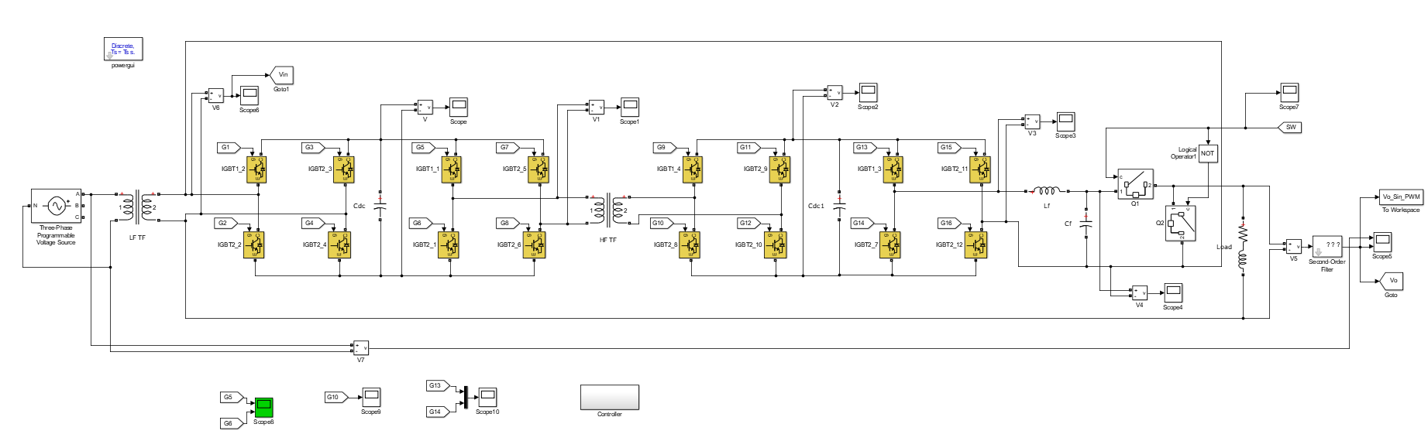

Fig.5. Power electronics module in the proposed distribution transformer using SPWM

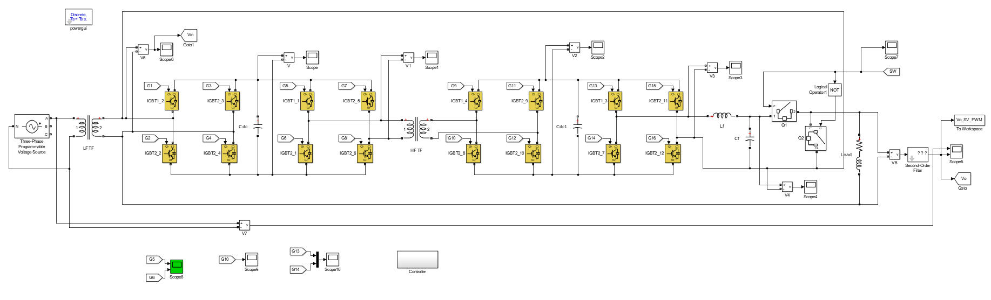

Fig. 6. Power electronics module in the proposed distribution transformer using SVPWM

The A phase voltage amplitude is varied at different intervals of time creating sags and swells in the magnitude of the input voltage. The controller of the voltage regulator circuit can be seen below with feedback from the input side voltage and output side voltage.

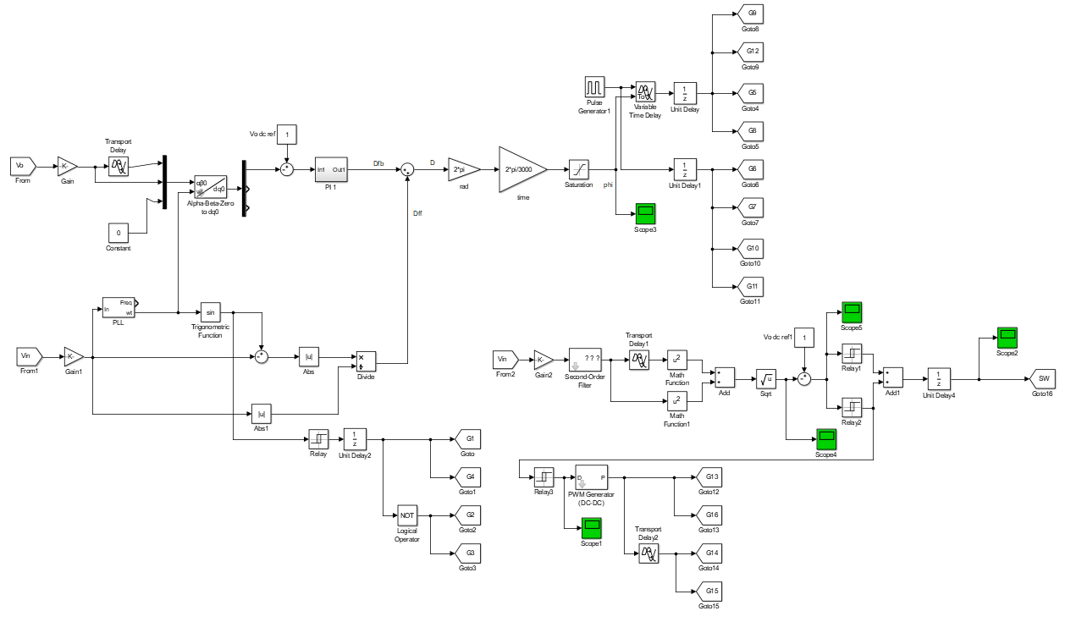

Fig. 7. Control modelling of the proposed using SPWM scheme.

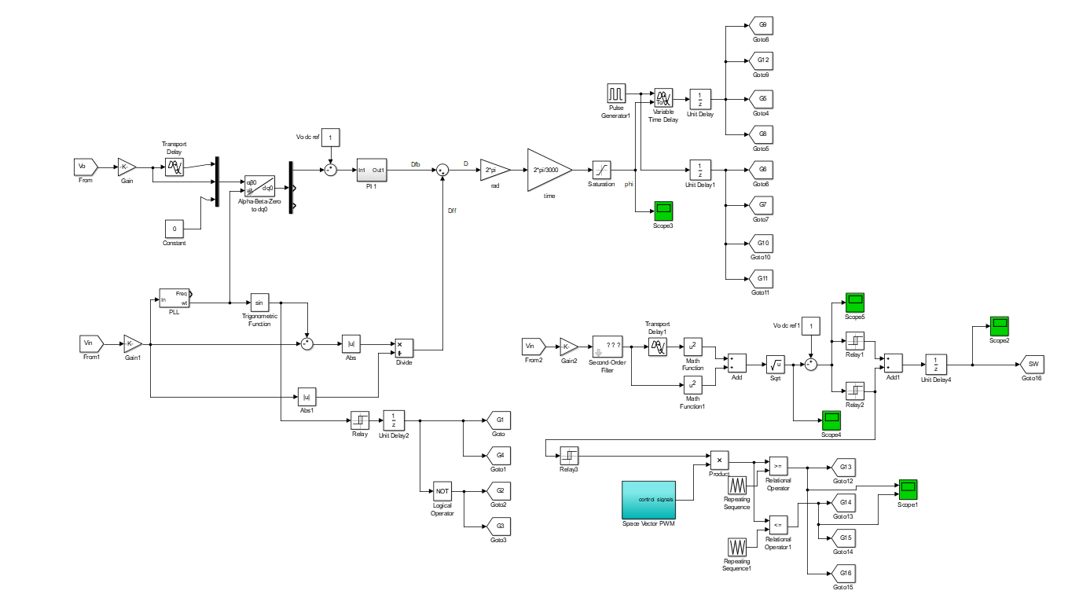

Fig. 8. Control modelling of the proposed using SVPWM scheme

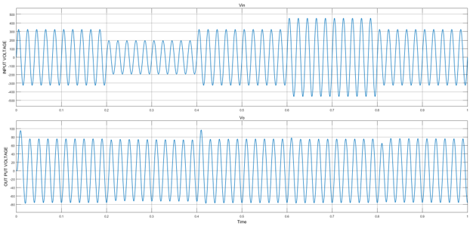

Fig. 9. Input and output voltage comparison

As seen the input voltage has sag from 0.2 - 0.4sec and swell from 0.6 - 0.8sec which is compensated in the output voltage by the proposed topology. There is some sudden peak (0.4sec) and drop (0.8sec) voltages created at the change instances but however they are controlled later. The below figure is the secondary side low frequency (50Hz) transformer voltage which have very less harmonic content.

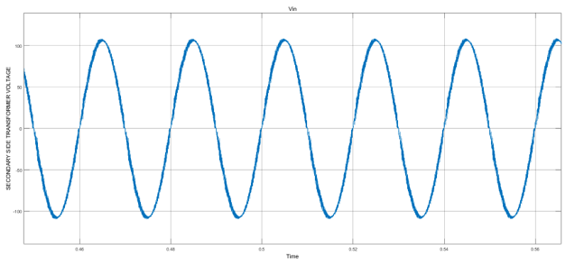

Fig. 10. Voltage at secondary side of the transformer

The below fig. is the low frequency side-controlled rectifier output which converts both positive and negative voltages of secondary voltage above to positive voltages.

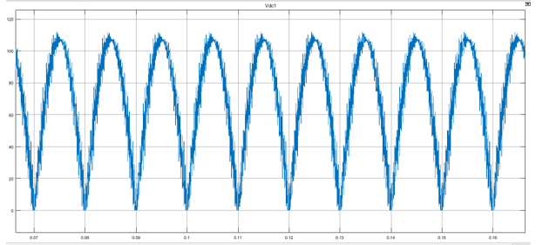

Fig. 11. Low frequency rectifier output voltage

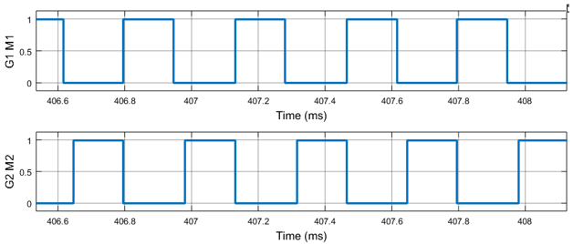

Fig. 12. Pulse inputs to the power electronics devices G1 M1 and G2 M2

The pulses to G1 M1 and G2 M2 switches are fed as shown above with 50% phase delay maintained always. In no state of operation these switches will turn ON simultaneously to avoid short circuit. The pulse inputs to G23 and M3 are shown below followed by pulse inputs to G1-G4 and M4.

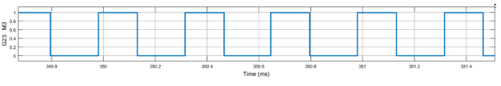

Fig. 13. Pulse inputs to the power electronics devices G23 and M3

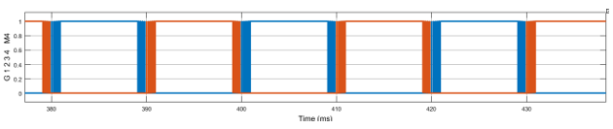

Fig. 14. Pulse inputs to the power electronics devices G1 G2 G3 G4 and M4

Folded voltage including HF components (Vfold) can be seen in fig. By 50 Hz unfolding switching operation, the HF fixed duty chopped 50 Hz sinusoidal voltage.

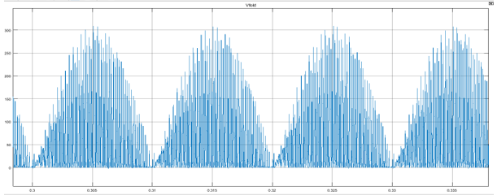

Fig. 15. Output voltage of the high frequency rectifier

The above is the voltage of the high frequency (20 kHz) rectifier which is placed on the secondary side of the high frequency transformer.

A THD comparative analysis with SPWM and SVPWM is shown in figures below.

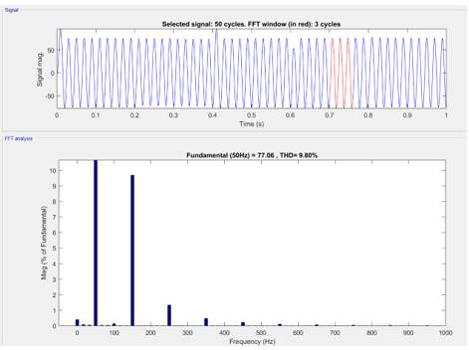

Fig. 16. THD of output voltage of the converter with sinusoidal PWM technique

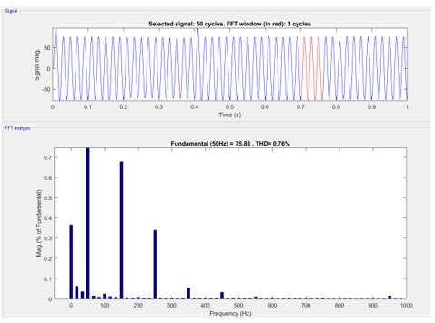

Fig.17. THD of output voltage of the converter with Space vector PWM technique

**3.2 Comparison Of Harmonics Of SPWM AND SVPWM**

Table 2.

|  |  |  |  |
| --- | --- | --- | --- |
| **SRN** | **Name** | **SPWM** | **SVPWM** |
| 1. | Out Put Voltage of a Converter | 8.9% | 0.76% |
| 2. | Voltage sag and Swell compensate | Less Compensate compatibility | High Compensate compatibility |
| 3. | Permfromance of Proposed system | Less Efficency | High Efficency |

**4. CONCLUSION**

There is a growing problem in the industrial sector and among consumers due to the increased demand for reliable power. Among them, voltage imbalance is regarded as the most significant factor that reduces the efficiency of electrical devices. The need for reliable electricity has grown in importance in the industrial sector and among consumers. Among them, voltage imbalance is regarded as the most significant impacting factor that causes electrical equipment to function poorly. as it can be seen in the results comparison of the input voltage and output voltages of the inverter, the input voltage has sags and swells at different time intervals. Sag from 0.2sec to 0.4sec and swell from 0.6sec to 0.8sec. The output voltage is however maintained at constant voltage magnitude even during input voltage fluctuation. The extra voltage compensation is given by the voltage regulator circuit using sinusoidal PWM and space vector PWM techniques. The THD comparisons of both the techniques are taken using FFT analysis recorded at 9.8% and 0.76% respectively. With the comparison of THDs the space vector PWM technique has very less harmonic content as compared to sinusoidal PWM technique.

**REFERENCES**

[1] T. Strasser et al., "A review of architectures and concepts for intelligence in future electric energy systems", IEEE Trans. Ind. Electron., vol. 62, no. 4, pp. 2424-2438, Apr. 2015.

[2] M. J. Sullivan, T. Vardell and M. Johnson, "Power interruption costs to industrial and commercial consumers of electricity", Proc. IEEE Ind. Commer. Power Syst. Tech. Conf. Rec., pp. 23-35, 1996.

[3] M. McGranaghan and B. Roettger, "Economic evaluation of power quality", IEEE Power Eng. Rev., vol. 22, no. 2, pp. 8-12, Feb. 2002.

[4] A. Moreno-Muñoz, J. M. Flores-Arias, V. Pallarés, J. J. G. and De la Rosa, "Power quality immunity in factory automation", Proc. Compat. Power Electron., pp. 12-17, 2009.

[5] S. Bhattacharyya, J. M. A. Myrzik and W. L. Kling, "Consequences of poor power quality: An overview", Proc. 42nd Int. Univ. Power Eng. Conf., pp. 651-656, 2007.

[6] S.-A. Yin, C.-N. Lu, E. Liu, C.-Y. and Huang, "A survey on high- tech industry power quality requirements", Proc. IEEE/PES Transm. Distrib. Conf. Expo., vol. 1, pp. 548-553, 2001. "IEEE 1159/2009.

[7] W. E. Brumsickle, R. S. Schneider, G. A. Luckjiff, D. M. Divan and M. F. Mc Granaghan, "Dynamic sag correctors: cost-effective industrial power line conditioning", IEEE Trans. Ind. Appl., vol. 37, no. 1, pp. 212-217, Jan./Feb. 2001.

[8] J. Kyei, R. Ayyanar, G. T. Heydt, R. Thallam and J. Blevins, "The design of power acceptability curves", IEEE Trans. Power Del., vol. 17, no. 3, pp. 828-833, Nov. 2002.

[9] D. Gao, Q. Lu and J. Luo, "A new scheme for on-load tap-changer of transformers", Proc. Int. Conf. Power Syst. Technol., pp. 1016-1020, 2002.

[10] N. Yorino, M. Danyoshi and M. Kitagawa, "Interaction among multiple controls in tap change under load transformers", IEEE Trans. Power Syst., vol. 12, no. 1, pp. 430-434, Feb. 1997.

[11] M. S. Calovic, "Modeling and analysis of under-load tap changing transformer control systems", IEEE Trans. Power App. Syst., vol. PAS-103, no. 7, pp. 1909-1915, Jul. 1984.

[12] A. Prasai and D. M. Divan, "Zero-energy sag correctors—Optimizing dynamic voltage restorers for industrial applications", IEEE Trans. Ind. Appl., vol. 44, no. 6, pp. 1777-1784, Nov./Dec. 2008.

[13] O. C. Montero-Hernandez and P. N. Enjeti, "Application of a boost ac-ac converter to compensate for voltage sags in electric power distribution systems", Proc. IEEE Power Electron. Spec. Conf., vol. 1, pp. 470-475, 2000.

[14] O. C. Montero-Hernandez and P. N. Enjeti, "Ride-through for critical load. Exploring a low-cost approach to maintaining continuous connections between buildings and/or industrial systems", IEEE Ind. Appl. Mag., vol. 8, no. 6, pp. 45-53, Nov./Dec. 2002.

[15] E. C. Aeloíza, P. N. Enjeti, L. A. Morán, O. C. Montero Hernandez and S. Kim, "Analysis and design of a new voltage sag compensator for critical loads in electrical power distribution systems", IEEE Trans. Ind. Appl., vol. 39, no. 4, pp. 1143-1150, Jul./Aug. 2003.

[16] A. K. Sadigh and K. M. Smedley, "Review of voltage compensation methods in dynamic voltage restorer (DVR)", Proc. IEEE Power Energy Soc. Gen. Meeting, pp. 1-8, Jul. 2012.

[17] S. S. Choi, J. D. Li and D. M. Vilathgamuwa, "A generalized voltage compensation strategy for mitigating the impacts of voltage sags/swells", IEEE Trans. Power Del., vol. 20, no. 4, pp. 2289-2297, Jul. 2005. A. Rauf and V. Khadkikar, "An enhanced voltage sag compensation scheme for dynamic voltage restorer", IEEE Trans. Ind. Electron., vol. 62, no. 5, pp. 2683-2692, May 2015.

[18] H. S. Krishnamoorthy, D. Rana, P. Garg, P. N. Enjeti, and I. J. Pitel, “Wind turbine generator-battery energy storage utility interface converter topology with medium-frequency transformer link,” IEEE Trans. Power Electron., vol. 29, no. 8, pp. 4146–4155, Aug. 2014.

[19] H. S. Krishnamoorthy, P. Garg, and P. N. Enjeti, “A matrix converter based topology for high power electric vehicle battery charging and V2G application,” in Proc. 38th Annu. Conf. IEEE Ind. Electron. Soc., 2012, pp. 2866–2871.

[20] Y. Zhuang, C. Wang, C. Wang, H. Cheng, Y. Gong, and H. Wang, “Deter mination method for topology configuration of hybrid cascaded H-bridge rectifiers,” J. Power Electron., vol. 16, no. 5, pp. 1763–1772, Sep. 2016.

[21] J. Shang, X. Nian, T. Chen, and Z. Ma, “Grid-friendly control strategy with dual primary-side series-connected winding transformers,” J. Power Electron., vol. 16, no. 3, pp. 960–969, May 2016.

[22] L. Asiminoaei, F. Blaabjerg, and S. Hansen “Detection is key—Harmonic detection methods for active power filter applications,” IEEE Ind. Appl. Mag. vol. 13, no. 4, pp. 22–33, Jul./Aug. 2007.

[23] A. S. Morsy, P. Enjeti, S. Ahmed, and A. Massoud, “Phase locked loop with fast tracking over wide stability range under grid faults,” in Proc. 29th Annu. IEEE Appl. Power Electron. Conf. Expo., Mar. 2014, pp. 1263–1267.

[24] Long Xian, Lizhen Wu, Xiaoying Zhang., “Improving fault ride‐through capability for doubly‐fed induction generator based on improved system structure and corresponding control scheme. IET Energy Syst. Integr. 6:73–85. March 2023.

[25] [P.Bhardwaj](https://onlinelibrary.wiley.com/authored-by/Bhardwaj/Prashant), [Anuj Verma](https://onlinelibrary.wiley.com/authored-by/Verma/Anuj),.,Synchronized Control Strategy of UPQC to Mitigate the Sag and Swell of Voltage., Macromolecular Symposia 407(1)DOI:[10.1002/masy.202200059](http://dx.doi.org/10.1002/masy.202200059)., February 2023.

[26] T. Kang, S. Choi, A. S. Morsy and P. N. Enjeti, "Series Voltage Regulator for a Distribution Transformer to Compensate Voltage Sag/Swell," in IEEE Transactions on Industrial Electronics, vol. 64, no. 6, pp. 4501-4510, June 2017, doi: 10.1109/TIE.2017.2668982.