Study of Wall Belt Support in Multistorey Building With Higher Importance Factor

Bhushan Madanlal Biyani, Ashwin Hardiya

PG Scholar, CED, Dr. APJ Abdul Kalam University Indore, M.P., India E mail -umarsheikh@gmail.com

Assistant Professor, CED, Dr. APJ Abdul Kalam University Indore, M.P., India E mail – ashwinhardiya@aku.edu.in

**ABSTRACT**

This paper briefs concerning purpose the effect of importance factor of structure with outrigger wall belt support system which is used in building where outrigger and wall belt supported system with the help of analytical method by design software. In this paper also brief the effects of earthquake and non-earthquake actions of multistory building with importance factor of concrete discussed in connection with outrigger and wall belt support system. The major principle of the review work is to study the effect of importance factor in outrigger and wall belt support system multistory buildings in the view of various researchers. The study can also be useful for low as well as high seismic prone areas as well. The software analysis also been referred for the analysis in the research field. This study deals with the comparative analysis of the research trend on the current topic and after the survey, comprehensive outcomes are provided in conclusions that forms the objectives of the further upcoming study.

Keywords— Importance Factor, Outrigger, Perceptional review, Seismic analysis, Wall belt supported system.

# INTRODUCTION

Outriggers are the combination of members of beams or plates linked from the core to external columns in both the directions that hold the structure and act as frame connections. The core provided such as shear wall core holds the whole construction resolutely that accepts the loads and transmit the loads uniformly to the external columns. This system provides more rigidity to the structure than conservative frame systems.The outrigger and belt support framework are one of the horizontal burdens opposing framework in which the outer segments are attached to the focal center divider with hardened outriggers and belt bracket at least one dimensions. faced many disaster activity in past such as earthquake, tsunami etc. In our country Earthquake has become more and more frequent in some part. As the earthquake is natural disaster, we cannot predict it but we can reduce damages by providing various lateral load resisting system in building. Buildings are subjected to two types of load (I) Vertical load due to gravity, and (II) Lateral load due to earthquake and wind. Lateral load resisting system is provided to resist seismic load and wind load. Generally multi-storey building is governed by lateral loads. Various Lateral load resisting systems are used to such as Shear wall, Belt Truss, Outrigger, Belt Truss + Outrigger, Diagrid, Staggered Truss, Tube in Tube etc. These systems may increase the stiffness of the structure and absorb lateral forces acting during earthquake and wind.

# LITERATUREREVIEW

**Minu Mathew ,Manjusha Mathew (2017)**

Concluded in their paper that he reviewed approach for the design and development of tall building using outrigger and belt wall is useful to provide a potential solution. Recently, outrigger and belt wall system is widely used to reduce lateral drift. To achieve required stiffness of tall building increase of bracings sizes as well as introduction of additional lateral load resisting system such as belt truss and outriggers is required. The placement of outrigger trusses increases the effective depth of the structure and significantly improves the lateral stiffness under lateral load. Three dimensional modelling for G+45 storey building of concrete is done and the analysis results are taken for the same. Outriggers are rigid horizontal structure i.e. truss or beam which connect core wall and outer column of building to improve building strength and overturning stiffness. Outriggers have been used in tall building for nearly half century, but innovative design principle has been improving its efficiency.Tall buildings need a lateral load resisting system to resist the lateral loads induced by wind or earthquake forces. One of the most efficient systems is outrigger. Outriggers are structural systems that support building against lateral loads. The various parameters like lateral displacement, storey drift, core moment and optimum position related to outrigger and belt wall are reviewed

**Prajyot A. Kakde, Ravindra Desai (2017)**

Concluded in their paper that heoutrigger and belt truss structural system has proved to be most promising structural system in resisting problem related to lateral stability and sway. The present study is conducted for 70 storied high rise building with core shear wall. High rise building with floor plan of 30 m x 30 m in addition with core shear wall of 10 m x 10 m is considered with building aspect ratio of 7.Wind analysis is carried out to study parameter’s maximum storey displacement, inter storey drift and base shear to compare building with application of concrete and steel outrigger at various position varying with the height of building and the software used for this analysis is ETABS of 2016 version.In today’s modern era it has become need to undertake development in tall structure to accommodate the present population as the cities are growing fast and land availability is becoming lesser for human beings, so there is need for development of tall structures, but with development of tall structures there is need to tackle the problems related to it .Outrigger and belt truss structural system has proved to be efficient and economical solution for the problems related to tall structure development.Rapid growth of infrastructure to accommodate modern civilization is demanding tall structures in cities. As the buildings are becoming taller the problem of their lateral stability and sway has to be tackled by engineering judgment. Structural system development has evolved continuously to overcome the problems related to lateral stability and sway, one such structural system is outrigger and belt truss structural system

**LekshmiSoman, SreedeviLekshmi(2017)**

Concluded in their paper thatOutrigger braced structures is an efficient structural form in which the central core is connected to the outer columns. The structural concept of these systems is that when the central core tries to tilt, its rotation at the outrigger level induces a tension-compression couple in the outer columns acting in opposition to that movement. Most

importantly, outrigger braced structures can strengthen a building without disturbing its aesthetic appearance and this is a significant advantage over other lateral load resisting systems. This paper presents the results of an investigation on storey drift and base shear reduction in RC building frame with rigid outriggers, through Response Spectrum Analysis using the software ETABS 2015. Mankind is always fascinated for Tall building. In Early era the symbol of economic power and leadership is the skyscraper. There has been a demonstrated competitiveness that exists in present mankind to proclaim to have the tallest building in the world. The design of tall and slender structures is controlled by three governing factors, strength (material capacity), stiffness (drift) and serviceability (motion perception and accelerations),Today’s increased need for housing in metropolitan cities leads to the emergence of high rise buildings. Tall buildings are becoming more and more slender and this leads to more possible sway during the occurrence of lateral loads. When building height increases tremendously, the structure should have lateral load resisting system other than shear walls for avoiding the effect of these loads, since the shear walls when used alone are suitable only up to 20 stories high. Outrigger systems are one such prominent system and are now considered to be the most popular and efficient because they are easier to build, save on costs and provide good lateral stiffness.

**Roslida Abd. Samat ,Nasly Mohamed Ali , Abdul Kadir Marsono , and Abu Bakar Fadzil(2018)**

Concluded in their paper that along-wind responses are determined by employing the procedures from the ASCE 7-16 while the across-wind responses of the buildings are calculated based on the procedures and wind tunnel data available in a database of aerodynamic load. Results from the analysis show that the belt wall reduces the along-wind and across-wind responses slightly. However, belt wall reduces the torsional acceleration of the buildings significantly, which otherwise cannot be reduced by the outrigger system.According to [4], human perception to motion and vibration is affected mainly due to acceleration. People can strongly perceive motion and have difficulty in walking naturally as well as losing balance while standing if the acceleration exceeds 0.4 m/s2 [5]. ASCE7-16 [6] specifies the need to control the structural motion by reducing both building and floor accelerations such that the discomfort of the occupants and the impairment of the equipment could be avoided. People in a quiet environment will be disrupted when the acceleration of nonstop vibrations is between 0.05g to 0.01g but those in a loud environment such as during events will be irritated only when the acceleration reaches 0.02 g to 0.05 g.Outrigger is one of the tall building structural systems that are used to reduce the building responses due to the wind. Outrigger is a stiff beam that connects the core wall to exterior columns and this enables the vertical shear to be transferred from the core to the external columns, thereby forcing the perimeter columns to participate in carrying the overturning moment due to the wind. Belt wall is often added to a building with outrigger system to further reduce the displacement and acceleration of a tall building having an outrigger system. However, it is not known how effective the belt wall is in further reducing the building responses. Thus, 64 story reinforced concrete buildings are studied in order to determine how the belt wall improves the building responses due to the wind. Buildings with an outrigger system and buildings with a combination of the outrigger and belt wall system are analyzed by a structural engineering software in order to determine the natural frequencies and eigenvectors in the along-wind, across-wind and torsional direction.

**Neeraj Patel , Sagar Jamle(2019)**

Concluded in their paper thathis study outrigger system is take en for analysis due the fact that is found the most optimal system for high rise buildings and skyscrapers. In this system the external columns are connected to main inner or outer core by means of outrigger beams at different floors to resist against story drift and rotating action of core due seismic and wind forces. In this study various papers allied to this topic are reviewed in which an enormous work is done in this field earlier. With the help of review of research paper we came to know about the conclusive outcome which forms the research objectives of our further study In the present situation of overcrowding and increasing trend of luxurious and fascinating lifestyle in the fast growing nation, the building sector faces new challenges day by day specially the structural engineers to fulfill the dreams. To fulfill such type of need various researchers have done a lot of work and a lot new techniques are developed for every new generated problem comprises of bracings, outriggers, RC shear wall and shear core, steel plate shear walls, box systems, base isolation, dampers, seismic invisibility cloak, rocking frame, etc. One of the solution adopted for our analysis for such kind of problems is outrigger system or we can say the application of this system i.e. use of shear wall belt at optimum height to make the structure capable of handling lateral loads developed due to earthquake forces or may be due to wind effects in case of high rise building or twin tower or skyscrapers as per the need of hour.Due to the increase in the demand of high rise and fascinating structure with vertical & horizontal irregularity, different themes, and increasing height day by day leads to new challenges and requirement of new safety measures. To resist from earthquake and expressly wind effect due to increasing stature as the stiffness of the building is increases with increasing height we need to adopt some preventing structural system

**C. Bhargav Krishna, V. Rangarao (2019)**

Concluded in their paper that Tall building development has been rapidly increasing worldwide introducing new challenges that need to be met through engineering judgment. In Metro cities like Mumbai, Delhi, Chennai, Bangalore, Kolkata, Hyderabad, Amravati etc multi-storied buildings are common and people are willing to stay in high rise building, the analysis and design of tall building structural system need more concentration than that of regular multi-storied building. The lateral stability of tall building plays an important role in safe analysis and design. the shape of building is not regular like a rectangular (or) square, but they are of the form of Y-shaped and C Shaped buildings . The target of the present work was to contemplate the utilization of outrigger and belt bracket for RCC frame set at various area’s exposed to wind. The ETABS programming program was chosen to perform the examination of (1) Lateral displacement, (2) Maximum storey drift, (3) Storey shear forces, (4) storey moments and (5) to strengthen the 85 story with story height of 3 meters of RCC building. Tall building development has been rapidly increasing worldwide introducing new challenges that need to be met through engineering judgment. In Metro cities like Mumbai, Delhi, Chennai, Bangalore, Kolkata, Hyderabad, Amravati etc multi-storied buildings are common and people are willing to stay in high rise building, the analysis and design of tall building structural system need more concentration than that of regular multi-storied building. The lateral stability of tall building plays an important role in safe analysis and design. the shape of building is not regular like a rectangular (or) square, The building frame was fortified horizontal way by giving Outrigger and Belt support framework at each 9 to 10 story level. Two methods of analysis have been considered for lateral stability analysis via linear static and linear dynamic for both seismic and wind. The various parameters like (1) Lateral displacement, (2) Maximum storey drift, (3) Storey shear forces, (4) storey moments and (5) Storey overturning moments were considered for better comprehension of Tall building, when it was exposed to substantial seismic and wind powers. The Seismic analysis was carried out according to the Indian measures.

**ArchitDangi , Sagar Jamle (2019)**

Concluded in their paper that he, shear core outrigger and belt supported system is used on G+10 multistory residential building located at seismic zone IV. General structure compared with both wall belt and truss belt supported system using optimum location suggested by Taranath method. Response spectrum method is used to evaluate nodal displacement, story drift time period with mass participation and beam stress values. Total seven cases has used and compared with each other in this work and most efficient case among all discussed in this article. The stability of tall structures requires some modifications into it since the scarcity of land generate need of the tall structures such as multistory building and skyscrapers. Since it has been observed that the competition is going on among the countries. Since the loads on the structure such as vertical and horizontal loads itself generate a huge combined load that has somehow generated by structure and that load has to be bear by structure itself. Since the earthquake generates oscillations from the ground which is connected to the structure and the most effective technique used to resist the structure by these combinations is the use of outriggers, belt supported.- It has been observed from various analyses that the stability of the structure solely depends upon its structural members which are connected to each other and transfer their loads. But when the structure height is more along with it is under the influence of seismic loads with gravity loads, its stability decreases.

**Jateen M. Kachchhi, Snehal V. Mevada& Vishal B. Patel (2019)**

Concluded in their paper that hestudy mainly focuses on determining the most effective and economical system which can resist lateral load such as wind load and seismic load. Based on literature review, carry out comparative study of various lateral load resisting systems such as Shear wall, Belt Truss, Outrigger, Belt Truss + Outrigger, Diagrid, Staggered Truss, Tube in Tube system of 10 story structure with plan dimension of 18m X 18m. Analysis has been carried out using ETABS-2017 for different method of analysis for static earthquake forces, dynamic earthquake forces (Response Spectrum analysis as per guidelines of IS: 1893- (Part 1) 2016) and static wind forces as per IS 875 (Part-3)-2015 and design based on IS: 800-2000 and found that storey Displacements and storey drifts are observed to be less in Dial grid systems in X Direction as compared to other lateral load resisting system. High rise building is playing a very important role in the development of any country in Modern world. India has faced many disaster activity in past such as earthquake, tsunami etc. In our country Earthquake has become more and more frequent in some part. As the earthquake is natural disaster, we cannot predict it but we can reduce damages by providing various lateral load resisting system in building.The building became more and more slender because of vertical development due to less availability of land in recent year it is dangerous in the earthquake. In high rise buildings, lateral load governing force in design as the height of building increases, lateral load becomes more dominant than gravity load. Lateral load include Wind load and Seismic Load are act on the high rise building. These loads are resisted by various lateral load resisting systems. In this paper, discus about the comparison of different types of lateral load resisting systems.

**Mohammad Bilal Rasheed, Sagar Jamle (2020)**

Concluded in their paper that hestudy can also be useful for low as well as high seismic prone areas as well. The software analysis also been referred for the analysis in the research field. This study deals with the comparative analysis of the research trend on the current topic and after the survey, comprehensive outcomes are provided in conclusions that forms the objectives of the further upcoming study In this era there are many multistory buildings that are constructed throughout the world. In the current circumstances of excess numbers of people and growing trend of lavish and attractive way of life in the quick rising nation, the structure sector faces new challenges gradually particularly the structural engineers to accomplish the dreams This paper briefs concerning purpose the effect of different grades of concrete which is used in building where outrigger and wall belt supported system with the help of analytical method by design software. In this paper also brief the effects of earthquake and non-earthquake actions of multistory building with different grades of concrete discussed in connection with outrigger and wall belt support system. The major principle of the review work is to study the effect of different grades of concrete in outrigger and wall belt support system multistory buildings in the view of various researchers

**Donny Morris (2020)**

Concluded in their paper that this research use 4 models building (A-BC-D) with 62 floors of tower and 6 floors of podium, has dual system portal combination with particular concrete shear-wall and located in the City of Jakarta which soft soil categorize. Building A doesn’t has outrigger & belt truss, meanwhile building B has it and the material of both buildings

are reinforcement concrete structure. Building C doesn’t has outrigger & belt truss, meanwhile building D has it and the material of both buildings are profile steel structure. Seismic load design based on Source Map and Indonesian Earthquake Danger 2017 in analysis was determine as seismic repeat load which has possibility to become bigger during age of building structure (50 years), 2 %. Building A and B has Immediately Occupancy performance level, building C is Damage Control and building D has Immediately Occupancy performance. The construction of high-rise building has become an iconic for every country including DKI Jakarta and a regulation in planning must concern to safety and geographical of the region. Building a 62-story building requires much costs, an economic-safe structural system is needed, and one of them is a dual system using an additional lateral outrigger.Using the lateral stiffener system, outrigger & belt truss is one of alternative to reduce the period of fundamental vibrate, displacement, and inter-story drift on high-rise building due to earthquake. The method that used to analysis structure performance, either it used an outrigger & belt truss system or not in post-elastic seismic load condition is nonlinear static analysis with pushover. The result of pushover analysis which shown the performance of building structure when an earthquake occurs, known as performance based design.

**Durgesh Kumar Upadhyay, Sagar Jamle**, **(2020)**

Concluded in their paper that heintroduction of wall belt supported system makes an additional effort to make the structures stiffer than before. The lateral displacement again a major parameter, obtained as less as compared without usage of the same The tall structures are preferred due to less consumption of the land area for living purpose. The earthquake activities in this approach made it more complicated. The I.S. 1893 shows the seismic zones where the shakes are observed. The shear wall belt system so introduced to make the tall structure stiff and the lateral movement of the same will reduced. To demonstrate this, total 10 tall structures are prepared and analyze it by applying the wall belt of different thickness of different grades. After deep comparative analysis, it has been found out that Building case B7 emerges as the best wall belt grade stability case.The lateral effects on the structures made it less stiff and for the tall structures, the main criteria to make it less displaced. The solution for this problem is to construct buildings as per growing demand with the usage of something that is required and now essential to earthquake.Again, the concrete grade plays a major role in construction field, since it is the backbone of the civil engineering industry. The performance of grade will affect the performance of the entire structure. Therefore it should not be ignored.

**Chirag Singh, Mayur Singi(2020)**

Concluded in their paper that hehave used the outrigger system and erected as discussed in graphical representations in discussion part. In conclusion, parametric result comparison noted down. Overall it is observed that the Case TLA is very efficient among all the cases. Also, we have enhanced the property of worst case TLC which is found by our result and discussion by implementing the outrigger system. When we are talking about human civilization, the major disaster was earthquake. This can harm lives, structures and property. There has been experimental work going on around the world to resolve this problem and provide a harmless environment so that

one can easily live his life hassle free. Now a day’s massive and huge structure designed with special techniques to withstand earthquake forces. This includes special buildings which have much higher cost of manufacture than its performance. But when we are thinking from safety point of view, there is not much greater than one’s life.When the structure has been analyzed under the effect of seismic activities, the main thing has been observed that we have only considered the efficient case, we have not considered the worst case. If there will be a provision of telecommunication tower over multistoried building in future and we have the worst location of tower position, we have to do some measures to erect the parametric values and to stable it.

**Tae‑Sung Eom, HiubaltMurmu and Weijian Yi (2019)**

Concluded in their paper that hethe force transfer mechanism and performance of the distributed belt walls, acting as virtual outriggers under lateral load, are investigated. For the reinforcement of the belt walls subjected to high shear demand, a reinforcing method using high-strength prestressing strands (i.e. PSC belt wall) is suggested, and the shear strength of the PSC belt walls is estimated based on the compression field theory. By performing nonlinear finite element analysis, the shear behavior of the PSC belt walls, including cracking and yield strengths, is investigated in detail. Based on these investigations, recommendations for the shear design of the belt walls reinforced by high-strength prestressing strands are given To overcome such disadvantages, alternative outrigger systems such as the offset outrigger and virtual outrigger have been studied in such alterative outrigger systems, the conventional outriggers connecting directly the core wall with the perimeter columns are not used. Instead, only belt structures to tie the adjacent perimeter columns are used. Although the core wall is not connected directly with the perimeter columns, a portion of the horizontal shear force acting on the core wall is transferred to the belt structures through the upper (or lower) floor slab, and the shear force is returned to the core wall through the lower (or upper) floor slab. Through this process, axial tension and compression forces are induced in the perimeter columns tied to the belt structures, while the bending moment acting on the core wall is reduced A new lateral force-resisting structural system for concrete high-rise buildings, distributed belt wall system, is proposed. Unlike conventional belt structures, the belt walls infilling the space between perimeter columns are distributed separately along the overall building height

**Pankaj Patel, Prof. Rahul Sharma (2021)**

Concluded in their paper that In this project a G+10 Storey structure has analyzed using seven different cases named as RA1 to RA7-OTB. 1 to 7 indicates single outrigger system, shear core outrigger system truss belt support system with optimized trusses, at various locations under seismic zone III. The built up area used for various case as 315 sq. m. After performing result analysis, the comparative analysis of all the cases shows that the most efficient case for the above study is Case RA4. Here for efficiency of the project, two types of optimized truss belt support which has performed well and observed as most optimized and correspondingly minimum in all the cases..Lateral stiffness governs the structural design of tall buildings, and, consequently, structural systems in tall buildings have evolved to produce higher lateral stiffness more efficiently. Among various structural systems developed for tall buildings, perimeter tube type structures with diagonals, such as braced tubes and diagrams, are very efficient in general. This is because they carry lateral loads by their primary structural members’ axial actions and the structural depth of the systems is maximized by placing the structural members on the building perimeter The outrigger structural system is one of the horizontal load resisting systems. In this system the belt truss ties all the external columns on the periphery of the structure and the outriggers connect these belt trusses to the central core of the structure thus restraining the exterior columns from rotation. The shear wall was implemented to oppose lateral loads. To complete these characteristic the Outrigger & wall belt system used in the structure

**METHODOLOGY AND RESEARCH OBJECTIVES**

**General**

Methodology is an approaching way to obtain a satisfying result about any kind of analysis done in any structure. The analysis is always done in an order to compare the previous situation of a structure and by getting a new result change it accordingly. If a methodology for any structure unsatisfied the comparison then it will have a new way to find the correct approach.

**Methodology and Analysis Procedure**

Quite a few methods are available for the earthquake analysis of buildings; two of them are presented here:

**Equivalent Static Lateral Force Method (pseudo static method)**

This is very simple method of analysis. The main assumption are made in these method that the lateral force is equivalent to actual loading. In these, the Base Shear which is the total horizontal force on the structure is calculated on the basis of structure mass and its fundamental time period of vibration. The total design lateral force or design seismic base shear (VB) along any principal direction shall be determined by the following expression:

**Dynamic analysis**

(1) Response spectrum method.

(2) Time history method.

**Response Spectra Method**

In Response Spectra Method, Response spectra curves are plotted between maximum response of SDOF system subjected to specified earthquake ground motion and its time period (or frequency). Response spectra thus help in obtaining the peak structural responses under linear range, which can be used for obtaining lateral forces developed in structure due to earthquake thus facilitates in earthquake-resistant design of structures. Response spectrum can be interpreted as the locus of maximum response of a SDOF system for given damping ratio. Typically response of a SDOF system is determined by time domain or frequency domain analysis, and for a given time period of system, extreme response is chosen. This process is continued for all range of possible time periods of SDOF method. Same process is carried out with different damping ratios to obtain overall response spectra. Final design with system time period on x-axis and response quantity on y-axis is the required response spectra pertaining to specified damping ratio and input ground motion

**Factor Influencing Response Spectra**

The response spectral values depends upon the following parameters such as Energy release mechanism, Epicentral distance, Focal depth, Soil condition, Richter magnitude, Damping in the system, Time period of the system.

It is known and concluded for response spectra method by researchers that sole approximation used in RSA is the combination of modal responses.

1. RSA is based on the structural dynamics theory and can be derived from the basic principles (e.g. Equation of motion).
2. Response Spectrum Analysis (RSA) is an elastic method of analysis and lies in between Equivalent force method of analysis and nonlinear analysis methods in terms of complexity.
3. Damping of the structures is inherently taken into account by using a design (or response) spectrum with a predefined damping level. RSA, unlike equivalent force method, considers the influence of several modes on the seismic behavior of the building.

**Research Objectives**

To find the most efficient for use of wall system in multistoried building with highest importance factor Multistory Building:-

1) To obtain the minimum values of Nodal Displacement and Base Shear in both X and Z direction

2) To determine Time period and Mass participation factor in both X and Z direction.

3) To find Maximum Axial Forces, Shear Force and Bending Moment in Column.

4) To compare Maximum Shear Forces, Bending Moments and Torsional Moments in beams parallel to X and Z direction.

**Table 1**: List of buildings framed with assigned abbreviation

|  |  |  |
| --- | --- | --- |
| **S. No.** | **Buildings framed for analysis** | **Abbreviation** |
| 1 | Wall Belt Not Provided with G+10 Configuration | WB1 |
| 2 | Wall Belt Provided at foundation with G+10 Configuration | WB2 |
| 3 | Wall Belt Provided at 1st floor with G+10 Configuration | WB3 |
| 4 | Wall Belt Provided at 3rd floor with G+10 Configuration | WB4 |
| 5 | Wall Belt Provided at 5th floor with G+10 Configuration | WB5 |
| 6 | Wall Belt Provided at 7th floor with G+10 Configuration | WB6 |
| 7 | Wall Belt Provided at 9th floor with G+10 Configuration | WB7 |

**Table 2:** Input details for Multistory Building for all cases

|  |  |
| --- | --- |
| Building configuration | G+10 |
| Height of building | 47.92m |
| Concrete and Steel Grade | M 30 & FE 550 |

**Table3**: Data taken for analysis of structure

|  |  |
| --- | --- |
| **Constraint** | **Assumed data for all buildings** |
| Soil type | Hard Soil |
| Seismic zone | V |
| Response reduction factor (ordinary shear wall with SMRF) | 4 |
| Importance factor (Clause 7.2.3 table 8) | 1.5 |
| Damping ratio | 5% |
| Plinth area of building | 575 sq. m |
| Floors configuration | G + 10 (Multistory building) |
| Depth of foundation | 4 m |
| Floor to floor height | GF-3.66 m, All floors-3.66 m each |
| Fundamental natural period of vibration (Ta) | 0.09*h/(d)0.5 |
| Earthquake parameters | Zone V with RF 4 & 5% damping ratio |
| Period in X & Z direction | 1.8625 sec. & 1.7874 sec. for both direction |
| Slab thickness | 150 MM |
| Beam sizes | 0.7 X 0.6  0.6 X 0.5  0.5 X 0.4 |
| Column sizes | 0.8 X 0.7  0.7 X 0.6  0.6 X 0.5 |
| Wall belt thickness | 150MM |
| Material properties | M 30 Concrete  Fe 550 grade steel |

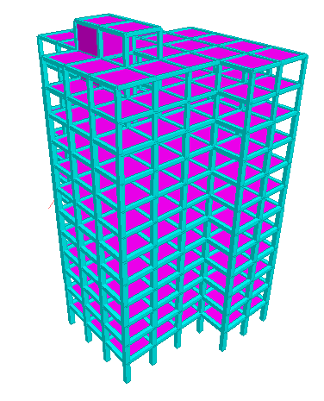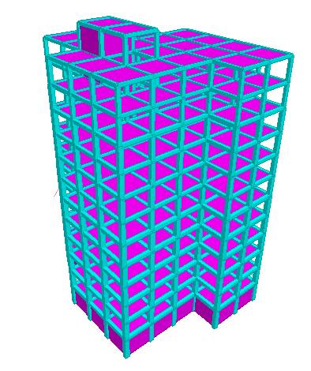

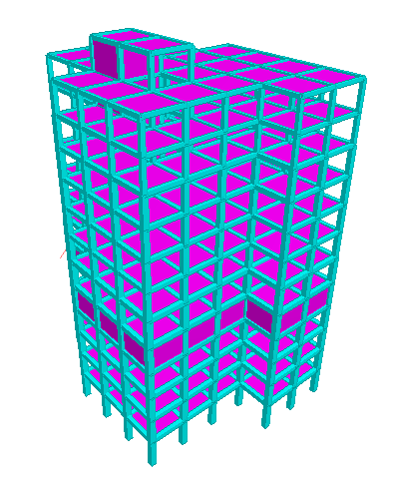

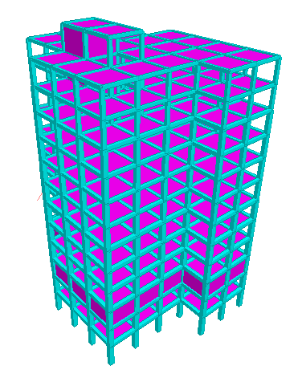

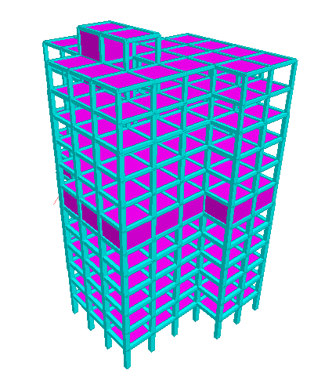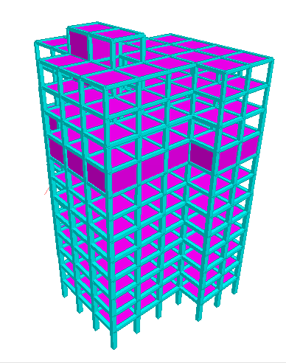

**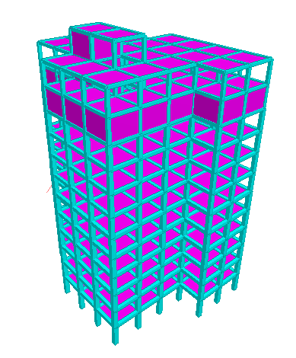  
  
Fig.1:** All Above Structure consist of Wall Belt Provided

**RESULTS AND DISCUSSION**

As per the objectives, the Response Spectrum Analysis has performed on different building models consist of building having G+ 10 storied structures with usage of wall belt RCC elements. The analysis results obtained using Staad pro software is shown in tabular form along with various graphs with various parameters as follows

**Table 4:** Maximum Shear Forces in Columns for all wall belt cases

|  |  |  |
| --- | --- | --- |
| **Case** | **Column**  **Shear Force**  **(KN)** | |
| **Shear along Y** | **Shear along Z** |
| **WB1** | 328.789 | 307.705 |
| **WB2** | 321.539 | 338.462 |
| **WB3** | 313.565 | 326.225 |
| **WB4** | 318.256 | 369.467 |
| **WB5** | 280.421 | 299.118 |
| **WB6** | 271.952 | 303.831 |
| **WB7** | 294.572 | 306.807 |

**Fig. 2:** Maximum Shear Forces in Columns for all wall belt cases

**Comparing the column shear force for all cases, case WB6 in Y direction and WB5 in Z direction is the optimum than other cases.**

**Table 5:** Maximum Bending Moment in Columns for all wall belt cases

|  |  |  |
| --- | --- | --- |
| **Case** | **Column Bending Moment**  **(KNm)** | |
| **Moment along Y** | **Moment along Z** |
| **WB1** | 721.127 | 669.443 |
| **WB2** | 848.355 | 772.129 |
| **WB3** | 781.69 | 772.041 |
| **WB4** | 769.467 | 776.941 |
| **WB5** | 737.429 | 774.932 |
| **WB6** | 741.060 | 756.566 |
| **WB7** | 726.855 | 738.935 |

**Fig. 3:** Maximum Bending Moment in Columns for all wall belt cases

**As per comparative results in column bending moment, case WB5 in Y direction WB7 in Z direction is very effective than other cases**

**Table 6:** Maximum Shear Forces in beams parallel to X direction for all wall belt cases

|  |  |
| --- | --- |
| **Case** | **Beam**  **Shear Force**  **(parallel to X direction)**  **(KN)** |
| **WB1** | 335.992 |
| **WB2** | 332.145 |
| **WB3** | 314.795 |
| **WB4** | 284.064 |
| **WB5** | 272.210 |
| **WB6** | 293.315 |
| **WB7** | 310.460 |

**Fig. 4:** Maximum Shear Forces in beams parallel to X direction forall wall belt cases

**Comparing the beam shear force in X direction for all cases, case WB5 is the optimum than other cases**

**Table 7:** Maximum Shear Forces in beams parallel to Z direction for all wall belt cases

|  |  |
| --- | --- |
| **Case** | **Beam**  **Shear Force**  **(parallel to Z direction)**  **(KN)** |
| **WB1** | 4.399 |
| **WB2** | 5.748 |
| **WB3** | 8.570 |
| **WB4** | 9.864 |
| **WB5** | 9.517 |
| **WB6** | 6.680 |
| **WB7** | 6.608 |

**Fig. 5:** Maximum Shear Forces in beams parallel to Z direction for all wall belt cases

**Comparing the beam shear force in Z direction for all cases, case WB2 is the optimum than other cases**

**Table 8:** Maximum Bending Moment in beams parallel to X direction for all wall belt cases

|  |  |
| --- | --- |
| **Case** | **Beam**  **Bending Moment**  **(along X direction)**  **(KNm)** |
| **WB1** | 10.343 |
| **WB2** | 17.422 |
| **WB3** | 24.032 |
| **WB4** | 25.917 |
| **WB5** | 26.984 |
| **WB6** | 17.384 |
| **WB7** | 17.073 |

**Fig. 6:** Maximum Bending Moment in beams parallel to X direction for all wall belt cases

**As per comparative results in beam in X direction bending moment, case WB7 is very effective than other cases**

**Table 9:** Maximum Bending Moment in beams parallel to Z direction for all wall belt cases

|  |  |
| --- | --- |
| **Case** | **Beam**  **Bending Moment**  **(along Z direction)**  **(KNm)** |
| **WB1** | 654.790 |
| **WB2** | 650.937 |
| **WB3** | 618.191 |
| **WB4** | 542.181 |
| **WB5** | 577.539 |
| **WB6** | 589.736 |
| **WB7** | 634.455 |

**Fig. 7:** Maximum Bending Moment in beams parallel to Z direction for all wall belt cases

**As per comparative results in beam in Z direction bending moment, case WB4 is very effective than other cases**

**CONCLUSION**

1. Comparing the column shear force for all cases, case WB6 in Y direction and WB5 in Z direction is the optimum than other cases.
2. As per comparative results in column bending moment, case WB5 in Y direction WB7 in Z direction is very effective than other cases
3. Comparing the beam shear force in X direction for all cases, case WB5 is the optimum than other cases
4. Comparing the beam shear force in Z direction for all cases, case WB2 is the optimum than other cases
5. As per comparative results in beam in X direction bending moment, case WB7 is very effective than other cases
6. As per comparative results in beam in Z direction bending moment, case WB4 is very effective than other cases

**References**

1. Mathew M., (June-2017) Optimum Position of Outrigger with Belt Wall International Journal of Innovative Research in Science, Engineering and Technology, Vol. 6, Issue 6, June 2017, ISSN(Online) : 2319-8753, ISSN (Print) : 2347-6710, pp 10376-10372, DOI:10.15680/IJIRSET.2017.0606033
2. BayatiZ,, M. Mahdikhani& et.al.(Oct.-2008) “Optimized Use Of Multi-Outriggers System To Stiffen Tall Buildings” The 14th World Conference on Earthquake Engineering Beijing, China, pp- 12-17, 2008,
3. Alhaddad W., Halabi Y. &et. al.(2020) “Outrigger and Belt-Truss System Design for High-Rise Buildings: A Comprehensive Review” Part II—Guideline for Optimum Topology and Size Design, Hindawi Advances in Civil Engineering,Volumev,Article-ID-2589735,pp-1-30, <https://doi.org/10.1155/2020/2589735>
4. Mathew M., (June-2017) Optimum Position of Outrigger with Belt Wall International Journal of Innovative Research in Science, Engineering and Technology, Vol. 6, Issue 6, June 2017, ISSN(Online) : 2319-8753, ISSN (Print) : 2347-6710, pp 10376-10372, DOI:10.15680/IJIRSET.2017.0606033
5. Herath N., Haritos N. &et. al. (2009) “Behaviour of Outrigger Beams in High rise Buildings under Earthquake Loads” Australian Earthquake Engineering Society 2009 Conference
6. Nadh V.S., Sumanth B.H. (Feb.- 2020 ) Ideal Location Of Outrigger System And Its Efficiency For Unsymmetrical Tall Buildings Under Lateral Loadings, International Journal Of Scientific & Technology Research volume 9, ISSUE 02, ISSN 2277-8616, Pp 2917-2920.
7. Gadkari A.P. , Gore N. G. (2016) “Review on Behaviour of Outrigger Structural System in High-Rise Building” IJEDR 2016 , Volume 4, Issue 2, ISSN: 2321 -9939
8. KogilgeriS. ,Shanthapriya B. (July-2015) “A Study On Behaviour Of Outrigger System On High Rise Steel Structure By Varying Outrigger Depth Srinivas” International Journal of Research in Engineering and Technology Volume-04 Issue: 07, e ISSN: 2319-1163, p ISSN: 2321-7308, pp 434-438.
9. Shah N.K., Gore N.G (June-2016) “Review on Behaviour of Outrigger System in High Rise Building” International Research Journal of Engineering and Technology (IRJET), e-ISSN: 2395 -0056, Volume-03, Issue-06, p-ISSN: 2395-0072, Pp 2803-2809.
10. Salman K. , Kim D. & et. al. (2020)Optimal control on structural response using outrigger braced frame system under lateral loads , Journal of Structural Integrity and Maintenance ISSN: 2470-5314 (Print) 2470-5322 (Online) vol. 5, no. 1, Pp 40–50
11. TavakoliR. ,Kamgar R. (Feb.-2019) “Seismic performance of outrigger–belt truss system considering soil–structure interaction” International Journal of Advanced Structural Engineering, pp 45-54.