# ANALYSIS ON EFFECTIVENESS OF DIGITAL MARKETING STRATEGIES FOR TRADITIONAL BUSINESSES

**FINAL PROJECT SUBMITTED FOR THE PARTIAL FULFILMENT OF BACHELORS IN BUSINESS ADMINISTRATION**

# STUDY FIELD: BBA MARKETING AND AUTOMOBILE SUBMITTED BY: ABDOULAYE KOUMA ENROLLMENT NUMBER: 20041060043

**SYSTEM ID: 21GSOB1060042**

# MASTER THESIS WRITTEN UNDER THE KIND SUPERVISION OF GUIDE: DR ANSHU GOYAL



**2024**

1

Table of contents Chapter One: Introduction

* 1. Objective and Scope 10
     1. Objective 10
     2. Scope 10

Chapter Two: Literature Review and Analysis

* 1. Traditional company profile 13
  2. Why digital marketing 13
  3. SWOT Analysis 14
     1. Strengths 14
     2. Weaknesses 14
     3. Opportunities 15
     4. Threats 15
  4. Importance of digital marketing 15
  5. Importance of building an online presence ,,,16
  6. Marketing 18

Theoretical Perspective

Traditional marketing vs Digital Marketing 20

Chapter Three: Methodology

* 1. Elements of Digital Marketing 25
     1. Offline Marketing 25
     2. Online Marketing 26
     3. Search Engine Optimization 27
     4. Social Media Marketing 31
     5. Pay per Click 34
     6. Email Marketing 34
     7. Affiliate Marketing 35
     8. Viral Marketing 35
  2. Analysis 40
     1. Competitive Analysis 40
     2. Digital Marketing is the Future 52
  3. Expenditures for Digital Marketing 53
  4. Digital Marketing in Poland 65

Chapter Four: Limitations ..............................2 66

Chapter Five: Result and Discussion 68

Chapter Six: Recommendation and Conclusion 78

List of Tables 81

References 82

# ACKNOWLEDGEMENT

I am grateful to the faculty members of the department of business studies who worked with me at various times through the program and from whom I acquired so much knowledge. From the get go of my studies, the faculty members have always given me the needed aid that have thus resulted in successful completion of my course. I have received a great amount of moral and intellectual support from most of my fellow students and friends like Ms. Abigail Moria, enabling me being able to be proven analytical at handling a steady increasing level of responsibilities.

I would also like to make mention of my dear parents who have guided me and taught me to always achieve my goals not only by word of mouth but by being such good emulating examples, making mention my mother specifically for her continuous support through all these years and for being my biggest motivation. She has provided moral, financial and emotional support at many instances of my life.

Place:……………. Signature of candidate:………………………………

Date:……/………/………………. Name:…………………………………



CHAPTER ONE



INTRODUCTION

Digital marketing is the promotion of goods or services through the use of digital media, such as the Internet, cell phones, display ads, and every other digital medium. Philip Kotler, known as the "Father of Modern Marketing" and author of more than 60 marketing books, teaches us valuable lessons that we can apply to our digital strategy. The beginnings of digital marketing can be traced back to the 1980s. This was a period where technological developments were occurring, allowing the computer system to evolve to the point that it could store customer information. The first personal computer was released by IBM in 1981, and by 1989, the storage capacity of the computers had risen to 100 MB. We had Traditional Marketing before Digital Marketing, which is a traditional form of marketing that uses different offline ads and promotional strategies to reach out to a semi-targeted audience. Although the methods have changed over the years, the fundamental aspects have remained the same. Traditional marketing paved the way for digital marketing to emerge. All marketing campaigns that use an electronic device or the internet are referred to as digital marketing. To communicate with current and potential customers, businesses use digital platforms such as search engines, social media, email, and other websites. Digital marketing is described as the use of a variety of digital strategies and platforms to communicate with customers who spend a significant amount of time online. Digital marketing comes in a variety of forms. Search Engine Optimization (SEO), Search Engine Marketing (SEM), Social Media Marketing (SMM), Marketing, Email Marketing, Online Advertising, Landing Page Marketing, Smartphone marketing, Affiliate Marketing, Viral marketing and Content Marketing are all discussed here. Digital marketing is a form of marketing that is commonly used to promote products or services and reach out to customers through digital channels. Smart phones, social media marketing, display ads, search engine marketing, and a variety of other digital media are all included. Digital marketing may provide value in the form of customer time, interest, and advocacy. Traditional marketing concepts are built on and adopted by digital marketing techniques, which take advantage of the opportunities and challenges presented by the digital medium.

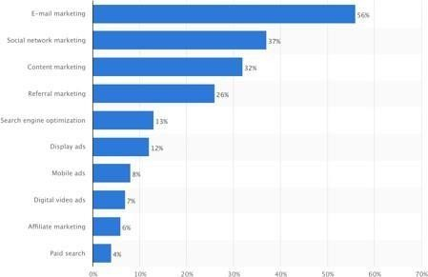

Figure 1: Share of respondents (student survey online 2023) Online survey from google

For businesses to succeed, online advertisement is a powerful marketing vehicle for creating brands and rising traffic (Song, 2001). Expectations in terms of generating performance and evaluating success for ad dollars expended, digital marketing is more cost-effective for calculating advertising ROI. Digital marketing has supplanted traditional advertisement and marketing strategies. Furthermore, it is so strong that it has the potential to help the economy recover and provide enormous opportunities for governments to operate more efficiently (Munshi, 2012). Firms in Singapore have put digital marketing tools to the test to see if they are successful and useful in achieving results. Teo (Teo, 2005) More specifically, digital marketing has evolved as a result of rapid technological advancements and shifting market dynamics (Mort, Sullivan, Drennan, Judy, 2002). Digital content such as usability, navigation, and speed are described as key characteristics for marketing in order for digital marketing to produce results for businesses (Kanttila, 2004). The use of word-of-mouth WOM on social media and for making the web famous is another tried and tested method for achieving success through digital marketing (Trusov, 2009). WOM is also associated with Adding new members and rising website traffic, which improves marketing exposure. An out-of-the-ordinary case of social media Facebook has provided companies with new marketing tools by allowing them to

connect with millions of people about their goods and services. Marketing professionals must have a thorough understanding of online social marketing strategies and services, as well as how to use success assessment metrics effectively. As the consumer dynamics in relation to the young audience's access to and use of social media change across the world. Strategic convergence techniques must be used in an organization's marketing communications. For companies, the Internet is the most effective tool available (Yannopoulos, 2011). Since the Internet is changing the brand, pricing, delivery, and promotion approach, marketing managers who fail to recognize the role of the Internet in their company marketing strategy will be at a disadvantage.

# OBJECTIVE AND SCOPE

1. **Objective:**
   * To demonstrate the various elements of digital marketing and analyze specifically for traditional businesses
   * To concentrate on the fundamental comparison between conventional and digital marketing;
   * To explore the impact of various modes of digital marketing on the firm's revenues and other activities;
   * To demonstrate the various benefits of digital marketing to consumers.

# Scope:

* How to Become a Pro Blogger
* Make money by affiliate marketing and AdSense
* Begin Offering Freelance Services
* Open your own firm
* Start a YouTube channel
* Begin your drop-shipping company



CHAPTER TWO



LITERTAURE REVIEW AND ANALYSIS

# LITERATUTRE REVIEW

Digital marketing, according to Hoge (1993), is the transition of products or services from a seller to a buyer using one or more electronic methods or media. It all started in the nineteenth century with the use of telegraphs. Electronic media has been the dominant marketing force since the invention and widespread adoption of the telephone, radio, television, and then cable television. McDonald's uses the internet to reinforce brand messages and build relationships with customers. They've created online communities for kids, such as the Happy Meal website, which features educational and fun games to keep customers connected (Rowley 2004). Reinartz and Kumar (2003) discovered that a company's amount of mailing efforts is positively related to its profitability over time. The key benefits of digital media marketing are cost savings and increased scope. Digital media has a lower cost than other marketing channels such as face-to-face sales or sales by middlemen or distributors. The key benefit of digital media is that it allows businesses to expand their scope while lowering costs (Watson et al. 2002; Sheth & Sharma 2005). Digital media marketing, according to Chaffey (2011), entails "encouraging consumer communications on the company's own website or through its social presence." Digital marketing, electronic marketing, e-marketing, and Internet marketing are all words that apply to "marketing online, whether by blogs, online advertising, opt-in emails, interactive kiosks, interactive TV, or mobile phones." (Chapter). Customer information satisfaction (CIS) for digital marketing, according to Giese and Gote (2000), can be described as a sum of affective responses of varying intensity that occur after consumption and are triggered by focal aspects of sales activities, information systems (websites), digital products/services, customer care, after-sales service, and company culture. Many Asian countries, according to Waghmare (2012), are taking advantage of e-commerce by opening up, which is critical for fostering competition and the spread of Internet technologies.

# TRADITIONAL COMPANY PROFILE

It is responsible for a company's entire online digital presence. They've been assisting in the creation of online brands as well as the shaping of the internet. Planning, designing, optimization, budgeting, maintenance, evaluation, and timely reporting are also part of the company's work process. They guarantee that their clients' online presence will not only boost their search engine rankings, but will also raise sales revenue.

Software Publishing; Consultancy And Supply software Publishing includes Production; Supply and Documentation of Ready-made (non-customized) Software; Operating Systems Software; Business and Other Applications Software; Computer Games Software for all Platforms. Consultancy Includes Providing the Best Solution IN the Form of Custom Software after Analyzing the User’s Needs and Problems. Custom Software also includes Made-to-order Software Based on orders from Specific Users. Also Included are Writing of Software of any kind Following Directives of the Users; Software Maintenance; Web-page Design. The company's goal is for clients to take advantage of digital marketing, which allows them to extend their business across a wider region and earn a higher return on investment than conventional marketing methods.

# 2. WHY DIGITAL MARKETING?

A flourishing business is one that is expanding. Its revenue is growing at a breakneck rate. Employees are pleased, and the owner is ecstatic. It's satisfying to be in control of a growing business. In today's world, the position of digital marketing is absolutely critical for business development. Are you taking advantage of the Internet and using online marketing tactics to promote your company? Let us help you make sense of the world of digital marketing. Digital marketing, according to HubSpot, is any marketing campaign that uses the Internet or an electronic device. Digital marketing refers to any marketing that takes place online. Over the last few years, digital marketing has become increasingly common. There's a simple explanation for this: the whole planet is now online. According to Technology Review, the

average American spent 9.4 hours online in 2000. Most people now spend 24 hours a week on the Internet, the majority of which is spent on their smartphones. Internet use is can, and as a business owner, you must capitalise on this trend. Or you'll be left behind if you don't understand the importance of digital marketing in your business. You probably don't have much resources, time, or manpower to invest in conventional marketing strategies if you have a small business or a startup. But that's fine! You don't need a large facility with hundreds of employees. All you need is a straightforward but effective digital marketing plan.

**SWOT ANALYSIS**

**Strengths**

* + Personalized and interactive channel
  + Provides opportunity of one to one communication with customer
  + Direct access to customer anytime anywhere same time
  + Very high selectivity, because it can be presented to individuals
  + Broader customer reaches with 3.5 billion mobile subscribers worldwide • Boom in the Smartphone and internet capability

**Weaknesses**

* + Not very user friendly mainly because of screen size, keypad and slow network speed
  + Minimal standardization across platforms.
  + Outreach to agencies and media –buyers is limited
  + Fate depends upon the mobile network operator and their effort for faster net speed
  + Perception problem, underestimation of the effectiveness of mobile marketing

**Opportunities**

* Provide possibility of mobile loyalty programs to complement the other marketing efforts
* Effectiveness of mobile marketing is measurable compare to TV and newspapers
* Mobile marketing subsidizes content and services for consumers who understand the benefits
* As publishers are lunching mobile additions which results into more quality content and more room for targeted ads

**Threats**

* Consumer laziness and resistance to change
* Sometimes consumers take mobile marketing as spamming and do not take is positively
* It creates secrecy related concerns for consumers
* Legislation to enforce consumer privacy
* Carriers are increasing the delivery fees

# Why Is Digital Marketing So Important?

Our culture has become so reliant on digital media that everyone can access a wealth of information at any time and from any place. It is becoming a more common source of a variety of items, including news, entertainment, shopping, social interaction, and so on. Prior to the invention of such technologies, marketing communication consisted of sending consumers messages about your goods or services. Only the information you wanted them to know will be included in this post. Things have changed since then. The contact between sellers and buyers—and even buyers between themselves—is at the heart of marketing. Consumers are also aware of not only what buyers tell them or what a company says about its products, but also what other people are thinking about the product or brand, thanks to the power of digital marketing. Any interaction about a brand that occurs among friends, family, colleagues, or even fellow consumers is crucial. Since people are more inclined to believe such experiences rather than the organization itself, this is the case. . Consumers trust brands more when they seek a second opinion. Digital advertising has given consumers a power they've never had before: the opportunity to study what they want and then make choices based on more detail than ever before.

Another benefit of digital media is that it has made it easier to communicate with product or service providers. This helps brands to become more tailored, appropriate, and customised to

the needs of their customers. Another way to see or assess the significance of digital marketing is to consider it as something that is just getting started. Digital marketing is still on the rise, as shown by the past trends and statistics I listed earlier in the chapter, and it appears that it will continue to do so. Digital marketing is the future of conventional marketing. Managing and monitoring more forms of audience interactions than just email and messages is key to success. These can be summarised in the Five D's that an organisation must consider when evaluating customer interactions:

1. Customer Interaction Systems: These are the devices that consumers use to communicate with companies. Smartphones and tablets, as well as desktop computers, televisions, and gaming consoles, are all examples.
2. Digital Platforms: These are spaces that can be reached using digital devices and where interactions can occur, such as Facebook, Google, and Twitter, among others.
3. Digital Media: Digital media refers to platforms for reaching and engaging customers through ads, promotions, and social media that are either paid, owned, or received.
4. Digital Data: This refers to all of the information and statistics gathered by businesses through online interactions. Many of these, such as audience profiles and interaction patterns, are controlled by law in most countries.
5. Digital technology is the technology that businesses use to create interactive experiences for customers as they visit websites, applications, or even in-store kiosks.

# Why do you need to build an online presence?

Make it easier for potential customers to find you by doing the following:

In the digital world, there is already an ocean of potential customers. They tend to look for companies that have already developed themselves in the region.By making the transition to the online world, you will be making it simpler for millions of potential customers who just need to find you.

1. Make showcasing your goods and services easier:

Rather than displaying a company's goods or services in specific places such as showrooms or stores, all of it can now be achieved virtually, making it much simpler for everyone.

Your website or social media page can be used to promote your goods and services. This can benefit you in two ways: it can increase interest in your company's products and make it easier for customers to interact with you.

1. Make it easier for customers and prospective customers to form relationships:

Once you're online, you'll notice that it's easier to form and maintain relationships because it'll be easier and less expensive for both of you to stay in touch, share your new product lines, and get feedback on your items. There will be no significant time delays, nor will it necessitate several trips to engage with customers.

1. Make it easier to promote your company:

It will also be much easier to market your company and brand because you will only have to focus your attention on one room rather than several spaces. Because the majority of the audience is online these days, the findings would be more effective.

A digital marketing agency will help you do just that, by helping you develop your online presence in a way that takes advantage of all of the features and opportunities available on the internet. Essentially, the type of company you run and the opportunities it can create will be combined with the opportunities offered by the online world. You must migrate your company to the digital world and integrate the physical and digital aspects of your company so that everything works together. This can be accomplished in a variety of ways. Every one will be discussed with you by a good digital marketing agency. With this in mind, we'll go through the different methods or measures that will be required to establish your company's online presence.

# MARKETING

"Marketing" is described by Philip Kotler as "satisfying needs and wants through an exchange mechanism."

The marketing concepts can be broken down into four Ps: positioning, positioning, positioning, positioning, positioning, positioning, positioning, positioning, positioning, positioning, positioning, positioning, positioning

* Product: Choices, quality, design, features, packaging, and other related services are all included in the product.
* Cost: This includes the list price, the marked price, discounts, delivery rates, and the prices of rivals**.**

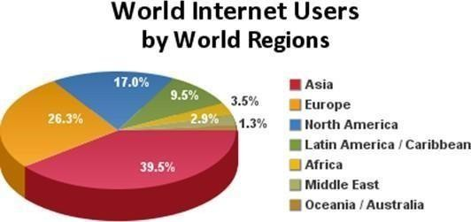

Figure 2: World Internet users by World regions (Source: Statista online data)

* Location: Distribution networks, forums, blogs, and other online presences, as well as physical locations, inventory, and delivery, are all included.
* Publicity: Branding, content marketing, advertisement, quest, influencer relations, social media, public relations, and sales are all included. The marketing communication blend is a combination of advertisement, personal selling, sales promotion, public relations, and direct marketing that an organisation employs to achieve its advertising marketing goals.
* Advertising: Any nonpersonal introduction and promotion of ideas, products, or services by a named sponsor for a fee.
* Promotion of Sales: Incentives that are provided for a limited time to promote the purchase or selling of a product or service.
* Selling one-on-one: The firm's sales team gives a personal presentation in order to close sales and create customer relationships.
* Relationship with the Public: Establish positive relationships with the company's various stakeholders by gaining favourable coverage, establishing a positive "corporate image," and managing or avoiding negative rumours, reports, and events.
* Direct marketing (also known as direct response marketing) is a direct contact with carefully selected individual consumers to obtain a quick response and establish a long-term customer relationship

# THEORETICAL PERSPECTIVE

**Traditional Marketing versus Digital Marketing**

Traditional marketing is the most well-known form of advertising. Traditional marketing is a non-digital method of promoting a company's goods or services. Digital marketing, on the other hand, is the promotion of goods or services through the use of digital platforms to meet customers.

Promotional efforts made via the Internet, social media, mobile phones, electronic billboards, as well as digital television and radio networks, could all be used as part of a company's digital marketing strategy. Digital marketing is a subset of conventional marketing that employs new digital media for product placement, such as downloadable music and video, primarily for informing stakeholders, such as consumers and investors, about the brand, products, and success of the business. The transformation of the industry and marketing practise is the most fascinating outcome of the technological explosion and quick access to it by customers. Today's customer is an empowered consumer who has complete control over the interactive online media, content, and communication process. Traditional marketing tools and communication are losing their effectiveness, and customers have no faith in companies. Marketers are constantly being forced to work in a diverse and changing environment where they no longer have complete influence over the media and the message due to technological advancements. Customer behaviour is evolving as well: customers are becoming more critical, smart, well- informed, and responsive than ever before. Today's and tomorrow's marketers will need new knowledge, skills, and methods not just to grasp the changing and technology-enabled marketing world, but also to comprehend and communicate with the new consumer. Marketers face new threats and opportunities as marketing becomes increasingly digital, thanks to ongoing technological advancements: Mobile marketing, Internet of Things, Analytics, Big Data, 3D printing, cloud computing, Artificial Intelligence, and Consumer Neuroscience / Neuro marketing are only a few of the most fascinating and daunting domains where potential marketers will be forced to excel. With the ultra-rapid growth of new technologies and social media, keeping track of those innovations and using them effectively is a huge challenge. That is why the author felt compelled to include it in this review.

The following are some comparisons:

|  |  |
| --- | --- |
| **Traditional Marketing** | **Digital Marketing** |
| Traditional marketing includes print, broadcast, direct mail, and telephone | Digital marketing includes online advertising, emailmarketing, social media, text messaging, affiliate  marketing, search engine optimization, pay per  click |
| No interaction with the audience | Interaction with the audience |
| Results are easy to measure | Results are to a great extent easy to measure |
| Advertising campaigns are planned over a long  period of time | Advertising campaigns are planned over short  period of time |
| Expensive and time-consuming process | Reasonably cheap and rapid way to promote the |
|  | products or services |
| Success of traditional marketing strategies can be celebrated if the firm can reach large local  audience | Success of digital marketing strategies can be celebrated if the firm can reach some specific  number of local audience |
| One campaign prevails for a long time | Campaigns can be easily changed with ease and innovations can be introduced within any  campaign |
| Limited reach to the customer due to limited number of customer technology | Wider reach to the customer because of the use of  various customers technology |
| 24/7 year-round exposure is not possible | 24/7 year-round exposure is possible |
| No ability to go viral | Ability to go viral |
| One way conversation | Two ways conversation |
| Responses can only occur during work hours | Response or feedback can occur anytime |



CHAPTER THREE



METHODOLOGY

Methodology is the systematic and theoretical examination of methods in order to determine the suitability of one method for use in a particular field of study. Concepts including paradigm, theoretical model, stages, and quantitative or qualitative techniques are often included. This research utilizes both primary and secondary data sources.

1. Primary Sources:

A primary source is a place where we get first-hand knowledge or original data about a topic. The primary data was collected using an interview methodology and a standardized questionnaire.

1. Secondary Sources:

A secondary source is a place where we gather information that has already been gathered by someone else. We gathered secondary data from the firms' released financial statements, as well as newspaper and magazine posts. We randomly selected 150 businesses that use a digital marketing system to sell their goods to consumers for the purpose of this analysis. In addition, we gathered information from 50 executives from the survey and other companies to learn about their perspectives on the efficacy of digital marketing. Various statistical methods and techniques were used to coordinate, describe, and interpret the collected data and knowledge. The findings of this analysis are presented in a descriptive and analytical manner. With the ultra-rapid growth of new technologies and social media, keeping track of those innovations and using them effectively is a huge challenge. That is why the author felt compelled to include it in this review.

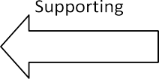

Qualitative

Answers and Conclusions

Qualitative and Quantitative *(Observation and Analysis)*

Qualitative and Quantitative

*(Secondary data)*

Selection of research

Selection of topic

Figure 3: Research methods

This research utilizes both primary and secondary data sources. This research paper employed three different methods of investigation. First, reviews of articles and books on digital marketing effectiveness, social media ROI, online marketing, and social media marketing demographics, which provide basic information to further understanding of these issues. Furthermore, a study of one hundred companies and fifty executives was chosen at random to

demonstrate the efficacy of digital marketing. Exploratory research is intended to encourage an investigator to simply look around in relation to a phenomenon in order to generate potentially useful ideas (Reynolds, 1971). This is an exploratory research that involves quantitative and qualitative review.

Data was collected on an all-India basis for the purpose of this study (critical review). For the purpose of preparing this document, secondary data and knowledge were extensively analysed. Secondary data and knowledge were gathered from a variety of sources, including published e-books, articles in various journals and periodicals, conference papers, working papers, and company websites. For internal newsletters, annual reports, and CSR activity reports Data and information about the firms are used, which is publicly accessible on the companies' websites. This is the best/standard practice for a critical analysis style of study.

# ELEMENTS OF DIGITAL MARKETING:

* 1. **Offline Marketing:**

Offline marketing is the method of raising brand awareness and reaching out to potential customers to meet their needs and desires. Individuals frequently use marketing mix strategy to promote their businesses. When your company doesn't have a website, the whole goal of offline marketing is to generate leads. There are numerous offline marketing strategies available, including print and non-print media. Television, radio, brochures, flyers, banners, newspapers, pamphlets, and posters are examples of offline marketing media. Offline marketing tools have a variety of advantages. The first advantage is that a company does not need to be connected to the internet to use them. If a web server goes down and a website becomes unavailable, valuable customers and discoverability can be lost. A smaller company's return to the internet may take some time, during which time valuable customer attention may have been diverted elsewhere. There are no such concerns for offline media because it exists in the real world and cannot be removed from the internet. Another advantage, which is less visible but no less significant, is that many consumers and clients see digital marketing as a waste of time. People have become used to seeing commercials, pop-ups, and marketing emails to the point that they no longer recognize them.

* 1. **Online Marketing:**

Online marketing is the method of capturing potential customers' attention for a company through specific banners, posts, videos, photographs, and flash animation, among other things. Marketing activities or details are designed to entice visitors to a specific website that a company wishes to attract. This information is prominently displayed on the website's front page or front page in order to target key audiences. It is possible to get traffic for a company in a variety of ways using online marketing concepts. The practice of using web-based platforms to convey a message about a company's brand, goods, or services to potential customers is known as online marketing. If a web server goes down and a website becomes unavailable, valuable customers and discoverability can be lost. A smaller company's return to the internet may take some time, during which time valuable customer attention may have been diverted elsewhere. There are no such concerns for offline media because it exists in the real world and cannot be removed from the internet. Email marketing, search engine marketing, content marketing, video blogging, and online classifieds are all examples of social media marketing.

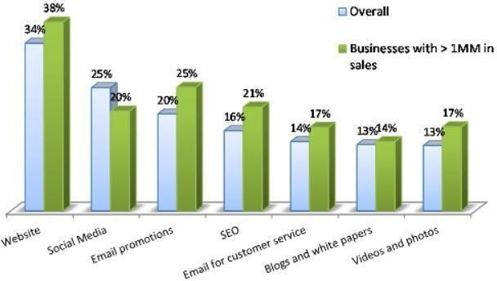

Figure 4: Model Graph of Websites and their promotion (2022) Source: Google search

* + 1. **Website:**

All other digital marketing elements guide visitors to your website, which should effectively convert them, your website is the key to a successful digital marketing strategy. Using best SEO practices and tools, providing a great user interface, and taking advantage of the abundance of analytics websites provide are all elements of website design that generate

conversions. A website that lacks successful SEO would not appear organically in the top spots on a Search Engine Results Page (SERP), resulting in less clicks from Google, Bing, and other search engines. These clicks are crucial to your digital marketing strategies because you need to get as much traffic to your platform as possible in order to generate direct sales. Without proper SEO, even the most beautiful website would be largely ineffective. Using keywords that visitors are likely to look for and optimizing your site for search engines will boost your SEO and propel your site to the top of the organic listings. While Facebook and Twitter only have limited analytics to monitor marketing promotions and tweets, your website will collect detailed details about who your visitors are, how they found your site, and what they look at while there. This data is invaluable when it comes to understanding and identifying your visitors, and it can also be used to advertise your resort to a specific, committed audience. Website analytics can collect a lot more data on how visitors interact with your website and brand than social media analytics can. Aside from gathering information about your visitors, website analytics can be used to monitor marketing campaigns, allowing you to easily evaluate the effectiveness of a campaign.

# Search Engine Optimization:

Search Engine Optimization (SEO) is a term that refers to the process of optimizing Search Engine Optimization (SEO) is a term that refers to it entails optimizing a website's place in search engine results pages using keywords and phrases. It falls under the heading of digital marketing. Search engine optimization (SEO) is the method of increasing the online exposure in unpaid search engine results. It all boils down to keywords. Google, Yahoo, and Bing are examples of search engines. TRS Tech is one of the biggest companies in Canada, providing the best digital marketing services in Toronto. It is the method of making a web page that is easy to search, crawl, and categories. It's all about assisting your customers in locating your company among thousands of others. Any digital marketing plan should include SEO. In the field of digital marketing, the most crucial aspect of digital marketing is SEO.

Off-page and on-page SEO are the two forms of SEO:

# Off page:

Off page refers to how we will advertise our website on the internet. On the off list, we've included

* + - * Social Media
      * Bookmarking
      * Forum Submission
      * Blog Directory
      * Submission
      * Article Submission
      * Question/ Answer
      * Video Submission
      * Image Submission
      * Info graphics
      * Document Sharing
    1. On Page:

On page is basically that we do within our website. Such as:

* + - * Meta Title
      * Meta Description
      * H1-H6
      * Content Optimize
      * Internal linking
      * Keywords Research
      * Google Analytics
      * Web master tool

Reach, Act, Convert and Engage with your Customers:

This digital strategy guide is designed to get you thinking about how to develop your marketing strategy by looking at additional activities, networks, and platforms to take your strategy to the next level. The number of options available to you can appear to be daunting, and there is often a need for clarification or simplification. Smart Insights' RACE Planning Framework is a helpful, simplified roadmap that lets you concentrate on some of the relevant marketing practises at different stages of the conventional marketing funnel that will help you make your digital marketing campaign a success.

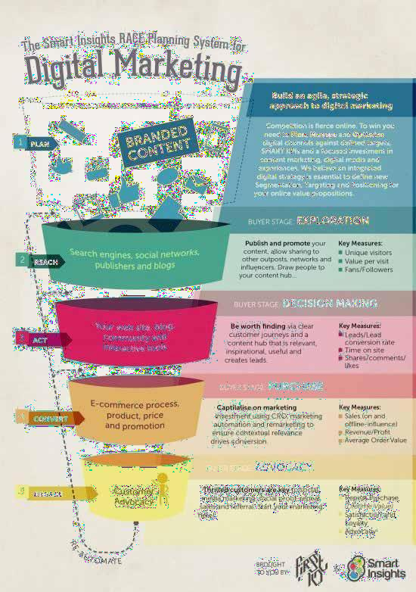

Figure 5: Digital Marketing, source: Google

We've broken down the framework further below, working our way from the top to the bottom of the funnel, highlighting the best strategic path to take at each point and summarizing the strategies to include in digital marketing strategy.

REACH Acquisition strategy to build awareness

Incorporate the following strategies and methods into your marketing strategy:

* + - * SEO
      * PPC
      * Affiliates and partnerships Online/display ads
      * PR
      * Social media marketing

ACT & CHANGE Connect visitors with useful, engaging, and meaningful content to persuade them to engage and achieve one of your conversion goals.

Incorporate the following strategies and methods into your marketing strategy:

* + - * Content marketing policy
      * Optimizing conversion rates generation of leads
      * Optimization of the homepage and landing page
      * A/B testing is the process of comparing two options.

GET INVOLVED Customer retention and development strategy to transform repeat visits, promotions, and brand loyalty into repeat visits and sales Incorporate the following strategies and methods into your marketing strategy:

* + - * Content marketing policy
      * Newsletters and promotional emails are examples of email strategy.
      * Strategy for mobile devices

The Smart Insights RACE system is a simple one to remember to simplify the strategy, but for optimum results, always maintain a balanced approach by using all areas of the Paid, Earned, and Owned model

* + 1. Google Search Console / Google web master:

Google Search Console is a web platform that Google makes available to all as a free service. Through using this tool to monitor your website's organic results, crawl issues, sitemaps, mobile usability, and backlinks, you can improve organic results, crawl issues, sitemaps, mobile usability, and backlinks. . It's a cutting-edge platform that's being used by an ever-

expanding group of marketing experts, website designers, app developers, SEO specialists, and business owners. A Google search console is another name for the Google webmaster tool. Google's webmaster service has been renamed Google search console. It is a free software application that allows you to handle the technical aspects of your website. To begin handling the technical aspects, you must first connect your website to Google Search Console and verify ownership.

* + 1. Crawling and Indexing:

Crawling is the process of collecting and recording URLs in preparation for indexing. They will trace all the valid links on those sites if you give them a webpage as a starting point. They return data about certain web pages to Google's servers as they move from link to link in the digital marketing link. After crawling, information is organized into indexes, which enables pages to be viewed. However, before indexing can take place, the page must be able to be crawled. As a result, it's important that all of your website's pages are crawlable. Google's algorithms will evaluate your search terms in the index to locate relevant pages for you while searching at the most basic level. If you're looking for "computers," you're probably just looking for photos, videos, a list of different brands, and so on. Google's indexing systems can take note of several different aspects of websites, such as videos, images, and when they were uploaded, in order to provide useful content to future visitors to your site.

# Social Media Marketing:

SMM (social media marketing) is an Internet marketing technique that makes use of social networking platforms as a marketing tool. The aim of social media marketing (SMM) is to create content that consumers can share with their social networks in order to help a company increase brand awareness and customer reach. . Social networking optimization is one of the most important aspects of SMM (SMO). SMO is a method for attracting new and exclusive visitors to a website, similar to search engine optimization (SEO). SMO can be accomplished in two ways: by including social media links in content, such as RSS feeds and sharing buttons, or by encouraging activity on social media, such as by updating statuses, tweets, or blog posts. SMM allows a business to receive direct input from customers (and potential customers) while also making the business seem more personable. Customers can ask questions or voice grievances through social media's interactive features, and they will feel heard. Social customer relationship management is the name given to this part of SMM (social CRM). Low-cost platforms that integrate technology and social networking with the use of words are referred to

as social media. Marketers now have a voice and a way to connect with friends, clients, and potential customers thanks to social media. A bad service, on the other hand, would result in a negative customer rating, which could damage the company's credibility.

* + 1. Social Media Marketers’ Platform Usage Trends:

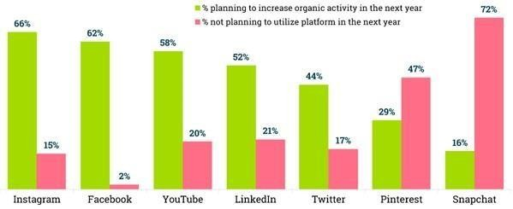

Figure 6: Social Media Usage Trends (August 2023) Source: created table from information on ChatGPT

# Google Analytics:

Google Analytics is a critical piece of digital marketing software. It gives you the ability to monitor the outcomes of individual campaigns in real time, compare data to previous periods, and much more. Google Analytics helps you to monitor a wide range of critical metrics. Your online marketing campaigns, onsite content, user interface, and application functionality can all be tracked. All of these figures show you what works and, most importantly, what doesn't. You can build a solution once you've identified some problems with your platform. Google Analytics provides you with the data you need to make your website the best it can be. The Google Analytics Tracking Code, which is a fragment of JavaScript code that the website owner applies to every page of the website, is used to implement Google Analytics. The tracking code collects visitor data and sends it to a Google data collection server when the client browser browses the page (if JavaScript is allowed in the browser).

* + 1. Ad Words:

Google AdWords is a platform where businesses can pay to have their websites appear in the top organic search results for specific keywords. The basic idea is that you choose keywords to advertise your brand. A keyword is a word or phrase that a user types into a search engine and then sees your ad for. Only the keywords you choose will appear in your advertising. Google tracks how many people click on your advertising and charges you for each one. They also monitor impressions, which is simply a number that indicates how many times your ad was shown as users searched for that keyword. The click-through-rate, or CTR, is calculated by dividing clicks by impressions. This is the number of users who arrive at your promoted page as a result of clicking on your ad. Consider Google AdWords to be a bidding platform. You make a budget and a proposal. The bid is the amount you're willing to pay for each click. If your maximum bid is $2, Google will only display your ad to people if no one else is bidding higher. Google doesn't necessarily want to show users the most expensive ads; they may also be awful. They care so much for their users that they'd rather show them a more interesting and better ad from a less expensive advertiser. Google's Ad Rank is a metric that determines the order in which paid search ads appear on the SERP.

* + 1. AdSense:

From part-time bloggers to some of the biggest publishers on the internet, Google AdSense is a common way for websites to make money from advertising. Advertisers that use AdWords pay Google either per click or per impression (PPC). Google then splits a portion of the sales with the AdSense publishers. When Google AdSense was first launched in 2003, it served ads using plain text rather than the graphical content that dominated the advertising scene at the time. In order to reduce the intrusiveness of ads, improve page loading speeds, and eventually evoke a more favorable marketing response from site visitors, Google decided to serve plain text. AdSense is a free and easy way to make money by showing targeted advertisements alongside your online content. You can display appropriate and entertaining advertisements to your site visitors using AdSense, and you can even customize the look and feel of the ads to fit the look and feel of your website. Google AdSense is a fantastic way for website owners and bloggers to supplement their income by generating traffic for Google. This is how Google AdSense works: spiders can crawl your website to see what all of your pages are about. They'll then go through their ad list and place relevant ads next to each of your posts. Someone who reads an article about fashion accessories, for example, is much more likely to purchase fashion

clothing than someone who reads an article about cars. With over a trillion impressions delivered to over 1 billion users every month, Google display ads reaches over 90% of internet users worldwide. It's pretty simple to get started with Google AdSense and display advertising, but you must first learn about the various styles and sizes of ads that will complement your website and ad campaign.

# Pay Per Click (PPC):

Pay-per-click (PPC) is an internet marketing model in which advertisers are charged a fee each time one of their advertisements is clicked. Essentially, it's a way of purchasing website traffic rather than trying to "earn" it organically. One of the most common types of PPC is search engine ads. When anyone searches for a keyword specific to their business product, it helps advertisers to bid for ad placement in a search engine's supported links. If we search for some keyword, for example, our ad will appear at the very top of the Google results page. We must pay a small charge to the search engine any time our ad is clicked, resulting in a visitor to our website. When PPC is functioning well, the fee is insignificant since the visit is worth more than the amount you pay. In other words, if we pay $3 for a click that results in a $300 deal, we've profited handsomely. There's a lot that goes into creating a successful PPC campaign, from keyword analysis and selection to grouping certain keywords into well-organized promotions and ad groups. This is how Google AdSense works: spiders can crawl your website to see what all of your pages are about. They'll then go through their ad list and place relevant ads next to each of your posts. Someone who reads an article about fashion accessories, for example, is much more likely to purchase fashion clothing than someone who reads an article about cars. It's important to learn how to do it correctly.

# Email Marketing:

Email marketing is described as sending a message about a product or service to a current or potential customer via email. Direct digital marketing is used to deliver advertisements, increase brand and consumer loyalty, increase customer trust, and raise brand awareness. This aspect of digital marketing allows a company to easily advertise its goods and services. In comparison to ads or other types of media representation, it is relatively inexpensive. By producing an appealing combination of graphics, text, and links on goods and services, a company can capture the customer's full attention.

# Text Messaging:

It is a method of sending product and service information from cellular and smart phone devices. The company can submit information in the form of text (SMS), images, video, or audio using phone devices (MMS). Cellphone-based marketing In the early 2000s, SMS (Short Message Service) became increasingly common in Europe and some parts of Asia. Text messages may be used to deliver order confirmations and shipping warnings. SMS campaigns yield quicker and more significant outcomes. Companies may use this strategy to deliver marketing messages to their customers in real time, at any time, and know that they will be seen. A company should create a questionnaire to collect valuable consumer feedback that will help them improve their goods or services.

# Affiliate Marketing:

Affiliate marketing is a form of pay-per-click advertising. A company rewards associates for each visitor or customer they bring to the company through marketing strategies they produce on behalf of the company in this form of marketing. The merchant (also known as "retailer" or "brand"), the network, the publisher (also known as "affiliate"), and the consumer are the four main players in the industry. Since the market has become so complex, a secondary tier of players has emerged, including affiliate management firms, super-affiliates, and specialist third-party vendors. Affiliate marketing can be approached in two ways: a company can either sell an affiliate program to others or sign up to be an affiliate for another company. If a business wishes to run an affiliate program, the owner must pay affiliates a commission for each lead or sale they bring to the business's website. The main aim of the company is to find affiliates that can help them enter untapped markets. A business that publishes an e-zine, for example, could make a good affiliate because its readers are hungry for information. As a result, launching one's offer through a "trusted" organisation will attract prospects who may not have otherwise been met.

# Viral Marketing:

Viral is the modern equivalent of old-fashioned word-of-mouth in today's world. Viral marketing is a technique in which a new piece of content spreads rapidly digitally as a result of how much it is enjoyed, posted, and liked. This is an excellent way to build your brand and increase traffic to your website. The material can be in any format; all you have to do is think outside the box. Marketers have caught the viral fever and are gradually incorporating viral elements into their campaigns. Not only is the strategy cost-effective, but it can also be more credible than traditional advertisements.

# Consumer privacy:

The decision-making process of consumers when purchasing a product or using a service The reality is that many factors affect a consumer's decision to purchase goods or services. According to George Joye F (2002, 165-180), many consumers are only comfortable placing an order after making a few transactions. They are concerned that their privacy will be compromised and that they will be misunderstood. Buyers would never want to make any online purchasing decisions if they do not trust the company that offers online sales services. Furthermore, e-marketing provides customers with more options for searching for product designs, functions, features, requirements, costs, and other information so that they can compare and contrast goods and services before making a final decision. Through their research into online travel agency services, they discovered that the lowest price, security, ease of website navigation, and quick website loading time were the most important factors that influenced customers' purchase decisions.

How consumers evaluate companies in the Internet

External variables like third-party visibility are also crucial. When a reputable third party certifies that a company's website is stable, consumers are more likely to trust it. Furthermore, guarantee words aid in the development of consumer interest. However, if the participants are of varying ages, the analysis will provide more detailed results.

Factors preventing consumers from enjoying Internet marketing

Internet credit card theft, fear of providing personal information, pornography and abuse, extensive Internet ads, information reliability, lack of physical interaction, failure to receive Internet goods purchased, failure to recognise the human factor while making Internet transactions, Internet use addiction

Activities offers various contact mix options for increasing the number of visitors to a website, as seen in the diagram below:

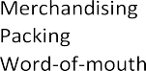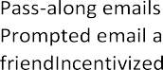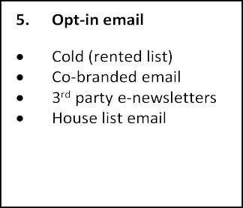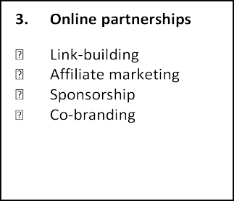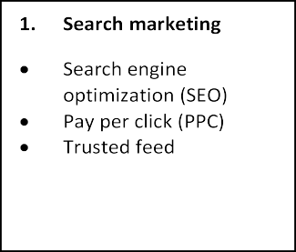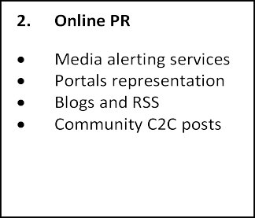

# .

Figure 7: Options available in the communications mix for increasing visitors to awebsite.

# Search Engine Marketing:

According to a research by AOL in 2004, search engines are considered as themost important

source when researching a product or service

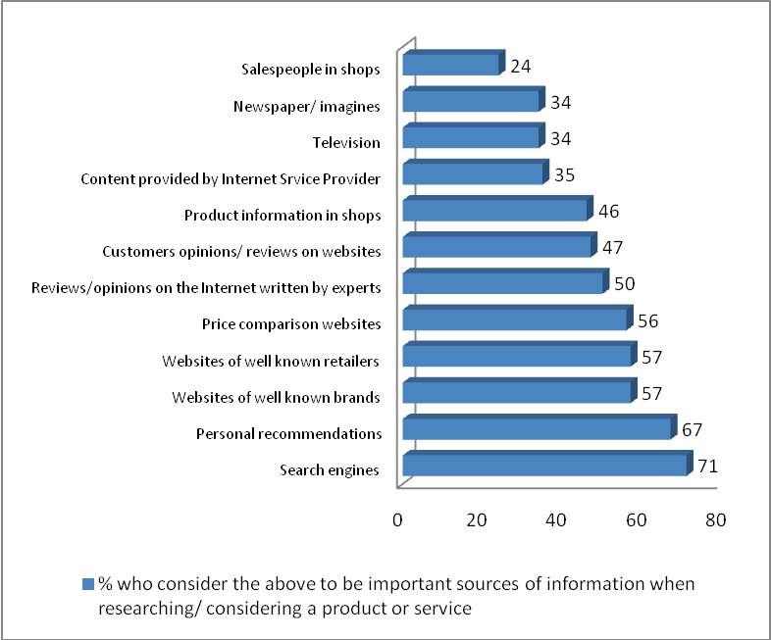

Figure 8: Percentage who considers the different information sources as importantwhen researching of considering a product or service (May 2023 Data) Source: ChatGPT

Each of these search engines has its own website ranking system. According to research conducted by Prospect about how we search, 81.7 percent of people would start a new search if they couldn't find a valid response within the first three pages. It also means that if your website isn't on the first few pages of Google, it'll probably get no or very few visitors. To put it another way, the higher a company's ranking in the search engine result pages (SERPs), the more visitors it will get. The graph below shows how the number of visits to a website decreases in proportion to the lower ranking location on a search engine results list.

However, this does not rule out the possibility of lower-ranking websites attracting tourists. Web analytics show that more than half of site visitors arrive at a site directly, rather than by search engines, by typing in the web address or following a bookmark.

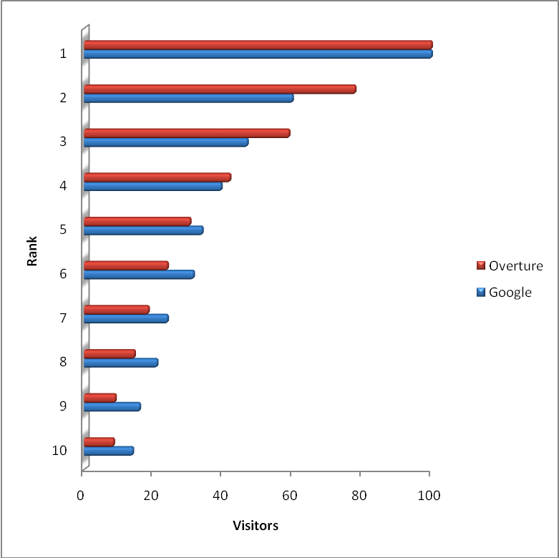

Figure9: Relative traffic projections based on the ranking on search engineresults pages (visitor numbers are shown relative to 100 for position 1) (Source: online survey 2022-2023)

# ANALYSIS

Consumers now have access to information at any time and from any location thanks to the widespread use of digital media. People used to get messages about particular goods or services that consisted solely of what a business needed them to hear.

|  |  |  |
| --- | --- | --- |
| **Model** | **R square** | **F** |
| Stay updated with products or services | .718 | 122.117 |
| Greater engagement | .516 | 51.276 |
| Clear information about the products or services | .629 | 81.254 |
| Easy comparison with others | .639 | 85.141 |
| 24/7 Shopping | .749 | 142.868 |
| Share content of the products or services | .656 | 91.498 |
| Apparent Pricing | .636 | 83.962 |
| Enables instant purchase | .667 | 96.028 |

Table 4-2 Model Summary (calculated using SPSS) Source: Input data in SPSS

We can infer from the above table that almost all of the variables with weight describe its relationship with digital marketing to a large extent. Staying up to date with goods or services, for example, is explained by 71.80% of digital marketing, while the remaining 28.20% is explained by other factors. Digital marketing accounts for 51.60 percent of increased involvement, while other factors account for the remaining 48.40 percent. Digital marketing accounts for 62.90 percent of product or service information, with the remaining 37.10 percent clarified by other factors. We can also see from the table above that the F value is greater than 80, indicating that the model is solid.

Coefficient of Different Variables:

Following is a discussion of the coefficients of various variables in relation to independent variables:

|  |  |  |  |  |
| --- | --- | --- | --- | --- |
| **Coefficients** | | | | |
| Model | Unstandardized Coefficients | Standardize d Coefficient  s | t | Sig. |

|  |  |  |  |  |  |
| --- | --- | --- | --- | --- | --- |
|  | B | Std. Error | Beta (β) |  |  |
| Constant | 1.000 | .215 |  | 4.649 | .000 |
| Digital Marketing | 2.882 | .261 | .847 | 11.051 | .000 |
| **Dependent Variable:** Stay updated with products or services | | | |  |  |
| Constant | 1.000 | .254 |  | 3.937 | .000 |
| Digital Marketing | 2.206 | .308 | .719 | 7.161 | .000 |
| **Dependent Variable:** Greater engagement | | | |  |  |
| Constant | 1.000 | .248 |  | 4.040 | .000 |
| Digital Marketing | 2.706 | .300 | .793 | 9.014 | .000 |
| **Dependent Variable:** Clear Information about the products or services | | | |  |  |
| Constant | 1.000 | .234 |  | 4.275 | .000 |
| Digital Marketing | 2.618 | .284 | .800 | 9.227 | .000 |
| **Dependent Variable:** Easy compare with others | | | |  |  |
| Constant | 1.000 | .215 |  | 4.649 | .000 |
| Digital Marketing | 3.118 | .261 | .865 | 11.953 | .000 |
| **Dependent Variable:** 24/7 Shopping | | |  |  |  |
| Constant | 1.000 | .223 |  | 4.482 | .000 |
| Digital Marketing | 2.588 | .271 | .810 | 9.565 | .000 |
| **Dependent Variable:** Share content of the products or services | | | |  |  |
| Constant | 1.000 | .262 |  | 3.816 | .000 |
| Digital Marketing | 2.912 | .318 | .798 | 9.163 | .000 |
| **Dependent Variable:** Apparent Pricing | | |  |  |  |
| Constant | 1.000 | .240 |  | 4.165 | .000 |
| Digital Marketing | 2.853 | .291 | .817 | 9.799 | .000 |
| **Coefficients** | | | | | |
| Model | Unstandardized Coefficients | | Standardize d Coefficient  s | t | Sig. |
| B | Std. Error | Beta (β) |
| Constant | 1.000 | .215 |  | 4.649 | .000 |

|  |  |  |  |  |  |
| --- | --- | --- | --- | --- | --- |
| Digital Marketing | 2.882 | .261 | .847 | 11.051 | .000 |
| **Dependent Variable:** Enables instant purchase | | | |  |  |

Source: SPSS data using online figures

Unstandardized Coefficients (B) expresses the effect of a zero (0) independent variable on the dependent variable. Staying up to date with goods or services would be 2.882 if we do not use digital marketing. Standardized Coefficients () show what happens if the independent variable increases by 1% and the dependent variable increases by 1%. If 1% of people use digital marketing, then 84.70 percent of people will be kept up to date on goods or services.

Correlation analysis:

To demonstrate the connection between various elements of digital marketing and increased sales, we gathered data from 150 businesses that use various digital marketing strategies or elements. The following are the outcomes:

|  |  |  |  |  |  |  |  |  |  |
| --- | --- | --- | --- | --- | --- | --- | --- | --- | --- |
| Increase dSales | Correlatio n(r) | Increase dsale | Online marketin  g | e-mail marketin  g | Text marketin  g | Socia l  media | Affiliated marketin  g | SEO | PPC |
| 1 | .869 | .873 | .840 | .667 | .560 | .840 | .560 |
| Sig 2 tailed | 100 | .056 | .053 | .075 | .219 | .326 | .075 | .326 |
| N | 100 | 100 | 100 | 100 | 100 | 100 | 100 |

Table 1: Correlations (SPSS values)

We may infer from the table above that every aspect of digital marketing is positively linked to sales growth. It implies that all aspects of digital marketing have a positive impact on a company's revenues. Search engine optimization, online ads, email marketing, and social media (SEO) .Since the value of r was found to be.869,.873,.840, and.840 respectively, they are strongly positively associated with sales increase. Text messaging, affiliate marketing, and pay per click (PPC) have r values of.667,.560, and.560, respectively, indicating a low positive association with sales growth.

Most Preferred Internet Marketing Approach:

In 2016, Ascend2 and its research collaborators conducted a global survey of 275 marketing professionals. The findings are shown in Fig 10 below.

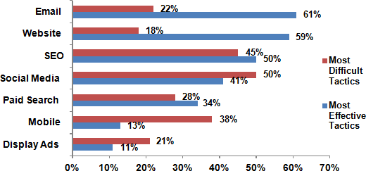

Figure 10: Preferred Internet Marketing Approach (July 2023) Source: Online google survey

Figure 2 shows that Email and Website are the most successful and easiest to implement strategies. Dave Chaffey (April, 2017) conducted a report on "Digital Marketing Trends for 2017" and asked Smart Insights readers for their opinions on the most relevant trends at a high level. A total of 2,352 responses were collected from advertisers all over the world. "Pick one marketing practise that you believe would give your company the greatest incremental uplift in leads and revenues in 2017 (or your clients if you work for an agency or as a consultant)," the respondents were asked. The data below demonstrates the digital marketing activities had the greatest commercial effect in 2017. The content marketing community is a hive of activity.

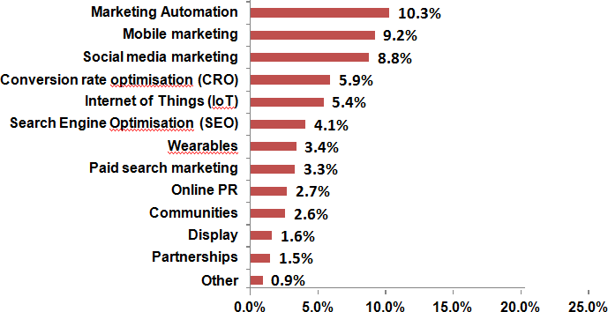

Figure 11: Digital Marketing Impact (July 2023) Source: Online google survey

To really understand the business and target audience, go beyond the basics covered in SWOT and PESTEL studies. You may have a general idea of your primary target market's age demographic, likes and dislikes, or the types of pages and brands they follow on social media up to this stage. You will be able to go beyond this and develop more in-depth business perspectives if you go beyond this. More in-depth business research can be time- consuming, but it can be well worth it once you have a better understanding and awareness of who you want to approach.

# COMPETITION ANALYSIS:

Mobile marketing is the multichannel promotion of products or services for mobile phones, gadgets, and businesses. Different types of versatile media platforms include creativity, job expos, and boards.

**Cost Leadership**: Using the cost leadership strategy, your aim is to often the best affordable product in the market. You look to cut costs whenever possible, only keeping the necessities.

**Product Leadership**: you will differentiate yourself by offering the highest quality Smartphone in the market. Innovation is key and you use it of offer the best and most exclusive smart phones to your customer.

**Customer Intimacy**: your goal is to focus on establishing a great and lasting relationship with your customers. Establishing a strong brand identity and chasing innovation will make your clients ambassadors of your business

**Combination of all of the above**: you don’t choose one specific focus decide to sit in the middle, price, quality and strong brand image with a good customer intimacy is all equally important to your business.

The key trends in portable Mobile Marketing Market area-based promoting, creation of most recent innovation that benefits clients, rise of development ideas that benefit clients, capacity utilisation of cell phone to generate cash, versatile as a gadget helps in overcoming any issues with the natural world, buyers are expanding by using various channels and gadgets an Mobile Marketing Market Size is a common marketing strategy used by businesses to warn consumers about a nearby business's commitment by using location-based applications. Area-based marketing is used to transcend some barriers between online and real-world customer peers and to gain an edge by promoting abundant procurement. Efforts receiving LBM systems can address customers' security concerns by putting in place strong security measures and procedures. Clients benefit from the creation of the most new breakthrough during difficult times when demonetization is trapped in the market.

The online money transfer businesses were prospering at the same time, and they were considering more profitable developments. Innovative features such as gotten installation doors, quick reaction codes, and easy-to-handle communications stickers have made cash moving arrangements easier for buyers and increased their trust in them.

The Mobile Marketing Market is segmented by customer category, vertical, and arrangement. It includes area-based highlighting in the arrangement segment. Area-empowered activities are often directly related to customer-related behaviour in area-based marketing.

* The multichannel advertising of goods or services through cell phones, mobile computers, tablets, and networks is known as mobile marketing. Since consumers search text messages more often than newsletters, mobile marketing platforms are the fastest growing means of connecting with the public.
* With the continuing transition from conventional to digital platforms, online retailers have had more flexibility in generating leads (B2C) by branding and promotional strategies using various mobile devices.
* Furthermore, global e-commerce behemoths are using mobile marketing tactics to create a recurring stream of revenue, boost consumer satisfaction, and maximise acquisition, all of which would help them grow their bottom line in the near future.

Traditional Marketing v/s Internet Marketing:

When we equate the approaches of online marketing to traditional marketing strategies, we can see that there are many places and possibilities where online marketing excels and has benefits over traditional marketing.

* Unlike conventional marketing, where we must wait for a set period of time to receive a response from consumers, online marketing is instantaneous.
* Since we can monitor consumer responses in real time, it is easier to determine if a specific strategy is effective for the product or not, and marketers can make necessary adjustments in the advertising campaign based on the feedback.
* Traditional marketing makes it difficult for small retailers to compete with big rivals in the market due to the costs and strategy-making experience needed, while online marketing allows you to reach your target audience with a wider reach and better quality assurance through a crisp website.
* Another argument that distinguishes traditional marketing strategies from internet marketing is the expense involved; a company may develop its own digital marketing campaign with very little money and substitute traditional expensive advertising approaches such as print media, radio news, television, and magazines.
* Any business promotional concept can have a much greater scope and coverage via online marketing because it can be seen in any part of the world through one marketing campaign at a low cost compared to traditional marketing campaigns, and once a marketer optimizes the important word search criteria material in a website, it is a great return on investment with very low cost to retain the placement.
* With electronic marketing, a marketer may create options to encourage their target audience to take positive appropriate action, such as visiting the respective website to learn about their goods and features, as well as different services. Through this process, consumers can express their thoughts on the product, their decision to purchase the product, and other information. Corresponding reviews, which is also available on the website, giving the marketer an important opportunity to connect with consumers, which is often diluted in conventional marketing methods.
* A well-designed website with quality information can target the requirements of customers and add significant value to their expectations with the creation of greater

opportunities by online marketing brand growth can be achieved better than conventional mode of marketing, a well-designed website with quality information can target the requirements of customers and add significant value to their expectations with the creation of greater opportunities.

* In comparison to conventional mode marketing, online marketing has the ability to produce a ripple and viral impact of promotion. For example, using social media networking websites, email, and social media platforms promulgates the content of the message to be spread incredibly rapidly.

Challenges of Online Marketing:

1. Problem of integrity:

The profession's core theme has been integrated marketing (Clown and Baak, 2013; Kitchen and Burgman, 2010; Blech and Blech, 2013). However, one of the main issues with marketing strategies is that they use a variety of offline and online promotion platforms, such as the press, brochures, catalogues, television, mobile phones, e-mail, the internet, and social networking, without a systematic, harmonizing marketing strategy. Each item is used in isolation and completed as a separate mission, rather than as part of a larger strategy aimed at achieving specific and specific goals. This shortcoming can be addressed by adopting a holistic approach that synchronizes various conventional and internet-era forms of marketing communication as moments in a larger framework. What's worth noting (or reminding) about the virtual, online part of integrated marketing is that, like offline marketing, all aspects of online marketing are inextricably connected- and in many cases interdependent.

As a result, none of the marketing elements can be considered in isolation. If there are no links to the website, it will never be visited; viral marketing necessitates this. All aspects of online marketing are inextricably related, and in many cases interdependent, with offline marketing and search engines are useless if there are no websites linking to it.

1. Lack of face-to-face contact:

Another flaw in online marketing that has been discussed in research and literature is the lack of personal communication (Goldsmith and Goldsmith, 2002; Phau and Poon, 2000). Since internet purchases do not require embodied, personal contact, some consumers find electronic forms of customer service impersonal and prefer the experience of shopping in a bricks-and- mortar store. They like to interact with store employees face to face, touch and feel related

products, and socialize with other customers. This feature of offline shopping is not available in a virtual marketplace, and it lacks personal contact. To be more precise, "for the types of products that depend heavily on buyers and sellers developing personal relationships, such as the sale of Internet marketing could be less suitable for the sale of life insurance and other items that require a physical inspection.

Face-to-face interaction is not only necessary in the case of unique products; culture is also a factor to consider. Rotchanakitumnuai & Speece (2003), for example, have drawn attention to the lack of personal interaction in online transactions. They mention Asian cultures that place a high value on personal relationships, among other things, and that this, They mention Asian cultures in which personal relationships are valued highly and that this, along with the transaction context, also plays a critical role in ensuring the success of financial transactions.

1. Security and Privacy:

In today's evolving technological environment, information privacy is one of the most important issues to consider. It is self-evident that today's consumers' data can be easily exchanged with other organisations without their consent. Furthermore, hackers can access their more sensitive personal information, such as usernames and passwords. Another issue is spas and pop-up ads, which are seen as an invasion of privacy by the majority of online customers.

These protection and privacy concerns are among the obstacles that online marketing faces. Effectiveness As a result, internet marketing is contingent on addressing the above issues. The option or consent is the most important aspect of privacy. This dimension stems from the idea that customers whose data has been obtained by a corporation should have control of how the data is used. They should be given the right to "watch how their personal information is used beyond the reason for which it was collected."

1. Lack of trust:

Closely linked to the topic of security and privacy is the issue of consumer distrust, which has been identified as a significant obstacle in the growth of online marketing. And it's for this reason that "online trust is becoming more important as a research subject, and its impact on internet marketing strategies is growing." "Internet confidence requires user views of how the site will deliver on expectations, how the site will deliver on expectations, how the site would

deliver on expectations, how the site would deliver on expectations, how the site would deliver on expectations, how the site would deliver on expectations, Despite the rapid growth of online purchases, many people still have doubts about electronic payment methods and whether or not the purchased goods will be shipped. On the other hand, the prevalence of online risk has caused consumers to have pessimistic or sceptic attitudes toward online transactions. Much more obviously needs to be done to earn consumers' confidence and persuade them that experiences in the virtual world are just as genuine and truthful as those in the real, offline world. Without a doubt, it is a lengthy and ongoing phase that will take time to complete. It is important to note that internet marketing cannot be used until confidence has been established. As a result, those in charge of online marketing must grasp the realities of the modern virtual world. "Today, confidence and consumer strength have combined to revolutionize marketing," says one of the most influential realities of this modern world.

Marketers and IT administrators are tasked with altering the online environment in order to attract online customers. This has resulted in a lot of buzz. This has sparked a lot of interest in learning more about online trust and designing new site designs to react to customers' growing power."

In this new age of feeling machines, our deep, hybrid strategic, creative, and technical capabilities will help you succeed.

1. More than half of commercial content will be produced outside of marketing by 2020. (IDC)

Marketers will no longer be the key content producers in the future. “Content is democratic,” as Schaub puts it. "How do I follow user-generated content?" would be the question you'll have to ask yourself soon." works in harmony. This can be accomplished in a variety of ways.

1. Events Will Overtake Advertising as the Most Expensive Investment

“A move away from the semi-sterile digital world into the real world,” says Schaub. The appeal of in-person experiences will increase as the amount of content available online expands. This rise would be reflected in marketing budgets, with event spending expected to overtake ads in 2017.

1. A portion of the sales budget will be diverted to marketing.

Marketing job growth is outpacing revenue growth, and marketing budgets are displacing funds previously allocated to sales activities. Similarly, tech marketing budgets are increasing,

indicating that marketing spend will continue to rise in the coming years. es, or to obtain customer reviews on your goods.

1. B2B marketers will increase their marketing technology spending.

In 2017, 77.6% of B2B marketers intend to increase their marketing technology budgets.Marketers are rising their budgets as they turn to technology for data and insights.

1. Brands will shift their focus away from acquiring new customers and toward retaining current ones.Early stage customer development will receive less resources, while middle and late stage efforts will receive more resources and capital. The explanation for this move, according to Schaub, is that “you don't have to invest as much money on consumer creation when you have better segmentation and data about your customers.”
2. Brands' Social Marketing Efforts Will Shift to Private Messaging Apps

Companies will move their social media activities away from the public domain and into private chat groups and messaging applications in the future. Private messaging apps like WhatsApp and WeChat have already surpassed emails as the main mode of communication in other parts of the world.Collaborates. Premium brands are now experimenting with these platforms as marketing tools.

1. Moving Forward, Brand Enablement Will Be Critical

According to IDC, half of all digital transformation (DX) projects will fail by 2020 due to a lack of an end-to-end customer experience orchestration service. You don't have to spend as much money on customer acquisition if you care for your customers.” When businesses begin to consider their digital transformation, they will almost always have to rethink their customer experience. Traditional siloed marketing must be phased out.Moving forward, you'll need to link your info, platforms, and teams. Emails have lost their dominance as the main mode of communication.

1. Persona-based marketing will be critical for development.

Rishi Dave provided his own testimonial on the advantages of a persona-based strategy at our MOCCA networking event in New York City.

# Advantages digital marketing brings for customers:

Digital marketing has modified consumers' purchasing habits as a result of rapid technological advancements. It has provided consumers with a number of benefits, as described below:

* + Keep up to date on goods or services - Digital marketing technologies enable customers to keep up to date on company details. Nowadays, a large number of consumers have access to the internet. You can access the internet from anywhere at any time, and businesses are constantly updating information about their goods and services.
  + Enhanced participation - Digital marketing allows customers to participate in the company's different activities. Consumers can go to the company's website to learn more about the goods or services, make online transactions, and leave reviews.
  + Simple information about products or services - Customers can get clear information about products or services through digital marketing. There is a small possibility that knowledge obtained from a salesperson in a retail store will be misinterpreted. The Internet, on the other hand, offers detailed product details on which consumers can base their buying decisions.
  + Easy competition with others - Since many businesses are attempting to advertise their goods or services through digital marketing, it is becoming the greatest benefit for the consumer in terms of being able to compare products or services from various suppliers in a cost-effective and time-efficient manner. Customers don't have to go to a bunch of different stores to learn about something.
  + 24/7 shopping - Since the internet is open 24 hours a day, there is no time limit for when a consumer may purchase a product online.
  + Share product or service content with others - Digital marketing allows viewers to share product or service content with others. One can easily transmit and obtain knowledge about the characteristics of a product or service using digital media.
  + Apparent Pricing - A company's prices for goods or services are shown across digital marketing channels, making prices very visible and open to consumers. The company can change the prices or offer specials on a regular basis.
  + Allows for Instant Buying - In conventional ads, consumers first watch the commercial before going to a local store to buy the items or products and services Customers can buy goods or services immediately through digital marketing.

**DIGITAL MARKET IS FUTURE**

Artificial intelligence would have a greater impact on the digital marketing industry in the coming years in three ways:

1. Effective Ads: One of the most significant ways artificial intelligence can affect marketing in 2017 is through the development of better advertising. The ability for brands to use AI to study and improve critical marketing aspects like keyword searches empowers marketers to create smarter, more effective marketing campaigns.
2. Smarter Search: Companies who want to remain competitive must learn how to integrate Artificial Intelligence they must incorporate intelligence into their marketing strategy or risk being left behind. Consumers in 2017 can search out and find knowledge more easily and effectively than in the past, and marketers are constantly searching for new ways to present their messages to individuals in a meaningful way. Marketers will take advantage of RankBrain by creating higher quality content targeted toward voice search. Google is using AI called Rank Brain to optimise search results by providing searchers with clearer answers to their questions.

Smarter Sentiment: Artificial intelligence (AI) enables advertisers to determine exactly what their target consumers are thinking and feeling about the brand. As a result, in this knowledge age, Digital Marketing is evergreen and has a bright future. Owing to a lack of knowledge of a company's product/service, Innovation with Digital Marketing of the product/service is used more, while Innovation without Digital Marketing of the product/service is used less. As a result, every industry would need a Digital Marketer in the future.

Every day, the field of digital marketing expands. Digital marketing on social media sites is growing in tandem with the number of platforms. In terms of social media marketing, this is true.

Every day, new businesses open their doors, and all of them try to sell their goods, and since the internet has taken over the world, there is no better way to market a product than digitally over the internet are still searching for new ways to communicate with individuals in a meaningful way.

Apart from social media marketing, there are other ways to do this, including email marketing, search engine optimization, and search engine marketing. There's also affiliate marketing and inbound marketing to consider.

As a result, by 2020, digital marketing will be the most widely used marketing strategy. When the number of businesses increases, so does the importance of digital marketing. Digital marketing is massive right now, and it isn't going anywhere anytime soon. We'll show you how: According to Boost Capacity, the United States will spend $120 billion on digital marketing in 2020. This figure accounts for about half of all media spending. The importance of digital marketing is rapidly increasing. According to Boost Capacity, the amount spent on social advertising is projected to double from 2016 to 2021 ($15,016 to $32,977). The sum spent on show advertisements and online videos will also rise. Digital marketing is predicted to outperform traditional marketing campaigns in the not-too-distant future. People simply prefer to consume information through the internet. When it comes to business development, Kevin O'Kane, managing director of Google Asia Pacific's Google Marketing Solutions, described the Internet as "rocket fuel." And he is right. According to Business World, O'Kane said, "Every business needs to be online and digital." “In order to continue to expand, SMBs [small and medium businesses] must reach customers where they are spending an increasing amount of time: online. Your 'local' market can be as large as you want it to be online.”

# EXPENDITURES FOR DIGITAL MARKETING OF COMPANIES

Average Digital Marketing Cost

How much digital marketing costs depends on various factors, as seen in the previous section. However, these are the average prices of different digital marketing services:

* SEO - from $1,500 to $5,000 per month
* PPC advertising - up to $10,000 per month
* Email marketing - from $500 to $5,000 per month
* Content marketing - from $2,000 to $10,000 per month
* Social media marketing - from $1,000 to $20,000 per month
* Website Design - from $2,500 to $100.000 per website

In terms of hourly rates, agencies charge between $80 and $200 on average.

Small to mid-sized businesses spend between $2,000 and $6,000 on digital marketing services, while more ambitious companies may spend between $10,000 and $20,000 monthly to achieve their marketing goals. Large enterprises may allocate well over $100,000 monthly toward their online marketing efforts, depending on their budget and objectives

# Five Types of Digital Marketing Pricing Packages

There are various ways to calculate digital marketing costs:

* 1. Packaged Pricing
  2. Public Pricing
  3. Price Quote Calculator
  4. Hourly Pricing
  5. Flat Project-Based Pricing

1. Packaged Pricing

Digital marketing agencies offer different package services, and potential buyers are aware of prices upfront. The package pricing varies widely, from $1,000 to $20,000. This pricing mode is convenient for clients and providers, promising transparency in deliverables. Small businesses can choose a package that suits their budget.

1. Public Pricing

Some agencies prefer public pricing, which implies pricing the services individually. This way, prospects can pick the individual services per their needs, wants, and budget. If you choose this pricing model, you need not fill out a detailed contact form.

1. Price Quote Calculator

This pricing model combines the public and package models. A price for each service is set, and clients can build their packages using the calculator. The method is ideal for clients with a specific budget. They can also get a customized quote for the opted services.

1. Hourly Pricing

Estimating the time needed to execute a task can be tricky. If you are looking for digital marketing strategies for small businesses, avoid the hourly pricing model to prevent added costs.

However, enterprises with bigger budgets and complex websites prefer to pay by the hour. They realize the importance of requiring added resources arising from unforeseeable issues.

1. Flat Project-Based Pricing

Certain SEO projects, like recovering from Google penalties, are one-time occurrences. In contrast, other tasks, like conducting content audits and keyword research, are essential but only required periodically. Such tasks are best suited for flat-fee pricing.

Paid advertising is another digital marketing service suitable for the flat fee approach. The costs of PPC can be anywhere from $500 to $5,000 flat. Based on the deal structure, you can negotiate an extra 15-30% ad spend.

On average, an SEO campaign costs $2,500 to $5,000 per month, while it can go up to $25,000 to $50,000 per month for the larger websites.

For video marketing projects, the project pricing is primarily determined by the scope of work. Content creation is also commonly priced by the flat fee structure. Some clients might even have to pay $50,000 for these services

# What Do Digital Marketing Services Include?

Digital marketing is a vast area, and businesses must be aware of the different services that come under it. These are:

* 1. Search Engine Optimization (SEO)
  2. Pay-per-Click (PPC) Advertising
  3. Content Marketing
  4. Social Media Marketing (SMM)
  5. Email Marketing
  6. Video Marketing
  7. Voice Search Optimization
  8. Web Design

1. Search Engine Optimization (SEO)

SEO is a core digital marketing service comprising a wide range of strategies for improving the online visibility of businesses. SEO is indispensable, with more than 80% of consumers relying on search to find their preferred products and services.

1. Pay-per-Click (PPC) Advertising

Pay-per-click (PPC) campaigns, like SEO, increase the online visibility of your business, but through paid advertising. PPC is a cost-effective digital marketing method for many companies, promising quick results.

1. Content Marketing

Content marketing promises impressive ROI; it generates 3x more leads than traditional marketing but costs up to 62% less. User-friendly content improves conversions, brand awareness, and revenue.

1. Social Media Marketing (SMM)

SMM is focused on enhancing your online presence, brand awareness, and brand loyalty. Social media provides a massive opportunity for businesses today and must be a part of any digital marketing strategy.

1. Email Marketing

Email marketing increases brand awareness and loyalty, increasing sales and conversions. It is a time-tested and cost-effective digital marketing service. It offers an unparalleled ROI of $36 for every $1 invested.

1. Video Marketing

Another valuable digital marketing asset that focuses on creating helpful and informational content for users and increasing conversions.

1. Voice Search Optimization

Gradually growing in demand, voice search optimization focuses on earning relevant featured snippets for your keywords. This service can range from $600 to $2,000 per month.

1. Web Design

Web design is an overlooked area in digital marketing. In most cases, web design is a one-time investment. However, web design is crucial because it offers a significant ROI.

If you are considering web design, its price ranges from $5,000 to $15,000 for a custom website and $300 to $1,000 for a customizable website from a template. Website maintenance costs vary from $50 to $2,000 a month.

# Things To Look for When Researching Digital Marketing Agencies

Now that you have an idea of the services and an estimate of the costs, here is a quick look at what you should look for while finding a provider:

* + Deliverables – You must know what your business is paying for, so reviewing an agency’s deliverables before signing a contract is essential.
  + Quotes – Several agencies do not disclose their prices online, leading to hidden fees. You must ensure your website’s digital marketing costs align with the custom quote they offer.
  + Methods – The agency must not follow a one-size-fits-all marketing approach. A personalized approach and customized methodologies should be preferred.

# Best Digital Marketing Agencies To Hire

If you’re considering hiring a digital marketing agency to help you with your online presence, look no further. Here is the list of top experts in the industry:

1. Matcha Design
2. Envicion Studio
3. Stellify Digital Solutions
4. Kaizenzo
5. Ernst Media
6. Chicago Marketing Consultancy LLC
7. Brandignity
8. DS&P Digital Marketing Agency
9. Adchemist Digital
10. Di Pietro Marketing Group
11. Decibel Blue
12. Blue Bumble Creative
13. Bright Pink Agency
14. ENHANCED MEDIA GROUP LTD
15. Centaur Interactive
16. Joombooz doo
17. Clash Copy Corp

# Matcha Design

* + Location: 8211 East Regal Place, Suite 100, Tulsa, Oklahoma 74433, United States
  + Average Hourly Rate: Inquire
  + Expertise: Website Development, UI/UX Design, Digital Marketing, Social Media Marketing...

Matcha Design is a Tulsa-based creative agency that helps businesses connect with their target audiences through web design, social media, logo design, and other marketing services.

Since 2004, the award-winning agency has combined goal-driven creativity with intelligent design practices to meet clients' unique needs. Their rigorous industry research ensures their finished product allows clients to serve their customers best.

Matcha Design is great for brands looking to break away from the status quo with a fresh and disruptive approach to business.

# Envicion Studio

* + Location: C-20-3A, Floor 20, 19 Sentral, Jalan Harapan, Seksyen 19, 46300 Petaling Jaya, Selangor, Petaling Jaya, 46300, Malaysia
  + Average Hourly Rate: $500/hr
  + Expertise: Digital Marketing, Web Design, Social Media Marketing Consulting, Digital Strategy...

Established in 2009, Envicion Studio has grown from a graphic studio to a full-suite creative and digital agency. They are now a trusted agency for technology-driven digital marketing, web and app development, branding, and other end-to-end services. Envicion Studio uses a combination of research, analysis, and design to help clients understand what works in their marketing campaigns.

The agency specializes in developing tailor-made campaigns for real estate businesses. Their clients include SP Setia, BRDB Developments, and Mah Sing.

# Stellify Digital Solutions

* + Location: Belcourt Parkway, Atlanta, Georgia 30076, United States
  + Average Hourly Rate: $100/hr
  + Expertise: Small Business Digital Marketing, Legal Digital Marketing, Social Media Marketing, Real Estate Web Design...

Stellify Digital Solutions is an all-inclusive web design and marketing agency that caters to businesses at all levels. With a comprehensive understanding of design concepts, logistics, and positive exposure, the agency helps bring brands up to speed with the latest design and marketing strategies. Their services range from web design, SEO, and social media to platform marketing and online and physical advertising.

The agency caters to brands across industries, including healthcare, real estate, dental, and legal. Clients include Your Premier Image, Bright Future Solar, and ATG Innovations

# Kaizenzo

* + Location: 95 Danforth Avenue, Toronto, M4K 1N2, Canada
  + Average Hourly Rate: $125/hr
  + Expertise: UI/UX Design, Digital Marketing, SEO, PPC

Based in Toronto, Kaizenzo is a results-oriented digital marketing agency that crafts high- performance and ROI-driven and data-driven strategies. The agency identifies marketing opportunities that allow brands to connect with and engage with audiences around the world, driving more leads and increasing revenue. Their services range from various forms of paid advertising to SEO, content marketing, and web design.

To date, Kaizenzo has successfully completed over 200 projects and managed more than 1,500 campaigns. Their clients include Nissan, Kia, Callture, and Telcan.

# Ernst Media

* + Location: 12402 N. Division St. STE 185, Spokane, Washington 99218, United States
  + Average Hourly Rate: $95/hr
  + Expertise: Enterprise Mobile App Development, Digital Marketing, Small Business Digital Marketing, Inbound Marketing, and ecommerce PPC.

Ernst Media is a premier digital marketing agency based in Spokane, Washington. Founded in 2018, the agency has become well-known throughout the area for its expertise in mobile app development, digital marketing services, and ecommerce PPC. Ernst Media's impressive client list has included DAV Network, Wisdom Labs, and DNS Filter — all trusting Ernst to bring their visions to life with professional and witty guidance.

Each team member brings more than 15 years of experience to the table and Ernst Media is committed to delivering measurable results.

# Chicago Marketing Consultancy LLC

* + Location: 8 S Michigan Ave #2310, Chicago, Illinois 60603, United States
  + Average Hourly Rate: Inquire
  + Expertise: Digital Marketing and SEO.

Chicago Marketing Consultancy (CMC) is a Chicago-based digital marketing and SEO agency that stands tall in the Midwest business landscape. First founded in 1993 and re-instated in 2020, CMC is a second-generation, family-owned, and managed consultancy that works with local and international clients alike.

CMC is no stranger to taking necessary risks and making lemonade out of the obstacles life throws at them; mirroring the paper plane proverb where challenges are seen as opportunities for creative growth. Moreover, CMC has positioned itself as an asset for any entity vying for digital marketing expertise — SEO understanding included.

Chicago Marketing Consultancy boasts an impressive client roster, some of which include the Hyatt, Marriott, and Hilton Hotels.

# Brandignity

* + Location: Naples, FL 34103, Naples, Florida 34103, United States
  + Average Hourly Rate: $50/hr
  + Expertise: Digital Marketing, Search Engine Marketing, SEO, and Local SEO.

Brandignity is a digital marketing agency based in Naples, Florida, that has been gaining traction since its humble beginnings in 2010.

Brandignity specializes in full-service search engine optimization (SEO) and web design that follows the latest advances in technology to optimize its clients' online presence. Brandignity's team of experts also offers services such as social media options, content creation, paid ads, custom web design, and turnkey solutions tailored to each client’s needs — depending on what platform works best for them.

With big-name brands, such as Canada Q Bank, Kapta, and Gozen, already benefiting from Brandignity’s commitment to delivering effective and innovative digital marketing strategies, Brandingity is proving itself time and time again a formidable force in this rapidly evolving industry.

# DS&P Digital Marketing Agency

* + Location: 605 N. Michigan Ave, 4th Floor, Chicago, Illinois 60611, United States
  + Average Hourly Rate: Inquire
  + Expertise: Public Relations, Mobile App Development, Website Development, Digital Marketing, SEO, PPC, Social Media Marketing, and VR/AR.

DS&P, founded in 2009, is a small but mighty digital marketing agency with offices throughout the U.S. and clients worldwide, with its HQ based in Chicago, Illinois.

Owned and operated by an incredibly talented team of designers, strategists, entrepreneurs, and marketing geniuses, DS&P offers every digital service that your business needs in one bundle. From mobile app development, digital marketing, and PPC to VR/AR, SEO, and PR, DS&P's expertise is unparalleled.

DS&P has successfully serviced clients such as Nelson Propane, Ritzy Rentals, and VastMed through their passion for delivering unparalleled results. DS&P provides the perfect combination of quality services at an affordable cost — boosting the success rate for your company is their main objective!

# Adchemist Digital

* + Location: 3274 San Jose st Sampaloc, Manila, 1008, Philippines
  + Average Hourly Rate: $18
  + Expertise: Small Business Branding, Digital Marketing, SEO Consultants, Search Engine Marketing...

Adchemist Digital offers the best local SEO services, social media management, website development, outreach marketing, Amazon listing, and NFT community management from Manila, Philippines.

The agency helps transform, create, and convert your “silver” business to “gold.” In other words, they can develop businesses to a new level to achieve goals and help create a solution to your problems.

# Di Pietro Marketing Group

* + Location: 525 Rt 73 N, Ste 104, Marlton, New Jersey 08053, United States
  + Average Hourly Rate: $200
  + Expertise: Web Design, Digital Marketing, Legal Digital Marketing, Branding, PPC...

DMG began running PPC campaigns way back in 1998 with GoTo.com. This was a year after Yahoo turned down an opportunity to buy Google for $1 million.

Interesting that no one in the fledgling digital advertising industry at that time even thought of metrics such as AOV and CPA — except this agency. They did because they came from the traditional advertising industry. Being so well-versed in the traditional side of things, they simply ported over their knowledge of marketing and advertising to the digital side.

# Decibel Blue

* + Location: 7524 E Angus Dr., Scottsdale, Arizona 85251, United States
  + Average Hourly Rate: $150
  + Expertise: Digital Marketing, Social Media Marketing, Real Estate Marketing, Influencer Marketing...

Every organization needs to communicate what makes them exceptional to tell their story. With over 60 years of collective experience, Decibel Blue’s leadership team helps real estate, franchise, and lifestyle clients achieve measurable results by telling their stories strategically and creatively.

With offices in Denver and Scottsdale, the 15-year-old PR firm represents businesses ranging from start-ups to mature regional and national brands.

# Blue Bumble Creative

* + Location: PO Box 557, Groton, Massachusetts 01472, United States
  + Average Hourly Rate: $150
  + Expertise: Branding, Graphic Design, Print Design, Website Development...

This agency is a woman-owned business with a team of passionate graphic designers, web developers, and marketing experts. Blue Bumble Creative (BBC) ensures results with industry- specific marketing techniques proven to drive interest to your business and showcase your brand correctly.

Founded in 2000, BBC is a one-stop solution for premium branding and marketing development. Their goal is to create a unique design or strategy for your business that sets you apart from your competition — and help you rise to the top!

# Bright Pink Agency

* + Location: 5401 N University, Dr Ste 102, Coral Springs, Florida 33067, United States
  + Average Hourly Rate: $150/hr
  + Expertise: Branding, Public Relations, Advertising, Creative, Web Design, Website Development, UI/UX Design, Digital Marketing, Search Engine Marketing, Legal Digital Marketing, Social Media

In this time and age, you need a digital marketing agency to help you continue taking your business to the next level. That's what Bright Pink Agency aspires to accomplish for its clients.

With 14+ years of experience and a series of prestigious awards, this agency boasts an impressive portfolio that includes work for franchises, multilocation, and nonprofit organizations.

# ENHANCED MEDIA GROUP LTD

* + Location: 2 Broom Avenue, Chesterfield, S45 8HP, United Kingdom
  + Average Hourly Rate: $24/hr
  + Expertise: Small Business Digital Marketing, Digital Advertising, Digital Marketing, Responsive Website Design, Print Design...

This online development brand agency tailors solutions to provide the best marketing solutions to enhance your business and brand image online. This is done by interacting, engaging, and uploading the most relevant media to platforms such as Twitter, Instagram, and Facebook.

Researching the market and keeping up to date with the latest technologies enables them to provide such a service to you and keep your business on its feet.

# Centaur Interactive

* + Location: 20140 Oakflower Ave, Tampa, Florida 33647, United States
  + Average Hourly Rate: $60/hr
  + Expertise: Digital Marketing, SEO, eCommerce, Real Estate PPC...

Centaur Interactive is an eCommerce digital marketing agency providing ROI-based eCommerce solutions. They aim to make new-age eCommerce marketing services accessible to businesses of all sizes.

The agency uses holistic techniques to manage and build effective eCommerce campaigns that provide results. They are dedicated to helping companies grow through a personalized marketing strategy tailored to their needs.

# Joombooz doo

* + Location: Pasterova 16a, Nis, 18000, Serbia
  + Average Hourly Rate: $50/hr
  + Expertise: YouTube Marketing, Video Marketing, Instagram Marketing, Social Media For Small Business...

Company Joombooz was founded in 2011 in Niš and has been successful in the country and abroad for years. The main activities of the company are web programming and design and digital marketing.

A special team of creative experts in the field of marketing, informatics, and graphic design works on marketing campaigns (content, advertising, social media, etc.). The goal of the company is customer satisfaction and long-term relationships because the client and their wealth are always the top priority.

# Clash Copy Corp

* + Location: 126 Frobisher Cres, Saskatoon, S7K4Y5, Canada
  + Average Hourly Rate: $95/hr
  + Expertise: Small Business Website Design, SEO, PPC, Email Marketing...

Clash Copy provides collaborative and rewarding marketing solutions to technology businesses of any size. Their mission is to ensure that you close more businesses with content that retains an authoritative presence in the IT industry.

Their services include website solutions, SEO, PPC, copywriting, marketing automation, CRM solutions, email marketing, and more.

Takeaways on the Cost of Digital Marketing

Done properly, digital marketing can be a highly effective tool for businesses looking to reach their target audience. Still, it can also come with a high cost. Therefore, businesses must thoroughly evaluate their digital marketing strategies and estimate the digital marketing cost, following their budget.

With so many digital marketing channels available, determining which ones will be most effective for the specific needs of your business can be challenging. In such cases, seeking the guidance of a digital marketing agency can be highly beneficial. Digital marketing experts can help businesses navigate the complexities of the digital marketing landscape and make informed decisions about where to allocate their resources.

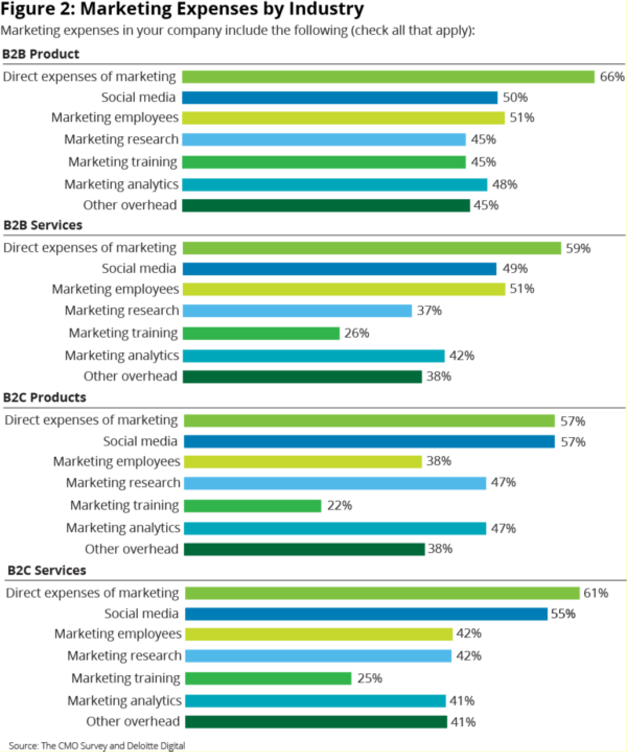

# Source: Online Data from Statista

**DIGITAL MARKETING IN POLAND**

The top three digital marketing firms in Poland have been growing rapidly and offer reliable marketing solutions and strategies for growing businesses. In recent times, every company needs to strategize its digital presence and a strategic marketing plan that creates or rather advocates for a positive ROI. Below is a list of said digital marketing firms in Poland

1. Delante

With its initiation or rather operations started in 2014, Delante is a search engine optimization provider that provides industry specific marketing solutions. The company was awarded Global SEO agency of the year in 2022. Delante caters for industries like law, fitness and travel including automotive and many other industries.

1. Fortunatos

This is a company that provides digital marketing in-house solutions with customized strategies backed up by data and research to boost a wide range of brands visible mark and overall sales. Fortunatos has a team of experienced marketers who give a perspective of individual companies using w wide range of systems to analyze a positive way the company can grow.

1. Skalski Growth

Skalski is a full-service results-oriented digital marketing agency. It helps with startups and scaling and product market fit, lead generation, conversion optimization, marketing automation and business analytics. From strategy to implementation.



**CHAPTER FOUR**



**LIMITATIONS**

According to the findings of this report, understanding which social media platforms a company's target market uses is another important factor in ensuring that online marketing is effective. It is possible to assess the efficacy of Internet marketing in relation to various businesses. The research can be expanded to compare internet marketing approaches that are unique to different types of businesses.



**CHAPTER FIVE**



**RESULT AND DISCUSSION**

The aim of this research was to figure out how traditional business design with Benefits could make better use of digital marketing in their overall marketing strategy. After a thorough examination of conventional marketing theory as well as various facets of digital marketing and developments, it is undeniable that the future of marketing is rapidly moving to the online world. This includes social media advertisements, as well as digital marketing tools including newsletters and search engine marketing (SEM), which includes SEO, SMO, and PPC advertising. Since their company is new to the US market, its exposure and awareness are poor. A more detailed description of the target segment is also needed. There is a wealth of literature, analysis, and statistics on marketing, including digital marketing, and the main goal of the study was to compile a detailed theoretical foundation based on this data. When assessing the overall prospects, blogs, figures, and surveys specific to the target market were used extensively. The study gathered primary data from these sources, including discussions and emails with Design With Benefits' co-founder (appendix 6). The primary data contributed to a deeper understanding of the company concept and marketing goals. The results revealed clear evidence that markets, as well as corporations' marketing efforts, are moving online. In the United States, online retail revenues increased by 12% from 2011 to 2012, with gross sales of $226 billion in 2012. (Source: Forester, 2012) Furthermore, user access to the Internet has increased year after year, and social media has become common among people of all social classes. According to the report, an organisations can perform most of its marketing actions more cost-effectively through digital marketing than through conventional marketing.

Digital marketing can also be done without the help of a third-party marketing firm. As a result, online marketing strategies can be implemented more quickly. However, conventional marketing platforms should not be abandoned just yet. Naturally, advertisers must migrate to a location where they can connect with customers, which is increasingly the Internet. This means that by focusing on digital marketing, Design with Benefits will attract more potential customers on a smaller budget. Despite a general change toward social media marketing, it is difficult to predict the next major social network or application, so advertisers must closely monitor customer behavior and how they interact with the media. The best way for Design with Benefits to make the most of digital marketing is to gain in-house knowledge of how to manage it effectively. The findings also revealed that demand for companies with green values is growing year after year, indicating that consumers are becoming more concerned about how their purchases impact social and environmental factors. This means that Design With Benefits has a bright future in the industry because they have both design and these values. The company

would be easier to extend to other regions in the future if it uses the online store to perform sales actions. A growing number of consumers, especially in Europe, are embracing the concept of sustainable consumption. Since the company can gain greater exposure within their precisely-defined target audience across various platforms such as Pinterest, Facebook, blogs, newsletters, search engines, and paid advertising, digital marketing is an ideal addition to their marketing strategy.

To summarize, digital marketing's potential for businesses lies in the ability to handle marketing actions with lower budgets, the ability to fine-tune the audiences of advertising, and the ability to engage consumers with the brand.

In general, we can divide these concepts into two main classes, Table 1, based on the authors' differing viewpoints.

The words in Group 1 are more complicated and have a broader definition. They involve the organization's marketing efforts that are carried out across various digital platforms. It is unique to them in that they are an important part of the overall marketing campaign and that they execute it using both modern and conventional strategies and methods.

The terms in Group 2 are very similar to the terms in Group 1, but they only concentrate on engaging with users and gaining their attention and interest based on the opportunities provided by the Internet environment.

The word "internet marketing" is used in this paper because, as previously stated, it has the most complex character and encompasses all other terms.

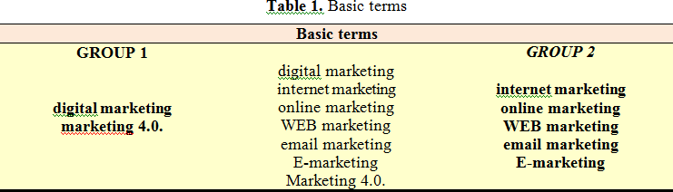

When examining the different authors' descriptions of the meaning and content of digital marketing, it becomes clear that, despite their wide range, the idea of resources is central to almost all of them. These techniques are used to carry out various marketing campaigns with the primary goal of increasing the company's profit by attracting new and maintaining current customers. This leads us to conclude that digital marketing is a highly evolved (thanks to technological advancement) medium in the company's overall communication mix, rather than an entirely new philosophy or form of marketing. The tools and techniques for marketing activities mentioned in Table 2 are included in this channel.

Table 2**:** Basic tools of digital marketing

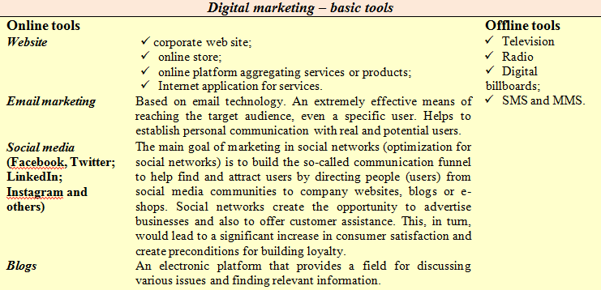

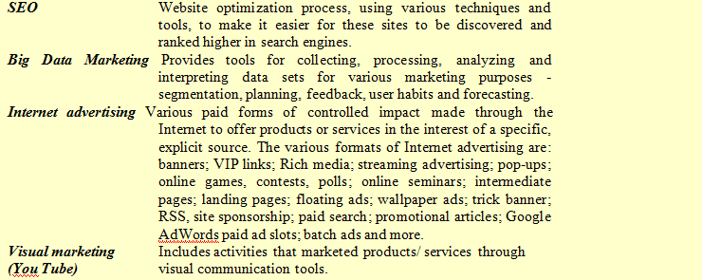

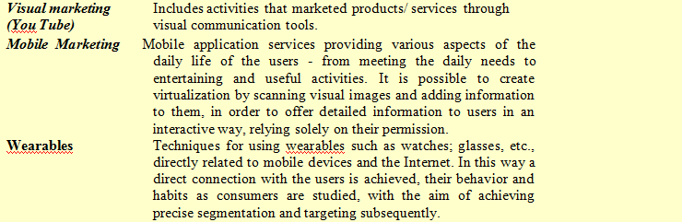

Every day, the value of digital marketing in practice grows, and more companies are taking advantage of the diverse range of resources it provides. Internet users in Bulgaria have risen

from 51 percent in 2013 to 62 percent in 2017, according to the latest data from the Bulgarian Media Card, and this figure is increasing every day. Companies' spending on online ads increased dramatically from EUR 20.22 million in 2013 to EUR 39.40 million in 2017, and it is projected to increase even further in 2019. A similar pattern can be seen around the world, with more and more capital being invested in the creation of digital marketing campaigns. In order to successfully invest these funds and generate the optimal return on investment, it is important to understand the benefits and drawbacks of digital marketing.

# Advantages of digital marketing:

Digital marketing enables businesses to be more agile and adaptable to changes in the external world, as well as to create effective relationships with their customers and be more open to their needs and understandings. The following main advantages of this method of marketing help to accomplish all of this:

1. High interactivity - allows for interactive contact with customers, making it more open to their understanding and desires for knowledge finding and receiving. As a result of interactive communication, opportunities to construct a dynamic environment, changing space, specific navigation based on the user's preferences, dynamic design, and more arise.

Top-level special computer code, mobile technology, and ongoing innovation are all used. Things change with each visit, depending on his or her abilities, system data, and awareness of his or her interests and orientation. As a result, it's easier to come up with new and exciting ways to draw and keep customers' attention.

1. Overcoming geographical barriers and weaknesses in marketing operations - digital marketing enables businesses to engage with consumers, sell goods and services, and find potential business partners in real time from anywhere on the planet.
2. Provides ways to adapt to user needs and desires more easily and flexibly.
3. High degree of measurability of marketing results - when running conventional advertising campaigns, the recorded results are often vague and unreliable, and do not indicate whether funds are being invested effectively, while the results of digital campaigns are easily and precisely measurable (using modern statistical tools) and accessible in real time.
4. Facilitates consumer segmentation and targeting, resulting in improved promotional advertisement targeting and marketing activity effectiveness.
5. Individual offers can be generated using gathered online information for consumers, adding value to them and reacting as specifically as possible to their needs and preferences in order to maximize customer satisfaction.
6. Consumers will have more convenience as a result of digital technology, as they will be able to access even more and better knowledge about goods and services that attract them, as well as purchase them from the comfort of their own homes, saving time.
7. Creates the necessary conditions for the effective creation of virtual businesses.
8. Allows businesses to reach a larger audience by using social media.
9. Increases the number of visitors to a company's website by developing high-quality online ads, Internet publications about the company's activities, and so on. As a result, consumers are more likely to associate with the thematic content that has been presented to them. As a result, interest in the offered products/services grows, and sales rise as well.
10. Facilitates contact and engagement with users - users may ask questions and get answers right away thanks to different channels such as social networks, web apps, and websites. As a result, businesses will speak directly with their current and future customers, create confidence, and receive input on their goods and services.
11. Streamlines the monitoring and review of competitors' behavior’s.
12. Improves the degree of control and correction in the production and execution of various marketing campaigns. Has the potential to reduce the time spent preparing and conducting marketing research.
13. It needs less investment - the use of various digital platforms for marketing activities necessitates less investment than conventional channels, resulting in higher profitability for digital marketing.
14. Suitable for start-ups, small and medium-sized businesses
15. Given all of the benefits mentioned above, we can conclude that digital marketing is particularly well suited to new and small businesses, as it offers a high level of productivity with minimal investment enables the development of new business models and techniques such as mass customization, co-creation, and others.

# Disadvantages of digital marketing:

In order to develop effective marketing strategies based on knowledge and communication methods and technologies, businesses must be mindful of not only the benefits they have, but also the drawbacks that can arise when they are used in practice.

1. One of the most significant drawbacks of digital marketing is that it makes businesses a "open book" for rivals. Digital marketing strategies can be instantly and easily replicated by competitors. They can copy trademarks and logos, as well as corporate identities, to deceive customers and gain market share. Furthermore, they can easily deceive customers by providing misleading information about goods, services, or brands, which can damage a company's reputation and contribute to customer exodus.
2. In digital marketing, you must develop relationships with customers you do not see in person, which necessitates a thorough understanding of the psychology of online consumer behavior. When it comes to digital marketing strategies, however, many advertisers ignore this and focus on conventional customer psychology. This, in turn, leads to a reduction in productivity because it ignores the nuances of customer behavior and the relationships that are formed online.
3. Users can view digital marketing campaigns as unprofessional if they are not well-designed and targeted.
4. Negative reviews may ruin a company's online credibility - negative remarks and facts about goods and services, as well as trademarks, are available and open to all Internet users, which can significantly harm a company's image and lead to customer outflow.
5. Lack of customer confidence - Since digital marketing strategies require the use of technology that monitor and collect data from Internet users, there are privacy concerns, including the protection of their personal information. As a result, people have a strong aversion to this form of marketing and often decline to participate in such activities, which is one of the most significant obstacles to the growth of digital marketing. As a result, the issue of online confidence and its effect on digital marketing strategies is becoming increasingly relevant, and much research has been conducted in this area.
6. Overloading the Internet with online advertising messages - an overabundance of online advertising messages in the form of banners, the constant display of open and close windows, disruption of video materials, and so on will irritate customers, affecting their attitude toward businesses.
7. Digital marketing is not appropriate for all goods, services, or businesses; there are a range of products and services whose target audience cannot be reached or affected by the resources available by digital marketing. This is due to the fact that these people are not online or do not trust the information they will access from the Internet for various reasons.
8. Digital marketing is heavily reliant on techniques and technology; this, on the one hand, necessitates a high level of expertise in the area, but it can also lead to a slew of technological mistakes, as the information and communication tools available through digital marketing are not without flaws. It is common for the chosen technological solution to fail because it does not perform correctly and produces incorrect results, resulting in the failure of the advertising campaign. Broken connections, sluggish or non-loading promotional messages or websites, non-working paid advertisement keys, statistical analysis software that do not process data correctly, and many more are examples.
9. Inappropriate use of digital resources and applications - the Internet has a plethora of tools and applications, and new ones appear every day. This makes it difficult for marketing professionals to choose the ones that will be the most appropriate for particular marketing activities that will better suit the needs and priorities of businesses.
10. There are no specific guidelines for selecting digital marketing resources in campaigns.
11. It is extremely difficult to keep up-to-date information in the modern world; due to the dynamism that is transforming the world of digital technology, information there rapidly becomes outdated and must be replaced with new information on a regular basis. For many businesses, it has become a major problem because they lack the requisite capital.

xi) Frequently, digital marketing strategies are created and implemented independently of the company's overall marketing plan, resulting in an inability to produce the desired results, reduced performance, and financial waste.

1. Emphasis on technological solutions at the cost of content - in order to appear glamorous and trendy to their customers, marketers often overdo the technical appearance of promotional messages, leaving the content in the background, which does not contribute to good and consistent results in the long run.

The major benefits and drawbacks of digital marketing have been explained, with new ones added. The additional benefits include: creating prerequisites and favorable conditions for the effective creation of virtual enterprises; increasing the degree of control and correction in the development and execution of various marketing activities; and being ideal for start-ups. It enables the development of new business models and strategies, such as mass customization, co-creation, and others, for small and medium-sized businesses. The following are some additional drawbacks: You must create relationships with a customer that you do not see in person in digital marketing; if digital marketing strategies are not properly planned and executed, consumers will view them as unserious. Digital marketing is not appropriate for all types of goods, so it must be properly tailored. , programs, and businesses; the use of ineffective digital tools and applications; the absence of specific requirements for selecting digital tools in marketing campaigns; Digital marketing strategies are often created and carried out independently of the company's overall marketing plan, with a focus on technological solutions at the cost of content. On the one hand, the results in this paper provide a solid foundation for potential advances in the area of digital marketing, and on the other, they will assist businesses in developing their marketing strategies and plans. However, in order to be accurate and successful, digital marketing practices must be viewed in conjunction with a company's overall marketing growth strategy. Only then would they be able to fully exploit the ability of information and communication technology to improve economic outcomes and competitiveness.



**CHAPTER SIX**



**RECOMMENDATION**



**AND**



**CONCLUSION**

# RECOMMANDATIONS

It has also been discovered that customers have a clear understanding of internet technology and are in favor of using web marketing, so it is suggested that any business, large or small, should take advantage of this opportunity and incorporate online marketing into their marketing strategy. Web marketing, e-commerce, and social media marketing are the most popular types of online marketing.

Consumers prefer online marketing over conventional marketing for a variety of reasons, so businesses can invest more on online media than on traditional resources. However, in addition to its benefits, online marketing has certain drawbacks, such as the risk of fraudulent activity or privacy concerns that are beyond one's control.

# CONCLUSION

The research began with the aim of examining the various types of marketing. Based on the debate, it was discovered that the most critical aspect of digital marketing is to communicate with the users. The customer experience ladder has demonstrated how to connect with consumers. The study also revealed that in order to effectively use digital marketing, businesses must first design an efficient platform. It has been demonstrated that in the current context, it is critical to integrate all structures with the digital platform. The transformation of a newspaper from a printed edition to an online edition has exemplified recent digitalisation trends. With the advent of technology, digital marketing research and practise are developing. In India, we are witnessing a significant shift toward digitalization. In comparison to traditional or conventional approaches, consumers are looking and searching more on the internet to find the best offer from sellers across India. In this research, we found that digital marketing, such as search engine optimization (SEO), search engine marketing (SEM), content marketing, influencer marketing, content automation, e-commerce marketing, campaign marketing, and social media marketing, social media optimization, e–mail direct marketing, display ads, e– books, optical discs, and games a, can be extremely beneficial to companies. It has been demonstrated that we are all linked via WhatsApp and Facebook, and the growing use of social media is opening up new opportunities for digital marketers to attract consumers via digital

platforms. User motivations must be understood in order to have a better understanding of what motivates consumers to create content about a brand or shop. . Chu (2011) investigated the relationship between Facebook brand-related group engagement, advertisement reactions, and psychological factors such as self-disclosure and attitudes among members and non-members of Facebook groups. Users who are members of Facebook groups are more likely to share personal information than non-members, according to the report. Digital marketing is cost- effective and has a significant commercial impact. Indeed, small businesses can now enter targeted customers at a lower cost and compete on an equal basis with larger corporations.

# SUMMARY

The aim of this study is to learn about the most common emerging media choices for marketing. Many new strategies for product advertising and marketing have emerged in the Internet era. Market research is now possible online, thanks to the transformation of "desk research" into "online research." Digital marketing is being used by many Indian businesses to gain a competitive edge. Since it allows people to chat and share posts and subjects, social media has rapidly grown in popularity. Businesses have been motivated to change the way they communicate their products as information technology has advanced, followed by the advancement of digital communication tools. A digital marketing communications strategy is a plan for using digital media to communicate. The study's aim is to look at the efficacy of online digital media ads as well as other new media options for marketing. This paper focuses on the evolution of digital marketing and its current importance, including the differences and connections between digital marketing and conventional advertising, as well as the relationship between digital marketers and traditional advertisers. It assists small companies, such as start- ups, in successfully adopting and implementing digital marketing as a strategy in their business plans, as well as recognizing the value of digital marketing in today's competitive market.

# List Of Tables

|  |  |  |
| --- | --- | --- |
| **FIGURE AND TABLES** | **DESCRIPTION** | **PAGE NO** |
| 1. | World Internet users by World regions | 14 |
| 2. | Research methods | 18 |
| 3. | Model Graph of Websites and their promotion | 20 |
| 4. | Digital Marketing | 23 |
| 5. | Social Media Usage Trends | 26 |
| 6. | Options available in the communications mix for increasing visitors to awebsite | 31 |
| 7. | Percentage who considers the different information sources as importantwhen researching of considering a product or service | 32 |
| 8. | Relative traffic projections based on the ranking on search engineresults pages (visitor numbers are shown relative to 100 for position 1) | 33 |
| 9. | Preferred Internet Marketing Approach | 37 |
| 10. | Digital Marketing Impact | 38 |
| Table 1 | Correlations | 42 |
| Table 2 | Basic tools of digital Marketing | 50 |

# REFERENCES

* 1. Alistair, D. and Copulsky, J. Managing webmavens: relationships with sophisticated customers via the Internet can transform marketing and speed innovation. Journal: Strategy and Leadership, Issn 10878572, Volume 34, Issue 3, Pages 14-22, Provider Catchword, Year 2006
  2. Allen, E. and Fjermestad, J. 2001. E-commerce marketing strategies: a framework and case analysis. Logistics Information Management, Vol.14, number !, pp14-23
  3. Barak, L. and Biyalogorsky. 2003. Setting referral fees in affiliate marketing. Journal: Journal of Service Research, JSR, Volume 5, Issue 4, Pages: 303-315, Provider Proquest
  4. Bayne, K. M. 2000. The Internet Marketing Plan: The completed guide to Instant Web Presence. Second edition, John Wiley & Sons, Inc.
  5. Bengtsson, M., Boter, H. and Vanyushyn, V. 2007. Integrating the Internet and Marketing Operations. Journal: International Small Business Journal, Issn 02662426, Volume 25, Issue 1, Pages 27, Provider Proquest
  6. Booms, B. and Bitner, M. 1981. Marketing strategies and organization structures for service firms. In J. Donnelly and W. George (eds), Marketing of Services. An American Marketing Association, New York.
  7. Chaffey, D., Ellis-Chadwick, F., Johnston, K. and Mayer, R. 2006. Internet Marketing: Strategy, Implementation and Practice. Third edition, Pearson Education Limited
  8. Chen, C. Y. and Greg, L. 2000. Will Amazon(.com) Save the Amazon?, Journal: Fortune, Issn 00158259, Volume 141,Issue 6,Pages 224-225, Provider Ebsco
  9. Chiu, Y. B., Lin, C. P. and Tang, L. L. 2005. Gender differs: assessing a
  10. Model of online purchase intentions in e-tail service. Issn 09564233, Volume 16, Issue 5, Pages 416-435, Provider Proquest
  11. Ryan D. Understanding digital marketing: marketing strategies for engaging the digital generation. Kogan Page Publishers; 2016 Nov 3.
  12. Chaffey, Dave, and Fiona Ellis-Chadwick. Digital marketing. Pearson UK, 2019.
  13. Chaffey, D. and Smith, P.R., 2013. eMarketing eXcellence: Planning and optimizing your digital marketing. Routledge.
  14. Archambault, A and Grudin, J. (2012) A longitudinal study of facebook, linkedin & twitter use. In Proceedings of the SIGCHI Conference on Human Factors in Computing Systems, 4(2), pp. 2741-2750).
  15. Wind, Yoram Jerry, and Vijay Mahajan. Digital marketing: global strategies from the world's leading experts. John Wiley & Sons, 2002.
  16. Wymbs, Cliff. "Digital marketing: The time for a new “academic major” has arrived." Journal of Marketing Education 33, no. 1 (2011): 93-106.
  17. Kannan, P. K. "Digital marketing: A framework, review and research agenda." International Journal of Research in Marketing 34, no. 1 (2017): 22-45.
  18. Charlesworth, A. (2014). Digital marketing: A practical approach. Routledge.
  19. Todor, R. D. (2016). Blending traditional and digital marketing. Bulletin of the Transilvania University of Brasov. Economic Sciences. Series V, 9(1), 51.