**Enhancing Early Patient Discharge:**

**RIDE (Reengineering Initiatives for Discharge Efficiency) Mechanism**

**Abstract:**

**Introduction:** Hospital discharge process is a high-risk and complex procedure characterised by fragmented, disorganised, and non-standardised care, presents global health systems with significant challenges in efficiency and effectiveness. This widespread issue necessitates sophisticated evaluation and innovative solutions. Delays in the discharge process notably diminish hospital profitability and patient satisfaction within communities.

**Methods:** By reengineering hospital discharge through innovative approaches such as interdisciplinary discharge planning, the adoption of health information technologies, and the integration of post-discharge follow-up care, hospitals can streamline early patient release and reinforce post-discharge communication. These strategies aim to contribute to reduced readmission rates, increased patient satisfaction, and more efficient utilisation of healthcare resources.  This may involve scheduling follow-up appointments, providing detailed discharge instructions, medication reconciliation, and remote monitoring services to track patients' progress post-discharge reducing complications and readmissions, ultimately improving patient outcomes and reducing healthcare costs.

**Result:** A 45-minute discharge process from hospitals could significantly contribute to healthcare research by offering insights into optimising operational efficiencies, enhancing patient throughput, and potentially improving patient satisfaction by minimising hospital stay durations. Additionally, it could serve as a critical evaluation point for assessing the impact of rapid discharge protocols on post-discharge outcomes and healthcare resource allocation.

**Discussion:** Improving the hospital discharge process is crucial for enhancing patient outcomes and reducing ALOS. This paper examines innovative approaches to reengineering hospital discharge by streamlining the early release of patients and reinforcing post-discharge communication. The study explores interdisciplinary discharge planning, the adoption of health information technologies, and the integration of post-discharge follow-up care. Results suggest that restructured discharge processes that are patient-centred and continuity-focused can contribute to reduced readmission rates, increased patient satisfaction, and more efficient utilisation of healthcare resources.

**Keywords:**

Hospital discharge, post-discharge communication, readmission rates, patient satisfaction, Lean Six Sigma methodologies.

**Key Message:**

* **What is already known on this topic?**

Early Patient Discharge is associated with a lower risk of hospital readmission, reduces ALOS, with improved patient outcomes. Various studies already state the factors contributing to delay in Discharge Process and lack of effective communication resulting dissatisfaction amongst patients.

* **What this study adds?**

Lean Six Sigma methodology aims to improve Discharge process efficiency and effectiveness by eliminating waste and variation, minimising the patient’s discharge time to less than 45 mins. Deming's Wheel, the PDCA (Plan-Do-Check-Act) cycle, provides a structured approach for continuous improvement. The integration of industrial engineering principles like Lean Six Sigma and Deming's PDCA cycle emphasised the systematic nature of the study.

* **How this study might affect research, practice or policy?**

This study targets the identification of fallacies in the Discharge Process and addresses them by minimising the patient’s discharge time to less than 45 mins implementing the Deming’s Wheel, reducing the readmission rates, and reducing the ALOS which would in turn lead to greater patient satisfaction as well as increased profitability with better process efficiency.

**Introduction:**

The transition from hospital to home is indeed a critical juncture in patient care that significantly impacts recovery and future health outcomes. Complex high-risk process characterised by fragmented haphazard, non standardised care that leads to multiple issues regarding efficiency and effectiveness of the process requires advanced assessment and solution. 15-30% of the patients have medicine discrepancies during hospitalisation. Age, high-risk medication and polypharmacy are risk factors and patient with medicine discrepancies are twice as likely to be readmitted. Evidence states nurses spends and average of 8 minutes on discharge. Less than half of patients understand their discharge diagnosis, medication, Treatments etc. Delay in Discharge process of the hospital impacts profitability and patient satisfaction in the community.

Various studies states RNs (Registered Nurses) more likely than MDs (Medical Doctors) to cite poor communication as reason for delays in discharge. 30% of Observed hospitalists did not communicate with nurse verbally at all during admission. MD-RN agreement on plans for medication changes was 59% overall.

To insight the impact of the Global – Local Congruence, Multiple QI Analysis over the past months showed delays in Discharges. Scattered issues communicated to the Quality Team by consultants & RMOs on the Quality of the Discharge Mechanism and Readmission Rates. The growing dissatisfaction among the Nurses in relation to the various communication gaps between them and the Physicians. Feedback and Complaints of Patients and Patient Kin about the Discharge Process Delays, Miscommunication, etc.

**Literature Review:**

Interdisciplinary discharge planning involves collaboration among healthcare professionals to ensure comprehensive and coordinated discharge plans tailored to individual patient needs [1]. By involving various disciplines like physicians, nurses, pharmacists, and social workers, hospitals can address complex patient requirements effectively and enhance care continuity. Effective discharge planning is crucial to prevent increased readmissions, with suboptimal readiness assessments, fragmented planning, communication breakdowns, inadequate post-discharge care, and non-patient-centred communication identified as contributing factors to readmission rates [2]. Additionally, the adoption of health information technologies such as electronic health records and tele-health platforms can facilitate seamless information sharing, real-time monitoring, and improved communication between patients and their care teams [3]. Integrating post-discharge follow-up care into the discharge process is essential for ensuring continuity of care and preventing readmissions [4].

Prolonging the patient discharge process can lead to delays in admitting new patients, increased wait times for available beds, and even the refusal of new patients in emergency departments, all of which can escalate costs and create additional challenges. Factors contributing to delays in the discharge process include delayed physician visits, tardiness in completing patient files, absence of a hospital information system, lack of guidelines, and financial constraints [5].  Furthermore, the fragmentation of discharge processes has been highlighted as a concern, emphasising the importance of collaboration between hospitals and third-party payers to establish standards and enhance patient flow efficiency [6]. Studies have also shown that the discharge process is intricate and influenced by healthcare personnel, patients, and primary healthcare services. This explored hospital physicians' views on discharge and readmission processes [7]. Deficiencies in discharge processes, such as variations in care, miscommunication among care team members, fragmented care transitions, and non-patient-centred communication, have been recognised as areas needing improvement [8].

In a study by [9], the authors highlighted the impact of ineffective communication and coordination among healthcare providers on the discharge process, leading to delays and increased length of stay.

Furthermore, emphasised the significance of post-discharge communication in reducing readmission rates and improving patient satisfaction. This underscores the need for improved communication and planning for post-discharge care to facilitate a smooth transition from hospital to home. In addition to coordination issues, inadequate post-discharge communication can also contribute to readmissions and diminished patient satisfaction. The study highlighted the importance of post-discharge communication in reducing readmission rates and improving patient satisfaction [10].

In addition, bureaucratic hurdles and administrative inefficiencies can contribute to delayed or inefficient hospital discharges. Addressing these challenges is crucial for early and planned discharge.

Patients who experience delays in discharge have higher mortality and morbidity because they are placed at unnecessary risk of hospital-associated deconditioning, delirium, and hospital-acquired infections [11].  In a single-center study, researchers found that over one month, nearly one-quarter of hospitalised paediatric patients experienced a discharge delay of at least 24 hours for "non-medical" reasons, such as delays in discharge planning, establishing follow-up, or obtaining test results [12]. Delay in the discharge process causes stagnation of patients, ultimately affecting new admissions [13].  Functional declines during or after hospitalisation are associated with adverse health outcomes, prolonged hospital stays, more frequent episodes of early hospital readmission, and even higher long-term mortality rates [14].  Overall, bed days lost to delayed discharges accounted for only a small proportion of all bed-days new policies using strict discharge criteria were implemented [15].  This study identified that the critical step in the hospital discharge process, causing the major problem, as writing of the prescription at a very late stage in the discharge process [16].  Moreover, patients in Swinkels and Mitchell's study assessing patient experiences with delayed discharge from hospitals in the United States described feeling disempowered during the discharge planning process and felt they had little control over their situation, including how long the delay would take and decisions about their discharge destination [17].

A meticulous and thorough study by emphasises the advantages of overhauling patient discharge protocols, highlighting the improvement in patient care and safety, cost reduction, and increased patient satisfaction [18]. The study suggests that restructuring discharge processes to be patient-centred and continuity-focused can lead to reduced readmission rates and more efficient utilisation of healthcare resources. Furthermore, the adoption of health information technologies and interdisciplinary discharge planning are crucial components in reengineering hospital discharge [19].

The effectiveness of the current discharge planning program and studied the feasibility of introducing an automated discharge planning system. This study could provide insights into optimising the discharge planning process [20]. The study conducted a qualitative study to understand the challenges faced by healthcare professionals in optimising the discharge process [21].

"Lean Six Sigma in healthcare" The TQM Journal (2019) discusses the application of Lean Six Sigma in healthcare settings and its impact on reducing the length of stay, which aligns with the goal of reducing discharge time. The study reported a reduction in the average length of stay from 10.66 to 7.8 days, representing a decrease of 26.8% [22]

[23]: "Effects of discharge education and telephone follow-up on patient satisfaction and readmission after orthopedic surgery" published in the Journal of Surgery and Trauma in 2018, may provide insights into the effects of discharge education on patient satisfaction and readmission rates after orthopedic surgery. [24]: "Safe handovers for every patient: an interrupted time series analysis to test the effect of a structured discharge bundle in Dutch hospitals" published in BMJ Open in 2019, discusses the implementation of a structured discharge bundle in hospitals to improve handovers and continuity of care.

The study's use of various techniques, including quantitative and qualitative methodologies, alongside industrial engineering principles and tools like process mapping and FMEA, demonstrated a systematic approach to industrial engineering research [25].

Research suggests that interventions such as video education in post-operative patient counselling, reengineered discharge processes, and enhanced recovery after surgery protocols have led to improvements in patient satisfaction, readiness for discharge, and self-management knowledge [26],[27],[28].

**Methods:**

A Prospective Intervention type study was designed. A multi-pronged approach, both quantitative and qualitative including implementation of Lean Six Sigma Methodology and other Industrial Engineering Principles were implemented. The study used various techniques, including quantitative and qualitative methodologies and industrial engineering principles like Lean Six Sigma and Deming's Wheel. The study also employed Probabilistic Risk Assessment (PRA), Process Mapping and Failure Mode and Effects Analysis methods. Deming’s Wheel was implemented in the streamlining of Discharge process with Large Improvement Projects (LIP) backed by a large number of Small Improvement Projects (SIP).

Data collection was done from various points (all floors and specialties) using a Stratefied Random Sampling through checklist as well as cross checked with the Hospital Management Information System (HMIS) for Quantitative Data. Qualitative Data was collected through Focused Group Discussion with various specialties and all other stakeholders of the Discharge Process. Total Sample Size was 650 discharges each for pre and post intervention was taken for the study. Data analysis was done using Minitab version 17.3 and Microsoft Excel – Normal and Statistical Functions.

To identify the existing discrepancies in Discharge process of the Hospital a process mapping was done starting from Discharge ordered by the consultant to patient wheeled out from the Hospital. To identify the fallacies Fish Bone analysis was done. Various cause of delay was identified in the process amongst which the vital causes that led to 80% of the changes were Identified and Failure Mode Effect Analysis (FMEA) was done to assess the potential risk that may arise due to delay.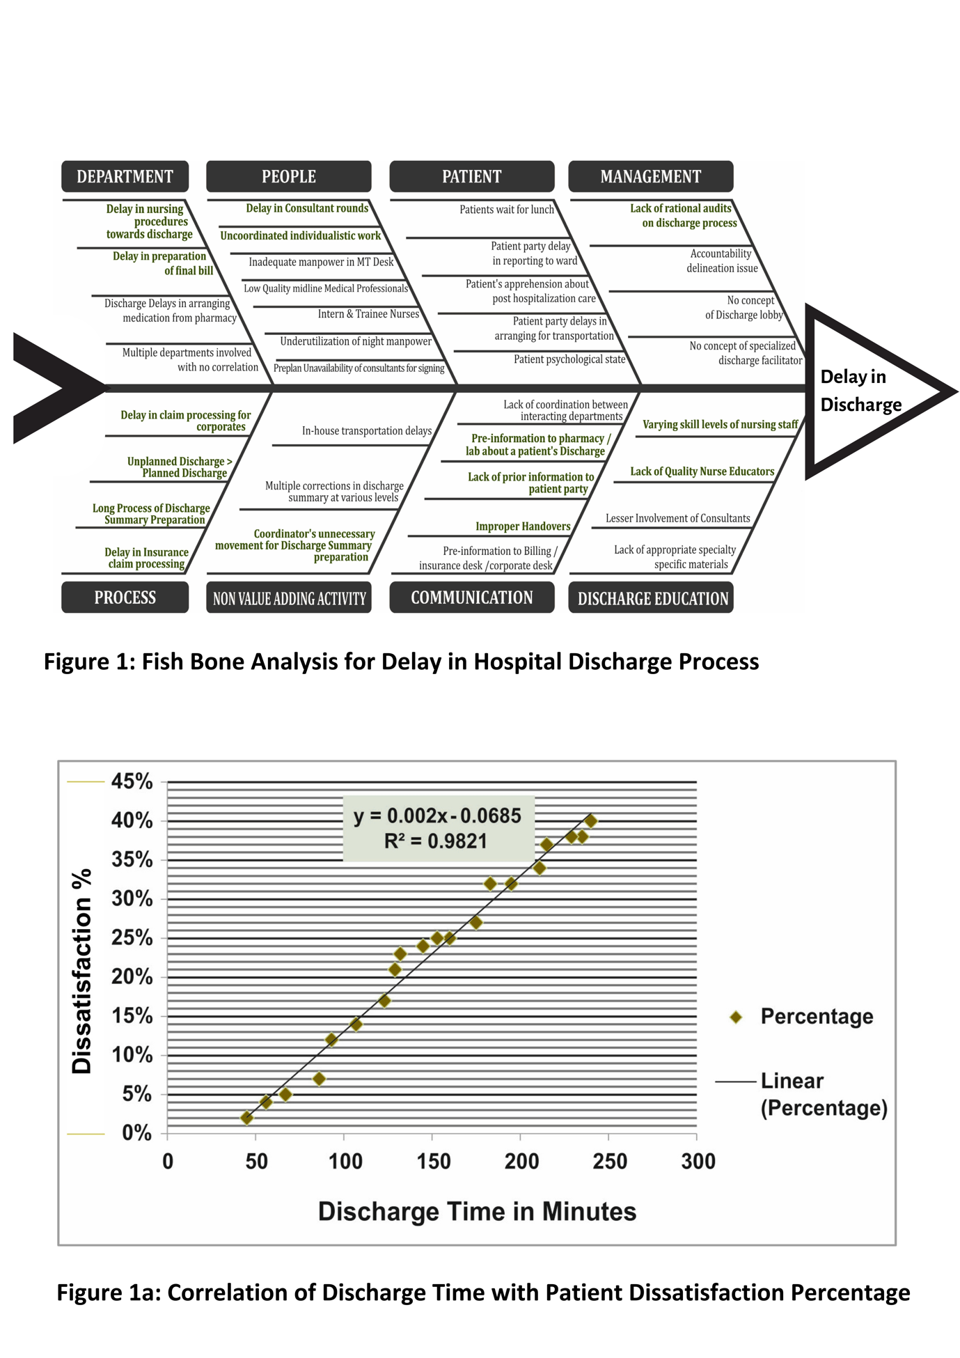

| **Table:1 Failure Mode Effect Analysis (FMEA) based on the Prime Factors contributing delay in Hospital Discharge Process** | | | | | | | | |
| --- | --- | --- | --- | --- | --- | --- | --- | --- |
| **SL NO.** | **Potential Failure Mode** | **Delay in Discharge** | **Potential cause(s)/Mechanisms of Failure** | **Severity** | **Occurrence** | **Detection** | **RPN**  **(SxOxD)** | **Corrective Action Taken** |
| 1 | Increase Percent of Unplanned Discharge | Potential Effect (s) of Failure | Less action time for consultants, nursing and other staff to complete all formalities for discharge | **6** | **6** | **2** | **72** | **Planned : Unplanned** ratio is modified, planned discharge is increase by a substantial percentage to 91% at present |
| 2. | Large no. Of people involved in Discharge decision | Prolonged hospitalization & increase in  ALOS | NO Concrete decision on discharge resulting in increase in ALOS | **7** | **3** | **3** | **63** | Streamlining of opinions by meetings & standard guidelines. Patient condition Awareness is stressed by CMS |
| 3. | Lesser  Involvement  Of Patient & Patient Kin in the Discharge process | Delayed discharge lesser coordination on discharge decisions | No fixed point of contact for patient kin. NO particular delineation of responsibility related to patient / patient kin  Communication about discharge | **8** | **7** | **6** | **336** | DFO’s act as liaison agents between the treating team & the patient kin so that the information flow is regularized & transparent.  On the day of admission, the point of contact is decided & discussions are only made with the same person each time/every time |
| 4. | Delay in Summary preparation & finalization | Delay in Discharge Mistakes due to last minute preparation of Discharge Summary | Multiple corrections in  Discharge Summary All Discharge Summary preparations not started from Date of Admission  Difference of observation between primary consultants & Midline Medical Professionals | **8** | **7** | **3** | **168** | Discharge summary preparation starts from the Date of Admission and signed by the consultant one day prior to the discharge.  Frequent training of Midline medical professionals by the Primary Care Consultant on discharge summary preparation. |
| 5. | Improper Handovers related to discharge in various transition points of care | Errors in  Discharge Communication Delay in Discharge | Communication links not completed resulting in faulty transmission & receiving of patient information at several places. Leading to errors | **8** | **6** | **6** | **288** | NICE (Nursing Interaction & Communication Excellence) developed based on Organizational Behaviour techniques of Transactional analysis to impart training based on s c mind states. |
| 6. | A large number of investigations (Lab/Radiology) ordered/planned on the Date of Discharge | Del ay in performing investigation which results in delay in discharge | Investigations (Lab/Radiology) being performed on the day of discharge automatically increases the time for the patient to get his samples sent & investigation reports to come which are then seen by the Primary Care Consultant to take the final decision on discharge | **8** | **7** | **3** | **168** | All investigations (Lab/ Radiology/ Others) are completed one day prior the date Of Discharge |
| 7. | Delay in  Consultant Rounds on the Date of Discharge | Delay in finalizing patient discharge | The final approval from the primary consultant being mandatory for a patient under him/her to be discharged led to delays when there were several occasions where the consultant rounds were delayed | **8** | **7** | **4** | **224** | Frequent addresses by Top Management to all consultants to Start their rounds by 8 am & finish by 9 am. Weekly monitoring & Status update to CEO & BOD by CMS & DMS |
| 8. | Lack Of a consistent process of medication order for discharge patients | Improper medication usage post discharge which leads to readmission | Faulty medication usage at home post discharge as a resultant process of improper & inconsistent process of conciliation of discharge medications | **6** | **6** | **3** | **108** | Medications are reconciled the day prior and patient friendly medication instructions given by the STRIDE Advocate at the time of discharge |
| 9. | Lack of an auditing / monitoring system for Discharge process | No defined fixation of expected timelines of discharge time. Improper haphazard systems with no defined benchmarks resulting in scattered & skewed discharge | Without defined timeliness the discharge process being highly complex & involving multiple stakeholders frequently had times in different intervals, not even being properly monitored | **9** | **10** | **3** | **270** | A rational discharge audit has been put in place. Which has been given a Kick Start / head splurge by the STRIDE Mechanism with statistical process control. Standard monitoring systems & defined process maps with a team which monitors it live |
| 10. | Delay in medicine refund for Medications | Increases in  Discharge time  & Discharge | Doing it on the same Date of Discharge increases the time span for Discharge. | **7** | **8** | **4** | **224** | All medicines which are not used after reconciliation is refunded to the pharmacy the previous day latest by 12 midnight |
| 11. | Various issues from the patient side | Delay in wheeling out time | Several issues such as the following   1. Patients who are interested to take lunch & go. 2. Patients who haven't arranged for commuting vehicles & arrange it at the last minute 3. Arranging funds in cases of critical patients with higher ALOS & bigger treatment | **9** | **7** | **8** | **504** | Most of the time. There are beyond management control. However, the following steps have been taken which had impacted results:   1. We have arranged packed lunch at our canteen / Cafeteria complimentary on the Date of Discharge 2. We have streamlined our communication to the patient kin & we advise them to keep all vehicular arrangements ready by 10 am on the Date of Discharge |

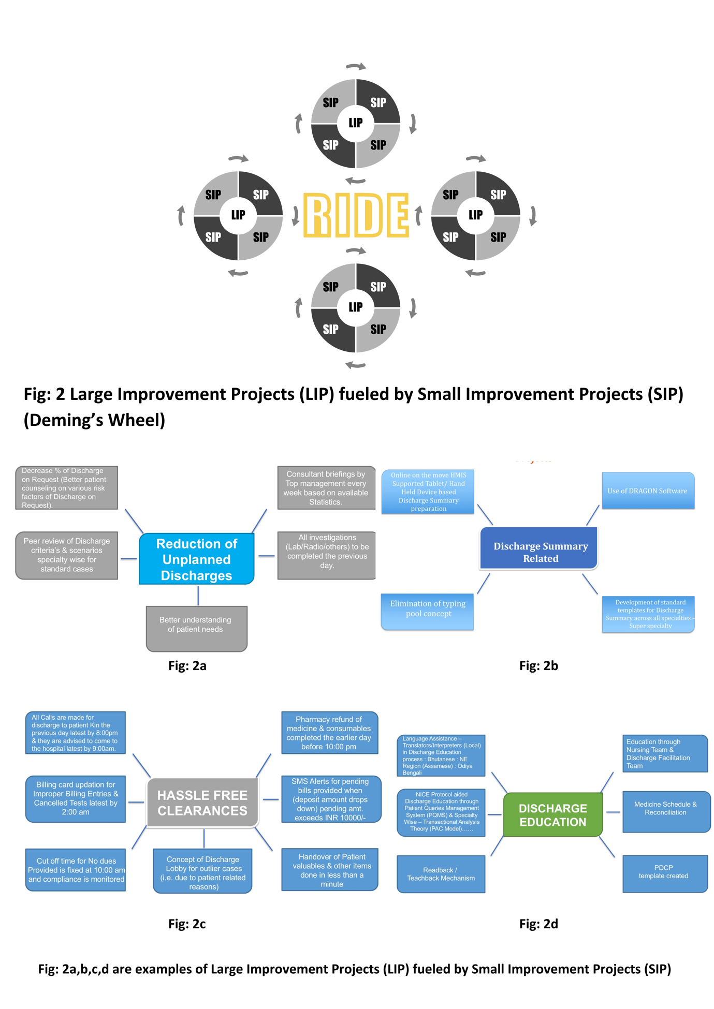

The Pre- Intervention Control Charts states the total turn around time for Discharges takes 214.8 mins (3 hrs 58 mins). The correlation between Discharge Time and Dissatisfaction revealed more the time taken for discharge higher dissatisfaction percentage among patients.

Interventions are done at various level using the RIDE mechanism to improve the Discharge Process Efficiency, using the Deming’s wheel principal for Large Improvement Projects fulled by Small Improvement Projects. To focus on the Clinical Discharges –Discharge Summary completion was done 1 day prior to Discharge, Expected Laboratory Investigations or Studies are advised before discharge process initiates. Discharge education and counselling were done and education about when and how to obtain urgent care is provided.

To streamline the administrative process, arrangement of Discharge medications were made before 9am the same day, follow up appointments were arranged prior, and preparation of final bill was expedited, cancellation of pending / wrongly entered tests were addressed.

**Results:**

A post – intervention Process Mapping was done to analyse the interventions in the process and to correlate the changes in the pre and post mapping. Pre-intervention process mapping stated that the earlier Discharge was initiated 1 days prior when the Discharge order was made by the consultant, but the post-intervention process mapping initiated the planning for Discharge process to start from the day of admission tracking the Expected Date of Discharge.

The implementation of the RIDE mechanism in the hospital discharge process resulted in significant improvements across various metrics. The study demonstrated a remarkable reduction in discharge time by 47% to less than 45 minutes, with a statistically significant p-value of less than 0.04.

This reduction in discharge time is indicative of the effectiveness of the RIDE mechanism in streamlining the discharge process, thereby enhancing efficiency and patient flow. Furthermore, the study reported a 35% reduction in other errors, with a statistically significant p-value of less than 0.05. This reduction in errors underscores the impact of the RIDE mechanism in mitigating potential risks and improving the overall quality of the discharge process.  The sigma level of 4.8 achieved through the implementation of the RIDE mechanism is indicative of the high level of process performance and the minimal variation in the discharge process. To improve the effective communication during Discharge Process, Post discharge Care Plan for all appointments, schedule for medicines, diagnosis information, patient activity for appointment and followups were handed over to the patient. Besides effective communication Post Discharge Care Plan also helped in minimising readmissions from 79% to 42%, making the patient aware of their diagnosis, treatment, medicines and post discharge care at home.

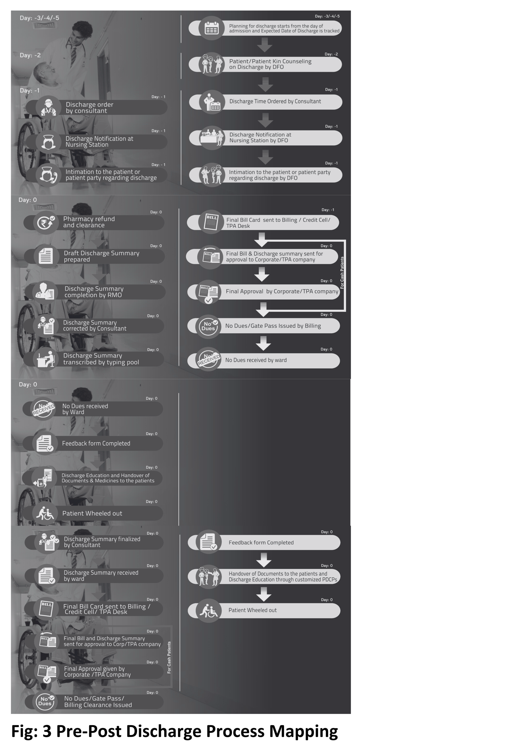

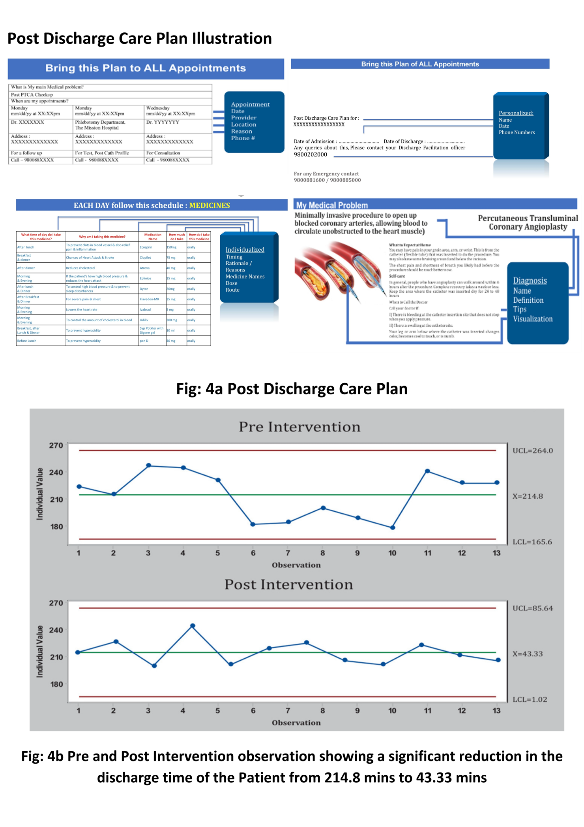

This intervention and outcomes of study signifies a robust and reliable discharge process, contributing to improved patient outcomes and safety. Additionally, the reduction in hospital readmission rates following the implementation of the RIDE mechanism further underscores its effectiveness in enhancing the continuity of care and reducing the likelihood of adverse events post-discharge.  The findings from the study highlight the tangible benefits of the RIDE mechanism in reengineering the hospital discharge process. The significant reduction in discharge time, decrease in errors, attainment of a high sigma level, and the reduction in hospital readmission rates collectively demonstrate the positive impact of the RIDE mechanism on patient care, operational efficiency, and healthcare quality.

**Discussion:**

The study is a comprehensive array of techniques, incorporating both quantitative and qualitative methodologies, as well as industrial engineering principles such as Lean Six Sigma and Deming's Wheel. Additionally, the researchers employed process mapping and failure mode and effects analysis (FMEA) methods, demonstrating a highly meticulous and thorough approach. On the other hand, qualitative methodologies involve the collection and analysis of non-numerical data, such as interviews, observations, and open-ended survey responses. This approach provides rich, in-depth insights into human behaviour, attitudes, and experiences, which can be invaluable in understanding the human factors involved in industrial processes and organisational dynamics.  The integration of industrial engineering principles like Lean Six Sigma and Deming's Wheel further underscores the rigor and systematic nature of the study. Moreover, the use of process mapping, which visually represents the flow of activities within a process, and failure mode and effects analysis (FMEA), which systematically evaluates potential failure modes and their effects, demonstrates the researchers' commitment to thoroughly understanding and optimising the industrial processes under investigation.  The study's utilisation of a diverse range of techniques, that exemplifies a rigorous and comprehensive approach to research in the field of industrial engineering.

**Conclusion:**

The implementation of a comprehensive 360-degree improvement process for hospital discharge has been shown to positively impact care delivery, patient satisfaction, and safety. These findings support the recommendation for healthcare facilities to adopt a reengineered discharge process as a best practice proposition, emphasising the importance of patient-centred care, interdisciplinary collaboration, and investment in health information technology. Further research is warranted to explore the long-term impacts and scalability of reengineered discharge processes across different healthcare systems.

**References:**

1. Soong C, Daub S, Lee J, Majewski C, Musing E, Nord P, Bell C. Development of a checklist of safe discharge practices for hospital patients. J Hosp Med. 2013;8(8):444-9. doi:10.1002/jhm.2032.
2. Wong E, Yam C, Cheung A, Leung M, Chan F, Wong F, Yeoh E. Barriers to effective discharge planning: a qualitative study investigating the perspectives of frontline healthcare professionals. BMC Health Serv Res. 2011;11:242. doi:10.1186/1472-6963-11-242.
3. Ding H, Fatehi F, Maiorana A, Bashi N, Edwards I. Digital health for COPD care: the current state of play. J Thorac Dis. 2019;11(S17):S2210-S2220. doi:10.21037/jtd.2019.10.17.
4. Huggins C, Boateng E, Zeana C. The impact of a standardized discharge process on 30-day readmissions for patients on outpatient parenteral antibiotic treatment. Hosp Pharm. 2020;57(1):107-11. doi:10.1177/0018578720985434.
5. Vatankhoh S, Chopani A, Aghdam E, Tavakoli M, Joudyian N, Nafar H. Investigating the prolonged discharge process in pediatric teaching hospital of Tehran, Iran: a cross-sectional study. doi:10.21203/rs.3.rs-1038665/v1.
6. Drew B, Angeli F, Dave K, Pavlova M. Impact of patients' healthcare payment methods on hospital discharge process: evidence from India. Int J Health Plann Manage. 2015;31(3). doi:10.1002/hpm.2310.
7. Glette MK, Kringeland T, Røise O, Wiig S. Hospital physicians’ views on discharge and readmission processes: a qualitative study from Norway. BMJ Open. 2019;9(8):e031297. doi:10.1136/bmjopen-2019-031297.
8. Shapiro M, Goodman D, Rodriguez V. In search of the perfect discharge: a framework for high-quality hospital discharges. Hosp Pediatr. 2021;12(1):108-117. doi:10.1542/hpeds.2021-006100.
9. Kripalani S, LeFevre F, Phillips CO, Williams MV, Basaviah P, Baker DW. Deficits in communication and information transfer between hospital-based and primary care physicians: implications for patient safety and continuity of care. JAMA. 2007;297(8):831-41.
10. Hansen LO, Young RS, Hinami K, Leung A, Williams MV. Interventions to reduce 30-day rehospitalization: a systematic review. Ann Intern Med. 2011;155(8):520-8.
11. Cai C, Lindquist K, Bongiovanni T. Factors associated with delays in discharge for trauma patients at an urban county hospital. Trauma Surg Acute Care Open. 2020;5(1):e000535.
12. Hamline M, Rutman L, Tancredi D, Rosenthal J. An iterative quality improvement process improves pediatric ward discharge efficiency. Hosp Pediatr. 2020;10(3):214-21.
13. Chaudhari P, Shinde V, Gudhe V. A study on reducing the discharge turnaround time of ipd patients at avbrh. J Pharm Res Int. 2021:3894-900.
14. Hao C, Hara Y, Horita N, Saigusa Y, Hirai Y, Kaneko T. Declined functional status prolonged hospital stay for community-acquired pneumonia in seniors. Clin Interv Aging. 2020;15:1513-9.
15. Panis L, Verheggen F, Pop P, Prins M. The impact of hospital discharge on inappropriate hospital stay. Int J Health Care Qual Assur. 2004;17(4):189-93.
16. Marriott J, Bessell T. Investigating the hospital discharge medication process. J Pharm Pract Res. 2008;38(2):117-20. doi:10.1002/j.2055-2335.2008.tb00816.x.
17. Everall A, Guilcher S, Cadel L, Asif M, Li J, Kuluski K. Patient and caregiver experience with delayed discharge from a hospital setting: a scoping review. Health Expect. 2019;22(5):863-73. doi:10.1111/hex.12916.
18. Clancy CM. Reengineering hospital discharge: a protocol to improve patient safety, reduce costs, and boost patient satisfaction. Am J Med Qual. 2009 Nov-Dec;24(6):507-13. doi: 10.1177/1062860609347683. Epub 2009 Oct 14. PMID: 19828507.
19. Greysen SR, Schiliro D, Curry L, Bradley EH, Horwitz LI. "Learning to Play the Game": How Hospitals in the New York City Region Responded to the COVID-19 Pandemic. J Hosp Med. 2021 Jan;16(1):8-10. doi: 10.12788/jhm.3543. PMID: 33410894; PMCID: PMC7833946.
20. Alghamdi AA, Justinia T. Automated Discharge Planning Systems: Perceived Challenges and Recommendations. Health Care: Current Reviews. 2016;4. doi: 10.4172/2375-4273.1000173.
21. Charlebois K, Law S. Optimising the discharge process in internal medicine in Québec: A qualitative interpretive descriptive study to understand the challenges faced by healthcare professionals. Health Soc Care Community. 2022 Nov;30(6):e5916-e5925. doi: 10.1111/hsc.14023.
22. Improta G, Balato G, Ricciardi C, Russo MA, Santalucia I, Triassi M, Cesarelli M. Lean Six Sigma in healthcare: Fast track surgery for patients undergoing prosthetic hip replacement surgery. TQM J. 2019;31(4):526-540. doi: 10.1108/TQM-10-2018-0142.
23. Akbari A, Nasiri A, Amirabadizade A. Effects of discharge education and telephone follow-up on patient satisfaction and readmission after orthopedic surgery. J Surg Trauma. 2018. doi: 10.32592/jsurgery.2018.6.4.106.
24. van Seben R, Geerlings SE, Maaskant JM, et al. Safe handovers for every patient: an interrupted time series analysis to test the effect of a structured discharge bundle in Dutch hospitals. BMJ Open. 2019;9:e023446. doi: 10.1136/bmjopen-2018-023446.
25. Zhang A, Wen L, Shi Y, Chia S, Sim Z. Lean and six sigma in logistics: a pilot survey study in Singapore. Int J Oper Prod Manag. 2016;36(11):1625-1643. doi: 10.1108/IJOPM-02-2015-0093.
26. Witherspoon L, Gan A, Breau R, Saumure G, Shea J, Mallick R, Lavallée L. Use of video education in post-operative patient counselling: a quality improvement initiative. Can Urol Assoc J. 2021;15(12). doi: 10.5489/cuaj.7240.
27. Mitchell SE, Martin J, Holmes S, van Deusen Lukas C, Cancino R, Paasche-Orlow M, Brach C, Jack B. How hospitals reengineer their discharge processes to reduce readmissions. J Healthc Qual. 2016 Mar-Apr;38(2):116-26. doi: 10.1097/JHQ.0000000000000005. PMID: 26042743; PMCID: PMC5102006.
28. Mitchell K. Impact of reengineered discharge toolkit on patients undergoing total joint surgeries. Rehabil Nurs. 2022 Jul-Aug;47(4):121-8. doi: 10.1097/RNJ.0000000000000375. PMID: 35701987.