# Medical Image Analysis using Deep Learning Algorithms for detecting Lung Cancer

## Suchitra Devi A1, Heena Ahmed2, Umme Kulsum3 ,Vishal Sharma4,Vivek Tandle5

**1** Asst Professor, Dept. Of Cse, Sambhram Institute Of Technology, Bengaluru-560091, Karnataka, India **2,3,4,5** Eight Semester,Dept Of Cse,Sambhram Institute Of Technology, Bengaluru-560091, Karnataka, India

## ABSTRACT

This project focuses on revolutionizing lung cancer diagnosis through the implementation of advanced deep learning algorithms, such as EfficientNetB3, ResNet50, and InceptionV3. The goal is to enhance the accuracy and efficiency of image analysis of lung images for early detection and classification of lung cancer. By leveraging diverse medical imaging datasets, the project aims to train and fine-tune these algorithms, providing a comprehensive evaluation of their performance in terms of accuracy, sensitivity, and specificity. The integration of the trained models within medical workflows facilitates seamless adoption. Anticipated outcomes include increased precision in lung cancer detection, improved sensitivity and specificity of the algorithms, and the development of a practical tool for medical professionals. This initiative holds significant promise in transforming lung cancer diagnostics, contributing to more informed medical decisions, and ultimately improving patient outcomes in the realm of oncology.

**Keywords:** Analysis, Diagnosis.

## INTRODUCTION

Lung Cancer Image Analysis using Deep Learning Algorithms (EfficientNetB3, ResNet50, InceptionV3)," addresses the pressing need for advancements in the field of lung cancer diagnostics. Lung cancer stands as the second most prevalent cancer globally, emphasizing the urgency of accurate and timely detection for effective treatment. Traditional diagnostic approaches often grapple with challenges related to precision and speed, necessitating a paradigm shift towards innovative technologies. In response to this, the project strategically employs state-of-the-art deep learning algorithms, namely EfficientNetB3, ResNet50, and InceptionV3, to revolutionize the analysis of medical images associated with lung cancer. The overarching goal is to significantly enhance the accuracy and efficiency of lung cancer diagnosis through the application of these advanced algorithms. By utilizing diverse datasets representing various stages and conditions, the project endeavors to train and fine-tune these deep learning models, offering a comprehensive evaluation of their performance metrics such as accuracy, sensitivity, and specificity. The anticipated outcomes include heightened precision in lung cancer detection, improved sensitivity and specificity when compared to conventional methods, and the development of a user-friendly interface facilitating seamless integration into existing medical workflows.

## LITERATURE SURVEY

The project focuses on revolutionizing lung cancer diagnosis through the implementation of advanced deep learning algorithms, including EfficientNetB3, ResNet50, and InceptionV3 . Traditional methods of lung cancer detection often face challenges in terms of accuracy and speed, leading to the introduction of deep learning algorithms to enhance the precision of lung cancer diagnosis and classification .

The goal is to enhance the accuracy and efficiency of image analysis for early detection and classification of lung cancer by leveraging diverse datasets and training and fine-tuning these algorithms . By utilizing state-of-the-art deep learning

algorithms, the project aims to significantly enhance the accuracy and efficiency of lung cancer diagnosis, contributing to more informed medical decisions and improved patient outcomes in the realm of oncology .

The anticipated outcomes of the project include increased precision in lung cancer detection, improved sensitivity and specificity, and the development of a practical tool for medical professionals, ultimately transforming lung cancer diagnostics and improving patient outcomes . By harnessing the power of deep learning algorithms, the project aims to redefine the standards in medical image analysis for lung cancer diagnosis .

In conclusion, the integration of advanced deep learning algorithms in this project marks a significant stride in enhancing the accuracy of lung cancer diagnosis, with anticipated improvements in sensitivity, specificity, and user-friendly interfaces, promising transformative impacts on clinical decision-making and setting the stage for continued advancements in deep learning and medical imaging at the intersection of oncology .

1. **PROBLEM STATEMENT**

Traditional methods of lung cancer detection often face challenges in terms of accuracy and speed due to the complexity of interpreting medical images and the variability in human interpretation. The project addresses these issues by introducing deep learning algorithms, which have shown promise in automating image analysis tasks and improving diagnostic accuracy in various medical domains. By leveraging the capabilities of deep learning models like EfficientNetB3, ResNet50, and InceptionV3, the project aims to enhance the precision of lung cancer diagnosis and classification by enabling more consistent and reliable analysis of medical images.

# SEQUENCE DIAGRAM

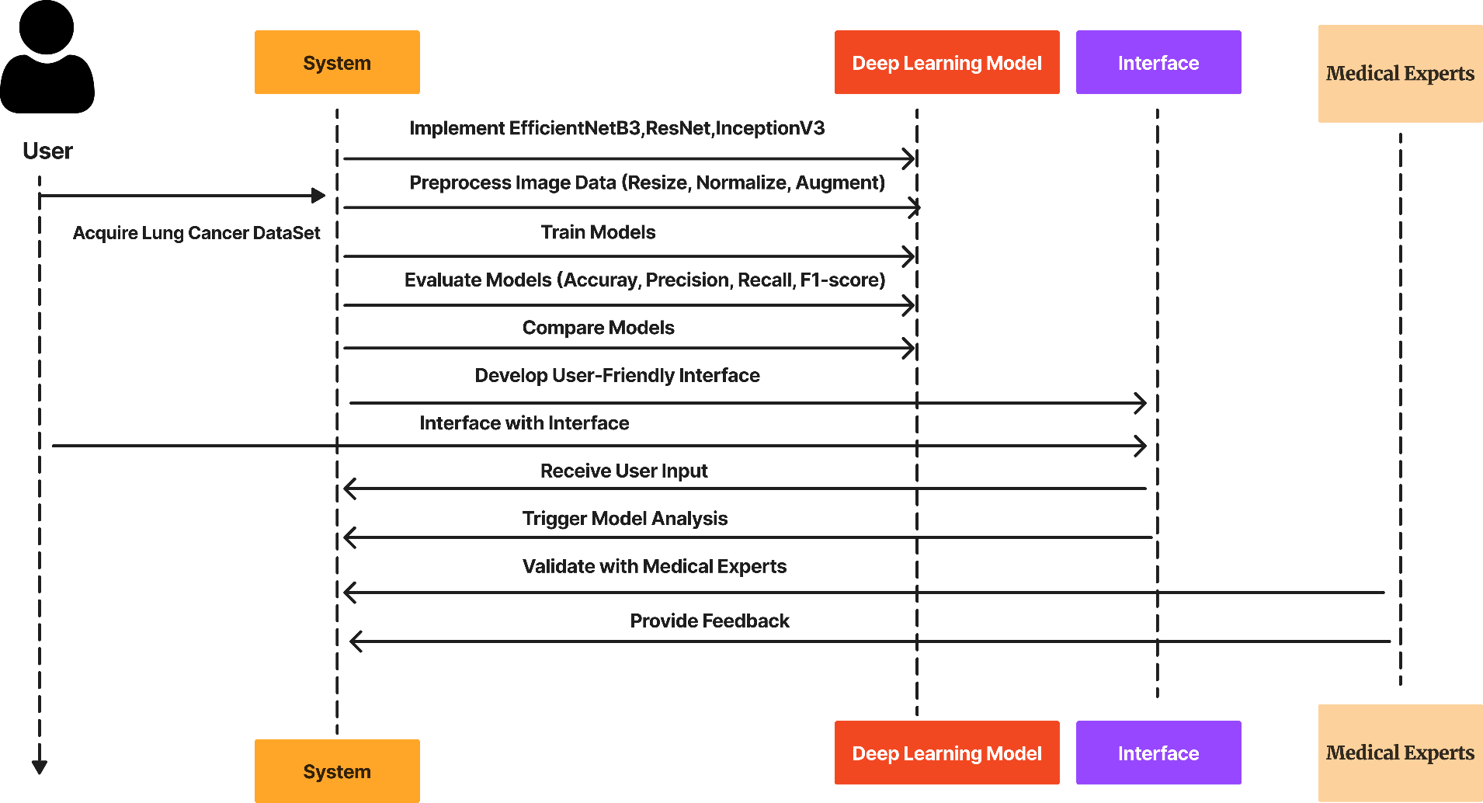

**Figure. 1:** Sequence Diagram

## SYSTEM DESIGN

**Figure. 1:** System Design

The dataset consists of training data, testing data, and validation data. Inside this data, there are images belonging to four labels: adenocarcinoma, large cell carcinoma, normal, and squamous cell carcinoma. The algorithm will process the images and detect which type of disease the image represents from these four labels. During processing, it will track the number of validation images belonging to each class and monitor the loss and accuracy of the data. It will analyze the loss and accuracy of the training, testing, and validation sets. Finally, the algorithm will provide the image path to determine which label it belongs

## IMPLEMENTATION

* 1. **Data Collection:** Gather a diverse dataset of lung cancer images, ensuring representation across different stages and conditions. Acquire high-quality images from reliable medical sources to enhance the models' training efficacy.
  2. **Data Preprocessing:** Prepare the dataset by performing essential preprocessing steps, including resizing, normalization, and augmentation, to ensure uniformity and enhance the models' ability to generalize.
  3. **Model Selection and Implementation:** Choose EfficientNetB3, ResNet50, and InceptionV3 as the deep learning models for lung cancer image analysis. Implement these models using popular frameworks such as TensorFlow or PyTorch.
  4. **Model Training:** Train the selected deep learning models on the preprocessed dataset. Fine-tune the models' hyperparameters to optimize performance, employing techniques such as transfer learning to leverage pre-trained weights.
  5. **Performance Evaluation:**Evaluate the trained models using key metrics such as accuracy, precision, recall, and F1-score. Conduct comprehensive testing on a separate validation dataset to assess the models' ability to generalize to new, unseen cases.

## Testing

* 1. **Number Of Validated Images Belonging to different labels**

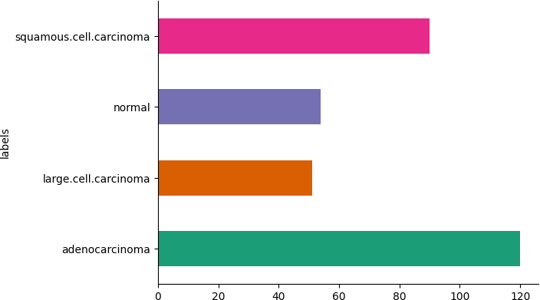

## 7.1 Confusion Matrix

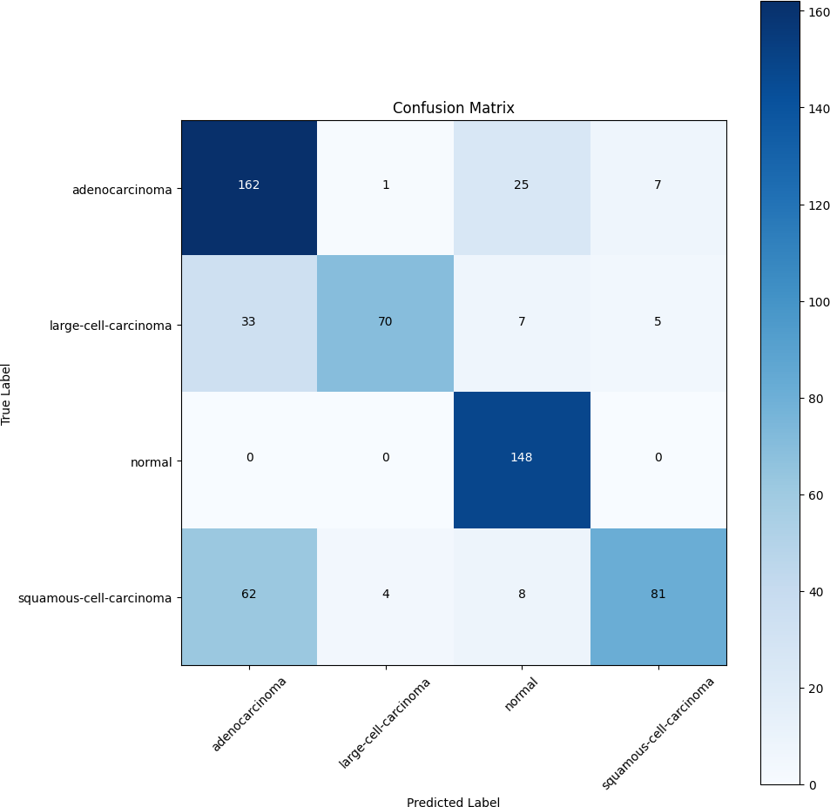

1. **Result**

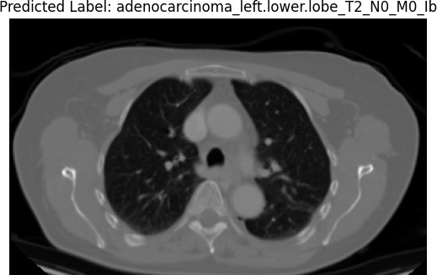

Increased accuracy in lung cancer detection and classification.Improved sensitivity and specificity compared to traditional methods.User-friendly interface for seamless integration into medical practices.Contribution to the development of efficient tools for early diagnosis and decision support in lung cancer cases.

## CONCLUSION AND FUTURE SCOPE

The integration of advanced deep learning algorithms, including EfficientNetB3, ResNet50, and InceptionV3, marks a significant stride in enhancing the accuracy of lung cancer diagnosis. The anticipated improvements in sensitivity, specificity, and user-friendly interface underscore the potential for transformative impacts on clinical decision-making. As these outcomes unfold, the project not only addresses current challenges in lung cancer diagnostics but also sets the stage for continued advancements at the intersection of deep learning and medical imaging, promising a positive trajectory for the future of oncology.

## 9. REFERENCE

1. L. Alzubaidi et al., “Review of deep learning: Concepts, CNN architectures, challenges, applications, future directions,” J. big Data, vol. 8, no. 1, pp. 1–74, 2021.
2. W. Rawat and Z. Wang, “Deep convolutional neural networks for image classification: A comprehensive review”, Neural Comput., vol. 29, no. 9, pp. 2352–2449, 2017.
3. A. Krizhevsky, I. Sutskever, and G. E. Hinton, “Imagenet classification with deep convolutional neural networks”, Commun. ACM, vol. 60, no. 6, pp. 84–90, 2017.
4. K. Simonyan and A. Zisserman, “Very deep convolutional networks for large-scale image recognition,” arXiv Prepr. arXiv1409.1556, 2014.
5. O. Ronneberger, P. Fischer, and T. Brox, “U-net: Convolutional networks for biomedical image segmentation,” in International Conference on Medical image computing and computer-assisted intervention, pp. 234–241, 2015.
6. J. Long, E. Shelhamer, and T. Darrell, “Fully convolutional networks for semantic segmentation,” in Proceedings of the IEEE conference on computer vision and pattern recognition, pp. 3431– 3440, 2015.
7. D. Bank, N. Koenigstein, and R. Giryes, “Autoencoders,” arXiv Prepr. arXiv2003.05991, 2020.
8. S. Hochreiter, “The vanishing gradient problem during learning recurrent neural nets and problem solutions,” Int. J. Uncertainty, Fuzziness Knowledge-Based Syst., vol. 6, no. 02, pp. 107–116, 1998.
9. K. He, X. Zhang, S. Ren, and J. Sun, “Deep residual learning for image recognition,” in Proceedings of the IEEE conference on computer vision and pattern recognition, pp. 770–778, 2016.
10. A. G. Howard et al., “Mobilenets: Efficient convolutional neural networks for mobile vision applications,” arXiv Prepr. arXiv1704.04861, 2017.