**Why do banks oppose digital currency?**

Submitted under the ordinances for the award of the degree of

Master of Business Administration

Project Submitted by: - Shivani Chauhan (22GSOB2010073)

Project Supervisor: Prof. Ranjul Rastogi

(Dept. of School of Business)

Department of School of Business

Session 2022-24



**Certificate**

This is to certify that the master’s thesis **“why do Banks Oppose Digital Currency”** has been preparedby **Shivani Chauhan,** under my supervision and guidelines. The project report is submitted towards the partial fulfilment of 2- a years, full-time master of business administration.

Name & signature of faculty

Prof. Rajul Rastogi ___________________

Date: -

**Declaration**

I **Shivani Chauhan** roll no. 22GSOB2010075, student of the School of Business, Galgotias University, Greater Noida, hereby declare that the master’s thesis on **“Why do banks oppose Digital Currency**“is an original and authenticated work done by me. I further declare that it has not been submitted elsewhere by any other person in any of the institutes for the award of any degree or diploma.

Name and signature of the student

Shivani Chauhan ___________________

Date: -

**Acknowledgment**

I take this opportunity to express my deep sense of gratitude to all those who have contributed significantly by sharing their knowledge and experience in the completion of this project work. I am greatly obliged to, you for providing me with the right kind of opportunity and facilities to complete this venture.

I am extremely thankful to **Prof.** **Ranjul Rastogi**– my faculty guide under whose able guidance this project work was carried out. I thank her for his continuous support and mentoring during the project's tenure. Finally, I would also like to thank all my dear friends for their cooperation, advice, and encouragement during the long and arduous task of carrying out the project and preparing this report.

**Executive Summary**

The proposed two-tiered retail central bank Digital currency system consists of transparent and private Digital currency accounts. The central bank issues Digital currency into transparent accounts, either maintained by the central bank or by payment service providers (PSPs). Digital currency account holders can deposit funds into the privacy pool via transparent Digital currency accounts or through special ATMs with cash deposits. Three types of payments are enabled: fully private, semi-private, and fully transparent transfers. Fully private transfers occur within the privacy pool, concealing identities and transaction amounts. Semi-private transfers occur between the privacy pool and transparent Digital currency accounts, revealing transaction amounts to PSPs and potentially the central bank. Fully transparent transfers occur between transparent Digital currency accounts, disclosing sender and receiver identities and transaction amounts to PSPs and potentially the central bank, akin to current electronic payments via commercial banks.

**Abstract**

In response to the declining use of cash and increased competition from Big Tech companies, cryptocurrencies, and stablecoins, many central banks in advanced economies are considering issuing central bank digital currencies . One critical aspect of Digital currency design is transaction privacy. Existing solutions often face security concerns or fail to provide complete privacy similar to cash transactions. Additionally, there's a concern that fully private payment systems may not comply with anti-money laundering (AML) and countering the financing of terrorism (CFT) regulations. This paper adopts a design science research approach (DSR) to develop and assess a comprehensive software-based Digital currency system that facilitates fully private transactions while adhering to regulatory constraints. Using zero-knowledge proofs (ZKPs), the system enforces privacy limits on transactions without revealing transaction details to third parties. Interviews with economic, legal, and technical experts confirm the feasibility of a regulatorily compliant Digital currency system based on ZKPs, supporting full privacy similar to cash transactions.

**INDEX**

|  |  |  |
| --- | --- | --- |
| **S. no.** | **Table Of Contant** | **Page No.** |
|  | **Certification** |  |
|  | **Declaration** |  |
|  | **Acknowledgment** |  |
|  | **Abstract** |  |
| **1.** | **Introduction** | **1-3** |
| **2.** | **Digital Currency concept and functioning** | **4-10** |
| **3.** | **Review of Literature** | **11-12** |
| **4.** | **Research Methodology** | **12-14** |
| **5.** | **Data Analysis** | **15-21** |
| **6.** | **Findings, conclusion, and Recommendations** | **22-34** |
| **7.** | **References** | **35** |
| **8.** | **Annexure** | **36-38** |

**CHAPTER- 1 INTRODUCTION**

**Introduction**

Banks' opposition to digital currencies is rooted in a complex web of concerns, ranging from regulatory uncertainties to competitive pressures and technological challenges. At the core of this opposition lies a fundamental fear of losing control. Banks have historically held a dominant position in the financial system, wielding significant power over currency issuance, transaction processing, and financial intermediation. The advent of digital currencies threatens to disrupt this established order by introducing decentralized systems that operate outside traditional banking channels.

One major concern for banks is the regulatory ambiguity surrounding digital currencies. Unlike traditional financial instruments, digital currencies often operate in a regulatory gray area, with rules and guidelines that vary widely across jurisdictions. Banks, bound by strict anti-money laundering (AML) and know-your-customer (KYC) regulations, are wary of the compliance risks associated with digital assets. The lack of clear regulatory frameworks for digital currencies can leave banks vulnerable to legal and reputational risks, discouraging them from fully embracing these emerging technologies.

Moreover, digital currencies pose a significant competitive threat to banks' traditional business models. Decentralized cryptocurrencies like Bitcoin offer lower transaction fees, faster settlement times, and greater accessibility compared to traditional banking services. This can potentially lure customers away from banks, eroding their market share and profitability. Banks also face pressure from fintech startups and non-bank entities that are leveraging blockchain technology to offer innovative financial products and services, further intensifying competition in the industry.

The inherent volatility and risk associated with digital currencies also give banks pause. Many cryptocurrencies experience extreme price fluctuations, making them unsuitable for traditional banking activities such as lending and investment. Banks are wary of the speculative nature of digital assets and the potential for significant losses. Additionally, security concerns, including hacking, theft, and fraud, pose significant challenges for banks looking to integrate digital currencies into their systems. The decentralized nature of cryptocurrencies makes them attractive targets for cyberattacks, raising questions about the security and integrity of these assets.

Furthermore, the emergence of central bank digital currencies (CBDCs) adds another layer of complexity to the equation. While some banks may see CBDCs as an opportunity to collaborate with central banks and streamline payment systems, others view them as a direct threat to their traditional business models. CBDCs could potentially disintermediate banks by allowing individuals and businesses to hold digital currency directly with the central bank, bypassing commercial banks altogether.

In addition to regulatory, competitive, and technological challenges, banks also grapple with legacy systems and infrastructure that may not be easily adaptable to accommodate digital currencies. Updating these systems to support the complexities of blockchain technology can be costly and time-consuming, deterring banks from fully embracing digital currencies.

In summary, banks' opposition to digital currencies stems from a combination of regulatory concerns, competitive pressures, technological challenges, and fears of losing control. While some banks may cautiously explore opportunities to leverage blockchain technology and collaborate with central banks in the development of CBDCs, many remain hesitant or even resistant to fully embracing the disruptive potential of digital currencies.

**CHAPTER- 2**

**DIGITAL CURRENCY**

**And ITS**

**FUNCTIONS**

**Digital Currency: Concept**

Digital currency refers to a form of currency that exists solely in digital or electronic form. Unlike traditional physical currencies such as coins or banknotes, digital currencies are intangible and rely on cryptographic techniques to secure transactions and control the creation of new units. They operate independently of central banks and governments, often utilizing decentralized technologies like blockchain.

One of the most well-known examples of digital currency is Bitcoin, which was introduced in 2009 by an anonymous person or group known as Satoshi Nakamoto. Bitcoin operates on a decentralized ledger called the blockchain, which records all transactions across a network of computers. Other examples of digital currencies include Ethereum, Litecoin, and Ripple.

Digital currencies offer several potential advantages over traditional currencies, including lower transaction fees, faster transfer times, increased security, and greater accessibility. They can be sent and received globally without the need for intermediaries like banks, which can make financial transactions more efficient and less expensive.

However, digital currencies also present challenges and risks, such as price volatility, regulatory uncertainty, and security concerns related to hacking and fraud. Additionally, their use in illicit activities like money laundering and tax evasion has raised concerns among regulators and policymakers.

Despite these challenges, digital currencies continue to gain popularity and adoption, with many seeing them as a transformative force in the world of finance and technology. Central banks and governments are also exploring the potential of issuing their own digital currencies, known as central bank digital currencies (CBDCs), which could further revolutionize the way we think about money and payments.

**Types of Digital Currency**

Digital currencies come in various forms, each with its own features and purposes. Here are some types of digital currencies:

**Cryptocurrencies:** These are decentralized digital currencies that use cryptographic techniques to secure transactions and control the creation of new units. Bitcoin, Ethereum, Litecoin, and Ripple are some examples.

**Central Bank Digital Currencies (CBDC**): CBDCs are digital currencies issued by a central bank. Unlike cryptocurrencies, CBDCs are centralized and typically represent the digital form of a country's fiat currency.

**Stablecoins:** Stablecoins are digital currencies designed to maintain a stable value by pegging their worth to a reserve asset, such as fiat currency (like the US dollar), other cryptocurrencies, or commodities. Examples include Tether (USDT), USD Coin (USDC), and Dai.

**Utility Tokens:** These digital assets are designed to provide access to a specific product or service within a blockchain-based ecosystem. They are not intended as investments but rather serve a functional purpose within their respective platforms. Examples include Binance Coin (BNB) and Ethereum's Ether (ETH).

**Security Tokens:** Security tokens represent ownership of assets such as real estate, stocks, or commodities, and are often issued and traded on blockchain platforms. They are subject to securities regulations and may offer dividends or other financial benefits.

**Non-Fungible Tokens (NFTs):** NFTs are unique digital tokens that represent ownership of a specific digital asset, such as digital art, collectibles, or virtual real estate. Unlike cryptocurrencies, each NFT has distinct characteristics and cannot be exchanged on a one-to-one basis.

**Community Tokens:** These are digital currencies created by communities or social networks for specific purposes within their platforms. They are often used for tipping, rewarding content creators, or facilitating transactions within the community.

**Commodity-backed Tokens:** Similar to stablecoins, commodity-backed tokens are pegged to the value of a physical commodity like gold, silver, or oil. These tokens offer a digital representation of the underlying commodity, enabling easier trading and transactions.

Each type of digital currency serves different functions and has unique characteristics, catering to various needs within the digital economy.

**Functions Of Digital Currency**

Medium of Exchange: Digital currencies serve as a means for conducting transactions in digital environments. They allow individuals and businesses to buy and sell goods and services online or in digital marketplaces. Transactions are facilitated through digital wallets and can occur peer-to-peer or through merchants that accept digital currency payments. Digital currencies offer advantages such as reduced transaction fees, faster settlement times, and increased accessibility compared to traditional payment methods.

Store of Value: Digital currencies enable individuals to store wealth in digital form. Unlike physical assets, digital currencies exist solely in digital form and are stored in digital wallets. Some digital currencies, such as Bitcoin, are designed to be scarce, with a predetermined maximum supply, which can make them attractive as a store of value akin to gold. Additionally, digital currencies can offer protection against inflation, especially in regions with volatile or depreciating fiat currencies.

Unit of Account: Digital currencies provide a unit for measuring the value of assets and transactions within digital ecosystems. Prices of goods and services can be denominated in digital currencies, providing a common standard for economic transactions. This function facilitates price transparency and comparability across different markets and platforms.

Speculative Investment: Digital currencies have gained popularity as speculative investments, attracting traders and investors seeking high returns in volatile markets. The prices of digital currencies can experience significant fluctuations over short periods, presenting opportunities for profit but also carrying inherent risks. Speculative investors may buy and hold digital currencies with the expectation that their value will increase over time, similar to investing in stocks or commodities.

Remittance and Cross-Border Payments: Digital currencies offer cost-effective alternatives for transferring money across borders, particularly in regions with limited access to traditional banking services. Individuals can send digital currency payments globally with lower fees and faster processing times compared to traditional remittance services. This function is especially valuable for migrant workers who rely on remittances to support their families in their home countries.

Smart Contracts and Programmable Money: Some digital currencies, such as Ethereum, support smart contracts, which are self-executing contracts with predefined conditions written in code. Smart contracts enable automated and programmable transactions without the need for intermediaries. This functionality opens up opportunities for decentralized applications (DApps) and decentralized finance (DeFi), allowing for innovative financial products and services to be developed on blockchain platforms.

Financial Inclusion: Digital currencies have the potential to promote financial inclusion by providing access to financial services for the unbanked and underbanked populations. Many people around the world lack access to traditional banking infrastructure but have access to mobile phones or internet-enabled devices. Digital currencies can empower these individuals to participate in the global economy, allowing them to store value, make payments, access credit, and engage in economic activities without relying on traditional financial institutions.

**Objectives of Digital currency**

Digital currency, like any other form of currency, serves several objectives:

**Efficiency:** Digital currency aims to streamline transactions, making them faster and more convenient. With digital currency, transactions can occur instantaneously, reducing the need for intermediaries like banks and clearinghouses.

**Accessibility:** Digital currencies can be accessed by anyone with an internet connection, providing financial services to people who may not have access to traditional banking systems.

**Security:** Blockchain technology, which underlies many digital currencies like Bitcoin, provides a high level of security through cryptographic techniques. Transactions are tamper-proof and transparent, enhancing trust among users.

**Lower Costs:** Digital currencies can potentially reduce transaction fees associated with traditional banking systems, especially for international transactions, where fees and exchange rates can be significant.

**Financial Inclusion**: By bypassing traditional banking systems, digital currencies can empower individuals in underserved or unbanked populations to participate in the global economy.

**Privacy:** While digital currencies offer transparency through the blockchain, they also offer varying degrees of privacy. Users can control the amount of personal information they share during transactions.

**Decentralization:** Many digital currencies operate on decentralized networks, meaning they are not controlled by any single entity or government. This decentralization can prevent manipulation and censorship of the currency.

**Innovation**: Digital currencies open up avenues for innovation in financial technology (fintech), including smart contracts, decentralized finance (DeFi), and new forms of asset tokenization.

Overall, the objectives of digital currency revolve around creating a more efficient, accessible, secure, and inclusive financial system.

**Boosting Cross-Border Transaction**

The integration of digital currencies into cross-border transactions for import and export activities presents both opportunities and challenges. While digital currencies promise advantages such as faster processing times, lower fees, and increased transparency, banks often oppose their use due to several key concerns. Firstly, the lack of regulation surrounding digital currencies raises apprehensions for banks, as they are subject to stringent compliance requirements aimed at preventing illicit activities like money laundering and terrorist financing. Additionally, the volatility of digital currencies, exemplified by the fluctuating value of Bitcoin, introduces risks for both buyers and sellers in cross-border transactions, potentially destabilizing financial transactions. Security is another major concern, as the decentralized nature of digital currencies leaves them vulnerable to hacking and fraud, undermining the trust and confidence banks have in these alternative payment methods. Moreover, ensuring compliance with complex international trade regulations poses a significant challenge, as verifying the legitimacy of transactions conducted through digital currencies can be problematic. Despite these obstacles, realizing the benefits of digital currencies in enhancing cross-border transactions necessitates regulatory clarity, robust security measures, and compliance standards to assuage banks' concerns and foster broader adoption within the international trade sector.

**Chapter- 3**

**REVIEW OF**

**LITERATURE**

**Literature Review**

In another study focusing on organisations, **(Andrychowicz et al. 2016)** approach examining organisation perspectives by developing a protocol for analysing the possibility of using bitcoin for a secure lottery system. **(Andrychowicz et al.)**’s study explored the possibility of designing an online protocol for playing lottery in a decentralized way, therefore addressing possible lottery organisation protocol modelling.

A similar study focused on organisational modelling, **(Kazan et al. 2015)** examined organisations to understanding how CC companies create and capture the value of their digital business models, with consideration of the potentially disruptive capabilities associated with the technology. Contrary to the review by **(Morisse 2015)** where the author identified the lack of new business models based on DC, the investigations by **(Andrychowicz et al.)** and **(Kazan et al.),** provide evidence that research on DC continues to evolve by addressing the need for new business models.

The study by **(Van Alstyne 2014),** evaluate the nature of Digital Currency to prove that the system has value andshould be accepted as a currency and innovative payment system. (Van Alstyne) also, examines the evolving DC phenomenon with particular reference to the systems protocol.

**(Cusumano 2014)** and**(Glaser and Bezzenberger 2015**) address similar issues of providing a better understanding of DC.While the study by **(Cusumano 2014)** is focused on providing an evaluation of Digital Currency ecosystem.

**(Glaser and Bezzenberger 2015)** Focuses on classifying various Decentralized Consensus Systems based on their characteristics. In the study by (Meiklejohn et al. 2016), the author also examines the characteristics of DC. Meiklejohn investigated the characterization of Digital Currency network with a particular aim of understanding the possible anonymity in the protocol design and the actual anonymity of its users.

**CHAPTER – 4**

**RESEARCH METHODOLOGY**

It seems like you've outlined a research design for a descriptive study focused on cryptocurrency and its potential impact on the Indian financial system. Here's a breakdown of the key components:

**Research Design:**

Type: Descriptive Research

Purpose: To describe events, gather data, and organize it into patterns.

Methods: Gathering data through questionnaires via personal meetings.

Analysis: Organizing, tabulating, depicting, and describing the data, possibly using visual aids like graphs and charts.

**Objectives of the Study:**

To understand the perspectives of both the government and the Banks towards cryptocurrency.

To explore the possibility of replacing the Indian financial system with cryptocurrency.

To assess the impact of cryptocurrency on the Indian financial system.

**Source of Data:**

Primary Data: Collected directly from respondents through questionnaires.

Secondary Data: no utilized in this research.

**Research Instruments:**

Questionnaire and Sampling Used for data collection via personal meetings and table-calling.

Sampling Area: Common people in the Delhi NCR area.

Sample Size: 15 respondents.

Sample Technique: Convenience sampling.

This research design provides a structured approach to gathering and analyzing data to address the objectives outlined regarding cryptocurrency and its implications for the Indian financial system

**Hypothesis Testing**

**Null Hypothesis (H0):** Banks oppose digital currency primarily due to concerns about losing control over the financial system, regulatory uncertainties, competitive pressures, and technological challenges.

**Alternative Hypothesis (H1):** Banks' opposition to digital currency is primarily driven by other factors such as concerns about security and anonymity risks, the potential for facilitating illicit activities, and the destabilization of monetary policy and financial stability.

The null hypothesis posits that banks' opposition to digital currency can be explained by factors commonly cited in the literature, such as loss of control, regulatory uncertainty, competition, and technological challenges. This hypothesis assumes that these factors are the primary drivers behind banks' reluctance to adopt digital currency.

Conversely, the alternative hypothesis suggests that banks' opposition to digital currency may stem from considerations beyond those commonly discussed. This hypothesis posits that concerns about security and anonymity risks associated with digital currencies, their potential for facilitating illicit activities such as money laundering and terrorism financing, and their potential to destabilize monetary policy and financial stability are the primary reasons behind banks' opposition.

To test these hypotheses, empirical research could involve surveys, interviews, or quantitative analysis of bank statements, regulatory documents, and industry reports to identify the main factors driving banks' opposition to digital currency. By analyzing the data, researchers can evaluate whether the null hypothesis, which suggests that banks' opposition is primarily due to factors such as loss of control and regulatory uncertainty, is supported, or if the alternative hypothesis, which proposes different motivations such as security risks and monetary policy concerns, is more plausible.

**DATA ANALYSIS**

**DATA PREPARATION,**

**PROCESSING PROCEDURE**

**& DATA INTERPRETATION**

Certainly! Here is a detailed outline of the data preparation, processing procedure, and data interpretation analysis for the research topic "Why do banks oppose digital currency" in respect of people, government, banks, including past and future aspects:

1.Data Preparation: - Identify relevant data sources: Gather data from surveys, interviews, academic studies, industry reports, and expert opinions to capture diverse perspectives on banks' opposition to digital currencies.

Clean and organize data: Remove any inconsistencies, errors, or missing values from the collected data to ensure its accuracy and reliability.

Categorize data: Segment the data based on key variables such as regulatory constraints, customer preferences, technological advancements, and competitive pressures to facilitate analysis.

Identify relevant data sources: Researchers can gather data from various sources such as academic studies, industry reports, government publications, surveys, interviews with banking professionals, and expert opinions on digital currencies and their impact on the banking sector.

Clean and organize data: Researchers need to carefully clean and organize the collected data by removing any inconsistencies, errors, or missing values. This process ensures that the data is accurate and reliable for analysis.

Categorize data: The collected data can be categorized based on key variables such as regulatory constraints, customer preferences, technological advancements, competitive pressures, and other factors that influence banks' opposition to digital currencies. Categorizing the data helps in structuring the analysis and drawing meaningful insights.

2. Processing Procedure:- Qualitative analysis: Conduct thematic analysis of qualitative data from interviews and open-ended survey responses to identify common themes and patterns related to banks' opposition to digital currencies.

Quantitative analysis: Use statistical analysis techniques to analyze quantitative data from surveys and structured interviews, such as descriptive statistics, correlation analysis, and regression analysis.

Comparative analysis: Compare data across different stakeholder groups (people, government, banks) to identify similarities and differences in their perspectives on digital currencies.

Trend analysis: Analyze historical data to understand how banks' opposition to digital currencies has evolved over time and forecast potential future trends based on current data.

Qualitative analysis: Researchers can conduct thematic analysis of qualitative data obtained from interviews with banking professionals and open-ended survey responses. This analysis helps in identifying common themes, patterns, and underlying reasons for banks' opposition to digital currencies.

Quantitative analysis: Using statistical analysis techniques such as descriptive statistics, correlation analysis, and regression analysis, researchers can analyze quantitative data from surveys to understand the relationships between different variables influencing banks' stance on digital currencies.

Comparative analysis: By comparing data across different stakeholder groups (people, government, banks), researchers can identify similarities and differences in their perspectives on digital currencies. This comparative analysis provides a comprehensive view of the factors driving banks' opposition to digital currencies.

Trend analysis: Analyzing historical data on banks' attitudes towards digital currencies helps in understanding how their opposition has evolved over time. Researchers can also forecast potential future trends based on current data and emerging developments in the digital currency space.

3. Data Interpretation Analysis:

People's perspective: Interpret data related to public attitudes towards digital currencies and their impact on banks' opposition. Explore factors such as consumer trust, adoption rates, and perceived benefits of digital currencies.

Government's perspective: Analyze data on regulatory frameworks, policy decisions, and government interventions that influence banks' stance on digital currencies. Consider how government actions shape the banking sector's response to digital currencies.

Bank's perspective: Interpret data on banks' concerns about digital currencies, including security risks, competitive threats, and regulatory challenges. Explore how these factors impact banks' decision-making processes and strategies.

Past and future aspects: Compare historical data with current trends to identify shifts in banks' attitudes towards digital currencies. Project potential future scenarios based on emerging technologies, regulatory developments, and market dynamics.

People's perspective: Researchers can interpret data related to public attitudes towards digital currencies and how they impact banks' opposition. Factors such as consumer trust, adoption rates, and perceived benefits of digital currencies can shed light on the reasons behind banks' resistance.

Government's perspective: Analyzing data on regulatory frameworks, policy decisions, and government interventions helps in understanding how government actions influence banks' stance on digital currencies. Researchers can explore how regulatory changes shape banks' responses to digital currencies.

Bank's perspective: Interpreting data on banks' concerns about digital currencies, including security risks, competitive threats, and regulatory challenges, provides insights into their decision-making processes. Understanding these factors helps in developing strategies to address banks' opposition to digital currencies.

Past and future aspects: Comparing historical data with current trends allows researchers to identify shifts in banks' attitudes towards digital currencies. By projecting potential future scenarios based on emerging technologies, regulatory developments, and market dynamics, researchers can anticipate how banks' opposition may evolve in the future.

Certainly! Here is a more detailed description of each step in the data preparation, processing procedure, and data interpretation analysis for the research topic "Why do banks oppose digital currency" in respect of people, government, and banks.

By following this comprehensive data preparation, processing procedure, and interpretation analysis approach, researchers can gain a deeper understanding of the reasons behind banks' opposition to digital currencies from multiple perspectives. This holistic analysis will provide valuable insights for policymakers, regulators, and industry stakeholders looking to address challenges related to digital currency

So this data preparation, processing procedure, and interpretation analysis approach, researchers can gain valuable insights into the reasons behind banks' opposition to digital currencies from multiple perspectives. This comprehensive analysis will help uncover underlying factors driving banks' resistance to digital currencies and inform strategies for addressing these challenges in the future.

Primary Data:-

1.

Forms response chart. Question title: What are the main challenges or concerns you foresee in the adoption of digital currencies by banks?
. Number of responses: 10 responses.

2.

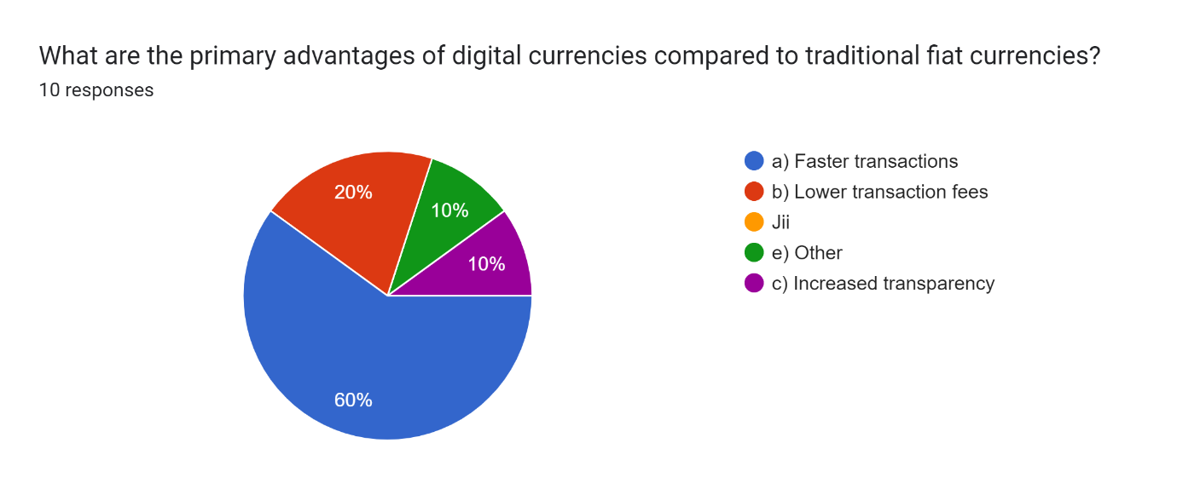

3.

Forms response chart. Question title: What role do you see banks playing in the issuance and management of digital currencies?
. Number of responses: 10 responses.

4.

Forms response chart. Question title: How prepared do you think your bank is for integrating digital currencies into its services?
. Number of responses: 10 responses.

5.

Forms response chart. Question title: How do you think digital currencies will impact the way banks handle anti-money laundering (AML) and know your customer (KYC) procedures?
. Number of responses: 10 responses.

6.

Forms response chart. Question title: In what ways do you think digital currencies could enhance the efficiency of banking operations?
. Number of responses: 10 responses.

**OPPORTUNITIES**

**AND**

**CHALLENGES**

**Opportunities: -**

Money laundering in the context of digital currencies presents unique opportunities and advantages for individuals seeking to obscure the origins of illicit funds. Digital currencies, such as Bitcoin and others, offer several features that can be exploited for money laundering purposes.

Firstly, the decentralized and pseudonymous nature of many digital currencies allows for greater anonymity compared to traditional financial systems. Transactions conducted using digital currencies are recorded on a public ledger known as the blockchain, but the identities of the parties involved are often obscured by cryptographic addresses. This anonymity makes it more challenging for law enforcement agencies to trace the flow of funds and identify those involved in money laundering schemes.

Secondly, the borderless nature of digital currencies enables individuals to conduct transactions across geographical boundaries with relative ease. This facilitates the movement of illicit funds across jurisdictions, making it more difficult for authorities to track and regulate such transactions effectively.

Moreover, the rapid growth and proliferation of digital currency exchanges and online trading platforms provide money launderers with a diverse range of channels through which they can convert and transfer their illicit funds. These platforms often operate with limited regulatory oversight, allowing individuals to buy, sell, and exchange digital currencies with minimal verification requirements, further facilitating the laundering process.

Additionally, the use of techniques such as "mixing" or "tumbling" services, which involve combining and reassigning digital currency transactions to obfuscate their origins, can further enhance the anonymity of illicit funds. These services aim to break the link between the sender and recipient addresses, making it even more challenging for authorities to trace the flow of funds.

Furthermore, the rapid pace of technological innovation in the digital currency space presents money launderers with opportunities to exploit emerging technologies and vulnerabilities in order to evade detection. For example, the use of privacy-enhancing technologies such as zero-knowledge proofs or ring signatures can further obscure the identities and transaction details of those involved in money laundering activities.

However, despite these perceived advantages, it's essential to recognize that money laundering in digital currencies carries significant risks and potential consequences. Law enforcement agencies and regulatory authorities are increasingly focused on combating illicit activities in the digital currency space, leading to enhanced surveillance and enforcement measures. Furthermore, the inherent transparency and immutability of blockchain technology mean that all transactions are permanently recorded and can potentially be traced back to their originators. Therefore, individuals engaged in money laundering in digital currencies must weigh the potential benefits against the heightened risk of detection and prosecution.

**Challenges: -**

The rise of digital currencies poses significant challenges for both banks and governments, as these new forms of currency challenge traditional financial systems and regulatory frameworks in several ways.

For banks, one of the primary challenges is the potential disruption to their role as intermediaries in financial transactions. Digital currencies operate on decentralized networks, bypassing the need for traditional banking institutions to facilitate transfers between parties. This threatens banks' revenue streams from transaction fees and could erode their market share in the payments industry. Additionally, the anonymity and borderless nature of many digital currencies make it more challenging for banks to monitor and regulate transactions effectively, increasing the risk of money laundering, fraud, and other illicit activities.

Furthermore, banks face operational challenges in adapting their existing infrastructure and processes to accommodate digital currencies. These challenges include integrating digital currency services into their existing platforms, ensuring compliance with anti-money laundering (AML) and know-your-customer (KYC) regulations, and managing the increased cybersecurity risks associated with digital assets.

Governments also face numerous challenges in regulating and overseeing digital currencies. One of the primary concerns is the potential for digital currencies to undermine monetary policy and financial stability. Central banks rely on their ability to control the money supply and interest rates to manage inflation and stabilize the economy. However, the decentralized nature of many digital currencies, such as Bitcoin, means that they are not subject to central bank control, making it more difficult for governments to influence economic conditions.

Moreover, digital currencies raise questions about taxation and revenue collection. The pseudonymous nature of many digital currency transactions makes it challenging for tax authorities to track income and enforce taxcompliance effectively. This could lead to lost tax revenue and undermine the government's ability to fund essential public services.

Additionally, governments face challenges in combating illicit activities facilitated by digital currencies, such as money laundering, terrorist financing, and cybercrime. The anonymity and cross-border nature of digital currency transactions make it easier for criminals to evade detection and launder illicit funds, posing significant challenges for law enforcement agencies.

Furthermore, the global nature of digital currencies complicates regulatory efforts, as different countries may have varying approaches to regulating and supervising digital currency activities. This lack of international coordination can create regulatory arbitrage opportunities and hinder efforts to combat illicit activities effectively.

Overall, the rise of digital currencies presents complex challenges for banks and governments alike, requiring innovative regulatory approaches and coordinated international efforts to address effectively.

**Cryptocurrency Awareness: -**

According to a survey conducted, 90% of respondents had heard of Bitcoin making it the most well-known cryptocurrency. Other familiar coins included:

Bitcoin – 90%

Ethereum – 50%

Dogecoin – 45%

Binance Coin – 36%

USD Coin – 27%

Tether – 26%

Solana – 21%

Cardano – 18%

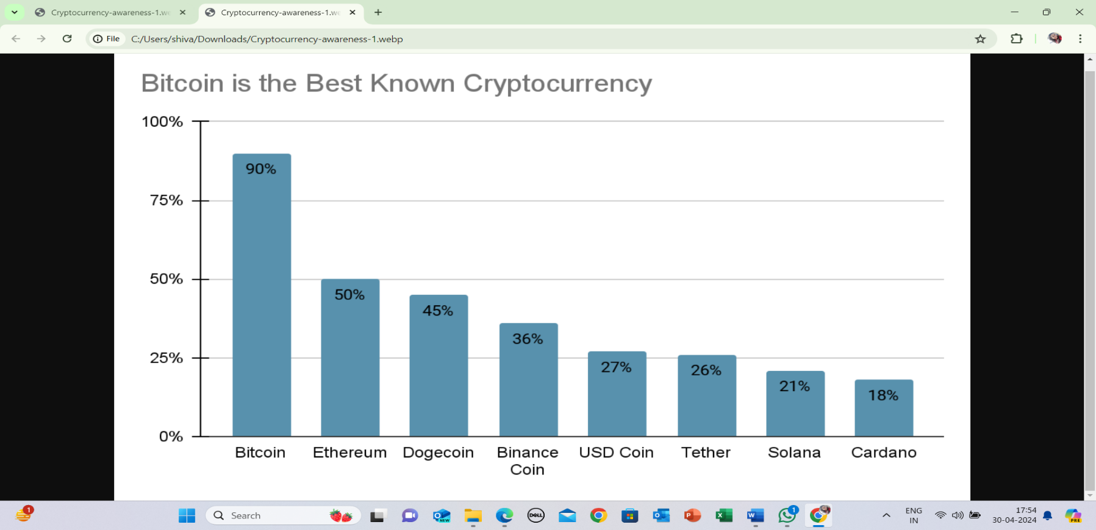

**Legitimacy of Cryptocurrency: -**

According to the survey: -

* Almost 67% agree that cryptocurrency is a legitimate form of investment (either strongly or somewhat agreeing with this statement).
* Almost 17% neither agree nor disagree with that statement.
* Almost 17% disagree that cryptocurrency is a legitimate investment.

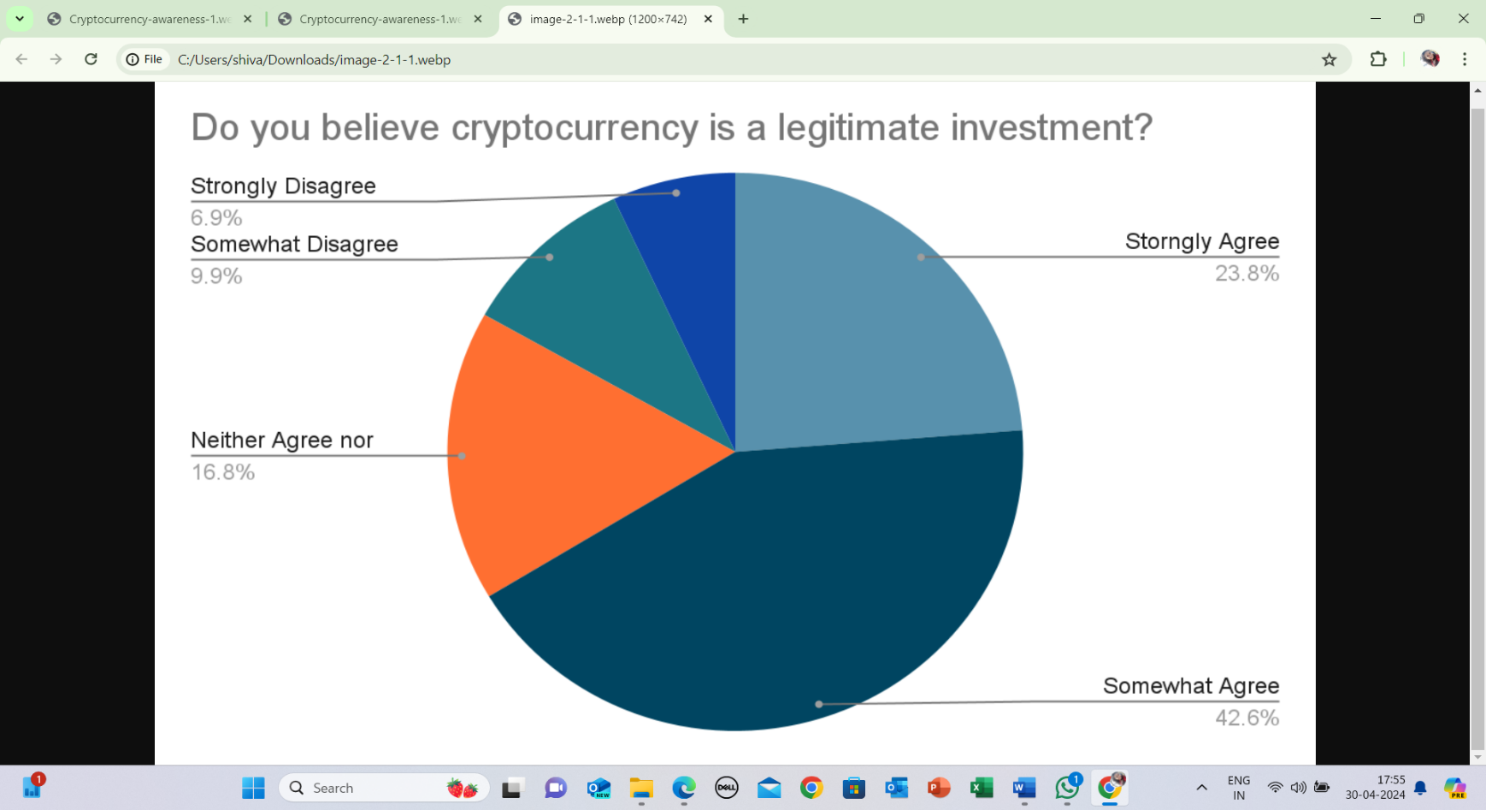

Meanwhile, 24% of those who invest in cryptocurrency say they trust it more than traditional investments, while, according to the FCA in the UK, some 60% of crypto holders said that they were happy to trade in the cryptocurrency market despite it being unregulated.

**Source: -** <https://www.forbes.com/advisor/au/investing/cryptocurrency/cryptocurrency-statistics/>

**Opposing Digital Currency by the Government**

Opposition from governments against individuals exploiting digital currencies for money laundering is a significant concern. Governments worldwide are increasingly recognizing the potential risks associated with digital currencies, including their potential use for illegal activities such as money laundering and terrorist financing.

To address these concerns, governments have been implementing regulations and enforcement measures aimed at combating money laundering in the digital currency space. These measures often include:

KYC/AML Regulations: Governments impose Know Your Customer (KYC) and Anti-Money Laundering (AML) regulations on digital currency exchanges and other service providers. These regulations require platforms to verify the identities of their users and report suspicious transactions to authorities.

Licensing and Registration: Some governments require digital currency exchanges and other businesses operating in the crypto space to obtain licenses or register with regulatory authorities. This helps ensure that these businesses comply with regulatory standards and can be held accountable for facilitating illicit activities.

Monitoring and Enforcement: Regulatory agencies monitor digital currency transactions and investigate suspicious activities. They may collaborate with law enforcement agencies to track down individuals involved in money laundering or other illegal activities using digital currencies.

Public Awareness and Education: Governments also invest in public awareness campaigns and educational initiatives to inform individuals about the risks associated with digital currencies and the consequences of engaging in illegal activities.

Overall, while digital currencies offer many benefits, including increased financial inclusion and innovation, it's crucial to address the risks of misuse, particularly for money laundering. Governments play a vital role in implementing regulations and enforcement measures to prevent illicit activities in the digital currency space and protect the integrity of the financial system.

**Opposing Digital Currency by the Banks**

Banks have also been increasingly vigilant in their efforts to combat money laundering facilitated by digital currencies. Here are some ways in which banks oppose individuals taking advantage of digital currencies for money laundering:

Transaction Monitoring: Banks employ sophisticated monitoring systems to detect suspicious transactions, including those involving digital currencies. They use algorithms and machine learning techniques to analyze transaction patterns and identify potentially illicit activities.

Enhanced Due Diligence: Banks apply enhanced due diligence measures when dealing with customers or businesses involved in digital currency transactions. This may include additional verification procedures and closer scrutiny of the source of funds.

Blocking or Suspending Transactions: Banks may block or suspend transactions involving digital currencies if they suspect money laundering or other illegal activities. They have the authority to refuse service to customers engaged in suspicious behavior.

Collaboration with Regulatory Authorities: Banks collaborate with regulatory authorities to share information and report suspicious activities related to digital currency transactions. This collaboration helps strengthen the overall efforts to combat money laundering in the financial system.

Customer Education: Banks also play a role in educating their customers about the risks associated with digital currencies and the importance of complying with anti-money laundering regulations. This may include providing information on the potential legal and financial consequences of engaging in illicit activities.

By taking these measures, banks aim to protect the integrity of the financial system and prevent the misuse of digital currencies for money laundering purposes. However, it's also essential for banks to strike a balance between preventing illicit activities and fostering innovation in the digital currency space.

Opposition from both banks and governments against individuals exploiting digital currencies for money laundering is indeed a critical issue. Money laundering involves the process of concealing the origins of illegally obtained money, typically by means of transfers involving foreign banks or legitimate businesses. Digital currencies, due to their decentralized and pseudonymous nature, have attracted individuals seeking to exploit them for illicit activities like money laundering.

Governments and banks have been taking measures to address this challenge. Regulatory bodies are increasingly implementing strict Know Your Customer (KYC) and Anti-Money Laundering (AML) regulations on cryptocurrency exchanges and other platforms dealing with digital currencies. These regulations aim to ensure that individuals engaging in digital currency transactions are properly identified and that suspicious activities are reported to authorities.

Banks, on the other hand, often impose restrictions or outright bans on transactions involving digital currencies to mitigate the risk of money laundering. They may also closely monitor accounts suspected of engaging in such activities and report any suspicious transactions to regulatory authorities.

While these measures are essential for combating money laundering, there are ongoing debates about the balance between regulatory compliance and preserving the privacy and decentralization that are core features of digital currencies. Finding effective solutions that strike this balance is crucial for fostering innovation in the digital currency space while preventing illicit activities like money laundering.

**Recommendations for Banks:**

**Integration of Digital Currency Services:** Banks should consider integrating digital currency services into their existing infrastructure to offer customers more diverse financial options. This may involve partnering with reputable cryptocurrency exchanges or developing their own digital currency platforms.

**Robust Security Measures:** Banks need to prioritize security when implementing digital currency services to protect customers' assets from cyber threats and fraud. This includes implementing multi-factor authentication, encryption protocols, and regular security audits.

**Customer Education and Support:** Banks should provide comprehensive educational resources and customer support for users of digital currency services. This includes guidance on safe storage practices, understanding the risks involved, and assistance with navigating the digital currency ecosystem.

**Compliance with Regulatory Standards:** Banks must ensure compliance with regulatory standards and anti-money laundering (AML) regulations when offering digital currency services. This involves implementing robust Know Your Customer (KYC) procedures, transaction monitoring, and reporting suspicious activities to regulatory authorities.

**Recommendations for Governments:**

**Regulatory Clarity**: Governments should establish clear and consistent regulatory frameworks for digital currencies to provide legal certainty for businesses and investors. This includes defining the regulatory status of digital currencies, licensing requirements for digital currency businesses, and taxation policies.

**Consumer Protection Measures:** Governments should implement consumer protection measures to safeguard the interests of users of digital currency services. This may include measures to address fraud, unauthorized transactions, and dispute resolution mechanisms.

**Promotion of Innovation:** Governments should encourage innovation in the digital currency space by fostering a supportive regulatory environment and providing incentives for research and development. This includes supporting initiatives that promote financial inclusion, interoperability, and the adoption of emerging technologies like blockchain.

**International Cooperation**: Given the global nature of digital currencies, governments should collaborate with international counterparts to establish common standards and regulatory principles. This includes sharing best practices, coordinating enforcement efforts, and addressing cross-border challenges such as money laundering and terrorist financing.

By following these recommendations, banks and governments can work together to ensure the responsible and sustainable implementation of digital currencies, fostering innovation and financial inclusion while addressing potential risks and challenges.

**Conclusion**

In conclusion, banks often oppose digital currency due to a combination of factors that challenge their traditional role, regulatory uncertainties, competitive threats, risk concerns, and technological challenges. The emergence of digital currencies, particularly decentralized ones like Bitcoin, fundamentally alters the dynamics of financial transactions by bypassing traditional banking intermediaries. This disruption poses a direct threat to banks' revenue streams and their established business models. Moreover, the regulatory ambiguity surrounding digital currencies creates compliance challenges and legal risks that banks are hesitant to navigate. Additionally, the potential competition posed by digital currencies, offering faster and cheaper payment solutions, threatens banks' market share and profitability. Concerns about the volatility of digital currencies, coupled with their association with illicit activities, further deter banks from embracing them. Lastly, integrating digital currencies into existing banking infrastructure requires substantial investment in technology and security measures, posing significant operational challenges. As a result, while some banks may explore opportunities in the digital currency space, many remain cautious and resistant to its adoption.

**References**

<https://www.boj.or.jp/en/announcements/>

<https://www.boj.or.jp/en/announcements/>

<https://www.bis.org/publ/qtrpdf/r_qt2003j.pdf>

<https://pic.bankofchina.com/bocappd/report/201704/>

<https://www.boi.org.il/en/NewsAndPublications/PressReleases/Documents/>

<https://www.lb.lt/en/news/>

<https://news.bitcoin.com/central-banks-testing-digital-currencies/>

<https://halshs.archives-ouvertes.fr/halshs-00414496>

<https://www.bis.org/publ/bppdf/bispap107.pdf>

<http://www.nber.org/papers/w23711>

<https://www.federalreserve.gov/newsevents/speech/brainard20180515a.htm>

<https://www.federalreserve.gov/newsevents/speech/files/brainard20190805a.pdf>

<https://www.bceao>.

<https://news.bitcoin.com/central-banks-testing-digital-currencies/>

<https://halshs.archives-ouvertes.fr/halshs-00414496/>

<https://www.bis.org/publ/bppdf/bispap107.pdf>

<http://www.nber.org/papers/w23711>

<https://www.federalreserve.gov/newsevents/speech/brainard20180515a.htm>

<https://www.federalreserve.gov/newsevents/speech/files/brainard20190805a.pdf>

**ANNEXURE**

**Questionnaire**

Q1. Do you believe that digital currencies will play a significant role in the future of banking?

a) Yes

b) No

c) Unsure

Q2. What are the primary advantages of digital currencies compared to traditional fiat currencies?

a) Faster transactions

b) Lower transaction fees

c) Increased transparency

d) Enhanced security

e) Other

Q3. What are the main challenges or concerns you foresee in the adoption of digital currencies by banks?

a) Regulatory issues

b) Security risks

c) Customer acceptance

d) Technological infrastructure

e) Other

Q4. How prepared do you think your bank is for integrating digital currencies into its services?

a) Very prepared

b) Somewhat prepared

c) Not prepared at all

Q5. What role do you see banks playing in the issuance and management of digital currencies?

a) Primary issuer and manager

b) Secondary service provider

c) No role

Q6. How do you think digital currencies will impact the way banks handle anti-money laundering (AML) and know your customer (KYC) procedures?

a) Positively

b) Negatively

c) No impact

Q7. In what ways do you think digital currencies could enhance the efficiency of banking operations?

a) Streamlined cross-border transactions

b) Simplified payment processes

c) Automated compliance procedures

d) Other (please specify)