"CHARITY DONATION USING BLOCKCHAIN"

¹Anushka Damade, ²Sakshi Khedekar, ³Kalpesh Gunjal, ⁴Shivam Karande, ⁵Sayali Karmode
^{1,2,3,4} Student, ⁵Assistant Professor

^{1,2,3,4,5}Department of Information Technology

^{1,2,3,4,5}MGM’s College of Engineering and Technology, Kamothe, Navi Mumbai, India

Abstract: Charity donation is a crucial process that can significantly impact and save lives. However, the current organ donation system often faces challenges such as lack of transparency, trust, and efficiency. To address these issues, this project proposes a blockchain-based organ donation platform. The platform allows users to easily register as organ donors by providing their organ name and a brief message. This information is securely stored on the blockchain, ensuring transparency and immutability. To facilitate donations, the platform integrates with the popular Metamask wallet, enabling users to make donations securely and conveniently. One of the key features of the platform is its ability to track and display the history of donations. This feature enhances transparency and accountability, as users can see where their donations are going and how they are being used. Additionally, the platform aims to increase trust among donors and recipients by providing a secure and transparent environment for organ donation. Overall, the blockchain-based organ donation platform aims to streamline the donation process, increase transparency, and ultimately save more lives through organ donation.

ACKNOWLEDGMENT

We acknowledge the support and guidance to Sayali Karmode and colleagues, whose insights and feedback have been invaluable throughout our journey. Their expertise has helped us navigate the complexities of blockchain technology and charity donation, guiding us towards meaningful solutions. Finally, we express our deepest appreciation to the donors and recipients of charitable donations, whose generosity and compassion continue to inspire us. It is their dedication to making a positive difference in the world that drives us to explore new possibilities and create a brighter future for all.

INTRODUCTION

Charity donation is a noble act that has the potential to save countless lives. However, the current organ donation system is plagued by inefficiencies, lack of transparency, and issues of trust. To address these challenges, this project proposes a blockchain-based organ donation platform that aims to revolutionize the way organ donation is carried out. The platform offers a user-friendly interface that allows individuals to easily register as organ donors. Users can provide details such as the organ they wish to donate and a brief message explaining their decision. This information is securely stored on the blockchain, ensuring its integrity and immutability. One of the key advantages of using blockchain technology for organ donation is its transparency. The blockchain is a distributed ledger that is accessible to all participants in the network. This means that anyone can view the history of organ donations, including who donated the organ, when it was donated, and where it was transplanted. This level of transparency helps build trust among donors and recipients, as they can see exactly how their donations are being used. Another important feature of the platform is its integration with the Metamask wallet. Metamask is a popular cryptocurrency wallet that allows users to securely store and manage their digital assets. By integrating with Metamask, the platform enables users to make donations securely and conveniently. This removes the need for traditional payment methods, which can be cumbersome and insecure. One of the main challenges facing the organ donation system is the lack of transparency and accountability. There have been instances where organs have been misused or misallocated, leading to mistrust among donors and recipients. By using blockchain technology, the platform ensures that all transactions are recorded on a public ledger that is accessible to all participants. This provides an extra layer of security and accountability, as all transactions can be traced back to their source. Overall, the blockchain-based organ donation platform has the potential to significantly improve the organ donation process. By leveraging the transparency and security of blockchain technology, the platform aims to increase trust among donors and recipients, streamline the donation process, and ultimately save more lives.
LITERATURE SURVEY

Trust and Transparency: Research by Irani et al. (2019) highlights the importance of trust and transparency in charity donation processes. Blockchain technology can provide a transparent and immutable record of donation transactions, ensuring that donors can see how their contributions are being used.

Efficiency and Security: Mendez et al. (2020) discuss how blockchain technology can improve the efficiency and security of charity donation processes. By eliminating intermediaries and automating donation processes, blockchain can reduce transaction costs and processing times, while also ensuring the security of donation transactions.

Smart Contracts: Xu et al. (2018) explore the use of smart contracts in charity donation processes. Smart contracts can be used to automate and enforce the terms of donation agreements, ensuring that donations are only released when certain conditions are met.

Decentralization and Peer-to-Peer Donation: Al-Bassam et al. (2017) discuss the potential of blockchain technology to enable decentralized and peer-to-peer donation models. This allows donors to support causes directly without the need for intermediaries, increasing the efficiency and transparency of donation processes.

Challenges and Limitations: De et al. (2019) highlight the challenges and limitations associated with using blockchain for charity donation. These include scalability issues, regulatory concerns, and the need for user education and awareness about blockchain technology.

Case Studies and Implementations: Several case studies and real-world implementations of blockchain technology in charity donation exist. For example, the United Nations World Food Programme (WFP) has used blockchain to distribute cash vouchers to refugees in Jordan, ensuring transparency and efficiency in the distribution process.

EXISTING SYSTEM

The current system for charity donation relies heavily on traditional methods, such as cash or check donations, bank transfers, and online payment gateways. Donors typically interact with charitable organizations through websites or donation drives, where they can make a one-time or recurring donation to support a cause. However, the existing system lacks transparency, as donors often have limited visibility into how their donations are being used. Additionally, the reliance on intermediaries, such as banks and payment processors, can lead to higher transaction costs and longer processing times. Overall, the existing system for charity donation is effective in facilitating donations but falls short in terms of transparency, efficiency, and security.

OBJECTIVES

- Transparency: Ensure transparency in the donation process by recording all transactions on the blockchain, allowing donors to track their donations and see how they are being used.

- Efficiency: Improve the efficiency of the donation process by eliminating intermediaries and automating donation processes using smart contracts, reducing transaction costs and processing times.

- Security: Enhance the security of donations by using blockchain technology to securely store and manage donation records, protecting them from tampering and unauthorized access.

- Accountability: Increase accountability in the donation process by providing a clear audit trail of all transactions, ensuring that funds are used for their intended purpose.

- Decentralization: Enable decentralized and peer-to-peer donation models, allowing donors to support causes directly without the need for intermediaries, empowering donors to have greater control over their charitable giving.

- User-Friendly Interface: Develop a user-friendly interface that allows donors to easily register, donate, and track their donations, making the donation process seamless and accessible to all.

- Regulatory Compliance: Ensure compliance with regulatory requirements and standards for charity donations, providing a trustworthy platform for donors and charitable organizations.

- Education and Awareness: Educate users about blockchain technology and its benefits for charity donation, increasing awareness and adoption of the platform.
PROPOSED SYSTEM

The proposed system for charity donation using blockchain technology aims to address the limitations of the existing system by providing a transparent, efficient, and secure platform for donors and charitable organizations. In the proposed system, donors can register and donate funds directly to charitable causes using blockchain technology. Each donation is recorded on the blockchain ledger, providing donors with a transparent view of how their donations are being used. Smart contracts are used to automate donation processes, ensuring that funds are released to charitable organizations only when certain conditions are met. This eliminates the need for intermediaries, reducing transaction costs and processing times. Overall, the proposed system using blockchain technology has the potential to revolutionize charity donation by providing donors with greater transparency, efficiency, and security.

METHODOLOGY

- Organ Selection: Users choose the organs they wish to donate. They can also specify any preferences or conditions for their donation.

- Payment: Users make a payment for organ donation using their blockchain wallet. The payment is recorded on the blockchain, ensuring transparency and security.

- Smart Contract Execution: Smart contracts are used to automate the donation process. The smart contract ensures that donations are only released to the recipient organization once certain conditions are met, such as the availability of the organ for donation.

- Feedback Message: After making a donation, users can provide a feedback message to the recipient organization. This message can include words of encouragement, gratitude, or any other message the donor wishes to convey.

FEATURES

- Donation Record: The system securely records the details of registered donors, including the organ(s) they have pledged to donate and any additional information they provide.

- Smart Contracts: Smart contracts are used to automate and enforce the terms of organ donation pledges, ensuring that organs are only transplanted to recipients who meet the specified criteria.

- Metamask Integration: The system integrates with the Metamask wallet for secure and convenient payment processing, allowing donors to make donations using cryptocurrency.

- Payment History: Donors can view their donation history, including details of all donations made, the amount donated, and the recipients of their donations.

ADVANTAGES

- Transparency: Blockchain technology provides a transparent and immutable ledger of all donation transactions, ensuring donors can see how their contributions are being used.

- Security: Donations are securely recorded on the blockchain, protected from tampering and unauthorized access.

- Accountability: Smart contracts ensure that donations are only released when certain conditions are met, increasing accountability in the donation process.

- Decentralization: Enables peer-to-peer donation models, allowing donors to support causes directly without the need for intermediaries.

- Global Reach: The platform can reach donors and charitable organizations worldwide, expanding the reach of charitable giving.

- Cost-Effectiveness: By reducing transaction costs and eliminating intermediaries, the platform is more cost-effective for both donors and charitable organizations.
CHALLENGES

- Technical Complexity: Blockchain technology is complex and may require technical expertise to implement and maintain, which could be a barrier for some users.

- Scalability: Blockchain networks can face scalability issues, especially during times of high transaction volume, which could impact the speed and efficiency of donation processing.

- Data Privacy: While blockchain technology ensures security and immutability of data, there may still be concerns about data privacy, especially regarding the storage of sensitive information.

- Integration Challenges: Integrating the platform with existing donation systems and infrastructure may pose challenges, especially for larger charitable organizations with complex systems in place.

FUTURE WORK

Future work for the proposed blockchain-based charity donation platform includes several key areas of development and enhancement. One area of focus is the integration of the platform with social media and crowdfunding platforms. This integration would allow the platform to reach a wider audience and attract more donors by leveraging the existing user base of these platforms. Additionally, enhancing security measures is crucial to ensure the safety of donation transactions and user data. Implementing additional security measures such as multi-factor authentication and encryption will further secure the platform against cyber threats. Another important area for future work is the optimization of smart contracts. Smart contracts are self-executing contracts with the terms of the agreement directly written into code. Optimizing smart contracts can improve the efficiency of donation processes and reduce gas fees on the blockchain network. Developing a mobile application for the platform is also a key step towards increasing accessibility and convenience for donors. A mobile application would allow donors to easily access the platform and make donations on the go.

Forming partnerships with charitable organizations is another important aspect of future work. Collaborating with established charitable organizations can help promote the platform and increase awareness among potential donors. Engaging with the community for feedback and suggestions is also crucial for the continued improvement of the platform. Gathering input from users can help identify areas for improvement and ensure that the platform meets the needs of its users. Implementing advanced data analytics is another key area for future work. Analyzing donation trends and donor behavior can provide valuable insights that can be used to tailor fundraising efforts and increase donations. Finally, expanding the platform to support donations for other causes beyond its initial focus is a long-term goal. By expanding to support donations for causes such as disaster relief, healthcare, and education, the platform can increase its impact and reach a broader audience of donors.

DATA FLOW DIAGRAM
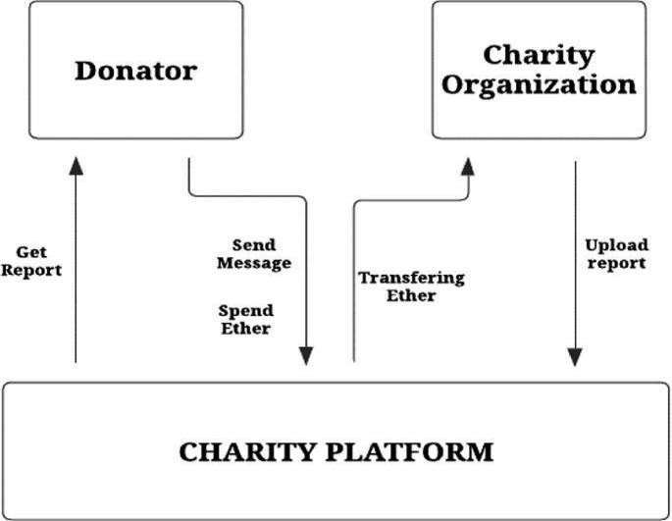

Fig.: Data Flow Diagram

ARCHITECTURE DESIGN
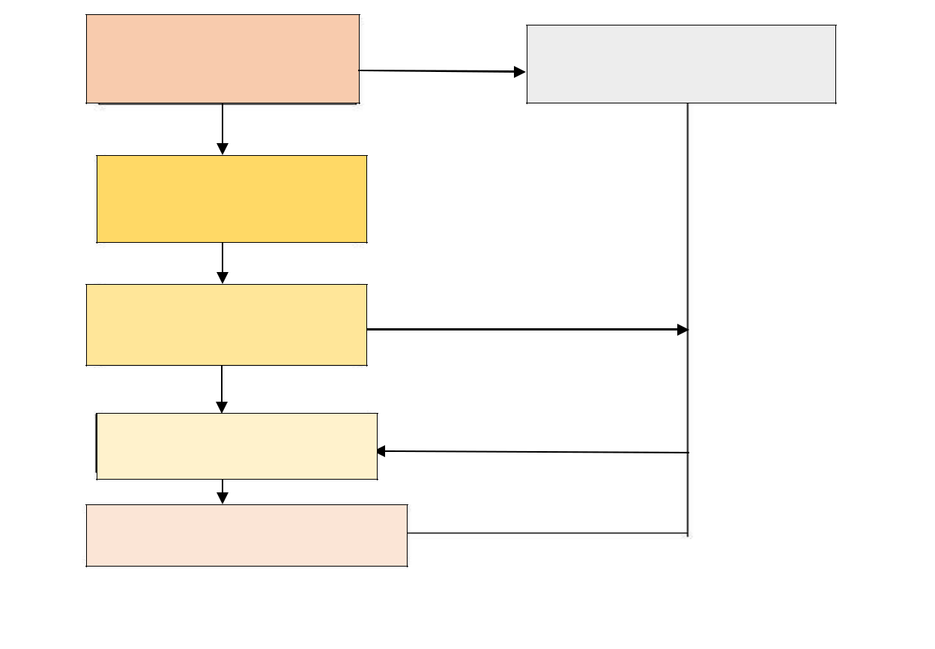

START

Intent Detection

Handle Intent
(Query, Data, Business,

Responses)

Response Sent

User Follow -up

USER INPUT


Fig. :Architecture Design

CONCLUSION

In conclusion, the use of blockchain technology for charity donation, especially in the context of organ donation, offers several significant benefits. The transparency and immutability of the blockchain ledger ensure that donors can track their donations and see exactly how their contributions are being used. This transparency builds trust between donors and charitable organizations, which can lead to increased donations and greater support for important causes. The security features of blockchain also play a crucial role in ensuring the integrity of the donation process. By using cryptography and decentralized storage, blockchain technology protects donation records from tampering and unauthorized access, ensuring that donations reach their intended recipients securely. Furthermore, the automation capabilities of smart contracts streamline donation processes, reducing the need for manual intervention and eliminating the potential for human error. Smart contracts can be used to automatically release donations to charitable organizations once certain conditions are met, such as the successful completion of a project or the verification of a recipient's need. Despite these benefits, there are still challenges to be addressed in implementing blockchain technology for charity donation. These include regulatory compliance, user education and adoption, and scalability issues. However, with ongoing research and development, these challenges can be overcome, paving the way for a more transparent, efficient, and secure system for charity donation using blockchain technology.

REFERENCES

- S. Gore, S. Hamsa, S. Roychowdhury, G. Patil, S. Gore and S. Karmode, "Augmented Intelligence in Machine Learning for Cybersecurity: Enhancing Threat Detection and Human-Machine Collaboration," 2023 Second International Conference on Augmented Intelligence and Sustainable Systems (ICAISS), Trichy, India, 2023, pp. 638-644, doi:

10.1109/ICAISS58487.2023.10250514.

- Layth Almahadeen, Renzon Daniel Cosme Pecho, Murugananth Gopal Raj, Nichenametla Rajesh, Zainab Mohammed Imneef, Sayali Karmode Yelpale, “Digital Investigation Forensic Model with P2P Timestamp Blockchain for Monitoring and Analysis” , Journal of Electrical System, Vol. 1, No 1, (2024): 09-17 ( DOI : https://doi.org/10.52783/jes.656)

- Sayali Karmode, Security Challenges for IoT Based Applications & Solutions Using Fog Computing: A Survey, Journal

of Journal of Cybersecurity and Information Management, Vol. 3, No.1, (2020): 21-28 (Doi: https://doi.org/10.54216/JCIM.030103)

- M. S. K. Yelpale, “Security and privacy challenges in cloud computing: a review,” Journal of Cybersecurity and

Information Management, vol. 4, no. 1, pp. 36–45, 2020. View at: Google Scholar

- Sayali Karmode Yelpale, “IOT Technology for Pandemic Situation”, NJITM, vol. 4, no. 2, pp. 25–27, Jan. 2022 https://mbajournals.in/index.php/JoITM/article/view/806.

- Karmode, S. S., & Bhagat, V. B. (2017). DETECTION AND BLOCKING SOCIAL MEDIA MALICIOUS POSTS. International journal of modern trends in engineering and research, 4(5).

- Kermode, S. S., & Bhagat, V. B. (2016). A Review: Detection and Blocking Social Media Malicious Posts. Int. J. Mod.

Trends Eng. Res, 3(11), 130-136. doi: 10.21884/IJMTER.2016.3133.Q4M8O .

- Prof. Bhushan B. Thakare, Prof. Sayali Karmode Yelpale, “Smart Home with Edge Computing”, International Journal of Interdisciplinary Innovative Research & Development (IJIIRD), Vol 6, 2021 https://ijiird.com/wp-content/uploads/CSE016-1.pdf

- Sayali Karmode, “Blockchain Technology Security Issues and Concerns : A Review”, International Research Journal of Modernization in Engineering Technology and Science, Vol 6, Issue 03, March 2024

DOI : https://www.doi.org/10.56726/IRJMETS50249

- Pranav Chavan, Harshraj Deshmukh, Aakash Dhotre, Aditya Gharat, Sayali Karmode, “Blockchain Democracy : Evaluating a Secure Voting System”, International Research Journal of Modernization in Engineering Technology and Science, Vol 6, Issue 03, March 2024

DOI : https://www.doi.org/10.56726/IRJMETS50478

- B. J. Dange, Kaustubh Manikrao Gaikwad, H. E. Khodke, Santosh Gore, S. N. Gunjal, Kalyani Kadam, Sayali Karmode, “Machine Learning for Quantum Computing Bridging the Gap between AI and Quantum Algorithms”, Int J Intell Syst Appl Eng, vol. 12, no. 21s, pp. 600–605, Mar. 2024.

- N Kumar, E Howard, S Karmode, “Reinforcement Learning for Optimal Treatment Planning in Radiation Therapy”, NATURALISTA CAMPANO, Vol 28, Issue 1, 2024 https://museonaturalistico.it/index.php/journal/article/view/355
- Irani, Z., Sharif, A. M., & Khadeer, S. (2019). Blockchain in charity: Trust, transparency, and accountability. Information Systems Frontiers, 21(5), 1067-1083.

- Mendez, A., Garrido, J. L., & Bueno, S. (2020). Blockchain technology in charitable organizations: A systematic review. Technological Forecasting and Social Change, 157, 120105.

- Xu, X., Weber, I., & Staples, M. (2018). A taxonomy of blockchain-based systems for architecture design. Proceedings of the 2018 IEEE International Conference on Software Architecture (ICSA), 243-252.

- Al-Bassam, M., Sonnino, A., & Bano, S. (2017). Chainspace: A sharded smart contracts platform. Proceedings of the 2018 ACM SIGSAC Conference on Computer and Communications Security, 270-282.

- De, S., Saha, D., & Chaki, R. (2019). A comprehensive review on blockchain for sustainable development goals. IEEE Access, 7, 50501-50524.

