**A COMPACT TRI-BAND ANTENNA WITH INVERTED**

**L-STUBS FOR SMART DEVICES**

**PROJECT GUIDE**: Dr.Sathiya Priya.S M.E,Ph.D (HOD)

Panimalar Institute of Technology, Poonamallee,

Chennai-600123.

MANGALAPUDI JOY NICHOLAS POLUDASU SRI CHAKRADHAR ROGITH RG

UG student ECE dept UG student ECE dept UG student ECE dept

Panimalar Institute of Technology, Panimalar Institute of Technology, Panimalar Institute of Technology,

Poonamallee, Poonamallee, Poonamallee,

Chennai-600123. Chennai-600123. Chennai-600123

[itzjoynicholas@gmail.com](mailto:itzjoynicholas@gmail.com) [chakku045@gmail](mailto:chakku045@gmail.com)  [rogithrg547@gmail.com](mailto:rogithrg547@gmail.com)

***Abstract*—** We created a brand-new, small tri-band monopole antenna specifically for smart gadgets. Inverted-L shaped stubs of different lengths were placed in a triangular monopole antenna fed by a coplanar waveguide to achieve multiband behaviour. Each band's resonance frequency can be adjusted by changing the length of the matching stub. It was simple to obtain three bands at 3 (3.05–3.13), 4 (3.25–4.09), and 5.5 (4.6–7.2) GHz using three stubs of varying lengths. A shorting pin was used to join the primary stub and the longest stub (printed at 3 GHz) on the substrate's other side in order to miniaturise it. In order to verify the idea, the antenna was made on an inexpensive, 20 × 15 × 1.6 mm3 1.6-mm-thick FR-4 substrate. The antenna showed an omnidirectional radiation pattern with a moderate gain of 0.035, 0.508, 0.7 dBi at 3, 4, 5.5 GHz respectively. over the bandwidths needed for WLAN-band, RFID, Bluetooth, ISM, and WiMAX applications.The antenna is appropriate for small smart devices because of these properties.

**keywords—** Multiband antenna; compact antenna; tri-band antenna; CPW antenna; stub-loaded antenna.

# INTRODUCTION

The integration of numerous communications systems into a single electronic device has increased the requirement for tiny, planar, multiband antennas that are low-profile. The systems use a range of frequencies to function, from 3 to 5.5 GHz. The 5G sub-6 GHz band (3.5 GHz), Bluetooth (2.4 GHz), long term evolution (LTE-2.5) and Industrial Scientific and Medical (ISM-2.4 GHz), as well as the radio frequency identification (RFID-2.54/5.8 GHz) and wireless local area network (WLAN-2.4/5.2/5.8 GHz) bands are popular frequency bands. It takes many antennas to operate in all of these frequency bands; one antenna cannot do it. The gadgets must be affordable and small, though. Multiband antennas are therefore crucial. Printed antennas are inexpensive, simple to construct, capable of operating in multiple bands, and easy to incorporate into other circuits. Numerous multiband printed antennas have formulated. Different shaped slits were made in a radiator in to stimulate different operating bands.It was possible to adjust the resonance frequency by changing the electrical length of the slots. Asymmetric coplanar strip (ACS)-fed meander lines were employed in certain investigations to guarantee multiband operation, but avoiding the requirement for intricate antenna designs. Multiband antennas have also been made using deformed ground structures (DGS), stacked layers, parasitic components, and metamaterials. In order to meet bandwidth requirements and guarantee consistent gain, high radiation efficiency, and omnidirectional radiation reception, numerous tri-band antennas operating in key frequency bands have been deployed. In a small tri-band antenna with several metallic strips arranged in a dual F-shaped monopole was displayed. This antenna has good radiation properties and operates in the 1.9, 3.5, and 5.5 GHz bands. A different tri-band antenna with omnidirectional emission patterns and resonances at 3.13, 4.09, and 5.5 GHz was observed. To attain the necessary resonance, three different antenna configurations were employed: an inverted-L slot, a π-shaped slot, and a truncated rectangular patch. The radiation efficiency of the antenna is high, with a flat gain of 3.39 dBi.For portable system applications, a uniplanar, ACS-fed tri-band antenna with extended rectangular strips was created. Three distinct bands can function simultaneously with this antenna because to its redesigned mouse and rectangular radiating strips. For tri-band operation, another ACS-fed F-shaped monopole with a rectangular split-ring resonator was presented in. All of the above-discussed antennas, despite their simplicity, have special advantages. They must, however, be physically smaller in order to be utilised in contemporary, multipurpose, small gadgets. Handheld devices need simple, compact, highly effective, and reasonably priced multiband antennas. Here, we provide a small, coplanar waveguide-fed tri-band antenna that covers many frequency bands, such as WLAN, ISM, Bluetooth, RFID, WiMAX, and other cutting-edge protocols (e.g., 5G sub-6GHz).The antenna features a moderate bandwidth, omnidirectional gain, and good impedance matching.

1. **ANTENNA GEOMETRY AND DESIGN**

In this section, we'll discuss the structure of the tri-band antenna, how its parameters are optimized, and the steps taken in its design. Initially, we'll introduce the antenna's geometry and the variables involved in its design. Then, we'll delve into a detailed explanation of the design process.

* **Geometry of Tri-band antenna**

The antenna's structure is depicted in Figure 1. It consists of three inverted-L shaped stubs of varying length but uniform width (w), connected to a triangular monopole antenna fed by a 50-ohm coplanar waveguide strip line. To reduce its size, a segment of the longest stub is printed on the underside of the substrate and linked to the remaining portion through a metallic pin. The antenna is fabricated on a low-cost FR-4 substrate with a dielectric constant (εr) of 4.4 and a loss tangent (tanδ) of 0.02. The overall dimensions of the antenna are given by A×W×h. The optimized parameters of the antenna are as follows: A=15; L=20; h=1.6; wL=2; s=0.5; w=1; w1=12; w2=9; w3=6; l1=6; l2=4; l3=2; p=7; wF=2; gL=5.5 and gW=6 [all in millimeters].

* **Antenna Design Procedure:**

The design process commenced with a simulation conducted using CST Microwave Studio (DassaultSystèmes, Vélizy–Villacoublay, France) of a triangular monopole fed by a coplanar waveguide (CPW). Employing a CPW feed offers various benefits, such as a wide impedance bandwidth and straightforward design. The length of a monopole can be determined using the following equation: 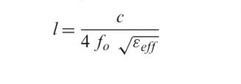

......(1)

.........................d....222f1.........

where c represents the velocity of light in free space, and fo signifies the central resonating frequency given by:

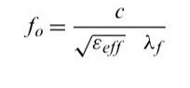

......(2)

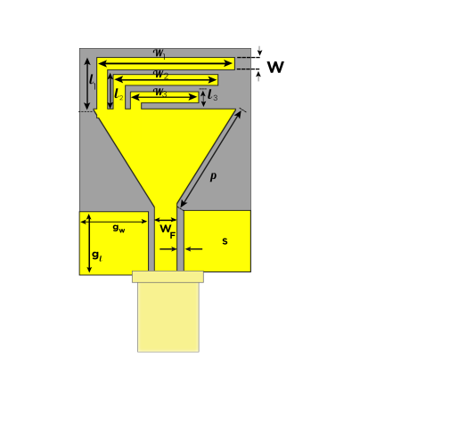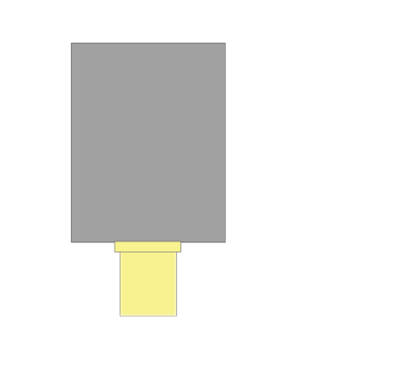

Back view

Front view

**Figure 1: Schematics of Tri-Band Antenna**

Here, λf denotes the guided wavelength at the central frequency, and εeff stands for the effective dielectric constant, calculated as:

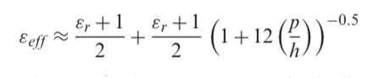

......(3)

where εr represents the dielectric constant of the substrate, p denotes the width of the monopole, and h represents the thickness of the substrate. The radiating elements of the antenna are fashioned using a lossy material (copper) with a standard thickness of 0.035 mm and are printed on top of an FR-4 substrate (tan δ = 0.02 and εr = 4.4, thickness = 1.6 mm). To ensure accurate simulation, a sub-miniature version A (SMA) connector model was incorporated to estimate the connector's impact on antenna performance during actual measurements. The monopole (Antenna-1; dimensions of 15 mm × 20 mm) resonates at approximately 6 GHz. Hence a inverted L-Shaped stub was added to the Antenna-1(Antenna-2)

Subsequently, additional (similarly optimized) inverted-L shaped stubs were added (Antennas-3 and-4) to generate resonance at 3/4/5.5 GHz and 3/4/5.5 GHz, respectively. The design progression is illustrated in Fig. 2. The positions and dimensions of the stubs were carefully selected. All the antennas measure 15 mm × 20 mm in size The reflection coefficient (|S11| values) of each antenna involved in the final design is also plotted to facilitate comprehension of the design procedure. Fig. 3 displays the |S11| plots of the final desired antenna with all the working frequencies as 1, 2 and 3 for 3/4/5.5 GHz respectively. According to the fundamental monopole antenna theory, the length of the entire stub should be approximately a quarter-wavelength at the resonance frequency, i.e., 31.2 mm at 2.4-3 GHz. The total stub length of Antenna-2 is p + l1 + w1 + h + w4 = 7 + 6 + 12 + 1.6 = 26.6 mm, which closely aligns with the theoretical requirement. In Antenna-3, a quarter-wavelength stub is added to the initial stub. This extends p + l2 + w2 = 7 + 4 + 9 = 20 mm to Antenna-3, facilitating additional resonance at 4.5 GHz . Thus, the stubs allow current to flow along several paths, elucidating the multiband behavior.

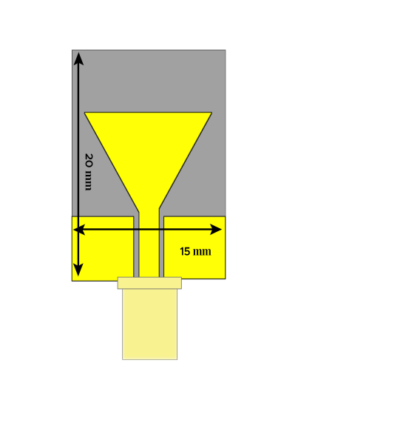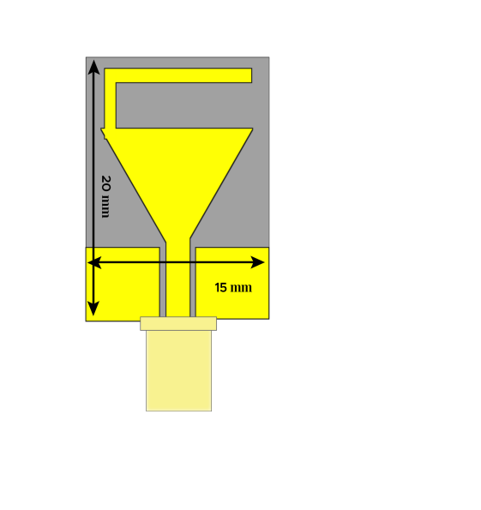

**Antenna-2**

**Antenna-1**

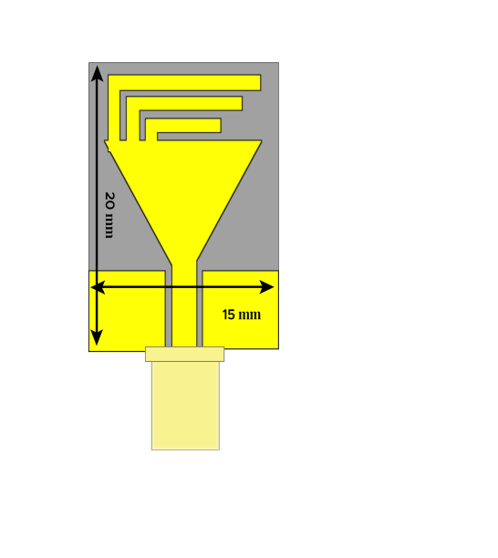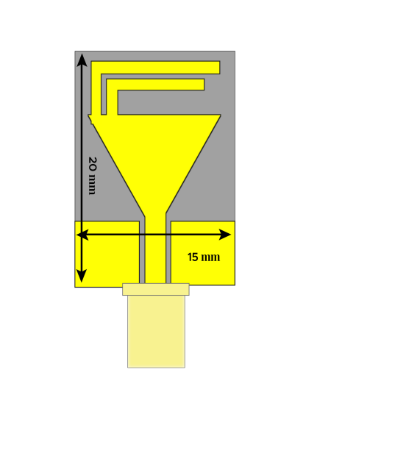

**Antenna-4**

**Antenna-3**

**Figure 2: Design Evolution of Proposed Tri-band antenna**

Similarly, another inverted-L stub was incorporated to generate an additional band at 5 GHz [Antenna-4 (proposed antenna) in Fig.2]. The 5 and 6 GHz bands intentionally overlap to provide the necessary ultrawide bandwidth (4.6–7.2 GHz) for the WLAN band. Importantly, we can adjust the operating frequency by modifying the stub length. Resonance shifts to lower frequencies with an increase in stub length. Operating frequency can be heightened according to user requirements by reducing the stub length. This can be comprehended by examining the |S11| characteristics of the final design.

1. **RESULTS AND DISCUSSION:**

We made a prototype of the antenna using a common technique called photolithography and tested how well it works (see Fig. 7). This antenna is very small and fits easily into tiny gadgets like USB dongles. We used a special machine called an E5071C network analyzer (made by Agilent in Santa Clara, CA, USA) to measure something called |S11|, and we checked the antenna's performance in a special room called an anechoic chamber

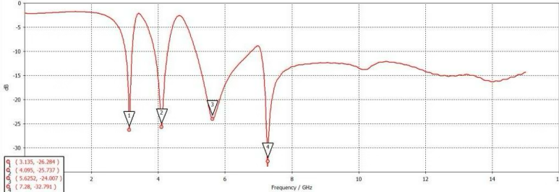

**Figure 3: |S11| Characteristics of the Antenna**

In Figure 3, you can see graph that compare what we expected to happen with what actually happened. Our measurements matched up well with our expectations. The antenna works well at three different frequencies: 3, 4, and 5.5 GHz, and it's good at matching up with the other parts of a device.

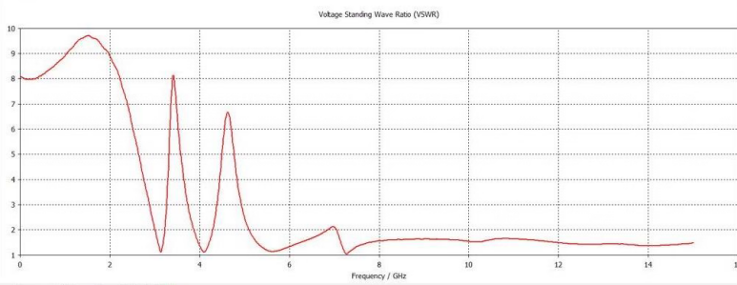

**Figure 4: VSWR of the Antenna**

In Figure 4, we have the graph showing the antenna's voltage standing wave ratio (vswr) of the desired antenna which is almost equals 1 at the desired frequencies. It works best at 3 GHz, giving a reading of 0.035 dBi, and even better at 4 GHz with 0.508 dBi, and 5.5 GHz with 0.7 dBi. But in some other frequencies, it doesn't work as well, showing negative readings. Generally, the antenna works better when the frequency is higher. We also checked how efficiently the antenna sends out signals. It's very efficient at its main frequencies, reaching up to 80%, but not as good at other times, dropping to 40%. In Figure 5, you can see diagrams showing how the antenna sends out signals at different frequencies. It sends signals in all directions at 3, 4, 5.5, and 7 GHz, and this pattern stays the same no matter what frequency it is; this is a good feature of the design.The patterns of how the antenna sends out signals at 3, 4, 5.5, and 7 GHz are displayed in Figure 5. The antenna sends signals out in all directions in one plane and in two directions in another. These patterns stay the same at all frequencies, which is a strong point of the design.

1. **PERFORMANCE COMPARISION:**

Focusing on size, operating bands, and average gain. Our antenna stands out because it's smaller, has better gain, and more stable radiation. While some antennas have higher gains, they are bigger. Our antenna is straightforward, and we can adjust its operating frequency bands as needed. Its compact size and good radiation show how we carefully designed the inverted-L stubs on a triangular monopole.

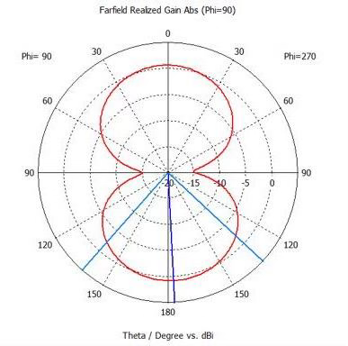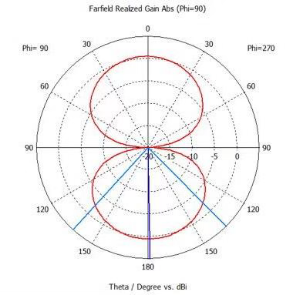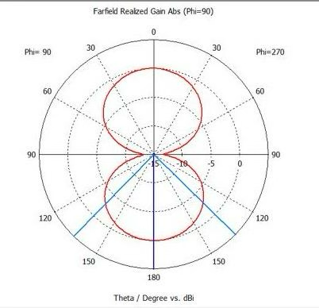

4

3

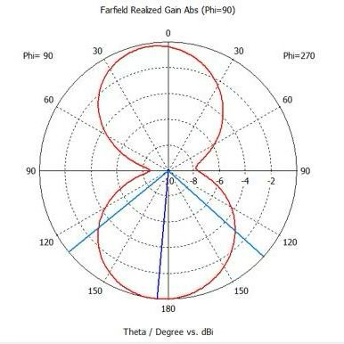

7

5.5

**Figure 5: Measured Radiation Pattern of the Antenna**

**5.CONCLUSION:**

We made a tri-band monopole antenna using inverted-L shaped stubs. It works across multiple frequency bands because of these stubs. We built it on a cheap, 1.6-mm-thick FR-4 substrate. The measurements confirmed our calculations. The antenna is small, measuring 20 × 15 × 1.6 mm³, and it matches impedance well while showing good gain and radiation patterns. It operates across three frequency bands: 3.13, 4, and 5.6 GHz and one ultra-wide band 7.27GHz.

**REFERENCES:**

1. E. H. Lim and K. W. Leung, “Compact multifunctional antennas in microwave wireless systems,” in *Compact Multifunctional Antennasfor Wireless Systems*. Hoboken, NJ, USA: John Wiley & Sons, pp. 1– 28, 2012.
2. D. K. Naji, “Miniature slotted semi-circular dual-band antenna for WiMAX and WLAN applications,” *Journal of Electromagnetic Engineering and Science*, vol. 20, no. 2, pp. 115–124, 2020.
3. T. Ali, M. M. Khaleeq and R. C. Biradar, “A multi-band reconfigurable slot antenna for wireless applications,” *AEU-InternationalJournal of Electronics and Communications*, vol. 84, no. 2, pp. 273–280, 2018.
4. S.-H. Lee and Y. Sung, “Multi-band antenna for wireless USB dongle applications,” *IEEE Antennas and Wireless Propagation Letters*, vol. 10, pp. 25–28, 2011.
5. I. Ahmad, H. Dildar, W. U. Khan, S. Ullah, S. Ullah *et al.,* “Frequency reconfigurable antenna for multi standard wireless and mobile communication systems,” *Computers, Materials & Continua*, vol. 68, no. 2, pp. 2563–2578, 2021.
6. C. Y. Pan, C. H. Huang and T. S. Horng, “A new printed G-shaped monopole antenna for dual-band WLAN applications,” *Microwave Optical Technology Letters*, vol. 45, no. 4, pp. 295–297, 2005.
7. A. Haider, T. Khan, M. Rahman, B. M. Lee and H. S. Kim, “Quintuple band antenna for wireless applications with small form factor,” *Computers, Materials & Continua*, vol. 66, no. 3, pp. 2241–2251, 2021.
8. H. B. Kim, K. C. Hwang and Y. B. Park, “Compact stub-loaded meander line antenna for wireless USB dongle devices,” *Microwave and Optical Technology Letters*, vol. 52, no. 10, pp. 2279–2282, 2010.
9. S. L. Gunamony, J. B. Gnanadhas and D. E. Lawrence, “Design and investigation of a miniaturized single-layer ACS-fed dual band antenna for LTE and 5G applications,” *Journal of Electromagnetic Engineering and Science*, vol. 20, no. 3, pp. 213–220, 2020.
10. W. P. Lin, D. H. Yang and Z. D. Lin, “Compact dual-band planar inverted E-shaped antenna using defected ground structure,” *InternationalJournalof Antennas&Propagation*, vol. 2014, no. 8, pp. 937423, 2014.
11. R. Patel, A. Desai and T. Upadhyaya, “An electrically small antenna using defected ground structure for RFID, GPS and IEEE 802.11 a/b/g/s applications,” *Progress in Electromagnetic Research Letters*, vol. 75, pp. 75–81, 2018.
12. J. Singh, R. Stephan and M. A. Hein, “Low-profile penta-band automotive patch antenna using horizontal stacking and corner feeding,” *IEEE Access*, vol. 7, pp. 74198–74205, 2019.
13. M. P. Raju, D. P. Kishore and B. T. P. Madhav, “CPW fed T-shaped wearable antenna for ISM Band, Wi-Fi, WiMAX, WLAN and fixed satellite service applications,” *Journalof Electromagnetic Engineering and Science*, vol. 19, no. 2, pp. 140–146, 2019.
14. J. H. Lu and B.-J. Huang, “Planar multi-band monopole antenna with L-shaped parasitic strip for WiMAX application,” *Electronic Letters*, vol. 47, no. 12, pp. 671–672, 2010.
15. S. Khan, X. C. Ren, H. Ali, C. Tanougast, A. Rauf *et al.,* “Reconfigurable compact wide-band circularly polarised dielectric resonator antenna for wireless applications,” *Computers, Materials & Continua*, vol. 68, no. 2, pp. 2095–2109, 2021.