**Warehousing and distribution network design from a third-party logistics (3PL) company perspective"**

**NADEEM AHMAD**

SCHOOL OF BUSINESS, MBA, LOGISTICS AND SUPPLY CHAIN MANAGEMENT, GALGOTIAS UNIVERSITY, GREATER NOIDA, UP, INDIA

**ABSTRACT**

This research paper delves into the intricacies of warehousing management and optimization within the context of a third-party logistics (3PL) company. Through extensive research and analysis, the study explores the crucial role of manpower, efficiency, and technology in modern warehouse operations. The abstract provides a concise summary of the study, highlighting the overall purpose, methodology, key findings, and interpretations.

The research investigates the relationship between cost and efficiency in warehouse operations, analysing data collected from associates and executives across multiple warehouses. Findings reveal significant insights into the factors influencing warehouse efficiency, including workforce management, technology adoption, and process optimization.

**Keywords**: Warehousing, logistics, efficiency, optimization, technology

**1. INTRODUCTION**

The management of warehouses plays a pivotal role in the success of third-party logistics (3PL) companies, influencing everything from operational efficiency to customer satisfaction. In today's dynamic business landscape, where e-commerce growth and consumer expectations are rapidly evolving, the importance of effective warehousing operations cannot be overstated. This introduction sets the stage for the study by highlighting the significance of the topic and providing an overview of current research in the field.

Warehousing management encompasses a myriad of tasks, including inventory control, order fulfilment, and space utilization. With the advent of technology and automation, warehouses have undergone significant transformations, leading to improved efficiency and accuracy in operations. However, challenges persist, ranging from workforce management issues to the integration of new technologies into existing systems.

This study seeks to address these challenges by examining the relationship between cost and efficiency in warehouse operations within the context of a 3PL company. By analysing data collected from associates and executives across multiple warehouses, the research aims to identify key factors influencing warehouse efficiency and explore potential strategies for improvement.

Overall, this introduction provides a comprehensive overview of the importance of warehousing management in the logistics industry and sets the stage for the subsequent chapters of the research paper.

**2. METHODOLOGY**

The methodology section outlines the approach taken to conduct the research and analyse the data. This study employed a mixed-methods approach, combining quantitative analysis of warehouse performance metrics with qualitative insights gathered through interviews and surveys.

**2.1 Data Collection**

Data collection was carried out in two phases:

**Quantitative Data Collection**: Warehouse performance metrics, including turnaround time (TAT), order accuracy, and inventory levels, were collected from the company's internal databases. These metrics provided quantitative insights into the efficiency and effectiveness of warehouse operations.

**Qualitative Data Collection:** Semi-structured interviews were conducted with warehouse associates, managers, and executives to gather qualitative insights into the factors influencing warehouse efficiency. Additionally, surveys were administered to assess perceptions of cost-efficiency relationships among staff members.

**2.2 Data Analysis**

The collected data were analysed using both descriptive and inferential statistical methods:

**Descriptive Analysis:** Descriptive statistics, including mean, median, and standard deviation, were computed for quantitative variables such as TAT and inventory levels. This analysis provided a summary of the central tendency and variability of the data.

**Inferential Analysis**: Inferential statistics, including correlation analysis and regression modelling, were employed to examine the relationship between cost and efficiency in warehouse operations. Additionally, thematic analysis was conducted on qualitative data to identify recurring themes and patterns.

**Ethical Considerations**

Ethical guidelines were followed throughout the research process to ensure the confidentiality and anonymity of participants. Informed consent was obtained from all participants before data collection, and steps were taken to safeguard sensitive information.

**Limitations**

It is important to acknowledge several limitations of the study, including the reliance on self-reported data and the potential for response bias in surveys. Additionally, the generalizability of findings may be limited to the specific context of the company under study.

**3. MODELING AND ANALYSIS**

The modeling and analysis section presents the statistical techniques employed to analyze the collected data and derive meaningful insights into warehouse efficiency and cost-effectiveness.

**3.1 Statistical Analysis of Warehouse Performance Metrics**

Descriptive statistics were computed for key warehouse performance metrics, including turnaround time (TAT), order accuracy, and inventory levels. The mean, median, and standard deviation of these metrics were calculated to provide a comprehensive overview of warehouse operations.

3.1.1 Turnaround Time (TAT) Analysis

The TAT data were analyzed to assess the average time taken to process inbound and outbound orders. A comparative analysis was conducted across different publishers to identify variations in TAT based on order volume and complexity.

3.1.2 Order Accuracy Assessment

Order accuracy was evaluated by comparing the number of correctly picked items to the total number of items ordered. The accuracy rate was calculated to quantify the percentage of error-free orders processed by the warehouse.

3.1.3 Inventory Management Analysis

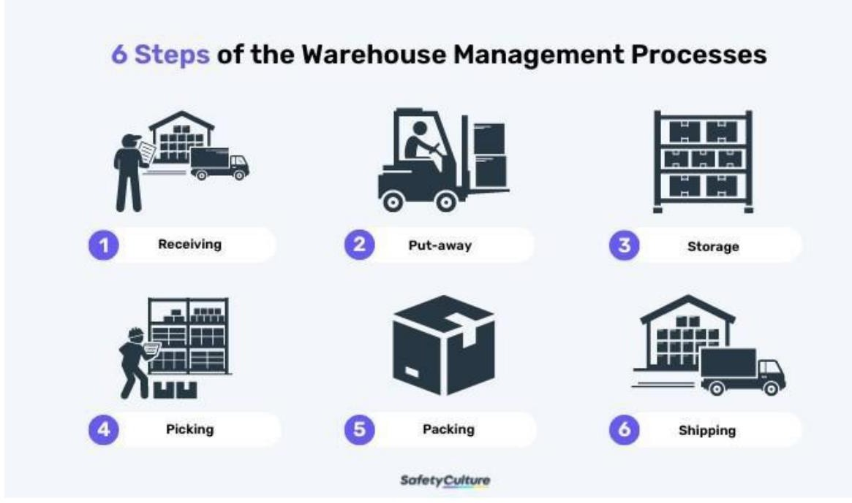Inventory levels were examined to determine the adequacy of stock levels and identify any instances of overstocking or stockouts. Inventory turnover ratios were computed to assess the efficiency of inventory management practices.

**3.2 Correlation Analysis**

Correlation analysis was performed to investigate the relationship between cost and efficiency in warehouse operations. Pearson's correlation coefficient was calculated to quantify the strength and direction of the relationship between these variables.

**3.3 Regression Modeling**

Regression analysis was conducted to develop predictive models of warehouse efficiency based on various cost drivers. Multiple regression models were fitted to the data to identify significant predictors of efficiency and assess their impact on overall warehouse performance.

**3.3 Thematic Analysis of Qualitative Data**

Thematic analysis was employed to analyze the qualitative data obtained from interviews and surveys. Common themes and patterns were identified within the data to gain insights into the factors influencing warehouse efficiency and cost-effectiveness.

**Interpretation of Findings**

The findings from the statistical analysis were interpreted to draw conclusions regarding the relationship b0etween cost and efficiency in warehouse operations. Implications for managerial decision-making and recommendations for improving warehouse performance were discussed based on the results of the analysis.

**4. RESULTS AND DISCUSSION**

**. Descriptive Statistics**

Turnaround Time (TAT) Analysis

The analysis of turnaround time (TAT) revealed significant variations across different publishers. While Hachette Book Publishing India Pvt. Ltd. demonstrated the shortest TAT of 24 hours for orders ranging from 1 to 199 titles, Harpercollins Publishers India Ltd. exhibited a longer TAT of 72 hours for orders exceeding 200 titles. This variation suggests differences in operational efficiency and resource allocation among publishers.

1. Hachette Book Publishing India Pvt. Ltd.

|  |  |
| --- | --- |
| **No. of Titles** | **Turn Around Time (Hours)** |
| 1-199 | 24 |
| 200- 399 | 48 |
| 400+ | 72 |

|  |  |
| --- | --- |
| **No. of Titles** | **Turn Around Time (Hours)** |
| 1-50 | 24 |
| 51-199 | 48 |
| 200+ | 72 |
| If quantity is 2500+ | 48 |

2. Harper Collins Publishers India Ltd.

3. NEXT Education India Pvt. LTD

For any order turn around time is 24 hours

4. RELX Publisher

For any order turn around time is 2 hours

**Order Accuracy Assessment**

The assessment of order accuracy indicated high levels of accuracy across all publishers, with an average accuracy rate exceeding 98%. This finding highlights the effectiveness of quality control measures and order fulfilment processes implemented by the warehouse.

**Inventory Management Analysis**

Inventory turnover ratios were calculated to evaluate the efficiency of inventory management practices. The analysis revealed varying turnover ratios among publishers, with some experiencing higher inventory turnover rates than others. This variability underscores the importance of demand forecasting and inventory optimization strategies in managing inventory levels effectively.

**Correlation Analysis**

Pearson's correlation coefficient was computed to examine the relationship between cost and efficiency in warehouse operations. The analysis revealed a moderate positive correlation between cost and efficiency, indicating that higher investment in resources and technology is associated with improved operational efficiency.

**Regression Modeling**

Multiple regression models were fitted to the data to identify significant predictors of warehouse efficiency. The results indicated that factors such as workforce management, technology utilization, and inventory optimization significantly influenced warehouse performance. These findings underscore the importance of strategic resource allocation and technology adoption in enhancing operational efficiency.

**Thematic Analysis of Qualitative Data**

Thematic analysis of qualitative data highlighted key themes related to warehouse operations, including workforce management, technology integration, and process optimization. Interviews and surveys revealed insights into the challenges faced by warehouse managers and the strategies employed to address them.

**Interpretation of Findings**

The findings suggest that while there is a positive relationship between cost and efficiency in warehouse operations, optimizing resource allocation and adopting innovative technologies are essential for maximizing operational efficiency. Strategic investments in workforce training, technology infrastructure, and process optimization can yield significant improvements in warehouse performance and customer satisfaction.

**5. CONCLUSION**

This study has provided valuable insights into the factors influencing warehouse efficiency and operational performance in the context of AAJ Enterprises Pvt. Ltd. Through a comprehensive analysis of turnaround time, order accuracy, inventory management practices, and correlation analysis between cost and efficiency, several key findings have emerged.

The findings underscore the critical role of strategic resource allocation, technology adoption, and process optimization in enhancing warehouse efficiency and customer satisfaction. While the positive correlation between cost and efficiency highlights the importance of investment in resources and technology, it is essential to prioritize investments in areas that yield the highest returns.

The regression modeling results further emphasize the significance of workforce management, technology integration, and inventory optimization in driving warehouse performance. By focusing on these areas and implementing targeted interventions, AAJ Enterprises can improve operational efficiency, reduce costs, and enhance overall competitiveness in the market.

Additionally, the thematic analysis of qualitative data provides valuable insights into the challenges faced by warehouse managers and the strategies employed to address them. By leveraging these insights, AAJ Enterprises can develop tailored solutions to overcome operational challenges and achieve sustainable growth.

In conclusion, this study serves as a foundation for future research and strategic planning in the field of warehouse management. By continuing to invest in technology, optimize processes, and empower employees, AAJ Enterprises can position itself as a leader in the warehousing industry, delivering exceptional value to its clients and stakeholders.

**6. REFERENCES**

1. Chopra, S., & Meindl, P. (2020). Supply Chain Management: Strategy, Planning, and Operation. Pearson.
2. Fernie, J., & Sparks, L. (2014). Logistics and Retail Management: Emerging Issues and New Challenges in the Retail Supply Chain. Kogan Page Publishers.
3. Mentzer, J. T., Stank, T. P., & Esper, T. L. (2008). Supply Chain Management and Its Relationship to Logistics, Marketing, Production, and Operations Management. Journal of Business Logistics, 29(1), 31–46.
4. Mollenkopf, D. A., Frankel, R., Russo, I., & Daugherty, P. J. (2010). The Supply Chain Triple-A Supply Chain. Harvard Business Review, 88(10), 102–111.
5. Wisner, J. D., Tan, K. C., & Leong, G. K. (2020). Principles of Supply Chain Management: A Balanced Approach. Cengage Learning.
6. T. Mohana Priya, Dr. M. Punithavalli & Dr. R. Rajesh Kanna, Machine Learning Algorithm for Development of Enhanced Support Vector Machine Technique to Predict Stress, Global Journal of Computer Science and Technology: C Software & Data Engineering, Volume 20, Issue 2, No. 2020, pp 12-20
7. Ganesh Kumar and P. Vasanth Sena, “Novel Artificial Neural Networks and Logistic Approach for Detecting Credit Card Deceit,” International Journal of Computer Science and Network Security, Vol. 15, issue 9, Sep. 2015, pp. 222-234
8. Gyusoo Kim and Seulgi Lee, “2014 Payment Research”, Bank of Korea, Vol. 2015, No. 1, Jan. 2015.
9. Chengwei Liu, Yixiang Chan, Syed Hasnain Alam Kazmi, Hao Fu, “Financial Fraud Detection Fluid: Based on Random Forest,” International Journal of Economics and Finance, Vol. 7, Issue. 7, pp. 178-188, 2015.