**Flood Management System: Integrating IoT for Enhanced Disaster Response**

R. Mary Victoria [1], Anith C [2], Dhanush Madhavan GP [3], NirmalKumar R [4]

1,2,3,4 Department of ECE, IV year, Panimalar Institute of Technology, Chennai, Tamil Nadu

**Abstract**

This project presents an integrated system designed to enhance disaster management and relief efforts in flood-affected areas. Utilizing an Arduino microcontroller as the central processing unit, the system incorporates water level sensors and rain sensors to monitor flood levels and precipitation respectively. A keypad enables users to input their needs during flood events. In the event of a flood, GPS coordinates are obtained from satellites to precisely locate the affected area, which are then transmitted to flood rescue teams via a GSM module through SMS. The project's status is visually represented on an LCD display. The Arduino effectively coordinates the operation of all components, including monitoring environmental conditions, receiving user input, activating GPS for location data acquisition, and facilitating communication with rescue teams. By providing real-time information on flood conditions and user needs, the system enables swift and efficient response from rescue teams, thereby improving disaster management and relief efforts in flood-prone regions.

**KEY WORDS:** Flood Rescue, GPS, Arduino, ESP8266.

**I.INTRODUCTION**

The described integrated system employs various sensors and communication modules to enhance disaster management and relief efforts

in flood-affected areas. At its core, an Arduino microcontroller serves as the central processing unit, orchestrating the functionalities of the entire system. Water level sensors continuously monitor flood levels, while rain sensors track precipitation, providing crucial data for assessing flood severity.

During flood events, users can input their needs through a keypad interface, allowing for personalized assistance. In parallel, GPS coordinates are acquired from satellites to precisely locate affected areas. These coordinates are then transmitted to flood rescue teams via a GSM module, using SMS for communication.

To provide real-time updates, the system employs an LCD display to visually represent its status, ensuring stakeholders are informed promptly. The Arduino manages the

coordination of all components, including sensor monitoring, user input processing, GPS activation for location data acquisition, and communication with rescue teams.

By seamlessly integrating IoT technologies, such as the ESP8266 module for connecting devices to a cloud database, data sharing and management are streamlined, facilitating efficient coordination between stakeholders. This enables swift and effective response from rescue teams, optimizing disaster management and relief efforts in flood-prone regions. Ultimately, the system aims to minimize loss of life and property by leveraging technology to improve preparedness and response capabilities in the face of natural disasters.

**II.RELATED WORKS**

Title 1: Flood Monitoring by Integrating Normalized Difference Flood Index and Probability Distribution of Water Bodies

Authors: Fuqiang Xue, Wei Gao , Chao Yin, Xinyu Chen, Zhihong Xia, Yunzhe Lv , Yangyang Zhou, and Mengmeng Wang.

Description: Climate change has led to more frequent floods, making it crucial to quickly and accurately map flood areas for disaster monitoring and risk assessment. One method, called the normalized difference flood index (NDFI), is efficient but sometimes mistakes permanent water bodies like lakes and rivers for floods. To address this, a new framework called NDFI-SPWB combines NDFI with data from optical remote sensing to identify permanent water bodies. In July 2020, this framework was tested in the Yangtze river basin and showed promising results. Compared to the original NDFI method, NDFI-SPWB increased accuracy by about 10% and the Kappa coefficient by approximately 0.08. This shows that the NDFI-SPWB framework is effective in accurately identifying floods while excluding permanent water bodies, helping improve flood mapping efforts.

Title 2: Estimating Ensemble Likelihoods for the Sentinel-1-Based Global Flood Monitoring Product of the Copernicus Emergency Management Service

Authors: Christian Krullikowski , Candace Chow , Marc Wieland , Sandro Martinis ,

Bernhard Bauer-Marschallinger , Florian Roth , Patrick Matgen, Marco Chini

Description: The Global Flood Monitoring (GFM) system, part of the Copernicus Emergency Management Service, helps deal with the problems caused by floods worldwide. It uses data from the Sentinel-1 satellite to provide real-time flood maps and information dating back to 2015. The system combines data from three different flood detection algorithms to create a more reliable flood extent map. Each algorithm also gives an estimate of how certain it is about its results, which helps in creating a final, more accurate picture of the flood situation. The system has been tested in places like Myanmar and Somalia, showing its ability to handle different types of floods and challenging conditions. In Myanmar, it showed its ability to provide consistent results even when individual algorithms disagreed, while in Somalia, it demonstrated its capability to reduce false detections and provide flood likelihoods that users can interpret with caution.

Title 3: Monitoring the Catastrophic Flood With GRACE-FO and Near-Real-Time Precipitation Data in Northern Henan Province of China in July 2021

Authors: Cuiyu Xiao, Yulong Zhong, Wei Feng, Wei Gao, Zhonghua Wang, Min Zhong, and Bing Ji.

Description: In July 2021, Zhengzhou and its surrounding areas in China's Henan Province faced continuous heavy rainfall, leading to severe flooding and damage. To better understand and manage such flood events in the future, this study used near-real-time precipitation data to track the rainstorm process. Additionally, daily terrestrial water storage anomalies (TWSAs) were reconstructed using GRACE and GRACE-FO satellite data, along with other datasets, to monitor the evolution of water storage during the flood. A wetness index based on TWSA was developed for flood warnings, along with soil moisture and runoff data. Results showed a significant increase in TWSA during the six-day period, indicating the potential for using this data for near-real-time flood monitoring. The wetness index derived from TWSA also showed promise for early flood warnings. Overall, these findings contribute to better flood management strategies in the region.

Title 4: UNet Combined with Attention Mechanism Method for Extracting Flood Submerged Range

Authors: Wenmei Li, Jiaqi Wu, Huaihuai Chen, Yu Wang.

Description: Synthetic aperture radar (SAR) satellites are used for real-time flood monitoring because they can operate in extreme weather conditions. However, there hasn't been an automatic method to quickly and accurately identify flood areas using SAR satellite images. In this study, researchers proposed a method called UNet combined with the attention mechanism (UNet-CBAM) to extract flood submerged areas. They tested this method in two sites, Longgan Lake and Dahuchi in the Poyang Lake Basin, using Sentinel-1A data. The results showed that UNet alone performed well in terms of recall, precision, and F1-parameter, but struggled with edge continuity and small bodies of water. The proposed UNet-CBAM method improved upon UNet, increasing recall and F1-parameter by small margins in both test sites. This advancement could enhance flood monitoring efforts using SAR satellite imagery.

Title 5: Flood Depth Estimation in Agricultural Lands from L and C-Band Synthetic Aperture Radar Images and Digital Elevation Model

Authors: SAMVEDYA SURAMPUDI, VIJAY KUMAR

Description: Flood depth is crucial for assessing damage, especially in areas with farming. But in low-lying areas, flood modeling is hard when heavy rain causes floods. SAR (Synthetic Aperture Radar) maps can help, but it's tough to measure flood depth accurately in places with plants growing. This new method combines SAR data from two different frequencies to find flood boundaries. Then it uses a digital elevation model to figure out water levels. Finally, it calculates the depth of the floodwater. The study looked at the 2016 Assam flood and found depths up to 1.56 meters. They compared their results with real measurements and found a small error of 0.25 meters. This method could help better understand and prepare for floods in the future...

**III.METHODOLOGY**

**Diagram**

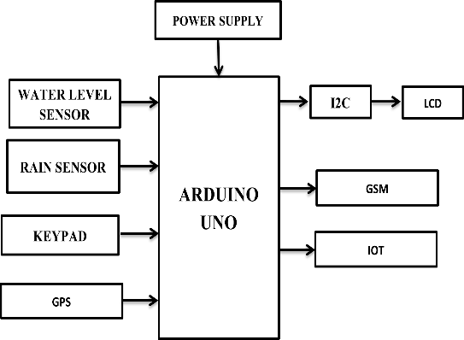

**Fig 1. Block diagram for Flood Management System**



**Fig 2. Block diagram for FLOOD LEVEL DETECTION**

**FLOOD LEVEL DETECTION** In this system, we detect flood levels using rain sensors and water level sensors. The Arduino integrates these sensors to work together. Additionally, we use a keypad to choose needs during floods, such as food or medicine. The rain sensor helps us monitor rainfall, while the water level sensor detects rising water levels. When floods occur, the sensors send data to the Arduino, which processes it. This setup allows us to respond effectively to flood situations by gathering crucial information and enabling users to communicate their needs promptly for efficient relief efforts.

**GSM MODULE**

The GSM module plays a key role in our system by sending GPS coordinates to flood rescue teams through SMS during flood events. This allows for quick and efficient communication between our system and the rescue teams, ensuring a rapid response. When floods happen, the module gathers the precise location data using GPS and sends it to the designated rescue teams via SMS. This instant transmission of information enables rescue teams to swiftly locate and assist those affected by the flood, aiding in timely and effective disaster response efforts.



**Fig 3. Block diagram GSM**

**Module**

**ESP8266 Module**

The ESP8266 Module is like a bridge that connects our devices to a cloud database. It's a crucial part of our system because it allows us to share and manage data easily. With this module, we can gather information about flood conditions and what people need in real-time. It's like having a direct line to a central hub where we can see everything that's happening and respond quickly. So, when there's a flood, we can know exactly what's going on and what help is needed, making our response more efficient and effective.



**Fig 4. Block diagram ESP8266 Module**

**IV. IMPLEMENTATION**

Implementing such a system involves setting up the hardware, including an Arduino microcontroller, water level sensors, rain sensors, keypad, GPS module, GSM module, and LCD display. Sensors are integrated and calibrated for accurate readings, while the keypad enables user input. The GPS module obtains coordinates, transmitted via the GSM module to rescue teams. An LCD visually represents project status. Arduino programming coordinates all components, monitoring conditions, receiving input, activating GPS, and facilitating communication. Thorough testing, debugging, and deployment in flood-prone areas follow, with ongoing monitoring and maintenance to ensure reliability and effectiveness. Collaboration with experts may enhance system design and alignment with disaster management needs. function is to find subterranean line faults. Six toggle switches are used in the detection method; each is assigned a certain place. When a failure is detected, the system automatically sends the GPS location data to a LoRa communication device and activates the toggle switch corresponding to the affected area.

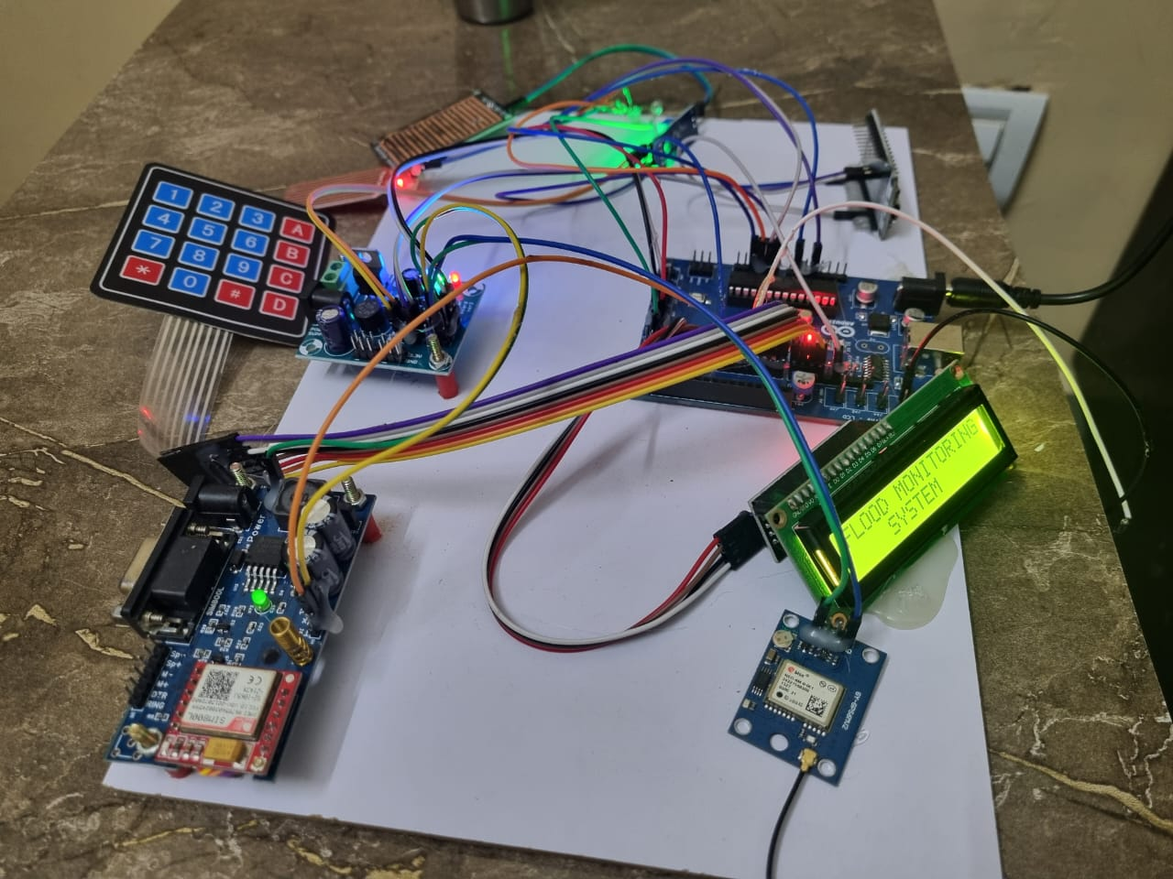

**Fig 5.Hardware setup**

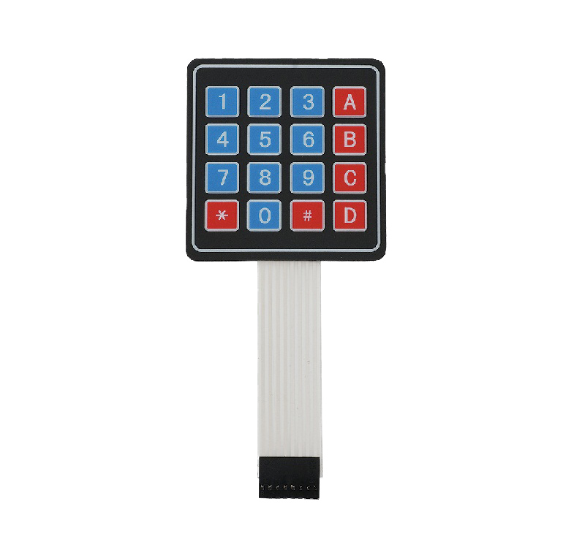

**Fig 6 Input using keypad**

.

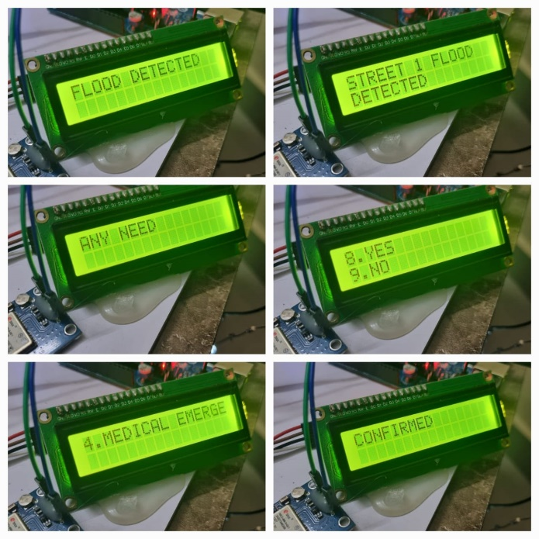

**Fig 7 Output from the kit**

**IV II.GETTING USING APPLICATION**

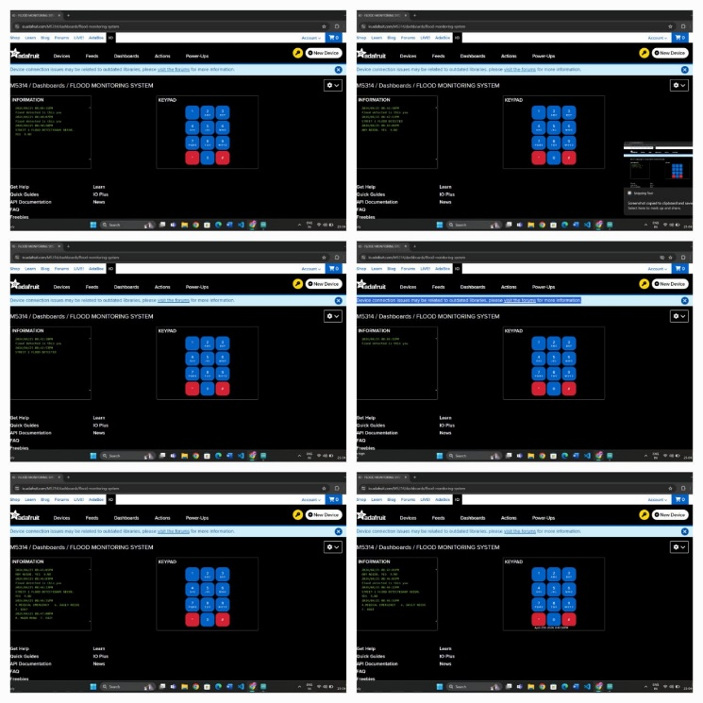

**Fig 8 getting input and output in application**

**V.RESULT**

The result of implementing this integrated disaster management system is a comprehensive solution that enhances response efforts in flood-affected regions. By utilizing a range of sensors and communication modules controlled by an Arduino microcontroller, the system effectively monitors environmental conditions, collects user input, acquires GPS coordinates, and communicates critical information to rescue teams in real-time. Through the visual representation of data on an LCD display, stakeholders gain immediate insights into flood conditions and user needs. This facilitates swift and targeted response actions, ultimately improving disaster management and relief efforts in flood-prone areas. Thorough testing, deployment, and ongoing maintenance ensure the system's reliability and continued effectiveness in mitigating the impact of floods. Collaboration with relevant experts ensures alignment with best practices and enhances the system's overall design and functionality

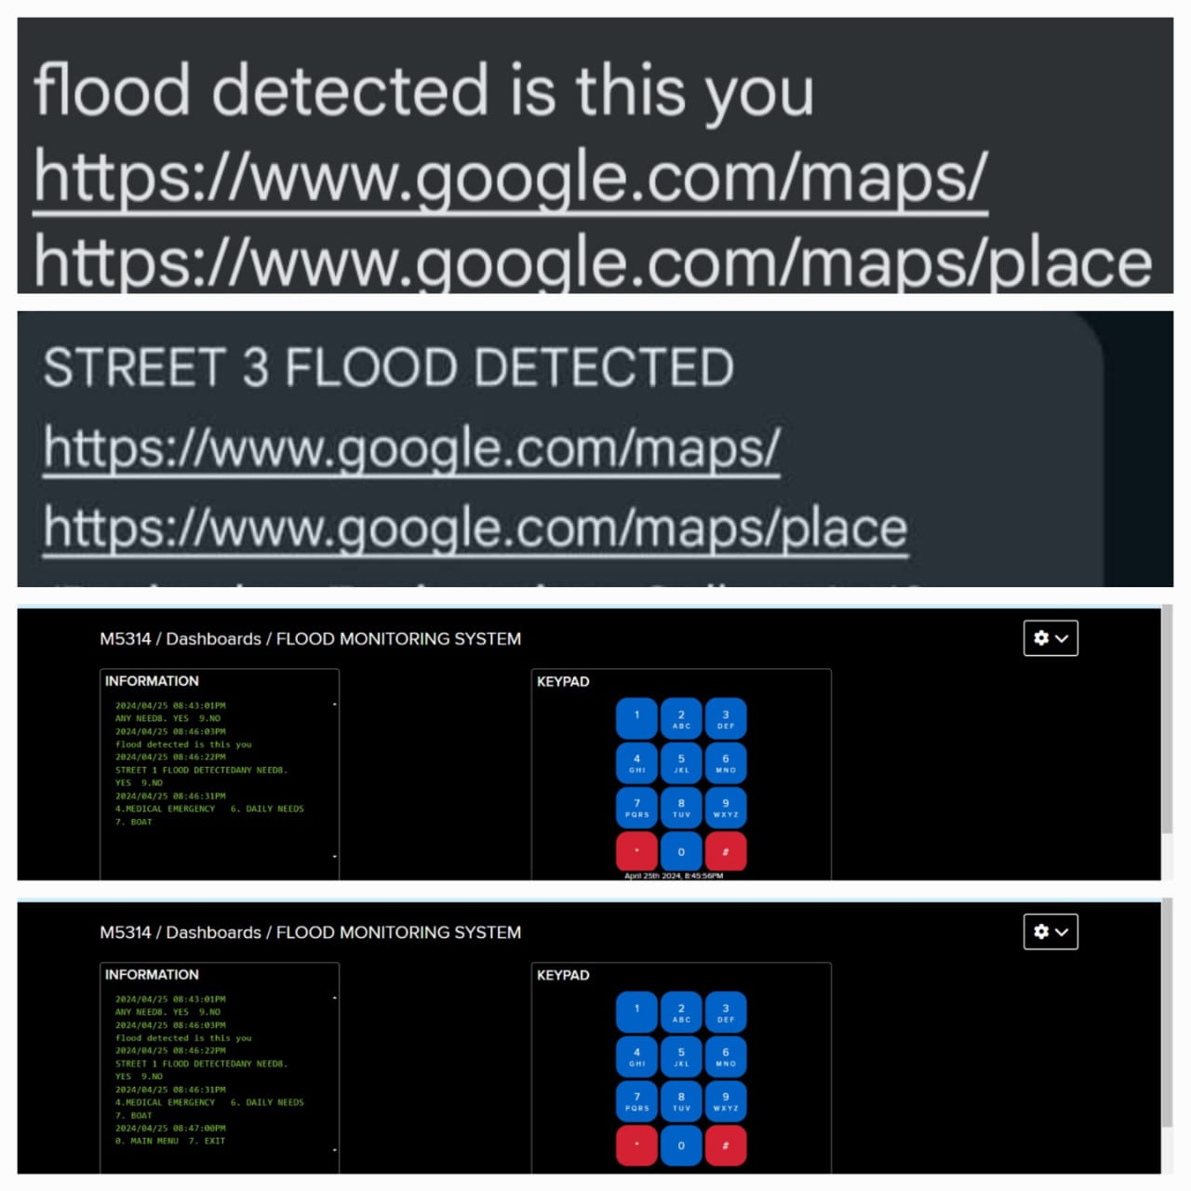

Fig 9 GPS location of affected area fetched via cloud and SMS.

**VI.CONCLUSION**

In conclusion, the integrated system utilizing an Arduino microcontroller, water level and rain sensors, a keypad, GPS module, GSM module, LCD display, and IoT with the ESP8266 module represents a significant advancement in flood detection and disaster management. By effectively coordinating the functioning of these components, the system enables real-time monitoring of flood conditions and facilitates prompt communication of user needs to rescue teams. Future enhancements such as the integration of artificial intelligence hold great potential for further improving the system's capabilities, including predictive analysis, optimized resource allocation, and personalized assistance. Overall, this system not only enhances disaster management and relief efforts in flood-affected areas but also demonstrates the power of technology in addressing humanitarian challenges. With continued innovation and development, such integrated systems have the potential to save lives, minimize damages, and improve resilience in the face of natural disasters, ultimately contributing to safer and more resilient communities worldwide.

**VII. REFERENCES**

[1] W. Hu, S. L. Shah, and T. Chen, “Framework for a smart data analytics platform towards process monitoring and alarm management,” Comput. Chem. Eng., vol. 114, pp. 225–244, 2018.

[2] J. Wang, F. Yang, T. Chen, and S. L. Shah, “An overview of industrial alarm systems: Main causes for alarm overloading, research status, and open problems,” IEEE Trans. Autom. Sci. Eng., vol. 13, no. 2, pp. 1045– 1061, 2016.

[3] K. Ahmed, I. Izadi, T. Chen, D. Joe, and T. Burton, “Similarity analysis of industrial alarm flood data,” IEEE Trans. Autom. Sci. Eng., vol. 10, no. 2, pp. 452–457, 2013.

[4] M. Fullen, P. Schuller, and O. Niggemann, “Validation of similarity ¨ measures for industrial alarm flood analysis,” in IMPROVE-Innovative Modelling Approaches for Production Systems to Raise Validatable Efficiency. Springer Vieweg, Berlin, Heidelberg, 2018, pp. 93–109.

[5] W. Hu, J. Wang, and T. Chen, “A new method to detect and quantify correlated alarms with occurrence delays,” Comput. Chem. Eng., vol. 80, pp. 189–198, 201

[6] V. Rodrigo, M. Chioua, T. Hagglund, and M. Hollender, “Causal analysis for alarm flood reduction,” IFAC-PapersOnLine, vol. 49, no. 7, pp. 723– 728, 2016.

[7] Y. Cheng, I. Izadi, and T. Chen, “Pattern matching of alarm flood sequences by a modified Smith–Waterman algorithm,” Chem. Eng. Res. Des., vol. 91, no. 6, pp. 1085–1094, 2013.

[8] S. Lai and T. Chen, “A method for pattern mining in multiple alarm flood sequences,” Chem. Eng. Res. Des., vol. 117, pp. 831–839, 2017.

[9] W. Hu, T. Chen, and S. L. Shah, “Detection of frequent alarm patterns in industrial alarm floods using itemset mining methods,” IEEE Trans. Ind. Electron., vol. 65, no. 9, pp. 7290–7300, 2018.