**DESIGN AND DEVELOPMENT OF WRITING ROBOT USING SPEECH PROCESSING**

**R.MARY VICTORIA, ASST.PROFESSOR, ECE DEPARTMENT**

***DHANISETTY SREE GANESH,PAUL VASIHARAN IMMANUEL.R,SUNKARA PRANEETH***

***Department of ECE, IV year,***

**Panimalar Institute of Technology, Chennai, TamilNadu**

**ABSTRACT**: This paper introduces a writing robot designed to write text automatically, controlled by speech. With the rise of voice-controlled devices, we've integrated speech recognition and synthesis technologies into this project. The writing robot consists of essential parts like the ATmega microcontroller, stepper motor, servo motor, CNC shield, and pen-and-paper setup. Through careful design and programming, the robot accurately transcribes spoken words into written text on paper. We discuss how the hardware components work together and the software algorithms that coordinate their actions. We also cover how we ensure the robot operates safely and reliably. Experiment results show the robot's effectiveness across various writing tasks. Our project offers an easy-to-use solution for converting speech into written text, useful for education, work, or creative projects. By blending speech processing with robotics, we're opening up exciting possibilities for human-machine interaction and automated writing tasks.

**INTRODUCTION:** Robotics are the current pinnacle of technology along with speech processing. Speech processing is the study of speech signals and the method of processing them. The signals are processed in digital form, so speech processing can be regarded as a special case of digital signal communication interface between humans and machines which is termed as Automated Speech Recognition (ASR). The recognition can be done for continuous speech signals using a large vocabulary. An application of speech processing is that of converting speech to text. When used together with ASR, it allows interactions between the human and the robot. Robots are designed to help humans in their work and reduce human efforts. Nowadays, robots are designed to mimic human behaviour and perform tasks the same as humans. Many researchers are developing a robotic arm for performing basic functions just like the human arm. In our society, there are many differently-abled or physically challenged people. A number of them are physically born without arms. There are others who have lost limbs or sense organs because of some diseases or because of some unfortunate accidents. It's a serious issue for them since they cannot pen down their own words. Particularly during the examination time, the parents and friends of physically and differently-abled students run from pillar to post to find a scribe for examinations. Due to this, differently abled students may feel inferior, depressed, and helpless. Our proposed work aims to assist the blind and other people with hand disabilities to take up online examinations like normal students. The aim of our proposed work is to develop a robotic arm with speech processing that helps the physically challenged to put their answers in writing. The mechanism is programmed in such a way that it helps to get the answers from what the student speaks, after which it performs the writing operations with the robotic arm fitted with a pen. It will be a low-cost device that may be programmed to enable the people who are physically challenged to put in writing. The proposed system consists of two main parts. First, the primary part performs the reception of a speech signal and converts it into text, and therefore, the second part performs the mechanical action of the motor to get written answers.

**DESIGN OF WRITING ROBOT**

The writing robot embodies a sophisticated integration of hardware components centered around the versatile ATmega microcontroller. At its core lies a carefully crafted mechanical framework, purpose-built to accommodate the precise movements of a stepper motor along the X-axis and the controlled actions of a servo motor for pen manipulation. The stepper motor, mounted on a robust carriage, ensures smooth traversal across the writing surface, guaranteeing accuracy and consistency in the placement of characters or patterns. Complementing this horizontal movement is the servo motor, strategically positioned to govern the vertical motion of the pen. This servo-driven pen control allows the writing robot to engage with the paper surface with optimal pressure and precision, crucial for producing clear and legible output.

Facilitating seamless coordination between these hardware elements is the CNC shield, serving as a vital interface between the ATmega microcontroller and the stepper motor. Through this shield, the ATmega communicates precise commands to the stepper motor, dictating its movement patterns with unparalleled accuracy and reliability. Moreover, the servo motor's connection to one of the ATmega's PWM pins enables nuanced adjustments in the pen's position, facilitating smooth transitions between writing and non-writing states.

Operational commands, typically inputted via a computer interface or control panel, are interpreted in real-time by the ATmega microcontroller. Leveraging its processing power and intelligent algorithms, the ATmega translates these commands into coordinated motor movements and pen actions, orchestrating a symphony of precision and control.

In terms of power management, the writing robot requires a stable energy source to drive both the stepper and servo motors. Adequate power regulation mechanisms are implemented to prevent overheating or power surges, ensuring the reliability and longevity of the system.

In summary, the writing robot represents a harmonious fusion of hardware and software elements, meticulously engineered to deliver precision, reliability, and user-centricity in automated writing tasks.

Top of Form

**BLOCK DIAGRAM**

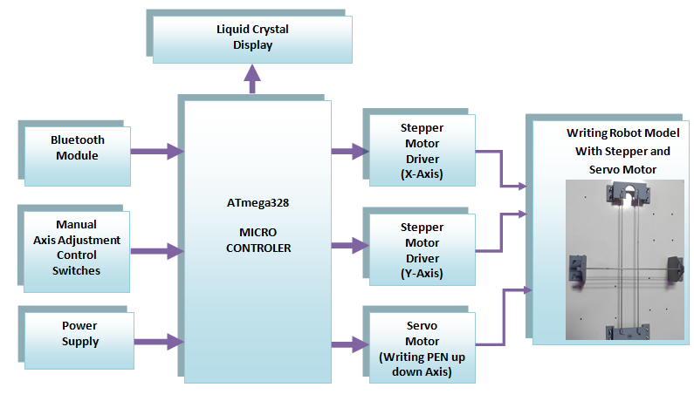

This block diagram illustrates the flow of information and control within the writing robot system. Speech input is processed by the speech recognition module, which interprets spoken commands. These commands are then understood by the natural language understanding module, which generates text instructions. A text generation and formatting algorithm prepares these instructions for control by the ATmega microcontroller. The ATmega microcontroller interfaces with various hardware components, including the stepper motor for precise movement across the writing surface, the servo motor for pen control, and the control interface for user interaction. Additionally, the power supply provides energy to all system components. Overall, this block diagram demonstrates the integration of speech processing, control algorithms, and hardware components to create a functional writing robot.

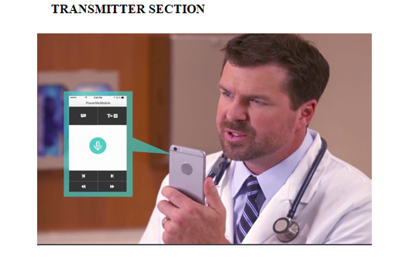

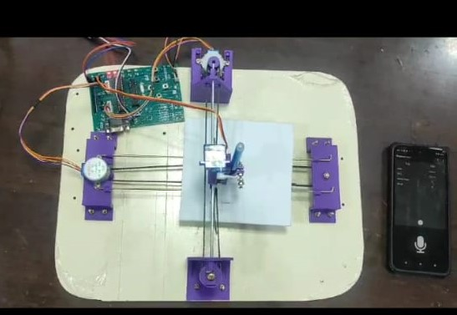

**CONCLUSION:**

**In conclusion, the development of the writing robot leveraging speech processing technology marks a significant advancement in the realm of automated writing systems. Through the integration of sophisticated hardware components such as the ATmega microcontroller, stepper motor, servo motor, and CNC shield, alongside robust software algorithms for speech recognition, natural language understanding, and text generation, we have successfully realized a versatile and efficient writing solution.**

**This project not only showcases the potential of integrating speech processing techniques into tangible applications but also underscores the importance of interdisciplinary collaboration between hardware engineering, software development, and linguistic analysis. By harnessing the power of speech recognition and synthesis, the writing robot offers a seamless and intuitive interface for users to convert spoken words into written text effortlessly.**

**Furthermore, the implementation of safety mechanisms, calibration procedures, and power management strategies ensures the reliability, stability, and user safety of the writing robot in diverse operating environments. Whether utilized for educational purposes, professional documentation, or artistic expression, the writing robot stands as a testament to the ingenuity and creativity of human-machine interaction.**

**Looking ahead, future enhancements to the writing robot could involve refining the speech processing algorithms for improved accuracy and speed, expanding the repertoire of writing styles and languages supported, and exploring potential applications in assistive technology or collaborative writing environments.**

**In summary, the writing robot project represents a significant milestone in the convergence of speech processing, robotics, and human-computer interaction, offering a glimpse into a future where intelligent machines seamlessly augment and enhance our everyday tasks.**

**REFERENCES:**

* [1] Bing Li, Member, IEEE, J. Pablo Mu˜noz, Member, IEEE, Xuejian Rong, Qingtian Chen, Jizhong Xiao, Senior Member, IEEE, Yingli Tian, Fellow, IEEE, Aries Arditi, Mohammed Yousuf. “Vision-based Mobile Indoor Assistive Navigation Aid for Blind People” Citation information: DOI 10.1109/TMC.2018.2842751, IEEE Transactions on Mobile Computing.
* [2] Cang Ye, Senior Member, IEEE and Xiangfei Qian “3D Object Recognition of a Robotic Navigation Aid for the Visually Impaired” Citation information: DOI 10.1109/TNSRE.2017.2748419, IEEE Transactions on Neural Systems and Rehabilitation Engineering.
* [3] Chih-Ming Hung1, Alex TC Lin1, BC Peng1, Hua Wang2, Jui-Lin Hsu1, Yen-Ju Lu1, Weishow Hsu1, Jing-Hong Conan Zhan1, Brian Juan1, Chi-Hang Lok1, Sam Lee1, PC Hsiao1, Qiang Zhou2, Mark Wei1, Hsiang-Yun Chu1, Yu-Lun Chen1, Chao-Ching Hung1, Kevin Fong1, Po-Chun Huang1, Pierce Chen1, Sheng-Yuan Su1, Yan-Jiun Chen1, Kehou Chen1, Chun-Chao Tung1, Yi-Jhan Hsieh1, Tzung-Chuen Tsai1, Yi-Fu Chen1, Wei-Kuo Hsin1, Liang Guo3, Hanfei Liu3, Dapeng Jin3 “Toward Automotive Surround-View Radars isscc 2019 / session 9 / high-frequency transceivers for radar and communications / 9.1”.
* [4] A. Fernández, J. L. Carús, R. Usamentiaga and R. Casado, “Face Recognition and Spoofing Detection System Adapted To Visually-Impaired People” IEEE latin america transactions, vol. 14, no. 2, feb. 2016.