**Assessment and Design of the Structure of Integral Bridge**

**Avinash Kumar1, Dr. Jyoti Yadav2**

1M.Tech Scholar, Department of Civil Engineering, Sarvepalli Radhakrishnan University, Bhopal, M.P, India

2Assistant Professor, Department of Civil Engineering, Sarvepalli Radhakrishnan University, Bhopal, M.P, India

**Abstract**

Bridges are often constructed using standard methods. Bearings and expansion joints, for example, need frequent inspection and maintenance when using the traditional approach. The expansion joints and bearings, by virtue of their roles, are sources of weakness in the bridge, and there are many cases of distress in bridges caused by poor performance of these two parts. This may be prevented by implementing Integral structures. Integral Bridges are constructions that have no joints. Integral bridges connection between the deck and the substructure. They stretch from one abutment to the other, without a single joint in the deck. Integral bridges have been built around the globe, including India. The study comprises analysis and design of an integral structure utilizing STADD PRO software, as well as manual analysis for a simple supported structure.

**Keywords-** Design of the Structure, Integral Bridge, STADD PRO Software, Substructure (Piers and Abutments)

1. **Introduction**

Traditional bridges use bearings and expansion joints to manage the thermal and horizontal stresses exerted on the deck. Bearings and expansion joints are critical components; their degradation may result in the disruption of traffic flow on the bridge. Integral bridges are designed based on the principle that the stresses generated by the superstructure and substructure are transmitted to the foundation soil via the flexible piles and the stiff connection between them.

The distinction between Integral bridges and Convention bridges such as Simply supported, Continuous in the transfer of moment. In a simply supported bridge, the highest bending moment occurs in the center of the span. However, in a continuous construction, the bending moment is often largest at the support of the span. In Integral Bridges, the moment is distributed to the superstructure, substructure, and foundation. This distribution of bending moment greatly reduces the value of the moment. Value engineering may be accomplished by choosing cost-effective sections for Integral bridges.

Integral bridges are distinguished by their monolithic connection, which means that the deck and substructure (piers and abutments) are joined together as a single unit. The bridge extends from one abutment to the other, passing over an intermediate support, and the deck does not have any joints. Integral bridges have been built worldwide, notably in India.

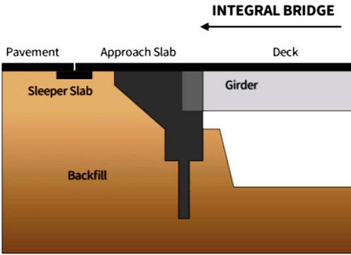

Figure 1: Typical Integral bridges

1. **Literature Review**

**(Verma and Mishra 2021)**This study examined the behavior of the substructures and foundation of a multi-span reinforced concrete (RC) integral bridge (IB). The soil's non-linear behavior was simulated using the Drucker-Prager yield criteria soil spring model. A five-span integral bridge, measuring 156 meters in length and supported by 30-meter deep reinforced concrete piles, was analyzed for two distinct scenarios involving various soil layers. In the first scenario, it was believed that there was a consistent layer of soil extending throughout the whole depth of the pile and the backfill of the abutment. In the second scenario, soil data acquired from the specific bridge location were used. The pile reactions resulting from the highest and lowest temperatures recorded annually and daily were analyzed for both scenarios. An analysis was conducted to study the combined effect of a thermal load, a moving load, and non-linear soil behavior on a vehicle load of 100 t. The findings indicated that both temperature and traffic load had a substantial impact on the behavior of the IB pile.

**(Sigdel et al. 2021)** Integral bridges are a types of bridge with integral or semi-integral abutments that lack expansion joints in the bridge deck of the superstructure. The importance of an integrated bridge design is that it eliminates durability and repeated maintenance difficulties with bridge joints and perhaps bearings, which are common in conventional bridges. Integral bridges are less expensive to build. They need less maintenance, resulting in fewer traffic delays and associated socioeconomic costs. As a result, integrated bridges are becoming the preferred bridge design for short-to-medium length bridges in a number of countries, including the United Kingdom, the United States, Europe, Australia, New Zealand, and many other Asian nations. However, integral bridge designs are not without challenges: difficulties such as concrete creep, shrinkage, temperature effects, bridge skew, structural restrictions, and soil-structure interactions are exacerbated in integral bridges. The enhanced cyclic soil-structure interactions between the bridge structure and soil will result in undesirable soil ratcheting and a settling bump at the bridge approach. If motions from bridge superstructures were transmitted to pile-supported substructures, pile-soil interactions might result in pile fatigue failure. These concerns exacerbate the geotechnical challenges of integrated bridges. The purpose of this study is to provide a complete assessment of current geotechnical design approaches and the improvement of soil-structure interactions in integral bridges.

1. **Objectives of the Study**

The objective of this study and design analysis of the Integral Bridge with simply supported.

1. **Method and Analysis**

The total width of the construction is 24.2 meters, with each deck measuring 12.00 meters and a 0.02 meter gap between the two decks. The structure has an estimated total length of 89.2 meters. The proposed span configuration consists of four continuous spans, with each span measuring 19.6+25.0+25.0+19.6 units. The chosen structural system is an integrated solution. The analysis and design of a unit with a total value of 89.2 is conducted.

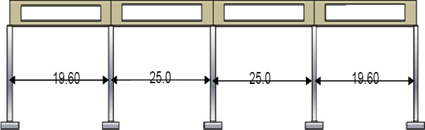

Figure 2: Typical span arrangement of Integral bridges

The continuous framed superstructure has four primary structural components, namely RCC precast girders. 2) In-situ cast deck slab 3) A column pier with a width of 3 times 0.8 and 4) Diaphragms that link the superstructure with the pier column, establishing a Beam-Column Joint. The superstructure has been discretized into a grillage model, as seen below. The deck is composed of four girders, each with section parameters specified in the corresponding sections. Two dummy members are positioned at the borders of the deck slab in the longitudinal direction. These members serve to define the edge of the deck slab and to transmit the weight of the crash barrier and moving load. The nominal section attributes have been assigned to these artificial members. Grillage members have been allocated at regular intervals in the transverse direction. The wall type piers are represented as a grillage structure consisting of two vertical elements with a distance of 1.5m between them. The sectional characteristics of these members have been allocated based on their respective contribution areas. The two vertical pieces have been joined together by transverse members in order to provide grillage motion. The support conditions of the piers, which represent the foundation, are simulated as being fixed. The precast girder is supported by temporary supports using the construction approach described. The calculation of Bending Moment and Shear Forces caused by Dead Loads has been conducted with the assumption that the beam is supported at both ends.

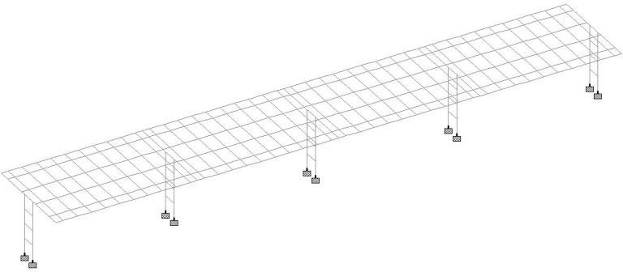

Figure 3: Typical Space Frame Model used for the analysis

The superstructure has been specifically built to exhibit orthotropic behavior. The longitudinal beams have been constructed as reinforced concrete parts, while the deck slab is made of reinforced concrete in both directions. The analysis was conducted using a grillage model in the STAAD Pro program. The dead load effects of the beams are studied individually under the assumption of simple support, according to the construction order. The structure has undergone analysis for the load scenarios and load combinations in accordance with IRC 6 2014.

* **Design of Girder**

The girders are intended to withstand continuous activity under service conditions. Prior to pouring the diaphragm, the girders are upheld by temporary supports. Currently, the girder will be supported only by temporary supports, and the calculations for the sagging bending moment are shown below. The sagging moment caused by the weight of an object itself.

Table 1: Design Parameters of Girder

|  |  |
| --- | --- |
| Effective span  Overall length of girder  Density of Concrete | 23.00 m |
| 24.10 m |
| 2.40 t/m3 |

1. **Result**

Width of the flange (bf) Cl 305.15.2 of IRC 21 3050 mm

Depth of flange (Df) 250 mm

Overall depth of section (D) 2000 mm

Clear cover 40 mm

Effective depth 1856.40 mm

Moment to be resisted by the section (Me) 6587.46 KNm

Dia of Main bars 32 mm

No. of bars 7

Dia of main bars 32 mm

No. of bars 7

Dia of main bars 32 mm

No. of bars 5

Dia of main bars 32 mm

No. of bars 3

Effective cover 143.6 mm

Area of steel (Ast) 17685 mm2

Grade of Concrete 40 N/mm2

Permissible compressive stress in bending 13.34 N/mm2

Permissible tensile stress in reinforcement 240 N/mm2

Modular ratio (m) 10

Neutral axis from top 478 mm

Centroid of flange (y) 110.25 mm

Lever arm 1746.15

Actual Stress in concrete 7.39 N/mm2 (Safe)

Actual Stress in Steel 213.35 N/mm2 (Safe)

Ast required = M/6st*LA 15719 mm2 (Safe)

M.R = Ast*6st*LA 7102.57 > Me

Table 2: Comparison between Integral bridge girder with simply supported

|  |  |  |  |  |
| --- | --- | --- | --- | --- |
| Sr.  No. | Description | Integral  type structure | Simply  supported structure | Remark |
|  | Area of |  |  | The cost of casting of one girder for Integral Flyover is Rs 203075/-  whereas the cost for casting of a girder for simply supported structure for the same span is Rs 414557/- In view of the above, by adopting the Integral type of flyover we can able to save the cost of Superstructures by more than 50%. |
| 1 | Concrete | 0.45 | 0.88 |
|  | (m2) |  |  |
|  | Area of |  |  |
| 2 | Steel | 8244 | 17685 |
|  | ( mm2) |  |  |
|  | Quantity of |  |  |
| 3 | Concrete | 11.25 | 22 |
|  | (Cum) |  |  |
| 4 | Weight of | 1.63 | 3.48 |
| Steel (MT) |
|  | Rate / Cum |  | |
| 5 | of M-40  Grade | 9414 | |
|  | Concrete |  | |
|  | Rate / MT |  | |
| 6 | of steel | 59612 | |
|  | (Rs) |  | |
|  | Cost of |  |  |
| 7 | Concrete | 105907 | 207108 |
|  | (Rs) |  |  |
| 8 | Cost of | 97168 | 207449 |
| Steel (Rs) |
|  | Total Cost |  |  |
|  | Concrete |  |  |
| 9 | and Steel | 203075 | 414557 |
|  | per Girder |  |  |
|  | (Rs) |  |  |

1. **Conclusions**
2. The maximum drooping bending moment for a 25m span integrated flyover girder is 2853.52 KN-m, whereas for a simply supported structure with the same span, the bending moment is 6587.46 KN-m.
3. The shear force for an integral type girder is 916.12 kilonewtons, whereas for a merely supported girder it is 1111.40 kilonewtons.
4. The cost of casting a single girder for an Integral Flyover is Rs 203,075, whereas the cost of casting a girder for a simply supported structure with the same span is Rs 414,557. Considering the information provided, using the Integral kind of flyover allows us to reduce the cost of Superstructures by over 50%.
5. The expansion joints and bearings, due to their roles, are areas of vulnerability in bridges and account for around 12 to 15% of the entire cost of the structure. However, these weaknesses are completely removed with integral type constructions.
6. Therefore, the implementation of Integral forms of Flyovers/Bridges may lead to the accomplishment of value engineering.
7. By using Integral type structures, it is possible to significantly decrease the size of structural parts, resulting in conservation of precious natural resources like as cement, sand, and aggregates.

**References**

1. Monzon, E. V., Itani, A. M., and Pekcan, G. (2014). “Seismic behavior and design of steel girder bridges with integral abutments.” Bridge Structures, IOS Press, 10(4), 117–128.
2. Walbridge, S., and Liu, Y. (2018). “Fatigue Design, Assessment, and Retrofit of Bridges.” Journal of Bridge Engineering, American Society of Civil Engineers (ASCE), 23(12).
3. Verma, M., and Mishra, S. S. (2021). “Non-linear soil–structure interaction of multi-span reinforced concrete integral bridge.” Proceedings of the Institution of Civil Engineers - Bridge Engineering, Thomas Telford Ltd., 174(4), 265–280.
4. Arockiasamy, M., Butrieng, N., and Sivakumar, M. (2004). “State-of-the-Art of Integral Abutment Bridges: Design and Practice.” Journal of Bridge Engineering, American Society of Civil Engineers (ASCE), 9(5), 497–506.
5. Sigdel, L. D., Al-Qarawi, A., Leo, C. J., Liyanapathirana, S., and Hu, P. (2021). “Geotechnical Design Practices and Soil–Structure Interaction Effects of an Integral Bridge System: A Review.” Applied Sciences, MDPI AG, 11(15), 7131.
6. Vander Werff, J., and Sritharan, S. (2015). “Girder Load Distribution for Seismic Design of Integral Bridges.” Journal of Bridge Engineering, American Society of Civil Engineers (ASCE), 20(1).
7. Helowicz, A. (2020). “Integral bridge and culvert design, Designer’s experience.” Open Engineering, Walter de Gruyter GmbH, 10(1), 499–505.
8. Chen, A., Frangopol, D. M., and Ruan, X. (2017). “Bridge design, assessment and monitoring.” Structure and Infrastructure Engineering, Informa UK Limited, 13(4), 417–417.