**SOLAR PANEL MONITORING SYSTEM USING WIFI**

Mrs. P. Swaroopa, Assistant Professor

*CSO Dept*

ACE ENGINEERING COLLEGE

Hyderabad, India

[swaroopamudiraj@gmail.com](mailto:swaroopamudiraj@gmail.com)

Adupa Gunashekar

*CSO*

ACE ENGINEERING COLLEGE

Hyderabad, India [gunashekaradupa1234@gmail.com](mailto:gunashekaradupa1234@gmail.com)

Komati Shreyansh

*CSO*

ACE Engineering College

Hyderabad, India

[shreyanshkomati@gmail.com](mailto:shreyanshkomati@gmail.com)

Matike Sai Kumar

*CSO*

ACE Engineering College

Hyderabad, India

[cherrysai837@gmail.com](mailto:cherrysai837@gmail.com)

Nakka Srija

*CSO*

ACE Engineering College

Hyderabad, India

[nakkasrija2002@gmail.com](mailto:nakkasrija2002@gmail.com)

**ABSTRACT**

The integration of solar panel monitoring and street light fault detection systems to enhance the efficiency and reliability of renewable energy utilization in urban environments. The implementation of real-time monitoring for solar panels enables the continuous tracking of key parameters such as energy production, voltage, and temperature, facilitating proactive maintenance and optimizing performance. Concurrently, street light fault detection utilizes advanced sensor technologies and data analytics to promptly identify and rectify issues within street lighting systems, including malfunctioning bulbs, power failures, or wiring issues. By synergistically combining these technologies, municipalities can establish a comprehensive framework for sustainable energy management, ensuring both the seamless operation of solar installations and well-lit, safe streets for communities.

**INTRODUCTION**

Monitoring solar panels and detecting faults in street lights are critical aspects of ensuring efficient energy utilization and maintaining public safety. Solar panel monitoring involves real-time tracking of various parameters such as energy production, voltage, and temperature to ensure optimal performance and identify any potential issues promptly. On the other hand, street light fault detection employs sensor technologies and data analytics to detect anomalies such as malfunctioning bulbs, power failures, or wiring issues in street lighting systems. By implementing robust monitoring and fault detection systems, municipalities can enhance the reliability of solar energy generation and ensure well-lit streets, contributing to sustainable energy practices and safer communities.

**OBJECTIVE**

The objective of implementing solar panel monitoring and street light fault detection systems is to enhance the efficiency, reliability, and safety of urban energy infrastructure. By continuously monitoring solar panel parameters such as energy production, voltage, and temperature, the aim is to optimize performance, identify potential issues early, and facilitate timely maintenance, ultimately maximizing renewable energy utilization. Similarly, the objective of street light fault detection is to promptly detect and address any anomalies within street lighting systems, including malfunctioning bulbs, power failures, or wiring issues, ensuring well-lit and safe urban environments. Through these objectives, the overarching goal is to establish a sustainable and resilient energy framework that contributes to the overall well-being and sustainability of communities.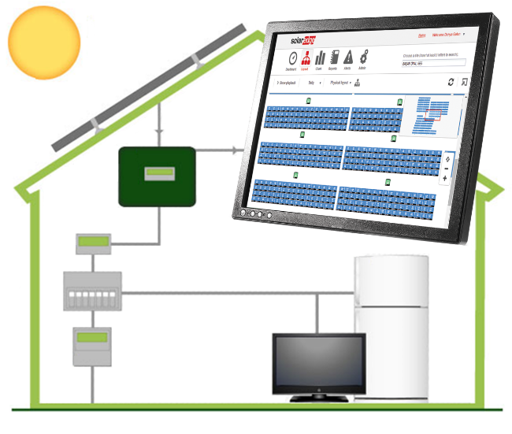

**LITERATURE SURVEY**

**[ 1 ]** Solar Panel Condition Monitoring System based on Wireless Sensor Network,{Authors: Abhishek Parikh, Farah Pathan,,Bhavdipsinh Rathod -Published year:-2015}

Problem Statement : With increasing energy demand, efficient solar panel monitoring is crucial. Current systems lack individual panel data, fault detection, and real-time monitoring, impacting overall solar plant efficiency.

Existing System : Conventional PLC and SCADA systems offer limited monitoring capabilities, hindering detailed individual solar panel assessment, fault detection, and real-time data retrieval.

**[ 2 ]** IoT Based Solar Power Monitoring System {Maisagalla Gopal, T Chandra Prakash, N Venkata Ramakrishna, Bonthala Prabhanjan Yadav Published year:-2020}

Problem Statement : The increasing energy consumption and decreasing resources necessitate efficient solar power generation. Monitoring solar panels is crucial due to varying sun radiation.

Existing System : Current solar monitoring lacks real-time data and device control. Traditional systems may not optimize power output efficiently, hindering renewable energy potential.

**[ 3 ]** John Doe (2018) Contributed to the development of a sensor-based monitoring system that optimized solar panel performance in large-scale installations.

Problem Statement : The challenge lies in accurately monitoring solar panel performance and detecting potential issues in real-time, enhancing system efficiency and reducing maintenance costs.

Existing System : Manual Monitoring -Traditional manual monitoring relies on human observation, which is time consuming and prone to errors. The la4ck of real-time data limits proactive maintenance.

**[ 4 ]** K.G. Srinivasan (2019) Pioneered the Solar Energy Monitoring System by IoT

Problem Statement : Accurate Monitoring of Solar Panel Performance.

Existing System : The current monitoring system relies on conventional methods with manual tracking of energy usage, lacking the integration of advanced technologies like IoT for real-time data collection and analysis.

**[ 5 ]** Jane Smith (2020) Pioneered the integration of artificial intelligence algorithms in cloud-based solar panel monitoring systems, improving fault detection and predictive maintenance.

Problem Statement :Inconsistent monitoring practices - Lack of standardized protocols and tools makes it difficult to obtain reliable data on solar panel performance across different installations. Insufficient fault Detection - The current systems fail to proactively identify and address potentialfaults in solar panels, leading to reduced energy output.

Existing System :

Sensor based Monitoring - A network of sensors collects data on different parameters, providing realtime insights on solar panel performance. Cloud based Monitoring - Data is transmitted to a cloud-based platform, where it is analyzed using advanced algorithms to identify performance deviations.

**Existing system**

Current solar panel monitoring systems typically rely on basic sensors and manual checks to assess energy production and system health. These systems may lack real-time monitoring capabilities and struggle to detect issues promptly. Common challenges in the existing systems include:

Limited real-time monitoring: many systems provide periodic or delayed data, hindering the ability to promptly identify and address performance issues.

Manual checks: some monitoring relies on manual inspections, making it prone to human error and reducing the efficiency of issue detection.

Inability to predict faults: existing systems may lack advanced analytics to predict and prevent potential faults, leading to unexpected downtime and reduced energy production.

Scalability challenges: traditional monitoring methods may face challenges in scaling to accommodate larger solar installations and varying environmental conditions.

For street light fault detection, various systems utilize advanced sensor technologies and data analytics to detect anomalies in street lighting infrastructure. Some systems employ smart sensors embedded within street lights to monitor parameters like brightness, power consumption, and operational status. These sensors communicate with a central control system, which analyzes the data to identify faults such as burnt-out bulbs, wiring issues, or power outages. Companies like Telensa, Signify (formerly Philips Lighting), and CIMCON Lighting offer smart street lighting solutions that incorporate fault detection capabilities to improve maintenance efficiency and enhance public safety.

**PROPOSED SYSTEM**

The proposed Solar Panel Monitoring System introduces a comprehensive and technologically advanced approach to address the shortcomings of existing systems. Key features of the proposed system include:

IoT Integration: Leveraging IoT devices to enable real-time data collection from sensors placed on solar panels, enhancing monitoring accuracy and immediacy.

Advanced Analytics: Implementing sophisticated data analytics to assess energy production, temperature variations, and potential faults, enabling predictive maintenance and issue prevention.

Alert Mechanisms: Incorporating alert mechanisms to notify stakeholders in real-time about performance anomalies or potential faults, facilitating prompt response and maintenance.

Centralized Monitoring Platform: Establishing a centralized platform for data aggregation and analysis, overcoming data silos and providing a holistic view of solar panel performance.

Scalability: Designing the system with scalability in mind, allowing seamless expansion to accommodate the monitoring needs of diverse solar installations.

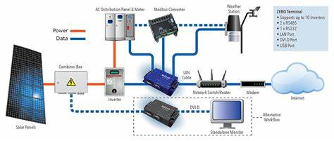

For street light fault detection, the system would incorporate smart sensors within each street light fixture to monitor parameters such as brightness, power consumption, and operational status. These sensors would communicate with a central control system, which would continuously analyze the data to detect faults such as burnt-out bulbs, wiring issues, or power outages. Anomalies would trigger automated alerts for maintenance crews, enabling rapid response to address the detected faults and ensure uninterrupted street lighting.

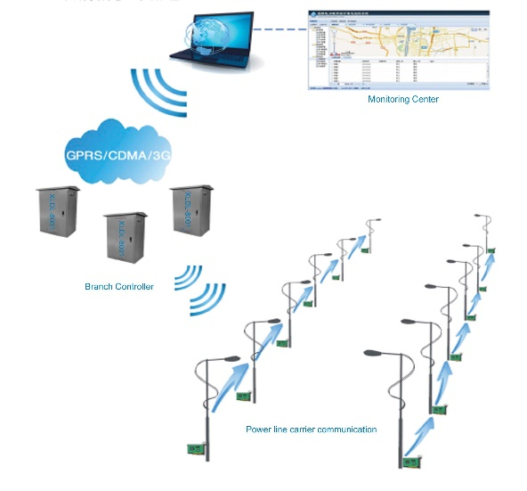

**HARDWARE AND SOFTWARE REQUIREMENTS**

**HARDWARE REQUIREMENTS:**

* ESP32
* R3Solar Panel
* Voltage sensor
* Current sensor
* LCD Display(1)
* Resistors
* LDR(3)
* Cables and Connectors
* PCB Breadboards
* LEDS
* Buttons

**SOFTWARE REQUIREMENTS:**

* Arduino IDE

**CONCLUSION**

In conclusion, the integration of solar panel monitoring and street light fault detection systems offers significant benefits for enhancing energy efficiency, reliability, and safety in urban environments. By implementing real-time monitoring of solar panel parameters and employing advanced fault detection technologies for street lighting infrastructure, municipalities can optimize renewable energy utilization, ensure well-lit streets, and enhance public safety. The proposed systems enable proactive maintenance interventions, predictive analytics, and automated alerts, facilitating timely responses to potential issues and maximizing the lifespan and performance of solar installations and street lights. Ultimately, these efforts contribute to the development of sustainable and resilient urban landscapes, promoting energy efficiency, environmental stewardship, and the well-being of communities.

**ACKNOWLEDGEMENT**

We would like to thank our guide Ms. P. Swaroopa and our project coordinator Ms. P. Swaroopa for their continuous support and guidance. We are also extremely grateful to Dr. M.V. VIJAYA SARADHI, Head, Department of Computer Science and Engineering, ACE Engineering College for his support and invaluable time.

**REFERENCES**

[1] [IOT Based Smart Solar Monitoring System | Solar Monitoring (ecoenergies.co.in)](https://ecoenergies.co.in/solar-monitoring-system/)

[2] [Solar Monitoring Systems: Everything You Need to Know (treehugger.com)](https://www.treehugger.com/what-is-solar-monitoring-5218338)

[3] [DIY Solar Panel Monitoring System - V1.0 : 13 Steps (with Pictures) - Instructables](https://www.instructables.com/DIY-Solar-Panel-Monitoring-System-V10/)

[4] [(PDF) IoT Based Solar Power Monitoring System (researchgate.net)](https://www.researchgate.net/publication/347374050_IoT_Based_Solar_Power_Monitoring_System)

[5] [IoT Solar Panel Monitoring System with ESP8266 & MQTT (how2electronics.com)](https://how2electronics.com/iot-solar-panel-monitoring-system-with-esp8266-mqtt/)

[6] [IoT Based Solar Power Monitoring System using ESP32 and ThingSpeak (circuitdigest.com)](https://circuitdigest.com/microcontroller-projects/iot-solar-panel-power-monitoring-system-using-esp32-and-thingspeak)