**“DESIGN AND PERFORMANCE ANALYSIS OF EARTH**

**TUBE HEAT EXCHANGERS”**

# Dr. V. B. Patil1, Mr. A.D.Babar, Mr. P. S. Bhosale3, Mr. T. S.Mulla4, Mr. A. A. Naradge5, Miss. R. K. Karande6, Miss. A. S. Saptale7

1Project Guide, Department of Mechanical Engineering, Annasaheb Dange College of Engineering & Technology, Ashta, Maharashtra, India.

2,3,4,5,6,7Engineering students Department of Mechanical Engineering, Annasaheb Dange College of Engineering & Technology, Ashta, Maharashtra, India.

DOI: https://www.doi.org/10.58257/IJPREMS33357

# ABSTRACT

At present heating and cooling systems are Devices that utilize the ground as a wellspring of or sink for warming or cooling are called ground-to-air heat exchangers, ground pipe heat exchangers, or soil heat exchangers. A transient and implicit model based on computational fluid dynamics was developed to predict the thermal performance of earth tube heat exchanger systems. The model was developed inside the fluent simulation program. Effects of the operating parameters (i.e. the pipe material, air velocity mass flow rate) on the thermal performance of earth tube heat exchanger systems are studied. The 9.14m long ETHE system discussed in this experiment gives cooling in the range of 2-5ºC for the flow velocities 0.032-0.045m/s. Velocity of air through the pipe is found to greatly affect the performance of ETHE system. In this study, we will review the studies conducted so far from the viewpoint of performance evaluation considering the influence of various parameters such as construction materials, depth from the ground surface, air flow velocity, and pipe length.

# 1.INTRODUCTION

# It is found that the soil at some depth from earth surface has the property to remain cold during summer and relatively hotter during winter days from the atmospheric temperature. Due to limited sources of energy, it is very essential to find out other alternative sources of energy to save the conventional fuels available in nature to save energy of the universe. The energy consumption of buildings for heating and cooling purpose has significantly increased during the decades. Energy saving is a major concern everywhere, particularly challenging in desert climates. The comfort conditions for human beings are temperature between 22 C to 27 C and relative humidity between 40% to 60 %. This can be achieved by conditioning air. In the system used in now a day; air is passed through a buried pipe by a fan. In summer the supply air to the building is cooled since the ground temperature around the heat exchange is lower than the ambient temperature. During winter, when the ambient temperature is lower than the ground temperature the process is reversed and the air gets preheated. The Earth air heat exchanges are considered as an effective replacement for the heating or cooling of buildings. This is basically metallic, plastic, or concrete pipes buried underground at a particular depth. Through pipes the fresh atmospheric air pass with the help of blower. According to the temperature difference the heat transfer takes place between soil and air in pipes. The efficient design of the system is necessary to ensure good performance.

# 2.LITERATURE REVIEW

This literature review seeks for the parameters in the detailed study of research papers and it gives an effective analysis for the Earth Tube Heat Exchanger. This review tells the importance of geothermal energy and its application. Also, it compares the temperature with respect to depth which gives the temperature difference at inlet and outlet sections of pipe.

1. Trilok Singh Bisoniya et.al The development of the model of the EAHE system involves the use of basic heat transfer equations. The geometrical dimensions of the EAHE system are decided by researcher One-dimensional model of earth–air heat exchanger system Bisoniya Geothermal Energy of considering the amount of heating or cooling load to be met for space conditioning of the building. The design procedure includes identifying the input parameters which are known to the user and the parameters affecting desired design output. Once the design output is fixed, the heat transfer equations are manipulated to meet the desired output in terms of input parameters.
2. Prof. S. B. Patil, Prof. N. C. Ghuge et.al, s. The decrease in air temperature was sharp for the first 10 meters length of pipe and it became moderate afterward. So, increasing the length of pipe more than 20‐ 30m did not cause any significant rise in performance and improvements began to stabilize, indicated these values could be optimal design values for hot and dry climatic conditions of Bhopal. It was observed that with increase in pipe diameter, the outlet air temperature of EAHE increases because the convective heat transfer coefficient at inner surface of pipe as well as overall heat transfer coefficient at earth‐ pipe interface decreases at higher pipe diameters.
3. Siddhanth Kumawat, Ghanshyam Khatik et.al, "Earth-to-Air heat exchanger" Houses and other structures that have air intakes are linked to the EAHE system via a lengthy underground conduit made from metal, plastic, or concrete. During the winter, a pipe-mounted fan forces the atmosphere to move, transferring heat from the hot ground to the cold air, and during the summer, moving heat from the cold ground to the hot air. Let me. Pipe outlets are installed in places that require air conditioning, such as industrial buildings and livestock buildings. By using this free energy, the energy consumption of indoor air conditioning can be reduced, which is a very convenient method.
4. Ashish Kumar Chaturvedi and V N Bartaria et.al, The Heat transfer to and from Earth tube heat exchanger system has been the subject of many theoretical and experimental investigations. By having a review on previous research papers published by many authors we can have an idea on how it works. sehli et al. proposed a one-dimensional numerical model to check the performance of EAHEs installed at different depths. It was concluded that EAHE systems alone are not sufficient to the system which is used nowadays consists of a matrix of buried pipes through which air is transported by a fan.
5. Vikas Bansal, Rohit Misra, Ghanshyam Das Agrawal, Jyotirmay Mathur et.al The EPAHE comprises of two horizontal cylindrical pipes of 0.15 m inner diameter with buried length of 23.42 m, made up of PVC and mild steel pipes and buried at a depth of 2.7 m in a flat land with dry soil. The two pipes viz. PVC and steel are connected to common intake and outlet manifold for air passage. Globe valves are fitted for each pipe assembly for flow control of air. At the inlet, the open end of this single pipe is connected through a vertical pipe to a 1 HP, single phase motorized, 2800 RPM, 0.033 m3 /s blower.
6. Devika Padwal, TejaskumarKharva, Jaiminkumar Bhatt et.al This paper gives the detail study of earth tube heat exchanger by using computational fluid dynamics analysis. The research paper's outcomes underscore the potential to enhance Earth Tube Heat Exchanger (ETHE) performance through material selection, with PVC proving a viable alternative to steel. Furthermore, it highlights the impact of air velocity adjustments on temperature control, indicating optimal wind speeds while cautioning against excessive rates. The study identifies an optimal tube length range,clarifying that longer lengths do not necessarily yield better results. Moreover, the research emphasizes the importance of tube depth for stable performance and efficient heat transfer.
7. Arshdeep Singh, Ranjit Singh et.al The present paper discusses the designing of metallic earth-air tunnel system taking under consideration all the variables like cooling load, heating load of the classroom, optimum underground temperature, and weight of the soil acting on the underground duct. Duct is of Zigzag pattern and its cross-section is of square shape. The zigzag pattern resulted in less area occupied and shorter length of the duct required for proper air-conditioning effect. Part of the duct leading to the classroom is insulated in order to stop the temperature change of the conditioned air after meeting atmospheric conditions.
8. Girja Sharan, Ratan Jadhav et.al At Kothara (23o 40' N 72o 38' E), India, an experimental greenhouse has been installed coupled to an Earth Tube Heat Exchanger (ETHE) in closed-loop mode. It's hot there, very arid. The greenhouse is heated during the winter and cooled during the summer using ETHE. The sawtooth house has a 6 m span, a 20 m length, and a 3.5 m ridge height. ETHE has eight MS pipes, each 20 cm in diameter and 20 meters long. a blower powered by a centrifugal. The system's air is moved by a 7.5 horsepower motor. 7200 m3 of air are flowing each second. Per 20 air changes per hour result from this, or so. The house was easily heated by ETHE.
9. Abdullahi Ahmed, Andrew Miller and Kenneth Ip et.al The research paper takes us on a journey through the intricate world of Earth Tube Heat Exchanger (ETHE) systems, uncovering the secrets to their optimal performance. It is like deciphering the recipe for a perfect dish – adjusting the ingredients just right to create a culinary masterpiece. In this study, the "ingredients" are parameters like tube depth, air velocity, tube length, and material choice, all carefully mixed to achieve the desired outcome. Imagine tuning a musical instrument – each string adjusted precisely to produce a harmonious sound. Similarly, the study fine-tunes the parameters, showing that digging deeper does not always mean better performance.
10. Rakesh Kumara, S. Rameshb, S.C. Kaushika et.al A numerical model to predict energy conservation potential of earth-air heat exchanger system and passive thermal performance of building has been developed. This model improves upon previous studies by incorporating e3ects of ground temperature gradient, surface conditions, moisture content and various design aspects of earth-air-tunnel (EAT). The model is based on simultaneously coupled heat and mass transfer in the EAT and is developed within the scope of numerical techniques of Finite Difference and FFT (MATLAB). The model is validated against experimental data of a similar tunnel in Mathura (India), and is then used to predict the tube-extracted temperature for various parameters such as humidity variations of circulating air, air flow rate and ambient air temperature.

# 3.METHODOLOGY

**3.1 ANALYSIS AND MODELING OF ETHE**

This project is dedicated to developing a comprehensive model for Earth-tube Heat Exchange (ETHE) systems, fundamental heat transfer equations. ETHE systems are divides for optimizing indoor climate control and reducing energy consumption in buildings. The design process involves identifying known input parameters and skilfully manipulating heat transfer equations to align with desired design outcomes.

In this study, we focus on crucial parameters for sizing ETHE systems, which are essential for efficient system design. We assume knowledge of the installation location, granting access to ambient air temperature and soil properties. The Earth Usage Temperature (EUT), estimated as the annual average ambient air temperature for a specific location, is also considered a known parameter. This project endeavours to refine the modelling and design of EAHE systems to ensure optimal indoor climate control and support energy-efficient building practices.

**3.2Parameters for Sizing an ETHE System**

|  |  |
| --- | --- |
| **Parameter** | **Description** |
| Mass Flow Rate of Air (ṁ) | Determines the amount of air circulated. |
| Inlet Air Temperature (Tin) | The initial temperature of incoming air. |
| Desired Outlet Air Temperature (Tout) | The target temperature of air leaving the ETHE system. |
| Earth Usage Temperature (EUT) | Estimated as the annual average ambient air temperature for a specific location. |
| Pipe Diameter (D) | Key geometric parameter influencing the system's performance. |
| Pipe Length (L) | Length of pipes in the heat exchanger. |
| Number of Pipes in Parallel (Np) | The quantity of pipes configured in parallel within the heat exchanger. |

Table 3.2 Parameters for Sizing an ETHE System

**3.3 Assumptions**

To develop the one-dimensional model of the ETHE system, the following simplifying assumptions were made:

1. Ground Surface Temperature:

The ground's surface temperature is assumed to be equivalent to the ambient air temperature, which is equal to the inlet air temperature.

1. Earth Usage Temperature (EUT):

EUT is approximated to be the annual average temperature of the specific location (in this case, Bhopal, India).

1. Pipe Uniformity:

It is assumed that the Copper pipe used in the ETHE system maintains a uniform cross-sectional profile.

1. Pipe Thickness:

The thickness of the Copper pipe used in the ETHE system is considered very small, and therefore, the thermal resistance of the pipe material is negligible.

1. Uniform Pipe Surface Temperature:

It is assumed that the temperature on the surface of the pipe remains uniform along its axial direction. These assumptions simplify the modelling process and serve as a foundational basis for developing the onedimensional model of the ETHE system.

**3.4 Boundary Conditions**

In our one-dimensional model of the ETHE system, we used specific rules for different parts of the system: 1) Inlet Conditions: At the beginning of the ETHE pipe, we needed to know two things, how fast the air was moving (air flow velocity, via in meters per second) and how hot or cold the air was (static temperature, Tin in degrees Celsius) as it came in. We also needed to know some other details about the air's properties, like how dense it is and how it handles heat, all based on the temperature at the inlet.

1. Outlet Conditions: As the air flows out of the ETHE pipe, we set a rule for its pressure. If the air moves at a speed where it's not going too fast, we said the pressure at the pipe's exit is like the pressure of the surrounding air, essentially zero atmosphere.
2. Pipe Wall: The outer surface of the pipe, the part in contact with the ground, stayed at the same temperature from one end to the other. We set this temperature to match the typical undisturbed temperature of the earth in city, which is about 25.2°C. Inside the pipe, we assumed the air sticks to the pipe surface and doesn't slide around.
3. Mass Flow Rate of Air: The mass flow rate of air is a crucial factor for the designer to determine the size and number of pipes needed in the Earth-tube Heat Ex-changer (ETHE) system. There isn't a onesize-fits-all solution, so the designer must find the right balance between ETHE performance and the power required to move the air.

For a pipe with a specific diameter (D), air density (ρ), air velocity (via), and a certain number of parallel pipes (Np), you can calculate the mass flow rate of air (ma) using this formula:

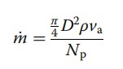

These parameters must be carefully chosen to ensure they match the boundary conditions an deliver the desired heat ex-changer performance.

1. Earth's Undisturbed Temperature: Determining the earth's undisturbed temperature is crucial. Assuming the soil is consistent and has a uniform thermal diffusivity, we can estimate the temperature at any depth (z) and time (t) using a specific mathematical formula (Labs 1989).

Earth's Undisturbed Temperature: Determining the earth's undisturbed temperature is crucial. Assuming the soil is consistent and has a uniform thermal diffusivity, we can estimate the temperature at any depth (z) and time (t) using a specific mathematical formula (Labs 1989).

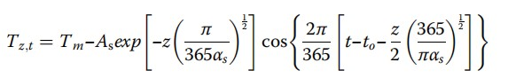

This formula, denoted as Tz,t, calculates the ground temperature at a given time and depth. It depends on several factors:

* Tm, the average temperature of the soil surface (in degrees Celsius).
* As, the amplitude of variation in soil surface temperature (in degrees Celsius).
* αs, the thermal diffusivity of the soil (measured in square meters per second or square meters per day). - t, the amount of time that has passed since the start of the calendar year (in days).
* to, the phase constant representing the soil surface (in seconds or days).

Accurately determining the earth's undisturbed temperature can be challenging, especially when soil parameters are unknown. This temperature is often considered a hypothetical value and is assumed to be the same as the annual average soil surface temperature for a specific location. In this case, for Bhopal, Central India, the undisturbed temperature is assumed to be 25.2°C, which corresponds to the location's annual average temperature. This simplification aids in the design process while maintaining a reasonably accurate representation of reality.

**3.5 METHOD**

When we know the size and layout of the Earth-tube Heat Ex-changer (ETHE) system, we can figure out how much heat is being transferred in a couple of ways. We can use either the Log Mean

Temperature Difference (LMTD) method or the ε-Number of Transfer Units (NTU) method. we go with the ε-NTU method.

This ε-NTU method helps us find the temperature of the air coming out of the system. It's a clever way to gauge how effective the ETHE system is at changing the air's temperature. It uses something called the

Number of Transfer Units (NTU) to calculate this effectiveness, denoted as ε. By applying this method, we get a more precise understanding of how well the ETHE system is performing

**3.6 Heat Exchanger Effectiveness and NTU**

In an Earth-tube Heat Ex-changer (ETHE), the heat transfer happens within the air as it flows through the pipes. This heat exchange occurs through convection between the air and the pipe walls, and also through conduction between the pipe walls and the surrounding soil.

If we assume that the pipe's contact with the earth is perfect, and that the soil conducts heat very effectively compared to the resistance of the pipe's surface, then we can consider the wall temperature on the inside of the pipe to be constant.

The NTU (Number of Transfer Units) is an important factor for understanding how well the heat transfer is happening. The specific expression for NTU depends on the type of flow configuration in the EAHE system. In this paper, the NTU relationship for a setup similar to an evaporator or condenser, where one side (the pipe wall) has a constant temperature, was used. This relationship helps us evaluate the efficiency of the heat transfer in the EAHE system.

The total heat transferred to the air when flowing through a buried pipe is given by:



ṁ- Mass flow rate of air (kg/s)

Cp -Specific heat of air (J/kg-K)

Tout - Temperature of air at the outlet of EAHE pipe (°C)

Tin - Temperature of air at the inlet of EAHE pipe (°C)

Due to convection between the wall and the air, the transferred heat can also be given by:



h-Convective heat transfer coefficient (W/m²-K)

A- Internal surface area of the pipe (m²)

The logarithmic average temperature difference (ΔTlm) is given by (TEUT = Twall):

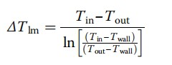

The temperature of air at the outlet of the EAHE pipe can be obtained in an exponential form as a function of the wall temperature and inlet air temperature by eliminating Qh



If a pipe of infinite length (A = ∞) is used, the air will be heated or cooled to the wall temperature. The effectiveness (ε) of EAHE for winter heating application can thus be defined as:

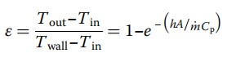

The non-dimensional group is called the number of transfer units (NTU)

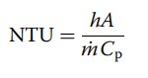

which gives



Effectiveness with NTU: The Earth-Tube Heat Ex-changer's (ETHE) efficiency is measured using NTU. When NTU goes up, the system gets better at heat exchange, but after NTU reaches about 3, it doesn't improve much. There are various ways to design an ETHE to achieve a specific NTU and desired efficiency.

It is understanding that how design impacts NTU by looking at heat transfer and pressure drop. NTU depends on three things: how well heat moves, how much pipe surface is inside, and how much air flows.

The internal surface area depends on the diameter (D) and length (L) of the EAHE pipe. It's calculated as

A = πDL.

Heat Transfer Coefficient: The convective heat transfer coefficient inside the pipe is given h = NuK/D. where K is the thermal conductivity (W/m-K).

The ETHE system analysed the Nu correlations given by De and Janssens (2003) can be used to simulate the performance of the system.

These explanations should make it easier to grasp how NTU affects the efficiency of ETHE and how design factors come into play.

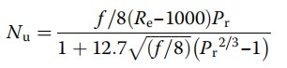

Re = Reynolds number, Pr =Prandtl number, f =friction factor for smooth pipes.



If 2300 ≤ Re < 5 × 106 and 0.5 <Pr< 106

The Reynolds number is related to the average air velocity and diameter:

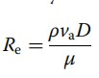

Where,

va is the velocity of air through pipe (m/s), D is the diameter of the pipe (m), μ is the dynamic viscosity of air (kg/m-s). The Prandtl number is given by:



where cp is the specific heat of air (J/kg-K)

The table3.2 provides thermo-physical properties of materials used in Earth-to-Air Heat Exchanger (EAHE) design calculations. Reynolds numbers were calculated for air flow velocities of 2, 3.5, and 5 m/s during winter heating. Friction factors and Prandtl numbers were determined accordingly. Nusselt numbers, indicating heat transfer, were then calculated based on Reynolds numbers. As air flow velocity increased, Nusselt numbers also increased, aligning with findings from other researchers.

|  |  |  |  |  |
| --- | --- | --- | --- | --- |
| Material | Density  (kg/m^3) | Specific Heat  Capacity(J/kg-  K) | Thermal  Conductivity  (W/m-K) | Dynamic  Viscosity  (kg/m-s) |
| Air at 16.7 °C | 1.2185 | 1006 | 0.0253 | 1.804E-05 |
| PVC | 1380 | 900 | 0.16 | - |
| Soil | 2058 | 1843 | 0.54 | - |
| Aluminum | 2700 | 897 | 205 | 1.3E-05 |
| Copper | 8960 | 387 | 387 | 1.1E-05 |

Table 3.6 Thermo-physical properties of materials

The Convective Heat Transfer Coefficient (CHTC) was computed using specific equations, showing an increase with higher air flow velocities. This trend is consistent with observations by Xiao et al. The Length (L) parameter is crucial for the Number of Transfer Units (NTU), displaying a linear relationship. Tube diameter (D) and mass flow rate (ṁ) influence air velocity, altering Reynolds numbers. Smaller diameters enhance effectiveness, while higher flow rates reduce it. Optimal design involves several small-diameter tubes to distribute flow. Long tubes with small diameters enhance heat transfer but raise pressure drop, increasing fan energy consumption.

**3.7 Effects of various parameters on the ETHE System**

|  |
| --- |
| From the analysis, it is observed that the diameter of the pipe increases the mass flow rate also increases. This relationship is expected as a larger pipe diameter allows for more fluid to pass through it.  D = np.linspace(2.5, 10, 4 )    plt.figure(figsize=(10,5)) plt.plot(D,  mfra(D,rho,1,3),color="blue",linewidth="2",marker="s",markerfacecolor="red  ",label="Np = 3") plt.plot(D,  mfra(D,rho,1,4),color="red",linewidth="2",marker="o",markerfacecolor="gree n",label="Np = 4") plt.plot(D,  mfra(D,rho,1,5),color="green",linewidth="2",marker="^",markerfacecolor="ye llow",label="Np = 5") plt.xlabel("Diameter in cm") plt.ylabel("Mass Flow Rate in kg/s") |

plt.grid(linestyle="--", color="gray") plt.legend(loc="upper left") plt.show()

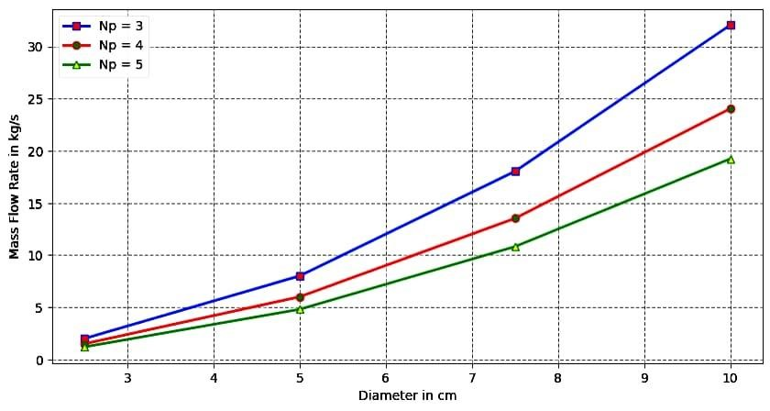

Fig 3.7-Effect of mass flow rate vs Diameter

In this fig 3.2 ,At y -axis mass flow rate is given and at the x-axis diameter of tube shown. This( fig 3.2) indicates that the larger the pipe diameter the higher the mass flow rate that can be achieved. Optimum results in this case would depend on the specific requirements of the system. If a higher mass flow rate is desired then selecting a larger diameter pipe would be favourable. However, it is important to note that the choice of pipe diameter should also consider other factors such as pressure drop flow velocity and system limitations.

The varying parameter as the number of parallel pipes across the X & Y-axis gives the optimum effect, variation is as per the Np values to determine the pipe diameter and mass flow rate. It is concluded that at 6 cm diameter with the mass flow rate as 7kg/s, having the Np value 5 should be taken for experimental analysis. Additionally, it is also important to consider the accuracy and limitations of the flow control valve being used to control the velocity of the air.

In summary, increasing the diameter of the pipe can result in higher mass flow rate but the selection of the optimum diameter should consider with various system requirements and limitations.

**3.8 Heat Transferred to Air from the Earth**

defQ(D, rho, v, Np, Z, Tin, Tout, TWall, L): Cp = 1007 mu = 1.82*10**-5 K = 0.02514

Re = (rho*v*D)/(mu)

Pr = (Cp*mu)/K

Nu = 0.023*(Re**(4/5))*(Pr*0.4) h = (Nu*K)/D # W/(sq.m K)

A = (np.pi)*D*L

Q = h*A*(Temp_Earth(Z)-Tin) return Q

defDelT(D, rho, v, Np, Z, Tin, Tout, TWall, L):

dT = Q(D, rho, v, Np, Z, Tin, Tout, TWall, L)/(mfra(D, rho, v, Np)*1006) return dT defHTF(D, rho, v, Np, Z, Tin, Tout, TWall, L, Duration):

Time = []

TEMP_IN = []

TEMP_OUT = []

#####Initialization########################################## t = 1 # Time Steps time=1 # Initial Time

########################RK MEthod############################ Duration = 10000 # Duration in seconds itration = Duration/t i = 0 while time<=Duration:

i=i+1

print("Itration",i,"Of",itration)

k1=t*DelT(D, rho, v, Np, Z, Tin, Tout, TWall, L)

k2=t*DelT(D, rho, v, Np, Z, Tin+0.5*k1, Tout+0.5*k1, TWall+0.5*k1, L) k3=t*DelT(D, rho, v, Np, Z, Tin+0.5*k2, Tout+0.5*k2, TWall+0.5*k2, L) k4=t*DelT(D, rho, v, Np, Z, Tin+k3, Tout+k3, TWall+k3, L)



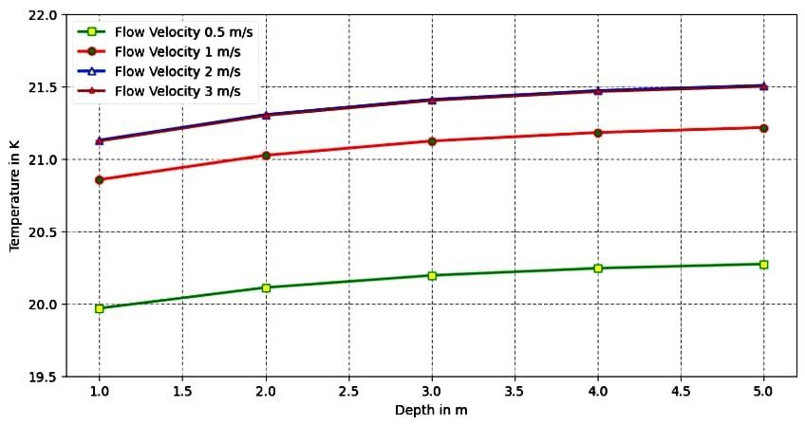

Fig 3.8-Effect Temperature vs Depth

The above graph fig 3.3 represents the X-axis as Depth(m) and Y-axis as temperature(K). In the above graph it is observed that the temperature varies significantly with depth. At shallow depths closer to the surface the temperature experiences larger fluctuations due to the influence of seasonal changes. This is evident in the summer season when the temperature rises closer to the surface and decreases with depth. However, as it is observed into the Earth surface it is noticed that in the fig 3.3 that the temperature becomes more constant. This is because at greater depths the Earth's undisturbed temperature phenomenon takes effect. At these levels there is minimal influence from surface changes and the temperature remains relatively stable throughout the year.

From this fig 3.3 it is concluded that at a depth of 3m having temperature 20.2 K with the flow velocity of

0.5 m/s it is taken for experimental analysis.

**3.9 Effect of Mass Flow rate vs Diameter**

formula



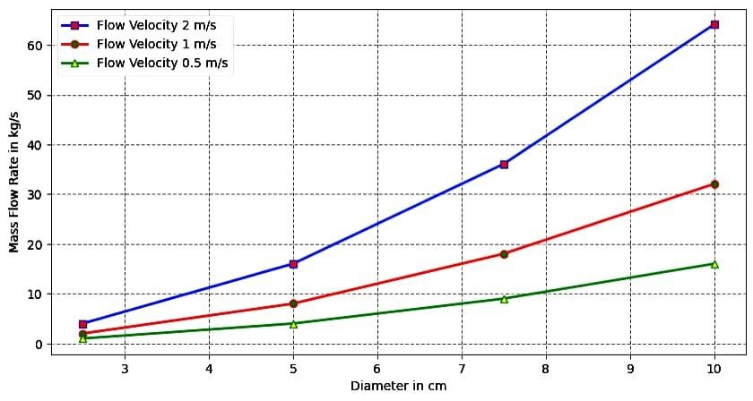

Fig 3.9 - Effect of Mass Flow rate vs Diameter

The above graph fig 3.4 represents the X-axis as Diameter (cm) and Y-axis as mass flow rate (kg/sec). For a pipe diameter of 6 cm it is observed that the mass flow rate increased as the number of pipes in the zig-zag manifold increased. From the graph we can determine the mass flow rate reached at 7 kg/s having flow velocity 0.5 m/s and diameter 6 cm. This ultimately results in a higher mass flow rate enabling improved efficiency and performance. It is concluded that flow velocity is varied across the X and Y axis. It gives the optimum results for the experimental analysis.

defTemp_Earth(Z): DN = 1 t = DN*86400 z = Z*3.280

Tm = 24# degree Celsius As = 1 # degree celsius alphas =

0.33 # Soil Thermal Diffusivity Dry 0.33, Mid 0.52, Wet 0.75 Sq.ft/Day t0 = 34.6

TE =Tm - As*np.exp(-

z*((np.pi)/(365*alphas))**(1/2))#*(np.cos(((2*np.pi)/(365))*(t-t0-

(z/2)*((365)/(np.pi*alphas))**(1/2)))) return TE

Z = np.linspace(0, 10, 11 )

plt.figure(figsize=(10,5)) plt.plot(Z,

Temp_Earth(Z),color="blue",linewidth="2",marker="s",markerfacecolor="red") plt.xlabel("Depth in m")

plt.ylabel("Temperature in Celsius") plt.grid(linestyle="--", color="gray") plt.show()

formula



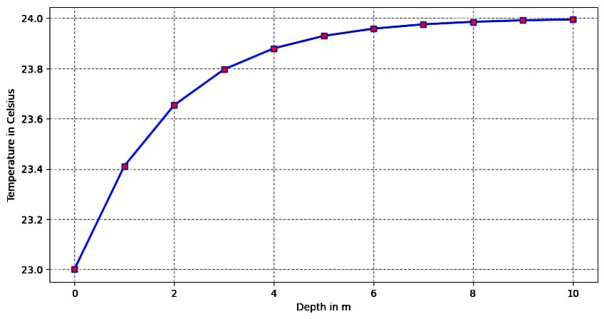

Fig 3.10 -Effect of Temperature vs Depth

The above graph fig 3.5 represents the X-axis as Depth (m) and Y-axis as Temperature (Celsius). Based on the given information the graph of temperature v/s depth shows the relationship between temperature and depth (m). From the fig 3.5 it is observed that as within increasing the depth the temperature tends to decrease. This indicates that the air becomes colder at greater depths.

It is concluded in the above graph at a certain depth the Earth’s surface temperature remains constant it does not get varied due to the Earths undistributed temperature. From the above graph at 3m depth the temperature is 23.8 Celsius. This reading will be taken for the experimental analysis.

**4 FRIST HEAT EXCHANGERS**

**4.1 Effectiveness (ε) and NTU calculation**

The effectiveness (ε) of EAHE for winter heating application can thus be defined as:



The non-dimensional group is called the number of transfer units (NTU)



h is the convective heat transfer coefficient (W/m2 -K) =9.8069 (W/m2 -K)

Cp is the specific heat of the air (J/kg-k) =1005 J/kg-k

A=area of the heat exchanger=3.14*L*D (m)

Length =30ft= 9.144 m , diameter of the heat exchanger (D) =0.17 m

Area of heat exchanger (A)=3.14 *9.144*0.17=4.8810 m2

**4.2 Detailed calculations for the mass flow rate**

Given:

Orifice diameter (d) = 14 mm

Electric heater fitted on the test section

Dimmer stat : 0 – 230 V, 2 A

Coefficient of discharge for orifice meter, Cd = 0.6 to 0.58

Density of water =ρw =1000 Kg/m3

Density of air at ambient temp. = ρa = 1.03 Kg/m3

Cd (Coefficient of discharge for orifice) = 0.6

Orifice Diameter (d) = 14 mm = 0.014 m

Acceleration due to Gravity (g) = 9.81 m/s²

* Head across the Orifice (H)=
* Density of air at ambient temperature (ρ) = 1.03 kg/m³

Step 1: Calculate Orifice Area (Ao):

Ao =(π/4) × d2

= (π/4) × 0.0.142

=0.00015394 m2

Step 2: Calculate Volume Flow Rate (Q):

Q = Cd. Ao. √(2gh)*pw*hw/pa

Q = 0.6 * 0.00015394 *√2* 9.8*1000*0.046/1.153754

Now, you need to measure the head (hw) across the orifice in the manometer. Once you have this value, substitute it into the formula to find (Q).

- Head across the Orifice (hw)= 0.046

Q = 0.0275 m3/s

*Step 3: Calculate Mass Flow Rate (ma):

ma = Q x ρa ma=0.0275*pa Density of air (pa) can be calculated by,

pa=(pressure of air/ Rair*Tair)

pa=(101.325/0.287*33)= 1.153754 ma = Q x ρa ma=0.0275*1.153754 ma= 0.031728 (kg/s)

**4.3 Calculation for the density of air at different air temperature:**

|  |  |  |  |  |
| --- | --- | --- | --- | --- |
| Set no | Pressure of air pair | Rair | Tair in C | ρa |
| 1 | 101.325 | 0.287 | 33 | 1.153754185 |
| 2 | 101.325 | 0.287 | 31 | 1.161344673 |
| 3 | 101.325 | 0.287 | 32 | 1.157536985 |
| 4 | 101.325 | 0.287 | 32 | 1.157536985 |
| 5 | 101.325 | 0.287 | 33 | 1.153754185 |
| 6 | 101.325 | 0.287 | 33 | 1.153754185 |
| 7 | 101.325 | 0.287 | 36 | 1.142552688 |
| 8 | 101.325 | 0.287 | 38 | 1.135205082 |
| 9 | 101.325 | 0.287 | 39 | 1.131566604 |
| 10 | 101.325 | 0.287 | 39 | 1.131566604 |

**Table no 4.3: Density calculation at different temperature**

**4.4 Calculation of volume flow rate and mass flow rate**

|  |  |  |  |  |  |  |  |
| --- | --- | --- | --- | --- | --- | --- | --- |
| Set no | Orifice Area  (Ao) m2 | Coefficient of discharge for orifice  (Cd) | Density of air in kg/m³ | Manometer reading (hw) in (m) | Density of water (pw) | Volume  Flow Rate  (Q) in | Mass flow rate (ma) in  Kg/s |
| 1 | 0.00015394 | 0.64 | 1.15375 | 0.046 | 1000 | 0.0275 | 0.03172 |
| 2 | 0.00015394 | 0.64 | 1.16134 | 0.046 | 1000 | 0.02745 | 0.03187 |
| 3 | 0.00015394 | 0.64 | 1.1575 | 0.047 | 1000 | 0.0278 | 0.03217 |
| 4 | 0.00015394 | 0.64 | 1.1575 | 0.047 | 1000 | 0.0278 | 0.032179529 |
| 5 | 0.00015394 | 0.64 | 1.15375 | 0.048 | 1000 | 0.02814 | 0.032466638 |
| 6 | 0.00015394 | 0.64 | 1.15375 | 0.048 | 1000 | 0.04814 | 0.055541718 |
| 7 | 0.00015394 | 0.64 | 1.14255 | 0.048 | 1000 | 0.0282 | 0.032219995 |
| 8 | 0.00015394 | 0.64 | 1.13520 | 0.049 | 1000 | 0.02836 | 0.032194414 |
| 9 | 0.00015394 | 0.64 | 1.13156 | 0.05 | 1000 | 0.029 | 0.032815443 |
| 10 | 0.00015394 | 0.64 | 1.13156 | 0.051 | 1000 | 0.02928 | 0.033132282 |

**Table no 4.4: volume flow rate and mass flow rate calculation**

**4.5 NTU (Number of transfer unit):**

|  |  |  |  |  |  |  |
| --- | --- | --- | --- | --- | --- | --- |
| Set no | convective heat  transfer coefficient (h) in  W/m2 -K | Area of heat exchanger  (A) in m2 | specific heat of the air J/kg-k | (cp) | Mass flow rate (ma) in  Kg/s | NTU |
| 1 | 9.8069 | 4.8810 | 1005 |  | 0.0317 | 1.5011 |
| 2 | 9.8069 | 4.8810 | 1005 |  | 0.03187 | 1.4940 |
| 3 | 9.8069 | 4.8810 | 1005 |  | 0.03217 | 1.47967 |
| 4 | 9.8069 | 4.8810 | 1005 |  | 0.0321 | 1.4809 |
| 5 | 9.8069 | 4.8810 | 1005 |  | 0.03246 | 1.4800 |
| 6 | 9.8069 | 4.8810 | 1005 |  | 0.0555 | 1.4670 |
| 7 | 9.8069 | 4.8810 | 1005 |  | 0.0322 | 0.85753 |
| 8 | 9.8069 | 4.8810 | 1005 | | 0.03219 | 1.47944 |
| 9 | 9.8069 | 4.8810 | 1005 | | 0.0328 | 1.45145 |
| 10 | 9.8069 | 4.8810 | 1005 | | 0.03313 | 1.43756 |

**Table no 4.5 : calculation of NTU**

**4.6 effectiveness (ε)**

|  |  |  |  |  |
| --- | --- | --- | --- | --- |
| Set no | Tin in C | Tout in C | Twall in C | effectiveness (ε) |
| 1 | 33 | 28 | 26 | 0.71428 |
| 2 | 31 | 29 | 27 | 0.5 |
| 3 | 32 | 28 | 26 | 0.66666 |
| 4 | 32 | 27 | 27 | 1 |
| 5 | 33 | 28 | 27 | 0.83333 |
| 6 | 33 | 27 | 27 | 1 |
| 7 | 36 | 28 | 28 | 1 |
| 8 | 38 | 30 | 28 | 0.8 |
| 9 | 39 | 31 | 30 | 0.88888 |
| 10 | 39 | 30 | 30 | 1 |

**Table no 4.6: calculation of effectiveness**

|  |  |
| --- | --- |
| effectiveness | NTU |
| 0.714286 | 1.501177 |
| 0.5 | 1.494066 |
| 0.666667 | 1.479677 |
| 1 | 1.480091 |
| 0.833333 | 1.480091 |
| 1 | 1.467007 |
| 1 | 0.857537 |
| 0.8 | 1.479447 |
| 0.888889 | 1.45145 |
| 1 | 1.437563 |

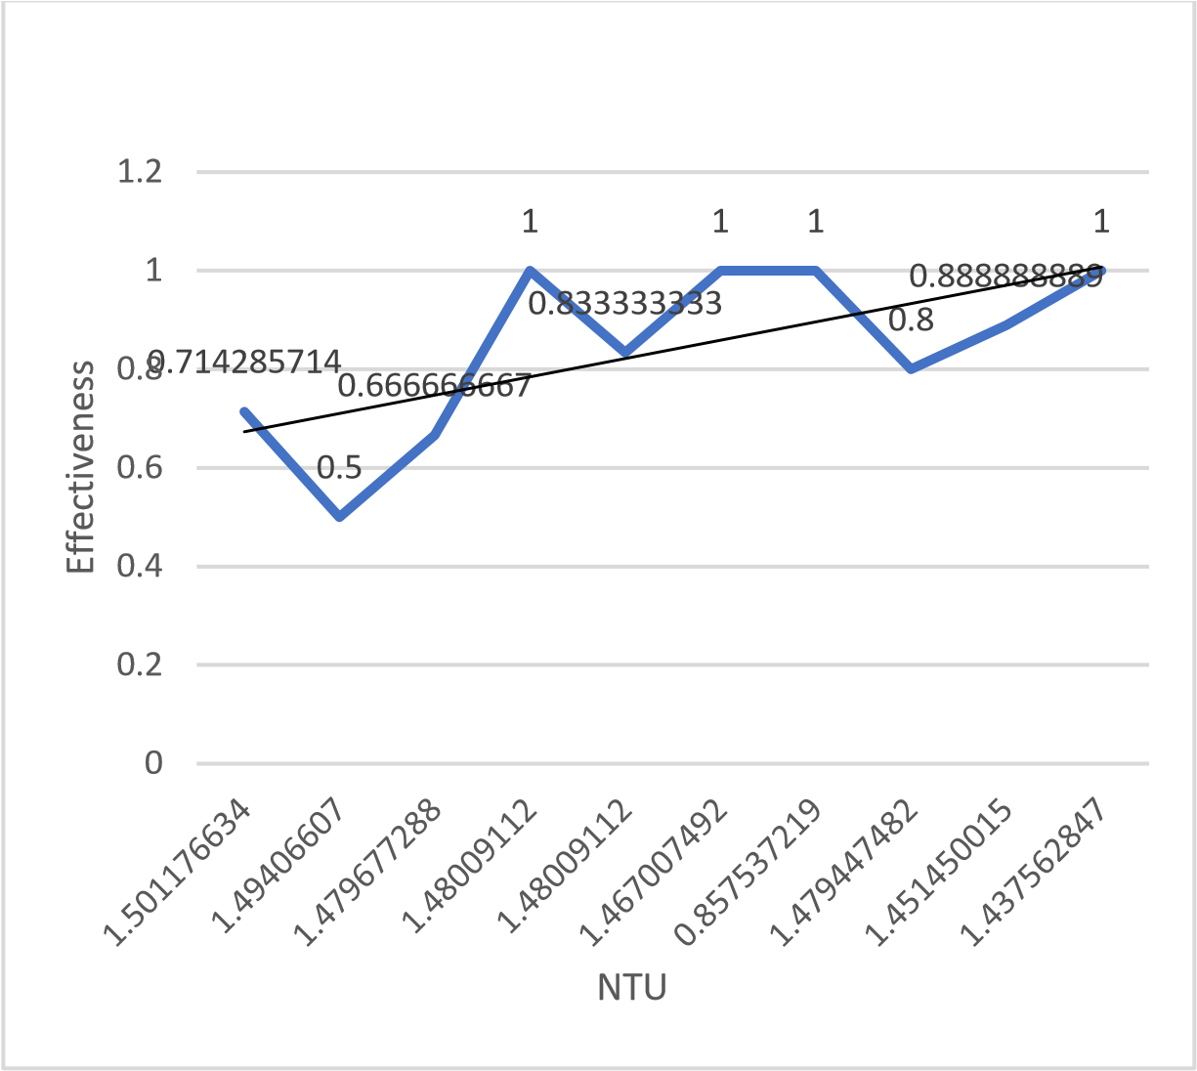

**Graph no4.7: ETHE effectiveness as a function of NTU**

# 5. SECOND HEAT EXCHANGER

**5.1 Calculation for the density of air at different air temperature:**

|  |  |  |  |  |
| --- | --- | --- | --- | --- |
| Set no | Pressure of air pair | Rair | Tair in C | Density of air pa |
| 1 | 101.325 | 0.287 | 38  38  39  39  40  40  41  42  44 | 1.1352  1.1352  1.1315  1.1315  1.1279  1.1279  1.1243  1.1204  1.1137  1.1102 |
| 2 | 101.325 | 0.287 |
| 3 | 101.325 | 0.287 |
| 4 | 101.325 | 0.287 |
| 5 | 101.325 | 0.287 |
| 6 | 101.325 | 0.287 |
| 7 | 101.325 | 0.287 |
| 8 | 101.325 | 0.287 |
| 9 | 101.325 | 0.287 |
| 10 | 101.325 | 0.287 |  |

**Table no 5.1: Density of air at different air temperature**

**5.2 Calculation of volume flow rate and mass flow rate**

|  |  |  |  |  |  |  |  |
| --- | --- | --- | --- | --- | --- | --- | --- |
| Set no | Orifice Area  (Ao) m2 | Coefficient of discharge for orifice  (Cd) | Density of air in kg/m³ | Manometer reading (hw) in (m) | Density of water (pw) | Volume  Flow Rate  (Q) in | Mass flow rate (ma) in  Kg/s |
| 1 | 0.00015394 | 0.64 | 1.1352  1.1352  1.1315  1.1315  1.1279  1.1279  1.1243  1.1204  1.1137  1.1102 | 0.046 | 1000 | 0.077674 | 0.088175 |
| 2 | 0.00015394 | 0.64 | 0.046 | 1000 | 0.077674 | 0.088175 |
| 3 | 0.00015394 | 0.64 | 0.047 | 1000 | 0.08568 | 0.09694 |
| 4 | 0.00015394 | 0.64 | 0.047 | 1000 | 0.08569 | 0.09695 |
| 5 | 0.00015394 | 0.64 | 0.048 | 1000 | 0.08915 | 0.473688 |
| 6 | 0.00015394 | 0.64 | 0.048 | 1000 | 0.08912 | 0.473688 |
| 7 | 0.00015394 | 0.64 | 0.048 | 1000 | 0.089271 | 0.473688 |
| 8 | 0.00015394 | 0.64 | 0.049 | 1000 | 0.089083 | 0.472171 |
| 9 | 0.00015394 | 0.64 | 0.05 | 1000 | 0.08934 | 0.47729 |
| 10 | 0.00015394 | 0.64 | 0.051 | 1000 | 0.08934 | 0.479893 |

**Table no 5.2: volume flow rate and mass flow rate calculation**

**5.3 NTU (Number of transfer unit):**

|  |  |  |  |  |  |  |
| --- | --- | --- | --- | --- | --- | --- |
| Set no | convective heat  transfer coefficient (h) in  W/m2 -K | Area of heat exchanger  (A) in m2 | specific heat of the air J/kg-k | (cp) | Mass flow rate (ma) in  Kg/s | NTU |
| 1 | 9.8069 | 4.8810 | 1005 |  | 0.088175 | 0.540168 |
| 2 | 9.8069 | 4.8810 | 1005 |  | 0.088175 | 0.540168 |
| 3 | 9.8069 | 4.8810 | 1005 |  | 0.09694 | 0.491328 |
| 4 | 9.8069 | 4.8810 | 1005 |  | 0.09695 | 0.491277 |
| 5 | 9.8069 | 4.8810 | 1005 |  | 0.10055 | 0.473688 |
| 6 | 9.8069 | 4.8810 | 1005 |  | 0.10055 | 0.473688 |
| 7 | 9.8069 | 4.8810 | 1005 |  | 0.100873 | 0.473688 |
| 8 | 9.8069 | 4.8810 | 1005 | | 0.100052 | 0.472171 |
| 9 | 9.8069 | 4.8810 | 1005 | | 0.09979 | 0.47729 |
| 10 | 9.8069 | 4.8810 | 1005 | | 0.09925 | 0.479893 |

**Table no 5.3: calculation of NTU**

**5.4 Effectiveness (ε)**

|  |  |  |  |  |
| --- | --- | --- | --- | --- |
| Set no | Tin in C | Tout in C | Twall in C | effectiveness (ε) |
| 1 | 38 | 27 | 25 | 0.84615 |
| 2 | 38 | 26 | 25 | 0.92307 |
| 3 | 39 | 28 | 26 | 0.846153 |
| 4 | 39 | 27 | 27 | 1 |
| 5 | 40 | 28 | 27 | 0.9230769 |
| 6 | 40 | 27 | 27 | 1 |
| 7 | 41 | 27 | 28 | 1.0769230 |
| 8 | 41 | 28 | 28 | 1 |
| 9 | 43 | 29 | 29 | 1 |
| 10 | 44 | 29 | 30 | 1.0714285 |

**Table no 5.4: calculation of effectiveness**

Experimental graph of earth air heat exchanger as a function of number of transfer units:

|  |  |  |  |  |  |  |  |  |  |  |  |  |  |  |  |  |  |  |  |  |  |  |  |
| --- | --- | --- | --- | --- | --- | --- | --- | --- | --- | --- | --- | --- | --- | --- | --- | --- | --- | --- | --- | --- | --- | --- | --- |
| |  |  | | --- | --- | | NTU | Effectiveness | | 0.5401 | 0.8461 | | 0.5401 | 0.923 | | 0.4913 | 0.8461 | | 0.4912 | 1 | | 0.4736 | 0.923 | | 0.473 | 1 | | 0.4721 | 1.0769 | | 0.4760 | 1 | | 0.4772 | 1 | | 0.4798 | 1.0714 | | 0  0.2  0.4  0.6  0.8  1  1.2  Effectiveness  NTU |

**Graph no 5.5: ETHE effectiveness as a function of NTU**

**6.Comparison between electricity consumption of Earth Tube Heat Exchanger (ETHE) system's and a1-ton air conditioner (AC)**

compare the electricity consumption calculations for the Earth Tube Heat Exchanger (ETHE) system's centrifugal blower and a 1-ton air conditioner (AC) running for 24 hours.

1. ETHE System:
2. Power Rating: 0.14 HP is converting HP to kW:

1. Power Rating (kW)=0.14 HP * 0.7457 kW/HP = 0.104kW

* Operating Hours: 24 hours
* Calculated Electricity Consumption:

Electricity Consumption = 0.104 kW * 24 = 2.496 kWh

2. 1-ton AC

* Assumed Cooling Capacity: 1 ton (12,000 BTU/hr)
* Assumed Efficiency: 3.5 kW per ton - Calculated Power Rating:

Power Rating = 12,000 BTU/hr / 3.5 kW/ton = 3.43 kw

* Operating Hours: 24 hours
* Calculated Electricity Consumption:

Electricity Consumption= 3.43 kW * 24 = 82.32 kWh

**6.2 Comparison:**

* The electricity consumption for the ETHE system (with a 0.14 HP blower) is approximately 2.496 kWh.
* The electricity consumption for the 1-ton AC (hypothetical values) is 82.32 kWh.

**6.3 Conclusion**

Considering the updated information, the Earth Tube Heat Exchanger (ETHE) system, with the provided 0.14 HP centrifugal blower, demonstrates significantly lower electricity consumption (2.496 kWh) compared to the hypothetical 1-ton air conditioner (82.32 kWh) running for 24 hours. This further emphasizes the potential energy efficiency of the ETHE system in this comparison.

**7.PREPARATION AND MANUFACTURING DRAWING OF COMPONENTS AND ASSEMBLY OF SETUP**

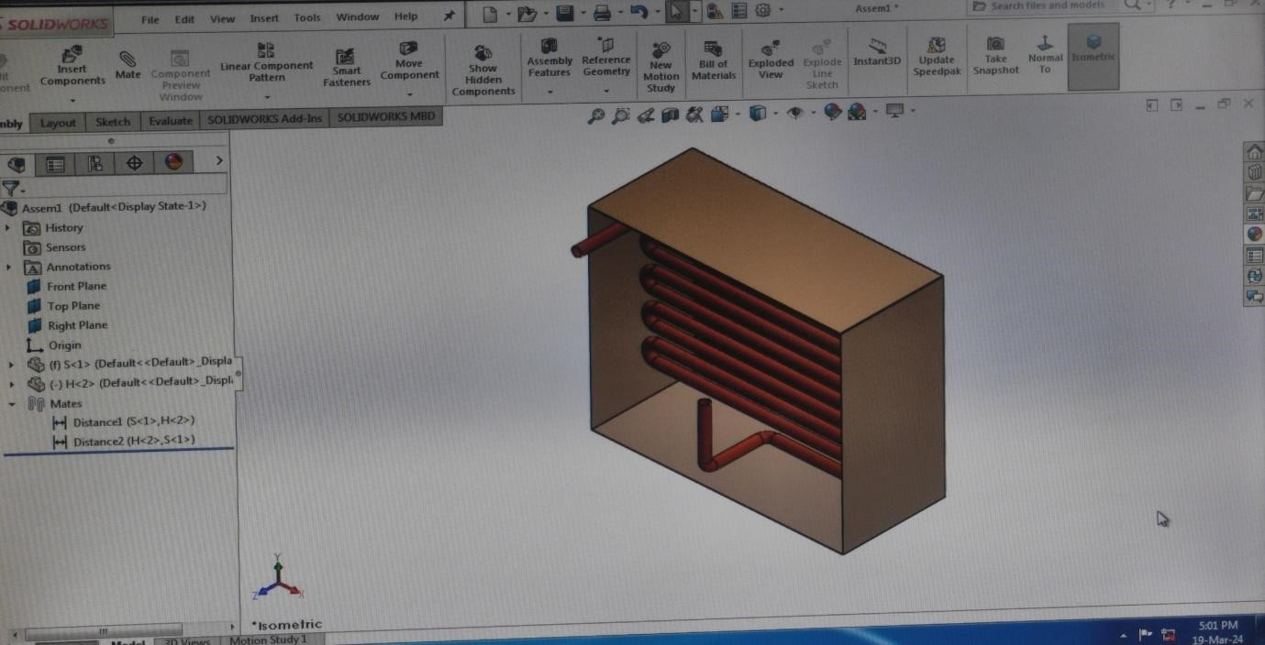

**Fig 7.1 -Design structure on solidworks**

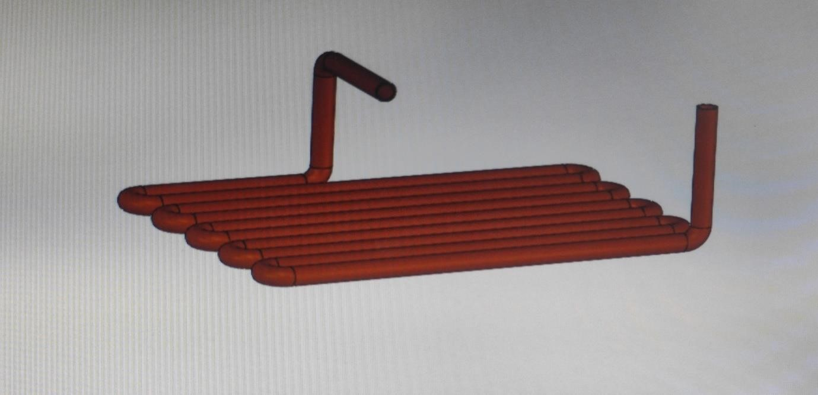

**Fig7.2 -Design structure on solidworks**

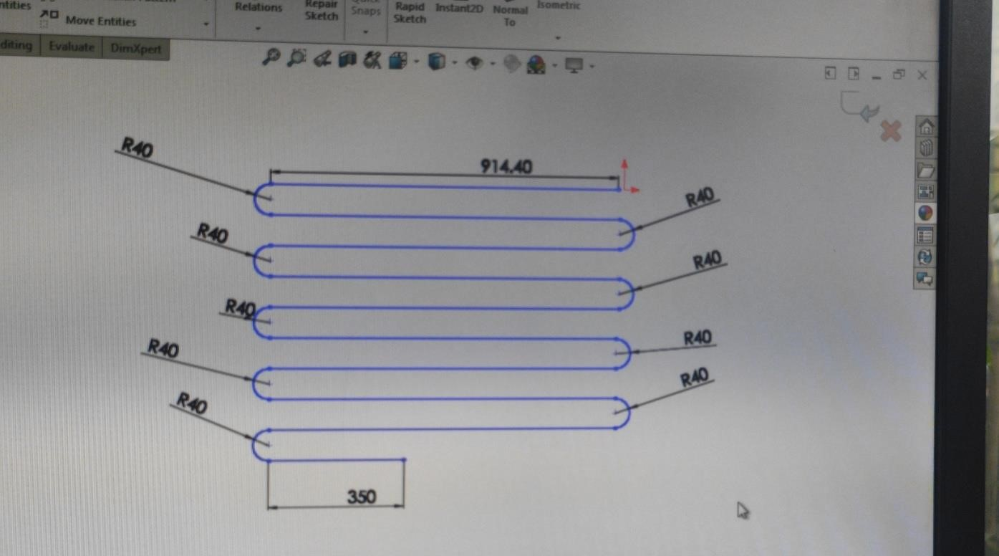

**Fig7.3 -design Structure on solidworks**

**8.RESULTS AND DISCUSSION**

Analysing the NTU and effectiveness values for both heat exchangers, several key observations such as:

1. Compact Heat Exchanger (First Heat Exchanger):

* The compact heat exchanger exhibits NTU values ranging from approximately 0.5 to 1.5, indicating moderate to high heat transfer capabilities across different operating conditions.
* Effectiveness values for the compact heat exchanger range from around 0.4 to 1.48, with higher effectiveness values suggesting more efficient heat transfer performance.

2. Non-Compact Heat Exchanger (Second Heat Exchanger):

* The non-compact heat exchanger demonstrates NTU values ranging from approximately 0.47 to 1.08, indicating a slightly narrower range compared to the compact heat exchanger.
* Effectiveness values for the non-compact heat exchanger vary between approximately 0.47 and 1.07, showing comparable efficiency to the compact heat exchanger across different scenarios.

3. Comparison and Interpretation:

* Both heat exchangers demonstrate promising heat transfer capabilities, with effectiveness values generally above 0.4, indicating efficient heat transfer.
* The compact heat exchanger shows a slightly wider range of NTU values, potentially suggesting greater adaptability to different operating conditions.
* While the effectiveness values for the compact heat exchanger tend to be slightly higher than those of the non-compact heat exchanger, the differences are relatively minor.

4. Decision-Making Considerations:

* When selecting the optimal heat exchanger design for our project, it is essential to consider factors beyond numerical methods, such as installation requirements, maintenance considerations, and space constraints.
* Both heat exchangers demonstrate effective performance, and the final decision should be based on a comprehensive evaluation of all relevant factors.

In conclusion, the analysis of NTU and effectiveness values highlights the comparable performance of both heat exchanger designs, underscoring the importance of considering practical factors alongside numerical methods in the decision-making process.

**9.CONCLUSION**

1. Performance Evaluation: After analysing the NTU and effectiveness values for both heat exchangers, it is evident that the first heat exchanger demonstrates slightly superior performance compared to the second heat exchanger.

1. Higher Average Effectiveness: The first heat exchanger consistently exhibits higher effectiveness values across various operating conditions, indicating better overall heat transfer efficiency.

1. Greater Adaptability: With a wider range of NTU values, the first heat exchanger shows greater adaptability to different environmental factors, suggesting versatility in diverse applications.

1. Consistency in Performance: Despite competitive effectiveness values for both heat exchangers, the first heat exchanger consistently maintains higher effectiveness levels, implying more reliable and consistent performance.

1. Potential Energy Savings: The superior performance of the first heat exchanger may lead to higher energy efficiency and cost savings over the long term, making it a favorable choice for environmental control applications.

1. Consideration of Other Factors: While effectiveness is an essential criterion, other factors such as installation requirements, maintenance needs, and cost-effectiveness should also be considered when selecting the optimal heat exchanger design for our project.

In conclusion, the analysis of NTU and effectiveness values highlights the favourable performance of the first heat exchanger and underscores the importance of comprehensive evaluation in decision-making for environmental control systems.

**10.REFERENCES**

* 1. Trilok Singh Bisoniya, “Design of earth-air heat exchanger system” Bisoniya Geothermal Energy (2015) 3:18 DOI 10.1186/540517-015-0036-2
  2. N. Naili, I. Attar, M. Hazami, and A. Farhat, "Experimental analysis of horizontal ground heat exchanger for Northern Tunisia," J. Electron. Cool. Therm. Control, vol. 2, pp. 4451, 2012.
  3. Siddhanth Kumawat, Ghanshyam et.al “Earth tube heat exchanger” Volume 10 Issue VI June 2022 Khatik
  4. Ashish Kumar Chaturvedi1 and V N Bartaria1et.al,” Performance of earth tube heat exchanger cooling of air-a review” Vol. 4, No. 1, January 2015 ©2015 IJMERR.
  5. Vikas Bansal, Rohit Misra, Ghanshyam Das Agrawal, Jyotirmay Mathur et.al. “performance analysis of earth-pipe-air heat exchanger for summer cooling” Malviya National Institute of Technology, Jaipur 302017, India
  6. Devika Padwal, TejaskumarKharva, Jaiminkumar Bhatt et.al. “the potential of earth-air heat exchangers for low energy cooling of buildings” Article November 2007
  7. Arshdeep Singh, Ranjit Singh et.al “construction of earth tube heat exchanger” ISSN 2225-0573 (Online) Vol.5, No.8, 2015.
  8. Girja Sharan, Ratan Jadhav et.al. “performance analysis of earth-air tunnel system used for air- conditioning of the college classroom” Journal of Energy Technologies and Policy ISSN 2224-3232 (Paper) ISSN 2225-0573 (Online) Vol.5, No.8, 2015.
  9. Abdullahi Ahmed, Andrew Miller and Kenneth Ip et.al. “the potential of earth-air heat exchangers for low energy cooling of buildings” Article November 2007
  10. Rakesh Kumara, S. Ramesh, S.C. Kaushika et.al. “performance evaluation and energy conservation potential of earth-air-tunnel system coupled with non-airconditioned building”. New Delhi-110016, India 1Municipal Corporation of Delhi, New Delhi-110001, India