**A STUDY AND ANALYSIS OF INVESTORS BEHAVIOUR TOWARDS MUTUAL FUND WITH REFERENCE TO MAHINDRA FINANCE**

**ABSTRACT**

The study is designed to gather information about people's investment behaviour and financial information. Data collected from the survey shows that most people prefer low-risk investments and have moderate or some confidence in their ability to make investment decisions. Good investment. Expected return is considered by most respondents as the most important factor when making investment decisions, while risk and diversification are also considered by the minority. The survey also revealed that most respondents did not attend financial lectures or conferences and did not create financial or financial plans. When faced with a loss of investment, most respondents would rather wait for recovery than seek professional advice or sell immediately

Research reports also show that financial advisors play a minor role in investment decision making, with the majority preferring to make decisions based on research and experience rather than financial advisors. Also, the data shows that a small percentage of respondents invest in stocks, while stocks and mutual funds are the more common investment options.

Overall, the study provides information on personal investment behaviour and financial literacy, indicating areas where education and training can be useful in improving investment decisions and financial planning.

**INTRODUCTION**

**Mahindra & Mahindra Financial Services Limited (MMFSL)** leading Rural NBFC headquartered in Mumbai, India. It is amongst the top tractor financer in India and offers a wide range of financial products to address varied customer requirements. The NBFC has 1000+ offices spread across 1 in every 3 villages across India with a total of more than 4.7 Million customers till date.

The Mahindra Finance journey started on January 1, 1991, as Maxi Motors Financial Services Limited. They received the certificate of commencement of business on date February 19, 1991. On November 3, 1992, Mahindra Finance changed their name to Mahindra & Mahindra Financial Services Limited. Mahindra Finance is registered with the Reserve Bank of India as an asset finance, deposit taking NBFC.

In 1993 it commenced financing M & M Utility vehicles and in 1995 started its first branch outside Mumbai, in Jaipur. Began financing Non M & M vehicles in 2002 and got into the business of financing of Commercial Vehicles and Construction Equipment’s in 2009. 2011 was the year in which they had a Joint Venture with

Rabo bank subsidiary for tractor financing in USA and consolidated the product portfolio by introducing Small and Medium Enterprises (SME) financing.

**Mahindra Mutual Fund**

Mahindra Asset Management Company Private Limited is a wholly owned subsidiary of Mahindra and Mahindra Financial Services Limited (MMFSL). Mahindra AMC Pvt. Ltd, is the Investment Management of Mahindra mutual fund. It started its operation in the first week of July 2016, with an AUM of 1200 Million INR and its NAV is floating around 1000 million INR. It endeavors to offer a variety of mutual fund schemes pan India, with special focus in rural and semi-urban.

**LITERATURE OF RIVEW**

**Gayathri, S. Karthika, S. & Kumar, Gajendran L. (2010)**

reviewed on Mutual Funds in India are financial instruments. A mutual fund

is not an alternative investment option to stocks and bonds; rather it pools the money of several investors and invests this in stocks, bonds,

Money Ma r k e t Instr uments.

The own e r of a mu t ual fu n d unit gets a proportional share of the fund’s Gains, Losses, Incomes and Expenses. Mutual Fund is vehicle for investment in stocks and Bonds. Each mutual fund has a specific stated objective.

Some popular objectives of a mutual fund are: Fund Objective - What the fund will invest in; Equity (Growth) - Only in stocks; Debt (Income); Only in fixed- income securities; Money Market (including Gilt) – In short-term money market instruments (including government securities).

**NEED OF RESEARCH**

The process involves comparing long-term returns in the case of equity funds, the fund manager’s track record, investment policies of the fund house, expense ratio and exit load, etc.

Performance comparisons must be used only to compare the same type of fund. .Almost all investing is risky, at least those investments that get you any meaningful returns. Unlike performance and risk, portfolio is one of the 'internals' of a fund. Investment analysis is when an investor examines, evaluates, and makes informed decisions about the potential profitability of an investment opportunity.

**OBJECTIVE OF THE STUDY**

My main and important objective of that study is I am more interested in mutual fund investments. I give more safety to its investors. Here are many more objectives of my study given as under-

1. To know the investors behavior on mutual funds.
2. To know about the literacy rate on mutual fund in India.
3. To identify the Interest level of the investors of Mahindra finance.
4. To identify the Purpose of the investors for investing in the mutual funds.
5. To find out the investment duration period of various investment in Mutual Funds etc.

**METHODOLOGY OF THE RESEARCH**

The methodology section of a study on the investor behaviour of mutual funds with reference to Mahindra Finance involves outlining the steps and procedures you will follow to conduct your research. Below is a suggested structure for the methodology section:

**Research Design:**

* Start by explaining the overall research design, whether it's exploratory, descriptive, or explanatory.
* Justify the choice of your research design based on the nature of the study and the information you aim to gather.

**Study Area and Period:**

* Specify the geographical scope of your study. In this case, mention if the study is focused on a particular region or if it has a broader national or international scope.
* Define the time frame for your study. This could include the years covered and any specific periods of interest.

**Data Collection:**

* Detail the sources of data you will use. This may include primary sources (directly from investors and Mahindra Finance) and secondary sources (existing literature, reports, etc.).
* Explain the method of data collection. If surveys or interviews are involved, describe the questionnaire design or interview structure. If using existing data, explain how it will be accessed and analysed.

**Sampling Technique:**

* Clarify the sampling technique employed. For instance, if you are conducting surveys or interviews, explain how you will select participants.
* Define the target population and the sampling frame.

**Sample Size:**

* Provide justification for the chosen sample size. This can be based on statistical considerations or the practical constraints of your study.
* Explain how the sample size contributes to the generalizability of your findings.

**Data Analysis:**

* Specify the statistical or analytical methods you will use to analyze the data. This might include regression analysis, factor analysis, or other relevant statistical techniques.
* Discuss any software tools you plan to use for data analysis.

**Ethical Considerations:**

* Address ethical concerns related to your study. Ensure that participant confidentiality and privacy are maintained.
* If applicable, describe any approvals obtained from ethical review boards or institutions.

**DATA ANALSIS AND INTERPRETATION**

In my study the 70% peoples believe in invest in mutual funds because of safety. This is the most recommended in investment.

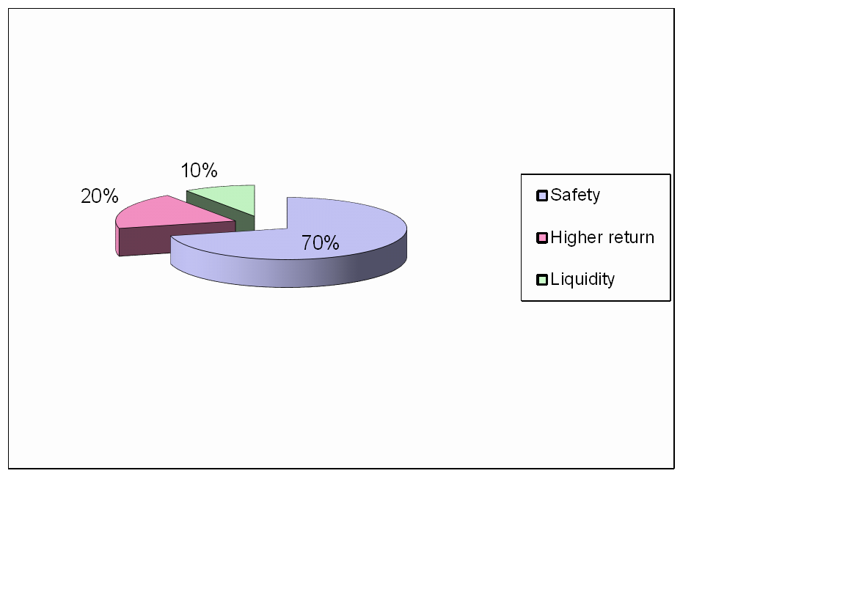

**FREQUENCY OF INVESTMENT**

**Interpretation :**

In my study I was 33% persons were regularly invited in mutual funds. 52% peoples want to try to invest and 15% are not interested.

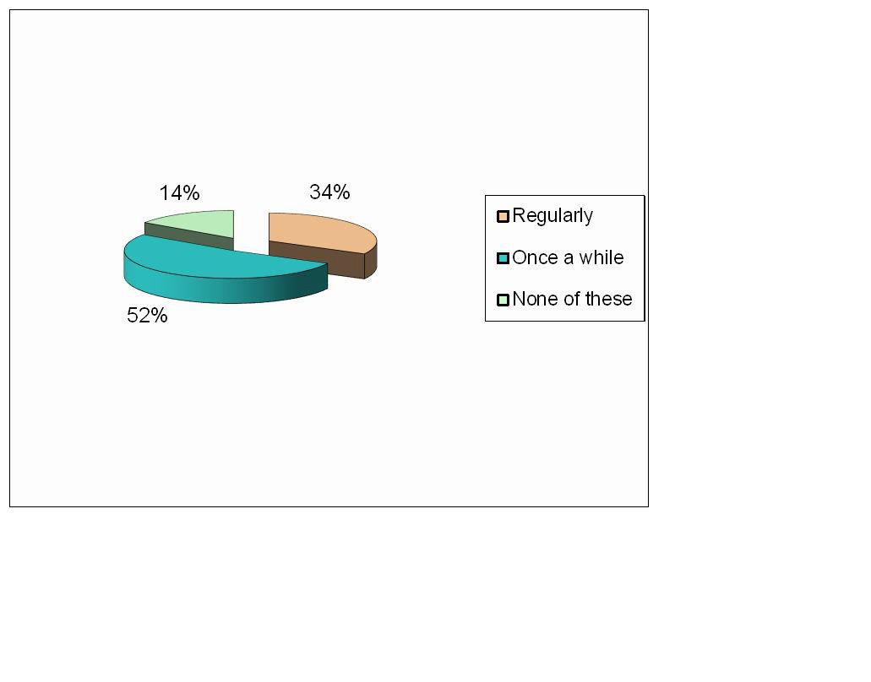

**OBJECTIVE BEHIND INVESTMENT**

**Interpretation :**

I was found that 67% peoples were invested in mutual funds for the regular income generation, 29% for tax saving.

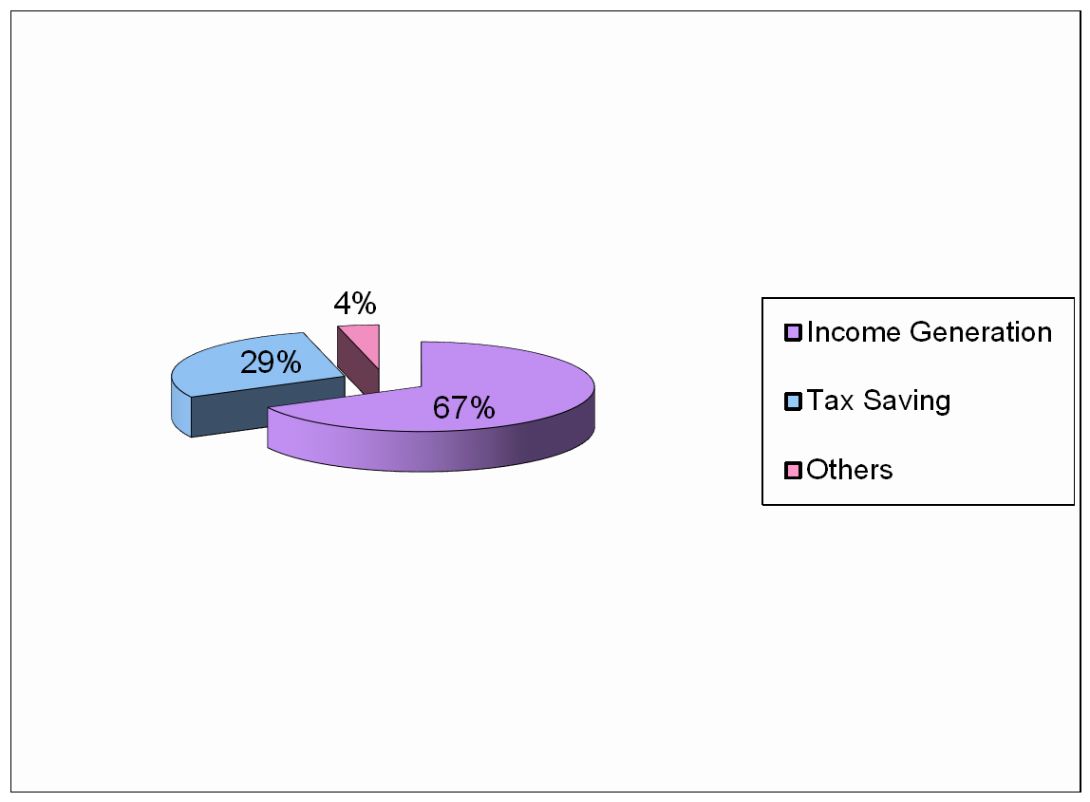

**SOURCES OF AWARENESS**

***Interpretation :***

I also found that many of the peoples get the knowledge about the mutual fund with thaw help of media like newspapers, TV etc.

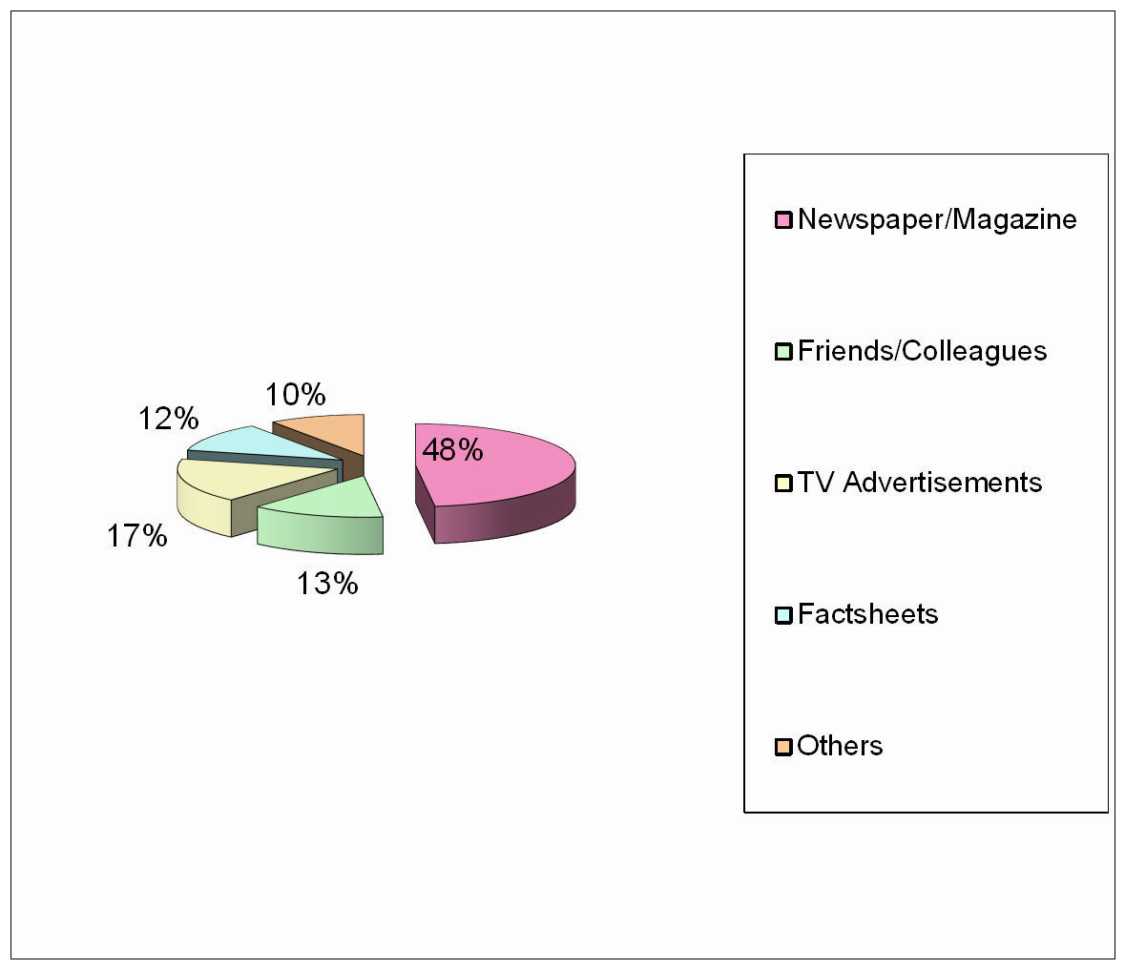

**SPECIFIC APPREHENSIONS ABOUT INVESTING IN MUTUAL FUNDS**

***Interpretation :***

In my study 20% population are having the lack of awareness, 50% are don’t have knowledge that is a mutual fund is an investment sources.

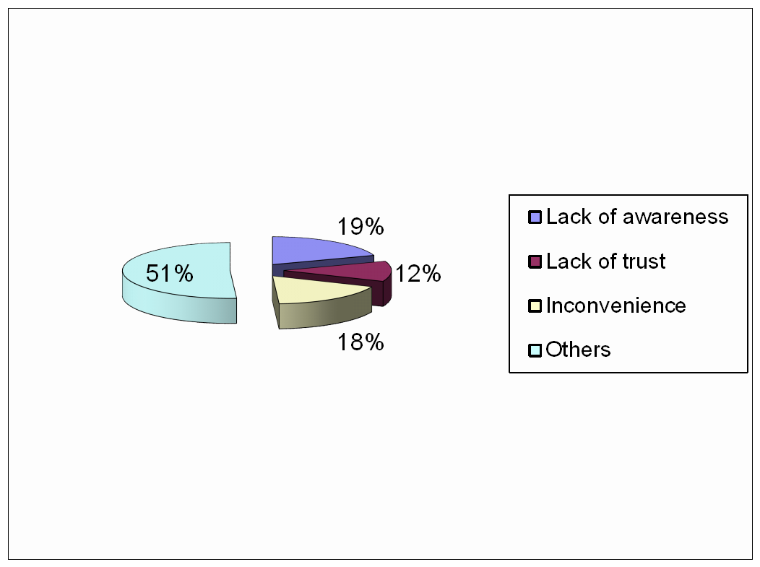

**CONCLUSION**

People save in Mutual Funds for different purposes i.e. children education, children marriage, house construction, retirement planning and tax planning. It was found that main purpose of savings in Mutual Fund by the respondents was for children education (56.33%) followed by Retirement Planning (48.33%).Tax planning was given the third priority by the respondents. People engaged in Business gave the first preference to children education (68.7%) followed by professionals (58.8%) and then salaried class (53.7%). Professionals gave the first preference to children marriage (50%), followed by salaried class (41.3%) and retired people (45.5%). Salaried class gave the first preference to house construction (44.6%) followed by Business people (36.1%) and professional (29.4%). Retired people gave the first preference to tax planning (47.1%) followed by salaried (43.8%) and Business people (42.2%). The relationship between educational qualifications and purpose of savings revealed that the respondents gave priority to children’s education (56.3%), retirement planning (48.3%) followed by tax planning (40%).

**REFERENCES**

**Magazines**

* The Analyst magazine
* Business Standard
* Smart investors
* Journals and magazines – business, market watch, investors.
* The financial express magazine

**Websites**

* [www.mfea.com](http://www.mfea.com/)
* [www.investments.com.ph](http://www.investments.com.ph/)
* Www.inflation.com
* Www.google.com <http://www.rediff.com/money/2007/mar/21inflation.htm>

[www.**inflation**data.com/**inflation**/**Inflation**_Articles/**Inflation**_**cause**_and_eff](http://www.inflationdata.com/inflation/Inflation_Articles/Inflation_cause_and_eff) ect.asp

[http://ezinearticles.com](http://ezinearticles.com/)