**An Analysis of Modal Pushover on a Multi-Span Bridge to Assess Seismic Responses**

**Avinash Kumar1, Dr. Jyoti Yadav2**

1M.Tech Scholar, Department of Civil Engineering, Sarvepalli Radhakrishnan University, Bhopal, M.P, India

2Assistant Professor, Department of Civil Engineering, Sarvepalli Radhakrishnan University, Bhopal, M.P, India

**Abstract**

Performance-based seismic design is increasingly incorporating nonlinear static procedures due to the comparatively straightforward method they offer for estimating inelastic structural response measures. Nevertheless, traditional nonlinear static methods that rely on lateral load patterns as suggested in FEMA-356 fail to sufficiently capture the consequences of fluctuating dynamic properties during the inelastic response or the impact of higher modes. In light of these limitations, a number of researchers have recently put forth enhanced methodologies. This paper investigates a method of modal combinations that implicitly accounts for higher mode effects. The modal pushover analysis method utilizes factored combinations of independent modal contributions to generate invariant force distributions. This study examines the efficacy of Modal Pushover Analysis (MPA) in forecasting the inelastic seismic behavior of a multi-span concrete bridge. Lateral forces acting on the bridge are proportionally distributed across its span in accordance with the product of mass and displaced shape. The target displacement is calculated using the peak displacement of the nth mode inelastic Single Degree of Freedom System to elevate the structure.

**Keywords-** Modal Pushover Analysis (MPA), Seismic Design, Pushover Analysis Method, Degree of Freedom, Multi-Span Bridge.

1. **Introduction**

Many bridges were built without considering seismic design measures, either because the regulations at the time did not include them or because the provisions were not up to modern standards. Several of these bridges are prone to significant structural damage when impacted by earthquakes, as shown by recent mild seismic events. Linearly elastic techniques are effective as long as the structure remains within its elastic limits. Linear studies may identify the position of initial yielding in a structure that goes beyond its elastic limits. However, these models are unable to forecast failure causes or include the redistribution of forces that occur as yielding progresses. This feature renders the elastic methodologies inadequate for conducting assessment and retrofitting evaluation for those specific bridges and structures in general. Nonlinear techniques, both static and dynamic, may effectively address this issue and accurately demonstrate the performance of structures under various stress conditions. The use of pushover analysis has become prevalent in the examination of the seismic performance of bridge constructions. It may be used as a technique for calculating the capacity of a bridge construction while disregarding the impacts of higher modes.

This method may effect in an inaccuracy when used to lengthy or irregular bridges, particularly when the bridge exhibits a significant dispersed mass distribution in the transverse direction. Simultaneously, several studies have shown the efficacy of pushover analysis in evaluating building structures, particularly those of low to medium height, which are often influenced mostly by the first mode. However, as the building becomes taller, the involvement of higher modes may intensify. The presence of these higher mode effects may have a considerable impact on the responsiveness of the structure. The use of a single unchanging force distribution in pushover analysis is insufficient to accurately reflect the whole range of loads encountered in dynamic response. Consequently, many novel analytic techniques have been devised to address the constraints of traditional pushover analysis. One approach is to do pushover analysis by applying a consistent lateral force distribution for each mode separately, taking into account the influence of higher modes. The peak responses obtained from each mode are merged using the square root of the sum of squares method. This approach is referred to as Modal Pushover Analysis (MPA).

MPA (Modified Pushover Analysis) is a more advanced method than standard pushover analysis for evaluating seismic loads on bridges. They argue that MPA offers conceptual simplicity while still providing higher accuracy. MPA has been shown to be compatible with Response History Analysis for the elastic range. The next discourse will be centered on the examination of MPA on a multi-span concrete bridge, particularly in the inelastic range.

1. **Literature Review**

**(SARITAŞ and HASGÜR 2023)** The seismic response of an isolated bridge to nonstationary ground vibrations is explored using frequency domain analysis. From bedrock to soft ground, modeling nonstationary earthquakes helps design dynamic solutions. A filtered white noise model and power spectral functions mimic seismic excitation spectrum densities. Many earthquake simulation programs employ stochastic techniques and finite element models of bridges. Rayleigh dispersion parameters for each soil profile are determined by 20 simulated ground vibrations. For each ground motion set, evaluate system responses. Soil affects seismic peak response. Probability of exceeding functions and tables show extreme answer distributions. Discussion of probabilistic design process probability degree replies. Stochastic studies often matched time domain calculations. Peak response exceedance probability curves linked well. Even at lower exceedance levels, soft soil reaction probability distributions were divided and had a larger range. Probabilities of surpassing indicate high responsiveness. This research revealed frequency domain estimation can estimate response variability. Softer soil increased peak response factors and variability. This research also shown that the frequency domain technique effectively generates nonstationary seismic responses.

1. **M. Vaidya 2020)** Nonlinear static techniques are widely used in performance-based earthquake design because they estimate inelastic structure response measures easily. However, traditional nonlinear static approaches utilizing lateral load patterns proposed in FEMA-356 do not sufficiently depict the impacts of shifting dynamic features during the inelastic response or higher modes. Several scholars have developed better ways to alleviate these disadvantages. This work investigates modal combinations that implicitly account for higher mode effects. Modal pushover analysis uses invariant force distributions from factored independent modal contributions. Modal Pushover Analysis (MPA) accuracy in forecasting multi-span concrete bridge inelastic seismic response is examined. Lateral pressures are distributed appropriately along the bridge span based on mass and displacement form. The peak displacement of the nth mode inelastic Single Degree of Freedom System determines the bridge's goal displacement.

**(Murdiansyah et al. 2020)** This report includes an assessment study of the effectiveness of reinforced concrete arch bridge constructions when subjected to seismic forces. The objective of the research is to examine the seismic performance of Wreksodiningrat Bridge, which is situated in the province of Yogyakarta, Indonesia. This bridge is a reinforced concrete arch bridge consisting of three spans. The main span has a length of 75 m, while the two side spans have lengths of 35 m each. This research is a component of a comprehensive effort conducted by the Ministry of Public Works to examine the effects of the recently implemented 2016 Indonesia Seismic Design Code for Bridges (SNI 2833:2016). The primary aim of this work is to ascertain the displacement requirements caused by earthquake forces, using the updated seismic design code for bridges, SNI 2833:2016. This research also examines the demand capacity ratios (D/C) of the primary structural elements, including the compression arch and main column (pier) at the fixed support. The research was conducted via nonlinear modal pushover analysis. The modeling of the arch bridge is done in three dimensions, with structural components such as beams, columns, and compression arches represented as frame elements. The plastic hinges are represented as fiber hinges, with the stress-strain relationship of the concrete material following the Mander formula, both in unconfined and confined conditions. The research indicates that the bridge's displacement requirements are 2.9 cm and 20 cm in the longitudinal and transverse directions, respectively. The D/C ratios for the compression arch under the demand earthquake load are 0.74 and 0.95 in the longitudinal and transverse directions of the bridge, respectively. The D/C ratios for the pier are 0.15 and 0.80 in the longitudinal and transverse directions, respectively. Based on the aforementioned findings, it can be inferred that the examined bridge is capable of meeting the seismic load criteria specified in the updated Indonesia Seismic Design Code.

**(Liu and Fu 2019)** Integral abutment bridges (IABs) are bridges where the deck is connected to the abutment stem in a continuous manner, and usually supported by a single row of piles to handle vertical loads and allow for longitudinal thermal expansion. In addition to its smooth pavement and cheap maintenance cost, IABs have shown superior seismic performance compared to traditional seat-type abutment bridges. This is attributed to their enhanced redundancy, better damping, and lower displacements. Nevertheless, the absence of comprehensive data about their seismic design and performance may have deterred their use in areas prone to significant seismic activity. This report provides a complete evaluation of the current research and application of IABs. The NYDOT has selected IABs with steel-concrete girders for a comprehensive seismic case study. The study develops three-dimensional finite element models of Isolated Abutment Bearings (IABs) to accurately simulate the behavior of various components such as the superstructure, abutment stem, piles, and backfill during nonlinear seismic analysis. Pushover studies are conducted in order to determine the capacity curves. The impacts of bearing are delineated by parametric research. Conclusions and suggestions are provided for the seismic assessment and design practice of IABs.

1. **Methodology**

**3.1 Steps of Pushover Analysis**

1. This is an expansion of the'standard' pushover analysis.
2. b.Modal pushover curves are then displayed and converted to SDF capacity diagrams using the same shape-based modal conversion parameters.
3. Calculate the natural periods (Tn) and modes (nφ) for linearly elastic vibration of the structure.
4. Conduct pushover studies for force distribution, * sn =mφn, where m is the structure's mass matrix, for each bridge mode. Create a base shear vs. displacement pushover curve for each mode using the monitoring point (Vbn-urn)

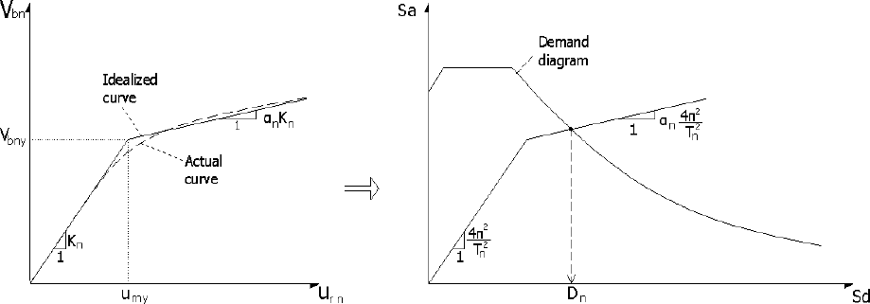

Figure 1:Idealized pushover curve and capacity curve for the nth mode of the MDOF system and analogous inelastic SDOF system

**3.2 Modeling Process**

The research case involves selecting a multi-span concrete bridge located near the Godavari river in the kopargao region. The bridge deck is upheld by a solitary-span of prestressed concrete girders. The girders are positioned on the concrete pier head using a bearing and secured in the horizontal direction. The supporting piers have different heights, however for this research, a uniform height of 8 meters has been chosen. The bridge has a width of 36.2 meters and a length of 50 meters for each span. The bridge is classified as a 7-span bridge, designed to accurately simulate the behavior of a multi-span bridge as a unified structure. The deck is supported by 14 prestressed girders that are interconnected. The deck structure in the SAP2000 Nonlinear program is represented as a collection of linear parts. The deck is presumed to be inflexible in the x- and y-axes. All nodes are located at the same height, namely at the center of gravity of the girder and stringers. The mass is concentrated at both ends of the element. Each pier is represented as an element exhibiting elastic-plastic behavior. It is hypothesized that the piers would experience failure due to flexural mode, resulting in the formation of a plastic hinge at the base of the pier. The plastic hinge's moment-rotation capacity is determined by analyzing the stress-strain relationship of the section, taking into account the influence of transverse reinforcement on confinement. The modeling of bearing is achieved by the use of the link element in the SAP2000 Nonlinear program. Each pile is represented as a spring with six degrees of freedom to provide for translational and rotational support, in order to handle the interaction between the soil and structure. After the modeling process, the subsequent phase in analyzing a structure involves the application of loads. It is necessary to have a design response spectrum in order to carry out pushover analysis. The construction of this bridge is planned for a seismic zone with a peak ground acceleration coefficient of PGA = 0.3g.

1. **RESULT AND DISCUSSION**

**4.1 Pushover Curve**

Pushover curves were obtained by applying the modal load pattern of the 4th, 18th, 19th, and 31st modes in the transverse direction of the bridge. These curves represent the relationship between the deck displacement and the corresponding load, as illustrated in Figure 3. It should be emphasized that these curves may not accurately reflect the true behavior of the structural elements of the bridge. For instance, the capacity curves associated with mode 4 have a mostly linear behavior, suggesting that the bridge does not experience significant deformation when exposed to the 4th modal load pattern. Only the center pier area exhibits elastic behavior in this example, while the edge piers enter the inelastic range. This is because the higher modal load patterns, which are not crucial for the core part of the bridge, affect the edge piers. When comparing the capacity curves based on different control load locations, it is evident that the curves generated using the most critical pier location are more accurate in reflecting the actual behavior of the bridge. These curves indicate that at some point in the response, one or more piers of the structure become yielding. In the analyzed bridge, the capacity curves shown in Figure 2 show that the structure would first experience yielding in response to the basic transverse mode (4th mode), followed by yielding owing to the 18th mode, and finally the 31st mode.

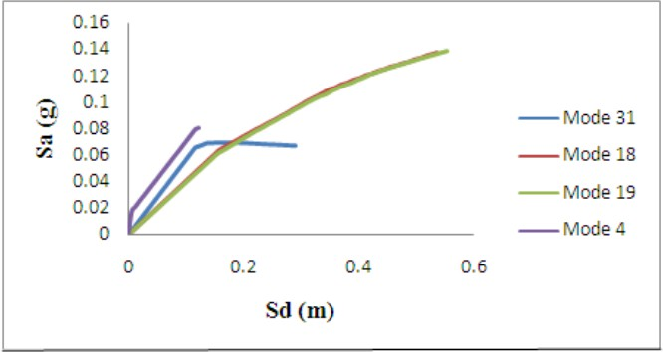

Figure 2: Capacity curves generated based on the deck's displacement.

**4.2 Assessment of the NL-THA and MPA method**

The efficacy of the modal pushover techniques was assessed by comparing them to the results obtained from the NL-THA. In order to do this, temporal acceleration records that are consistent with the design spectrum were used in the NL-THA assessments. The deck displacements obtained from MPA studies, relative to the control point of the most critical pier, were compared to those obtained from NL-THA for various degrees of seismic excitation. This comparison is shown in Figure 3. The deck displacements shown in the images for the THA instance are the mean of the highest displacements observed in the structure during time history analysis. The MPA technique, which considers four transverse modes, accurately forecasts the deck displacements of the bridge. at contrast, the MPA approach exhibits a higher degree of similarity to NL-THA and yielded more accurate predictions at the terminal regions of the bridge. As the amount of excitation intensifies, the influence of higher mode contributions becomes more prominent.

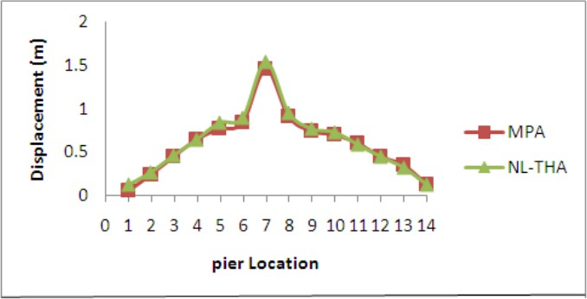

Figure 4: Show the displacement of the deck at the pier site.

**4.3 Calculation of the total base shear and determination of plastic rotations**

To enhance the assessment of the MPA analysis findings, a comparison is conducted between the total base shear and plastic hinges' rotations at the bottom of piers. This comparison involves the results obtained from the MPA analysis and the equivalent values from the NL-THA process. The comparison is carried out for different degrees of earthquake excitation. The MPA method yields superior outcomes and underestimates the base shear by a mere 21%. MPA demonstrated superior predictive accuracy, with variations ranging from 2% to 14%. One notable benefit of the MPA approach is its ability to accurately observe the formation of plastic hinges at P2 and P11. As a result, the level of agreement between MPA and NL-THA is considered quite acceptable.

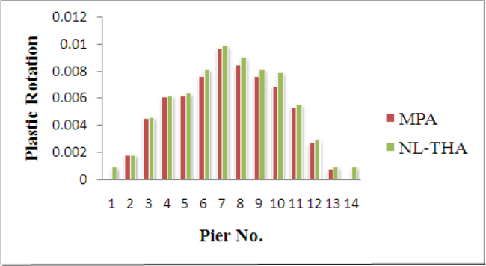

Figure 5: Show the rotation of plastic hinges located at the bottom of piers

1. **Conclusion**
2. Bridges are characterized by their horizontal extension and the restraint of their two ends, which distinguishes their dynamic properties from those of structures. After conducting an analysis of the structure using the Modal pushover analysis (MPA) and Nonlinear time history analysis (NL-THA) methods.
3. it was determined that MPA is a promising approach that provides more accurate results compared to the standard pushover method. Additionally, MPA does not require extensive modeling effort, computational cost, or other complications associated with NL-THA.
4. The maximum displacement computed using the MPA at pier no. 7 is 5% higher than that of the NL-THA. The displacement profile of the MPA closely matches the profile produced from NL-THA, with deviations ranging from 3% at pier no. 11 to 9% at pier no. 5.
5. The MPA approach demonstrated improved outcomes when the intensity of earthquake stimulation and the amount of inelastic deformation in the structure were heightened.
6. In contrast, the MPA technique offered a much enhanced estimate of the maximum displacement pattern, which closely resembled the more detailed NL-THA method. This was seen even when the earthquake loading rose, leading to a greater influence of higher modes.

**References**

1. Li, S., Farshad, H. D., Wang, J. Q., and Alam, M. S. (2022). “Utilizing a new self-centering hysteresis model to assess the seismic vulnerability of a long-span cable-stayed bridge equipped with SMA wire-based roller bearings.” Advances in Bridge Engineering, Springer Science and Business Media LLC, 3(1).
2. Poojitha, G. N., Vinod, Y., and Lingeshwaran, N. (2021). “Seismic fragility analysis of multi span highway bridge based on probabilistic approach.” Materials Today: Proceedings, Elsevier BV, 47, 5185–5193.
3. Zhang, J.-Z., Jiang, J., and Li, G.-Q. (2016). “An improved consecutive modal pushover procedure for estimating seismic demands of multi-storey framed buildings.” The Structural Design of Tall and Special Buildings, Wiley, 26(4), e1336.
4. Liu, X., and Fu, C. C. (2019). “CASE STUDY OF 3D SEISMIC PUSHOVER ANALYSIS OF INTEGRAL ABUTMENT BRIDGE.” Proceedings of International Structural Engineering and Construction, (D. Ozevin, H. Ataei, M. Modares, A. P. Gurgun, S. Yazdani, and A. Singh, eds.), ISEC Press, 6(1).
5. Mu, Y. N., Shi, L., and Zhang, Z. (2010). “Studies and Improvements on Modal Pushover Analysis and Application on Bridge.” Advanced Materials Research, Trans Tech Publications, Ltd., 163–167, 4076–4082.
6. SARITAŞ, F., and HASGÜR, Z. (2023). “Seismic Responses of an Isolated Long-span Bridge using Frequency Domain and Time Dependent Procedures.” Turkish Journal of Civil Engineering, Teknik Dergi, 34(4), 45–70.
7. Zou, Z. Q., Zhou, L. P., and He, G. J. (2010). “Seismic Analysis of Continuous Rigid Frame Bridge with Energy-Based Modal Pushover Method.” Advanced Materials Research, Trans Tech Publications, Ltd., 163–167, 3939–3942.
8. S. M. Vaidya. (2020). “A Modal Pushover Analysis on Multi-Span Bridge to Evaluate Seismic Responses.” International Journal of Engineering Research and, ESRSA Publications Pvt. Ltd., V9(06).
9. Murdiansyah, L., Permata, R., and Essen, D. (2020). “Modal pushover analysis on reinforced concrete arch bridge to estimate seismic responses.” E3S Web of Conferences, (S.-J. Hwang, L. Comfort, I. W. Segara, and A. Hakam, eds.), EDP Sciences, 156, 03005.