AN INTEGRATED SMART METERING SYSTEM USING LORA TECHNOLOGY
Gunasekaran. I¹, M. Kavya², R. Kowsalya³, P. Nishanth⁴, R. Arun Prasath⁵, R. Mahendran⁶
^{1,2,3,4,5 & 6} UG Student, Department of EEE, Sengunthar Engineering College, TamilNadu – 637205, India
ABSTRACT
Precise meter readings are essential for effectively regulating residential energy systems in India's smart city context. However, due to the high number of users and the absence of daily consumption monitoring, standard meter reading methods are expensive and time-consuming, which causes consumer unhappiness. The suggested approach to address this issue is to put in place an integrated wireless smart energy system that makes use of smart metering technologies. The way utilities manage energy could be completely changed by this method. The integrated system is intended to take the place of the traditional digital energy meters, which are primarily used to record meter readings properly for payment purposes. This allows for automatic meter readings without the need for frequent travels to the location where the meters are located.Low Power Wide Area Networks (LPWAN) technology, which is renowned for its low power consumption, cost-effectiveness, long-range coverage, and efficient penetration, are used in this technology to enable the transfer of accurate and secure data on energy usage in real-time. The experiments that resulted from the trials allowed the energy to successfully communicate and documented reliable readings. By providing users with real-time usage data and guarding against overloaded scenarios, the system also benefits consumers. Additionally, the device reports electricity theft to the utility company. The shortcomings of the conventional systems and design difficulties are addressed by the suggested system
Keywords: LoRa, PZEM-004T, Current Sensor, Relay, Digital meter, Web or Mobile application
- INTRODUCTION
Cities place a strong emphasis on becoming smart cities to address the issues of a growing population, hyper-urbanization, and globalization while ensuring the stability of the economy and environment. The goal of a "smart city" is to enhance and improve city infrastructure and operations by utilizing technology and networked data sensors. Meters are typically fixed to the consumer's home and used to collect data on how much energy is used. The data is then displayed, either on a dial meter or a digital display. Each time they visit a site, whether weekly or monthly, meter readers record usage information. This strategy has several shortcomings. When meters are installed inside a customer's home, the meter reader might not be able to read and record the customer's monthly energy usage if the customer is not home. The utility provider must in these circumstances base usage decisions on the average monthly bill sum. Estimates of electricity usage and billing are unfair to both the business and the customer. If power is not used, the customer can face additional financial hardship or may be displeased with the situation. This billing strategy is improper from the provider's point of view as it will give an inaccurate picture of the entire amount of energy used in the consumer's area and could result in errors in the business's future planning. The utility company employs meter readers at large since the conventional method also necessitates regular trips to the customer's property. The traditional method of gathering and analyzing data on a daily basis takes time, and there is a high possibility that human error may lead to erroneous data. Therefore, manually gathering the data is not possible, especially in countries with dense populations. Therefore, it’s essential to have an automated system that can keep track of consumption, warn users of any irregularities, and offer real-time information. AMR, which intends to automatically collect meter measurements and send commands to the meters, has additional prospects thanks to the growing usage of wireless connections. Scalable, dependable communication at an affordable price is essential for smart meter reading’s technical and commercial success. In order to find the best way to combine the aforementioned variables, several service providers have experimented with various communication technologies or even developed their own.
- OBJECTIVE
The purpose of a Lora (Long Range) energy meter is to remotely and efficiently monitor energy consumption in various applications. It uses Lora technology, a low-power, long-range wireless communication protocol, to transmit energy consumption data to a central system or receiver. Lora energy meters enable the remote monitoring of energy consumption in homes, businesses, and industrial settings without the need for physical access to the meter. They help individuals and organizations track their energy usage patterns, identify inefficiencies, and make informed decisions to reduce energy consumption and save costs. Lora energy meters collect data on energy consumption, which can be used for billing purposes, load forecasting, and optimizing energy distribution. These meters provide real-time data on energy usage, allowing for immediate response to unusual or unexpected spikes in consumption. They promote sustainability by encouraging users to reduce energy wastage.

EXISTING SYSTEM
The digital energy meter records power usage by detecting LED flashes within the meter through an optocoupler, consisting of an IR diode and a phototransistor. Each LED flash activates the IR diode, emitting infratted light that turns on the phototransister functioning like a regular bipolar transistor these phototransistor pulses interrupt the microcontroller tracking the total consumption. which is stored in an EEPROM. This digital meter consider 3200 LED flashes as one power unit per hour.In the setup the microcontroller is programmed to interput 320 flashes as one unit every 6 minutesa (1 hour =60 minutes/10). It includes consumed over to hourly An LCD is connected to the microcontroller to display the current cycle
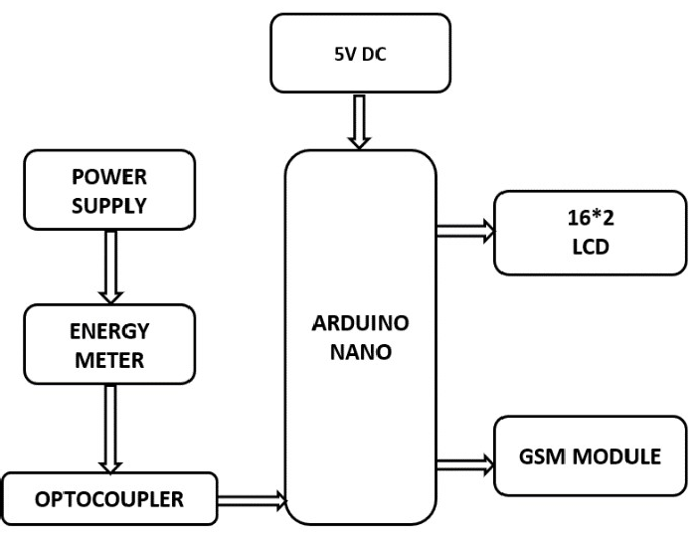

Figure 1: Block diagram of existing system
After each cycle, the microcontroller calculates the billing amount based on local rates and sends both the total consumption and the billing amount to the GSM module. The GSM module programmed with AT command wirelessly transmit this information to user as an SMS.

PROBLEM IDENTIFICATION

In current systems,either an electric an electronic energy gauge or an electro-mechanical gauge is installed with in the permises to gauge the consumption. The gauge presently in operation can soley document kilowatt-hour (Kwh) units The Kwh units still units still necessitate monthly recording by meter inspector , individuals who must traverse from One building to another The recorded information needs to be processed by a meter reading corporation. To process the meter reading, the corporation must initially associate each recorded power usage data point with an account holder and then ascertain the amount due by utilizing the specific tariffic in effect. Consequently, wireless intelligent energy meter are submitted to ensure precise tariff computation and minimize inaccuaacies stemming From human reader. These intelligent energy meters employ wireless technologies such as GSM and Wi-Fi. The principal drawback of these systems is the requirement for network connectivity at the consumer’s end for the smart energy meter to establish a wireless connection.The current electricity consumption biling system exhibits inaccuracies in recording and is also higky time-consuming.Errorsmare prone to occur at each stage due to the ude of electro-mechanical metrers ,human mistakes during meter reading ,and errrors in processing both paid and due bills. The smart enrgy meter represents an innovative approach capable of mitigating these billing-related problems and reducing the need for manual meter reading.It offers numerous advantages for both electricity distributors and consumer. This intelligent energy meter has been developed based on LoRa technology.By utilizing LoRa echnology it can overcome the drawbacks associated with using gsm or wifi networks importantly it doesn’t necessitate additional towers or consumer side network acess for these smart enerdy meters to establish a wireless connection. Consequently these smart energy meters transmit data wirelessly from consumers to distibutors using LoRa technology. On the distributor’s end, the acquired dsta is uploaded to a webpage. Enabling consumers to acess it at any time and from anywhere.

- PROPOSED SYSTEM

The suggested dystem adopts an inventive approach to smart energy meters, harnesting the benefits of LoRa technology. In contract to conventional wireless nrtworks like GSM or wi-fi, this system obivstes the need for additional towers or consumer-side network access. This not onbly reduces infrastructure expenses but also streamlines energy meters facilitate seamless wireless communications between consumers and distributors. Energy consumption data is transmitted securely and dependably acros extended distances, thanks to LoRa’s long- range capabilities.

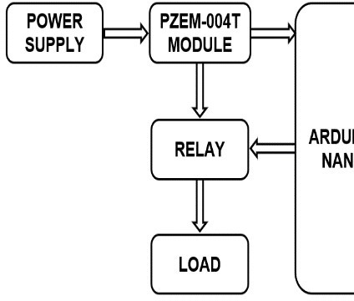
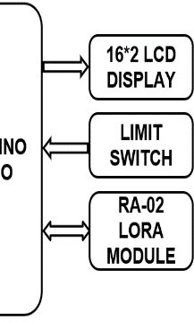

Figure 2: Block diagram of receiver side
This guarantees that even remote consumers can easily connect to the system without connectivity restrictions. On the distributor's end, received data is efficiently uploaded to a dedicated webpage, granting consumers convenient access to their energy consumption data at any time and from anywhere. This web-based interface offers an intuitive and user- friendly platform for consumers to oversee and assess their energy usage patterns, empowering them to make informed decisions regarding their consumption habits. Furthermore, by capitalizing on the robustness and scalability of LoRa technology, our system can accommodate numerous smart energy meters within an extensive area network.
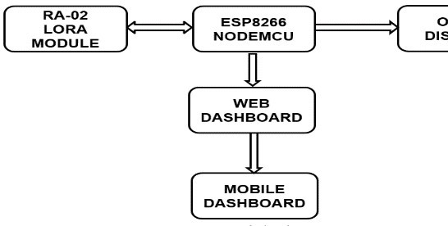
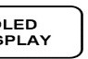

Figure 3: Block diagram of receiver side

- METHODOLOGY

The Smart Energy meter consists the PZEM-004T module which is used to measure the various parameters like voltage, current, power, energy, power factor and frequency. These data are measurerd using this module and communicate with Arduino using a SPI communication,In that any voltage fluct lation ocurrs, the liad is connected with the relay switch it suddenly cut-off the power given to the load. It also has Limit switch it is placed under the enclosure where the connection is made once the connection is done it will be sealed. But some consumers break thar seal and bypassing the meter under that condition the switch open and the message is sent to the operator as the energy theft occurs. These data are transmitted data using the RA-02 Lora module which uses the free frequency band to transfer the data. The transmitted data is received by the receiver which the Lora module is connected with the nodemcu because it has the inbuilt Wi-fi module. The transmitted data are shown using the OLED display and the same data is transmitted to web and Mobile Dashboard. Here the receiver is known as master node, We are using two nodes connected with single master node for every 5 seconds the data transmitted from the nod to the master node.

- SIMULATION AND RESULT

The software module consists of the various electronic components such as step-down transformer, Diode, Resistor, Current Sensor, Arduino uno and LCD Display. The simulated block diagram of The software module consists of the various electronic components such as step-down transformer, Diode, Resistor, Current Sensor, Arduino uno and LCD Display. The simulated block diagram of the proposed system measures the energy consumption data and shown the values on the LCD display is shown in figure.4.

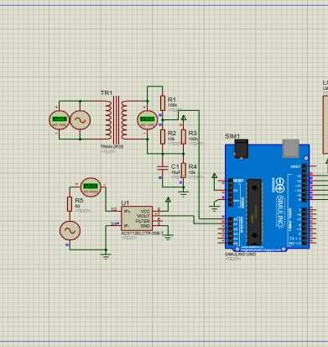
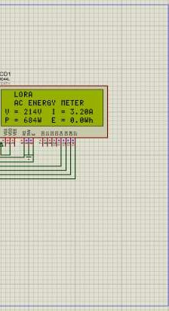

Figure 4: Simulation diagram
In which the step-down transformer down the voltage which is giv n to the variable resistor which the less than 5v to the analog pin of the arduino which measures the voltage and shown on the display. ACS712 Ic is used measure the current value flown in the circuit.
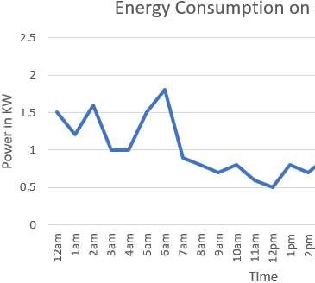
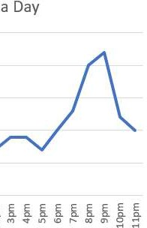

Figure 5: Energy consumption data on a data

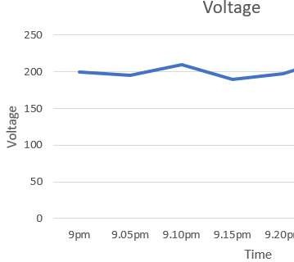
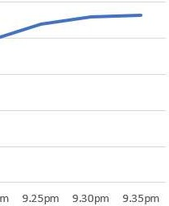

Figure 6: Voltage range data

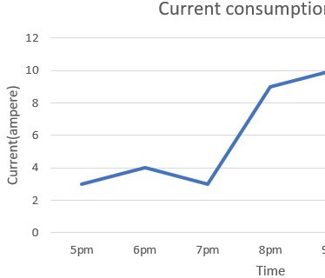
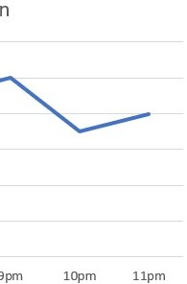

Figure 7: Current consumption data

- CONCLUSION

The comprehensive solution outlined in this research presents various functions, including remote power control, disconnection and reconnection, alerts for disconnection, power theft, and overloading. These features set the system apart from existing alternatives, emphasizing its unique attributes, improved functionality, and flexibility. The platform incorporates advanced sensing and communication capabilities, thereby enhancing its suitability for real-time deployment. By utilizing the LoRa communication protocol, an affordable and efficient solution is established to seamlessly manage the integrated energy meter. Energy consumption data is transmitted wirelessly via LoRa, with the integrated meter demonstrating effective long-range communication spanning up to 5 kilometers. This integrated system effectively monitors a household's energy usage, making it well-suited for smart city applications. Furthermore, the monitoring system assists users in identifying and addressing unusual energy consumption patterns. Currently, the unified system is implemented for a single user, with plans to expand its application to two users in subsequent studies. Future research will extend these experiments to include multiple users.
- REFERENCES

- Vijayakumar K, Abdul Samad N, Deepak Raj M, Haripraveen S, “Iot Based Smart Energy Meter Using LoRa Technology”, International Scientific Journal of Engineering and Management, Volume: 02 Issue: 08 | August 2023.
[2] N. Sushma, H. N. Suresh, J. Mohana Lakshmi, Parvathaneni Naga Srinivasu, Akash Kumar Bhoi, Paolo Barsocchi, “A Unified Metering System Deployed for Water and Energy Monitoring in Smart City”, IEEE, volume 11, 2023.
[3] Amarjeet Singh Chauhan, Mohit Yadav, Aditya Vardhan, “IoT Based Smart Electricity Meter with Energy Prediction and Consumption”, Journal of Emerging Technologies and Innovative Research, Volume 9, Issue 1, January 2022.
[4] Nutan B. Jadhav, Prathmesh S. Powar, “IoT based Smart Energy Monitoring System”, Journal of Emerging Technologies and Innovative Research, Volume 8, Issue 8, August 2021.
[5] F. Richard, R. Ragul, M. Abdul Majeed, V. Hamsadhwani, “LoRa Based Smart Energy Meter”, International Journal of Scientific Development and Research (IJSDR), Volume 6, Issue 4, April 2021.
[6] Ketaki S. SudameProf.Sumera Ali Dr.AM.Rawate, “Review on Design of IOT Based Energy Monitoring System and Home Automation”, Journal of Emerging Technologies and Innovative Research, Volume 7, Issue 3, March 2020.
[7] Dhande Sharayu, Dhanawade Harshada, “Smart Electricity Consumption Meter using LoRaModule”, International Journal of Advance Research, Ideas and Innovations in Technology, Volume 5, Issue 4, 2019.
[8] Ms. Komal Shirke, Ms. Meghna Brid, Ms. Tanuja Adhikari, “IoT Based Energy Meter Android Application”, Journal of Emerging Technologies and Innovative Research, Volume 6, Issue 5, May 2019.
[9] Dr. R. Satish Kumar, Dr.K.Umadevi, Mrs.T.Gohila, S.Gayathri, S.A.Joshika, N.SidheswariIOT Based Smart DC HouseAn International Multidisciplinary Double-Blind Peer-reviewed Research JournalVol- 01,Issue III & 94-98 2020.
[10]Ms.K.Deepa, Dr.K.Umadevi Mr.V.Vasanth, Mr.S.Sarathkumar, Mr.S.Lokesh Stepper Motor Controller An International Multidisciplinary Double-Blind Peer-reviewed Research Journal Vol-01, & 10-12-2020

