Fuzzy logic based level monitoring using IoT and LabVIEW

R.Sharan Instrumentation and control

engineering Saranathan college of engineering

Tiruchirappalli, India [sharanravindran05@gmail.com](mailto:sharanravindran05@gmail.com) Dr.S.M. Girirajkumar Instrumentation and control engineering

Saranathan college of engineering Tiruchirappalli, India [ice.hod@saranathan.ac.in](mailto:ice.hod@saranathan.ac.in)

S.Rohan Instrumentation and control

engineering Saranathan college of engineering

Tiruchirappalli, India [s.rohan4127@gmail.com](mailto:s.rohan4127@gmail.com)

BA.Yeshvant Instrumentation and control engineering

Saranathan college of engineering Tiruchirappalli, India [yeshvantyesh10@gmail.com](mailto:yeshvantyesh10@gmail.com)

***Abstract*— The research presented here presents a revolutionary industrial-level management device, leveraging fuzzy logic and IoT technologies. The system, implemented in LabVIEW, provides an efficient method for monitoring liquid or chemical levels in tanks. It uses sensors to gather data, processed by a fuzzy logic controller, designed to handle uncertainties and imprecisions, offering more accurate results than traditional methods. The LabVIEW user-friendly interface allows easy programming for the controller and visualization of results. IoT integration enables remote system control and real-time data access, facilitating global decision-making. The system's effectiveness is validated through simulations and experimental results, demonstrating its potential for diverse industrial applications. This cost-effective, efficient, and reliable solution enhances level monitoring using advanced technologies.**

***Keywords—LabVIEW, MyRio, Level Monitoring, Fuzzy Logic Controller, PID controller, IoT, MATLAB.***

1. Introduction

In Industries such as manufacturing, agriculture, and chemical processing, there is a constant need to monitor and control the levels of liquids in tanks or containers [4]. Accurate and efficient level monitoring is essential for ensuring the smooth operation of these processes and avoiding costly downtime or accidents. Traditional methods of level monitoring often rely on simple threshold-based approaches or complex mathematical models, which may not always provide accurate results, especially in dynamic or uncertain environments.

With the development of technology, the Internet of Things, also known as IoT, has made it possible to connect and communicate with a wide range of systems and objects. IoT has demonstrated great promise in many important sectors, including industrial control and surveillance [2].

Fuzzy logic controller, offers a more flexible and robust approach to dealing with uncertainty and imprecision, making it well-suited for applications such as level monitoring [6]. The combination of fuzzy logic and Internet of Things (IoT) technologies has emerged a]s a promising approach for tackling the challenges of level monitoring in various industrial applications. The ability to accurately monitor and control levels is crucial for ensuring the efficient and safe operation of processes involving tanks, reservoirs, and other liquid storage systems. However, traditional monitoring systems often face limitations in handling uncertainties and imprecise input data, which can lead to unreliable measurements and inadequate control. This approach leverages the benefits of fuzzy logic-based control and the connectivity of IoT to develop a robust and flexible level monitoring system. Fuzzy logic offers an effective basis for handling imprecise and uncertain data [7]. In contrast to conventional binary logic, fuzzy logic enables the representation of degrees of membership and partial truths, allowing the system to manage the inherent uncertainty involved in level monitoring. By using fuzzy rules, the proposed system can effectively capture and model the complexities and uncertainties of real-world level monitoring scenarios.

Moreover, the integration of IoT technologies enhances the capabilities of the system. By connecting sensors, actuators, and other devices to the internet, the system gains real-time data acquisition, remote accessibility, and enhanced communication capabilities. This enables operators to monitor levels, receive alerts, and even control processes remotely, improving operational efficiency and reducing the need for manual intervention [1].

The LabVIEW platform, a widely adopted graphical programming environment, serves as the foundation for implementing the proposed fuzzy logic-based level monitoring system. LabVIEW's intuitive interface and extensive libraries make it an ideal choice for developing IoT applications, facilitating the design, implementation, and deployment of the system. The main objective is to present the design, and evaluation of the fuzzy logic-based level monitoring system using IoT by LabVIEW [2].

The system's architecture, including the fuzzy logic controller, IoT integration, and data analysis modules, will be discussed in detail. Experimental results and performance evaluation will be presented to demonstrate the effectiveness and reliability of the proposed approach. The contributions of this research include providing a comprehensive solution for level monitoring in

industrial applications, addressing the challenges of uncertainty and imprecision using fuzzy logic, and real-time capabilities of IoT. The proposed system has the potential to enhance operational efficiency, improve safety, and reduce costs in various industries, including manufacturing, chemical processing, and water management [8].

1. Methodology
2. *Fuzzy logic design - mumdani-based fuzzy interface system:*

The intelligent controller utilized a Mamdani-type Fuzzy Inference System (FIS), which fundamentally establishes a nonlinear transformation of the input data vector into a singular output, employing fuzzy rules. This transformation process encompasses input and output membership functions, fuzzy logic operators, fuzzy if-then rules, the aggregation of output sets, and defuzzification (Alshalaa & Issmail, 2013; Zvonko, Predrag, Dragan, & Milan, 2012; Guillaume & Charnomordic, 2015; Shakiru Olajide KASSIM, Aishatu Garga Ali, & Ibrahim Muhammad Harram,Oct 2021). Refer to Figure 1 for a comprehensive depiction of the Fuzzy Inference System FIS structure.

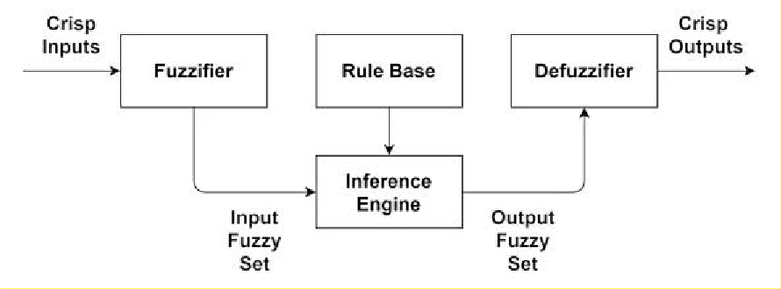

Fig 1 : Block diagram of Fuzzy Inference System (FIS)

Mamdani-based Fuzzy Inference Systems (FIS) are predominantly utilized by numerous researchers (Michael & Kiriaki, 2018; Shakuntla, Agarwal, & Sandhu, 2020) and are recognized for their ability to encapsulate expert knowledge. This is due to their capacity to describe a system in a manner that is more intuitive and human-like compared to Takagi-Sugeno based FIS (Arshdeep & Amrit, 2012; Deepa & Ahijit, 2015; Shrivishal, Ashish, Shashank, & Sandeep, 2018; Vandna & Amrit, 2013). While both systems have their unique advantages, the expressive power and interpretability of Mamdani output render the Mamdani-based FIS a popular choice for decision support applications. Consequently, it was selected for level controller in this study.

1. *Implementation of process tank:*

Several types of level indicators have been proposed by many researchers (Reza, Tariq, & Reza, 2010; Anyanwu, Mbajiorgu, & Anoliefo, 2012; Mallikarjun, Nagaraj, Shrikanth, Ali, & Pramod, 2018; Latte, 2017; Kassim & Abatcha, 2016; Shakiru Olajide KASSIM, Aishatu Garga Ali, & Ibrahim Muhammad Harram,Oct 2021). Based on the majority of studies, electrical sensing devices have demonstrated superior reliability and ease of construction and installation. This study presents a simulation of a level indicator centered around a fuzzy logic controller. The controller is predicated on a fundamental level indicator comprising transistors and sensor levels within an electronic circuit. Figure 2 for representation of process tank.

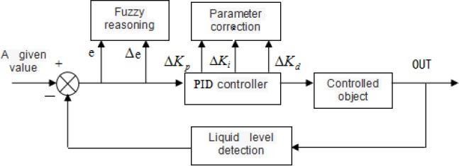

Fig 2: Block diagram of Level Monitoring System

1. *Mathematical model of the process tank:*

In this design, Liquid or fluid is supplied from a supply tank or main tank via a pump, with the flow rate being modulated by an actuator or control valve. The supply tank or main tank liquid level is gauged through a pressure transmitter, which conveys the differential pressure signal (4-20mA) to the controller. The system’s mathematical model is encapsulated by a first- order system.

(In general): Ratio of accumulation of mass in system = Ratio of mass entering system – Ratio of mass leaving system





PROCESS VARIABLE

200

150

100

50

0

0

20

40

60

80

100

120

Fig 3: Real Time reading of Level range For first order transfer function for the process control system is defined as:

(In general):  (For Level process) :

1. Simulation system design:
   1. *Fuzzy logic system design:*

The controller of the system is based on the Mandani model and it was developed using the Fuzzy Logic control system in LabVIEW figure 3.

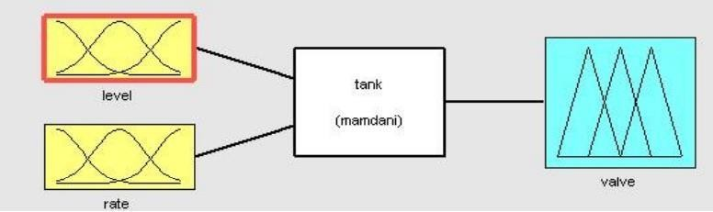

Fig 4: Block diagram of mamdani system

The simulation utilizes a rule base expressed in linguistic terms, incorporating two input parameters and one output parameter.

liquid level= [0,100] and liquid error= [-5, +5]

While the output parameter is the control angle of inlet valve [0,10].

* 1. *Fuzzification system:*

In the fuzzifying process, the input and output variables, triangular membership functions have been chosen. Each of the two inputs incorporates three fuzzy sets, while the output variable comprises five fuzzy sets. The system’s fuzzification processes, with the y-axis representing membership values, are depicted in the subsequent figures 4,5,6 & 7.

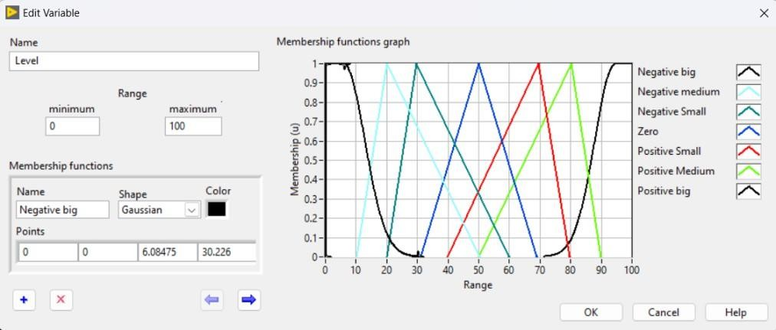

Fig 5: Input membership of Mamdani system.

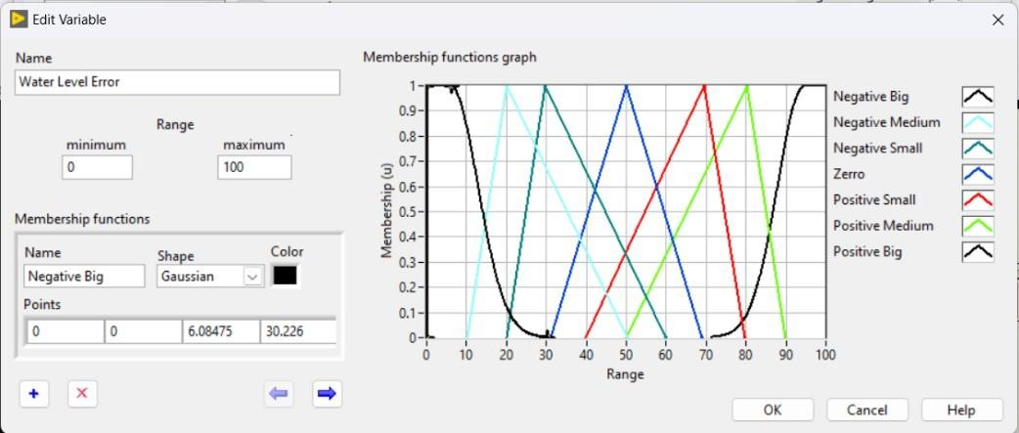

Fig 6: Input membership of Mamdani system.

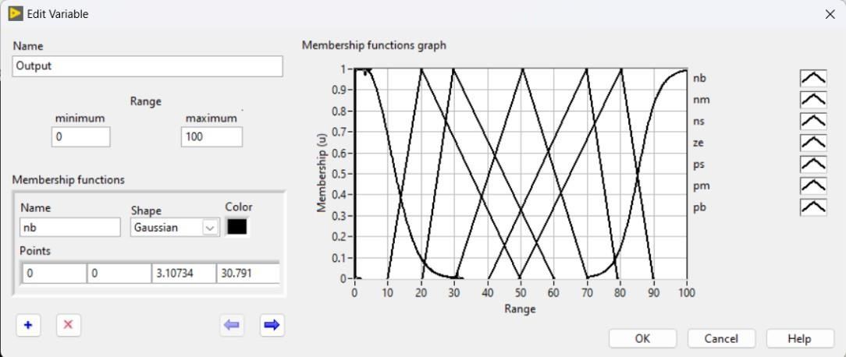

Fig 7: Output membership Mamdani system

* 1. *Controller rules:*

The fuzzifications of two input and the abbreviation are show in figure 8. Twenty-five (25) rules were created for the system controller to make up the rule base, this are clearly shown in the rule editor window given in figure 8 below. The Basic Rules Table Rules translate the relationships between input and output linguistic variables into words based on their linguistic language.

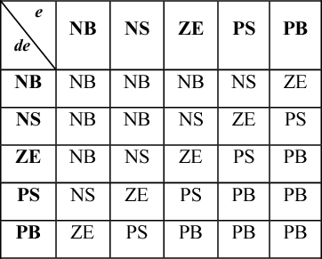

Fig 8: Rules for Mamdani system

The total number N of possible rules for a fuzzy system is defined by the following formula: N = p1 × p2 × … × pn is the number of linguistic phrases for the input linguistic variable n. If every input linguistic variable has the same number of linguistic terms, then the total number N of feasible rules is defined by the following equation:

N is equal to p^m, where p is the quantity of linguistic phrases for every input linguistic variable and m is the total number of input linguistic variables. Plotting a rule base as a matrix could be helpful in finding discrepancies, such as contradicting rules. However, matrix plotting of a rule basis works best for relatively small rule bases. Large rule bases make discrepancies difficult to discover. Huge rule bases in fuzzy systems with several controller inputs can be avoided with the usage of cascaded fuzzy systems.

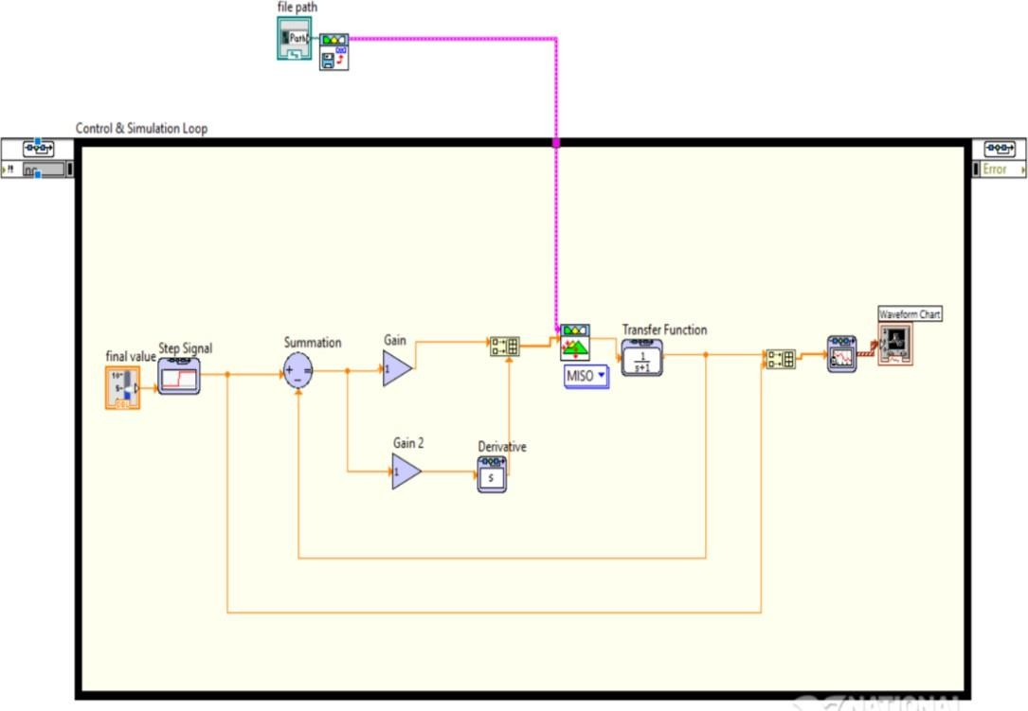

Fig 9: Block diagram of Mamdani system in LabVIEW

* 1. Internet Of Things IoT:

The integration of IoT technologies, including devices, sensors, communication protocols, and cloud-based platforms, is being explored for the efficient and accurate monitoring of liquid levels in industrial processes. This paper highlights the benefits, challenges, and potential future developments in leveraging IoT for industrial process control. By enabling real-time and remote monitoring of level data, proactive decision-making, and predictive maintenance can be achieved. The paper also discusses the challenges and potential future developments in leveraging IoT for level measurement in industrial settings, highlighting its potential for operational efficiency, safety, and resource optimization.

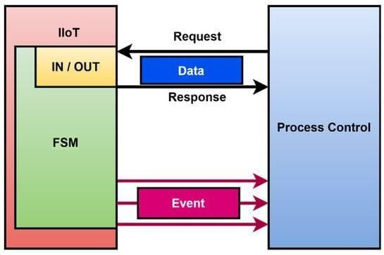

Fig 10: Block diagram of IoT

1. Results and Analysis

The fuzzy logic controller (FLC) was successfully implemented for the level control system. The mathematical model accurately represented the dynamics of the tank, including inflow and outflow rates, and tank dimensions. The FLC design incorporated linguistic variables, membership functions, fuzzy rules, and a defuzzification method. The input variables considered were error (difference between desired and actual level) and rate of change of error.

A comprehensive set of fuzzy rules was developed that mapped these input variables to appropriate control actions. The simulation model was implemented using a suitable programming language. These included step changes in the desired level, disturbances in the inflow rate, and variations in the tank dimensions. The simulation results showed that the FLC performed exceptionally well across all test scenarios. Various test scenarios were defined to evaluate the performance of the FLC.

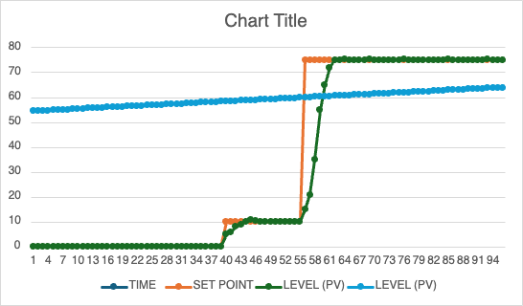

Fig 11: Result

|  |  |  |  |
| --- | --- | --- | --- |
| **TIME** | **SET POINT** | **LEVEL (PV)** | **LEVEL (PV)** |
| 61.8 | 75 | 74.8 | 61.8 |
| 61.9 | 75 | 75.1 | 61.9 |
| 62 | 75 | 75.2 | 62 |
| 62.1 | 75 | 75 | 62.1 |
| 62.2 | 75 | 74.99 | 62.2 |
| 62.3 | 75 | 74.98 | 62.3 |
| 62.4 | 75 | 75.1 | 62.4 |
| 62.5 | 75 | 75 | 62.5 |
| 62.6 | 75 | 75.1 | 62.6 |
| 62.7 | 75 | 74.99 | 62.7 |
| 62.8 | 75 | 75 | 62.8 |
| 62.9 | 75 | 75.2 | 62.9 |
| 63 | 75 | 74.99 | 63 |
| 63.1 | 75 | 75.1 | 63.1 |
| 63.2 | 75 | 75.12 | 63.2 |
| 63.3 | 75 | 74.98 | 63.3 |
| 63.4 | 75 | 74.8 | 63.4 |
| 63.5 | 75 | 75.1 | 63.5 |
| 63.6 | 75 | 75 | 63.6 |
| 63.7 | 75 | 75.2 | 63.7 |
| 63.8 | 75 | 74.99 | 63.8 |
| 63.9 | 75 | 75.1 | 63.9 |
| 64 | 75 | 75.12 | 64 |

Table: Real time reading of LabVIEW

The controller was able to maintain the desired level with minimal error. It responded quickly to disturbances and showed robust performance even with variations in the tank dimensions. When compared with traditional PID control, the FLC demonstrated superior performance. It exhibited faster response times, better stability, and reduced overshoot. The performance of the FLC was further optimized by fine-tuning the membership functions, rule base, and other parameters.

1. Conclusion

Simulation of this paper a novel approach for level monitoring using fuzzy logic and IoT technologies, implemented through LabVIEW. The proposed system demonstrated superior performance in handling uncertainties and variations inherent in real-world environments, outperforming traditional methods. The FLC, designed with specific linguistic variables, membership functions, and a robust rule set, exhibits adaptability and precision. It outperforms traditional PID control in various scenarios, including step changes, inflow disturbances, and tank dimension variations.

The integration of IoT enabled real-time data access and decision-making from anywhere in the world, enhancing the system’s adaptability. The effectiveness of the system was validated through rigorous testing, highlighting its potential for various industrial applications. Future work could explore automated tuning methods or adaptive fuzzy systems to further enhance the controller’s performance. Overall, the proposed system offers a promising alternative to traditional control strategies, underscoring the potential of fuzzy logic control in industrial applications where precision, adaptability, and robustness are required

1. References
2. K Niharika, S. Srinivasulu Raju, Y Sujan, K. Sai Tarun, and B. Teja, “Design and Implementation of Fuzzy Logic Controller for Boiler Temperature Control using LabView,” Jan. 2023, doi: https://doi.org/10.1109/iccci56745.2023.10128550.
3. A. N. Yumang, L. Aldwin, and G. A. Mandapat, “IoT-based Monitoring of Temperature and Humidity with Fuzzy

Control in Cherry Tomato Greenhouses,” Mar. 2023, doi: https://doi.org/10.1109/iccae56788.2023.10111404.

1. Z. Muhammad, A. Dziauddin, Shabinar Abd Hamid, and Nor, “Water Level Control in Boiler System Using Self- Tuning Fuzzy PID Controller,” Aug. 2023, doi: https://doi.org/10.1109/iccsce58721.2023.10237138.
2. Y. M. K. Ali, O. A. Zargelin, F. Lashhab, and A. Alaribi, “Water Level Control System using Programmable Logic Controller (PLC): Rujban Water Supply System,” IEEE Xplore, Apr. 01, 2021. https://ieeexplore.ieee.org/document/9422619 (accessed Jun. 22, 2023).
3. V. Osadchyy and O. S. Nazarova, “Laboratory stand for investigation of liquid level microprocessor control systems,” 2020 IEEE Problems of Automated Electrodrive. Theory and Practice (PAEP), Sep. 2020, doi: 10.1109/paep49887.2020.9240868
4. Y. Feng, M. Wu, X. Chen, L. Chen, and S. Du, “Fuzzy PID control based on working condition identification for mould level in continuous casting process,” 2019 12th Asian Control Conference (ASCC), pp. 833–837, Jun. 2019, [Online]. Available: <http://ieeexplore.ieee.org/document/8764997>
5. D. Shiferaw, A. Hailegnaw, A. Assefa, A. Daniel, E. Dagne, and G. Fekadie, “LabVIEW based Fuzzy Logic Controller for PLC,” 2019 International Conference on Computer, Control, Electrical, and Electronics Engineering (ICCCEEE), Sep. 2019, doi: 10.1109/iccceee46830.2019.9071278.
6. B. Bo, L. Chuang, and C. Meng, “Based on PLC Fuzzy Control Algorithm in the Application of Level Control,” Jul. 2016, doi: [https://doi.org/10.1109/is3c.2016.179.](https://doi.org/10.1109/is3c.2016.179)
7. Kassim, S. O., & Abatcha, G. H. (2016, November). Design, Construction and Implementation Water Level Indicator with Auto-Refill and Numeric Display. Sahel International Multi-disciplinary Journal, 1(2), 6-19.
8. Ihedioha, A. C., & Eneh, I. (2015, November). Water Level Monitoring and Control Using Fuzzy Logic System. International Research Journal of Engineering and Technology (IRJET), 2(8), 1382 - 1395. Retrieved from [www.irjet.net](http://www.irjet.net/)
9. S. B. Prusty, U. C. Pati, and K. Mahapatra, “Implementation of fuzzy-PID controller to liquid level system using LabVIEW,” International Conference on Control, Instrumentation, Energy & Communication, Nov. 2014, doi: https://doi.org/10.1109/ciec.2014.6959045
10. Davood, M. S., Seyed, H. A., & Faridoon, S. (2013, January). Comparative Study between Tank’s Water Level Control Using PID and Fuzzy Logic Controller. Advances in Intelligent Systems and Computing (AISC),195, 141–
11. 153. doi:10.1007/978-3-642-33941-7-15
12. Arshdeep, K., & Amrit, K. (2012, May). Comparison of Mamdani-Type and Sugeno-Type Fuzzy Inference Systems for Air Conditioning System. International Journal of Soft Computing and Engineering (IJSCE), 2(2), 323-324.