**DC to DC Boost Converter with Optimized Speed Control for BLDC Motors**

**P. Gukan1, R.Gowtham2, M. Logeshwaran3, M.Suthi4, R.Dhasarathan5, T.Praveen6**

1,2,3,4,5 & 6 UG Student, Department of EEE, Sengunthar Engineering College, Tamil Nadu – 637205, India.

**ABSTRACT**

BLDC motors offer the potential to replace induction motors, yet implementing an efficient, cost-effective, and easily deployable drive system presents a significant challenge. In this study, we propose an enhanced speed control system for BLDC motors utilizing sensors and readily available controllers. This system is adaptable to operate under diverse conditions, rendering it suitable for a broad spectrum of applications and facilitating the transition from induction motors to BLDC motor systems. The system's response has been analyzed for different speed and load conditions using MATLAB simulation tools.

**Keywords:** Metaheuristic algoritm Permanent magnet brushless DC motors (PMBLDC) PID controller Optimization

**1. INTRODUCTION**

The induction motor is often described as the workhorse of modern industry, possessing numerous advantages over other types of motors. However, it has a limited speed range. This drawback can be overcome while maintaining and enhancing its existing advantages through the use of a BLDC motor system. Some of the notable advantages of BLDC motors include:

* It has long operation life
* It has higher speed range as well as efficiency
* The speed v/s torque characteristics are superior
* The operation is noiseless to some extent
* Compared with other motors the torque-weight ratio is better

Conventional DC motors boast several attractive properties, including high efficiency and linear torque-speed characteristics. Additionally, controlling DC motors is straightforward and does not necessitate complex hardware. However, the primary drawback of DC motors is the requirement for periodic maintenance. The brushes of the mechanical commutator also introduce undesirable effects such as sparks, acoustic noise, and the release of carbon particles.

Brushless DC (BLDC) motors can often serve as replacements for conventional DC motors. Despite their name, BLDC motors are actually a type of permanent magnet synchronous motor. They are powered by DC voltage, but current commutation is achieved using solid-state switches. The timing of commutation events is determined by the rotor position, which can be detected either by position sensors or by sensor less techniques.

BLDC motors offer several advantages over conventional DC motors, such as:

* Long operating life
* High dynamic response
* High efficiency
* Better speed vs. torque characteristics
* Noiseless operation
* Higher speed range
* Higher torque-weight ratio

**1.1. Comparison of BLDC Motor with Other Motors**

In this section, we provide a basic comparison of various machine parameters of a Brushless DC Motor with Brushed DC and Induction Motors. We highlight the advantages of BLDC over the other types and discuss how it can be widely accepted for use in industrial and various other applications. Additionally, we explore how a BLDC motor has the capacity to replace all other types due to its wide range of advantages and its capability to be applied to almost all applications with just a small drive system.

**Table.1** Comparison of BLDC Motor with Brushed DC and Induction Motor

|  |  |  |  |
| --- | --- | --- | --- |
| **Features** | **Brushless**  **DC motor** | **Brushed DC**  **Motor** | **Induction**  **motor** |
| **Mechanical l Structure** | Field magnets on the stator and rotor are made of permanent magnets | Field magnets on the rotor and stator are made of permanent magnets or electromagnet s | Both the rotor and stator have windings but the AC lines are connected to the  stator |
| **Maintenance** | Low or no maintenance | Periodic maintenance because of  Brushes | Low maintenance |
| **Speed- Torque characteristic** | Flat – operation at all speeds with rated load | Moderate – Loss in torque at higher speeds because of losses in  Brushes | Non-linear |
| **Efficiency** | High – no losses in the brushes; Stator is on the outer periphery and is thus able to dissipate more heat and produce more torque | Moderate – losses in the brushes; Rotor is on the inner Periphery | Low – Heat and current losses in both rotor and stator; High efficiency induction motors are also available  (higher cost) |
| **Commutation method** | Using solid state switches | Mechanical contacts between brushes and commutator | Special starting circuit is required |
| **Speed range** | High - no losses in brushes | Moderate – losses in brushes | Low – determined by the AC line frequency; increases in load further reduces speed |
| **Detecting method of rotors position** | Hall sensors, optical encoders, etc | Automatically detected by brushes and commutator | NA |
| **Direction reversal** | Reversing the switching sequence | Reversing the terminal voltage | By changing the two phases of the motor input |
| **Output power / Frame size** | High – Since it has permanent magnets on the rotor, smaller size can be achieved for a given Output power. | Low – because a large amount of power is lost in the brush | Moderate – Since both stator and rotor have windings, the output power to size is lower than BLDC. |
| **Electrical noise** | Low | High – as brushes used | Low |
| **Rotor Inertia** | Low – permanent magnets on rotor, this improves dynamic response | Higher rotor inertia which limits the dynamic characteristics | High – Poor dynamic characteristics |
| **System cost** | High- because of external controller requirement | Low | Low |

**1.2 Objective**

Recent research suggests that permanent magnet motor drives, such as the Permanent Magnet Synchronous Motor (PMSM) and the Brushless DC Motor (BLDCM), could become formidable competitors to induction motors for servo applications. Inspired by these findings, the objectives of this thesis are:

* Providing a theoretical background on the BLDC motor and its controller.
* Designing an Intelligent Artificial Neural Network (ANN) for adaptive and optimized tuning of PID controller parameters KD, KI, and KP.
* Controlling the speed of the BLDC motor using an ANN-based PID controller.
* Implementing closed-loop speed control of the BLDC motor using the MATLAB/SIMULINK software package.
* Comparing the results obtained for the speed control of the BLDC motor using a conventional PID controller versus an ANN-based PID controller.

**2. BLDC MOTOR DRIVE**

A brushless DC (BLDC) motor is a rotating electric machine with a classic three-phase stator similar to that of an induction motor, while the rotor contains surface-mounted permanent magnets. Polarity reversal in BLDC motors is achieved by power transistors switching in synchronization with the rotor position. The BLDC motor is driven by rectangular voltage strokes synchronized with the rotor position. The generated stator flux interacts with the rotor flux, determining the torque and thus the speed of the motor. Despite the name, BLDC motors are actually a type of permanent magnet synchronous motor. In many cases, BLDC motors can replace conventional DC motors.

**2.1 Typical block diagram – brushless dc motor**

The basic block diagram of brushless DC motor drive system is shown. The brushless DC motor drive system consists of four main parts:

* DC power supply
* Power inverter
* Power electronic Switches
* Permanent magnet BLDC motor

**2.1.1 DC power supply**

The fixed DC voltage is derived from either a battery supply, low voltage power supply or from a rectified mains input. The input voltage may be 12V or 24V as used in many automotive applications, 12V-48V for applications such as disc drives or tape drives, or 150V-550V for singlephase or three-phase mains-fed applications such as domestic appliances or industrial servo drives or machine tools.

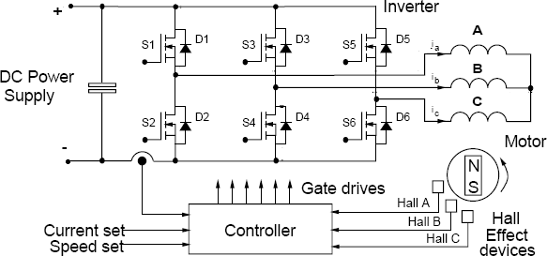

**Figure 1:** Basic Block Diagram of a BLDC Motor

**2.1.2 Inverter**

The inverter bridge serves as the primary power conversion stage in the brushless DC motor drive system. It is responsible for controlling the direction, speed, and torque delivered by the motor through the switching sequence of the power devices. These power switches can either be bipolar devices or more commonly, Power MOS devices. Additionally, mixed device inverters, such as systems using p-n-p Darlingtons as the high side power switches and MOSFETs as the low side switches, are also feasible.

The freewheel diodes in each inverter leg may either be internal to the main power switches, as in the case of FREDFETs, or may be separate discrete devices in the case of standard MOSFETs or IGBTs. The switching speed of the inverter typically ranges from 3 kHz to 20 kHz and above. For many applications, operation at ultrasonic switching speeds (>15-20 kHz) is necessary to reduce system noise and vibration, minimize the amplitude of the switching frequency currents, and eliminate switching harmonic pulsations in the motor.Due to the high switching speed capability of Power MOS devices, they are often the most suitable devices for BLDC motor inverters.

**2.1.3 Power electronic switches**

In the case of the 'inside out' BLDC motor, it is still essential to switch the armature current into successive armature coils as the rotor advances. However, since the coils are now located on the stator of the machine, the need for a commutator and brush gear assembly has been eliminated. The advancement of high voltage and high current power switches, initially thyristors, bipolar power transistors, and Darlingtons, but more recently MOSFETs, FREDFETs, Sensor FETs, and IGBTs, has made it possible to electronically control motors of significant power, thus enabling the development of feasible BLDC motor drive systems.

**2.1.4 Motor**

A two-pole BLDC motor, with the field magnets positioned on the surface of the rotor and featuring a conventional stator assembly, is illustrated in Fig. 2.1. Depending on the application requirements for motor size, rotor speed, and inverter frequency, machines with higher numbers of poles are often utilized. Additionally, alternative motor designs, such as disc motors or interior magnet rotor machines, are employed for certain applications. The motor phases are typically connected in a star configuration, as depicted in Fig.

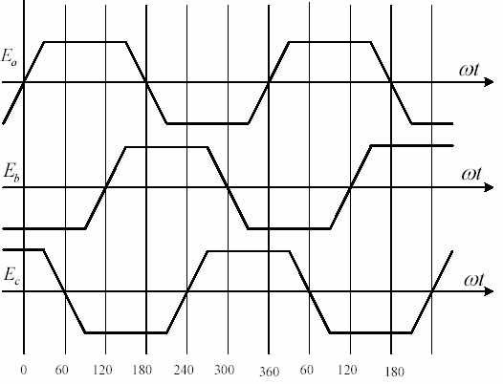

**Figure 2:** Trapezoidal back EMF of three phase BLDC motor

Rotor position sensors are essential for controlling the switching sequence of the inverter devices. Typically, three Hall Effect sensors are employed, spaced either 60° or 120° apart, and mounted on the stator surface near the air gap of the machine. As the rotor rotates, the switching signals from these Hall Effect sensors are decoded to provide rotor position information, enabling determination of the inverter firing pattern.

To minimize torque ripple, it's crucial for the electromotive force (EMF) induced in each motor phase winding to remain constant throughout the duration when that phase is conducting current. Any fluctuation in the EMFs during energized phases directly translates to variations in the developed torque for that phase. The 'trapezoidal EMF' motor, illustrated in Fig. 2.7, sustains a constant induced EMF for 120°, making it an ideal motor design that ensures optimal performance in a BLDC motor drive system.

**2.1.5 Controller**

The inverter is managed to regulate device currents, thereby controlling motor torque, direction, and speed of rotation. The average output torque is dictated by the average current in each phase during energization. Since motor current equals DC link current, output torque is directly proportional to DC input current, akin to a conventional DC motor. Motor speed synchronizes with applied voltage waveforms, allowing control through adjustment of the inverter switching sequence frequency.

Rotor position feedback signals are typically obtained from Hall Effect devices, as previously mentioned, or from optical transducers utilizing a slotted disc arrangement mounted on the rotor shaft. While it's also feasible to sense rotor position by monitoring the EMFs in the motor phase windings, this method is more complex. In certain applications, the outputs of Hall Effect sensors can be utilized to generate a signal proportional to the motor speed. This speed signal can be incorporated into a closed-loop controller if necessary.

**2.2 Basic control techniques of a BLDC motor**

The following are some of the motor control options discussed below, aimed at ensuring reliable operation and protection of motors. Motor control can be classified into the following categories based on the functions they serve:

* + Speed control
  + Torque control

Implementing these control functions involves monitoring one or more motor parameters and taking corresponding actions to achieve the desired functionality. Before delving into the specifics of these control function implementations, it is essential to comprehend the logic and hardware required to initiate motor rotation or establish commutation.

**2.2.1 Speed control**

Following the commutation sequence in a specified order ensures the proper rotation of the motor. The motor speed is dependent on the amplitude of the applied voltage. This voltage amplitude is adjusted using pulse width modulation (PWM). Figure 2.10 illustrates the switching signals for various power devices.

From the diagram, it can be observed that the higher side transistors are driven using PWM. By manipulating the duty cycle of the PWM signal, the amplitude of the applied voltage can be controlled, subsequently regulating the motor's speed.

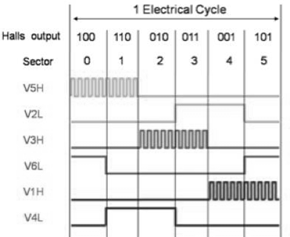

**Figure 3:** Switching signals of Power devices

To be able to achieve the required speed smoothly, the PI control loop is implemented as shown in Fig.

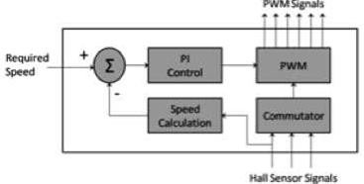

**Figure 4:** Speed Control Loop

The difference between the required speed and the actual speed is input into the PI controller, which then modulates the duty cycle of the PWM based on the error signal obtained by the difference between the actual speed and required speed.

**2.2.2 Torque control**

Torque control is important in various applications where at a given point of time, the motor needs to provide a specific torque regardless of the change in load and speed at which the motor is running. Torque can be controlled by adjusting the magnetic flux; however flux calculations require complex logic. However, magnetic flux is dependent upon the current flowing through the windings. Thus, by controlling current, torque of a motor can be controlled.

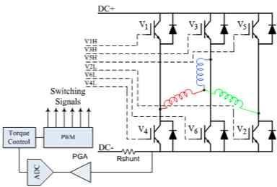

**Figure 5:** Torque Control

Fig 5. shows the torque control implementation logic. By maintaining the current flowing through the windings, torque can be controlled. A PI loop similar to that used to control speed can be implemented to smooth the torque response curve with changes in load.

**3. SYSTEM IMPLEMENTATION AND ANN BASED PID INTELLIGENT CONTROL**

When utilizing a PID controller for BLDC motor control, manually specifying parameters such as KD, KI, and KP can be cumbersome and inefficient. This manual tuning process poses a significant disadvantage, especially when needing to adjust parameters for various motor speed operations.

To address this issue, the system designed in this project offers an automated solution. By employing intelligent algorithms, the system dynamically calculates optimal KD, KI, and KP values, ensuring precise control of the BLDC motor across all speed ranges. This automated approach streamlines the tuning process, eliminating the need for manual parameter adjustments and enhancing the motor control system's efficiency and accuracy.

**3.1 Block Diagram**

The diagram below depicts a block diagram of how the optimized speed control for BLDC motor can be implemented.

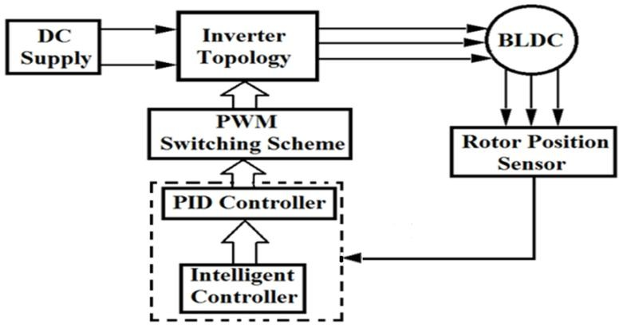

**Figure 6:** Implementation of Optimized Speed Control for BLDC Motor

Conventional feedback controllers, such as PID or linear quadratic controllers, rely on accurate mathematical models that describe the dynamics of the system under control. However, this requirement can be a significant limitation for systems with unknown or varying dynamics. Even if a model can be obtained, unknown conditions like saturation, disturbances, parameter drifts, and noise may be challenging to model accurately. While these unknown conditions and system nonlinearities may be negligible for basic electric drive applications, they can lead to unsatisfactory tracking performance, especially when high accuracy is not critical.

Although conventional PID controllers, based on linear control theory, are straightforward to understand and implement, they suffer from disadvantages when operating conditions or plant parameters change due to disturbances. For processes with variable time delays, changing plant parameters, significant nonlinearities, and considerable process noise, PID controllers may not deliver optimal performance. In such cases, fixed-gain feedback controllers require adjustment to obtain new optimal settings.

**3.2 ANN based PID intelligent control of BLDC motor**

BLDC motors have found extensive use as variable speed drives in a wide range of applications owing to their numerous advantages, including high efficiency, silent operation, compact size, reliability, and low maintenance requirements. In industrial settings, BLDC motor drives were commonly utilized due to their inherent robustness and impressive torque-to-weight ratio. The availability of cost-effective embedded processing power in recent years has facilitated the widespread adoption of sensorless control techniques for BLDC motors. Eliminating the need for speed and position sensors significantly enhances robustness and leads to cost savings.

BLDC motors excel in high-performance drive (HPD) applications such as robotics, guided manipulation, and dynamic actuation, where precise rotor movement over time is crucial. Additionally, the absence of brushes in brushless DC motors makes them suitable for various industrial applications, including airplane actuation, food processing, and chemical industries. Achieving precise rotor movement, even under varying loads, inertia, and parameters, requires an adaptive, robust, accurate, and simple-to-implement speed control strategy. Some adaptive control techniques, such as variable structure and self-tuning methods, do not require a model for system dynamics. Instead, the dynamic model is developed based on the online input/output response of the system under control. These models are typically linear but are updated periodically to ensure accuracy.

For this reason, intelligent methods like Artificial Neural Networks (ANN) can be effectively employed to address control challenges in electric drives, such as BLDC motor control for high-performance applications. ANN applications in this context can be divided into four main categories:

* + 1. Modeling and Identification
    2. Optimization and Classification
    3. Process Control
    4. Pattern Recognition.

A multi-layer Neural Network architecture is proposed for the speed control of BLDCM, serving two primary functions. Firstly, it is utilized to identify the nonlinear system dynamics continuously, eliminating the need for detailed and elaborate models for the BLDCM. Additionally, the trained neural network can effectively recognize unknown nonlinear dynamics, including load disturbances, system noise, and parameter variations, which are often challenging to model accurately. The second function of the ANN is to regulate the motor voltage by adjusting the gain parameters of the PID controller, ensuring that the speed and position closely track pre-selected trajectories at all times. This control action, performed by the ANN, is based on indirect model reference adaptive control principles. Utilizing parallel and distributed processing units, the Artificial Neural Network (ANN) can effectively fulfill the functions of system modeling and control. The ANN offers several key features, including robustness, fault tolerance, noise immunity, and the ability to establish nonlinear mappings between the inputs and outputs of an electric drive system without requiring a predefined model. These attributes make ANN well-suited for the speed control of BLDC motors, particularly under varying load torque conditions.

**4. SIMULATION AND RESULTS**

The closed-loop speed control of a BLDC motor using an ANN-based PID controller, as discussed in previous chapters, is simulated using the MATLAB 7.9 software package. The circuits are designed using the SimPower Systems toolbox, and the simulated results are presented in the subsequent chapter.

Additionally, the speed control of the BLDC motor using a conventional PID controller and its optimization are implemented using MATLAB/SIMULINK, as depicted in Fig 7.

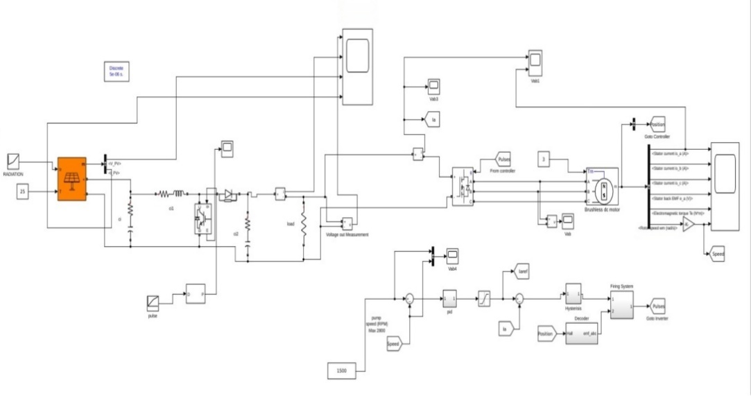

**Figure 7:** Simulation circuit using Simulink Design Optimization

* 1. **Simulation Result**

The figure shown below shows the various simulation results of the Implementation of Optimized Speed Control for BLDC Motor.

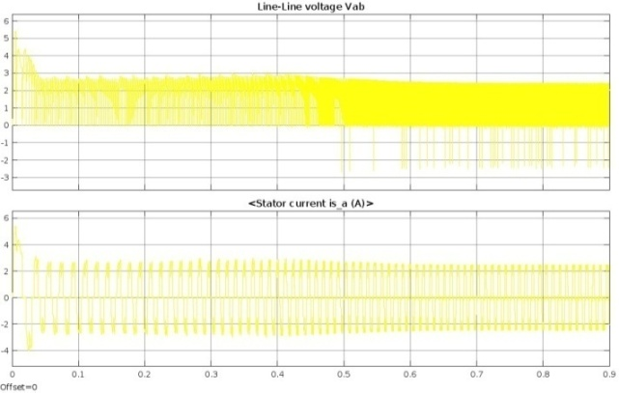

**Figure 8:** Current measurement

Phase Current waveforms Ia , Ib & Ic

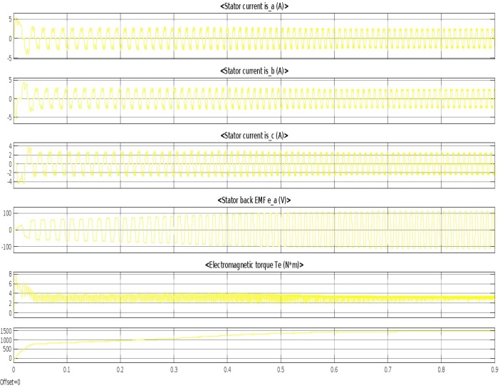

**Figure 9:** 3 phase stator current

The diagram shown below shows the electromagnetic torque for the simulation of the Implementation of Optimized Speed Control for BLDC Motor.

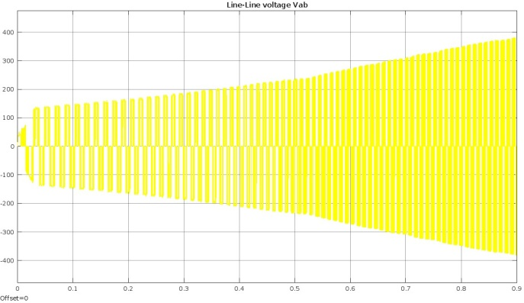

**Figure 10:** Voltage measurement

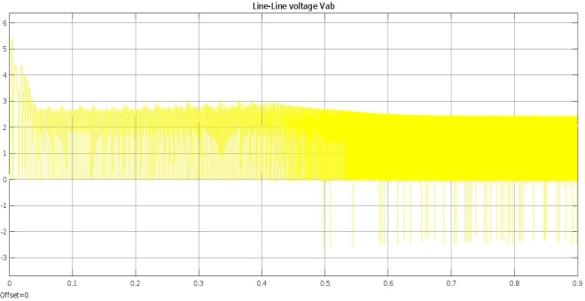

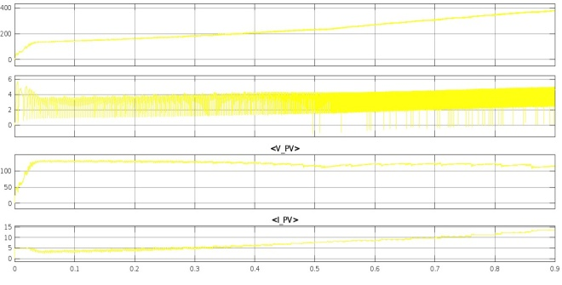

**Figure 11:** Line to Line Voltage

The diagram shown below shows the Phase Current Waveforms for the simulation of the Implementation of Optimized Speed Control for BLDC Motor

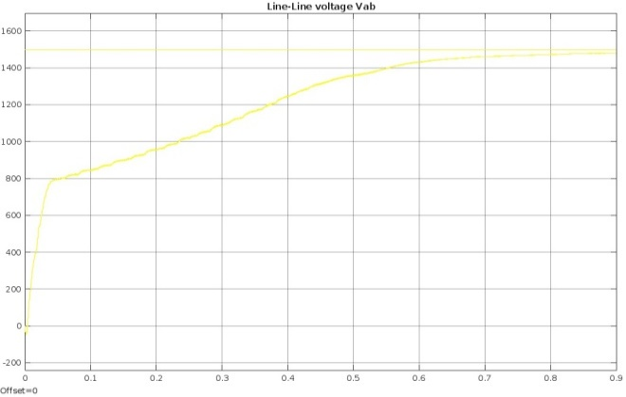

**Figure 12:** Constant And Gain

The diagrams given below show the simulation result for the BLDC motor under the proposed scheme

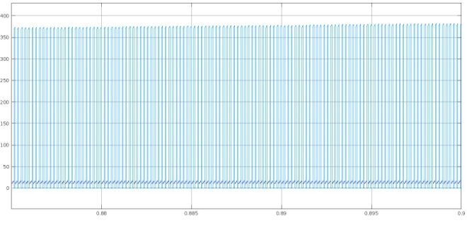

**Figure 13:** Current Scope 2

The diagram shown below shows the Back MF Waveforms for the simulation of the Implementation of Optimized Speed Control for BLDC Motor

* 1. **Simulation Parameters**

The test parameters of the motor taken for simulation are given below.

**Table 2:** BLDC motor specifications

|  |  |
| --- | --- |
| **Motor Parameters** | **Values** |
| Rated power | 1 KW |
| No. of phases | 3 |
| Rated voltage | 400 V dc |
| Stator resistance/phase | 2.875 Ω |
| Stator Inductance/phase | 0.0085 H |
| Moment of Inertia | 0.0008 Kg-m/sec2 |
| Rated speed | 3000 rpm |

The values of the PID controller gain constants using the manual tuning method which were used for the conventional PID control of BLDC Motor.

**Table 3:** PID tuning parameters

|  |  |  |
| --- | --- | --- |
| **PID Parameters** | | |
| **Kp** | **Ki** | **Kd** |
| 40 | 225 | 0.3 |

* 1. **Comparison Of Results**

The performance indices are computed from the results obtained for conventional PID and PID controller based on Simulink Design Optimization and are compared as reported in Table below

**Table 4:** Comparison of Result

|  |  |  |  |
| --- | --- | --- | --- |
| **Controller** | **Spee d** | **Rise time**  **(sec)** | **Percentage**  **overshoot** |
| Conventional PID controller | 1000 | 0.6 e-3 | 70 |
| 2000 | 0.5 e-3 | 47 |
| PID controller based on  Simulink Design Optimization | 1000 | 1.5e-3 | 7.1 |
| 2000 | 1.9 e-3 | 1.8 |

**Table 5:** Boost Converter

|  |  |  |  |  |
| --- | --- | --- | --- | --- |
| **Input Voltage** | **Input**  **Current** | **Duty**  **Cycle** | **Output**  **Voltage** | **Efficiency**  **%** |
| 23 | 4.85 | 0.04 | 24.1 | 89.6 |
| 18 | 7.56 | 0.25 | 24.0 | 73.5 |

The results obtained from the PID controller based on Simulink Design Optimization for speed control of BLDC are analyzed and compared with those of a conventional PID controller. The PID controller based on the Simulink Design Optimization tool is utilized to determine the PID controller parameters: Proportional constant (KP), Integral constant (Ki), and Derivative constant (Kd).

**5. CONCLUSION**

In this project, a PID controller model has been developed for the speed control of a BLDC motor using MATLAB/Simulink. A comparative analysis was conducted at various speeds (1000 and 2000 rpm) under different load torques ranging from 0 to 10 N-m of the BLDC motor with both the PID controller based on Simulink System Design Optimization and a conventional PID controller. Performance indices, including rise time and percentage overshoot of the controller, were computed and compared.

The results demonstrate that the Simulink System Design Optimization-based PID controller enhances the response and performance of the conventional Proportional Integral Derivative (PID) controller in a nonlinear dynamic environment. The simulation was conducted using the MATLAB/Simulink System Design Optimization tool.

**6. REFERENCES**

1. 1.VanchinathanKumarasamy,ValluvanKarumanchetty Thottm Ramasamy, GokulChandrasekaran, GnanavelChinnaraj, Padhmanabhaiyappan Sivalingam,Neelam Sanjeev Kumar, “A review of integer order PID and fractional order PID controllers using optimization techniques for speed control of brushless DC motor drive”, 2023.
2. 2. Laith A. KHALAF1, Omar T. MAHMOOD,Ahmed, M. T. IBRAHEEM,” Smart speed control of BLDC motor using programmable logic controller” , 2023.
3. 3. Lokesh Kumar Agrawal, Bhavesh Kumar Chauhan, Nitin Kumar Saxena, Puneet Joshi, “Speed control of BLDC motor with neural controller” , 2021.
4. 4. Sweety Kumari , Ramesh Kumar , “Hybridized GWO-RUN optimized fractional order control for permanent magnet brush-less dc motor”, 2023.
5. 5. V.Matthew, M.Srikanth, “Controlling of PV fed BLDC Motor using LionOptimization Algorithm”, Vol-12 Issue-12 No.02, 2022.
6. 6. Kudavalli Harshita, K. Priyanka , “Controlling of PV fed BLDC Motor using Lion Optimization Algorithm” , 2022.
7. 7. Tingting Wang, Hongzhi Wang, Huangshui Hu, Jinhui Qing, Chuhang Wang, “Lion swarm optimisation‐based tuning method for generalised predictive fractional‐order PI to control the speed of brushless direct current motor” , 2022.
8. 8. Ho-Jin Kim, Hyung-Seok Park, Jang-Mok Kim,” Expansion of Operating Speed Range of High-Speed BLDC Motor Using Hybrid PWM Switching Method Considering Dead Time” , 2022.
9. 9. De Almeida P M, Valle R L, Barbosa P G, Ribeiro P F, Montagner V F and Cuk V 2021 Robust control of a variable-speed BLDC motor drive IEEE Journal of Emerging and Selected Topics in Industrial Electronics.
10. 10. Vanchinathan K and Selvaganesan N 2021 Results in control and optimization adaptive fractional order PID controller tuning for brushless DC motor using artificial bee colony algorithm Results Control Optim.
11. 11. Trivedi M S and Keshri R K 2020 Evaluation of predictive current control techniques for PM BLDC motor in stationary plane IEEE Access.
12. 12. El-Sousy F F M, Amin M M and Mohammed O A 2021 Robust optimal control of high-speed permanent-magnet synchronous motor drives via self -constructing fuzzy wavelet neural network IEEE Trans. Ind. Appl.
13. 13. Eltoum M A M and Abido A H M A 2021 Hybrid fuzzy fractional—Order PID—based speed control for brushless DC motor Arab. J. Sci. Eng.