**A Project Report on Design of a Reinforced Concrete Structure**

**Naib Chand**

Civil Engineering, Lingaya’s Vidyapeeth, Faridabad, Haryana, India

# ABSTRACT

## INTRODUCTION

Structural Engineers greatest challenge in today’s scenario is constructing seismic resistant structure. The challenge further increases due to increased eye pleasing high rise structures with architectural problems. These architecturally pleasing structures with shape irregularity, when subjected to devastating earthquake are a matter of concern. The behavior of a building during earthquakes depends critically on its overall shape, size and geometry, in addition to how the earthquake forces are carried to the ground. ABC Engineering college building is used for the case study. A detailed study of this building for gravity loads and earthquake loads are analyzed and results like shear, moment carrying capacity and reinforcements required are compared. For the gravity load case a suitable method of retrofitting is recommended if it is below performance level. With better understanding of seismic demand on structures and with our recent experiences with large earthquakes near urban centers, the need of seismic retrofitting is well acknowledged.

## OBJECTIVES

1. To make a comparison between the ordinary existing building with gravity loads only and that of seismic resistant structures to understand the behavior of each structure during earthquake using STAAD-Pro.
2. To suggest a proper retrofitting for existing buildings wherever there is a low performance during an earthquake.
3. To introduce the principle of good earthquake resistant building practices.

## METHODOLOGY

1. Validation of STAAD-Pro to check the software.
2. Load calculation according to IS: 875-1987, IS: 1893-2002.
3. STAAD modelling of ABC Engineering college building.
4. Manual design is done and compared with STAAD-Pro design.
5. Comparison of analysis and design results between ordinary and earthquake resistant structure.

## RESULTS AND CONCLUSIONS

1. A detailed Analysis and Design of ABC College building for gravity and earthquake loads and comparing the results by means of graphs and tables, shows that college building under zone III designed only for gravity loads has poor performance during earthquake.
2. Columns are severely affected by earthquake forces compared to beams.
3. Square or circular sections suitable for columns.
4. Jacketing method of retrofitting is suitable for columns strengthening.

**CHAPTER 1**

# INTRODUCTION

## GENERAL

An earthquake also known as a quake or tremor is the result of a sudden release of energy in the Earth’s crust that creates seismic waves. The most important cause from an engineering point of view, it is believed at present, is the movement of faults which are buried deep below the earth surface. Earthquake causes ground to vibrate and these results a lateral force on the surface.

“Earthquakes don’t kill people but poorly built buildings do”. Poorly built buildings include poor quality of materials used poor shape of the buildings and poor design without considering the codal provisions. Several countries including India have experienced severe losses in the past, in terms of human casualty and property; most recent are the Bhuj earthquake of 26th January, 2001; Sumatra earthquake of 26th December, 20004 leading to Tsunami and Kashmir earthquake of 8th October, 2005. Most of the casualties were due to collapse of poorly constructed buildings in the seismically vulnerable regions.

### ARCHITECTURAL BEHAVIOUR OF A BUILDING

Sometimes the shape of the building catches the eye of visitor, sometimes the structural system appeals, and in other occasions both shape and structural system work together to make the structure a Marvel. If the building is irregularly shaped there will be excessive deflection and twisting moment during earthquake. The architectural problem includes the different aesthetically good looking structure with irregularities. The irregularity may be plan or vertical irregularity, this includes soft storey, L-shape, T-shape building, large horizontal size of building and square building with a central opening.

### ABC COLLEGE BUILDING – CASE STUDY

ABC College of engineering and management building is situated in Adyar, Karnataka. The construction of college building was started in the year 2007 with a base area of 35 acres. The building has G+ 4 storeys with two wings. The college building has already been analysed and designed for gravity loads only. Since the college building falls under seismic zone III we need to design for earthquake forces. In the present case study, we analyze and design the collage building for earthquake force in addition to gravity loads and bring out the major difference of size of beam and column, reinforcement in it etc.

## RETROFITTING

In India almost all the buildings are not earthquake resistant and hence in addition to building earthquake resistant structure there must also be some method to strengthening of existing building is known as retrofitting. Retrofitting is required in all the existing important structures

in India. For example, the administrative office or DC offices which contain important documents should be protected from any damage from earthquakes. Also colleges and hospitals should be earthquake resistant as this provides shelter and treats large people when such natural calamity occurs.

## STUDY AREA

Earthquake engineering is a large area of study. The analysis and design of superstructure is our major interest. The analysis and design of superstructure includes earthquake prone regions with base fixed. It also includes the failure mechanism of geometric irregular superstructure.

## AIM OF THE PRESENT PROJECT

* Identifying the architectural problems in a building during earthquake. However due to the desire to create an aesthetic and functionally efficient structure, architects suggest wonderful and imaginative structures. But in practice more the irregularities, more difficult for the structure to resist earthquakes or lateral forces.
* Taking ABC College of Engineering and Management building as a case study, we try to bring out the major differences to vertical load carrying building to earthquake resistant buildings.
* For the existing college building which comes under earthquake zone III and which are not designed as per the earthquake codes are then retrofitted with suitable methods.

## OBJECTIVES OF THE STUDY

* To study the architectural problems in different geometrical structures and the solutions by STAAD-Pro using analysis results like ultimate load, ultimate moment, etc.
* To introduce the principle of good earthquake resistant building practices.
* To study the effect of shape of the structure on the overall seismic performance.
* To study the portion of structure to be retrofitted if required.
* The objective of design is the achievement of an acceptable probability that structures being designed will perform satisfactorily during their intended life even if earthquake occurs.

## SIGNIFICANCE OF PRESENT PROJECT

Field inspection and analysis of the performance of structures during earthquake shaking off their foundations have clearly shown that building design which blindly follows seismic code regulations does not guarantee safety against collapse or serious damage. Repair, retrofitting and/or modifications, must also be considered in addition to the design aspects. Also the important structures like hospitals, colleges, etc should be designed by using seismic codes as these buildings can be used as emergency evacuation centre. Hence it is necessary to study the behaviour of the structure when earthquake forces hit the structure.

Structural engineer should have the knowledge of earthquake and its effect. Ductility should be considered when we consider earthquake forces. The ductile detailing of the building is done

which prevents from sudden failure of the building. Hence we strictly adopt a ductile detailing using design codes.

## METHODOLOGY

Building is analysed using a static approach of earthquake analysis. For this purpose STAAD- Pro is used. In this method the earthquake force acts at the nodes or joints of the building. Force at each node is calculated and applied. The design methods used in STAAD Pro analysis are Limit State Design conforming to Indian Standard Codes of Practice. For earthquake design seismic codes IS:1893-2002 are used and ductile detailing code IS:139201993 is used. Complicated and high rise structures need vey time taking and cumbersome calculations using conventional manual methods. STAAD-Pro provides us a fast, efficient, easy to use and accurate platform for analyzing and designing structures.

## ORGANIZATION OF THE REPORT

Project report has been organized under the following chapters which are as follows:

**Chapter 1: I**ntroduces to the main purpose of the project

**Chapter 2:** This deals with the literature survey and the methodology adopted.

**Chapter 3:** Deals with the earthquake aspects and seismic waves which affect the structure.

**Chapter 4:** This chapter validates the STAAD-Pro.

**Chapter 5:** Deals with the architectural problem during earthquakes.

**Chapter 6:** Deals with the case study- ABC College building.

**Chapter 7:** It deals with the seismic strengthening of the building i.e. retrofitting **Chapter** **8:** This deals with the further scope for the topic and conclusions.

**CHAPTER 2**

# LITERATURE REVIEW

## GENERAL

An attempt is made here to understand the behaviour of the building during earthquake force. Also a detailed study of the behaviour of different shape of the building under earthquake is understood. Study based on the past earthquake effects are done on different shapes under different zoning. The failure occurred during these earthquakes are taken as a precaution so that the building is avoided with similar shape, design, etc. If the shape and design of the building cannot be avoided then in such cases a detailed study of the codal provision of such irregularity is done, which also include the strengthening of the building taking into account the additional column or reinforcements required. The different codes and literatures that helped in the study are given below:

## CODE OF PRACTICE FOR DESIGN LOADS

Indian standard code of practice for design loads (other than earthquake) for building and structures. It includes five parts as follows:

**IS: 875 (Part 1)-1987,** this code includes the dead load to be considered for the structure.

**IS: 875 (Part 2)-1987,** this code involves the imposed load or live load acting on the structure. It includes the imposed load i.e. roof load, dust load, loads due to partition etc.

**IS: 875 (Part 3)-1987,** this code involves the wind load consideration for a structure.

**IS: 875 (Part 5)-1987,** this involves the special code and load combinations to be considered. The different combination of dead load, live load, wind load and erection load after proper application of factor is given in this code.

## SEISMIC DESIGN CODES

Seismic codes are unique to a particular region or country. They take into account the local seismology, accepted level of seismic risk, building topologies, materials available in the locality and the methods used in the construction. In India we refer to Bureau of Indian Standards (BIS) which include the following seismic codes-

**IS 1893 Part 1)-2002,** Indian standard Criteria for Earthquake Resistant Design (5th revision)

–IS 1893-2002 is the main code for the earthquake resistant design which provides the seismic

design force, seismic zone map and different factors and coefficient such as importance factor, seismic zone factor , stiffness, factor related to the soil on which structure rests, which are required in earthquake resistant design.

**IS 13920-1993:** Indian Standard code of Practice for Ductile Detailing of Reinforced Concrete Structure Subjected to Seismic Forces – In India, reinforced concrete structures are designed and detailed according to IS 456 (2002). However, structures located in high seismic regions require ductile design and detailing. After the Bhuj earthquake this code has been made mandatory for all the structures in India which fall under the zone III, IV and zone V. Provision for the ductile detailing of the monolithic reinforced concrete frame and shear wall structure are specified.

**IS 13935-1993:** this code involves the seismic evaluation, repair and strengthening of buildings. It involves the repair material and techniques used. Provisions are applicable to buildings under zone III to V.

## PAST EARTHQUAKE EFFECTS

Venkatraman. al., (2004) studied the lessons from Bhuj earthquake and the damages caused on the RC structures.

Iyengar, R.N. (2004) has studied the earthquakes in India. Also has studied the engineering prospect in earthquake disaster. Different method to reduce the earthquake taking the past earthquake effects are also studied.

Murthy, C.V.R., (2005) has developed paper on earthquake related affects and given some earthquake tips. He also studied the short column effect, additional reinforcement required and behaviour of joints during earthquake.

## SEISMIC ANALYSIS AND STRUCTURAL IRREGULARITY – ARCHITECTURAL PROBLEM

Murthy, C.V.R., et. al., (2005) has studied the concepts on behaviour of building during earthquake.

Modakwar, et. al., (2014) studied the Seismic Analysis of Structures with Irregularities. The behaviour of the structures with these irregularities is studied.

Jayalekshmi, B.R. (2004) has studied the seismic analysis and design of a multi-storey RC building. As the height increases the twisting moment increases. A detailed study on this twisting moment has been carried out.

Ravikumar CM, et. al., (2012) have studied the Effect of irregular configurations on seismic vulnerability on RC buildings.

Gomes, G.M., et. al., (2009) has studied the wind effects on and around L-shape and U-shape buildings. They conducted experiments in wind tunnel which gives a wind flow pattern for

different angle of wind forces. It was found that pressure distribution can considerably change with the building shape and wind incidence angle.

Bangiwar, R.S., et. al., (2012) in their paper has clearly explained how architectural problem and structural irregularity effect on the seismic behaviour of the structure by response spectrum method. They analysed the structure using ETABS.

Prof. Sable, K.S., Ghodechor, V.A and Prof.Kandekar, S.B. has compared the seismic behaviour of multi-storey flat slab structure and reinforced concrete framed structure in an international journal. It shows the storey drift, time period and base shear variation and also gives the variation between two structures.

## RETROFITTING

Central public works department and Indian building congress (2007) has brought up a handbook on seismic retrofit of building which gives the behaviour of building, the soil on which it rests on and the earthquake force. It gives method to retrofit all kind of building which include brick, masonry and RC structure.

Dr. S.A., Arya, (2004) has carried out seismic evaluation and strengthening of reinforced concrete buildings. Detailed study on the strengthening aspects of the building has been carried out. Different methods, their advantages and disadvantages are also studied.

**CHAPTER 3**

# EARTHQUAKE

## GENERAL

An earthquake is a vibration that travels through the earth’s crust. The waves are called seismic waves. In an earthquake, the initial movement that causes seismic vibrations occurs when two sides of a fault suddenly slide past each other. A fault is a large fracture in rocks, across which the rocks have moved. Earthquakes are the manifestations of sudden release of strain energy accumulated in the rocks over extensive periods of time in the upper part of the earth. These elastic waves radiate outwards from the focus and vibrate the ground.

### WHAT CAUSES EARTHQUAKE?

Earthquakes are caused by the movement of the earth’s tectonic plates. A number of smaller size earthquakes take place before and after a big earthquake. Those occurring before the big one are called Foreshocks, and the ones after are called Aftershocks. Shocks smaller than magnitudes 2.5 are usually not felt and those with magnitude 7 cause serious damage over large areas. Intensity of shaking is measured on the modified Mercalli scale, ranging from 1 far from the epicentre to a maximum near it, which can reach 12 in the strongest earthquakes.

## TERMINOLOGIES USED IN EARTHQUAKE

* + 1. **Epicenter:** The geographical point on the surface of earth vertically above the focus of the earthquake.
    2. **Hypocenter or Focus:** The originating earthquake source of the elastic waves inside the earth which causes shaking of ground due to earthquake.

**Epicentral distance:** Distance between epicenter and recording station in km.

* + 1. **Focal depth:** The depth of focus from the epicenter is called focal depth. It is an important parameter in determining the damaging potential of an earthquake. Most of the damaging earthquakes have shallow focus with focal depths less than about 70km.
    2. **Fault:** A fracture in the rocks along which strain is occasionally released as an earthquake. By definition, only active faults are associated with earthquakes.

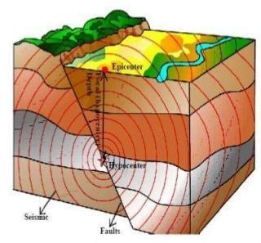

#### Fig. 3.1: Terminologies of earthquake

* + 1. **Seismology:** It is the scientific study of earthquakes and propagation of elastic waves through
    2. earth.
    3. **Magnitude of Earthquake:** Magnitude is a quantitative measure of the actual size of the earthquake. The magnitude of earthquake is a number, which is a measure of energy released in an earthquake. It is defined as logarithm to the base 10 of the maximum trace amplitude, expressed in microns, which the standard short-period torsion seismometer would register due to the earthquake at an epicentral distance of 100km
    4. **Intensity of earthquake:** The intensity of an earthquake at a place is a measure of the strength of shaking during the earthquake, and is indicated by a number according to the modified Mercalli scale or M.S.K scale of seismic intensities. It is a qualitative measure of the actual shaking at a location during an earthquake, and is assigned as Roman Capital Numerals. There are many intensity scales. Two commonly used ones are the Modified Mercalli Intensity (MMI) scale and the MSK scale. Both scales are quite similar and range from I (least perceptive) to XII (most severe).
    5. **Importance Factor (I):** It is a factor used to obtain the design seismic force depending on the functional use of the structure, characterized by hazardous consequences of its failure, its post-earthquake functional need, historic value, or economic importance.
    6. **Natural Period (T):** Natural period of a structure is its time period of undamped free vibration.
    7. **Response Reduction Factor (R):** It is the factor by which the actual base shear force, which would be generated if the structures were to remain elastic during its response to the Design Basis Earthquake (DBE) shaking, shall be reduced to obtain the design lateral force.
    8. **Seismic Mass:** It is the seismic weight divided by acceleration due to gravity.
    9. **Seismic Weight (W):** It is the total dead load plus appropriate amounts of specified imposed load.
    10. **Zone factor (Z):** It is a factor to obtain the design spectrum depending on the perceived maximum seismic risk characterized by Maximum Considered Earthquake (MCE) in the zone in which the structure is located. The basic zone factors included in this structure are reasonable estimate of effective peak ground acceleration.
    11. **Structural Response Factors (Sa/g):** It is a factor denoting the acceleration response spectrum of the structure subjected to earthquake ground vibrations, and depends on natural period of vibration and damping of the structure.

## SEISMIC WAVES

During an earthquake there are different types of seismic waves generated, but in general there are two categories-

* **Body waves –** These waves travel through the earth’s inner layers.
* **Surface waves –** These waves can only travel on the surface of the crust.

### BODY WAVES

Body waves consist of –

* + - * **P-waves (Primary waves) –** These waves are the first waves that arrive during an earthquake, which move faster than S-waves. It can move through liquid and solid rock and behaves similar to sound waves. It pushes and pulls the rock that it travels through. Particles subjected to P-wave move in the same direction as that of the direction of wave propagation.

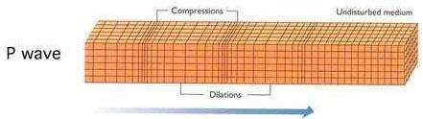

#### Fig. 3.2: Primary - waves

* + - * **S-waves (Secondary waves) -** These waves are felt after the P-waves. They move much slower and can only travel through solid rock. The particles in their path are moved side to side, up and down, perpendicular to the wave propagation.

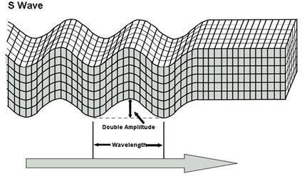

### SURFACE WAVES

#### Fig. 3.3: Secondary waves

Surface waves occur after the body waves, but have lesser frequencies. They can be detected easily in seismograph, as they create huge fluctuations. Damages are caused to the structure by these waves itself. Surface waves consist of –

* + - * Love wave – This is the first kind of surface wave names after the mathematician who worked out the model for this kind of wave. Love waves move in a horizontal motion, and move the ground side to side.

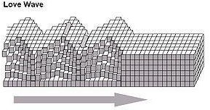

#### Fig. 3.4: Love waves

* + - * Rayleigh wave **–** It is the second type which is also named after the mathematician who predicted the mathematical method. These waves roll along the ground, exactly like waves on the sea, and can be much larger than the other waves. Rayleigh waves move the ground up and down, side to side in the direction that the wave is moving.

The below figure shows the Rayleigh waves.

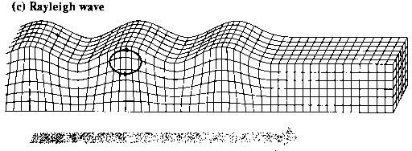

**Fig. 3.5: Rayleigh waves**

## SEISMIC ZONES OF INDIA

The varying geology at different locations vary the likelihood of damaging earthquake taking place at different locations is different. Thus seismic zone map is important to identify different regions. Based on the levels of intensities sustained during past earthquakes zones are classified as zone II, zone III, zone IV and zone V as on 2002 revision. For the purpose of determining seismic forces, the country is classified into four seismic zones. About 59% of the land area of India is liable to seismic hazard damage. The different zones and their zone factor are given in the below table 3.1 and important cities under different zone are given in the table 3.2.

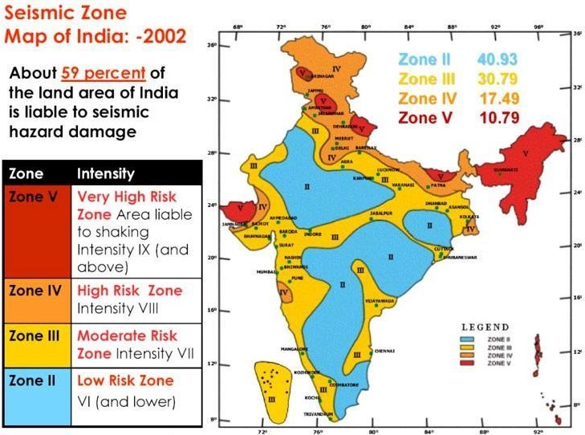

#### Fig. 3.6: Seismic zoning of India

The different zones and their zone factor are given in the below table:

|  |  |  |  |  |
| --- | --- | --- | --- | --- |
| **Seismic zone** | **II** | **III** | **IV** | **V** |
| **Seismic Intensity** | Low | Moderate | Severe | Very severe |
| **Zone factor** | 0.10 | 0.16 | 0.24 | 0.36 |

#### Table 3.1: Zone factor, Z

|  |  |  |  |
| --- | --- | --- | --- |
| **Zone II** | **Zone III** | **Zone IV** | **Zone V** |
| Ajmer | Agra | Ahnora | Bhuj |
| Allahabad | Ahmedabd | Amritsar | Darbhanga |
| Aurangabad | Belgaum | Barauni | Guwahati |
| Bangalore | Bhubaneshwar | Bulandshahr | Imphal |
| Bhilai | Bijapur | Chandigarh | Jorhat |
| Bhopal | Mangalore | Darjeeling | Kohima |
| Chitradurga | Pune | Debra Dun | Mandi |
| Gulbarga | Chennai | Delhi | Srinagar |
| Hyderabad | Coimbatore | Gangtok | Tezpur |
| Jaipur | Kolkata | Gorakhpur | Sadiya |
| Jamshedpur | Cuttack | Ludhiana |  |
| Jhansi | Dharwad | Monghyr |  |
| Jodhpur | Dharamapuri | Moradabad |  |
| Kota | Goa | Nainital |  |
| Kurnool | Gaya | Patna |  |
| Madurai | Mumbai | Pilibhit |  |
| Mysore | Kalapakkam | Roorkeea |  |
| Nagpur | Kanchipuram | Simla |  |
| Nagarjuna sagar | Kanpur |  |  |

**Table 3.2: Important cities under different zones**

An earthquake resistant building has four attributes in it-

* **Good structural configuration:** Its size, shape and structural system carrying loads are such that they ensure a direct and smooth flow of inertia forces to the ground.
* **Lateral strength:** The maximum lateral (horizontal) force that it can resist is such that the damage induced in it does not result in collapse.
* **Adequate stiffness:** Its lateral load resisting system is such that the earthquake – induced deformations in it do not damage its contents under low-to-moderate shaking.
* **Good ductility:** Its capacity to undergo large deformations under severe earthquake shaking even after yielding is improved by favorable design and detailing strategies.

**CHAPTER 4**

# STAAD-PRO SOFTWARE

## INTRODUCTION

STAAD-Pro is a Structural Analysis and Design computer program developed by Bentley systems, Inc., which is a powerful tool for structural analysis and design. Complicated and high-rise structures need very time taking and cumbersome calculations using conventional manual methods.

STAAD-Pro provides us a fast, efficient, easy to use and accurate platform for analyses and designing structures. Design and construction of a structure are intimately related and the achievement of good workmanship depends, to a large degree, on the simplicity of detailing of the members and of their connections and supports.

STAAD-Pro features a state of the art user interface, visualization tools, powerful analysis and design engines with advanced finite element and dynamic analysis capabilities. From model generation, analysis and design to visualization and result verification, STAAD-Pro is the professional’s choice for steel, concrete, timber, aluminum and cold-formed steel design of low and high-rise buildings, culverts, petrochemical plants, tunnels, bridges, piles and much more.

To start with we have solved some sample problems using STAAD-Pro and checked the accuracy of the results with manual calculations. The results were to satisfaction and were accurate. In the initial phase of our project we have done calculations regarding loadings on buildings and also considered seismic and wind loads.

## VALIDATION OF STAAD-Pro

Since the present study uses the STAAD-Pro as a software tool for carrying out design and analysis, the method of analysis in the STAAD-Pro is verified at the beginning by comparing STAAD-Pro results with classical method for symmetrical frame.

### PROBLEM DEFINITION:

Problem-8.2 Page number143, “Structural Design and Drawing Reinforced concrete and Steel- Third Edition” text book; author- N Krishna Raju

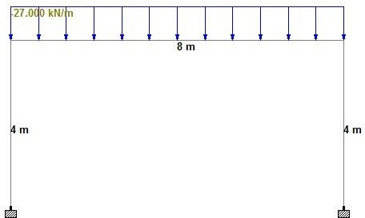

## COMPARISON

#### Fig.4.1: Loading diagram

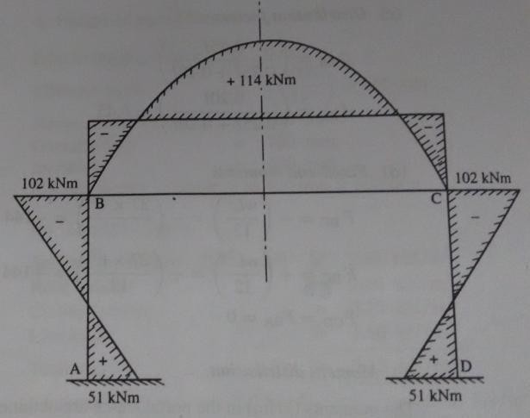

**Fig.4.2: Bending moment diagram (**N Krishna Raju, **solution)**

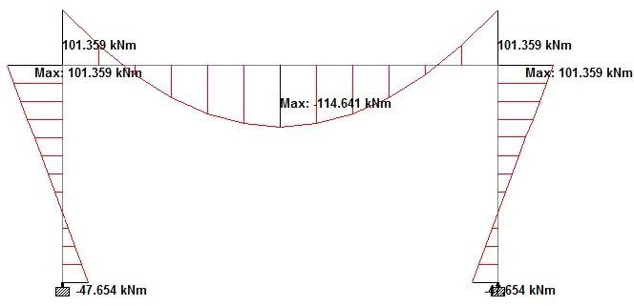

**Fig.4.3: Bending moment diagram (From STAAD-Pro)**

## CONCLUSION

In this chapter the modelling features of STAAD-Pro has been discussed. Also, verification problems are carried out to check the accuracy of modelling done in STAAD-Pro v8i Release 20.07.04.12.

It is found that

1. All results from STAAD-Pro matches with the Excel and classical approach.
2. STAAD-Pro is a very convenient to perform seismic analysis.
3. STAAD-Pro gives BMD and Earthquake force at the face of a column which is essential for economic design.
4. It is possible to obtain the value of BMD at any point of interest in the structural element.

**CHAPTER 5**

# ANALYSIS AND DESIGN OF COLLEGE BUILDING

## GENERAL

For the current study we considered ABC College of engineering building. The construction of college building was started in the year 2012 with a base area of 35 acres. The college building consists of G+4 stories and has 4 wings.



**Fig. 5.1: ABC College**

## EQUIVALENT STATIC LOADING ON THE STRUCTURE AND DUCTILITY

Structures on the earth are generally subjected to two types of loads i.e.

#### Static load

* + 1. **Dynamic load**
    2. **STATIC LOADS**

Static loads are constant with time while dynamic loads are time varying. The majority of civil structures are designed with the assumptions that all applied loads are static. The effect of dynamic loads is rarely subjected to dynamic loads, since dynamic analysis makes analysis more complicated and time consuming. But neglecting the dynamic forces may sometimes cause disaster, particularly in the case of earthquake.

### DYNAMIC LOADS

The dynamic force may be an earthquake force resulting from rapid movement along the plane of faults within earth’s crust. This sudden movement of fault releases great energy in the form of seismic waves, which are transmitted to the structures through their foundations, and cause to set the structure in motion. These motions are complex in nature and induce abrupt horizontal

and vertical oscillations in the structure, which results accelerations, velocities and displacements in the structure. The induced accelerations generate inertial forces in the structure, which are proportional to the acceleration of the mass and acting opposite to the ground motion.

The energy produced in the structure by ground motion is dissipated through inertial friction within the structural and non-structural members. This dissipation of energy is called damping. The structures always possess some intrinsic damping, which diminishes with time once the seismic excitation stops. These dissipative or damping forces are represented by viscous damping forces, which are proportional to the velocity induced in the structure. The constant of proportionality is called as linear viscous damping. The resisting force in the structures is proportional to the deformation induced in the structure during the seismic excitation and the constant of proportionality is referred to as stiffness of the structure.

The stiffness of the structure greatly affects the buildings behavior i.e. stiffness decides whether the building is brittle or ductile. Brittle structures have greater stiffness and prove to be less durable during earthquake while ductile structure performs well during earthquakes. This behaviour of the structure evokes additional desirable characteristics called ductility. Ductility is the ability of the structure to undergo distortion or deformation without damage or failure.

The ABC building is designed only for gravity loads, considering dead load and live load. It is not designed for earthquake force or lateral force. But the changes in the seismic zones and revision of codes make it necessary to design a building considering earthquake forces. The ABC building falls under seismic zone III and hence need to be designed considering lateral forces.

### EQUIVALENT STATIC METHOD OF ANALYSIS

For the analysis equivalent static method is used. The idea of equivalent lateral force method is to distribute part of the seismic force (base shear) to every floor, which are able to transfer lateral loads. As a result of this method, the static forces are generated and applied to rigid (or semi-rigid) diaphragms or vertical elements (columns, walls), which can carry calculated forces. Every code proposes specific limitations of using such method. Most common limitations are structure regularity and its height.

Buildings are the complex system and multiple items have to be considered when designing them.

### ASSUMPTIONS IN EARTHQUAKE DESIGN

The following are the assumptions in the earthquake resistant design of structures used in equivalent static lateral force method of analysis:

* + - * Even though earthquake occurs dynamically, we consider them to be static forces acting at the nodes.
      * Wind, maximum flood or maximum sea waves will not occur simultaneously with the earthquake.
      * For static analysis, elastic modulus of materials shall be taken unless otherwise mentioned.
      * Impulsive ground motions of earthquake are complex, irregular in character, changing in period and time and of short duration. They, therefore, may not cause resonance as visualized under steady-state sinusoidal excitations, except in tall structures founded on deep soft soils.
      * Mass of the storey includes added masses and dynamic masses from converted loads.
      * Diaphragms assure proportional distribution of seismic loads on vertical elements. Generated force should be applied to the Centre of mass of the diaphragm. Diaphragm or panel not positioned at the plane of storey top does not carry seismic force.
      * Loads are applied slowly and gradually until they reach their full magnitudes. Suddenly applied loads cause additional displacements, strains and stresses.

## SEISMIC DESIGN PHILOSOPHY

We do not attempt to make earthquake-proof buildings that will not get damaged even during the rare but strong earthquake; such buildings will be too robust and also too expensive. Instead, the engineering intention is to make buildings earthquake-resistant; such buildings resist the effects of ground shaking, although they may get damaged severely but would not collapse during the strong earthquake. Thus, safety of people and contents is assured in earthquake- resistant buildings, and thereby a disaster is avoided. This is a major objective of seismic design codes throughout the world.

The earthquake design philosophy can be summarized as follows:

* Under minor but frequent shaking, the main members of the building that carry vertical and horizontal forces should not be damaged. However, buildings parts that do not carry load may sustain repairable damage.
* Under moderate but occasional shaking, the main members may sustain repairable damage, while the other parts of the building may be damaged such that they may even have to replace after the earthquake and
* Under the strong but rare shaking, the main members may sustain severe damage, but the building should not collapse.

An earthquake measuring 8.9 on the Richter scale which hit the west coast of northern Sumatra in Indonesia on April 11 of 2012 also caused a mild tremor in the Northern part of India including ABC College. etc. For the ABC College building which is the existing building, we cannot redesign or reconstruct it. Reconstruction needs full demolition of existing building which is simply unnecessary and can be done earthquake resistant just by retrofitting.

## DESIGN PRINCIPLE OF R.C.C MEMBERS

The two base philosophies that are adopted in the design of reinforcement concrete members are:

#### Working stress method

1. **Limit state method**

**Working stress method** is the earliest adopted method or design. In this method the structural elements rate designed for severe loads only. The method is also called as elastic methods of analysis since the structural members were designed in such way that stress in both contexts are within the elastic limit. However, one cannot be sure of the ultimate failure load since elastic behavior of the material ceases after certain level of stress on material.

**Limit state method** came to existence due to the advancement on materials of the desired range of the strength and thus increasing the confidence levels.

So research started in the direction of stressing the material beyond elastic limit to make the full strength of the material. In the design of the ABC building we have used only limit state methods for design.

## DESIGN OF SLABS:

Basically, the slabs are of two types, based on the ratio of larger side (ly) to shorter side (lx) as it is recommended in IS 456:2000, to design the slabs having ly/lx ratio greater than two as one way slab and less two as two way slab.

### ONE WAY SLABS

Reinforced concrete slabs supported on two opposite sides or on all four sides worth the ratio of long to short span exceeding 2 are referred to as one-way slabs. The slabs are designed as beams of unit width for a given type of loading and support condition. The span/depth ratios specified in IS 456:2000 code for beam is also applicable for slabs. One-way slab may be either continuous, simply supported or cantilever slabs. For the determination of the moments and stresses in the continuous slabs the coefficients given in the table 7 & 8 of IS 456:2000 respectively can be sued for the most of the cases. However, for the case of triangular and points loads any conventional methods of analysis of statically indeterminate structure are to be used. Simply supported and cantilever slabs can be analysed in conventional methods.

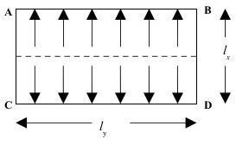

**Fig. 5.2: One-way slab load distribution supported by beams on two sides**

### TWO WAY SLAB

In case of hostels and residential buildings with slab and beam construction, the floor and roof slabs are supported on all the four sides. Two way slabs should have their longer span not exceeding two times the shorter span so that significant flexural moments are maximum at the centre of the slabs with larger magnitude of moment developing along the shorter span.

The moments developed in the slabs are influenced by the following factors:

Short and long span length (lx and ly). The most appropriate method of analysing two way slabs is using field line pattern and Johnson’s field theory. However, field analyses are tedious and time consuming. Hence for practical utility, moment coefficients given in table 22 of IS 456:2000 can be used upon the boundary condition.

For the design of slabs in ABC, imposed loads are considered as given in IS 875 (Part 2) – 1987.

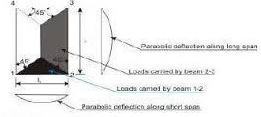

**Fig. 5.3: Load distribution of typical two-way slab**

### CLASSIFICATION OF SLABS

Slabs are classified based on many aspects

* + - 1. **Based on shape:** Square, rectangular, circular and polygonal in shape
      2. **Based on type of support:** slab supported on walls, slab supported on beams, slabs supported on columns (Flat slabs).
      3. **Based on support or boundary condition:** simply supported, cantilever slab, overhanging slab, fixed or continues slab.
      4. **Based on use:** Roof slab, floor slab, foundation slab, water tank slab.
      5. **Basis of cross section or sectional configuration:** Ribbed slabs /grid slab, solid slab, filler slab, folded plate.

#### Basis of spanning direction:

One-way slab-spanning in one direction Two-way slab-spanning in two directions

### DESIGN OF SLAB

#### Condition:

One short edge discontinuous (Restrained slab)

 Hence this slab will be designed as a one-way slab

Here are model is **ABC** Engineering college building as per IS 875 ( Part 2) 1987 take live load as 4kN/m2 .

#### To calculate loads and effective span,

Assume d = 120mm

Assume total depth D = 150mm Dead load = 0.15× 25 = 3.75kN/m2

Dead load due to finish = 1.5kN/m2

Total dead load = 3.75+1.5

= 5.25N/m2

Live load = 4 kN/m2 Factored load wu = 1.5× (4+5.25)

=13.87 kN/m2

Effective span is the lesser of the following [clauses 22.2 of code] 1] Clear span + effective depth = 3.4 + 0.12 =

3.52m 2] c/c of supports = 3.4 + 0.23 = 3.63m Hence, effective depth = 3.52m.

1. **Calculate Mu and Vu** Mu = wul2/10

= 13.875x 3.522/ 10

= 17.191kN-m Vu

= wu l/2

= 13.875 x 3.52/2

= 24.42kN-m

1. **Check for depth for bending moment** Assuming balanced section Mulim = 0.138 fckbd2

[where b=1000mm for slab] d = 

= 70.589mm < 120mm

Hence, the assumed depth is adequate.

#### Calculate the reinforcement

The depth is greater than that required for bending. Hence the section is under reinforced.

To calculate  and Ast

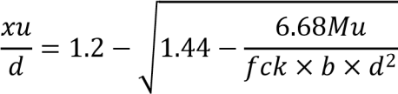

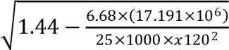= 1.2 –

= 0.141 < 0.479

Hence, it is under reinforced

Z = d× 

= 120× (1-0.416×0.141)

= 112.96mm

Ast



= 421.51 mm2

Alternatively, the reinforcement can also be calculated in the following way using SP16

From table -3, Pt = 0.3696

Ast 

= 443.52mm2

Provide 10 no. of bars at 150mm c/c Distribution steel [clause26.5.2.1]

Asty 

 = 180mm2.

Provide 8mm diameter bars at 220mm c/c. Spacing less than 5d = 5×120 = 600mm > 220mm. Hence adequate.

#### Check for shear

Nominal shear stress = 

= 0.203N/mm2

Pt

Assume tension steel at support = 0.

From table 19 of IS 456, τc = 0.318N/mm2 > 0.203N/mm2. Hence the slab is safe in shear, even without shear enhancement using factor K.

#### Check for deflection (clause23.2.1)

Basic span to depth ratio = 20



Fs = 0.58fy

= 0.58×415×= 237.23N/mm2 = 1.7×20 = 34

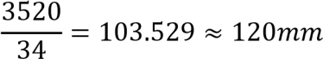

provided

**Hence deflection satisfied**

## DESIGN OF BEAM

A beam is one dimensional member which provides support to the slab and vertical walls. A reinforced concrete beam should be able to resist tensile, compressive and shear stress induced by it in loads on the beam. Plain concrete beams are thus limited in carrying capacity due to low tensile strength.

### BALANCED SECTION

A RC section in which maximum compressive strain in concrete reaches its ultimate values Ec

= 0.0035 and maximum tensile strain in reinforcement reaches its yield value simultaneously is known as balanced section or critical section. The percentage of steel in this section is known as critical percentage of steel, in this case failure occurs by yielding of steel in tension and crushing of concrete in compression simultaneously, causing what is known as balanced or critical failure.

### UNDER REINFORCED SECTION

A section having percentage of steel less than critical percentage is known as under reinforced section. Since steel is insufficient to balance compression in concrete, the tensile strain in steel reaches yield value which the maximum compressive strain in concrete is less than its ultimate crushing value. The section undergoes large rotational deformation in the initial stage to final stage and impending failure. Since failure is initiated by yielding of fail in tension, it is known as primary tension failure.

### OVER REINFORCED SECTION

A section having percentage of steel greater than critical percentage is known as over reinforced section. Since concrete in this section is relatively insufficient to balance the tension in steel, the maximum compressive strain in concrete reaches the ultimate crushing value before the tensile strain in steel reaches the yield value. This causes the sudden failure of section due to crushing of concrete in compression, without giving any warning. Since this failure is initiated by compression in concrete, it is known as primary compression failure.

### SELECTION OF CROSS SECTION DIMENSIONS

The cross-sectional dimension of reinforced concrete beams is selected based on the following guidelines:

* + - 1. The effective and overall depth of the beam is estimated from span/depth ratios to satisfy the limit state of serviceability. Overall depth to width should be in the range of 1.5 to 2.
      2. The width of the section should be accommodating the required number of bars with sufficient spacing. Between them with a minimum side cover of 20mm to the links.
      3. The depth of the beam should be such that the percentage of the steel required is around 75% of that required for balanced section.

Structural concrete beams are designed to support a given system of external loads such as walls and slabs of roof and floor systems. The cross-sectional dimensions are generally assumed based on serviceability requirements. The width is fixed based on thickness of walls and housing of reinforcements and the depth is selected to control deflections within safe permissible limits. The reinforcement in beam are designed for flexural and shear forces along the length of the beam based on structural analysis.

The designed beam is checked for limit state of serviceability. Main limit states that are considered in the design of beams are limit state of serviceability. However, the check for the limit state of deflection involves lengthy calculations. This limit state is generally critical in case of simply supported members. However, for continuous beam deflection is less. However, IS 456:2000 clause 22.2 recommends that limit state is determined is to be satisfied. Hence reinforcement is designed only for limit state of collapse.

### DESIGN OF BEAM NO 96 (7.1m span)

#### Design value and loads

1. **Materials**

Unit weight of RCC = 25 kN/m3

#### Grade of steel and concrete

* 1. High yield strength deformed bars 415 N/mm2
  2. M28 grade of concrete is used having compressive strength of 28 Bearing = 230mm **3)**

#### Depth of the beam

Overall depth (D) = 450mm Effective depth (d) =D-

#### D = 415mm

**Breadth of the beam**

#### B = 300mm

**Effective width of flange**

* + 1. bf = [(Lc/6) + bw + 6Df]

= [(7.1/6) + 0.3+ 6x0.15]

**=** 2.3833m = 2383.3mm

* + 1. centre to centre of ribs bf = 3.4 – 0.3

= 3.1m = 3100mm

Hence least of (i) and (ii) is bf = 2384mm **4) Bending moment:**

B.M is taken from STAAD-Pro result that is Mu = 272.39KN-m

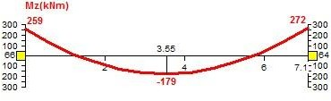

#### Fig.5.4: Bending moment by STAAD-Pro

1. **Moment capacity of the flange**

Muf = 0.36xfckxbfxDf (d- 0.42Df)

= 0.36x28x2384x150 (415 – 0.42x150)

= 1268.82 KN-m

Since Mu < Muf the section is an under reinforced section.

#### Steel calculation (Main bars):

Mu = 0.87fyAstd (1-

272.39x106 = 0.87x415xAstx

272.39x106 = 149835.75 x Ast – 2.244 Ast2 Ast

= 1870.312mm2

Area of one bar, ast 

No. of bars required bars

Hence 6 bars of 20mm ∅ (Ast = 1870.312mm2) are provided and two hanger bars of 2 bars of 16mm∅.

#### Shear reinforcement:

Maximum shear along the beam, Vu = 220KN

Nominal shear stress



τv = 1.767N/mm2 Percentage tension reinforcement

Pt 



= 1.5022

Refer table 19 of IS 456:2000

τc= 0.76N/mm2 < 1.767N/mm2 τv > τc hence design shear reinforcement

Provide 8mm 2LVS for shear reinforcement

Shear reinforcement shall be provided to carry a shear equal to Vus = Vu – τc bd

= 220x 103 – 0.76x300x415

= 125.38KN

Spacing of reinforcement

Sv 



= 120.126mm

Sv< 0.75d = 0.75x415 = 311.25mm

Sv < 300mm whichever is lesser.

Hence provide a 8mm 2lvs at a spacing of 180mm c/c

The STAAD result below shows that the maximum of the provided reinforcement using STAAD-Pro is same as that calculated manually.

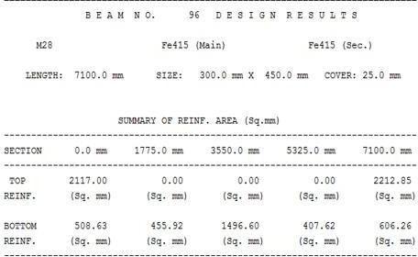

#### Table 5.1: Result of area of steel by STAAD-Pro

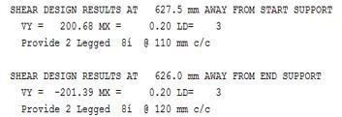

1. **Check for deflection:**

Pt 

#### Table 5.2: Details of stirrups



= 1.50

Refer

From fig. 5.1 of IS 456-2000, Kt = 2.00

From fig. 5.2 of IS 456-2000, Kc = 1.00

From fig. 5.3 of IS 456-2000, Kf = 1.00

(L/d)max = [(L/d)basic x Kt x Kc x Kf]

= [16 x 2 x 1 0.8]

= 32

(L/d)provided = 7100/415 = 17 < 32

## DESIGN OF COLUMNS

Column is compressive members of structural system. In general design of column mainly depends on the axial loads. However, as a special case as in the case of columns of industrial shed moments in the column govern the design in column in multistoried framed structures. Depending on the configuration of framed system the moments plays an important role in the design of columns. However as per clause 24.4 of IS456-2000 columns are to be designed for maximum eccentric moments in either direction.

Biaxial bending is significant in outer columns especially corners column. However interior columns are fairly symmetric loaded or subjected to axial load plus uniaxial bending involves lengthy calculations and is to be designed by trial and error method. The design is still complicated in the case of biaxial bending and slender column. Hence IS 456:2000 recommends the use of interaction diagrams given in SP-16. Hence in this report all columns are designed using relevant interaction diagrams.

### 5.7.1 DESIGN OF COLUMN

#### Data:

b = 300mm D = 450mm

Pu = 1681.92KN My = 1.37 KN-m

Mz = 110.87 KN-m fck = 28N/mm2

Fy = 415N/mm2



**1)** u = 1.15 

= 1.15  = 127.51KN-m

1. 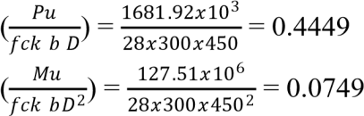Non dimensional parameter
2. refer chart 32 SP-16 (fy = 415) & ( ,

P= 0.055x28 = 1.54%, (for column it should be 0.8% - 6%) Provide

1.54%

Ast,req mm2

**Therefore provide lateral ties of 8mm dia @ 300mm c/c**

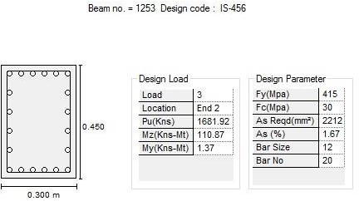

## STAIR CASE

#### Fig.5.5: Result of area of steel by STAAD-Pro

The purpose of a staircase is to provide pedestrian access to the different levels within the building. The geometrical forms of the staircase may be quite different depending on the individual circumstances involved.

There are two main components of a staircase: stairs and landing slab. The stair and landing slab can arrange in different forms to get different types of staircase. The shape and structural arrangement of a staircase would generally depend on two main factors: type of construction of the structure around the staircase, that is, load searing brick structure or reinforced concrete frame structure and availability of space. Rise and going are the two terms associated with a stair. The term rise refers to the vertical height of a step and going represents the horizontal dimension.

Over the years several types of stair cases have been developed with varying geometrical shapes and structural behaviour. The most common types are classified as follows:

* + 1. Dog-legged stair case.
    2. Open well stair case.
    3. Tread-riser stair case.
    4. Isolated cantilever stair case.

**DESIGN OF STAIR CASE**

**Data –** Assume the width of landing = 1000mm.

It is proposed to provide a Dog legged stair case and keeping in view the functional requirements its width will be kept 1000mm.

#### Assume

No. of flights = 2 Rise = 160mm Tread = 300mm Bearing = 230mm

#### Height of each flight

No’s of rises in each flight

#### = 1.75mm



**=** 10.93 ≈ 11 nos

Number of treads to be provided in each flight,

= Total numbers of rises - 1

= 11 - 1

= 10 nos

It is proposed to adopt width of tread (T) = 300 mm Therefore space occupied by 11 treads

= 10 x 300

= 3000mm

* + - 1. **Effective horizontal span (l)** = going + landing + bearing

= 3.0 + 1.5 + 

= 4.165m

#### Thickness of waist slab:

Assuming thickness of waist slab = D = 150mm and 10mm  and clear cover of 15mm

d = 15 = 130m

#### Load calculation:

Dead load = D x weight density of concrete = 0.15 x 25 x 1 = 3.75 kN/m Ceiling finishing = 0.25 kN/m (assumed)

Total load on inclined portion = 4.0 kN/m

Load in horizontal portion = 4.48 kN/m

D.L of step = x weight density of concrete = x25x1 = 1.875kN/m Top finish = 0.3 kN/m (assumed)

Live load = 3.0 kN/m Total load/m = 9.655 kN/m

Factored load = 1.5x9.655 = **14.48 kN/m**

Factored Moment Mu = = 38.55 kN-m

#### Check for effective depth (d):

Mu = Mu.lim

**As per IS 456-2000** (value of Mu.lim for 415 steel = 0.138fck bd2, b

= 1000mm)

38.55x106 = 0.138x35x1000xd2

d = 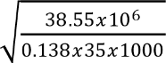 =

89.34mm d = 89.43mm<130mm

#### Area of reinforcement:

Mu = 0.87 fy Ast d (1-

38.55x106 = 0.87x415xAstx1

38.55x106 = 46936.5Ast – 4.28Ast2 Ast

= 894.242 mm2

Hence using 12mm Ø bars.

Assume 12mm Ø area of bars = = 113.09 mm Spacing = = 126.46mm

#### Provide 12mm Ø @ 130mm c/c.

* + - 1. **Distribution reinforcement:**

Ast = 0.12%bd

Ast  x 1000x150 Ast = 180mm2

Assuming 8mm Ø bars = x 1000 Spacing = 279.25mm say 270mm

**Provide Distribution reinforcement 8mm dia @ 270mm c/c**

## MODEL OF ABC COLLEGE BUILDING

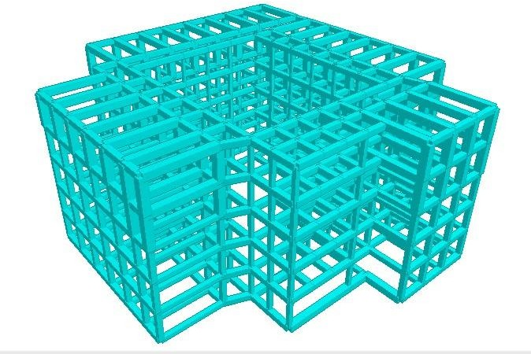

#### Fig. 5.6: 3D model of ABC College

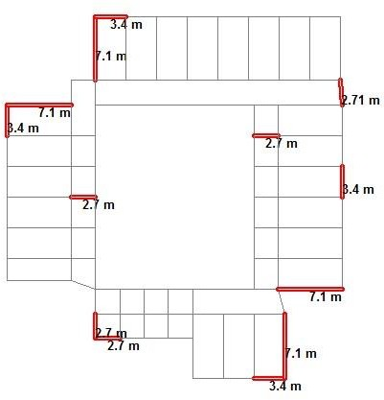

**Fig.5.7: Structural Plan**

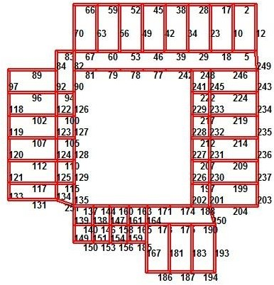

#### Fig.5.8: Beam details

**Fig. 5.9: Earthquake force along X- direction (1)**

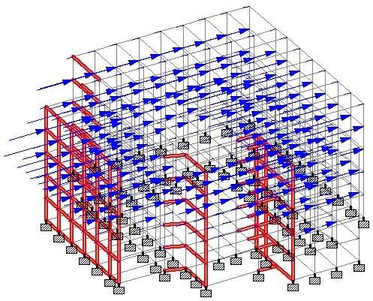

**Fig.5.10: Earthquake load along X- direction (2)**

**5.9.2 COLLEGE BUILDING WITHOUT EARTHQUAKE FORCES:**

The structure was subjected to self-weight, dead load and live load under the load case details in STAAD-Pro. The materials are specified and cross-sections of the beam and column members are assigned. The supports at the base of the structure are also specified as fixed.

The codes of practise to be followed were also specified for design purpose with other important details. Then STAAD-Pro was used to analyse the structure and design the members. In the post-processing mode, after completion of the design, we worked on the structure and studied the bending moment and shear force values with the generated diagrams. We also checked the deflection of various members under the given loading combinations. The design of the building is dependent upon the minimum requirements as prescribed in the Indian Standard Codes. Structure and structural elements were normally designed by Limit State Method.

## COMPARISON OF REINFORCEMENT DETAILS

|  |  |  |  |  |  |  |  |
| --- | --- | --- | --- | --- | --- | --- | --- |
| **FOR EARTHQUAKE LOAD** | | | | **FOR GRAVITY LOAD ONLY** | | | |
| **BEAM** | **Mz** | **My** | **AREA OF**  **STEEL** | **BEAM** | **Mz** | **My** | **AREA OF**  **STEEL** |
| **NO** | **(KNm)** | **(KNm)** | **PROVIDED** | **NO** | **(KNm)** | **(KNm)** | **PROVIDED** |
|  |  |  | **(Sq.mm)** |  |  |  | **(Sq.mm)** |
| 672 | 112 | 94 | 4245 | 672 | 34 | 139 | 4300 |
| 850 | 196 | 0 | 4500 | 850 | 152 | 0 | 1972 |
| 797 | 0 | 0 | 1005 | 797 | 0 | 0 | 565 |
| 560 | 15 | 175 | 2230 | 560 | 78 | 9 | 2000 |
| 536 | 36 | 284 | 3692 | 536 | 127 | 2 | 2000 |
| 1220 | 189 | 4.5 | 3800 | 1220 | 12 | 62 | 1043 |
| 1264 | 238 | 0 | 4368 | 1264 | 0 | 0 | 720 |
| 1253 | 15 | 331 | 3435 | 1253 | 54 | 3.5 | 1122 |

#### Table 6.2: Comparison of reinforcement details

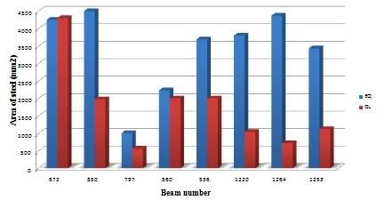

**Fig.5.11: Design results**

## CONCLUSION

Following conclusions are derived –

* From the graph above we can see that there is 60% increases in reinforcement in ground floor and 30% increase in the reinforcement in other floors when we consider earthquake design than the gravity design.
* The torsional effect shown in the figure clearly shows the torsion effect is maximum at the re-entrant corner. The four corners are severely affected when subjected to high earthquake force.
* The corner columns with maximum torsion can be strengthened by jacketing- a method of retrofitting, to safeguard the structure.
* In earthquake regions square or circular columns are more efficient than rectangular columns.

**CHAPTER 6**

# SEISMIC STRENGTHENING – RETROFITTING

## INTRODUCTION

Field inspection and analysis of the performance of structures during earthquake shaking off their foundations have clearly shown that building design which blindly follows seismic code regulations does not guarantee safely against collapse or serious damage. First there are large uncertainties in many of the aspects involved in the numerical design of structures, particularly in establishing the design earthquake shaking and in estimating the demands and predicting the supplies of the real three dimensional soil, foundation, building (super structure)system; second the performance of the system depends on its state when the earthquake strikes – thus construction and maintenance , which includes repair, retrofitting and or modifications , must also be considered in addition to the design aspects.

The constructions lack earthquake resistance in regions which has a rich heritage of historical architecture and many vernacular construction forms and pose a danger of loss of valuable architectural heritage, in the event of a major earthquake seismic retrofitting is the modification of existing structures to make them more resistant to seismic activity, ground motion or soil failure due to earthquakes.

Strengthening a building or increase the seismic resistance of a building is known as retrofitting. Prior to the introduction there may be many reasons to retrofit the building. Due to increased earthquake prone areas and the revision of codal provisions made it necessary to strengthen a building to sustain earthquake forces. This strengthening is known as retrofitting.

It is mostly done for damaged buildings. But in the case of earthquake - vulnerable buildings that have not yet experienced severe earthquakes can also be retrofitted before the damage occurs.

## METHOD OF REDUCING SEISMIC FORCE

### REDUCING MASS OF A BUILDING

Seismic shaking causes inertia forces which are proportional to the mass of the building; reduction in mass also reduces the seismic forces. Lower mass leads to lower natural period and hence higher seismic coefficient. However latter effect is less efficient than reducing the gravity loads which enables member to take more seismic load. This reduction in weight can be achieved by the removing water tanks which produce water pressure on the building which is not desirable during earthquake. Also weight can be reduced by removing heavy pillars, parapets, balconies etc.

### STRENGTHENING OF BUILDING – RETROFITTING

The seismic capacity of the building can be increased by strengthening the earth quake resistant element of the building or adding a new lateral load resistant element.

#### ADDING A NEW LATERAL – LOAD RESISTANT ELEMENT

Lateral load resisting element include shear walls, frame inside the building, steel bracing etc

#### SHEAR WALLS

Shear wall is a structural system composed of braced panels to counter the effects of lateral load acting on a structure. Wind and seismic loads are the most common loads that shear walls are designed to carry. Depending on the size of the building some interior walls must be braced as well. A structure of shear walls in the centre of a large building often encasing an elevator shaft or stairwell which form a shear core.

A typical timber shear wall is to create braced panels in the wall is to create braced panels in the wall line using structural plywood sheathing with specific nailing at the edges and supporting framing of the panel. Shear wall resist in plane loads that are applied along its height. The applied load is generally transferred to the wall by a diaphragm or collector or drag member.

Plywood is the conventional material used in shear walls but with advances in technology and modern building methods, other prefabricated options have made it possible to inject shear assemblies into narrow walls that fail at the either side of an opening. Sheet steel and steel backed shear panels in the place of structural plywood in shear walls has proved to provide stronger seismic resistance.

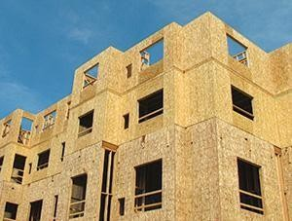

#### Fig 6.1: Shear walls for building

* + - 1. **JACKETING**

Jacketing is one of the most frequently and popularly used techniques to strengthen reinforced concrete columns. With this method axial strength, bending strength and stiffness of the original column are increased. It is well known that the success of this procedure is dependent on the monolithic behaviour of the composite element. To achieve this purpose the treatment of the interface must be carefully chosen. The common practice consists of increasing the roughness of the interface surface and applying a bonding agent, normally an epoxy resin. Steel connectors are also occasionally applied. These steps involve specialized workmanship, time and cost. Concerning the added concrete mixture and due to the reduced thickness of the jacket, the option is usually a grout with characteristics of self – compacting concrete (SCC) and high strength concrete (HSC).

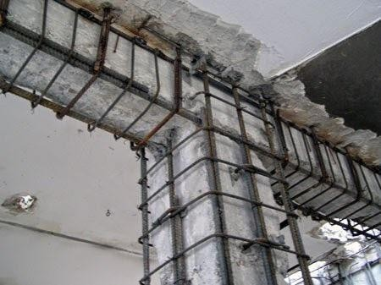

## Fig 6.2: Jacketing

* 1. **WHY RETROFITTING?**

After the earthquake in BHUJ, Gujarat, in 2001, there has been a concerted effort to address the seismic vulnerability of existing buildings in India. In the past, building codes where less stringent compare to today’s standards. All the existing buildings are not earthquake resistant. Retrofitting is required in all the existing important structures in India. For example, the administrative office or DC offices which contain important information should be protected from any damage from earthquakes. Also collages and hospitals should be earthquake resistant as this provides shelter and treats large people when such natural calamity occurs.

India has ancient monuments which were built without considering engineering aspects. But those structures are very strong that they have very long life span in normal conditions.

These structures have high strength against vertical loads but not in lateral direction. During earthquakes some structure fails due to excess internal loads. These structures cannot be rebuilt considering earthquake loads, Hence we need to use retrofitting techniques to safeguard them.

In buildings, conventional process of retrofitting typically includes strengthening weak connections found in roof to wall connections, continuity ties, shear walls and the roof diaphragm.

## RETROFITTING OF EXISTING REINFORCED CONCRETE BUILDING

Retrofitting is technical interventions in structural system of a building that improve the resistance to earthquake by optimizing the strength, ductility and earthquake loads. Strength of the building is generated from the structural dimensions, materials shape and number of the structural elements. Ductility of the building is generated from good detailing, materials used, degree of seismic resistant etc. Earthquakes load is generated from the site seismicity, mass of the structures, important of the buildings, degree of seismic resistant etc. Due to variety of structural condition of building it is hard to develop typical rules for retrofitting.

Each building has different approaches depending upon the structural deficiencies. Hence engineers are needed to prepare and design the retrofitting approaches. In the design of retrofitting approach, the engineers must comply with the building codes. The results generated by adopting retrofitting techniques must fulfill the minimum requirements on the building codes such as deformation, detailing strength etc. This can be accomplished through the addition of new structural elements, the strengthening of existing structural elements and/or the addition of base isolators.

## THE GOALS OF SEISMIC RETROFITTING CAN BE SUMMARIZED AS FOLLOWS (IS 13935:1993)

1. Increasing the lateral strength and stiffness of the building
2. Increasing the ductility and enhancing the energy dissipation capacity.
3. Giving unity to the structure.
4. Eliminating sources of weakness or those that produce concentration of stresses.
5. Enhancement of redundancy in the number of lateral load resisting elements.
6. The retrofit scheme should be cost effective.
7. Each retrofit strategy should consistently achieve the performance objective.

**CHAPTER 7**

# CONCLUSIONS AND FUTURE SCOPE

## CONCLUSIONS

* + 1. Architectural features that are detrimental to earthquake response of buildings should be avoided. If not, they must be properly designed with high care.
    2. Decisions made at the planning stage on building configuration are more important, and are known to have made greater difference, hence Architects and Structural engineers has to work together.
    3. If the existing building is built with architectural problem, they should be properly retrofitted.
    4. Comparing a detailed Analysis and design of ABC College building for gravity and earthquake loads given by means of charts and tables. Results shows that the building under zone III designed by only gravity loading has poor performance during earthquake at the re-entrant corners.
    5. It also shows that the building designed with a square or circular column resist the earthquake very efficiently than rectangular columns.

## FUTURE SCOPE

* + 1. The same project can be done by E-TABS, SAP, different software’s and compares the results.
    2. With the available results there is a scope for Geotechnical engineers to design the foundation for earthquake resistant structures.
    3. By taking the available results there is a scope for implementation of retrofitting for the same structural element.
    4. There is a scope for dynamic analysis which can be compared with existing results.

# REFERENCES

Agarwal, P and Shrikhande , M (2006) “ Earthquake Resistant Design of Structures” Prentice – Hall of India Private Limited New Delhi India

Banginwar, R.S, Vyawahare, M.R. and Modani , P.O. (2012) Architectural problems and structural irregularity effect on the seismic behavior of the structure by response spectrum method, They analysed the structure using ETABS.

### Bureau of Indian Standards:

IS-875, (part 1) 1987, Dead Loads on Buildings and Structures IS-875,(part 2) 1987, Live Loads on Buildings and Structures

IS-875,(part 3) 1987,Wind Loads on Building and Structures IS-875,(part 5) 1987, Load Combination Details.

IS 1893, (part 1) – 2002, Indian Standard Criteria for Earthquake Resistant Design (5th Revision)

IS 13920-1993, Indian standard code of practice for Ductile Detailing of Reinforced Concrete structure subjected to seismic forces.

IS 13935-1993, Indian standard code for repair and seismic strengthening of structure.

Central public works department and Indian building congress (2007) “Handbook on Seismic Retrofit of Building”.

Dr. S. A , Arya, (2004) “ Seismic evaluation and strengthening of reinforced concrete buildings” UNDP disaster risk management program IIT Roorkee.

Gomes, G.M, Rodrigues, A.M. and Mendes, P.(2009) “ Wind Effects on and around L- shape and U-shaped buildings.

Iyengar, R. N(2004) “Earthquakes in India; an Engineering Perspective”. ERDRRCS.

Jayalekshmi, B.R (2004) “Seismic Analysis and Design of a Multi-storey RC Building”, ERDRRCS

Modakwar, Neha P, Meshram, Sangita S. and Gawatre, D.W. (2014) “Seismic

Analysis of Structures with Irregularities”.

Murthy, C.V.R, Goswami, Rupen, Vijayanarayanan, A.R. and Mehta, Vipul V “Behaviour of Building during Earthquake”.

Prashanth. P, Anushman. S, Pandey. R.K, Arpan Herbert, (2012), “Comparison of design results of a Structure designed using STAAD and ETABS software”, Volume 2, No 3, 2012.

Prof. Sable, K.S., Ghodechor, V.A. and Prof. Kandekar, S.B. (2012) “Comparative Study of Seismic Behaviour of Multi-storey Flat Slab and Reinforced Concrete Framed Structure” International Journal of Computer Technology and Electronics Engineering (IJCTEE) Volume 2, Issue 3.

Ravikumar C M, Babu Narayan K.S, Sujith B.V and Venkat Reddy D (2012) “ Effect of Irregular configurations on seismic vulnerability on RC buildings.

Varghese, P.C. (2010) “Limit state design of reinforced concrete structure” PHI Learning Pvt. Ltd

Venkataramana k., Rao, M.G (2004) “Lessons from Bhuj Earthquake; Damage of RC Structures”, ERDRRCS.