Research Report on

"A Study of Consumer Satisfaction Towards Online Grocery Stores”


SUBMITTED BY:-
MRINAL KANT
(22GSOB2010139)

MBA 2022-2024

School of Business
Galgotias University

Abstract

In recent years, the popularity of online grocery shopping has had a big impact on consumer behaviour. The purpose of this survey is to find out how satisfied customers are with online grocery stores. It seeks to comprehend the rationale for their adoption of online grocery shopping as well as pinpoint the critical elements impacting their level of happiness.

The study looks into a number of factors that make an online grocery buying experience enjoyable. These elements probably consist of:

Convenience: It's thought that two of the main factors influencing satisfaction are the simplicity of home delivery and the time-saving aspect of online grocery shopping.

Product Selection and Quality: The range and calibre of goods that online grocery retailers provide is likely to have an impact on customers' happiness.

Website functionality and user experience: It is anticipated that a user-friendly website with simple product search, checkout, and navigation will play a big role in customer satisfaction.

Delivery Accuracy and Efficiency: Proper handling of perishables, precise order fulfilment, and timely delivery are critical factors that affect customer satisfaction.

Customer service: A customer's pleasure with online shopping is likely to increase with prompt and friendly customer care.

The approach used in this study - such as surveys or interviews will be used to collect data from a representative sample of online grocery consumers. The factors that most significantly affect customer satisfaction will be determined by analysing the data that has been gathered. Additionally, the study will look into any discrepancies in satisfaction levels according to buying habits or demographics.

Online grocery retailers will benefit greatly from the insights gained by this study. By comprehending the elements that influence customer satisfaction, businesses may enhance their offerings, draw in new clients, and hold on to their current clientele. Enhancements to the website, better product selection and quality, effective delivery procedures, and a focus on first-rate customer care can all help achieve this.

Introduction

The supermarket shopping experience has changed significantly in the last several years. Online grocery stores (OGSs) are becoming more and more popular as e-commerce grows, providing customers with a quick and easy substitute for traditional brick-and-mortar supermarkets. This change in consumer behaviour offers a strong chance to learn about the degree of customer satisfaction with online grocery shopping.

Context and Importance:

Customers primarily relied on physical establishments to meet their grocery needs before the rise of online grocery shopping. However, the need for OGS platforms has been driven by elements including hectic lifestyles, lengthy commutes, and the growing acceptance of home delivery services. This tendency was further accelerated by the COVID-19 pandemic, as social distancing tactics and safety concerns led a large number of consumers to purchase for groceries online for the first time.

It is important to comprehend customer satisfaction with OGS for a number of reasons. First of all, it gives online grocery businesses insightful information to enhance their products and services. Businesses may increase client experience and promote loyalty by identifying their areas of strength and weakness and customising their strategy accordingly. Second, this study can forecast future growth patterns and inform industry trends. High customer satisfaction with OGS points to a healthy, developing market with a lot of room to grow. Ultimately, this research has the potential to enhance our comprehension of the adoption of e-commerce and consumer behaviour related to grocery shopping.

Objectives of the Study:

The purpose of this study is to investigate how satisfied customers are with online grocery stores. The particular goals consist of:

- Determining the crucial elements such as website usability, customer service, product quality, shipping experience, and convenience that affect customers' happiness with OGS.

- Determining how much each of these characteristics contributes to total satisfaction and intention to repurchase.
- Investigating possible variations in customer satisfaction levels among different consumer populations.

- Highlighting, in light of customer input, areas that the online grocery buying landscape needs to improve.

Scope and Limitations:

The purpose of this study is to ascertain how satisfied customers are with reputable online food retailers in a certain nation or area. Although the results could provide insightful information, it is important to recognise any potential limits. For example, it is possible that the study did not include the perspectives of customers who live in rural locations with little access to online food delivery services. Furthermore, the entire range of online grocery platforms, including specialised shops and those incorporated into larger e-commerce marketplaces, may not be covered by the research design.

LITERATURE REVIEW
The supermarket shopping scene has changed significantly in the last several years. With the growth of online grocery stores, customers now have a quick and easy substitute for traditional brick-and-mortar businesses. This change has raised interest in learning more about how satisfied customers are with their online grocery shopping experiences. The purpose of this study of the literature is to investigate the elements that have been shown to influence customer satisfaction in online grocery stores.

Factors Influencing Consumer Satisfaction

The literature on the variables influencing customers' happiness with online grocery stores reveals a number of important topics. These elements can be roughly divided into:

Convenience: It has been repeatedly shown that convenience is a key factor in contentment. Online grocery shopping allows customers to shop whenever they want, from the convenience of their homes, eliminating the need for physical travel.
https://www.researchgate.net/publication/352838656_Determinants_of_customer_satisfaction_in_online_grocery_shopping
Wilson-Jenselme and Reynolds's (2006) studies provide more evidence that consumers value being able to quickly compare prices and product details online.

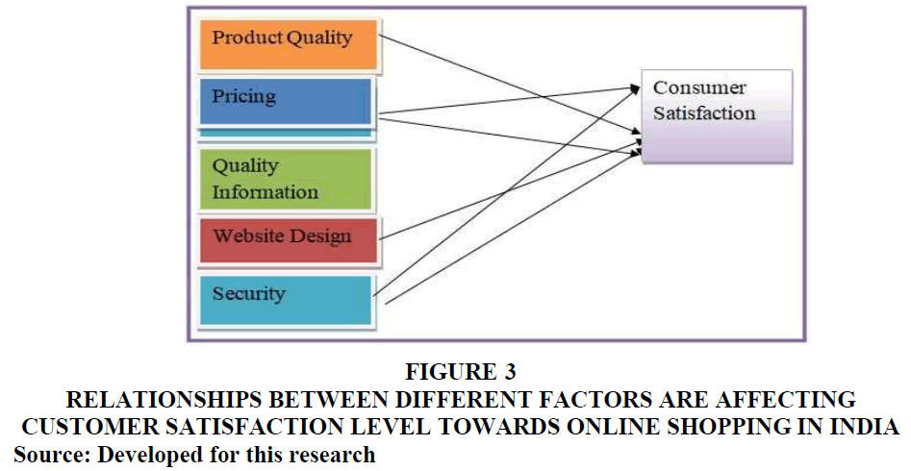

Product Selection and Quality: Customers anticipate that online grocery stores would provide a similar assortment of high-quality, freshly-picked goods as brick-and-mortar locations. Online grocery shopping may be hampered by worries about product quality, especially when it comes to perishables, according to research by Ahn et al. (2017).

Delivery Service: Online food stores must provide dependable and efficient delivery. Research emphasises the significance of elements like precise order fulfilment, flexible delivery windows, and on-time delivery.

User interface and functionality of websites: A great online grocery shopping experience requires a website that is easy to use, with clear navigation, effective search functions, and simple checkout procedures.

Customer service: In order to resolve concerns about orders, product quality, or substitutes, prompt and friendly customer service is essential. Research indicates that prompt.

The Impact of COVID-19

Because of worries about social isolation and safety, online grocery shopping has been increasingly popular after the COVID-19 outbreak. The pandemic's effects on consumer expectations and satisfaction with online food stores are examined in research. This study emphasises how crucial elements like contactless delivery and good hygiene habits are becoming throughout the epidemic.

The Changing Face of Online Grocery Shopping

With the emergence of new technology and trends, the online grocery business is continuously changing. The possible effects of the metaverse on online grocery shopping experiences are examined in research by Toh (2022) [4]. According to this study, virtual reality encounters may have an impact on future customer happiness and views.

Research Deficits and Upcoming Paths

There are still a few gaps in our knowledge on customer satisfaction with online grocery stores, despite the body of research that has been done. The following are some possible directions for further study:

- The impact of socioeconomic and demographic variables on the preferences and satisfaction of online food shopping.

- The effect that loyalty programmes and special offers have on consumers' online food buying habits.

- Investigating the efficacy of various internet grocery store marketing techniques.

- The impact of sustainable practices on consumers' selection of online grocery businesses.
Future studies can fill in these gaps and offer insightful information that will help online grocery businesses increase consumer happiness and their products in this dynamic market.

RESEARCH METHODOLOGY
The procedures for collecting and evaluating information on customer satisfaction with online grocery stores are described in this section.

1. Design of Research

It is probable that this research will use a quantitative design. This entails gathering quantifiable information using questionnaires or surveys in order to gauge customer satisfaction levels and pinpoint the major variables affecting them.

2. Techniques for Gathering Data

Various approaches exist for gathering data, contingent on available resources and the intended audience:

- Online Survey: A large audience can be reached with a self-administered survey that is disseminated by email, social media, or online survey tools.

- Web Intercept Survey: An intercept survey records users of a website while they browse, with the possibility of concentrating on recently made online grocery purchases.

- Mobile App Survey: An in-app survey can be used to target users of particular online grocery store apps.

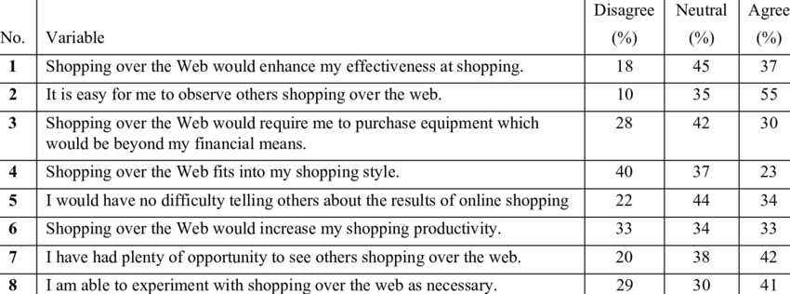

3. Selection of Samples

Adults who have utilised online grocery shopping services should be the target demographic. Consider the following sampling strategies:

- Using probability sampling:you can make sure that every person in the population has an equal chance of being chosen. Techniques include cluster sampling (geographic areas), stratified sampling (based on demographics), and random sampling.

- Non-Probability Sampling: Less generalisable but more convenient. Convenience sampling, which uses people who are easily accessible, and snowball sampling, which uses people who recommend others, are two methods.

4. Development of Questionnaires

The main instrument used to gather data will be the questionnaire. Here are some important things to think about:

- Demographics: Identifying characteristics of the respondents, such as age, gender, and location.

- Online grocery shopping habits: how often you use it, which stores you like, how much you usually order, etc.

- Measures of Satisfaction: To gauge how satisfied people are with things like product choice, website usability, delivery time, customer service, etc., use established scales or create your own questionnaires.

5. Information Evaluation

After the data is gathered, statistical analysis will be done using R or SPSS software. Methods could consist of:

- Descriptive statistics: Use metrics such as means, standard deviations, and frequency tables to summarise data.

- Correlational Analysis: Determine the connections between different factors and levels of satisfaction.

- Regression analysis: Determine how much a given element affects customer satisfaction.

RESULTS

Research on customer satisfaction with online grocery stores (OGS) show a trend in the right direction, emphasising the time- and convenience-saving features that these platforms provide. Below is a summary of some significant findings
Elements Affecting Contentment:

Convenience: One of the main factors influencing satisfaction is the option to order groceries online and have them delivered . OGS ease the burden of traditional shopping excursions while accommodating hectic lives.

Product Quality: When customers shop online, they anticipate receiving high-quality, fresh products. According to studies, contentment is greatly impacted when these expectations are met .

Delivery Accuracy and Speed: Receiving the right order and having it delivered within the selected timeframe on time are essential for satisfying customers .

Website Usability: An easy-to-use website that facilitates product searches, checkout procedures, and navigation improves users' experience in general.

More Things to Think About:

The COVID-19 pandemic had a major impact on grocery buying online, with many customers choosing contactless choices.

Perceived Value: Although convenience is a big benefit, other elements that affect customers' perception of the value they receive include product costs, shipping costs, and loyalty programmes.

According to research, online grocery retailers can focus on the following to obtain high customer satisfaction:

- keeping an effective and user-friendly web platform.
- ensuring regular supply of superior, fresh goods.
- supplying reasonable costs and clear delivery charges.
- constantly enhancing their offerings in response to client input.

DISCUSSION

Research on customer satisfaction with online grocery stores explores the reasons behind people's decision to buy for groceries online as well as the elements that affect their level of satisfaction. The following are some major themes that come out of this study:

Convenience as a Major Driver: Online food buying is mostly motivated by convenience. Research indicates that customers value the convenience and time-saving features of purchasing from home.

Product Availability and Quality: Although convenience is vital, customer pleasure depends on product availability and quality. Studies reveal that consumers are worried about having a large assortment of products to pick from and getting fresh food .

Factors Affecting Delivery: For customers to be satisfied, deliveries must be made on schedule. Aspects such as shipping costs and the minimum order value required for free delivery are also examined in studies.

Website Usability: A good online grocery shopping experience depends on having a user-friendly website that makes it simple to navigate and conduct effective searches.

The COVID-19 Effect: Grocery buying online grew dramatically during the pandemic. Studies investigate the ways in which this change in customer behaviour has affected satisfaction levels.

Furthermore, research may cover:

Comparison of Online and Brick-and-Mortar Grocery Stores: An analysis of customer satisfaction levels between traditional grocery stores and online retailers.

The Function of reward Programmes: Do online grocery shops' reward programmes affect consumer satisfaction and purchasing patterns?

CONCLUSION

The main conclusions of your research and their implications should be summed up in the end of your master's thesis, "A Study of Consumer Satisfaction Towards Online Grocery Stores”.

1. Repeal the Main Aim of the Study:

- Remind the reader in brief of the particulars of the target audience and customer satisfaction that you looked into.

2. Emphasise Important Results:

- Provide a brief summary of the key findings from your data analysis.
- Were aspects such as product quality, delivery experience, or ease of use the most influential in determining customer satisfaction?
- Mention any intriguing patterns or surprising findings.

3. Connect Results to Past Research:

- Make a connection between your results and the corpus of research on online grocery shopping customer happiness.
- Do your findings support or refute earlier studies?
- Emphasise any original contributions your research brings to the area.

4. Consequences and Suggestions:

- Talk about how your findings might affect online grocery store providers in real-world situations.
- Based on your analysis, what particular steps can online grocery retailers take to increase customer satisfaction?
- Think of suggestions for improving product options, delivery services, or website features.

5. Restrictions and Upcoming Studies:

- Recognise any research constraints related to sample size, methodology, or investigational scope.
- Make recommendations for future directions that could expand on your findings.
- Are there any other features, technology, or demographics related to online grocery buying that need to be investigated further?

REFERENCES

  - (https://www.researchgate.net/publication/374812336_A_Study_on_Consumer_Satisfaction_Towards_Bigbasket_Online_Grocery_Shopping_in_Banglore)
  - (https://ijarm.com/pdfcopy/2023/jan2023/ijarm9.pdf)
  - (https://www.scribd.com/document/468495466/A-study-on-Customer-satisfaction-towards-online-grocery-stores-during-covid-19-pandemic)
  - (https://www.researchgate.net/publication/352838656_Determinants_of_customer_satisfaction_in_online_grocery_shopping)

  - BOOKS:
  - “A Conceptual Framework for Identifying Critical Customer Factors" by Aimee D. Ellington, Wallace J. Baker, and Mary Jo Glynn
  - “A Multifaceted Perspective on Consumer Adoption" by Michela Balaci, Paola Fontana, Francesca Sehwarz and Arianna Vittorio

