MBA Project Dissertation Report on

**Customer Engagement Behavior on Social Media Platforms**

***Submitted by***

# Shivam Tomar

**Roll No: 22GSOB2010584**

**Under the Guidance of**

# Dr. Diksha Bisht



**GALGOTIAS SCHOOL OF BUSINESS**

**Galgotias University**

Gautam Buddh Nagar, Greater Noida, Uttar Pradesh 201308

**CERTIFICATE**

This certificate confirms that **Shivam Tomar** has completed their master's thesis titled in **“Customer Engagement Behavior on Social Media Platforms”** under my supervision and guidance. The project report is submitted as part of the completion requirement for the two-year, full-time Master of Business Administration (MBA).

Faculty's name and signature

**Dr. Diksha Bisht_____________________**

Assistant Professor

Date:-

## Declaration

I, **Shivam Tomar**, Roll No. **22GSOB2010584**, Student of Galgotias University Greater Noida School of Management, I declare that the Master's thesis on **"****Customer Engagement Behavior on Social Media Platforms"** is an original and certified work done by me. I further declare that no one at these institutions is authorized to award degrees or certificates elsewhere.

Student's name and signature

**Shivam Tomar____________________**

Date:-

## Acknowledgement

I would like to express my sincere gratitude to everyone who contributed to the realization of this project. I am so grateful for the knowledge and skills shared by everyone involved. I would like to thank my department head, Dr., for providing valuable guidance and support to the project. I am very grateful to **Dr.** **Diksha Bisht**. I really appreciate their help and support. I would also like to thank my dear friends for their cooperation, advice and support in the challenging journey of completing this project and preparing the report. Overall, I am grateful for the opportunities and resources I have been given, and I am grateful for the collective efforts that made this project possible.

## Executive Summary

Community segments and social relationships have a significant impact on the antecedents that influence consumer behavior in social media marketing. This indicates that a higher level of interaction between the user and other residents leads to the exchange of information or ideas. Conversely, the level of entertainment and interactivity in advertisements also has a significant impact. Social media marketing that involves a high level of entertainment or levels of user interaction increases the user's ease of marketing, thus increasing their profits and profits. According to this study, among the previous seven factors affecting users' behavior in social media marketing, public relations, entertainment level and interactivity have a significant impact. In addition, in social media marketing, sharing on social media, commenting and creating behavior based on the influence of user behavior have a significant impact on improving users' relationships with social media, brands and products. This research shows that consumer participation in social media marketing causes consumers to have certain emotional preferences towards the relevant brand, increasing satisfaction and brand-product interactions, leading to positive outcomes. This study contributes to existing research in several ways. In previous cases involving user social media marketing activity, we found that social capital and equity had a significant impact. This may be because the brands used in this study consist of generic brands and mass brands. Consumers therefore face less risk when purchasing brands or less complexity in their purchasing decisions. Therefore, social capital has unique effects on relationship development. Future research should identify clothing brands with higher levels of differential effects. Regarding the practical contribution of this research, we examined the effects of social media marketing on measuring social media participation behavior. Based on these findings, marketers and researchers should consider the following recommendations when planning social media. First of all, when developing a social media site, entrepreneurs should focus on managing fan pages or social media sites on social media to increase activity and interaction between users and members or fan sites, thereby increasing user behavior. Moreover, because we have shown that the visual information level and credibility of the advertisement have a special impact, marketing personnel need to focus on the level of entertainment and interactivity in advertising design to help users find interesting and innovative advertisements. Consumer interest and willingness to purchase are closely linked; therefore, promoting such benefits in advertising may encourage consumer behavior. In addition, according to the behavioral evaluation results regarding users' participation in social media marketing, users' behaviors may differ depending on their perceptions of social media marketing. Also the level of user activity on social media. In this study, well-known brands Uniqlo and Lativ were selected and the overall score of both products was , which was considered satisfactory without many negative comments. Therefore, feedback behavior has no impact on advertising. Future research should investigate whether perceived value can moderate the relationship. Additionally, marketing staff can plan creative activities focused on the company's website, product, or fan page to attract customers to the fan page.

# Content

|  |  |  |
| --- | --- | --- |
| **S.NO.** | **Particular** | **Page No.** |
| **1.** | Certificate | 3 |
| **2.** | Declaration | 4 |
| **3.** | Acknowledgement | 5 |
| **4.** | Executive summary | 6-7 |
| **5.** | Introduction | 9-10 |
| **6.** | Objective of the study | 10-12 |
| **7.** | Literature Review | 13-16 |
| **8.** | Research Methodology | 17 |
| **9.** | Hypothesis Development | 18-27 |
| **10** | Data analysis and results | 28-35 |
| **11.** | Discussion | 36-39 |
| **12**. | Limitations and Future Research | 40 |
| **13.** | Conclusion | 41 |
| **14.** | References | 42 |
| **15.** |  |  |
| **16.** |  |  |
| **17.** |  |  |

## Introduction

In recent years, the advancement of technology and the dominance of the internet have led to the rapid growth of social media. According to 2013 eMarketer statistics, one quarter of the world's population uses social media and this number is expected to reach 55 billion in 2017. This shows that social media is widely used and its impact is not limited. to be despised. According to Kelsey, the cost of the campaign in the US was $6. This amount, which was 8 billion in 2014, is expected to increase to 9.2 billion dollars in 2016. Social media marketing has become an important topic in marketing and plays a huge role in marketing. With the rise of social media, businesses and companies' investments in social media marketing have increased significantly, demonstrating the importance of social media. Previous research has examined the effects of mass media advertising, including consumer acceptance of social media advertising and the impact of social media on consumer decision making. Previous research suggests that social media marketing research focuses on the overall effects of online advertising; However, there is little research on consumer behavior and the effects of online advertising. With the rapid growth and development of social networking services, companies have significantly increased their social media marketing budgets. Social media marketing has attracted the attention of marketers and researchers. However, little work has been done on social media marketing and measuring the impact of individual clicks. This study developed a model to analyze consumer participation in social media marketing, relationships in antecedents of social media marketing, participation behavior of social media marketing, and effects of social media marketing. In this study, an online survey was conducted among 502 internet users. Partial partial analysis was used to analyze relationships between antecedents and effects of social media marketing. Finally, discussions and inferences will be made regarding the research results and suggestions will be made based on the results.

## Objective of the study

With the advent of social media, businesses and companies have significantly increased their investments in social media marketing, demonstrating the importance of social media to their success. Previous research has examined the importance of social media marketing, including consumer acceptance of social media marketing and the impact of social media marketing on consumer decision making. Primary research shows that social media marketing studies focus on the overall effects of online marketing; However, there are few studies addressing consumer behavior and effects in internet advertising. The current study developed a model to examine the antecedents of consumer engagement behavior in social media marketing and the effects of such behavior on member relationships, product interactions, and interactions. Therefore, the aims of this study are as follows:

1) To investigate the antecedents of social media marketing and the resulting value of the process.

2) In this study, the antecedent structures of social media marketing are verified using factor analysis.

5) Examining customer interaction behaviors on social media that have a significant impact on positive emotions.

6) Examining different customer behaviors on social media.

7) To investigate whether there is a significant impact on the purchase price depending on the purchase of the product.

8) Investigate the reasons behind customers' impulse buying of various products on social media.

9) Need for research to predetermine consumer behavior (CEB) regarding social media.

**Literature Review**

Online networking is possible through many popular forums and social media. For everyone, these sites have changed the way people communicate, socialize, learn and make decisions. In terms of consumer relations, it is possible to see changes in the way recommendations are made and experiences are shared on this site, creating new ways to create trust and loyalty networks among consumers When a company creates a fan page on Facebook, it can post custom marketing content to engage more consumers. This relationship is made public when users log into a company's website and use reaction buttons to express their feelings. Only after this behavior will the real actions and content advertised by the brand be shown to users and their network of friends. In this sense, these fan pages can be considered VBC because they are based on the basic principle of a non-physical, closed community, based on a strong relationship between members and the brand. In this environment, value propositions need to be fun and interesting so that consumers can identify with them and their personal stories, allowing them to realize the value the product adds to their lives. stated that consumers want to establish relationships with brands when they see that the brand has a strong impact and changes their lives. From this perspective, the aim of product management is to establish lasting and quality emotional relationships with consumers and to be a part of their stories, memories and relationships. Establishing these positions results in a large base of loyal and committed customers. The composition of these positions is based on three basic elements: common understanding; rituals, stories, and shared traditions that help define the meaning of a community; and then the development of moral responsibility or shared responsibility between the community and its members. In this context, many communities focus on areas of special interest that may be individually related to different themes. This article can be found in Ridings definition of collaborative organization. They considered audiences to be "groups of people with common interests and activities who communicate regularly, at specific times, in an organized manner, via the Internet, using specific tools." According to Kozinets has many different characteristics, including the effects of traditional communities on consumer behavior. Sometimes people's interests are in products, organizations, and/or brands. Such families are known as VBCs. Even when talking about brands and organizations, it is important to remember that participation in these communities is based on positive relationships that people intentionally build based on the characteristics of the organization. The more compatible the group's core activities are with members' goals, the more likely they are to join that group. Considering the commonalities found in all definitions (such as nature, structure and relationship), it is important to note that the motivation for participating in VBC is the benefit that members derive from the interaction and shared use between members and the company. shared information. When discussing the concept of participation in general, two different interests can be considered, hedonic and utilitarian, defined by both identity and social theory. According to identity theory, the individual engages in VBC to create specific social categories that will meet his needs and characteristics. The self-care process takes place as long as it is in the group. According to Bourdieu, the concept of capital can be understood as “the possession of real or potential long-term assets”. communication channel of particular knowledge or wisdom”.

## Research Methodology

To verify the level, a survey question was created using full statistics following the guidelines of Krejcie & Morgan and Saunders, Lewis & Thornhill (as shown in Figure 2). The research question is considered a suitable method to measure consumer behavior and adaptive behavior. The research was carried out in three stages: pre-flight testing, flight testing and main study. The population consisted of social media sites because social media is a source of insight for practitioners and marketers. The article asked questions of Anderson and Gerbing to better understand the concepts, test development, and accepted measurement criteria. Different items are prepared for each measurement according to measurement books. The constructs were identified and the items developed for the instruments and scales were modified from the original study to make the items measuring the constructs more appropriate in terms of purpose and reliability. Instruments and scales from previous studies were adapted to the research context. Additionally, hypotheses based on cause-effect relationships were developed in the model. Appendix B (Table 8) provides a detailed description of the literature used to measure each parameter. Empirical research was used to ask a group of experts (academics and PhD students knowledgeable in the field) to measure the level of the construct of each item using a Likert scale (1 = well representative, 2 = representative, and 3 = not representative). All). Preliminary tests were followed to arrive at the final analysis. Finally, a sample survey was conducted among 40 social media users to find out what went wrong. These participants did not request further development. A total of 733 responses were received to the final survey, which is sufficient for the purpose of this study. Finally, factor analysis (CFA) was conducted using a comprehensive method to evaluate brand equity.

## 3. Research model and hypothesis development

### 3.1 Hypothesis development

Consumer research and IS literature have identified attitudes as precursors to general behavioral intentions, which in turn lead to specific behaviors such as resistance to technology. It is also clear that behavior is the result of belief. However, psychologists say that emotional or affective components play an important role in this process. Thus, many important factors such as enjoyment, self-enhancement, anxiety, and confidence were identified and discussed as components of these factors. Therefore, it is important to evaluate these practical factors and cognitive components that arise as a result of the evaluation of the behavioral factor (positive or negative evaluation of active behavior). In terms of the main theoretical basis of this study, the attitudinal effects of the items cannot be confirmed due to the large number of emotions discussed in consumer research. This study develops the following model (Figure 1) and hypotheses involving cognitive and emotional factors as antecedents of social media engagement. The model is similar to the previous one and shows that Perceived Opportunities (PO), Social Perceptions (PSI) and Perception Control (PC) are utilitarian attitudinal cognitive factors, and happiness, positivity, fear and trust are concrete attitudinal factors. This study suggests that consumers exhibit positive social media adaptation behavior towards social media to seek or use the benefits of technology, or negative social media adaptation behavior to return to social media or avoid it altogether. Appendix A (Table 5) details consumers' compliance behaviors, sources, and contributions to the hypotheses. This study, unlike CMUA, reports that blocking social media leads to both time- and behavior-based changes in consumer behavior. They have not only an intellectual appreciation but also a strong emotional connection with these modern pieces.

**Cognitive attitude**

Eagly and Chaiken propose that cognitive processes occur when people process information consisting of beliefs about an object. Similarly, this study suggests that PO, PSI, and PC are cognitive beliefs that shape consumers' attitudes toward social media participation. Appendix A provides details about attitudinal intelligence, their origins, and their contributions to hypotheses.

**3.1** Consumers prepare a comprehensive assessment of the opportunities offered by social media to improve their performance and reduce their effort. These are performance indicators of useful, performance-enhancing processes; proven to be easy to use and energy-free; and has a relative advantage because social media is seen as superior to the previous one. This study suggests that PO includes the issue of performance, expected power, and social media impact. Consumers who are personally highly innovative tend to view social media as an opportunity to improve their performance and are better suited to the goals they want to achieve. Consumers develop evaluations of social media platforms and features that they find useful and innovative. Therefore, the following hypothesis is formulated (Research on Benefits of Social Media) to show that consumers see social media as an opportunity to characterize their performance, relative efficiency and ease of use and tend to exhibit positive adaptive behavior 'EMSMB' and social media to meet their interests used for (ESSMB).

**H1** – Availability of opportunities has a positive impact on positive climate change behavior.

**3. 1** These social emotions create positive relationships, creating relationships and social support. PSI is the desire to communicate, socialize and build relationships. Social media is being adopted by consumers to enhance interactions, connect them wherever they are, and complement their online relationships. Consumers are driven by psychological goals to improve their relationships to meet their needs, which influences their anti-technology behavior. Consumer behavior is related to social forces determined by social

. Therefore, this study presents the following hypothesis, indicating that PSI are consumers who feel that there is social pressure of social relationships, good relationships, and social well-being. This puts psychological pressure on them to adopt positive anti-social media behaviors and seek out or use more social media to win.

**H2–** Social visibility has a positive effect on positive climate change behavior.

**3.1** They analyze social media sites and link to these latest sites for relevancy and relevancy. This study demonstrates the following hypothesis: visual control is consumers' attitude and increases their positive attitudes towards engaging in social media engagement (studies proliferate or are used to meet the benefits of social media). They are more likely to satisfy their social media interests if they perceive that social media provides them with a strong sense of control, that is, control over their personal beliefs, independence, and information (Table 2). They tend to engage in effective social media integration and research to improve their use and satisfaction with social media behavior. Eagly and Chaiken suggest that components of attitudinal intelligence occur when individuals process information about an object to form a belief. Similarly, this study hypothesizes that PO, PSI, and PC are cognitive beliefs that shape users' attitudes toward social media participation. Appendix A provides details about attitudinal intelligence, their origins, and their contributions to hypotheses.

**3. 1. 1. 1** Perceived Opportunities (PO) Perceived opportunities are consumers' beliefs that technology that provides ease of use is useful, improves performance, and has relative advantages. Consumers who plan to comprehensively evaluate the opportunities offered by social mediaincrease their productivity and reduce the effort they need to spend.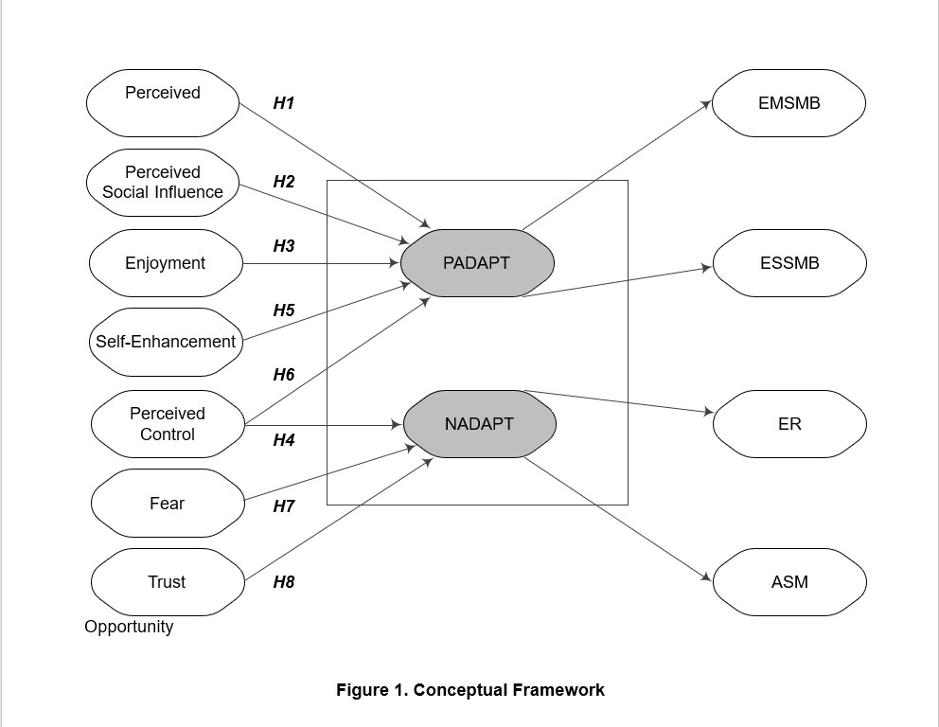

**H3** – Perceived control has a positive effect on positive climate change behavior.

Additionally, the appearance of checks is relevant to the technical literature. Technology users would try to switch back to technology if they perceived that they had little control over it. They tend to minimize the negative effects of technological disruption. Moreover, people tend to stay away from technology altogether unless they are involved in it. They will use adaptive measures to eliminate the mental pain caused by technological disruption and leave technology behind. Therefore, this study hypothesizes that consumers are more likely to leave or avoid social media when they perceive that they exhibit negative compliance behavior and have no control over social media.

**H4** - Perception of control has a negative effect on antisocial behavior.

3.1 Positive emotions such as fun, enjoyment, and positivity are the result of positive experiences on social media, resulting in positive consumer attitudes towards social media. Negative emotions, such as fear, emerge from social media experiences and lead to consumers' negative attitudes towards social media. Appendix A (Table 7) provides a detailed description of the attitude factors, their origins, and their contributions to the hypotheses.

**3.1. 2**. Joy is happiness or joy when interacting with social media. Consumers use social media for entertainment, which has a huge impact on their behavior. Therefore, this study proposes the following hypothesis that happiness is an emotion that creates the consumer's intrinsic emotional satisfaction, satisfies his pleasure needs, and motivates him to engage in positive interactions on social media.

**H5–** Happiness has a positive effect on positive climate change behavior.

**3. 1. 2. 2** Self-Esteem (SE) Self-esteem is the positive feeling that the consumer has about himself. Self-esteem, self-image, and self-esteem are what they need to meet their need for self-aggrandizement and express their ideals on social media. In order to attract attention, their emotional satisfaction will strengthen their social image and they will participate more in social media. Emotional intelligence is a good indicator of social media engagement. Positive comments from users affect other users emotionally. A large increase in the number of consumers will increase their self-confidence and they will be more inclined to express their status and share information on social media. Therefore, this study proposes the following hypothesis that consumers' intention to use social media, which increases their self-esteem, may lead to positive adaptive behaviors, including exploration to maximize their benefits.

**H6–** Restructuring has a positive impact on positive climate change behavior

**3. 1. 2. 3 Fear** If individuals see technological disruption as a threat, they avoid technology altogether. Social media providers collect and share consumer information. Therefore, exposure to bad social media (harming their lives), abuse, or unauthorized access to their personal information can cause fear and anxiety in consumers. Fear is influencing people's online shopping. Similarly, this study predicts the next hypothesis that fear of social media tends to create social media in a way that causes consumers to feel threatened and engage in negative adaptive behaviors and seek ways to disconnect or avoid social media. . Consumers are disclosing personal information on social media, which can lead to privacy and security concerns. people think their lives are in danger and tend to stay away from social media. Therefore, it would be logical to assume that such effects lead to emotional problems for consumers and that consumers tend to engage in negative activities.

**H7–** Fear has a positive effect on maladaptive behavior.

**3. 1. 2. 4** Beliefs Trust is the consumer's sense of skepticism and protectionism on social media. Consumer behavior and information sharing on social media depends on the integrity and reliability of the site. This refers to how consumers feel about the credibility, trustworthiness, and integrity of social media; Lack of these can lead to emotional concerns about health and safety. is the feeling of trust in the reliability of the social network. Similarly, this research suggests that trust is a behavioral characteristic rather than an intuitive paradigm of consumers as they may not be aware of all aspects of social media. Therefore, their social media credibility is not determined by careful and methodical comments on this site; Rather, it is a very subjective effect made up of their emotions, their feelings. They rely on empirical evidence from other social media sites that emotional connection increases trust in social media to an unimaginable degree and increases social media identity. Therefore, this study hypothesizes that consumers do not exhibit negative compliance behavior (they are less likely to avoid social media or seek to return to social media) when they perceive social media as trustworthy.

**H8**– Belief has a negative effect on maladaptive behaviors.

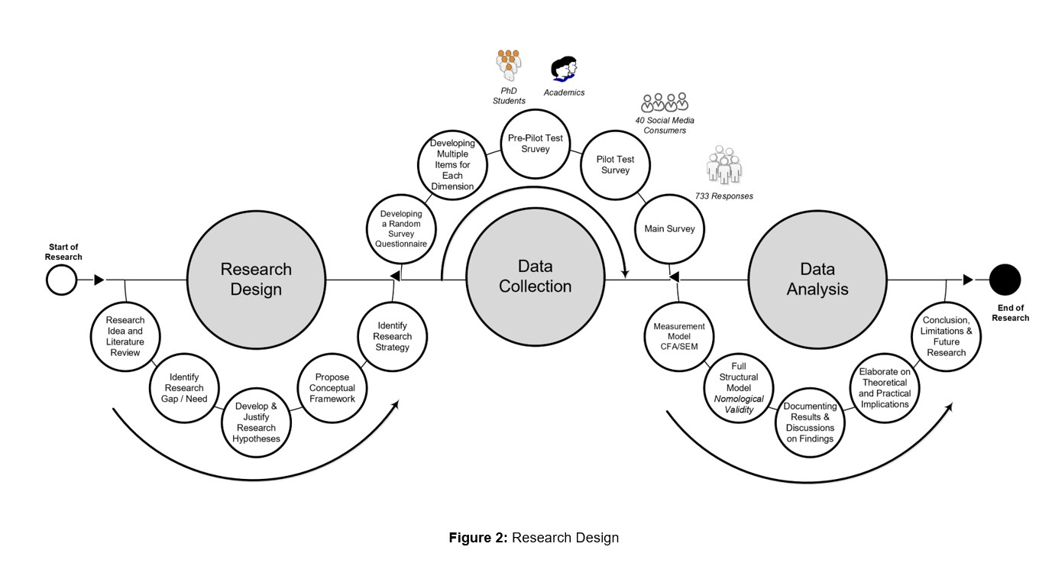

## 5. Data analysis and results

Profiles of participants showed that approximately 99.05% of participants were social media users. Social media used by consumers included Facebook, Instagram, WhatsApp, YouTube, Twitter and LinkedIn, and their main activities and social media were shopping-related. Data analysis was performed in two stages using SEM as recommended by Anderson & Gerbing. In the first step, factor loadings were developed, followed by reliability and validity testing through confirmatory factor analysis (CFA) of the latent constructs of the measurement scales. In the second stage, the structural equation method was applied to determine the relationships between the structures of the model. To validate the scale, standard deviations (SEM) were applied using AMOS 25 with the standard likelihood method. A two-step testing model with nominal factors (full model in Method 2) was used to measure validity and reliability. Once validated, the study tested its nomological validity. Adaptive behavior of positive adaptive behavior and negative adaptive behavior were determined using three indicators (PO, PSI, and PC) and four emotional factors (enjoyment, self-esteem, fear, and confidence). Specifically, based on the a priori theoretical framework, subsequent engagement was expected. A comprehensive structural inspection was performed. This is important as it relates to speed verification. Table 1 shows the relationships (or weighted factors) that were combined from one level to the next when tested in the first CFA model.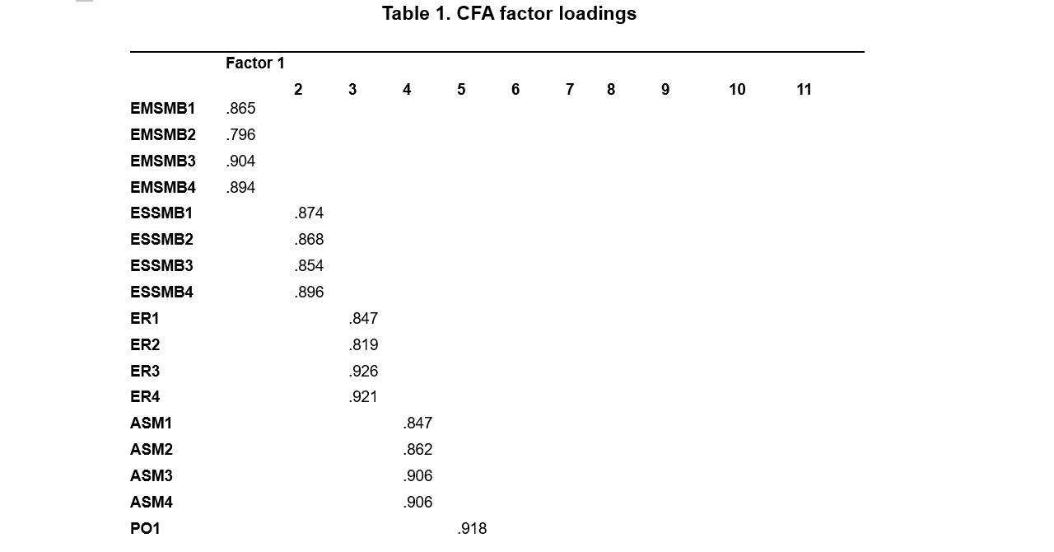

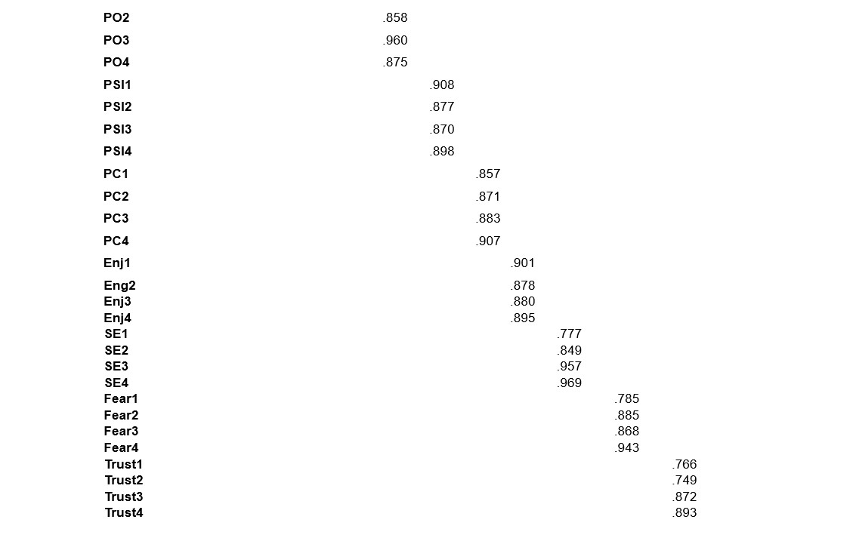

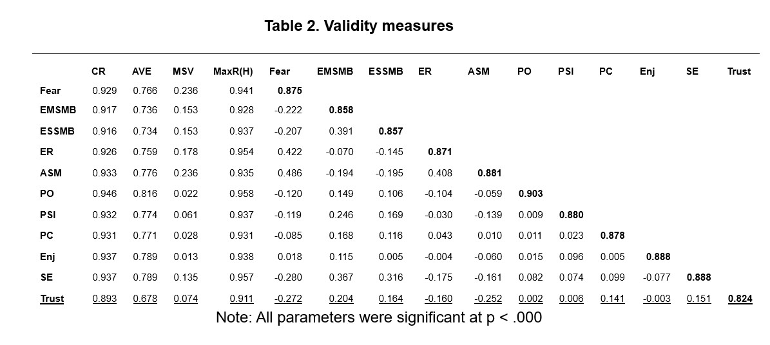

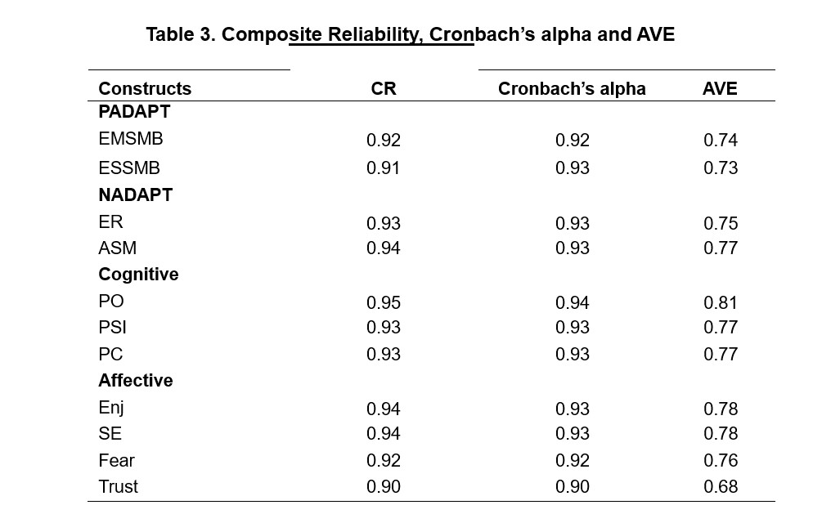

Discriminant values ​​were determined by comparing total AVE estimates with the quadratic correlation between factors and examining the cross-sectional dimensions and error terms of the measured factors. Furthermore, discriminant validity was confirmed for all latent functions, as the square root of the AVE of each construct was greater than the sum of its components (see Table 2). The cross-sectional area between measurements and errors also did not meet the cross-sectional area; normal residuals were all <2. 58 (Byrne, 2016). The current transformation is supported with all parameters >. Table 2 shows the mean of the correlation value specific to each CFA factor, and all factors are statistically significant at p <. 000. A second approach was performed on both variables to determine the parameters of the best adaptive behavior. This was also driven by an a priori assumption that both EMSMB and ESSMB represent positive tuning and that ASM and ER are defined through negative tuning. Incompatibilities in models with items that cross multiple boundaries have been relaxed as desired. In addition to the relaxation of measures, the removal or addition of measures from one level to another in cases of transition was also carried out based on logical, statistical and practical evaluations. Final results show two indicators of goodness Behavior Change: (1) Seeking the Benefits of Social Media and (2) Seeking the Benefits of Social Media. On the other hand, the negative behavior of adaptation to climate change also emerges in two dimensions: (1) Examination of transformation and (2) Avoidance of social media. Both examples reach positive numbers, i.e. first order: (² = 137. 108; p < . 000; ² / df = 1.; GFI =. 97; IFI =. 99; TLI =. 98; CFI =. 99; and RMSEA = . 038). Goodness of fit statistics showed that the first and second models (² = 139.152; p < . 000; ² / df = 1. 988; GFI =. 97 mi? IFI =. 99 mu? TLI =. 98 mi? CFI =. 99; ve RMSEA =. 038) fit the data well. The results of both the first and second stages were compared. Both were operated in the same way; The second model yielded almost identical results to the first model, so both models were accepted for analysis. After all the steps taken to determine the validation process, it was decided to continue the analysis by choosing the second phase instead of the first phase. This is based on: (1) the initial direction of the two parameters in reality; . Finally, all nine constructs were tested step by step. The full measurement model fits the data well (² = 1564.779; p < 0.000; ² / df = 2.014; GFI = 0.90; IFI = 0.90). 97 mi? TLI =. 97 mi? CFI =. 97 mi? ve RMSEA = . 038). 5. 2 Step 2: Full model – nomological value The second approach was concerned with testing the research model, its objectives, and its hypotheses. The two-stage test showed a positive trend (χ2 = 1598.006, p < .000; χ2/df = 2.038; GFI = 0. 89; IFI = 0.96; TLI = 0.96; CFI = 0.97; RMSEA = 0.03), two factors were extracted. Valid transformations are supported by all models. 5 and all factors were statistically significant at p = . 000. The reliability of the constructs was tested using Cronbach alpha and , all of which are above the recommended level as shown in Table 3. Correlations (covariance) between constructs were also allowed to be less than .000. 01 to . 55 and AVE =>. 5 (Fornell and Larcker, 1981) (see Table 3). A further test to determine the adequacy of the discriminant value was performed by comparing all AVE estimates with the square correlation between factors and cross-section tests between measured values ​​and error terms (Hair et al., 2010). The results show that discriminant validity was confirmed for all latent functions, as the mean square of the AVE of each construct was greater than that for all bivariate functions. Cross-loadings between measured errors and word errors are also unaffected by the weight of multiple loadings and any normal residuals <. 258. Therefore, the results of the evaluation sufficiently support the discriminatory value of the test model.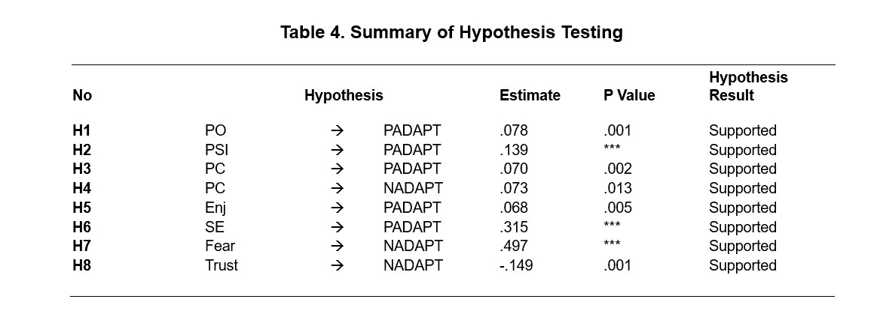

## Hypothesis Result

## All hypotheses were tested and showed positive effects (H1–H8). Both cognitive and affective traits showed statistically significant positive and negative adaptation behavior. Table 4 summarizes the results and comparisons. Thus, in the second step, the nominal validity of the scale was tested with positive and negative adaptation behavior and its determinants. Theoretically, a positive relationship between attachment behavior and social media was possible. Validation results show PO (p < 0.001), PSI (p < 0.000), PC (p < 0.002 and p < 0.013), and SE (p < 0.013) and SE (p < 0.000). 000) had a positive impact on positive climate change behavior. Similarly, results show that anxiety (p < .000) has a significant effect on negative adaptation behavior. On the other hand, trust has a positive effect on negative compliance behavior (p < .001). The findings of this study indicate that attitudes play an important role in consumers' participation in online behavior change. A framework of 8 causal relationships was developed as shown in Table 4 (Figure 1). The results show that consumer belief in perceived opportunity, perceived quality of life, and perceived control are the most important aspects of perception. As shown in Table 4, H1, H2 and H3 are supported (in the observed case, it is assumed that plays an important social role and control to have a significant impact on positive behavior in adapting to climate change). Similarly, perceived control has a direct impact on negative behavioral regulation. Therefore, as shown in Table 4, H4 is supported. The results also show that consumers' attitudes consist of subjective elements such as pleasure, self-sufficiency, confidence and fear. Subjective aspects have a significant impact on consumers' use of social media. As shown in Table 4, H5 and H6 are supported (enjoyment and self-enhancement have a significant impact on positive attitude towards climate change). On the other hand, empirical results show that fear and trust components have a significant effect on negative adaptation behavior. H7 and H8 were supported as shown in Table 4.

## 6. Discussion

The proposed hypotheses indicate that positive and negative consumer behavior regarding social media use is influenced by both aspects of cognitive performance. As noted in the existing literature, combining the two attitudinal dimensions provides a deeper and more comprehensive understanding of consumer attitudes in a particular context. In contrast to CMUA and UTAUT, the results of this study indicate that cognitive (opportunities, perceived social problems, and perceived control) and affective (enjoyment, self-enhancement, anxiety, and confidence) attitude components are antecedents of positive and negative adaptation. behavior. Weather Cognitive and emotional aspects (positive or negative) shape beliefs and affect. Therefore, according to the empirical evidence from this study, social media users have the ability to know and influence how positive attitudes lead to positive attitudes towards climate change and 'bad behavior leads to bad behavior change'. The results of this study support that PO has a strong and direct effect on positive adjustment. Consumers often view social media as a perceived opportunity due to its functionality, relative benefits, ease of use, and convenience, which influence their perceptions. Consumers are discovering that social media meets their needs and provides them with convenience, success and improved performance. As a result, consumers tend to search for different things on social media (exploration) and use the social media sites or applications they find most useful (exploit). This might make sense if users consume different content on platforms like Facebook and Instagram. The findings also shed light on why consumers are trying different social media platforms like Facebook and LinkedIn. However, it often happens that some consumers do not like to try and/or research everything and continue to use certain websites and their features in the most conventional way. It seems that while Twitter is hugely popular among special interest groups, TikTok has also become popular during the COVID-19 pandemic as customers stay home while creating new videos. Additionally, the findings show that PSI has a direct effect on positive adjustment. This means that consumers experience social pressure for positive relationships, positive relationships, and social support. So they want to do more and satisfy social media. Relationships and routines with peers are encouraged and can also help them practice positive engagement behaviors. Social influence further enhances interaction with these modern sites. Consumers tend to believe they are supported by people on social media and use these platforms to stay socially engaged. The results therefore demonstrate the effects of consumers' psychological stress on their relationships, interactions, and provision of social support, as demonstrated by the existing literature. However, this article builds on existing knowledge of social roles as antecedents of adoption. This article discusses and confirms the contribution of PSI to positive adaptation. The findings also show that perceived control has a direct effect on positive compliance, meaning that consumers tend to reduce and use the benefits of social media to compensate for it. Their attitudes toward greater independence in social media, consistent with prior art-accepted literature, are consistent with these findings. This is consistent with previous literature indicating that when users are given more control, they have positive attitudes towards social media. Therefore, PC is the smart attitude of the consumer who adds his positive attitude to his positive attitude of harmony. On the other hand, it is also interesting that supervisory control has a direct effect on negative compliance. Beyond the individual's control, they may have the freedom to withdraw and/or stay away from social media*.*

## Limitations and future research

This study has limitations that must be acknowledged. First of all, this generally happened through social media. It was difficult to limit this research to a single social network. Therefore, determining the cognitive and emotional attitudinal effects of the same social media platform is an avenue for future research. Second, while this study tested a sample of social media users, future research could potentially focus on social media users in general. Third, this study sought to identify and determine the actual content of social media: future research could extend the model in other ways. The sample presented in this study has a wide range and therefore future studies can extend this to different levels, including cross-cultural levels. Finally, this study used cognitive and emotional factors as antecedents of positive climate change behavior. Future research could extend the model by considering the nature and cause and effect of cognitive antecedents or, conversely, provide a deeper understanding of the nature of attitudinal factors. Future studies could therefore be expanded to include the use of different methods to assess behavioral traits and behavioral regulations.

**Conclusion**

The findings of this study empirically support the fact that consumer attitudes also consist of subjective elements such as enjoyment, self-promotion, trust and fear, implying that attitudinal cognitive characteristics are not the only determinants of climate change behaviors. After social media, the physical component plays an important role in consumer behavior. The results of this study show that happiness has a direct effect on positive adjustment. Consumers are driven by pleasure (hedonic and emotional), which leads to their adaptive behavior. Therefore, when consumers are satisfied with social media, they tend to look for ways to use it more and use it to realize the benefits of social media. According to Bala and Venkatesh, participation behavior refers to the normal use of technology, while action research refers to the positive exploration of the benefits of technology. Therefore, the findings of this study confirm that consumers tend to go beyond the typical characteristics of social media and exhibit positive adaptive behaviors when enjoying these sites. This also strengthens consumers' desire for innovation and characterizes their desire to discover new things, which has to do with the success of Web 2.0 and smart technologies. Therefore, in line with previous research, this paper confirms that consumers' needs lead to hedonic motivation, causing them to enjoy things and realize their desires. Another important finding of this study is the strong role of self-enhancement in positive adaptation; This means that users want to find and use more to reap the benefits of social media as their growth increases. Their personal style and image on social media increases their self-esteem because it reflects their greater focus on this site. Self-esteem and self-esteem meet the hedonic self-esteem needs of social media users and help them express the opinions they want on social media. Therefore, empirical evidence from this study confirms that self-promotion triggers positive consumer behavior towards social media.

This study examines the impact of cognitive (opportunity, perceived social influence, perceived control) and emotional (pleasure, self-promotion, trust, and anxiety) attitudinal behaviors on positive and negative social media behaviors and how they influence consumer behavior. and social media. The study confirms that cognitive and emotional attitude components drive consumers' positive and negative behaviors to adapt to social media. The findings provide marketers with greater insight into creating appropriate psychographic and behavioral approaches for modern technology users. Additionally, adaptive behavior also contributes to our understanding of why consumers choose to engage in new technological activities and, in particular, how factors such as fear and belief may influence their decision to continue and/or discontinue use of technology even if they have used it. useful activities and those who see the benefits.

## References

Agarwal, N., Chauhan, S., Kar, AK and Goyal, S. (2017). The role of human behavior in mobile hearing: a systematic review of the literature. Digital Policy, Policy and Management, 19(2), 168-185.

Agarwal, R. and Prasad, J. (1999). Are individual differences acceptable when using new technologies Decision Science, 30(2), 361-391.

Akar, E. and Topçu, B. (2011). Examining the factors affecting consumer behavior towards social media marketing. Journal of Internet Business, 10(1), 35-67.

Akpan, I.J. , Soopramanien, D. and Kwak, D. H. (2020). Modern small business technology and innovation during the COVID-19 global health pandemic. a little magazine Business and Entrepreneurship, 1-11. Akter, T. and Nweke, G.E. (2016).

Social media users and their adaptation to social environments: Is it easy for Turkish Cypriots to live together? Computers in Human Behavior, 61, 472-477.

Ali, H. (2011). Value exchange in interpersonal networks: A human resource for healthcare. Journal of Product Management, 27(3-4), 316-335.

Ali, M. and Lee, H. (2010). Culture or social interaction? An exploration into the essence of blog design. Alwi, SFS and Mutfak, P. J. (2014).

Corporate branding and behavioral outcomes in business schools: cognitive or symbolic? Journal of Business Research, 67(11), 2324-2336.

Anderson, J. C. and Gerbing, D.W. (1988). Comparison of structures in practice: overview and application of two methods. Psychological Bulletin, 103(3), 411.

Bagozzi, R.P. and Heatherton, T.F. (1994). Creating a universal representation of cultural diversity: Applying self-esteem to the state. Structural Equation Modeling: A Multidisciplinary Journal, 1(1), 35-67.