Topic” Human factor in aviation safety a study of crew resource management training.”

Abstract:

Flying security remains a basic concern, with human components playing a noteworthy part in mishaps and episodes. This consider dives into the adequacy of Team Asset Administration (CRM) preparing in moderating these dangers. Through a comprehensive writing survey and observational examination, this inquire about surveys the affect of CRM preparing on upgrading collaboration, communication, decision-making, and situational mindfulness among flight groups. By looking at case ponders and information from flying occurrences, the think about assesses the relationship between CRM preparing execution and security results. Also, the inquire about investigates the challenges and confinements of CRM preparing and proposes proposals for optimizing its adequacy in making strides flying security. Eventually, this think about contributes to a more profound understanding of the human components included in flying security and gives experiences into methodologies for improving team execution and lessening the probability of mischances.

Introduction:

The origin of Crew Resource Management (CRM) can be traced back to a series of tragic aviation accidents in the 1970s, which highlighted the critical role of human factors in flight safety. One of the most notable incidents was the crash of Eastern Air Lines Flight 401 in December 1972, where a perfectly functioning aircraft crashed into the Florida Everglades due to the flight crew's preoccupation with a landing gear indicator light, leading to inadequate monitoring of the autopilot system and subsequent loss of situational awareness.

In response to such accidents, psychologists and aviation experts began to recognize the importance of non-technical skills, such as communication, leadership, decision-making, and teamwork, in enhancing aviation safety. The term "Crew Resource Management" was coined to describe a training program designed to improve these interpersonal skills among flight crews. One of the pioneering figures in the development of CRM was Captain John Lauber, a former United Airlines pilot and psychologist, who conducted research on cockpit communication and crew coordination. Lauber, along with other researchers and industry stakeholders, advocated for the integration of CRM principles into pilot training curricula.

The early days of CRM training focused primarily on cockpit resource management, emphasizing effective communication, leadership, and decision-making within the flight deck. Training programs typically involved interactive simulations, case studies, and role-playing exercises to simulate real-world flight scenarios and enhance crew coordination. In 1979, United Airlines became one of the first major carriers to implement CRM training for its flight crews, followed by other airlines and regulatory agencies worldwide.

As CRM has grown in popularity, its scope has expanded beyond the airline to include other airline personnel, such as flight attendants, maintenance technicians, and flight attendants, and includes their aviation security responsibilities has been following this for decades. We evolve in response. Advances in aviation technology, changing regulatory requirements, as well as insights gained from human case studies. Current CRM training programs cover a wide range of topics, including situational awareness, workload management, stress management and burnout reduction, reflecting the multifaceted nature of a person's job on an airplane. It is a safety procedure that is built into the training and operations of airlines and operators around the world. The principles have been applied to other high-risk industries such as healthcare, marine, nuclear and others, emphasizing their potential to promote collaboration and error management.

LITERATURE REVIEW

1. Baker, D., Prince, C., Shrestha, L., & Oser, R. (1993). Flying computer diversions for group asset administration preparing. Universal Diary of Flying Psychology~. 3, 143-156. Theoretical:

Proposes that strategies for giving discuss groups with openings to hone team asset administration (CRM) abilities have been constrained to part plays in course and scenarios in operational battle coaches. There are disadvantages to both preparing strategies; role-plays have few reasonable natural signals to assist groups behave as they do within the cockpit, and the fetched and accessibility of the test systems constrain simulator-scenarios. Inquire about utilizing cheap, tabletop computer-based reenactments as CRM preparing media were conducted with 112 male military aviators. Responses of the crewmembers taking portion within the investigate were exceptionally positive both in their acknowledgment of the framework in common and as a coach for CRM abilities. (PsycINFO Database Copyright 1994 American Mental Assn, all rights saved).

2. Beard, L. R, Salas, E., & Prince, C. (1995). Enhancing training transfer: Using role-playing to develop teamwork in the cockpit. [On-line]. International Journal of Aviation Psychology, 5, 13: 1–143. Abstract from Ovid File: PsycINFO Item: 83-03 121 Abstract: This paper discusses the use of role plays in the classroom to provide practice and feedback for air crew team development training, as well as guidelines for designing semi-structured role plays to elicit crew resource management behaviours and provide trainees with performance feedback. When compared to other training methodologies, role play gives targeted practice and feedback on specific behaviours at a cheap cost, with the trade-off of limited fidelity. (PsycINFO Database Copyright 1996 American Psychological Association; all rights reserved)

3. Eissfeldt, H., Goeters, K. M., Hoermann, H. J., Maschke, P., & Schiewe, A. Effective work in teams: Team asset administration preparing for pilots and discuss activity controllers. [On-line]. Unique from:

silverplate Record:

NTIS Thing:

TIBB95033 14XSP Theoretical:

More than 60% of all mischances in commercial fly operation can be credited to mistakes of the flight team. The existing repetition within the multi-crew cockpit is often not utilized to extend execution viably. The crew-induced mischances appear as causal variables lacks with respect to the trade of data, the interpersonal interaction, decision-making and push resistance. Subsequently, team asset administration courses prepare the behavioral potential about commination, pioneer@ and cooperation, judgment and decision-making as well as push adapting. Hence, work summarizes the existing models and strategies of preparing and gives suggestions concerning their optimization. In a uncommon chapter the exchange of the concepts initially created for cockpit work force into air-traffic control is talked about. Quirks of this range are detailed.

4. Gayman, A. J., Schopper, A. W., Gentner, F. C., Neumeier, M. C., & Ranlun, W. J. (1996, February). Review analysis: Group asset administration (CRM) mysterious detailing framework (ARS) survey assessment. [On-line]. Theoretical from:

Silver platter Record:

NTIS Thing:

CSERIACRA96003 Unique:

The reason of this report is to outfit recommendations for change of the Discuss Portability Command (AMC) Team Asset Administration (CRM) Mysterious Detailing Framework (ARS) detailing frame based on current logical writing. This report depicts CRM measurements and CRM assessment methods supportive in refining the AMC CRM ARS shape. The AMC CRM ARS shape is compared to investigate discoveries, and proposals for corrections to the ARS frame are given. In rundown, this report:

surveys current writing with respect to CRM, recognizes concurrent CRM measurements common to the Government Flying Adhibition (FAA), the US Discuss Constrain (USAF), and standard CRM writing; personalities appropriate CRM rating strategies., assesses the current AMC CRM ARS announcing shape utilizing broadly acknowledged CRM measurements and rating strategies., and presents proposals for the advancement of the AMC CRM ARS detailing frame.

5. Karlins, M., Koh, F., McCully, L., & Chan, C. T. (1996). CRM for CRM: Cockpit relevant movies for cockpit resource management. [On-line]. Availability: http://www. hf. faa. g... MvidedCRMvideo. htrn Abstract: It is genuine that a picture is worth a thousand words, at that point envision how numerous hours of CRM addresses may well be condensed with a number of well-chosen video introductions! In truth, the utilize of his in CRM programs produces noteworthy benefits past time preservation. By cautioning the flying unmnudy to this select gather of movies it is trusted that:

(a) their utilize in CRM programs will increment; and (b) aircrafts will spare time and cash by not "rehashing the wheel":

creating "in-house" preparations when comparative items are as of now commercially accessible.

6. Mortag, K. (1 997). Development of a crew resource management training syllabus (Master research report, Southern Illinois University at Carbondale, 1997). [Online]. Availability: First search File: World cat. Abstract:

The enlisting hones of carriers are changing. Modern workers require solid interpersonal abilities to adjust to CRM reasoning in preparing teams viably for today's exceedingly mechanized airplane. Since of the changes within the carrier industry preparing, it is consented for colleges and colleges, whose mission it is to prepare pilots and get ready them for the work drive, to coordinated CRM concepts into their curriculums. The reason of this ponder was to create a syllabus, for a course to implement CRM concepts within the Flying Administration educational programs.

Research Methodology

The data was collected was survey done with different people working in the field by circulation the questionnaire with them and asked them to forward the survey with their teammates and co-workers. There include freshers as well the superiors and the supervisors who worked in this field

Data Analysis and Interpretation:

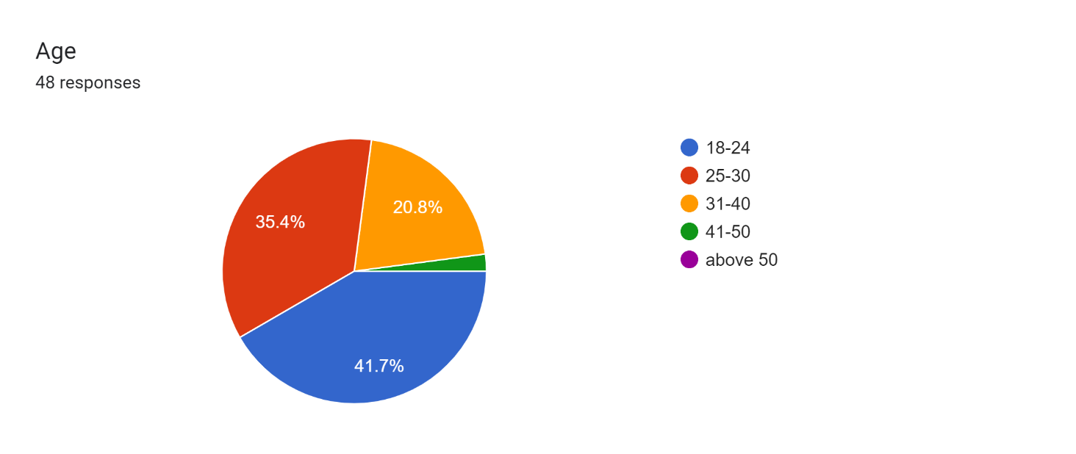

Interpretation: It can clearly be seen from the figure that 41.7%of respondent is from age group of 18-24 and 35.4% are from 25-30 age group and rest are from 31-40 i.e. 20.8

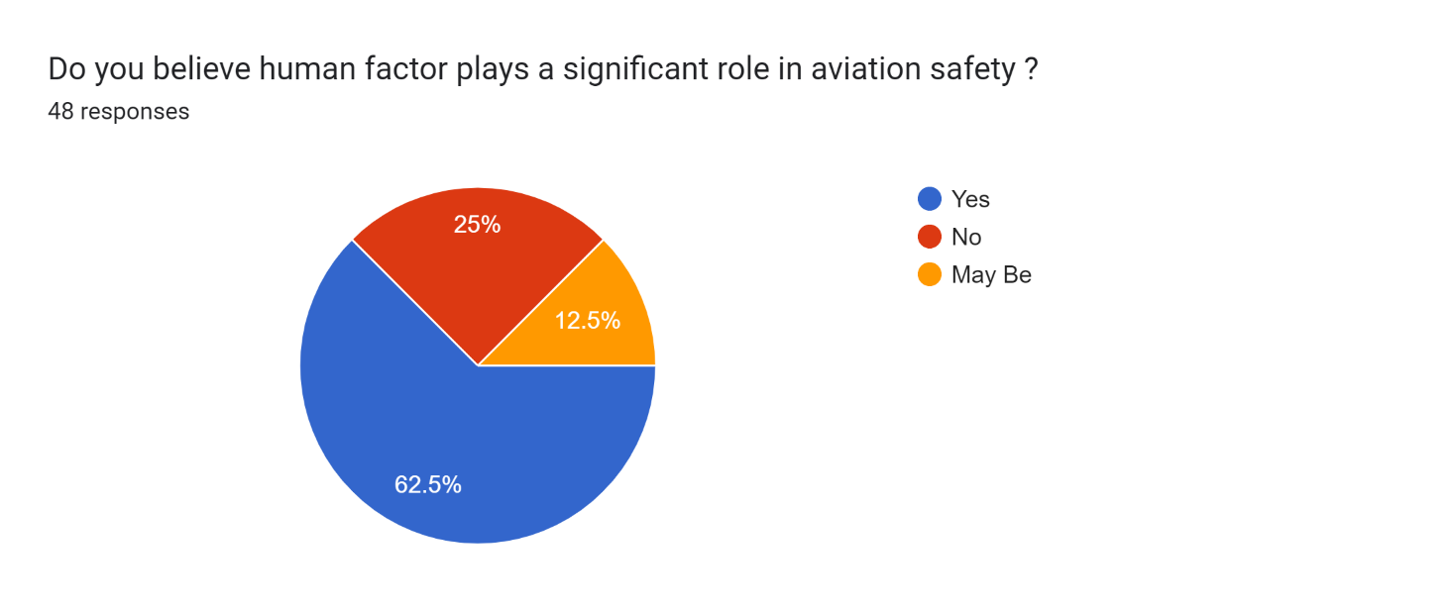

Interpretation: from the survey it has been clearly clarify that human factor play a very important role in aviation safety as 62.5% are in favour of yes 25% are not in favour of the statement are rest are not sure.

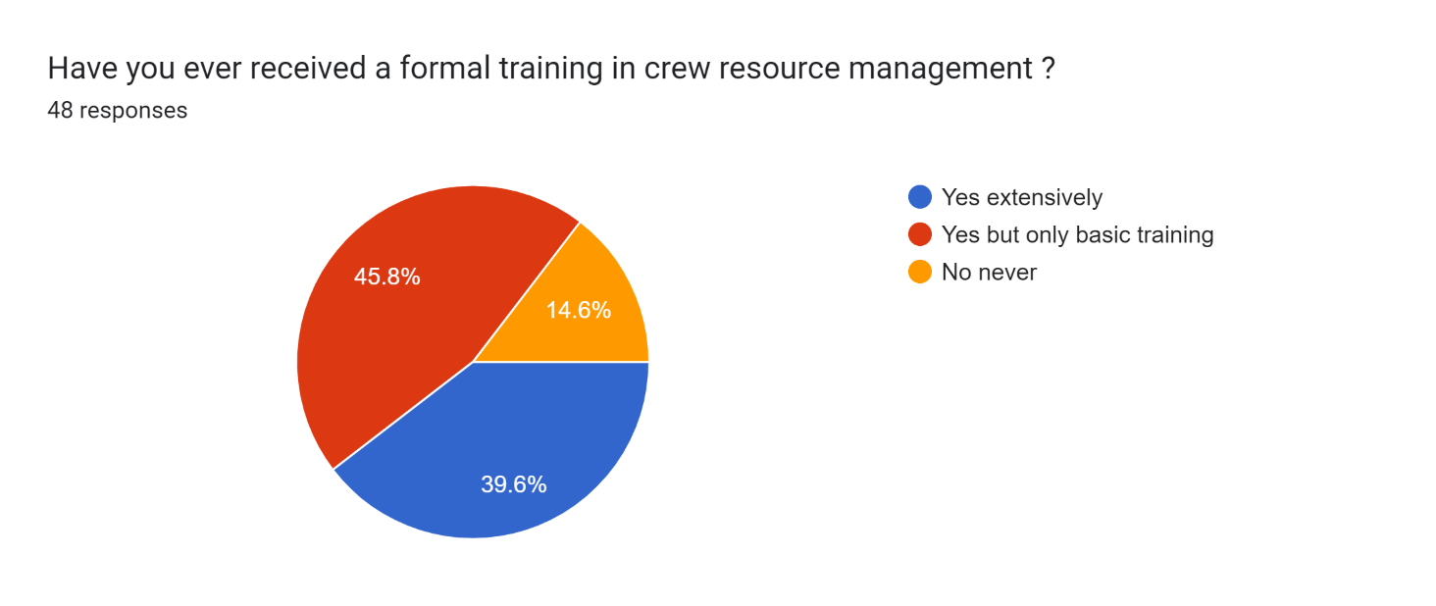

Interpretation:45.8% says they received only basic training where 39.6% got extensively trained and 14.6% got no training at all.

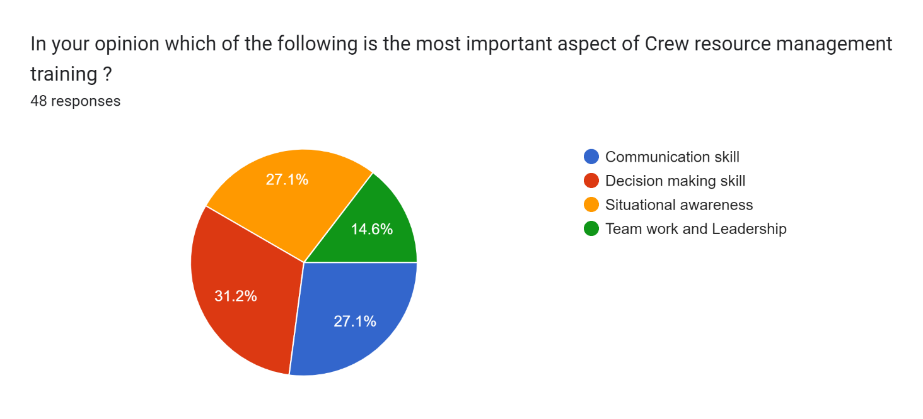

Interpretation: according to the respondent 31.2% says decision making skill is most imporatant aspect of crew resource management training, 27.1% says situational awareness is imporatant, where 27.1% again says communication skills are better than other aspects lastly 14.6% are in favour of team work and leadership.

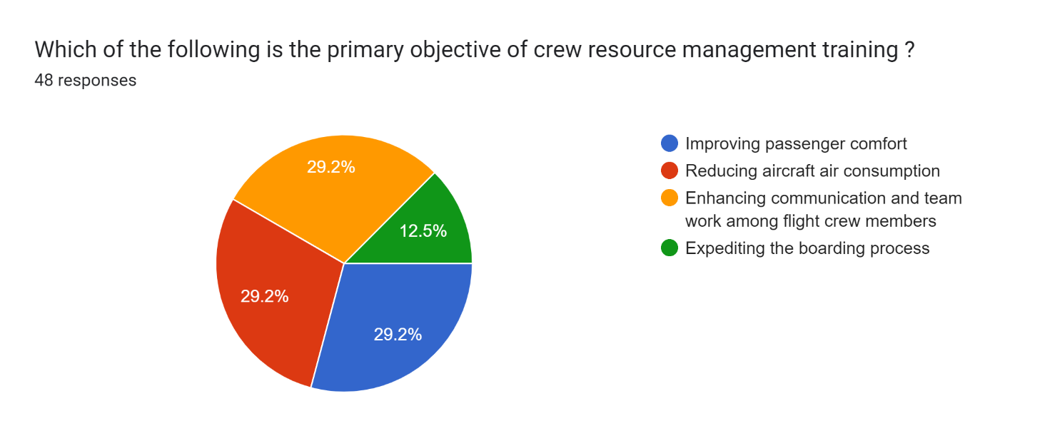

Interpretation: 29.2 % respondent says improving passenger comfort is primary objective again same percentage of response occur that are in favour of reducing aircraft air consumption is priority, 12.5% says expediting the boarding process in primary goal and 29.7% believe enhancing communication and team work is primary objective.

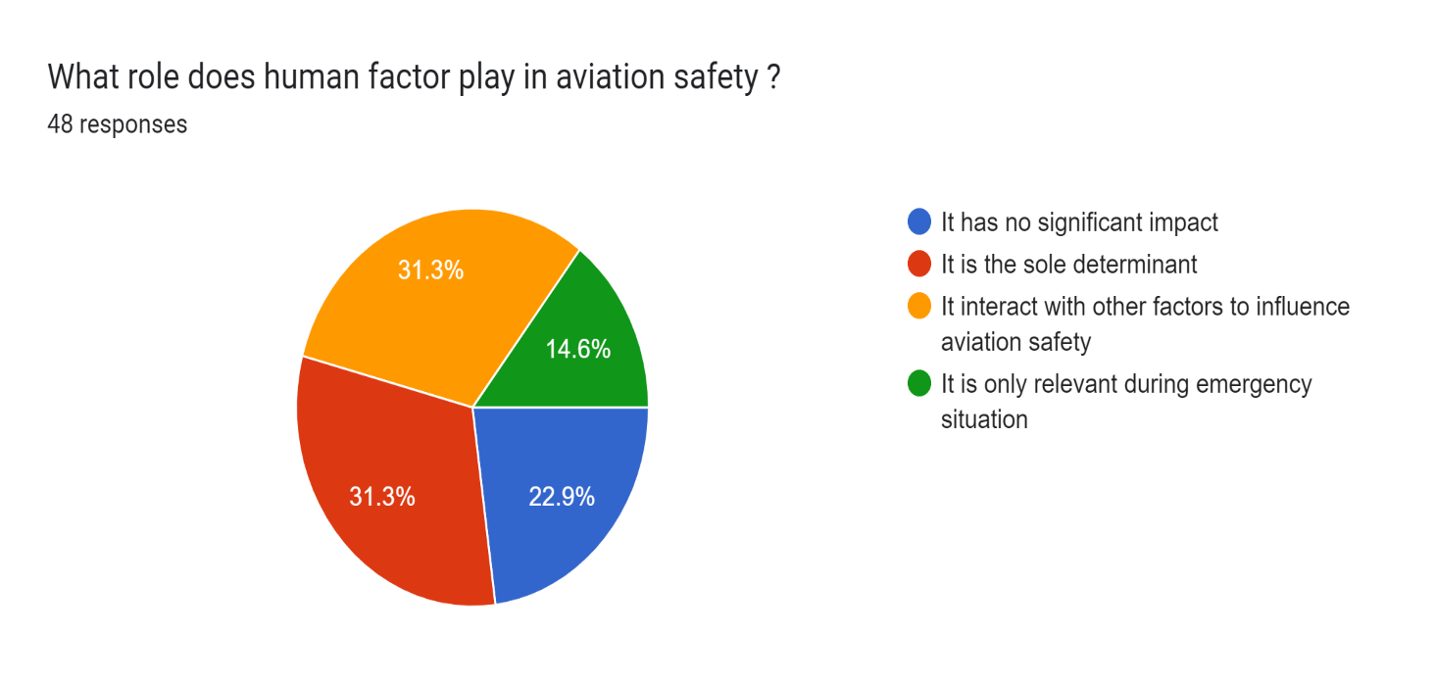

Interpretation:31.3% says it is the sole determinant where 22.9% respondent says human factor has no significant impact on aviation safety, 14.6% are with the option that it is only relevant during emergency situations and lastly 31.3% says it interact with other factors to influence aviation industry.

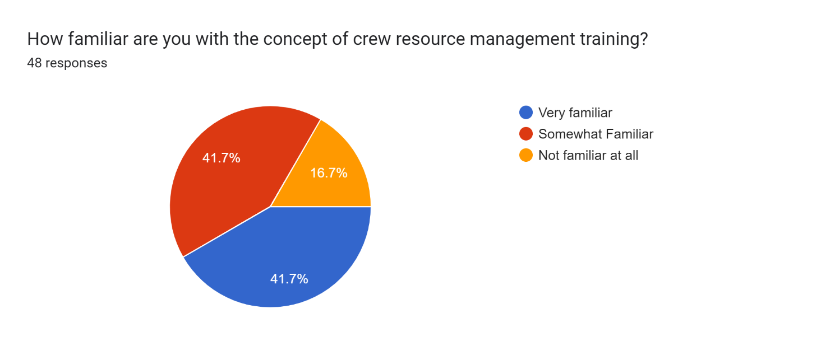

Interpretation:41.7% are very similar with the concept of crm training, where 16.7% are not familiar and again 41.7% are somewhat familiar.

Forms response chart. Question title: How effective do you think crew resource management training is in reducing the likelihood of human error in aviation ?

. Number of responses: 47 responses.

Interpretation:42.6% considered it very effective where 40.4% says somewhat effective and 17% are saying not at all effective.

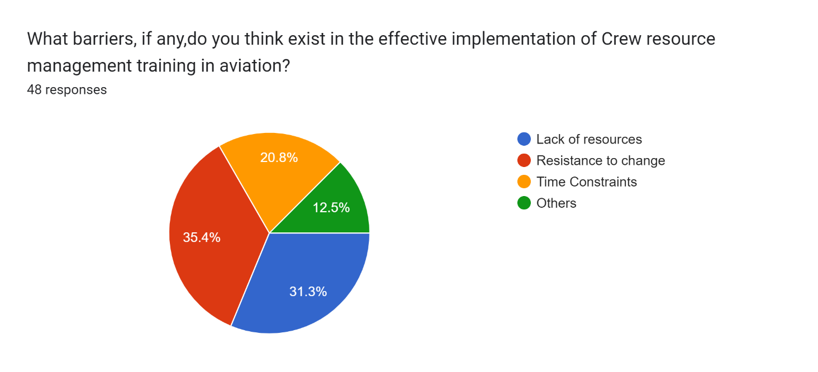

Interpretation:35.4% respondent consider resistance to change as a barrier, 20.8% are with time constraints,12.5% are having other reasons and 31.3% are with lack of resources.

Forms response chart. Question title: How confident are you in the ability of aviation personnel trained in crew resource management training to handle challenging situations during flights?

. Number of responses: 48 responses.

Interpretation: 39.6% were somewhat confident in handling challenging situations during flights, 41.7% were very confident and rest were not confident.

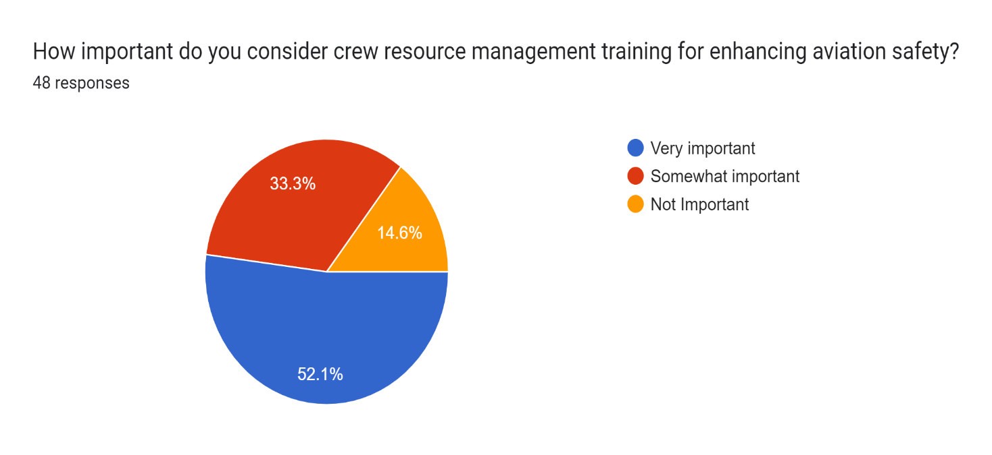

Interpretation: there were 52.1% respondents who says crm is very important and 33.3 says somewhat important and 14.6% says not important.

**Findings of the research:**

1-Effectiveness of CRM Training: Research might find that CRM training significantly improves communication, teamwork, and decision-making skills among flight crews. CRM training contributes to the development of a safety-focused culture within aviation organizations, where proactive risk assessment and mitigation strategies are ingrained in daily operations.

2. Reduction of Human Error: Findings could indicate that CRM training leads to a decrease in accidents and incidents caused by human factors such as miscommunication, poor decision-making, and lack of teamwork. Enhanced Teamwork: Flight crews trained in CRM demonstrate better teamwork skills, enabling them to collaborate more efficiently in managing challenging situations and sharing workload responsibilities.

3. Cultural Impact: The study might uncover insights into how CRM training influences the safety culture within aviation organizations, fostering an environment where safety is prioritized and proactive measures are taken to mitigate risks. CRM training fosters open and effective communication channels among crew members, reducing the likelihood of misunderstandings and communication breakdowns during flights.

4. Implementation Challenges: Research might identify barriers to effective CRM training implementation, such as resistance to change, resource constraints, and organizational culture issues. CRM training equips flight crews with the tools and techniques to make informed and timely decisions, even under pressure, leading to safer flight operations and fewer instances of human error.

5. Continuous Improvement: Findings could highlight the importance of ongoing CRM training and the need for continuous evaluation and refinement of training programs to address evolving challenges in aviation safety. The findings underscore the importance of ongoing CRM training and its role in continuously improving aviation safety standards and practices.

Conclusion:

In conclusion, this study highlights the significant role of crew resource management (CRM) training in enhancing aviation safety by improving communication, teamwork, and decision-making skills among flight crews. Despite the limitations identified, such as sample size constraints and potential biases, the findings underscore the importance of ongoing investment in CRM training initiatives. Moving forward, a holistic approach that considers contextual factors, addresses organizational challenges, and incorporates diverse research methodologies will be essential for advancing CRM training practices and ensuring the continued safety and efficiency of aviation operations."

the comprehensive analysis conducted in this study emphasizes the pivotal role of crew resource management (CRM) training as a cornerstone of aviation safety protocols. The robust findings illuminate the tangible benefits of CRM training, including its profound impact on fostering effective communication channels, cultivating a culture of teamwork, and sharpening decision-making acumen within flight crews. While acknowledging the inherent limitations inherent in research, such as sample size constraints and potential biases, the identified outcomes serve as compelling evidence for the continued prioritization of CRM training initiatives across the aviation industry.

Moreover, this study underscores the imperative for ongoing refinement and evolution of CRM training methodologies to remain attuned to the dynamic challenges and complexities inherent in modern aviation. By embracing a multidimensional approach that not only addresses technical proficiency but also delves into the nuances of human factors and organizational dynamics, aviation stakeholders can fortify their resilience against emergent threats and enhance operational efficiency.

Looking ahead, concerted efforts aimed at synergizing research endeavours, fostering collaboration between industry stakeholders, and leveraging emerging technologies hold immense potential for propelling CRM training into new frontiers of effectiveness and applicability. By harnessing the collective wisdom gleaned from this research endeavour, we can chart a course towards a safer, more secure future for aviation, where CRM training stands as an unwavering pillar of excellence.

Reference:

Aarom, N. R (1996, February). The infiation flow begins. [On-line]. Business and Commercial Aviation. 78, 7 1-72. Abstract from: InfoTrac File: Business Index It*: A1 8033270

Aviation crew resource management web site. (1 998). [On-line]. Availability: http://www. py. utex. . . /helmreich/acrm. Htm

Baker, D. , Prince, C. , Shrestha, L. , & Oser, R. (1993). Aviation computer games for crew resource management training. International Journal of Aviation Psvcholow. 3, i 43- 156.

Beard, L. R , Salas, E. , & Prince, C. (1995). Enhancing transfer of training: Using role-play to foster teamwork in the cockpit. [On-line]. International Journal of Aviation Psvchologv, 5,13 1 - 143. Abstract from: Ovid File: PsycMFO Item: 83-03 121

Bonney, J. (1996, November). High performance teams: Lessons from the cockpit. [On-line]. Organizations & peo~le. 3,34-38. Abstract from: InfoTrac File: Business Index Item: A188964336

,34-38. Abstract from: InfoTrac File: Business Index Item: A188964336 Cooper, E. E. , White, M. D. , & Lauber, J. K. (Eds). (1 979). Resource management on the flight deck (NASA Conference Publication 2120). Moffett Field, CA: NASA Ames Research Center

Duncanson, J. P. (1 994) Visual and auditory symbols: A literature review. Technical note. [On-line]. Abstract fiom: Silverplatter File: NTIS Item: ADA2902229XSP

Edward, H. P. (1997, April 14). Crew acted swiftly in FedEx DC-10 fire. [On-line]. Aviation Week & Space Technolow. 146.32-35. Abstract fiom: InfoTrac File: Business Index Item: A1932745

Fh H. R. (1995, September). Crew resource management for teams in the offshore oil industry. [On-line]. Journal of European Industrial Training. 19,23-27. Abstract fiom: MoTrac File: Business Index Item: A17594252

Gayman, A. J. , Gentner, F. C. , Canaras, S. A. , & Crissey, M. J. (1996, December). Implications of crew resource management training for tank. [On-line]. Abstract fiom: Silverplatter File: NTIS Item: ADA3235900XSP

ce management training for tank. [On-line]. Abstract fiom: Silverplatter File: NTIS Item: ADA3235900XSP Guidelines for simulator scenario development: Increasing hits and reducing misses in CRMILOS scenarios. (1993). International Journal of Aviation Psycholow. 3,69-8