|  |
| --- |
| Research Paper On: |

**“A DETAILED STUDY ON EXPANDING THE**

**NEED OF FINANCIAL SERVICES ACCESS TO**

**THE PEOPLE RESIDING IN RURAL AS WELL**

**AS IN URBAN AREAS IN INDIA”**

**Submitted By: Pawan Kumar Pandey**

**22GSOB2010201**

**Under the supervision**

**Of**

**Dr. Gaurav Gupta**

**School of Business**

**GALGOTIAS UNIVERSITY**



# 1. Abstract

The burgeoning population across both rural and urban regions of India, coupled with rapid global growth, has brought forth a multitude of economic challenges such as unemployment and shortages in basic amenities like food, clothing, and shelter, particularly accentuating urban poverty. India’s trajectory toward globalization and urbanization has led to a notable rise in urban poverty, with many urban dwellers, due to limited awareness, paying scant attention to investing in savings products. To address the pressing need for improved access to financial services for both rural and urban populations in India, it is imperative to scrutinize the current levels and distribution patterns of financial service access among households. This study delves into various approaches for delivering financial services to the rural and urban populace, highlighting the necessity for heightened awareness among those currently uninformed about available financial services.

Furthermore, the research undertakes a comparative analysis of financial management practices, encompassing household budgeting, personal finance, and future investment strategies, between rural and urban demographics.

The central focus lies in understanding the financial behaviour of individuals residing in both rural and urban areas, with a particular emphasis on their levels of financial literacy. Despite facing common challenges such as livelihood insecurity and vulnerability, individuals in these areas often resort to informal banking sectors, even in the presence of formal banking institutions offering credit at more affordable rates.

# 2. Research Objective

The overarching aim of enhancing the availability of financial services across both rural and urban regions is to foster financial inclusion, a process geared towards ensuring that individuals and businesses can access beneficial and affordable financial products and services tailored to their specific requirements. This endeavours encompasses several pivotal objectives. Firstly, it entails a comprehensive examination of the necessity for financial access, particularly concerning the diverse needs of rural and urban populations. Secondly, it seeks to bolster financial stability within communities by extending access to essential financial tools and resources. Additionally, it involves pinpointing and addressing the various barriers hindering the achievement of financial inclusion. Moreover, it entails a comparative analysis of the levels of financial literacy between urban and rural demographics, shedding light on areas that require targeted educational interventions. Furthermore, it delves into understanding how households manage their finances, including their approaches to budgeting and financial planning. Concurrently, it entails the cultivation of innovative solutions to bridge existing gaps in financial access and usage. Moreover, it involves investigating people's concerns regarding investment and savings practices, aiming to provide insights into effective wealth management strategies. Lastly, it encompasses studying the awareness levels among individuals regarding the diverse array of financial products available, facilitating informed decision-making and fostering greater financial empowerment. This can have several benefits including:

* To study the need of financial access with reference to rural and urban people.

* Improving financial stability.

* Identifying barriers to financial inclusion.

* To study about the level of financial literacy between the urban and rural people.

* To know how people manages their households (do the make their budget plan).`

* Developing innovative solutions.

* To study the concern of people about their investment and savings.

* To study people awareness about financial products.

# 3. Introduction

Recognition of access to financial services as a catalyst for enabling individuals to pursue their aspirations is steadily gaining prominence as a crucial driver of economic development. This research endeavours to shed light on the financial management practices of individuals, providing insights into how residents of rural and urban areas handle their personal finances, plan for savings and investments, and whether they have adequate access to available financial services.

A comprehensive analysis is conducted through detailed paired comparisons between individuals hailing from rural and urban backgrounds. The study meticulously assesses the extent of financial access in both rural and urban settings, utilizing a structured questionnaire for data collection to ascertain the level of awareness among individuals regarding their financial objectives, household expenditure patterns, and personal finance management strategies. Through this investigation, a nuanced understanding of how people navigate their financial circumstances in different environments is gleaned, offering valuable insights into potential avenues for enhancing financial inclusion and literacy across diverse demographics.

## 3.1 . Research topic explanation

Access to financial services holds immense significance for individuals, businesses, and economies alike, serving as a cornerstone for various pivotal reasons. Firstly, financial services offer a secure and reliable avenue for individuals to save their money, facilitating effective planning and attainment of their financial objectives. Secondly, access to credit empowers both individuals and businesses to pursue purchases or investments that would otherwise be beyond their financial reach, thereby fostering growth and enhancing their financial standing. Additionally, financial services play a crucial role in mitigating financial risks for individuals and businesses, enabling them to navigate unforeseen events such as illness, accidents, or economic downturns more effectively. Moreover, these services provide avenues for individuals and businesses to invest their funds, thereby generating returns and fostering wealth accumulation. Furthermore, by facilitating financial inclusion, access to financial services ensures that all members of society, regardless of their background or circumstances, can fully participate in the economy. Ultimately, the significance of financial services lies in their pivotal role in driving economic growth, alleviating poverty, and enhancing overall well-being within communities.

## 3.2 Rural Areas

In rural regions, the availability of financial services is often constrained by inadequate physical infrastructure and comparatively lower levels of financial literacy among residents. Moreover, the presence of financial institutions and services is notably sparse in rural locales, with a predominant concentration observed in urban centers. Compounded by lower income levels and diminished savings capacities prevalent in rural settings, individuals face notable challenges in accessing financial services, including credit facilities. Research conducted by the World Bank underscores these disparities, revealing that rural inhabitants exhibit lower rates of bank account ownership and a heightened reliance on informal financial channels such as moneylenders or savings collectives

**3.3 Urban Areas**

When compared to rural locations, urban areas usually provide a wider variety of financial services because there are more financial institutions per square mile, providing a wider range of choices. The main causes of this discrepancy are the concentrated economic activity and high income and savings rates found in metropolitan areas. Furthermore, metropolitan dwellers typically have greater access to technology and higher literacy rates, both of which greatly ease their interaction with financial services. However, some demographic groups continue to face obstacles to access, even though financial services are comparatively more easily accessible in urban areas. Low-income people and those without official identification documents are among them, highlighting ongoing disparities in metropolitan financial environments.

# 4. Research Design and Methodology

**4.1. Research Design**

Initially, I undertake a thorough and comprehensive secondary study to gain a deeper understanding of the sector I am investigating, aiming to grasp its complete impact and vision. During this phase, I review and analyze available sources to identify the key issues that need to be addressed or modified. Subsequently, I proceed to collect primary data by administering questionnaires to 100 respondents from both rural and urban areas. This step allows me to narrow down and select only the most pertinent questions and issues that are pertinent to the growth and development of the industry. By collecting primary data, I am able to focus on the most crucial aspects that require attention, thereby ensuring that my research remains focused and effective.

During the research design process, I have undertaken several tasks, including defining the information requirements and designing various types of research, such as exploratory, descriptive, questionnaire, and causal research.

Defining the information need: This involves clearly outlining what information is required to address the research objectives. By defining the information needs, I ensure that the research is focused and targeted towards achieving its goals effectively.

Designing Exploratory, Descriptive, Questionnaire, and Causal Research: In this phase, I have developed the methodologies for different types of research.

* Exploratory Research: This type of research is conducted to explore and gain insights into a problem where little is known or understood. It helps in defining the research problem and developing hypotheses.
* Descriptive Research: This involves describing the characteristics of a population or phenomenon being studied. It focuses on answering questions like who, what, when, where, and how.
* Questionnaire Design: I have designed questionnaires to gather primary data from respondents. This includes selecting appropriate questions and formatting them in a way that ensures reliable and valid responses.
* Causal Research: This type of research aims to establish a cause-and-effect relationship between variables. It helps in understanding the impact of one variable on another.

## 4.2. Methodology

The method I used for exploratory research was , primary data collection and the secondary data.

* Primary Data collection
* Secondary Data collection

### Primary data collection-

For primary data collection a survey has been done through questionnaire method to understand the financial literacy between the people living in rural and urban areas. **Secondary data collection-** • Internal data

* External data

Information already available elsewhere, has been store for another purpose. Sources include census report, commercial publications, and registration services. Data that has already been gathered from various sources such as census reports, commercial publications, and registration services is being collected for a different purpose.

* Internal data refers to information that is generated or collected within an organization. This could include sales figures, Customer information, employee records, and operational data.

* External data, It means, the information that comes from out-side the organization. This can include market research reports, customer surveys, government data, social media analytics, and industry publications.

In summary, internal data is generated within the organization, while external data is obtained from sources outside the organization. Both types of data are valuable for businesses in making informed decisions and understanding their operating environment.

Data collected either within or outside the organization, intended for a purpose other than the current research, may include internal information such as existing data concerning the financial needs and plans of urban and rural populations for both their present and future. Additionally, it could encompass research conducted by other entities.

The secondary sources of data utilized for this research include books and websites. It is suggested that a comprehensive secondary study be conducted initially to fully comprehend the problem's scope and vision. This will involve reviewing and analysing the financial service’s needs, policies, and reports. Specific issues will be selected for further examination, focusing on identifying areas that require attention or modification.

# 5. Data Analysis and Interpretation

Q1.What is your gender?

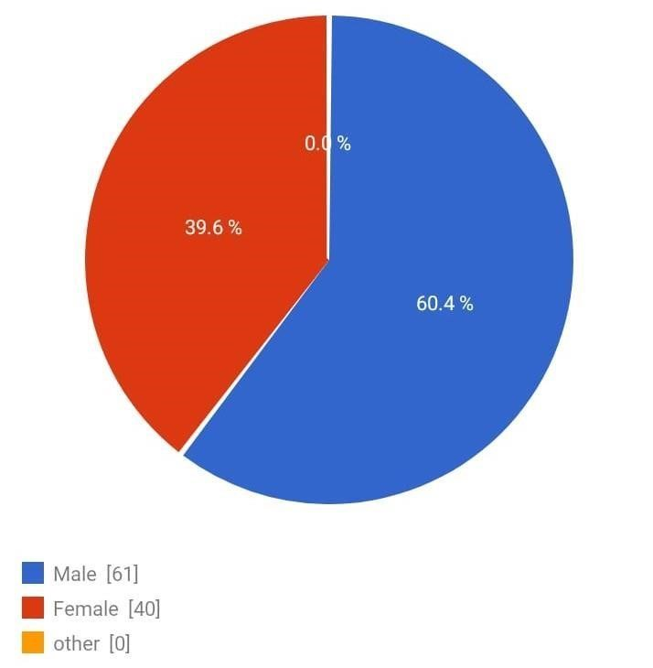

Q2. Which of the best describes the community you live in?

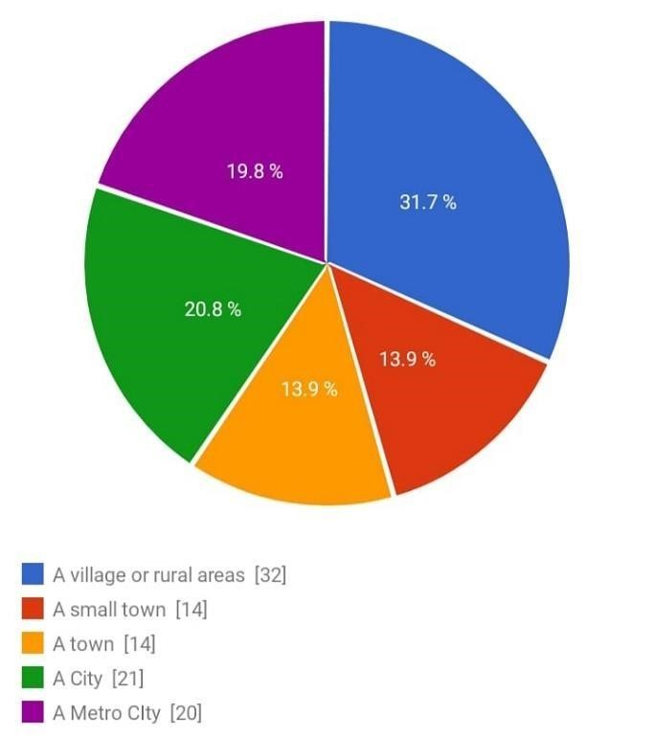

Q3. Does your household have budget?

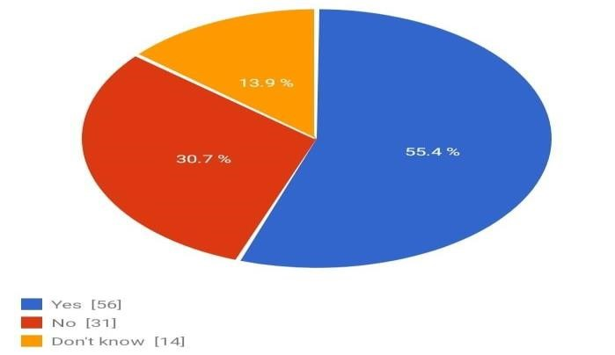

# 6. Limitations

According to the survey data:

* Only 24.8% of respondents make a household budget plan, indicating a lack of financials management. Some of them plan with their family or rely on other members for planning.
* A significant 55.4% of respondents do not have a budget for their expenses, making it difficult for them to manage their finances and make investments.
* The majority of people use their existing resources to take credit when their income does not cover their expenses.
* 31.7% of respondents stated that they could not survive for at least one week if they lost their main source of income. This underscores the importance of financial awareness, particularly among rural populations, regarding various financial products and services.

Only a minority of respondents make household budget plans, indicating a lack of financial management skills.

A significant portion of respondents do not have a budget for their expenses, making it difficult for them to manage their finances and make investments.

Many respondents rely on existing resources for credit when their income does not cover their expenses, indicating a need for better financial planning and management.

Furthermore, a significant number of respondents stated that they could not survive for at least one week if they lost their main source of income, highlighting the importance of financial awareness and preparedness, especially among rural populations.

Overall, these findings underscore the need for improved financial literacy and access to financial products and services, particularly in rural areas, to help individuals better manage their finances and secure their futures.

# 7. Conclusion

Whether they live in an urban or rural location, people from all walks of life are impacted by the urgent need to extend financial services. As a result, research or a thesis on financial access expansion can offer insightful information about how to guarantee that everyone has access to the financial instruments and resources required to make wise financial decisions.

Such a study's main conclusion is that a large number of people, both in urban and rural areas, do not invest in financial products or plan their budgets. This is caused by a number of things, such as a general mistrust of financial institutions, a lack of financial awareness, and restricted access to financial resources.

It is imperative to create focused strategies and interventions suited to the unique requirements of rural and urban communities in order to solve this issue. For example, financial literacy initiatives can be put into place in community centers, schools, and other public areas to aid in the understanding of fundamental financial ideas like investing, saving, and budgeting. Furthermore, by making information about their services and goods clear and easy to acquire, financial institutions may win over potential clients' trust.

The impact that technology plays in increasing financial access is another important consideration. Particularly in rural areas where traditional banking services may be scarce, mobile banking and other digital financial services have become more effective instruments for increasing financial access in recent years. Financial institutions can reach a wider audience and give individuals the resources they need to handle their money wisely by utilizing technology.

In the end, increasing financial access is about giving people the tools they need to make wise financial decisions—not merely about giving them access to financial services and goods.

In conclusion, the urgent need to extend financial services to all communities, both urban and rural, is a pressing issue. Despite the availability of financial products and services, many people do not invest or plan their budgets due to various factors such as mistrust of financial institutions, lack of financial awareness, and restricted access to financial resources.

To address this issue effectively, focused strategies and interventions tailored to the unique requirements of urban and rural communities are necessary. Financial literacy initiatives can play a crucial role in enhancing understanding of fundamental financial concepts like investing, saving, and budgeting. These initiatives can be implemented in community centers, schools, and other public areas to reach a wider audience.

# 8. Recommendations

Economic development depends on financial inclusion, and attaining this objective requires granting access to financial services in both rural and urban areas. In order to improve access to financial services in both contexts, consider the following suggestions:

* Develop and Implement Financial Literacy Programs: To assist people better grasp fundamental financial concepts like budgeting, saving, and investing, financial literacy programs should be developed and implemented in community centers, public places, and schools.
* Establish confidence with Financial Institutions: By making information about their services and goods clear and easily obtainable, financial institutions can help to establish confidence with prospective clients.

* Leverage Technology: To increase financial access, particularly in rural areas where traditional banking services may be scarce, embrace technology such as digital financial services and mobile banking.

* Create Targeted Strategies: To guarantee that everyone has access to the financial tools and resources they require to make educated financial decisions, create targeted strategies and interventions that are suited to the unique needs of rural and urban populations.

We can endeavor to achieve greater financial inclusion and economic development for everybody by putting these suggestions into practice.

# 9. References

* [www.taylorfrancis.com](https://www.taylorfrancis.com/chapters/edit/10.1201/9781003097921-17/urban-poor-financial-behavior-firdous-ahmad-malik-yadav-hebatallah-adam-amina-omrane?context=ubx)

* [Rural Consumers’ Financial Literacy and Access to FinTech Services | SpringerLink](https://link.springer.com/article/10.1007/s13132-022-00936-9)

* [Huge gap between urban and rural India an opportunity for digital penetration to grow: Bankers, ET](https://bfsi.economictimes.indiatimes.com/news/banking/huge-gap-between-urban-and-rural-india-an-opportunity-for-digital-penetration-to-grow-bankers/88449828)

[BFSI (indiatimes.com)](https://bfsi.economictimes.indiatimes.com/news/banking/huge-gap-between-urban-and-rural-india-an-opportunity-for-digital-penetration-to-grow-bankers/88449828)