WHAT ARE THE PROBLEMS WITH REVERSE LOGISTICS IN E-COMMERCE

SHAILESH KUMAR JHA

SCHOOL OF BUSINESS,GALGOTIAS UNIVERSITY,(2022-2024)

ABSTRACT

Reverse logistics, encompassing the process of managing product returns, exchanges and refurbishments is becoming increasingly crucial in the e-commerce sector. This abstract explores the multiple challenges faced by e-commerce businesses in effectively managing reverse logistics operations. Existing research and analysis, this paper identifies key issues such as customer dissatisfaction, inventory management complexities, transportation inefficiencies, and environmental concerns. Furthermore, it examines the impact of these challenges on overall business performance and customer satisfaction levels.

# INTRODUCTION

This Thesis aims to delve deeper into the problems with reverse logistics in e-commerce, drawing upon existing research and analysis to identify key challenges and potential strategies for addressing them. Through a comprehensive examination of empirical studies, industry reports, and case studies, this paper seeks to provide valuable insights into the complexities of reverse logistics in ecommerce and offer practical recommendations for e-commerce businesses looking to optimize their reverse logistics operations.

In the realm of e-commerce, the process of reverse logistics often remains a formidable challenge. Unlike traditional brick-and-mortar retail, where returned items are simply taken back to the store, the digital marketplace presents a complex web of logistics hurdles when products flow in reverse. From managing returns to refurbishing or repackaging items, the reverse logistics landscape demands intricate coordination and strategic planning. At the heart of this complexity lies the evolving nature of consumer behavior in online shopping. With the convenience of making purchases at the click of a button comes the expectation of hassle-free returns. Consumers today demand seamless processes for returning items that don't meet their expectations, whether due to sizing issues, product discrepancies, or simply a change of mind. As a result, e-commerce companies are grappling with the intricate dance of managing returns efficiently while maintaining profitability and customer satisfaction.

One of the primary challenges in reverse logistics within e-commerce is the sheer volume of returns. Unlike traditional retail, where returns might trickle in gradually, online shopping can result in a flood of returned items due to the ease of purchasing and the absence of physical examination before buying. This surge in returns puts significant strain on logistics networks, warehousing facilities, and inventory management systems, often leading to bottlenecks and increased costs for e-commerce businesses.

The nature of returned items adds another layer of complexity. Unlike new products flowing from manufacturers to consumers, returned items often come back in various conditions. Some may be lightly used and suitable for resale, while others may be damaged, defective, or missing components. This variability complicates the process of determining the appropriate disposition for each returned item, whether it's restocking, refurbishing, recycling, or disposal. Reverse logistics in e-commerce also poses financial implications for businesses. The cost of processing returns, including transportation, inspection, restocking, and potential refunds, can eat into profit margins significantly. Furthermore, the value of returned items may depreciate over time, especially in the case of seasonal or perishable goods, further impacting the bottom line.

Another critical aspect of reverse logistics in e-commerce is the environmental footprint. The increase in returns translates to higher transportation emissions, packaging waste, and potential landfill contributions. Sustainable disposal and recycling practices become paramount for ecommerce companies striving to minimize their environmental impact while managing the influx of returned merchandise. The rise of omnichannel retail adds another layer of complexity to reverse logistics. With consumers expecting seamless experiences across online and offline channels, e-commerce companies must integrate their reverse logistics processes with traditional retail operations, creating a cohesive system for managing returns regardless of the initial point of purchase.

# BACKGROUND

The evolution of e-commerce has revolutionized the retail landscape, offering consumers unprecedented convenience and access to a vast array of products and services with just a few clicks. However, as the e-commerce sector continues to thrive, the management of reverse logistics has emerged as a critical concern for businesses operating in this space. Reverse logistics refers to the process of handling product returns, exchanges, and refurbishments, presenting unique challenges and complexities in the e-commerce ecosystem.

The concept of reverse logistics is not new; traditional retail channels have long grappled with managing product returns and refurbishments. However, the dynamics of e-commerce introduce a new set of challenges that significantly impact the reverse logistics process. Unlike brick-andmortar stores where customers can physically inspect items before making a purchase, online shoppers rely on product descriptions, images, and reviews to inform their buying decisions. As a result, the likelihood of returns in e-commerce tends to be higher, driven by factors such as sizing issues, discrepancies between online and offline product perceptions, and dissatisfaction with product quality.

# LITERATURE REVIEW

The management of reverse logistics in the context of e-commerce has garnered increasing attention from scholars and practitioners alike, reflecting the growing recognition of its significance in shaping business outcomes and customer satisfaction. This literature review synthesizes existing research and analysis to provide insights into the challenges and complexities associated with reverse logistics in the e-commerce domain.

In Reverse logistics within the e-commerce sector are driven by a combination of factors including convenience-driven impulse purchases, sizing discrepancies, product quality

mismatches, and cross-border transactions. Addressing these challenges requires a multifaceted approach encompassing technological innovation, consumer education, and strategic partnerships to streamline reverse logistics processes, reduce costs, and enhance customer satisfaction.

The E-Commerce sector are multifaceted and require innovative solutions to address effectively. By leveraging technology, optimizing processes, and adopting a strategic approach to inventory management, e-commerce companies can mitigate these challenges and enhance the efficiency and profitability of their reverse logistics operations.

The E-Commerce sector present significant challenges for businesses, impacting customer satisfaction, operational efficiency, and overall profitability. Addressing these challenges requires innovative solutions, collaboration with transportation partners, and investment in technology to streamline reverse logistics transportation processes and enhance visibility and tracking capabilities. By effectively managing transportation inefficiencies, e-commerce businesses can mitigate operational costs, improve customer service levels, and gain a competitive advantage in the marketplace.

The E-Commerce sector present significant challenges for businesses, impacting customer satisfaction, operational efficiency, and overall profitability. Addressing these challenges requires innovative solutions, collaboration with transportation partners, and investment in technology to streamline reverse logistics transportation processes and enhance visibility and tracking capabilities. By effectively managing transportation inefficiencies, e-commerce businesses can mitigate operational costs, improve customer service levels, and gain a competitive advantage in the marketplace.

# RESEARCH GAP

Research in reverse logistics within e-commerce reveals several notable gaps that merit further investigation:

1. Efficacy of Reverse Logistics Systems in E-commerce:
2. Technology Integration and Automation
3. Environmental Sustainability and Circular Economy Practices*
4. Consumer Behavior and Return Patterns
5. Collaboration and Partnerships in Reverse Logistics Networks
6. Regulatory and Legal Considerations

# RESEARCH BASED QUESTIONS

1. What Is Reverse Logistics ?
2. What Are The Principal Steps Involved In Reverse Logistics?
3. What Do Companies Do With The Returned Products?
4. How Do Environmental Issues Affect The Reverse Logistics Decisions?
5. Why Are Things Returned?
6. Why do companies involved in reverse logistics? And So On.

# OBJECTIVES

The primary objective of this research is to investigate the challenges and opportunities associated with reverse logistics in the context of e-commerce.

The Study Aims To :

* 1. Identify the key issues and obstacles encountered in the implementation of reverse logistics processes within the e-commerce supply chain.
  2. Identify the key issues and obstacles encountered in the implementation of reverse logistics processes within the e-commerce supply chain.
  3. Explore strategies and best practices employed by e-commerce companies to address reverse logistics challenges effectively.
  4. Assess the role of technology, legislation, and consumer behavior in shaping the landscape of reverse logistics in e-commerce.
  5. Provide actionable insights and recommendations for e-commerce businesses to optimize their reverse logistics operations and enhance overall performance.

# RESEARCH METHODOLOGY

The research methodology for investigating the problems with reverse logistics in e-commerce involves a multi-faceted approach encompassing both quantitative and qualitative methods. Firstly, a comprehensive literature review will be conducted to identify existing theoretical frameworks, models, and empirical studies related to reverse logistics challenges in the ecommerce sector. This will provide a foundation for developing research hypotheses and guiding data collection methods. Quantitative data will be gathered through surveys distributed to e-commerce companies, focusing on factors such as return rates, reasons for returns, and the effectiveness of current reverse logistics processes. Additionally, qualitative data will be obtained through interviews with key stakeholders including e-commerce managers, logistics providers, and consumers, to gain deeper insights into the underlying issues and potential solutions. The collected data will be analyzed using statistical techniques and thematic analysis

to identify patterns, trends, and correlations, ultimately leading to a comprehensive understanding of the problems associated with reverse logistics in ecommerce.

# DATA ANALYSIS AND INTERPRETATION

## CURRENT SITUATION OF E-COMMERCE INDUSTRY

* Global online retail sales totalled 4.9 trillion U.S. dollars, with forecasts projecting a growth of over 50% in the next four years.
* The continuous expansion of mobile commerce is evidenced by the fact that in 2021 alone, retail ecommerce sales from mobile users amounted to a staggering $3.56 trillion. This surge underscores the longstanding efforts of ecommerce platforms to enhance the mobile user experience, strategically aiming to boost their online sales figures.
* 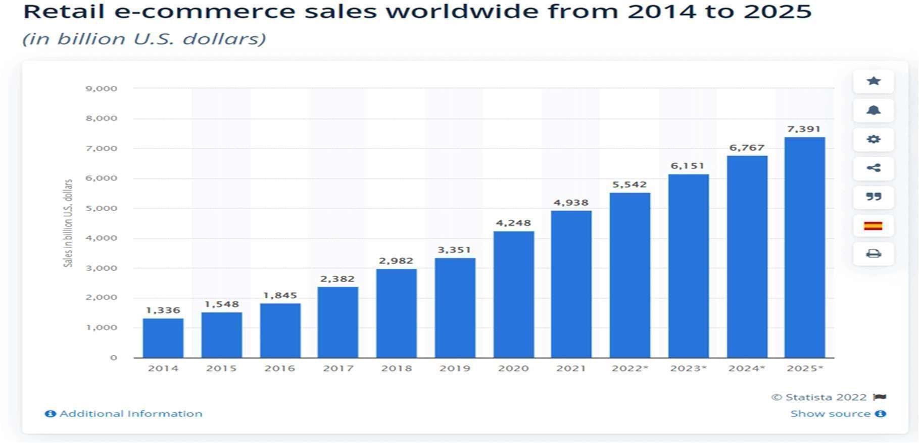The data indicates a significant trend, with 58.4% of internet users making online purchases on a weekly basis. The consumer electronics and fashion emerge as the leading categories in terms of expenditure, with consumer electronics accounting for a substantial $988.4 billion and fashion following closely behind at $904.5 billion.

## REVERSE LOGISTICS IN E-COMMERCE GLOBALLY

The global reverse logistics market, valued at USD 951.12 billion in 2022, is forecasted to achieve a substantial growth trajectory, reaching approximately USD 3,217.24 billion by 2032, with a compounded annual growth rate (CAGR) of 12.96% anticipated during the forecast span from 2023 to 2032.

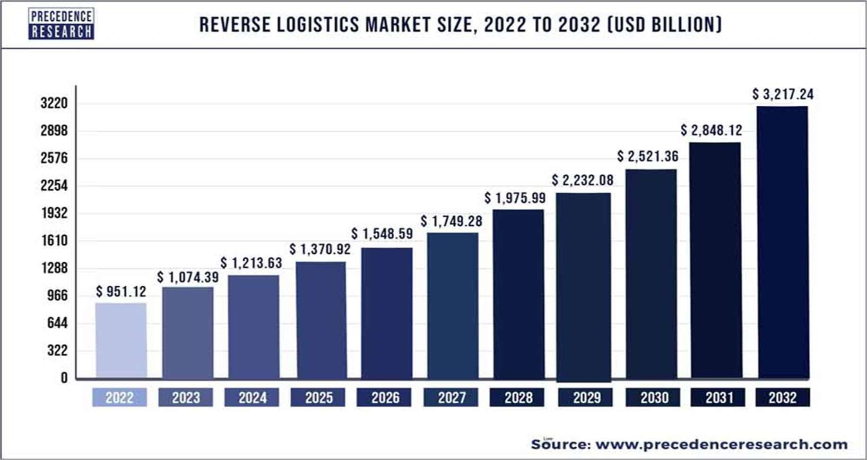

Reverse logistics encompasses a spectrum of tasks, from managing product returns and warranty repairs to facilitating recycling efforts. This multifaceted process demands meticulous organization and cooperation among diverse stakeholders, including manufacturers, retailers, logistics firms, and consumers. Effective execution hinges on strategic planning and seamless coordination to optimize resource utilization and minimize environmental impact. With its focus on repurposing goods due to repair, damage, restocking, or surplus inventory, reverse logistics plays a pivotal role in enhancing sustainability and reducing waste throughout the supply chain.

## MARKET SHARE OF REVERSE LOGISTICS

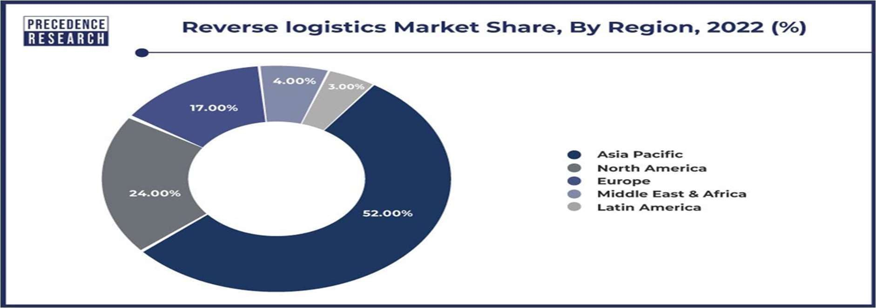Asia Pacific emerged as the top contributor to global income in 2022, accounting for over 52% of the total, and is forecasted to experience the fastest Compound Annual Growth Rate (CAGR) between 2023 and 2032. The surge in e-commerce activities is expected to bolster market growth, alongside the expansion of manufacturing sectors in emerging economies within the region and the growing demand for reverse logistics, particularly for electric vehicles. Consequently, the frequent utilization of reverse logistics in Asia Pacific is poised to further augment income generation.

Between 2023 and 2032, the Middle East and Africa region are forecasted to achieve the secondhighest Compound Annual Growth Rate (CAGR) at 13%. This growth is attributed to expanding opportunities and substantial investments in the e-commerce sector. Additionally, significant investments in transportation infrastructure further bolster market expansion. These factors collectively render the region more accessible for market entry compared to other marketplaces, particularly with the concurrent rise in discretionary income. Market participants can expect diverse opportunities across Europe and Central and South America to expand their operations and attract a broader customer base.

## GROWTH OF REVERSE LOGISTICS

Reverse logistics plays a pivotal role in handling the increasing volume of returns resulting from the growth of e-commerce. It encompasses all the necessary steps to efficiently manage returned goods, ensuring they are repurposed, refurbished, or responsibly disposed of, starting from their end-user destination back to their origin or production location. This comprehensive process involves various stages such as product development, remanufacturing, refurbishment (ensuring products are resold in excellent condition after repair), and environmentally conscious disposal strategies.

## MARKET TRENDS

The reverse logistics sector is experiencing a surge in the integration of advanced technologies like automation, artificial intelligence (AI), and data analytics, revolutionizing operations and offering invaluable decision-making insights. An illustrative instance of this transformative shift is the utilization of AI-driven systems to autonomously evaluate returned items, classify them by their condition, and suggest optimal courses of action such as refurbishment, recycling, or resale.

# RESULTS AND DISCUSSIONS

## PROBLEMS ENCOUNTERED IN REVERSE LOGISTICS

* E-commerce often experiences higher return rates compared to traditional retail, posing challenges in managing the volume of returned products and associated costs.
* Returned items may arrive in varying conditions, including damage, wear, or missing components, complicating refurbishment or resale efforts.
* High return-related costs, such as shipping, restocking, and processing fees, can significantly impact profitability and strain resources.
* Fluctuations in returned inventory levels can disrupt demand forecasting and inventory planning, leading to overstocking or stockouts.
* Coordinating the reverse flow of goods from customers back to warehouses or suppliers can be complex, especially across large geographic areas.
* Meeting customer expectations for hassle-free returns and exchanges while balancing costeffective processes poses a significant challenge for e-commerce companies.
* Delays in processing returns and issuing refunds can lead to customer dissatisfaction and impact brand reputation.

## OVERCOME THE CHALLENGES

* Simplify return processes for customers by providing clear instructions and easy-to-use return portals, reducing friction and enhancing customer satisfaction.
* Adopt advanced technology solutions, such as automated sorting systems and data analytics tools, to streamline reverse logistics operations, improve efficiency, and gain insights into return patterns.
* Collaborate with logistics partners to optimize transportation routes and methods, reducing costs and environmental impact while ensuring timely return processing.
* Implement rigorous inspection processes to assess the condition of returned items accurately, enabling effective refurbishment or resale decisions and minimizing losses from damaged goods.
* Utilize inventory management software and demand forecasting tools to better anticipate return volumes and adjust inventory levels accordingly, reducing the risk of overstocking or stockouts.
* Maintain transparent communication with customers throughout the return process, providing updates on return status and refund processing to enhance trust and satisfaction.

# CONCLUSION AND RECOMMENDATIONS

## CONCLUSION

Reverse logistics in e-commerce is multifaceted, presenting both challenges and opportunities for businesses. Throughout this exploration, we've delved into various aspects of reverse logistics, from its definition and significance to the problems encountered and potential solutions.

Reverse logistics, the process of managing returned products and materials, is essential in ecommerce due to higher return rates compared to traditional retail. However, this process comes with its fair share of challenges. Issues such as increased return rates, product condition variability, high costs, and logistical complexities pose significant obstacles to efficient reverse logistics operations.

To address these challenges, businesses must adopt strategic approaches. Implementing streamlined return processes, investing in advanced technology, optimizing transportation routes, enhancing product inspection protocols, improving inventory management systems, fostering transparent communication with customers, prioritizing sustainability initiatives, enhancing data analytics capabilities, implementing fraud detection mechanisms, and ensuring regulatory compliance are all crucial steps.

## RECOMMENDATIONS

Investing in advanced technology solutions is paramount. Implementing robust data analytics tools, automated sorting systems, and inventory management software can streamline processes, improve decision-making, and enhance overall efficiency in reverse logistics operations. Additionally, adopting blockchain technology for enhanced traceability and transparency can mitigate fraud risks and improve trust in the supply chain.

Optimizing transportation routes and methods is essential for cost reduction and environmental sustainability. Collaborating with logistics partners to consolidate shipments, minimize empty miles, and utilize eco-friendly transportation modes can significantly reduce carbon emissions and transportation costs associated with reverse logistics.

Prioritizing sustainability initiatives is crucial. Implementing circular economy principles, such as product refurbishment, recycling, and responsible disposal, not only reduces environmental impact but also enhances brand reputation and appeal to environmentally conscious consumers. Furthermore, engaging in partnerships with eco-certified suppliers and investing in renewable energy sources can further bolster sustainability efforts across the supply chain.

Enhancing customer communication and support throughout the return process is vital for building trust and loyalty. Providing clear return policies, easy-to-use return portals, and proactive updates on return status can improve the overall customer experience and mitigate potential dissatisfaction associated with returns.

# REFERENCES

https://[www.precedenceresearch.com/reverse-logistics-market](http://www.precedenceresearch.com/reverse-logistics-market) https://[www.linkedin.com/pulse/impact-e-commerce-returns-reverse-logistics-truxcargo-j408c/](http://www.linkedin.com/pulse/impact-e-commerce-returns-reverse-logistics-truxcargo-j408c/) https://[www.sciencedirect.com/science/article/pii/S2352146521003859](http://www.sciencedirect.com/science/article/pii/S2352146521003859) https://retail.economictimes.indiatimes.com/blog/the-role-of-reverse-logistics-in- managingproduct-returns-in-e-commerce/100787003 https://[www.statista.com/topics/4323/reverse-logistics/](http://www.statista.com/topics/4323/reverse-logistics/) https://[www.clickpost.ai/blog/reverselogistics-in-ecommerce](http://www.clickpost.ai/blog/reverselogistics-in-ecommerce) https://[www.researchgate.net/publication/42385790_Study_of_Reverse_Logistics_in_the_](http://www.researchgate.net/publication/42385790_Study_of_Reverse_Logistics_in_the_) Ecommerce_Environment https://[www.skyquestt.com/report/reverse-logistics-market](http://www.skyquestt.com/report/reverse-logistics-market) https://[www.xstak.com/blog/reverse-logistics-problems-ecommerce](http://www.xstak.com/blog/reverse-logistics-problems-ecommerce) https://pdf.sciencedirectassets.com/308315/1-s2.0-S2352146521X00051/1- s2.0S2352146521003859/

https://[www.ijmh.org/wpcontent/uploads/papers/v4i12/L10930841220.pdf](http://www.ijmh.org/wpcontent/uploads/papers/v4i12/L10930841220.pdf) https://[www.precedenceresearch.com/reverse-logistics-market](http://www.precedenceresearch.com/reverse-logistics-market) https://[www.netsuite.com/portal/resource/articles/inventory-](http://www.netsuite.com/portal/resource/articles/inventory-) management/reverselogistics.shtml https://ieomsociety.org/dc2018/papers/264.pdf https://[www.clickpost.ai/blog/life-cycle-of-a-product-and-how-it-applies-to-reverselogistics](http://www.clickpost.ai/blog/life-cycle-of-a-product-and-how-it-applies-to-reverselogistics)